**Web API Microservices**

**Question 1: Implement JWT Authentication in ASP.NET Core Web API**

**Program.cs:**

using Microsoft.AspNetCore.Authentication.JwtBearer;

using Microsoft.IdentityModel.Tokens;

using Microsoft.OpenApi.Models;

using System.Text;

var builder = WebApplication.CreateBuilder(args);

builder.Services.AddControllers();

builder.Services.AddEndpointsApiExplorer();

builder.Services.AddSwaggerGen(options =>

{

options.SwaggerDoc("v1", new OpenApiInfo { Title = "JwtAuthDemo", Version = "v1" });

options.AddSecurityDefinition("Bearer", new OpenApiSecurityScheme

{

Name = "Authorization",

Type = SecuritySchemeType.Http,

Scheme = "Bearer",

BearerFormat = "JWT",

In = ParameterLocation.Header,

Description = "Enter 'Bearer YOUR_TOKEN_HERE'"

});

options.AddSecurityRequirement(new OpenApiSecurityRequirement

{

{

new OpenApiSecurityScheme

{

Reference = new OpenApiReference

{

Type = ReferenceType.SecurityScheme,

Id = "Bearer"

}

},

Array.Empty<string>()

}

});

});

builder.Services.AddAuthentication(JwtBearerDefaults.AuthenticationScheme)

.AddJwtBearer(options =>

{

options.TokenValidationParameters = new TokenValidationParameters

{

ValidateIssuer = true,

ValidateAudience = true,

ValidateLifetime = true,

ValidateIssuerSigningKey = true,

ValidIssuer = builder.Configuration["Jwt:Issuer"],

ValidAudience = builder.Configuration["Jwt:Audience"],

IssuerSigningKey = new SymmetricSecurityKey(

Encoding.UTF8.GetBytes(builder.Configuration["Jwt:Key"]))

};

});

builder.Services.AddAuthorization();

var app = builder.Build();

if (app.Environment.IsDevelopment())

{

app.UseSwagger();

app.UseSwaggerUI();

}

app.UseHttpsRedirection();

app.UseAuthentication();

app.UseAuthorization();

app.MapControllers();

app.Run();

**AuthController.cs:**

using Microsoft.AspNetCore.Mvc;

using Microsoft.IdentityModel.Tokens;

using System.IdentityModel.Tokens.Jwt;

using System.Security.Claims;

using System.Text;

using JwtAuthDemo.Models;

namespace JwtAuthDemo.Controllers

{

    [ApiController]

    [Route("api/[controller]")]

    public class AuthController : ControllerBase

    {

        private readonly IConfiguration _config;

        public AuthController(IConfiguration config)

        {

            _config = config;

        }

        [HttpPost("login")]

        public IActionResult Login([FromBody] LoginModel model)

        {

            if (IsValidUser(model))

            {

                var token = GenerateJwtToken(model.Username);

                return Ok(new { Token = token });

            }

            return Unauthorized();

        }

        private bool IsValidUser(LoginModel model)

        {

            return model.Username == "test" && model.Password == "password";

        }

        private string GenerateJwtToken(string username)

        {

            var claims = new[]

            {

                new Claim(ClaimTypes.Name, username),

                new Claim(ClaimTypes.Role, "Admin")

            };

            var key = new SymmetricSecurityKey(

                Encoding.UTF8.GetBytes(_config["Jwt:Key"]));

            var creds = new SigningCredentials(key, SecurityAlgorithms.HmacSha256);

            var token = new JwtSecurityToken(

                issuer: _config["Jwt:Issuer"],

                audience: _config["Jwt:Audience"],

                claims: claims,

                expires: DateTime.Now.AddMinutes(

                    double.Parse(_config["Jwt:DurationInMinutes"])

                ),

                signingCredentials: creds

            );

            return new JwtSecurityTokenHandler().WriteToken(token);

        }

    }

}

**TestController.cs:**

using Microsoft.AspNetCore.Authorization;

using Microsoft.AspNetCore.Mvc;

namespace JwtAuthDemo.Controllers

{

    [ApiController]

    [Route("api/[controller]")]

    public class TestController : ControllerBase

    {

        [HttpGet("secure")]

        [Authorize]

        public IActionResult Secure()

        {

            return Ok($"Hello {User.Identity.Name}, you accessed a protected endpoint!");

        }

        [HttpGet("public")]

        public IActionResult Public()

        {

            return Ok("This is a public endpoint, no token needed.");

        }

    }

}

**appsettings.json:**

{

  "Jwt": {

    "Key": "MysecretJwtTokennumberzzz1234567890123456789",

    "Issuer": "MyAuthServer",

    "Audience": "MyApiUsers",

    "DurationInMinutes": 60

  },

  "Logging": {

    "LogLevel": {

      "Default": "Information",

      "Microsoft.AspNetCore": "Warning"

    }

  },

  "AllowedHosts": "*"

}

**OUTPUT:**

**Input credentials for token generation:**

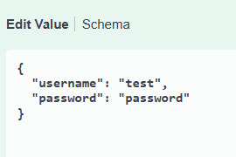

**JWT token:**

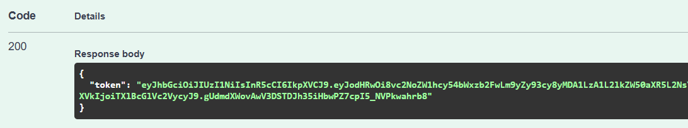

**Authorization using token:**

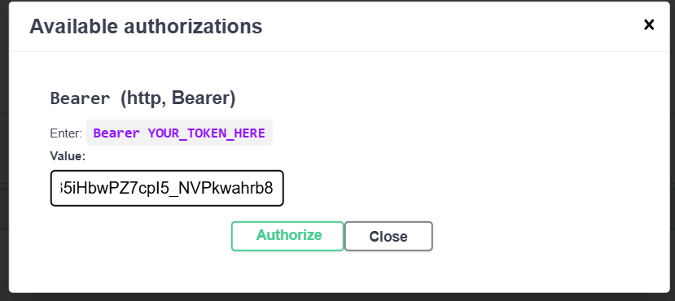

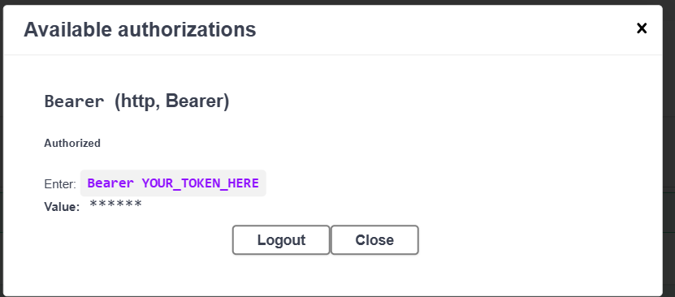

**Response after authorization:**

