**Week 6 – ReactJS HOL**

**Exercise 1:**

**App.js:**

function App() {

  return (

    <div>

      <h1>welcome to the first session of React</h1>

    </div>

  );

}

export default App;

**OUTPUT:**

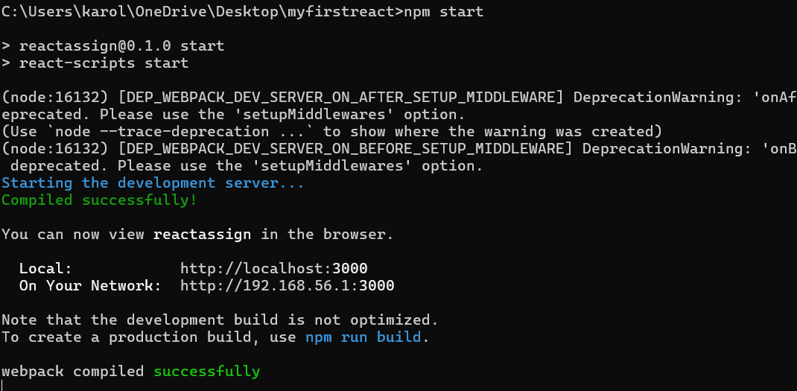

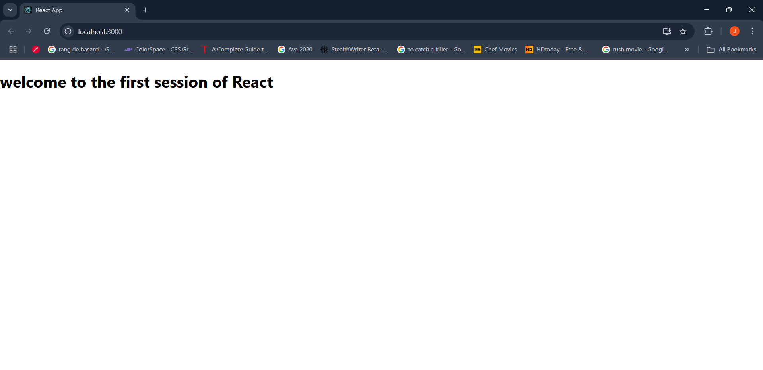

**Exercise 2:**

**App.js:**

import React from 'react';

import Home from './Components/Home';

import About from './Components/About';

import Contact from './Components/Contact';

function App() {

  return (

    <div>

      <Home />

      <About />

      <Contact />

    </div>

  );

}

export default App;

**Home.js:**

import React from 'react';

function Home() {

  return (

    <div>

      <h1>Welcome to the Home page of Student Management Portal</h1>

    </div>

  );

}

export default Home;

**Contact.js:**

import React from 'react';

function Contact() {

  return (

    <div>

      <h1>Welcome to the Contact page of the Student Management Portal</h1>

    </div>

  );

}

export default Contact;

**About.js:**

import React from 'react';

function About() {

  return (

    <div>

      <h1>Welcome to the About page of the Student Management Portal</h1>

    </div>

  );

}

export default About;

**OUTPUT:**

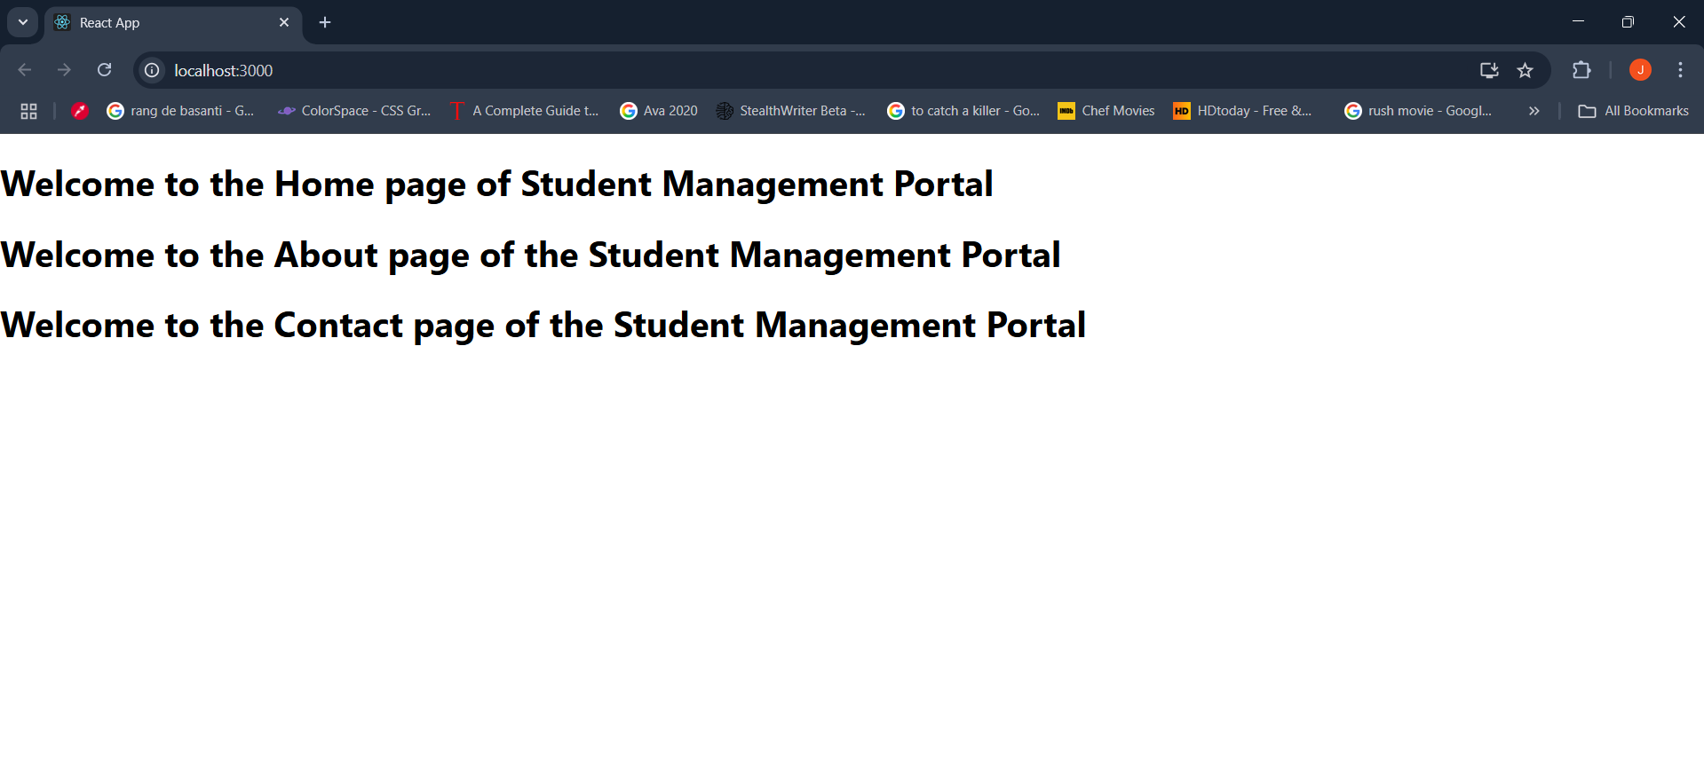

**Exercise 3:**

**App.js:**

import React from 'react';

import CalculateScore from './Components/CalculateScore';

function App() {

  return (

    <div>

      <CalculateScore Name="Claire Murphy" School="Little Flower High School" Total={450} Goal={5} />

    </div>

  );

}

export default App;

**Mystyle.css:**

.score-card {

  border: 2px solid #4CAF50;

  padding: 20px;

  margin: 20px;

  border-radius: 8px;

  background-color: #f9f9f9;

  font-family: Arial, sans-serif;

}

.score-card h2 {

  color: #4CAF50;

}

.score-card p {

  font-size: 18px;

  margin: 5px 0;

}

**CalculateScore.js:**

import React from 'react';

import '../Stylesheets/mystyle.css';

function CalculateScore(props) {

  const average = props.Total / props.Goal;

  return (

    <div className="score-card">

      <h2>Student Score Calculator</h2>

      <p><strong>Name:</strong> {props.Name}</p>

      <p><strong>School:</strong> {props.School}</p>

      <p><strong>Total:</strong> {props.Total}</p>

      <p><strong>Goal:</strong> {props.Goal}</p>

      <p><strong>Average Score:</strong> {average.toFixed(2)}</p>

    </div>

  );

}

export default CalculateScore;

**OUTPUT:**

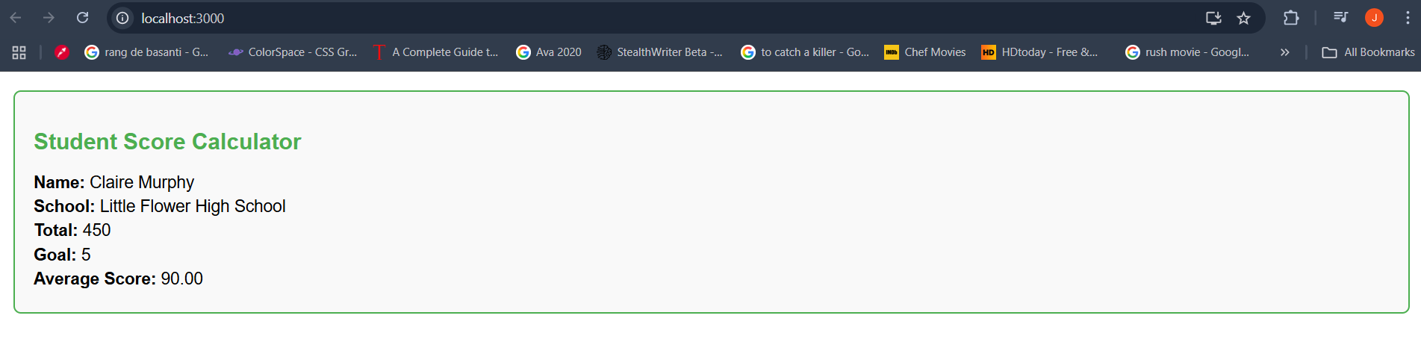

**Exercise 4:**

**Post.js:**

class Post {

constructor(userId, id, title, body) {

this.userId = userId;

this.id = id;

this.title = title;

this.body = body;

}

}

export default Post;

**Posts.js:**

import React, { Component } from 'react';

import Post from './Post';

class Posts extends Component {

  constructor(props) {

    super(props);

    this.state = {

      posts: [],

    };

  }

  loadPosts() {

    fetch('https://jsonplaceholder.typicode.com/posts')

      .then(response => response.json())

      .then(data => {

        const posts = data.map(

          post => new Post(post.userId, post.id, post.title, post.body)

        );

        this.setState({ posts });

      })

      .catch(error => {

        console.error('Error fetching posts:', error);

      });

  }

  componentDidMount() {

    this.loadPosts();

  }

  componentDidCatch(error, info) {

    alert(`An error occurred: ${error}`);

    console.error(error, info);

  }

  render() {

    return (

      <div>

        <h1>Blog Posts</h1>

        {this.state.posts.map(post => (

          <div key={post.id}>

            <h2>{post.title}</h2>

            <p>{post.body}</p>

          </div>

        ))}

      </div>

    );

  }

}

export default Posts;

**App.js:**

import React from 'react';

import Posts from './Posts';

function App() {

return (

<div>

<Posts />

</div>

);

}

export default App;

**OUTPUT:**

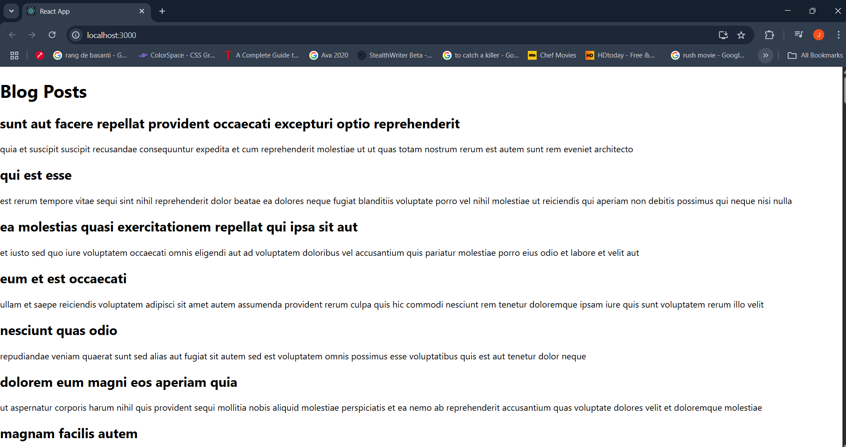

**Exercise 5:**

**OUTPUT:**

