**Week 7 ReactJS – HOL**

**Exercise 9:**

**App.js:**

import React from "react";

import ListofPlayers from "./components/ListofPlayers";

import IndianPlayers from "./components/IndianPlayers";

function App() {

  const flag = false;

  return (

    <div className="App">

      <h1>Cricket App</h1>

      {flag ? <ListofPlayers /> : <IndianPlayers />}

    </div>

  );

}

export default App;

**IndianPlayers.js:**

import React from "react";

const IndianPlayers = () => {

  const oddTeam = ["Sachin1", "Virat3", "Yuvaraj5"];

  const evenTeam = ["Dhoni2", "Rohit4", "Raina6"];

  const [odd1, odd2, odd3] = oddTeam;

  const [even1, even2, even3] = evenTeam;

  const T20Players = ["Mr. First Player", "Mr. Second Player", "Mr. Third Player"];

  const RanjiPlayers = ["Mr. Fourth Player", "Mr. Fifth Player", "Mr. Sixth Player"];

  const mergedPlayers = [...T20Players, ...RanjiPlayers];

  return (

    <div>

      <h2>Odd Players</h2>

      <ul>

        <li>First : {odd1}</li>

        <li>Third : {odd2}</li>

        <li>Fifth : {odd3}</li>

      </ul>

      <h2>Even Players</h2>

      <ul>

        <li>Second : {even1}</li>

        <li>Fourth : {even2}</li>

        <li>Sixth : {even3}</li>

      </ul>

      <h2>List of Indian Players Merged:</h2>

      <ul>

        {mergedPlayers.map((player, index) => (

          <li key={index}>{player}</li>

        ))}

      </ul>

    </div>

  );

};

export default IndianPlayers;

**ListofPlayers.js:**

import React from "react";

const ListofPlayers = () => {

  const players = [

    { name: "Player1", score: 80 },

    { name: "Player2", score: 65 },

    { name: "Player3", score: 90 },

    { name: "Player4", score: 55 },

    { name: "Player5", score: 100 },

    { name: "Player6", score: 45 },

    { name: "Player7", score: 70 },

    { name: "Player8", score: 85 },

    { name: "Player9", score: 60 },

    { name: "Player10", score: 75 },

    { name: "Player11", score: 95 },

  ];

  const filteredPlayers = players.filter(player => player.score < 70);

  return (

    <div>

      <h2>All Players:</h2>

      <ul>

        {players.map((player, index) => (

          <li key={index}>{player.name} - {player.score}</li>

        ))}

      </ul>

      <h2>Players with Score below 70:</h2>

      <ul>

        {filteredPlayers.map((player, index) => (

          <li key={index}>{player.name} - {player.score}</li>

        ))}

      </ul>

    </div>

  );

};

export default ListofPlayers;

**OUTPUT:**

1. **Flag is true:**

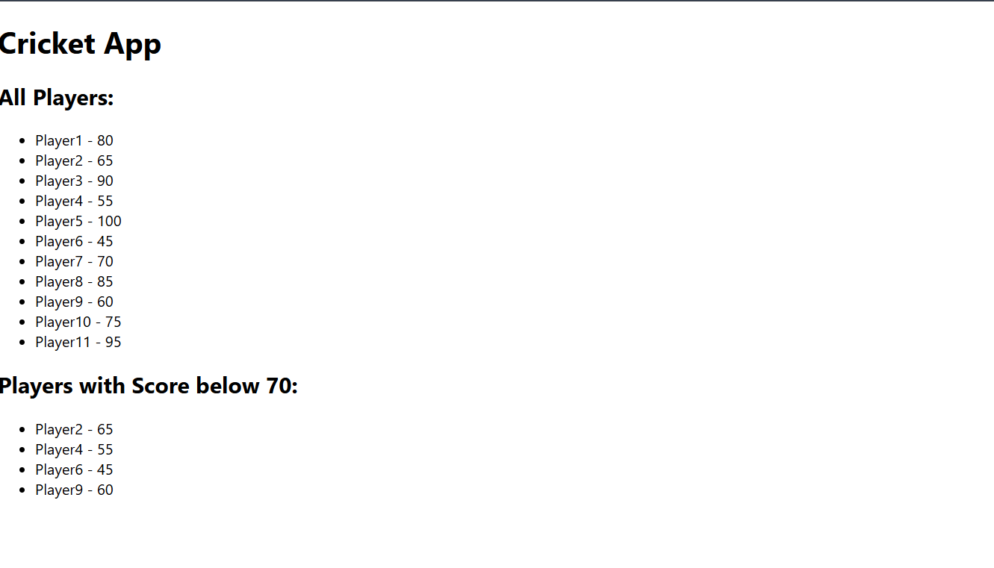

1. **Flag is false:**

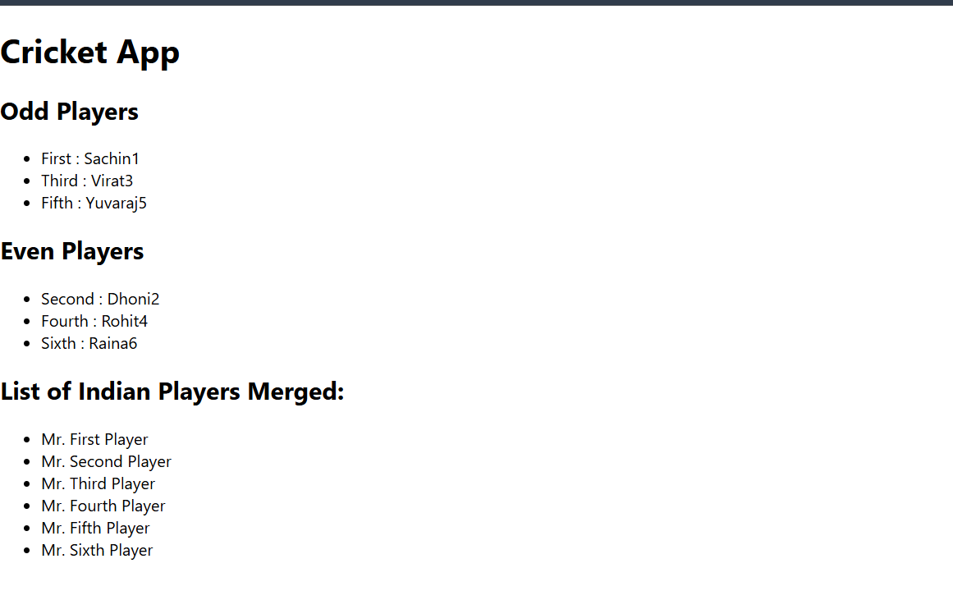

**Exercise 10:**

**App.js:**

import React from "react";

import "./App.css";

function App() {

  const element = "Office Space";

  const sr = "https://www.stikwood.com/cdn/shop/files/Reclaimed_Barrel_Oak-RCBO-commercial-office-accent_wall-horizontal-residential-Office-Credit_Christopher_Caparro_b2c8c11d-205b-4a05-8116-e7cd5062ef4f.jpg?v=1687882741";

  const ItemName = { Name: "DBS", Rent: 50000, Address: "Chennai" };

  let colors = [];

  if (ItemName.Rent <= 60000) {

    colors.push("textRed");

  } else {

    colors.push("textGreen");

  }

  const OfficeList = [

    { Name: "DBS", Rent: 50000, Address: "Chennai" },

    { Name: "Regus", Rent: 65000, Address: "Bangalore" },

    { Name: "WeWork", Rent: 70000, Address: "Hyderabad" },

  ];

  const jsxatt = (

    <img src={sr} width="50%" height="50%" alt="Office Space" />

  );

  return (

    <div className="App">

      <h1>{element} at Affordable Range</h1>

      {jsxatt}

      <h1>Name: {ItemName.Name}</h1>

      <h3 className={colors.join(" ")}>Rent: Rs. {ItemName.Rent}</h3>

      <h3>Address: {ItemName.Address}</h3>

      <h2>All Office Spaces</h2>

      <ul>

        {OfficeList.map((item, index) => {

          let rentColor = item.Rent <= 60000 ? "textRed" : "textGreen";

          return (

            <li key={index}>

              {item.Name} - <span className={rentColor}>Rs. {item.Rent}</span> -{" "}

              {item.Address}

            </li>

          );

        })}

      </ul>

    </div>

  );

}

export default App;

**App.css:**  
.App {

  text-align: left;

font-family: Arial, sans-serif;

  padding: 90px;

}

.App-logo {

  height: 40vmin;

  pointer-events: none;

}

@media (prefers-reduced-motion: no-preference) {

  .App-logo {

    animation: App-logo-spin infinite 20s linear;

  }

}

.App-header {

  background-color: #282c34;

  min-height: 100vh;

  display: flex;

  flex-direction: column;

  align-items: center;

  justify-content: center;

  font-size: calc(10px + 2vmin);

  color: white;

}

.App-link {

  color: #61dafb;

}

img {

  margin: 20px 0;

}

.textRed {

  color: red;

}

.textGreen {

  color: green;

}

@keyframes App-logo-spin {

  from {

    transform: rotate(0deg);

  }

  to {

    transform: rotate(360deg);

  }

}

**OUTPUT:**



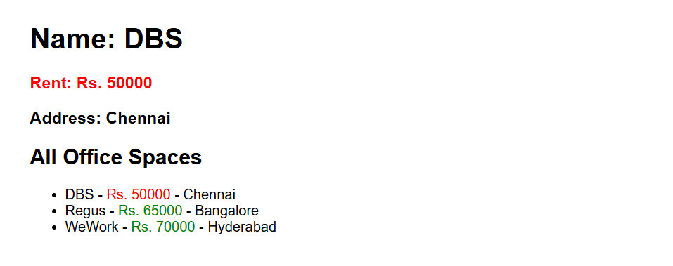

**Exercise 11:**

**App.js:**

import React, { useState } from "react";

import CurrencyConvertor from "./components/CurrencyConvertor";

function App() {

  const [counter, setCounter] = useState(0);

  const handleIncrement = () => {

    incrementCounter();

    sayHello();

  };

  const incrementCounter = () => {

    setCounter(counter + 1);

  };

  const sayHello = () => {

    console.log("Hello! Counter incremented.");

    alert("Hello! You clicked Increment.");

  };

  const handleDecrement = () => {

    setCounter(counter - 1);

  };

  const sayWelcome = (msg) => {

    alert(msg);

  };

  const handleOnPress = () => {

    alert("I was clicked");

  }

  return (

    <div className="App">

      <h1>Event Examples App</h1>

      <h2>Counter: {counter}</h2>

      <button onClick={handleIncrement}>Increment</button>

      <button onClick={handleDecrement}>Decrement</button>

      <br /><br />

      <button onClick={() => sayWelcome("Welcome!")}>Say Welcome</button>

      <br /><br />

      <button onClick={handleOnPress}>OnPress Button</button>

      <br /><br />

      <CurrencyConvertor />

    </div>

  );

}

export default App;

**CurrencyConvertor.js:**

import React, { useState } from "react";

function CurrencyConvertor() {

  const [rupees, setRupees] = useState("");

  const [euro, setEuro] = useState(null);

  const handleSubmit = () => {

    const converted = rupees / 90;

    setEuro(converted.toFixed(2));

  };

  return (

    <div>

      <h2>Currency Convertor</h2>

      <input

        type="number"

        placeholder="Enter amount in Rupees"

        value={rupees}

        onChange={(e) => setRupees(e.target.value)}

      />

      <button onClick={handleSubmit}>Convert</button>

      {euro !== null && (

        <p>

          ₹{rupees} is equal to €{euro}

        </p>

      )}

    </div>

  );

}

export default CurrencyConvertor;

**OUTPUT:**

**Currency Convertor:**

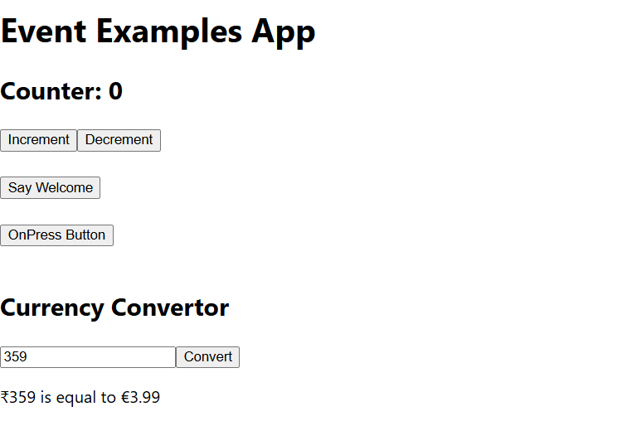

**Counter button click:**

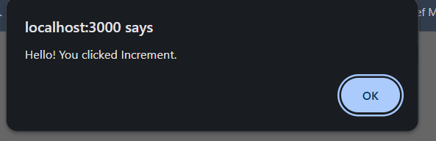

**Welcome button:**

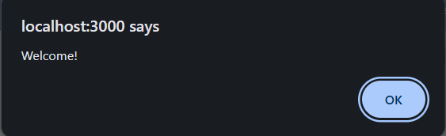

**OnClick button:**

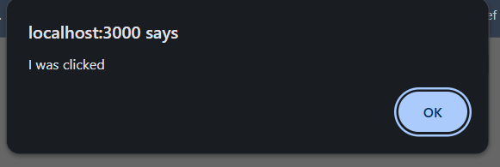

**Exercise 12:**

**App.js:**

import React, { useState } from "react";

import GuestPage from "./components/GuestPage";

import UserPage from "./components/UserPage";

function App() {

  const [isLoggedIn, setIsLoggedIn] = useState(false);

  const handleLogin = () => {

    setIsLoggedIn(true);

  }

  const handleLogout = () => {

    setIsLoggedIn(false);

  }

  return (

    <div className="App">

      <h1>Ticket Booking App</h1>

      {isLoggedIn ? (

        <UserPage onLogout={handleLogout} />

      ) : (

        <GuestPage onLogin={handleLogin} />

      )}

    </div>

  );

}

export default App;

**GuestPage.js:**

import React from "react";

function GuestPage({ onLogin }) {

  const flights = [

    { id: 1, airline: "Indigo", from: "Delhi", to: "Mumbai", time: "10:00 AM" },

    { id: 2, airline: "Air India", from: "Chennai", to: "Bangalore", time: "1:00 PM" },

    { id: 3, airline: "SpiceJet", from: "Kolkata", to: "Hyderabad", time: "5:30 PM" },

  ];

  return (

    <div>

      <h2>Welcome Guest! Browse Flights Below</h2>

      <ul>

        {flights.map(flight => (

          <li key={flight.id}>

            {flight.airline} | {flight.from} → {flight.to} at {flight.time}

          </li>

        ))}

      </ul>

      <button onClick={onLogin}>Login</button>

    </div>

  );

}

export default GuestPage;

**UserPage.js:**

import React from "react";

function UserPage({ onLogout }) {

  return (

    <div>

      <h2>Welcome User! Book Your Tickets Below</h2>

      <p>Booking page: (pretend booking form here)</p>

      <button onClick={onLogout}>Logout</button>

    </div>

  );

}

export default UserPage;

**OUTPUT:**

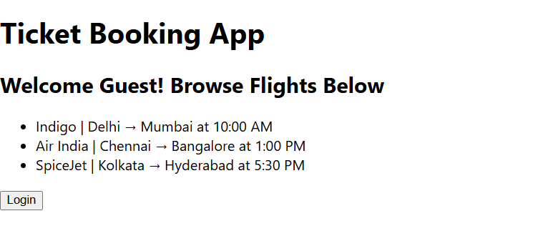

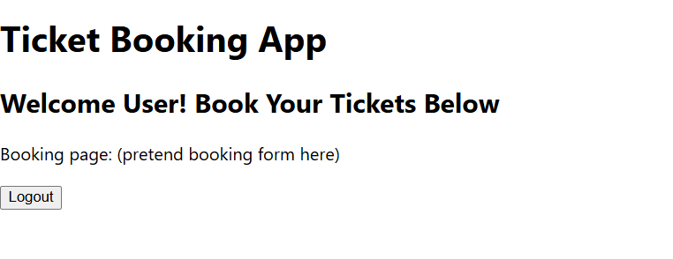

**Exercise 13:**

**App.js:**

import React, { useState } from "react";

import BookDetails from "./components/BookDetails";

import BlogDetails from "./components/BlogDetails";

import CourseDetails from "./components/CourseDetails";

import { books } from "./data";

function App() {

  const [showBooks, setShowBooks] = useState(true);

  const [showBlog, setShowBlog] = useState(false);

  const [showCourse, setShowCourse] = useState(false);

  return (

    <div>

      <h1>Blogger App</h1>

      <button onClick={() => {

        setShowBooks(true);

        setShowBlog(false);

        setShowCourse(false);

      }}>

        Show Book Details

      </button>

      <button onClick={() => {

        setShowBooks(false);

        setShowBlog(true);

        setShowCourse(false);

      }}>

        Show Blog Details

      </button>

      <button onClick={() => {

        setShowBooks(false);

        setShowBlog(false);

        setShowCourse(true);

      }}>

        Show Course Details

      </button>

      <hr />

      {showBooks ? <BookDetails books={books} /> : null}

      {showBlog && <BlogDetails />}

      {showCourse ? <CourseDetails /> : null}

    </div>

  );

}

export default App;

**BookDetails.js:**

import React from "react";

const BookDetails = (props) => {

  const bookdet = (

    <ul>

      {props.books.map((book) => (

        <div key={book.id}>

          <h3>{book.bname}</h3>

          <h4>{book.price}</h4>

        </div>

      ))}

    </ul>

  );

  return (

    <div className="st2">

      <h1>Book Details</h1>

      {bookdet}

    </div>

  );

};

export default BookDetails;

**data.js:**

export const books = [

  { id: 101, bname: "The Road to React by Robin Wieruch", price: 670 },

  { id: 102, bname: "Python Crash Course by Eric Matthes", price: 800 },

  { id: 103, bname: "C# in Depth, Fourth Edition by Jon Skeet", price: 550 },

];

**CourseDetails.js:**

import React from "react";

const CourseDetails = () => {

  return (

    <div className="mystyle1">

      <h1>Course Details</h1>

      <h2>Courses include:</h2>

      <li>React - 20h 30min</li>

      <li>Java - 30h 45min</li>

      <li>C# - 30h 30min</li>

      <li>Angular - 30h</li>

      <li>Python - 30h 40min</li>

    </div>

  );

};

export default CourseDetails;

**BlogDetails.js:**

import React from "react";

const BlogDetails = () => {

  return (

    <div className="v1">

      <h1>Blog Details</h1>

      <h2>.NET Blog</h2>

      <p>This is a sample blog about .NET framework.</p>

      <h2>React Blog</h2>

      <p>This is a sample blog about React framework.</p>

    </div>

  );

};

export default BlogDetails;

**OUTPUT:**

