**WEEK 8 – GIT HANDSON**

**EXERCISE 1:**

**Welcome.txt using ls -al:**

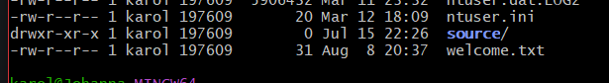

**Printing file content:**

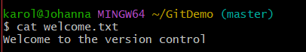

**Git status before & after adding the new file:**

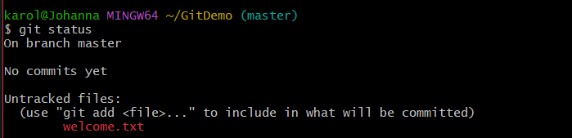

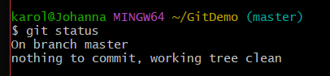

**Git push:**

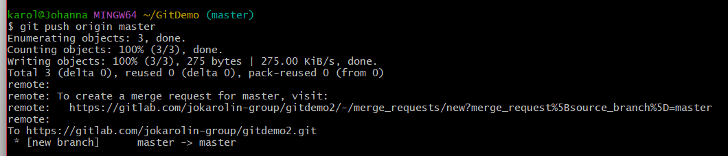

**EXERCISE 2:**

**Creating a log file, log folder and .gitignore file:**

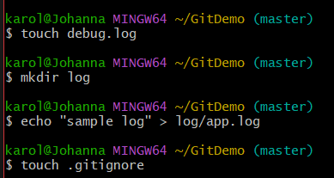

**Configuring .gitignore file:**

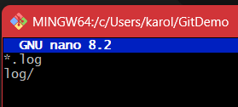

**Adding .gitignore file & commiting:**

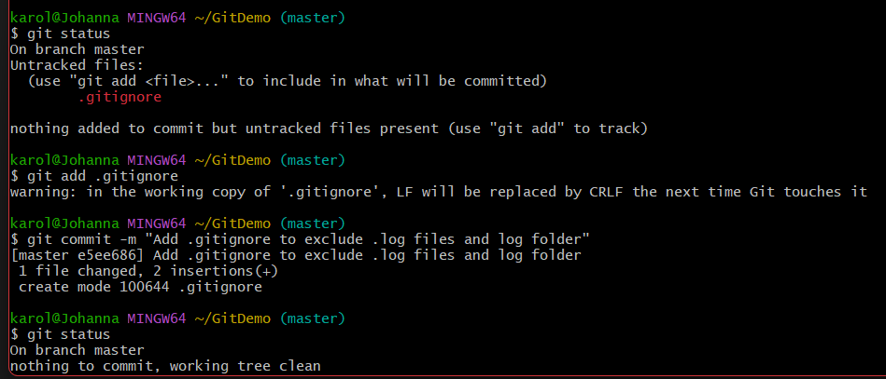



**EXERCISE 3:**

**Creating new branch and adding it:**

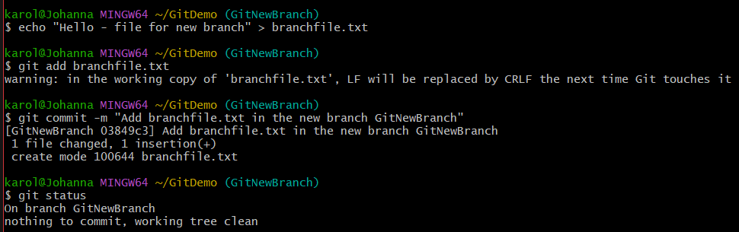

**View differences between trunk and branch:**

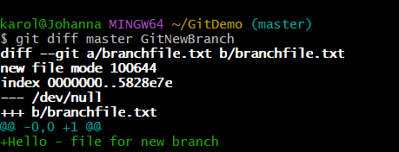

**Visual differences using P4Merge tool:**

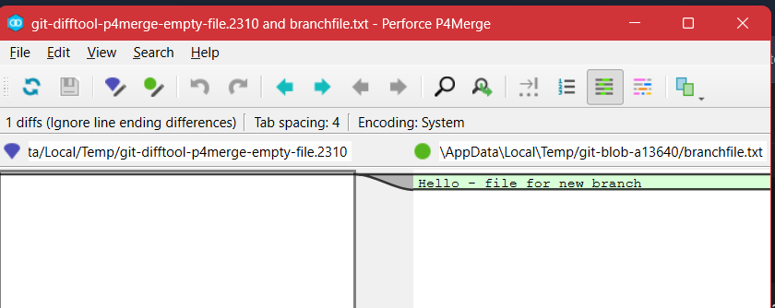

**Merging source branch to trunk:**

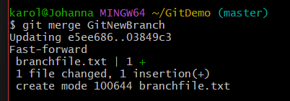

**Observe logging:**

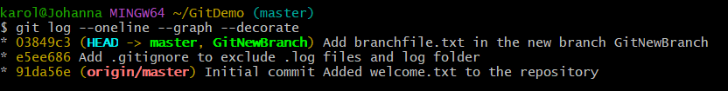

**Deleting the branch after merging:**

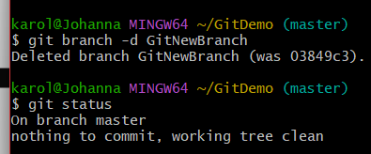

**EXERCISE 4:**

**Creating branch and adding file:**

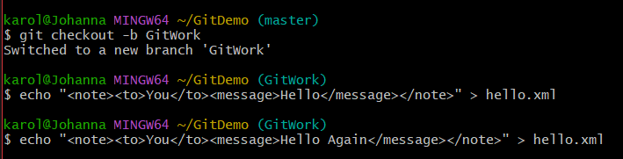

**Add file to master:**

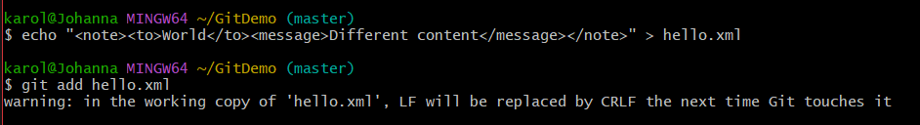

**Check logs:**

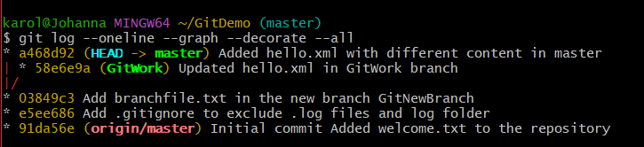

**View differences:**

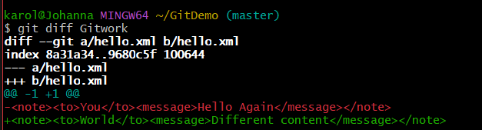

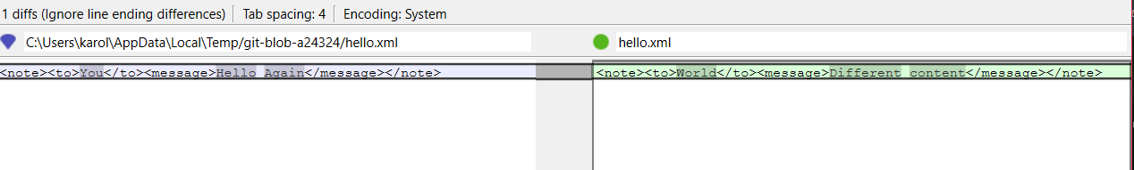

**Merge branch to master:**

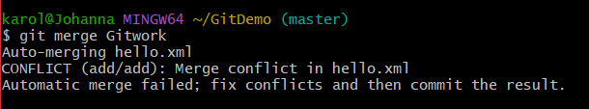

**3-Way merge tool:**

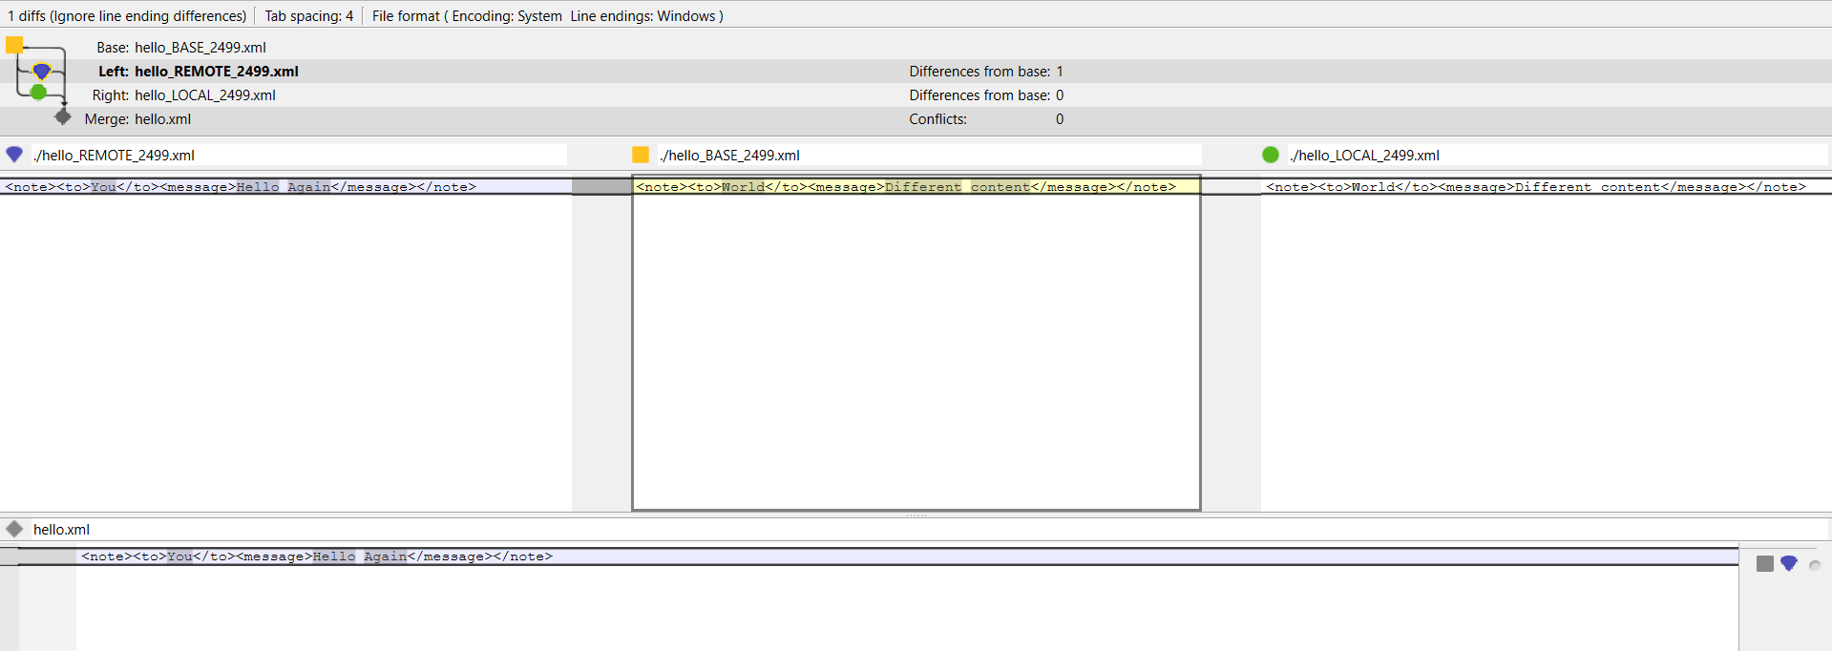

**Observe logs:**

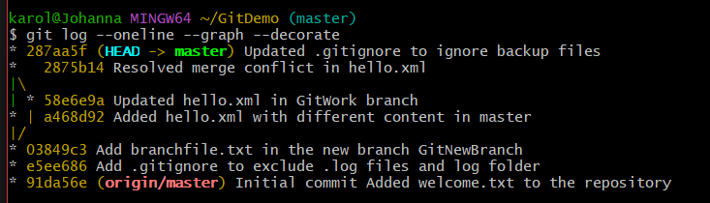

**EXERCISE 5:**

**Listing out branches:**

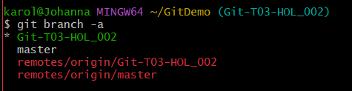

**Pushing & checking logs:**

