Structure Switching:
A Structural Paradigm for Post-Packet Network Architectures
Velsanet Research Institute | March 2026

Abstract
Communication networks have historically evolved through architectural transitions rather than incremental protocol improvements. The first major paradigm was circuit switching, in which a dedicated path was established between endpoints. The second paradigm was packet switching, which enabled dynamic routing and statistical multiplexing, forming the foundation of the global Internet. This paper proposes a third architectural concept — Structure Switching — in which connectivity is determined primarily by the designed topology of the network rather than by dynamic packet routing. In this model, structural relationships between nodes define persistent connectivity patterns, allowing multiple users and systems to simultaneously utilize the same structural pathways. Structure Switching shifts the network paradigm from route discovery toward topology-defined communication, and offers an architectural foundation for AI-native, autonomous, and large-scale machine-cooperation environments.

Keywords: Structure Switching, Network Architecture, Packet-Free Networks, Topology-Defined Communication, AI-Native Networks, 6G, Distributed Networks

1. Introduction
The evolution of communication networks has traditionally been driven by improvements in efficiency, scalability, and reliability. However, fundamental architectural changes have occurred only rarely, each representing a paradigm shift rather than an incremental improvement.
Circuit switching dominated early telecommunications, particularly in the public switched telephone network (PSTN). Packet switching later emerged as a more flexible and scalable alternative, forming the foundation of modern Internet architecture [1].
Despite the success of packet switching, the increasing demands of AI-native systems, autonomous infrastructure, and large-scale machine cooperation are exposing structural limitations in packet-based communication models. These emerging environments require persistent, highly coordinated connectivity patterns rather than independent packet flows [2].
Furthermore, current 6G standardization discussions have begun to acknowledge that traditional transport protocols may be structurally misaligned with the requirements of next-generation network environments [3]. This context motivates the exploration of a new architectural paradigm.
This paper introduces Structure Switching as a third network paradigm and examines its architectural characteristics, operational model, and implications for future network systems.

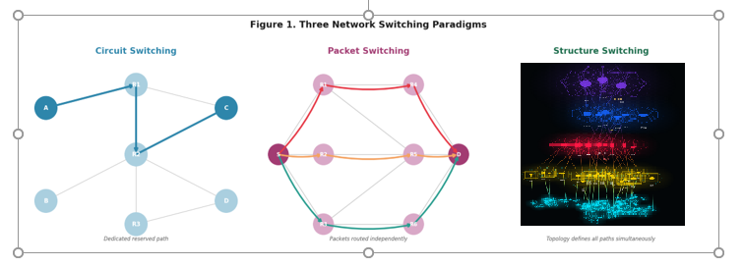
Figure 1. Comparative illustration of the three network switching paradigms: Circuit Switching (dedicated path), Packet Switching (dynamic routing), and Structure Switching (topology-defined connectivity).

2. Historical Paradigms of Network Switching
Network communication architecture can be interpreted through a sequence of major paradigm transitions. Each transition was not merely a technical improvement but a reconceptualization of how connectivity is established and maintained.
2.1 Circuit Switching
In circuit switching networks, communication begins with the establishment of a dedicated physical path between two endpoints. Once the path is reserved, data flows continuously over the circuit. Reliability is achieved through exclusive resource allocation; however, efficiency is limited because network resources remain reserved even when no data is being transmitted [4].
2.2 Packet Switching
Packet switching divides data into discrete units that travel independently through the network. Each packet may take a different route, determined dynamically by routing algorithms. This model maximizes resource utilization and scalability, enabling the global Internet as it exists today [1]. However, packet networks introduce significant complexity in congestion control, routing protocol management, and latency optimization.
Notably, many of the architectural additions that have been layered onto the Internet — including NAT, CDN, overlay networks, SDN, and NFV — represent compensatory mechanisms designed to address the structural limitations of packet switching rather than solutions derived from a coherent architectural foundation.

3. The Concept of Structure Switching
Structure Switching introduces a fundamentally different approach to network connectivity. Rather than dynamically discovering routes for each individual packet, the structural topology of the network defines connectivity relationships in advance. Communication occurs over these predefined structural pathways.
In a Structure Switching network, the network itself is designed as a set of structural relationships between nodes. These structures act as communication frameworks that can be shared simultaneously by multiple users or systems. The central architectural principle is that topology itself becomes the switching mechanism.
This principle represents a fundamental inversion of the packet switching model: whereas packet switching asks 'how does a packet find its destination,' Structure Switching asks 'what structural relationship already exists between origin and destination.'

4. Operational Model
In a Structure Switching network, the communication process follows a fundamentally different logic from packet-based networks.
First, structural connectivity between endpoints is established through the design of network topology. These structural connections may consist of parallel pathways, hierarchical relationships, or multidimensional connectivity patterns such as hypercube geometries.
Second, multiple users or systems simultaneously utilize the same structural framework. Unlike circuit switching, which reserves exclusive paths, and unlike packet switching, which computes routes per packet, Structure Switching allows simultaneous flows to coexist within the same structural fabric.
Third, communication flows along structural pathways without requiring continuous route computation. As a result, the network's operational complexity shifts from routing algorithms to structural design and topology optimization.
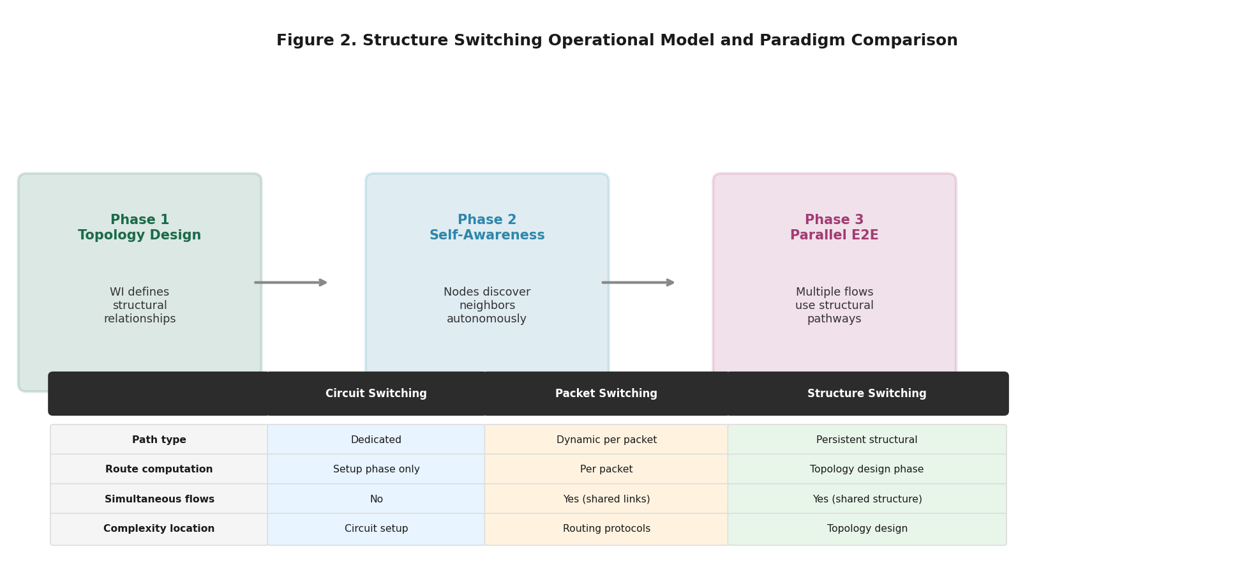
Figure 2. Structure Switching operational model: three phases of topology-defined communication.

Table 1. Comparative Analysis of Three Network Switching Paradigms
Category | Circuit Switching | Packet Switching | Structure Switching
Core Philosophy | Dedicated path reservation | Dynamic route discovery | Deterministic topology definition
Meaning of Address | Endpoint telephone number | Logical identifier (IP address) | Structural coordinate
Connection Model | Fixed 1:1 connection | Connectionless packet transmission | Shared structural topology
Path Determination | Determined once at call setup | Routed independently per packet | Derived from structural axes
Intelligence Location | External to network | External to network | Embedded in topology
Primary Advantage | Deterministic latency | Resource efficiency and scalability | Massive parallelism and structural resilience
Limitation | Severe resource underutilization | Latency variability (jitter) | Participation-based deployment — requires ecosystem formation
Historical Context | PSTN telephone networks | Internet (TCP/IP) | AI-native, autonomous systems, 6G infrastructures
Table 1. Systematic comparison of Circuit Switching, Packet Switching, and Structure Switching across eight architectural dimensions. The Intelligence Location row highlights the fundamental distinction of Structure Switching: intelligence is embedded in topology rather than residing in external systems.

5. Architectural Characteristics
Structure Switching introduces several distinctive architectural characteristics that differentiate it from both circuit and packet switching models.
Connectivity is determined by topology rather than dynamic routing decisions. Communication paths are persistent structural relationships rather than temporary packet routes. Multiple flows can coexist simultaneously within the same structural framework. Network complexity is reduced at the protocol level while increasing in the structural design phase.
This model emphasizes the importance of network geometry and topology as the primary determinants of communication behavior. The structural design phase — analogous to the planning of physical infrastructure — becomes the central engineering discipline.
A significant consequence of this architecture is the elimination of packet collision and congestion as operational phenomena. Because each communication flow occupies a structurally defined pathway, interference between flows is addressed at the design level rather than through runtime protocol mechanisms.

6. Implications for Future Networks
Emerging technological environments are increasingly defined by continuous machine-to-machine interaction, real-time coordination, and AI-driven infrastructure. Representative examples include autonomous transportation systems, distributed robotic networks, large-scale sensor ecosystems, and multi-agent AI coordination platforms.
In such environments, communication patterns are fundamentally persistent and collaborative rather than intermittent and transactional. The assumption underlying packet switching — that each data transfer is an independent event requiring dynamic route discovery — becomes structurally misaligned with these requirements.
Structure Switching may therefore provide an architectural foundation for future network systems in which connectivity reflects persistent structural relationships between intelligent agents rather than individual packet exchanges. The topology of the network becomes an expression of the intended interaction architecture of the systems it serves.
Additionally, the participation-based formation model enabled by Structure Switching — in which network structure grows organically from the bottom up as nodes join — offers a governance architecture that is inherently distributed. No central authority deploys the network; instead, participants collectively constitute it.
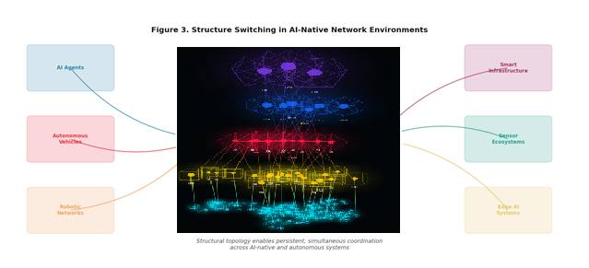
Figure 3. Structure Switching as infrastructure for AI-native environments. Structural topology enables persistent, simultaneous coordination across autonomous vehicles, robotic networks, AI agents, smart infrastructure, sensor ecosystems, and edge AI systems.

7. Conclusion
The history of communication networks can be interpreted as a sequence of architectural transformations, each driven not by incremental improvement but by a reconceptualization of the fundamental switching mechanism.
Circuit Switching established the principle of dedicated communication paths. Packet Switching introduced dynamic routing and statistical resource sharing. Structure Switching proposes a third paradigm in which the topology of the network itself constitutes the switching mechanism, and structural relationships between nodes define persistent connectivity.
As network systems increasingly support AI-native and autonomous infrastructures, the structural approach to connectivity may become not merely an alternative but a necessary architectural foundation. The question is no longer whether packet-free networks are theoretically conceivable. The question is who will demonstrate that they work.

References.
[1] Cerf, V. & Kahn, R. (1974). A Protocol for Packet Network Intercommunication. IEEE Transactions on Communications, 22(5), 637–648.
[2] ITU-T Focus Group on Network 2030 (2019). Network 2030: A Blueprint of Technology, Applications and Market Drivers Towards the Year 2030 and Beyond.
[3] 3GPP TR 38.913 (2022). Study on Scenarios and Requirements for Next Generation Access Technologies. 3rd Generation Partnership Project.
[4] Stallings, W. (2014). Data and Computer Communications (10th ed.). Pearson Education.
[5] Velsanet Research Institute (2025). Velsanet Network White Paper #01 v2.0. Topology-First Network Architecture.
[6] Velsanet Research Institute (2026). VELSA Network AI Complete Design Specification v2.0. VELSA-NET-AI-SPEC-001.

