VELSANET MOCT
"We Are Not Challenging Impossible Physics.
We Are Integrating Proven Technologies into a New Structure."
— Velsanet Architecture Group, 2026

Core Argument
When people first encounter the Velsanet MOCT (Multi-Optical-Core Transceiver), a common reaction is: "Does this require entirely new physical inventions?" The answer is clear. No.
Every one of the four core technology components that constitute the MOCT already exists and has been validated somewhere in the world. What Velsanet proposes is not that these technologies do not exist. What is new is integrating them under a different structural principle.
What is new is not each technology. What is new is the structure that integrates them.

1. Four Technology Components — All Already Exist
The MOCT is composed of four technology components. All four are either commercially available today or have completed research-level validation.
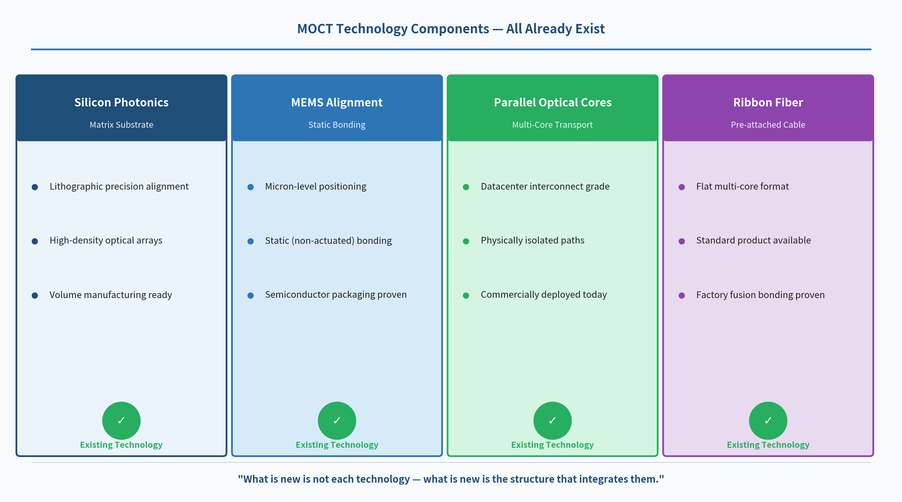
Figure 1. The four technology components of MOCT and their current availability
① Silicon Photonics
Silicon photonics uses semiconductor lithography to fabricate optical components. TSMC, GlobalFoundries, and Intel Foundry already offer commercial silicon photonics foundry services.
- Sub-micron precision alignment pattern fabrication
- High-density optical contact array implementation
- Volume manufacturing using existing semiconductor infrastructure
② MEMS Alignment
MEMS-based optical alignment has been widely validated in semiconductor packaging and optical communications. Velsanet uses static (non-actuated) MEMS — an approach proven in semiconductor packaging for decades.
- Micron-level positional accuracy guaranteed
- Static (non-actuated) — permanent alignment without moving parts
- No mechanical fatigue, temperature-invariant physical anchoring
③ Parallel Optical Cores
Multi-core parallel optical transmission is already commercially deployed in datacenter optical interconnects.
- Physically isolated independent optical paths — already implementable
- Interference-free independent operation between parallel cores — validated
- Core density scaling technology — continuously advancing
④ Ribbon Fiber
Ribbon fiber is a standard product used extensively in telecommunications infrastructure. Factory fusion bonding technology is also a well-established manufacturing process.
- Flat multi-core format — standard product available
- Factory fusion bonding — validated manufacturing process
- Long-term stability — proven over decades of deployment

2. The Integration Is New — MOCT Layer Architecture
If all four technologies already exist, why has no one built a MOCT before? The reason is simple. The goal of the conventional optical communications industry has been to make connectors better and switches faster. There was no structural motivation to eliminate connectors and switches entirely.
Velsanet starts from a different premise. Building a structure-based network that replaces packet switching requires a physical substrate where connectors and electrical switching are structurally unnecessary. That requirement is what defined the MOCT layer architecture.
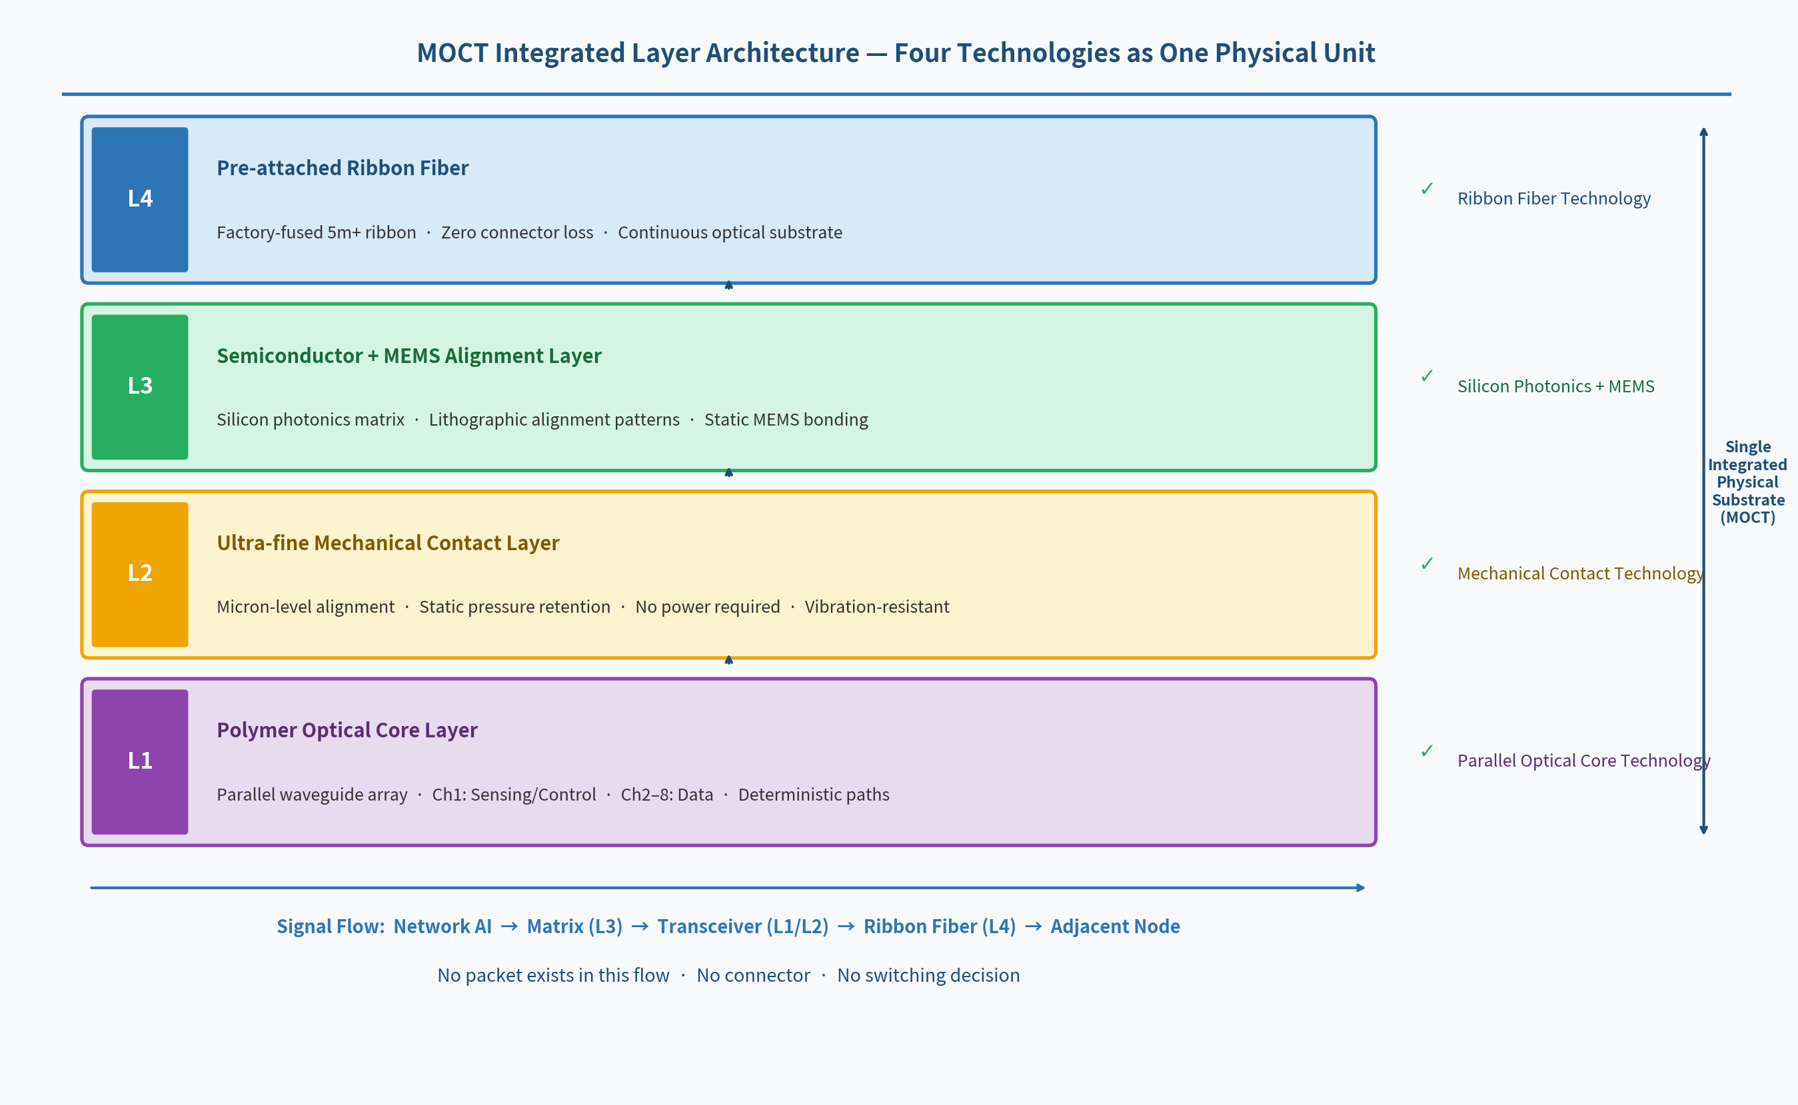
Figure 2. MOCT four-layer integrated architecture — how existing technologies form a single physical substrate
- L4 Ribbon Fiber is permanently bonded to the L3 MEMS+semiconductor layer by factory fusion.
- L3 MEMS alignment maintains micron-level precision through static pressure.
- L2 Ultra-fine mechanical contact forms a connector-free optical path with L1 polymer cores.
- L1 Channel 1 enables full system verification in pre-bonding contact state.
Signal Flow: Network AI -> Matrix (L3) -> Transceiver (L1/L2) -> Ribbon Fiber (L4) -> Adjacent Node
No packet exists in this flow. No connector. No switching decision.

3. The Critical Difference from Conventional Approaches
Conventional optical systems also use the same technology components — silicon photonics, MEMS, parallel cores. So what is different? The difference is not whether each technology exists, but under what structural principle they are integrated.
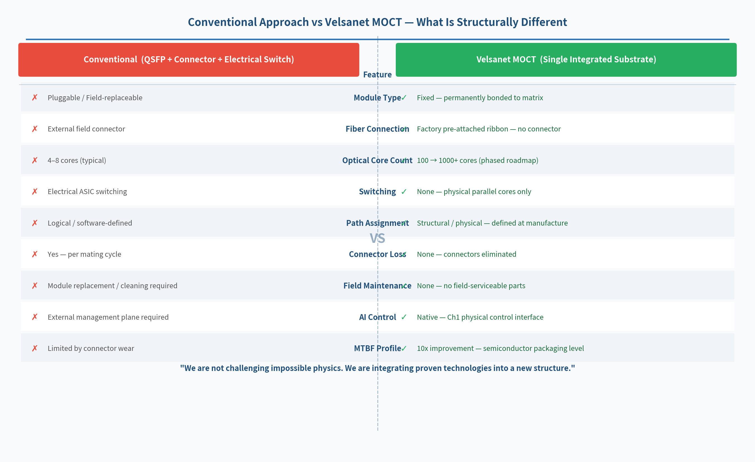
Figure 3. Conventional (QSFP + Connector + Switch) vs Velsanet MOCT — structural difference
- Conventional: Independent components connected by connectors and switching — loss and complexity accumulate.
- Velsanet MOCT: Four technologies integrated into a single substrate — connectors and switching structurally eliminated — deterministic physical paths.

4. Why a Prototype Is Realistic
- No new physical phenomena need to be discovered. Existing physics is sufficient.
- No new manufacturing infrastructure needs to be built. Existing foundries and manufacturers can be engaged.
- The core challenge is design. Integrated design of matrix-transceiver-ribbon cable is the key Phase 1 task.
- Verification is stepwise. Full system verification via Channel 1 in contact state can begin before any permanent bonding.
With a partner possessing semiconductor design capability, a Phase 1 prototype (100 cores) is achievable within a relatively short time after the Velsanet Research Institute is established.
Every technology component of the MOCT is already operating somewhere in the world.
What Velsanet does is bring them together, for the first time, in the right structure.

Velsanet Architecture Group | Velsanet Research Institute (Proposed) | Republic of Korea
github.com/joa337/velsanet-whitepapers

