WP#26-A — PAI/EAI Internal Design (Three Independent AIs)
Velsanet Architecture Group | PAI/EAI Internal Design Document
Classification | Version | Document Basis | Status
Internal Design — PAI/EAI (three independent AIs) | v0.4 2026 | WP#24 · WP#26 · FG-AINN-I-237-R1 S8.2 · Integrated Arch. S5 · FG-AINN-I-262-R1-att3 | Draft — structure confirmed in-session; unverified figures as Open Items
Table 0-1. Document Control Block
1. Internal Design Diagram
PAI and EAI are internally structured as THREE INDEPENDENT AIs — not a single merged unit. Each AI carries on its own job, and they operate through their mutual relationship: cooperation is requested when needed, and a state change originating in one AI is applied by another. The diagram below shows the three AIs mapped onto the O8 node slots (WP#29 Table 10-3, Mode A). The CONTROL path — CooperationAI cooperates with the Velsanet Network AI (Velsa) over Slot 2 s 12 control cores to assign each user to a slot/core — and the DATA path — device signal enters directly on the assigned slot/core (Slot 3, Slot 4, or Slot 2 s 180 neuron cores) into PerceptionAI, composed of multiple NPUs managing that resource by request load — are physically separate. CooperationAI does not carry data; it only assigns. CubeAI owns all storage and exposes a single Cube Router interface through which every cube exchange passes — AAI loop write-back (§6.4 CH14), E2E report, upper linkage, and administrator-intent inflow; its detailed spec is deferred to FG-AI4SSC (OI-C6). Unverified values (NPU count / throughput OI-1, control predicate OI-C1, report destination OI-C2, HBF policy OI-C4, Cube Router spec OI-C6) are marked as Open Items, not invented.
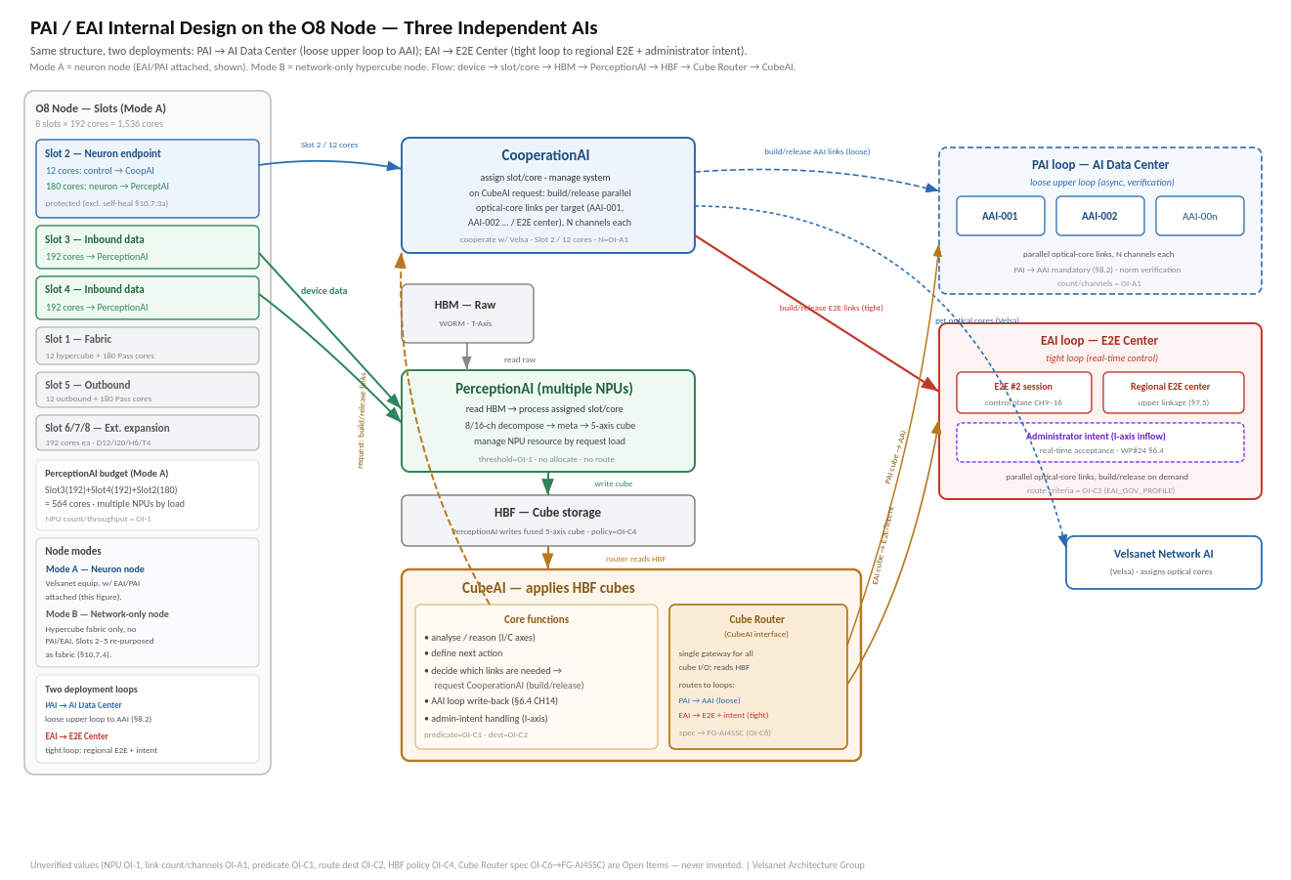
Figure 1-1. PAI/EAI internal design on the O8 node. Same structure, two deployments: PAI → AI Data Center (loose upper loop to AAI-001/002/… for norm verification, §8.2); EAI → E2E Center (tight real-time loop to E2E#2, regional E2E center, and administrator-intent inflow). CubeAI decides which links are needed and requests CooperationAI, which builds/releases the parallel optical-core links. Cube Router (CubeAI interface) spec deferred to FG-AI4SSC (OI-C6). Slot mapping per WP#29 Table 10-3; Mode A shown.
1A. Processing Flow (Overview + Details 1–4)
This section presents the runtime flow as diagrams so the process can be understood without reading the reference code. The overview shows the whole flow in four parts; Details 1–4 then expand each part. Colour is consistent throughout: blue = CooperationAI, green = PerceptionAI, amber = CubeAI, red = stuck/release, purple = user/resume.
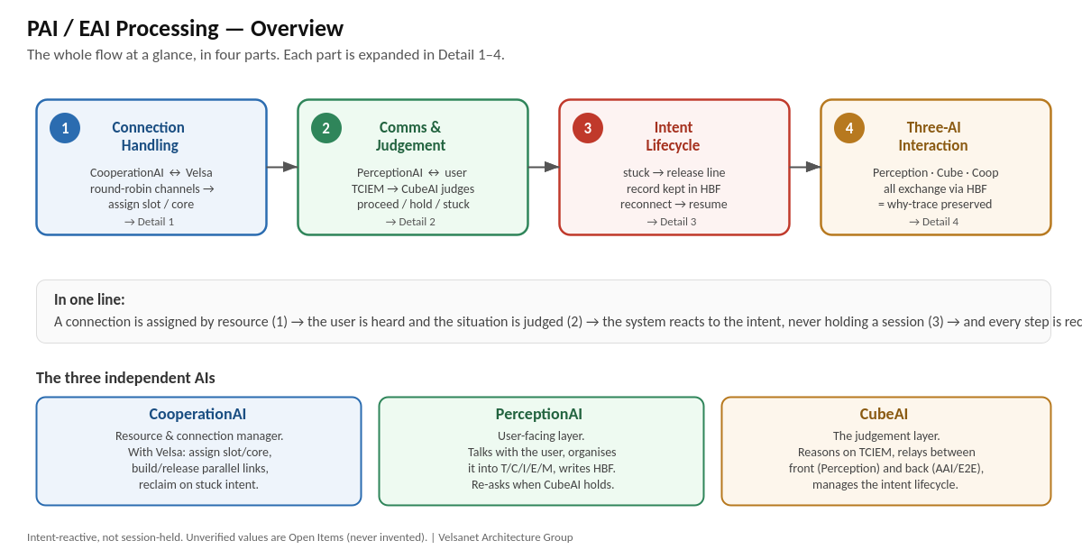
Figure 1A-0. Overview — the whole flow in four parts (Connection Handling, Comms & Judgement, Intent Lifecycle, Three-AI Interaction).
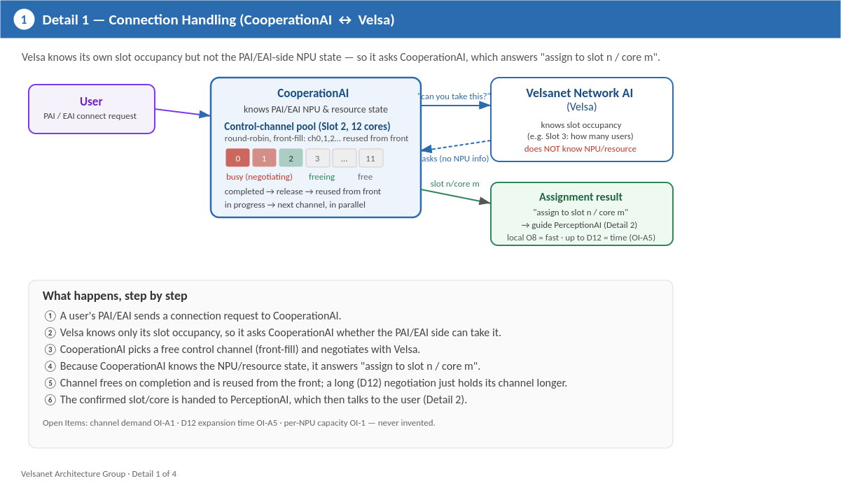
Figure 1A-1. Detail 1 — Connection Handling. Velsa knows slot occupancy but not the PAI/EAI NPU state, so it asks CooperationAI, which negotiates over a round-robin front-fill control-channel pool and answers “assign to slot n / core m”.
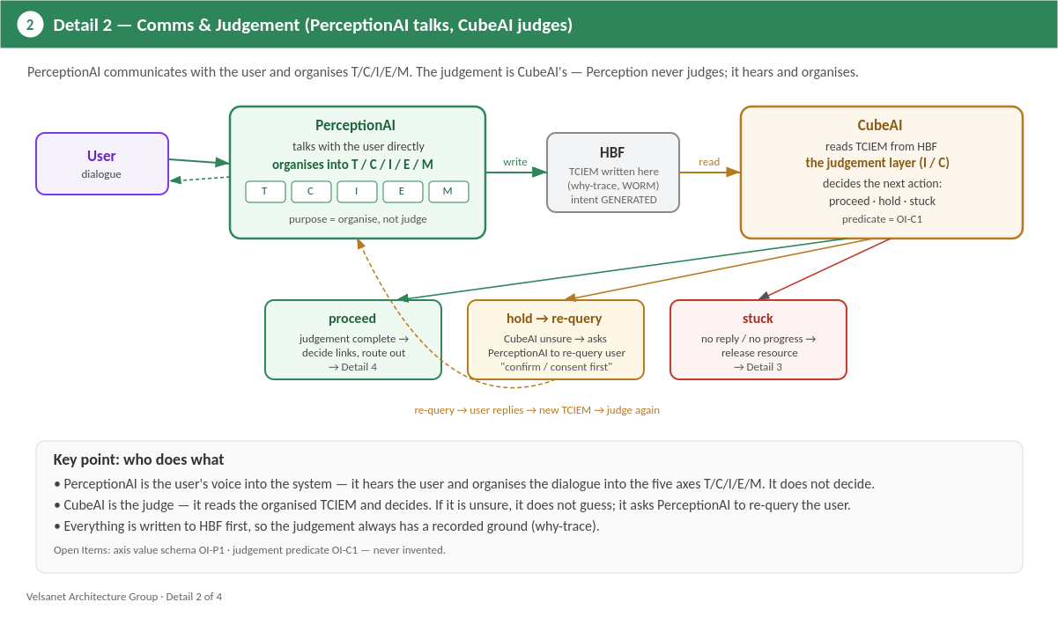
Figure 1A-2. Detail 2 — Comms & Judgement. PerceptionAI talks with the user and organises T/C/I/E/M (it does not judge); CubeAI reads the TCIEM and judges: proceed / hold / stuck.
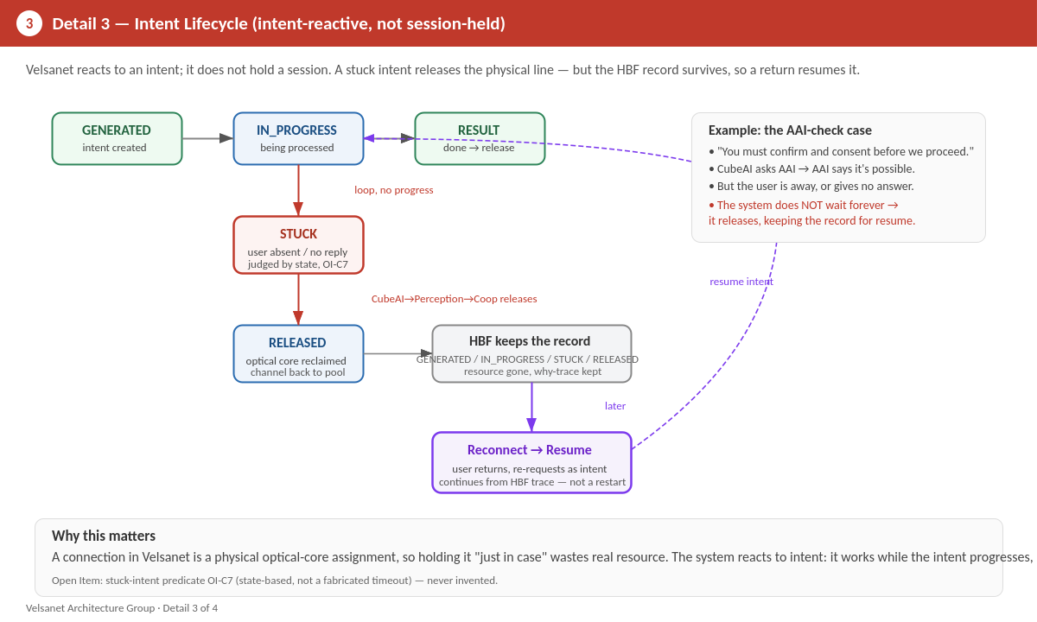
Figure 1A-3. Detail 3 — Intent Lifecycle. Intent-reactive, not session-held: a stuck intent releases the optical-core line, the HBF record is kept, and a reconnection resumes rather than restarts.
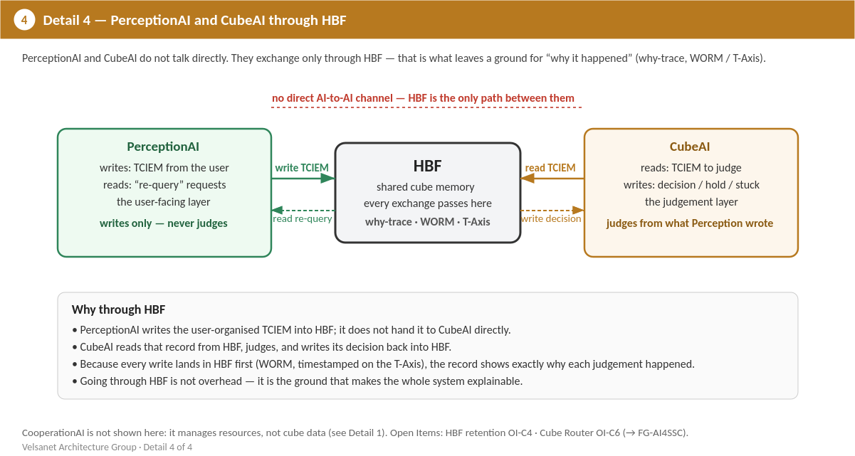
Figure 1A-4. Detail 4 — PerceptionAI and CubeAI exchange only through HBF (they never talk directly), which preserves the why-trace (WORM / T-Axis). CooperationAI manages resources, not cube data, and is covered in Detail 1.
2. Definition of the Three Independent AIs
AI | Own Job (본업) | Relationship (상호관계)
CooperationAI (협력 AI) | Resource allocation & system management. Entry point for connection requests; decides core/HBM; runs the O8 request→result loop. | Guides PerceptionAI with the allocation; receives state changes back and manages the system accordingly.
PerceptionAI (인지 AI) | HBM raw-signal processing. Reads the assigned core/HBM; 8/16-channel decomposition; fuses a 5-axis cube. | Receives allocation from CooperationAI; hands the fused cube to CubeAI. Does not allocate, does not route.
CubeAI (큐브 AI) | HBF storage, reasoning, next-action definition. Stores the cube; reasons over I/C axes; defines & routes the action. | Routes: PAI → designated AAI (S8.2); EAI → E2E#2 / operator / upper center. Feeds state changes back through the relationship.
Table 2-1. Three independent AIs — own job and relationship
2A. Layer Framework — Axis Weighting (PAI / AAI / AsAI)
All five cube axes (T/C/I/E/M) are always present. The PAI/AAI/AsAI layers differ by which axes they CENTRE weight on and who may write them — not by owning a disjoint subset. This is grounded in the WP#24 §2.1 Table 2-2 ACL_PERM matrix.
Layer | Centre / Role | Axis authority (WP#24 T2-2)
PAI | Generates all five axes; centres weight on Intent(I) + Emotion(E). Context(C) is a required base; some intents are time(T)-bound. | RW on C, I, E; R on T, M. Only layer with RW on both I and E.
AAI | Reads Emotion(E) to correct over-weighting; re-weights toward Intent(I). Applies legal / ethical / social norms (§8.2). | RW on I, M; R on T, C, E.
AsAI | Receives AAI-approved intent (I read-only); executes in real field terms; accumulates on Meta(M). | RW on M; R on T, C, I, E.
Table 2A-1. Layer framework — axis centre and authority
Flow is axis re-WEIGHTING, not axis swap: PAI expresses intent+emotion, AAI corrects the emotion weighting and re-expresses as normatively-checked intent, AsAI executes. The weighting-adjustment algorithm (how much to lower E, how much to shift to I) is a norm judgement and remains OI-F1 — the axis authority is fixed, the adjustment is not.
3. Data Flow (confirmed in-session)
① A user PAI connection request reaches CooperationAI through the Velsanet device (not Perception/Cube directly).
② CooperationAI issues a cooperation request to the O8 device (parallel count P = OI-A1) and ③ receives the result.
④ CooperationAI guides PerceptionAI: "connect A to core n / HBM x".
⑤ PerceptionAI reads the HBM signal, ⑥ decomposes into 8/16 channels, fuses a cube, and hands it to CubeAI.
⑦ CubeAI stores the cube in HBF, reasons over I/C axes, defines the next action, and ⑧ routes it (PAI → AAI; EAI → E2E#2 / operator / upper center).
4. Design Invariant
Three independent AIs. Each does its own job and is authoritative for its own layer only; they operate through their mutual relationship, not as one merged unit. CooperationAI is the sole allocator and request entry point. PerceptionAI is the sole processor of HBM raw signal. CubeAI is the sole writer of the HBF cube and the sole author of the reasoning / next-action decision. PAI has no direct AI-to-AI path; it reaches AAI only (topological, not policy). This invariant is encoded as the TRI_AI_DESIGN constant.
5. Reference Implementation
Complete reference implementation (JavaScript, Velsa v2.1 style of FG-AINN-I-262-R1-att3). v0.4 defines the confirmed resource and routing MECHANISMS while keeping every unverified VALUE as an Open Item: lane rotation across the 384-lane substrate with NPU scale-up/idle (threshold = OI-1); channel-scoped HBM mapping (WP#24 §1.1; physical address = OI-A3); intent-injected control decision (intent is admin/AAI-injected, WP#24 §6.4; predicate = OI-C1); non-control situational report ALWAYS emitted, destination delegated to EAI_GOV_PROFILE_REG (WP#24 §5.5; OI-C2); plus the v0.2 structural fixes (O8 timeout OI-A4, cross-AI release cleanup, HBF retention hook OI-C4).
5.0 File header and prelude
// =============================================================
// VELSANET ARCHITECTURE GROUP | PAI/EAI INTERNAL DESIGN
// PAI/EAI Internal Design -- Three Independent AIs
// (Cooperation / Perception / Cube) v0.3
//
// Classification : Internal Design -- PAI/EAI Internal (three independent AIs)
// Version : v0.3 (2026)
// Document Basis : WP#24 (Cognition Cube Physical Spec) *
// WP#26 (FPGA/ASIC Design Guide) *
// FG-AINN-I-237-R1 S8.2 (mandatory AAI routing) *
// Integrated Architecture S5 (dual E2E control) *
// FG-AINN-I-262-R1-att3 (Velsa v2.1, core groups)
// Status : Draft -- structure confirmed by Changho Song
// in-session; unverified figures registered as
// Open Items (never invented).
//
// Republic of Korea | Velsanet Architecture Group
// =============================================================
//
// PURPOSE
// -------
// This file defines the PAI/EAI internal design as THREE INDEPENDENT
// AIs -- not a single merged/on-chip layer. Each AI does its own job
// and they operate through their mutual relationship: each carries on
// its own work, and interacts only when cooperation is needed or when
// a state change from one must be applied by another. This mirrors the
// Velsa v2.1 principle (att3): each unit is authoritative for its own
// state; interaction is by request/relationship, not direct intrusion.
// The three AIs sit above the register-level blocks already specified
// in WP#24 (WORM / HBF / Transform Engine / MUX Engine).
//
// PerceptionAI -- processes HBM raw signal, decomposes into
// 8/16 channels, hands result to CubeAI.
// CubeAI -- stores the cube (HBF, 5 axes T/C/I/E/M),
// recognises & reasons over it (I/C axes),
// defines the next action, routes it.
// CooperationAI -- entry point for connection requests; decides
// core/HBM allocation; issues cooperation
// requests to the O8 device and receives the
// result; manages the PAI/EAI system as a whole.
//
// DATA FLOW (confirmed in-session):
// user PAI request
// -> [device] -> CooperationAI (request arrives here)
// -> CooperationAI decides (core n, HBM x)
// -> CooperationAI guides PerceptionAI ("connect A to core n / HBM x")
// -> PerceptionAI processes HBM signal
// -> PerceptionAI -> CubeAI (store to HBF cube, 5 axes)
// -> CubeAI reasons (I/C) -> defines next action -> routes:
// PAI : send to the designated AAI
// EAI : request E2E#2 session / report to operator /
// forward to upper E2E center
//
// DESIGN PRINCIPLE (mirrors Velsa v2.1 DISTRIBUTED_DESIGN):
// Perception does not decide allocation; Cube does not decide
// allocation; only Cooperation does. Cooperation does not touch
// raw signal; only Perception does. Cube is the sole writer of
// the reasoning/action decision. Each AI is authoritative for
// its own layer only.

'use strict';
5.1 Constants
// -------------------------------------------------------------
// Constants (grounded in WP#24 / WP#27 / WP#29 / Velsa v2.1 att3)
// -------------------------------------------------------------

// Channel counts -- WP#24 S1: "EAI 16 channels or PAI 8 channels"
const CH_PAI = 8; // CH1..CH8 (perception plane only)
const CH_EAI = 16; // CH1..CH8 perception + CH9..CH16 control

// Optical lanes -- WP#27 Table 4-1 / Cognition Cube HW Design S5:
// Node_8 Face B/C = 192 cores x 2 faces = 384 Cube lanes.
// PAI: one lane -> one independent PAI instance (8-ch SEU1).
// EAI: same 384-lane width split 16 channels; per HW Design S5.3
// the perception plane (E2E#1, CH1-8) and control plane
// (E2E#2, CH9-16) occupy separate core groups.
const LANES_TOTAL = 384; // WP#27 T4-1
// EAI perception/control core-group split (HW Design Table 5-2):
// E2E#1 perception = cores #1..#24, E2E#2 control = cores #25..#48
// (per 16-ch group). The split is structural; exact per-instance
// counts scale with the same 384-lane substrate.

// Core groups -- Velsa v2.1 att3 (FG-AINN-I-262-R1-att3):
// CTRL_CORES = 12 -> Slot 1 control-channel group (WP#29 S10.7.3)
// Slot 2 = response channel for the cooperation request/response loop.
const CTRL_CORES = 12; // Slot 1 control group: cooperation request out
const RESP_SLOT = 'S2'; // Slot 2: cooperation response channel

// Cube axes -- WP#19 / WP#24: T, C, I, E, M
const AXIS = Object.freeze({ T: 'T', C: 'C', I: 'I', E: 'E', M: 'M' });

// Per-layer axis authority -- WP#24 S2.1 Table 2-2 (ACL_PERM).
// R = read, W = write, RW = read+write. This grounds the framework:
// PAI centres on I+E (only layer with RW on both), AAI reads E and
// writes I (corrects emotion-weighting -> re-expresses as intent),
// AsAI reads I and writes M (executes, accumulates mission). All five
// axes always exist; layers differ by WEIGHTING, not by owning a subset.
const AXIS_ACL = Object.freeze({
// T C I E M
PAI: { T:'R', C:'RW', I:'RW', E:'RW', M:'R' },
AAI: { T:'R', C:'R', I:'RW', E:'R', M:'RW' },
AsAI: { T:'R', C:'R', I:'R', E:'R', M:'RW' },
});

// System kind
const SYS = Object.freeze({ PAI: 'PAI', EAI: 'EAI' });

// EAI routing choices made by CubeAI after reasoning
const EAI_ROUTE = Object.freeze({
E2E2_SESSION: 'E2E2_SESSION', // control needed (robot dispatch etc.)
OPERATOR_REPORT:'OPERATOR_REPORT', // human-in-loop report (CH11 MANUAL path)
UPPER_CENTER: 'UPPER_CENTER', // forward to upper E2E center
});

// Layer framework -- confirmed in-session, grounded in AXIS_ACL above
// and FG-AINN-I-237-R1 S8.2. Flow is axis re-WEIGHTING, not axis swap.
const LAYER_FRAMEWORK = Object.freeze({
PAI: 'Generates all five axes; CENTRES weight on Intent(I) + Emotion(E). ' +
'Context(C) is a required base; some intents are time(T)-bound. ' +
'Only layer with RW on both I and E.',
AAI: 'Reads Emotion(E) to correct over-weighting; RE-WEIGHTS toward ' +
'Intent(I), which it may write. Applies legal / ethical / social ' +
'norms (S8.2). Refined intent only is forwarded to AsAI.',
AsAI: 'Receives AAI-approved intent (I read-only); executes in real ' +
'field terms; accumulates on Meta(M). No direct tie to any person.',
note: 'All five axes always present. Layers differ by axis WEIGHTING, ' +
'not by owning a disjoint subset. Weighting-adjustment algorithms ' +
'(how much to lower E, how much to shift to I) are norm judgements ' +
'-> OI-F1 (not invented).',
});

// The single design invariant of this layer.
const TRI_AI_DESIGN = Object.freeze({
principle:
'Three independent AIs. Each does its own job and is authoritative ' +
'for its own layer only; they operate through their mutual relationship, ' +
'not as one merged unit.',
cooperation:
'CooperationAI is an independent AI: the sole allocator (core/HBM) and the sole ' +
'entry point for connection requests. It runs the request/response ' +
'loop to the O8 device and manages the PAI/EAI system.',
perception:
'PerceptionAI is an independent AI: the sole processor of HBM raw signal. It does not ' +
'allocate and does not route; it executes the allocation it was given.',
cube:
'CubeAI is an independent AI: the sole writer of the HBF cube and the sole author of the ' +
'reasoning/next-action decision. It routes: PAI -> designated AAI; ' +
'EAI -> E2E#2 / operator / upper center.',
routingInvariant:
'PAI has no direct AI-to-AI path; it reaches AAI only ' +
'(FG-AINN-I-237-R1 S8.2). This is topological, not policy.',
});

// -------------------------------------------------------------
// Utilities
// -------------------------------------------------------------
function nowNs() {
// Placeholder wall clock. Real T-Axis timestamp comes from the
// WORM T-Axis Timestamp Engine (WP#24 S1.1, offset 0x20).
return BigInt(Date.now()) * 1_000_000n;
}

function genId() {
return 'xxxxxxxx-4xxx-yxxx'.replace(/[xy]/g, c => {
const r = Math.random() * 16 | 0;
return (c === 'x' ? r : (r & 0x3 | 0x8)).toString(16);
});
}
5.2 CooperationAI
// =============================================================
// 1. CooperationAI -- allocator, request/response loop, manager
// =============================================================
//
// Responsibilities (confirmed in-session):
// - Receive the connection request (a user's PAI asks to connect).
// - Decide which core (index n) and which HBM partition to use.
// - Issue a cooperation request to the O8 device: "I need a link
// to D12 X with P parallel cores" -- and RECEIVE the result.
// - Guide PerceptionAI: "connect A to core n, HBM x".
// - Manage the PAI/EAI system through Perception+Cube state.
//
// What is deliberately NOT hardcoded (registered as Open Items):
// - OI-A1: parallel-core count P per request. Depends on OI-1
// (NPU throughput per SEU) -- unresolved. Passed in,
// never invented here.
// - OI-A2: O8 cooperation request/response wire format.
// - OI-A3: HBM partition selection policy.
// -------------------------------------------------------------
class CooperationAI {
constructor(sysKind, o8Link = null) {
if (!Object.values(SYS).includes(sysKind))
throw new Error(`Invalid system kind: ${sysKind}`);
this.sysKind = sysKind; // PAI or EAI
this.o8Link = o8Link; // interface to O8 device (injected)
this.channels = sysKind === SYS.EAI ? CH_EAI : CH_PAI;
this.allocTable = new Map(); // connId -> { coreIndex, hbmPartition, parallel }
this.log = [];

// Lane rotation state (resource efficiency, confirmed in-session):
// requests are assigned lanes in rotation across the 384-lane
// substrate (WP#27 T4-1). When the current NPU instance's capacity
// is exhausted, the next NPU is prepared; when load falls, an NPU
// goes idle. The MECHANISM is fixed here; the capacity THRESHOLD
// (how many lanes/instances one NPU handles) is OI-1 / OI-27-01 --
// caller-supplied, never invented.
this.nextLane = 0; // rotation cursor (0..LANES_TOTAL-1)
this.lanesTotal = LANES_TOTAL; // 384 (WP#27 T4-1)
this.npuCapacity = null; // OI-1: lanes per NPU (injected)
this.activeNpus = 1; // current NPU instances in use
}

// Entry point: a user's PAI requests a connection to this system.
// Returns an allocation directive that CooperationAI will hand to
// PerceptionAI. Does NOT process any signal itself.
async onConnectRequest(req, perception) {
// req = { userId, deviceId, requestedParallel }
const connId = genId();

// Decide the local resource. Lane rotation + NPU scaling mechanism
// is fixed (WP#27 T4-1); per-NPU capacity threshold is OI-1.
// HBM mapping rule is fixed (WP#24 S1.1); physical address is OI.
const coreIndex = this._selectCore(); // lane rotation
const hbmPartition = this._selectHbm(coreIndex); // channel->sector rule
const parallel = req.requestedParallel; // OI-A1: caller-supplied, never invented

// Ask the O8 device to establish the fabric side of the link and
// wait for the RESULT (the request/response loop). Format is OI-A2.
const coopResult = await this._cooperateWithO8({
connId,
wantParallel: parallel, // OI-A1 / OI-1
// targetD12 is decided by CubeAI reasoning later for outbound
// cubes; for inbound connection setup the O8 resolves the fabric.
});

if (!coopResult || !coopResult.granted) {
this.log.push({ connId, event: 'COOP_DENIED', at: nowNs().toString() });
return { connId, granted: false, reason: coopResult?.reason ?? 'no-grant' };
}

// Record the allocation this AI now manages.
this.allocTable.set(connId, {
coreIndex, hbmPartition,
grantedParallel: coopResult.grantedParallel,
});

// Guide PerceptionAI: connect this user to core n / HBM x.
perception.acceptAllocation({
connId,
userId: req.userId,
coreIndex,
hbmPartition,
});

this.log.push({ connId, event: 'ALLOCATED', coreIndex, hbmPartition,
at: nowNs().toString() });
return { connId, granted: true, coreIndex, hbmPartition };
}

// The cooperation request/response loop to the O8 device.
// Out on the Slot 1 12-core control group; response on Slot 2.
//
// Structural resilience: the loop must not block forever waiting on
// O8. We race the request against a timeout so a silent O8 yields a
// TIMED_OUT result instead of hanging. The timeout VALUE is not fixed
// here -- it is caller-supplied (opts.timeoutMs) and registered as
// OI-A4 until grounded; att3 uses the same pattern (Promise.race +
// setTimeout) for its control-channel RTT window.
async _cooperateWithO8(request, opts = {}) {
if (!this.o8Link) {
// No O8 attached (unit-test / standalone). Cannot fabricate a
// grant with invented capacity -> report ungranted honestly.
return { granted: false, reason: 'no-o8-link' };
}
const call = this.o8Link.requestCooperation({
...request,
ctrlCores: CTRL_CORES, // Slot 1 control group
respSlot: RESP_SLOT, // Slot 2 response channel
});
// opts.timeoutMs is OI-A4 (value not invented). If absent, we do not
// impose a made-up number -- we await the call directly and leave the
// timeout as an explicit open item rather than fabricating a bound.
if (opts.timeoutMs == null) return call; // OI-A4
const timeout = new Promise(res =>
setTimeout(() => res({ granted: false, reason: 'o8-timeout' }), opts.timeoutMs));
return Promise.race([call, timeout]);
}

// Lane selection by rotation across the 384-lane substrate (WP#27
// T4-1). This is the resource-efficiency mechanism confirmed in
// session: rotate 1->2->...->384, and when the current NPU's capacity
// is reached, prepare the next NPU. The rotation MECHANISM is fixed;
// the per-NPU capacity threshold is OI-1 (injected via npuCapacity).
_selectCore() {
const lane = this.nextLane;
this.nextLane = (this.nextLane + 1) % this.lanesTotal; // rotate

// NPU scaling: if a capacity threshold is known (OI-1 resolved and
// injected), prepare the next NPU when this one is exhausted. Without
// it we do NOT invent a threshold -- we rotate lanes only and flag
// that NPU-boundary scaling is unresolved.
if (this.npuCapacity != null) {
const needed = Math.ceil((this.allocTable.size + 1) / this.npuCapacity);
if (needed > this.activeNpus) {
this.activeNpus = needed; // prepare next NPU
this.log.push({ event: 'NPU_SCALE_UP', activeNpus: needed,
at: nowNs().toString() });
}
} // else: OI-1 -- threshold unknown, lane rotation only
return lane;
}

// HBM mapping: which HBM logical sector holds this lane's perception
// signal. Grounded in WP#24 S1.1 -- each physical channel owns its own
// register block (WORM_CHAN_ID, offset 0x14) and a SECTOR_BASE_ADDR.
// The MAPPING RULE (channel n -> its own dedicated sector) is fixed;
// the physical SECTOR_BASE_ADDR value is deployment/OI (not invented).
_selectHbm(coreIndex) {
// Rule: lane -> its own channel-scoped sector (WP#24 S1.1 channel
// isolation). We return the logical mapping, not a physical address.
return {
chanId: coreIndex % this.channels, // WORM_CHAN_ID (WP#24 0x14)
sectorBase: null, // SECTOR_BASE_ADDR -- OI (physical)
};
}

// NPU scale-down: when active connections fall below capacity, an NPU
// instance goes idle. Threshold is OI-1; mechanism is fixed.
_maybeScaleDown() {
if (this.npuCapacity == null) return; // OI-1: no threshold
const needed = Math.max(1, Math.ceil(this.allocTable.size / this.npuCapacity));
if (needed < this.activeNpus) {
this.activeNpus = needed; // move surplus NPU to idle
this.log.push({ event: 'NPU_IDLE', activeNpus: needed,
at: nowNs().toString() });
}
}

// Release everything for a connection (system management duty).
// Structural fix: releasing must also clear the state the other two
// AIs hold for this connection, or their maps leak. CooperationAI, as
// the manager, drives the teardown across the relationship -- it does
// not reach into their internals directly (each AI clears its own),
// it asks each to forget the connection.
release(connId, perception = null, cube = null) {
const had = this.allocTable.delete(connId);
if (perception) perception.forget(connId); // Perception clears its binding
if (cube) cube.forget(connId); // Cube clears cubes for this conn
this.log.push({ connId, event: 'RELEASED', at: nowNs().toString() });
return had;
}

status() {
return {
sysKind: this.sysKind,
channels: this.channels,
active: this.allocTable.size,
};
}
}
5.3 PerceptionAI
// =============================================================
// 2. PerceptionAI -- HBM signal processing, hands cube to CubeAI
// =============================================================
//
// Responsibilities (confirmed in-session):
// - Accept the allocation directive from CooperationAI.
// - Process the HBM raw signal on the assigned core / HBM.
// - Decompose into 8 (PAI) or 16 (EAI) channels [WP#24 S1].
// - Produce meta-abstraction per channel and fuse into a cube,
// then hand the cube to CubeAI for storage in HBF.
//
// Does NOT allocate and does NOT route.
//
// Open Items:
// - OI-P1: per-channel meta-abstraction detail beyond WP#24
// (semantic summary / confidence / evidence ptr).
// -------------------------------------------------------------
class PerceptionAI {
constructor(sysKind, cubeAI) {
this.sysKind = sysKind;
this.channels = sysKind === SYS.EAI ? CH_EAI : CH_PAI;
this.cubeAI = cubeAI;
this.bindings = new Map(); // connId -> { userId, coreIndex, hbmPartition }
}

// Called by CooperationAI. Perception now knows where to read from.
acceptAllocation(alloc) {
this.bindings.set(alloc.connId, {
userId: alloc.userId,
coreIndex: alloc.coreIndex,
hbmPartition: alloc.hbmPartition,
});
}

// Clear this connection's binding on release (structural fix: no leak).
forget(connId) {
return this.bindings.delete(connId);
}

// Process HBM raw signal for a connection and build a cube.
// rawSignal is whatever the assigned HBM/core delivered.
// Structural fix (#4): wrap processing so a failure surfaces as a
// structured error result instead of crashing the caller.
processSignal(connId, rawSignal) {
const bind = this.bindings.get(connId);
if (!bind) throw new Error(`No allocation for conn ${connId}`);

try {
// 8/16-channel decomposition [WP#24 S1]. Channel independence is
// a structural invariant -- no semantic interpretation here.
const channels = this._decompose(rawSignal);

// Per-channel meta-abstraction [WP#24 / OI-P1].
const meta = channels.map((ch, i) => this._meta(i, ch));

// Fuse into a 5-axis cube (T/C/I/E/M). T comes from WORM T-Axis.
const cube = {
seuId: genId(),
tAxis: nowNs(), // WP#24 S1.1 T-Axis timestamp (WORM, 0x20)
axes: {
[AXIS.T]: nowNs(),
[AXIS.C]: null, // context -- filled by meta fusion (OI-P1)
[AXIS.I]: null, // intent -- admin/AAI-injected (WP#24 S6.4)
[AXIS.E]: null, // emotion -- filled by meta fusion (OI-P1)
[AXIS.M]: null, // meta/mission accumulation
},
channels: meta,
origin: { connId, userId: bind.userId },
};

// Hand the cube to CubeAI for HBF storage + reasoning.
return this.cubeAI.store(cube);
} catch (err) {
// Do not crash the pipeline; return a structured failure the
// manager can act on (retry / release). No value invented.
return { error: true, connId, reason: String(err && err.message || err) };
}
}

_decompose(rawSignal) {
// Structure only: split into `this.channels` lanes. Real DEMUX is
// the WP#24 DEMUX Engine (Block A). We keep lane independence.
return Array.from({ length: this.channels }, (_, i) =>
({ ch: i + 1, payload: rawSignal?.[i] ?? null }));
}

_meta(index, ch) {
// OI-P1: semantic summary / confidence / evidence pointer are
// not fully specified. We carry the raw reference, no fabrication.
return {
ch: ch.ch,
summary: null, // OI-P1
confidence:null, // OI-P1
evidence: ch.payload,
};
}
}
5.4 CubeAI
// =============================================================
// 3. CubeAI -- HBF store, reasoning (I/C), next-action, routing
// =============================================================
//
// Responsibilities (confirmed in-session):
// - Store the cube in HBF (cube memory layer).
// - Recognise the stored cube and reason over it, using the
// Intent (I) and Context (C) axes, to DEFINE the next action.
// - Route the action:
// PAI : send to the designated AAI (mandatory, S8.2).
// EAI : choose E2E#2 session / operator report / upper center.
//
// Confirmed EAI trigger (in-session, robot-dispatch example):
// - Idle/charging robot runs on E2E#1 (perception) only.
// - A dispatch/actuation need => request an E2E#2 session
// (control plane activation = bringing the idle robot online).
//
// Open Items:
// - OI-C1: reasoning logic that maps cube (I/C) -> next action.
// - OI-C2: decision criteria among the three EAI routes for the
// non-control cases (operator report vs upper center).
// - OI-C3: which AAI is "the designated AAI" (registration/§6.8).
// -------------------------------------------------------------
class CubeAI {
// retention: optional policy hook so HBF does not grow without bound.
// The POLICY VALUES (capacity, TTL, eviction rule) are NOT invented
// here -- they are OI-C4 and are injected by the caller. If no policy
// is supplied, we do not silently cap with a made-up number; we leave
// HBF unbounded and the gap is visible as OI-C4.
constructor(sysKind, aaiLink = null, e2eLink = null, retention = null,
govProfile = null, cubeRouter = null) {
this.sysKind = sysKind;
this.aaiLink = aaiLink; // PAI outbound path (to designated AAI)
this.e2eLink = e2eLink; // EAI outbound path (E2E#2 / centers)
this.hbf = new Map(); // seuId -> cube (cube memory layer)
this.byConn = new Map(); // connId -> Set<seuId> (for release cleanup)
this.retention = retention; // { onStore(hbf) } hook -- OI-C4 (values not invented)
// EAI_GOV_PROFILE_REG (WP#24 S5.5-5.6): selects operator-report vs
// upper-center for NON-CONTROL reports. Deliberately deployment-
// delegated (norm-dependent) -> injected, not invented. See OI-C2.
this.govProfile = govProfile;
// Cube Router = CubeAI's single interface for ALL cube traffic in/out.
// CubeAI owns all storage, so every cube exchange -- AAI loop write-
// back (WP#24 S6.4 CH14), E2E report, upper linkage, administrator-
// intent inflow -- passes this one gateway (3-control: register /
// authorise / record, S7.4). The DETAILED interface spec is deferred
// to FG-AI4SSC (it may be redefined there) -> OI-C6. Injected, not
// invented; if absent, exchanges fall back to the direct links.
this.cubeRouter = cubeRouter; // { send(kind, cube), onLoop(handler) } -- OI-C6
this.actions = [];
}

// AAI bidirectional loop write-back (WP#24 S6.4 CH14): a cube arriving
// from AAI (downward intent) is written back into HBF through the Cube
// Router gateway. Loop management lives on the interface.
loopWriteBack(cube) {
this.hbf.set(cube.seuId, cube); // reflect into storage
const cid = cube.origin && cube.origin.connId;
if (cid) {
if (!this.byConn.has(cid)) this.byConn.set(cid, new Set());
this.byConn.get(cid).add(cube.seuId);
}
this.actions.push({ seuId: cube.seuId, event: 'AAI_LOOP_WRITEBACK',
at: nowNs().toString() });
return cube.seuId;
}

// Store cube in HBF, then recognise + reason + route.
store(cube) {
this.hbf.set(cube.seuId, cube);
// Index by connection so release() can drop this conn's cubes.
const cid = cube.origin?.connId;
if (cid) {
if (!this.byConn.has(cid)) this.byConn.set(cid, new Set());
this.byConn.get(cid).add(cube.seuId);
}
// Apply retention policy if one was injected (OI-C4). Long-term
// accumulation (M-axis / WORM) is a separate concern -- see OI-C5.
if (this.retention && typeof this.retention.onStore === 'function') {
this.retention.onStore(this.hbf, cube); // OI-C4: caller-defined
}
const action = this._reason(cube); // recognise + define next action
return this._route(cube, action);
}

// Clear cubes for a released connection (structural fix: no leak).
forget(connId) {
const set = this.byConn.get(connId);
if (!set) return false;
for (const seuId of set) this.hbf.delete(seuId);
this.byConn.delete(connId);
return true;
}

// Reasoning over the cube. Control decision uses INTENT (I) injected
// by the administrator/AAI layer (WP#24 S6.4), applied against the
// node's own CONTEXT (C). The concrete predicate is OI-C1 (not
// invented). Non-control still produces a situational report.
_reason(cube) {
const intent = cube.axes[AXIS.I]; // administrator-injected (WP#24 S6.4)
const context = cube.axes[AXIS.C]; // node-perceived context

if (this.sysKind === SYS.PAI) {
// PAI: the only structural outcome is "hand to designated AAI".
return { kind: SYS.PAI, needsAAI: true /* S8.2 */ };
}

// EAI: control needed only if the INJECTED intent directs actuation.
// The system does NOT infer control from context keywords.
const controlNeeded = this._impliesControl(cube); // OI-C1 (injected predicate)
if (controlNeeded) {
return { kind: SYS.EAI, route: EAI_ROUTE.E2E2_SESSION };
}

// Non-control (idle / sensing / standby): NOT "do nothing". E2E#1
// perception stays live, so each non-control situation emits a
// situational report whose CONTENT reflects the current context
// (idle -> idle status; sensing -> what was sensed). The content is
// the cube's own perception -- nothing invented. Only the DESTINATION
// (operator vs upper-center) is delegated to EAI_GOV_PROFILE_REG.
const report = { situation: context, cubeRef: cube.seuId };
const dest = this.govProfile
? this.govProfile.selectNonControlRoute() // HUMAN_IN_LOOP / AUTO_ESCALATION
: null; // OI-C2: deployment config absent
return { kind: SYS.EAI, route: dest, report,
pending: dest ? undefined : 'OI-C2' };
}

// Control decision is NOT inferred by the system from context. Intent
// (I-axis) is injected by the administrator/AAI (WP#24 S6.4: AAI has
// RW on I). The system reads that injected intent and follows it.
// - No injected intent -> do not originate control (safe default).
// - The predicate "does this intent direct actuation?" depends on the
// intent schema (OI-P1) -> supplied via injected classifier, else
// held pending (OI-C1). Never fabricated from keywords.
_impliesControl(cube) {
const intent = cube.axes[AXIS.I];
if (intent == null) return false; // no admin intent -> no control
return this.intentRequiresControl
? this.intentRequiresControl(intent, cube.axes[AXIS.C]) // injected
: null; // OI-C1: predicate unset -> hold
}

// Route the defined action outward. If a Cube Router is present, ALL
// cube I/O goes through that single gateway (CubeAI's interface);
// otherwise fall back to the direct links. Gateway spec = OI-C6.
_route(cube, action) {
const via = this.cubeRouter; // single interface when present
if (action.kind === SYS.PAI) {
// PAI -> designated AAI only (FG-AINN-I-237-R1 S8.2). OI-C3 = which AAI.
const rec = { seuId: cube.seuId, to: 'AAI', at: nowNs().toString() };
this.actions.push(rec);
if (via) via.send('AAI', cube); // via Cube Router (OI-C6)
else if (this.aaiLink) this.aaiLink.sendToDesignatedAAI(cube); // OI-C3
return rec;
}

// EAI routing.
if (action.route === EAI_ROUTE.E2E2_SESSION) {
const rec = { seuId: cube.seuId, route: EAI_ROUTE.E2E2_SESSION,
at: nowNs().toString() };
this.actions.push(rec);
if (via) via.send('E2E2', cube); // via Cube Router
else if (this.e2eLink) this.e2eLink.requestE2E2Session(cube);
return rec;
}

// Non-control: situational report ALWAYS emitted (idle/sensing) --
// never silence. Content = action.report (perceived context).
// Destination from GOV_PROFILE (OI-C2); all cube I/O via router.
const rec = { seuId: cube.seuId, route: action.route,
report: action.report, pending: action.pending,
at: nowNs().toString() };
this.actions.push(rec);
if (action.route) {
if (via) via.send(action.route, action.report); // via Cube Router
else if (this.e2eLink) this.e2eLink.sendReport(action.route, action.report);
}
return rec;
}

recall(seuId) { return this.hbf.get(seuId) ?? null; }
get stored() { return this.hbf.size; }
}
5.5 PaiEaiSystem
// =============================================================
// 4. PaiEaiSystem -- wires the three INDEPENDENT AIs (PAI or EAI)
// =============================================================
//
// This is an assembly of three independent AIs, NOT a merged unit.
// Each AI keeps its own job; the container only wires their
// relationship (who guides whom, who releases what). EAI differs from
// PAI only in that it also owns the control plane (E2E#2, CH9..CH16);
// the difference is the channel count and the presence of e2eLink.
// -------------------------------------------------------------
class PaiEaiSystem {
constructor(sysKind, links = {}) {
this.sysKind = sysKind;
// retention (OI-C4) and govProfile (OI-C2) are injected, never invented.
this.cube = new CubeAI(sysKind, links.aaiLink, links.e2eLink,
links.retention ?? null, links.govProfile ?? null,
links.cubeRouter ?? null);
this.perception = new PerceptionAI(sysKind, this.cube);
this.cooperation = new CooperationAI(sysKind, links.o8Link);
// NPU capacity threshold (OI-1) injected here if known; else lane
// rotation only, no invented boundary.
if (links.npuCapacity != null) this.cooperation.npuCapacity = links.npuCapacity;
// optional injected intent->control predicate (OI-C1) and gov route
if (links.intentRequiresControl)
this.cube.intentRequiresControl = links.intentRequiresControl;
}

// Full inbound path: request -> allocate -> (later) process signal.
async connect(req) {
return this.cooperation.onConnectRequest(req, this.perception);
}

// Deliver a raw signal for an established connection.
feed(connId, rawSignal) {
return this.perception.processSignal(connId, rawSignal);
}

// Release: CooperationAI drives teardown across all three AIs so no
// AI leaks state for a closed connection; then reconsider NPU scale-down.
release(connId) {
const r = this.cooperation.release(connId, this.perception, this.cube);
this.cooperation._maybeScaleDown(); // OI-1 threshold; mechanism fixed
return r;
}

status() {
return {
sysKind: this.sysKind,
cooperation: this.cooperation.status(),
cubesStored: this.cube.stored,
};
}
}
5.6 Exports & Open Items
// -------------------------------------------------------------
// Exports
// -------------------------------------------------------------
module.exports = {
SYS, AXIS, AXIS_ACL, EAI_ROUTE, CTRL_CORES, RESP_SLOT, CH_PAI, CH_EAI,
LANES_TOTAL, TRI_AI_DESIGN, LAYER_FRAMEWORK,
CooperationAI, PerceptionAI, CubeAI, PaiEaiSystem,
};

// =============================================================
// OPEN ITEMS REGISTER (never invented -- carried forward)
// -------------------------------------------------------------
// OI-1 NPU throughput per SEU / compute per cubification. Sets the
// per-NPU capacity threshold (lanes/instances one NPU handles).
// Lane-rotation + NPU scale-up/idle MECHANISM is fixed; the
// threshold VALUE is injected (npuCapacity). UNRESOLVED (global).
// OI-A1 Parallel-core count P per cooperation request. Caller-supplied
// until OI-1 resolves. Never defaulted.
// OI-A2 O8 cooperation request/response wire format (Slot1 12-core out
// / Slot2 response). Loop shape modelled; format open.
// OI-A3 HBM PHYSICAL address/size (SECTOR_BASE_ADDR). The channel->
// sector MAPPING RULE is fixed (WP#24 S1.1 WORM_CHAN_ID); only
// the physical address value remains deployment/OI.
// OI-A4 O8 cooperation timeout value (Promise.race+setTimeout structure
// added; millisecond bound caller-supplied).
// OI-P1 Per-channel meta-abstraction (summary/confidence/evidence)
// beyond WP#24; also the C/I/E axis value schema.
// OI-C1 Predicate "does the injected intent direct actuation?" Intent
// is admin/AAI-injected (WP#24 S6.4); predicate is injected
// (intentRequiresControl) or held pending. Not keyword-inferred.
// OI-C2 Non-control report DESTINATION (operator vs upper-center).
// Delegated to EAI_GOV_PROFILE_REG (WP#24 S5.5, deliberately not
// standardised). The report ITSELF is always emitted (never mute).
// OI-C3 Identity of the "designated AAI" (registration / S6.8).
// OI-C4 HBF retention policy (capacity/TTL/eviction). Hook added;
// values injected, never a made-up cap.
// OI-C5 Long-term memory: M-axis / WORM accumulation path beyond a
// single connection's HBF cubes.
// OI-F1 Layer weighting-adjustment algorithm (how much AAI lowers E,
// how much it shifts to I). Norm judgement -- axis authority is
// fixed (WP#24 Table 2-2 / AXIS_ACL); the adjustment is not.
// OI-C6 Cube Router interface spec (CubeAI's single gateway for all
// cube I/O + loop management: AAI loop, E2E report, upper
// linkage, admin-intent). Structure present; detailed interface
// DEFERRED TO FG-AI4SSC and may be redefined there.
// =============================================================
6. Open Items Register
No numbers or criteria are invented. Every unverified specification is registered here and marked in the code.
ID | Open Item | Status
OI-1 | NPU throughput per SEU (per-NPU capacity threshold). Lane rotation + NPU scale-up/idle mechanism fixed; threshold injected. | Unresolved (global); mechanism done
OI-A1 | Parallel-core count P per cooperation request. Caller-supplied until OI-1 resolves. | Open
OI-A2 | O8 cooperation request/response wire format (Slot 1 12-core out / Slot 2 response). | Open
OI-A3 | HBM physical address/size (SECTOR_BASE_ADDR). Channel→sector mapping RULE fixed (WP#24 §1.1); address value open. | Open (rule done)
OI-A4 | O8 cooperation timeout value (Promise.race+setTimeout structure added; bound caller-supplied). | Open (structure done)
OI-P1 | Per-channel meta-abstraction and C/I/E axis value schema beyond WP#24. | Open
OI-C1 | Predicate "does the injected intent direct actuation?" Intent is admin/AAI-injected (WP#24 §6.4); predicate injected or held. Not keyword-inferred. | Open (structure done)
OI-C2 | Non-control report destination (operator vs upper-center). Delegated to EAI_GOV_PROFILE_REG (WP#24 §5.5). Report itself always emitted. | Delegated (WP#24 §5.5)
OI-C3 | Identity of the "designated AAI" (registration / §6.8). | Open
OI-C4 | HBF retention policy (capacity/TTL/eviction). Hook added; values injected. | Open (hook done)
OI-C5 | Long-term memory: M-axis / WORM accumulation path beyond single-connection HBF. | Open
OI-F1 | Layer weighting-adjustment algorithm (how much AAI lowers E, shifts to I). Axis authority fixed (WP#24 T2-2); adjustment not. | Open
OI-C6 | Cube Router interface spec — CubeAI single gateway for all cube I/O + loop management (AAI loop, E2E report, upper linkage, admin-intent). Structure present; detailed spec deferred to FG-AI4SSC. | Deferred (FG-AI4SSC)
OI-C7 | Stuck-intent predicate — when is an intent stuck (user absent / no reply / no progress)? State-based, not a fabricated timeout. Lifecycle recorded in HBF for why-trace and resume; predicate injected. | Open (structure done)
OI-A5 | Time cost when parallel construction expands beyond the local O8 up to D12 (regional). Channel stays busy longer; duration injected/measured, not invented. | Open
OI-C6 | Cube Router interface spec — CubeAI single gateway for all cube I/O + loop management (AAI loop, E2E report, upper linkage, admin-intent). Structure present; detailed spec deferred to FG-AI4SSC. | Deferred (FG-AI4SSC)
Table 6-1. Open items — v0.4
Revision Log
# | Change | Rationale
R1 | Initial draft: three AIs (Cooperation / Perception / Cube), generic to PAI/EAI; reference implementation added. | Structure dictated in-session; grounded in WP#24 register blocks and att3 core groups. Unverified figures registered as Open Items.
R3 | v0.3: defined confirmed MECHANISMS keeping values as Open Items — lane rotation over 384-lane substrate + NPU scale-up/idle (OI-1), channel-scoped HBM mapping (WP#24 §1.1; OI-A3), intent-injected control decision (WP#24 §6.4; OI-C1), non-control situational report always emitted with destination delegated to EAI_GOV_PROFILE_REG (WP#24 §5.5; OI-C2), processSignal try-catch, the PAI/AAI/AsAI axis-weighting framework (WP#24 §2.1 Table 2-2; adjustment = OI-F1), and the Cube Router as CubeAI's single interface with loop management — AAI loop write-back (§6.4 CH14), E2E report, upper linkage, admin-intent — detailed spec deferred to FG-AI4SSC (OI-C6). | Structure confirmed in-session and grounded in existing WPs. Every mechanism is defined without inventing a single value: thresholds, physical addresses, predicates, destinations, and weighting adjustments all remain injected/delegated Open Items. Rejected the review's temp defaults (round-robin cap, HBM 0, keyword intent, operator-priority) as they would record unresolved items as resolved.
R4 | v0.4: added the Processing Flow section (Figures 1A-0..4) so the runtime flow is understandable without the code — overview plus Details 1–4 (connection handling, comms & judgement, intent lifecycle, three-AI interaction). Structure diagram updated to two deployment loops (PAI loose → AI Data Center; EAI tight → E2E Center). Code: CubeAI intent lifecycle (record/stuck/release/resume, why-trace preserved), CooperationAI round-robin front-fill channel pool, build/release parallel links, PerceptionAI relay. New Open Items OI-C6 (Cube Router → FG-AI4SSC), OI-C7 (stuck-intent predicate), OI-A5 (D12 expansion time). | Diagrams requested so non-code readers can follow the flow; structure confirmed in-session and grounded in existing WPs. Intent-reactive (not session-held) behaviour and HBF why-trace made explicit. Every unresolved value stays an injected/deferred Open Item — nothing invented.
R2 | Renamed from "On-Chip Tri-AI" to "PAI/EAI Internal Design" (three independent AIs). Internal design diagram added. Structural fixes: O8 timeout structure (OI-A4), cross-AI release cleanup, HBF retention hook (OI-C4), long-term memory registered (OI-C5). | "On-chip" implied a single merged chip, which is inaccurate: the three are independent AIs operating by relationship. Structural resilience gaps (block-forever, state leak, unbounded HBF) fixed WITHOUT inventing values — bounds/policies remain caller-supplied Open Items.
Table R-1. Revision Log — R4

