The Velsanet Cognition Cube
From Real-World Multi-Channel Events to Sovereign Structural Cognition
Integrated Note — Consolidating Four Positioning Documents: Sim/Real Limits, Paradigm Comparison, Hardware Convergence, and Institute Scope
Changho Song
Velsanet Architecture / Velsanet Research Institute (in formation)
joa337@gmail.com · 2026

Introduction
This note consolidates four previously separate pieces — a multi-channel critique of world models, a paradigm comparison between learned inference and structural query, a cross-layer convergence memo with KAIST's memory-centric hardware roadmap, and a positioning note for the Velsanet Research Institute — into a single, ordered account. Read in sequence, they answer one question from four directions: why should embodied cognition be built as queryable structure rather than learned weights, and what does an institution built on that premise actually do. A structural diagram of the Cognition Cube itself, not previously produced, is included in Section 3.

1. The Problem: What World Models Miss

1.1 Reality Arrives as Eight Multimedia Channels
A single real-world event does not arrive as one signal. It decomposes simultaneously into video, audio, spatio-temporal, biometric, linguistic, motion, device, and environmental channels — eight independent streams arriving at once. This multi-channel simultaneity is where cognition begins, not an incidental complication to be resolved before cognition can start.

1.2 The Limit of Simulation: It Reproduces Only a Subset
A world-model simulation decides in advance which channels to model. In practice this means some channels are faithfully reproduced and others are quietly omitted — and the cross-channel correlations that existed only between an omitted channel and a modeled one are lost entirely, not partially. This is not a training deficiency to be fixed with more data; it is a structural consequence of deciding, at design time, which slice of reality a simulation will represent. The omission returns later as a transfer gap: capability that looked complete in simulation degrades on contact with the channels that were never modeled.

1.3 The Absence of Real Cognition: No Structure to Receive It
Reality does not pause to be processed. When a system attempts to work directly from real, multi-channel input without a structure designed to hold eight simultaneous channels, a shared fabric merges them into a flat input. This produces channel collapse, non-deterministic delay, and lost traceability — precisely the place where cognition could have formed disappears at the point of ingestion, before any model ever runs.

1.4 Why Simulation Won, and Why Real Is Hard — It Is the Network
Simulation became the dominant approach because it cut the cost of building a real-world-grounded system through pre-training, at the price of an opaque process. Real-world grounding is harder for a specific, structural reason: every datum updates in real time, and conventional internet-style input is built for one-to-one delivery — key, voice, and touch inputs collapse toward a single merged channel because the transport itself forces a selection. A channel-based input, by contrast, keeps each of N channels independent as it arrives. Whether the delivery pattern is one-to-one or one-to-N, each channel must be constituted as one, intact unit — this is a transport requirement, not a modeling choice.

1.5 World Model vs. Digital Twin vs. Velsanet
Three positions follow from where a system starts and how it treats channels. A world model is simulation-based (sim → real): it starts in simulation and reproduces only a subset, incurring cross-channel loss and a transfer gap. A digital twin is real-based (real → sim): it starts in reality and mirrors live state, which is the right direction, but it often still merges channels in transport. Velsanet is real-based plus end-to-end channel integrity (real → sim + 1 core, 8 channels): it starts in reality, assigns one physical core per actor, and keeps eight channels separate inside that single core — so cognition can form because the channels never had a chance to collapse.
The real bottleneck is not where learning starts (sim vs. real), but whether the network can deliver multi-channel in real time without collapse.

2. Velsanet's Answer: One Core, Eight Channels
Each actor — human, robot, or AI agent — is assigned one dedicated optical core, and the eight channels of a Signal Experience Unit (SEU) are kept separate inside that single core. There is no physical location, at any point in the transport path, where the channels could merge. Because there is no place for collapse to happen, multi-channel delivery in real time is not an optimization target to be approached statistically — it is a structural guarantee of the transport itself. The single optical core carries 1 Tbps with eight channels held apart inside it; on the receiving side, those eight channels are what the Cognition Cube synthesizes into C, I, E, and T — detailed structurally in the next section.

3. Structural Diagram of the Cognition Cube
The following diagram traces the complete structural pipeline from a real-world event to a queryable cognitive object: SEU encapsulation, eight-channel decomposition, per-channel meta-abstraction, PAI/EAI weighted judgment (new), five-axis cube synthesis (T/C/I/E, plus the R2-added M-axis), dual-layer memory, and the structural OLAP interpretation layer defined in FG-EAI-I-011R2 §3.4. This diagram did not exist as a single figure prior to this note; it is assembled here from Velsanet White Papers #9, #10, and #19 and FG-EAI-I-011R2 §§4.1–4.4 and 3.4.
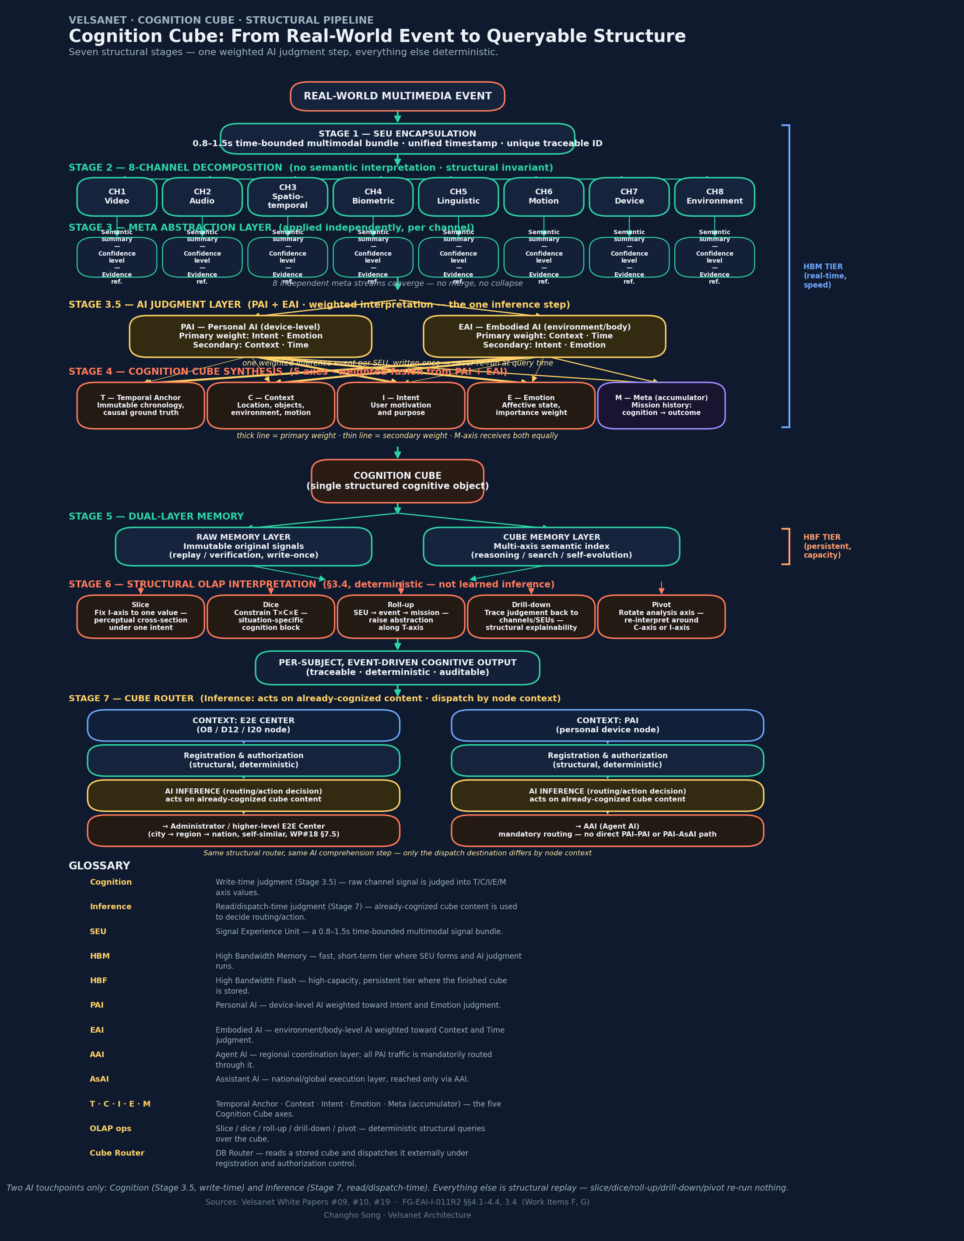
Figure 1. The Cognition Cube structural pipeline — from real-world event to per-subject, event-driven cognitive output, in eight stages.

3.1 Where AI Actually Enters — Stage 3.5, a Single Inference Step
AI (learned judgment) enters this pipeline not after the cube is built, but immediately before the eight meta-channel streams are synthesized into the T/C/I/E axes — Stage 3.5. Here, PAI (Personal AI, device-level) and EAI (Embodied AI, environment/body-level) judge the raw channel meaning into intent, emotion, time, and context.
This judgment does not split the four axes cleanly in two; both AIs participate across all four axes, but each axis carries a different primary weight:
Axis | Primary weight | Secondary weight
I — Intent | PAI (purpose inferred from personal-device voice/behavior) | EAI (secondary input)
E — Emotion | PAI (affect inferred from personal-device biometric/language) | EAI (secondary input)
C — Context | EAI (spatial/object/motion state of environment and body) | PAI (secondary input)
T — Time | EAI (physical timing and causal ordering) | PAI (secondary input)
M — Meta (accumulator) | PAI and EAI, equal weight | —

This judgment occurs exactly once per SEU, at write time. Every later query against the completed cube — the slice, dice, roll-up, drill-down, and pivot operations of Stage 6 — is a deterministic replay of that already-completed judgment, not a re-inference. This is precisely where Section 5's central claim (convergence with Professor Kim's HBF argument: store once, retrieve repeatedly) becomes structurally true: the cost of AI inference is incurred only at Stage 3.5, and every stage after it is structural and deterministic.

3.2 Hardware Tier Mapping — From HBM to HBF
Mapping the pipeline onto physical memory tiers: SEU formation, eight-channel decomposition, meta-abstraction, Stage 3.5 AI judgment, and five-axis cube synthesis (Stages 1–4) all occur in the **HBM tier** — high-bandwidth, real-time, speed-oriented. Once this is complete, the finished cube is stored in the **HBF tier** — high-capacity, persistent, accumulation-oriented (Stage 5). This mapping applies Professor Kim's framing from Section 5 — “HBM is speed, HBF is memory” — directly onto the Cognition Cube pipeline.

3.3 Stage 7 — The Cube Router: Inference After Cognition, and a Branch in Dispatch Direction
Once the cube is stored in HBF, the Cube Router (DB Router, WP#19 §7.2–7.4) is responsible for sending that stored content to external systems. The point to establish here is that Stage 3.5 (Cognition) and Stage 7 (Inference) are different operations.
**Cognition vs. Inference**: Cognition is the write-time judgment that fixes raw channel signal into T/C/I/E/M axis values (Stage 3.5). The cube carries this cognized result in self-describing form, so its meaning need not be re-interpreted. However, **deciding what to do with that already-fixed meaning — whether to transmit it, where to send it, what action follows — is a separate operation, and that is inference (Stage 7).** The Router's task, in other words, is not to re-grasp the cube's meaning but to act as an inference device that decides action based on already-cognized content. This distinction preserves Section 5's central claim of “cognize once, query repeatedly” — cognition happens exactly once, at Stage 3.5, and inference only consumes that cognized result; it never re-interprets the raw signal.
The direction this inference router dispatches to, however, depends on which node it operates on — the router structure and the inference step are identical, but **the destination branches by node context**:
- Operating in an E2E Center context (O8/D12/I20 nodes) — after registration/authorization, inference decides whether and where to dispatch, sending content to an administrator or a higher-level E2E Center, following the self-similar city → region → nation expansion (WP#18 §7.5).
- Operating in a PAI context (personal device node) — after the same registration/authorization, inference decides dispatch, sending content mandatorily to AAI (Agent AI). No direct path from PAI to another PAI or to AsAI exists; this is a topological constraint, not a policy choice (a principle already established in FG-AINN-I-262-R1 §8.2).
This router mechanism is rooted in FG-EAI Work Item I (Human Projection-Based Cognitive Interface); FG-AI4SSC-I-XXX §6.3 already states that “the Cube Router extends FG-EAI Work Item I.” That is, the router mechanism itself (registration, authorization, inference, branching) falls within this contribution's (FG-EAI) scope, while the point at which this mechanism generalizes into interoperability across a city's many administrative subjects and systems falls within FG-AI4SSC's scope — the two contributions describe one architecture, by the same author, at different scopes, following the same principle already established in §1 regarding FG-AINN Work Items A–E.

3.4 Glossary
Term | Definition
Cognition | Write-time judgment (Stage 3.5) — fixes raw channel signal into T/C/I/E/M axis values.
Inference | Read/dispatch-time judgment (Stage 7) — acts on already-cognized cube content to decide routing/action.
SEU | Signal Experience Unit — a 0.8–1.5s time-bounded multimodal signal bundle.
HBM | High Bandwidth Memory — fast, short-term tier where SEU forms and AI judgment runs.
HBF | High Bandwidth Flash — high-capacity, persistent tier where the finished cube is stored.
PAI | Personal AI — device-level AI weighted toward Intent and Emotion judgment.
EAI | Embodied AI — environment/body-level AI weighted toward Context and Time judgment.
AAI | Agent AI — regional coordination layer; all PAI traffic is mandatorily routed through it.
AsAI | Assistant AI — national/global execution layer, reached only via AAI.
T · C · I · E · M | Temporal Anchor · Context · Intent · Emotion · Meta (accumulator) — the five Cognition Cube axes.
OLAP operations | Slice / dice / roll-up / drill-down / pivot — deterministic structural queries over the cube.
Cube Router | DB Router — reads a stored cube and dispatches it externally, via inference, under registration and authorization control.

4. The Paradigm Shift: Learning vs. Cognition Cube Query
Today's mainstream AI dissolves capability into weights: metaverse-style simulation and deep learning are one family, because both learn capability by passing space or data through a model. The Cognition Cube inverts this: reality is loaded onto explicit T/C/I/E axes, and perception becomes an OLAP query and transformation over that loaded structure — structural transformation, not batch inference.
Aspect | Metaverse · Learning Paradigm | Cognition Cube (OLAP)
Paradigm | Space/data simulation → learning | Structure reality into T/C/I/E → query
Perception | Inference over learned weights | slice · dice · roll-up · drill-down · pivot
Processing unit | Batch inference | Per-subject, event-driven
Explainability | Separate XAI, post-hoc | Drill-down = evidence, intrinsic
Capability | Learned from experience (learning-first) | Structural transplant + practice only for embodiment
Reality relation | Simulation first → sim-to-real transfer | Topology/reality first → cube structuring
Reproducibility | Probabilistic, non-deterministic | Deterministic — verifiable, auditable

4.1 Strengths and Trade-offs, Stated for Both Sides
Neither paradigm is presented here as costless. The learning paradigm's genuine strengths: unlimited repeated training of risky or costly scenarios in simulation; a shared multi-actor space enabling natural collaboration; augmentation of data-scarce domains with synthetic data; rich, intuitive visual and spatial representation. Its weaknesses: a reality gap causing performance collapse in sim-to-real transfer; opaque inference that is hard to trace to its basis; a batch structure that is inefficient for per-subject responses; and heavy training and rendering compute that requires the space to be built before anything runs.
The Cognition Cube's strengths: explainability intrinsic to the operation itself, since drill-down is the evidence; immediate, low-latency per-subject and per-event query; deterministic, reproducible, and auditable behavior; cognition deployed by structural transplant rather than learning. Its genuine challenges: an up-front design burden in defining axes and SEU channel mapping; weaker handling of unstructured, unforeseen situations; embodied skill still requires physical practice regardless of transplanted cognition; and axis and schema standardization is a governance-dependent prerequisite for coherence across deployments.
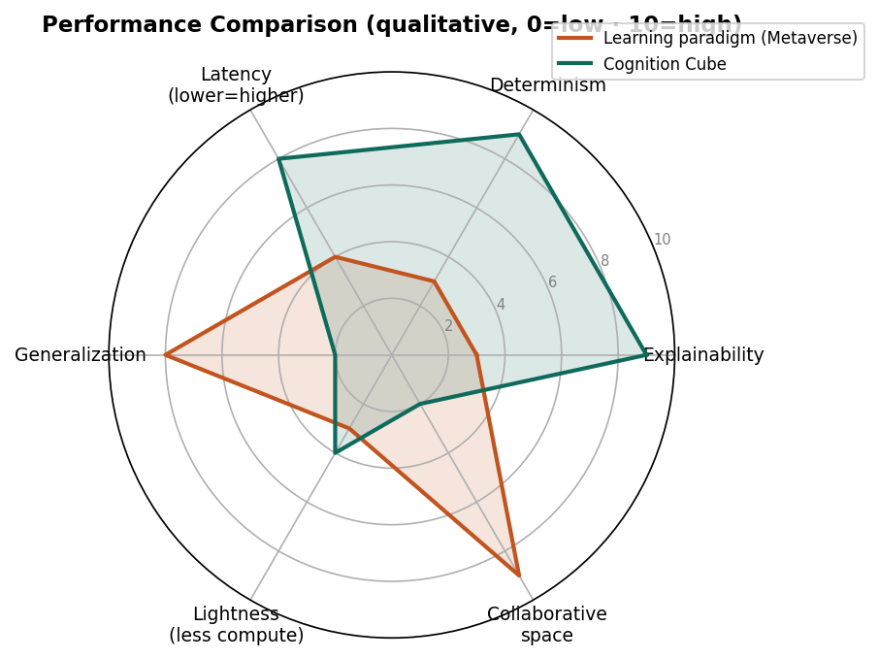
Figure 2. Qualitative performance comparison across six characteristics (0=low, 10=high). The two paradigms trade determinism and explainability against generalization and collaborative space.
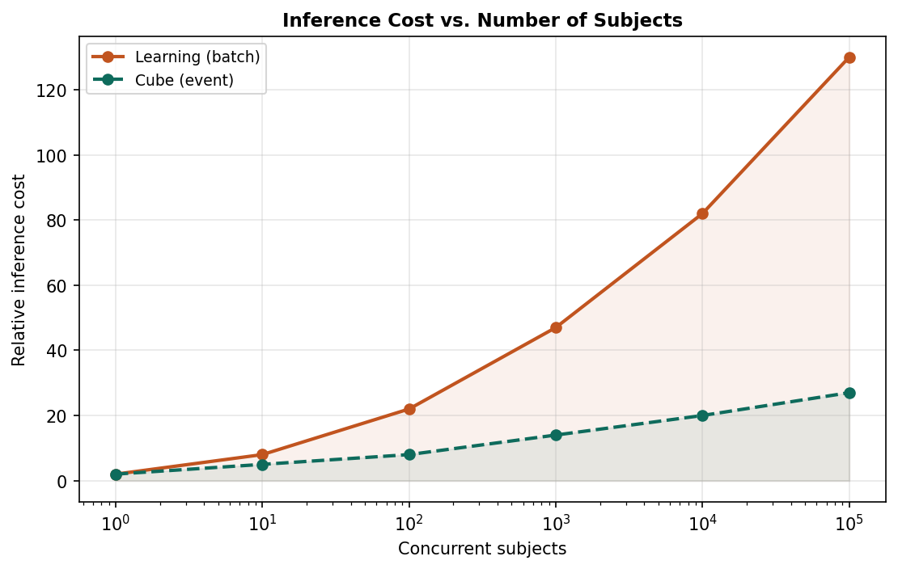
Figure 3. Relative inference cost as concurrent subjects scale. Batch inference grows steeply; cell-level event query stays comparatively shallow.

5. Convergent Validation: Software Meets Hardware
Two arguments were developed independently, at different layers of the technology stack, and arrive at the same conclusion. The Cognition Cube (software) holds that perception should be a query over loaded structure rather than a forward pass through learned weights — compute is paid once, at accumulation time, not repeatedly at every query. Professor Joungho Kim of KAIST, widely known as "the father of HBM," reaches the equivalent conclusion from the silicon side: at a 3 February 2026 briefing on High Bandwidth Flash (HBF), his central claim — validated by his lab's own modeling and simulation — is that the decisive bottleneck in AI is no longer the compute core but the memory structure.

5.1 What Kim Actually Claims
In Kim's framing, HBM functions as a shallow reference shelf beside the desk — short-term memory, valued for speed. HBF functions as a vast library of stacked NAND — long-term memory, valued for capacity. As AI systems mature, reading vast quantities of past information from the cold-memory tier becomes the dominant workload, which is HBF's domain. Computing, in this account, is being re-centered from the GPU to memory: speed belongs to HBM, memory belongs to HBF.

5.2 Point-by-Point Mapping
Dimension | Software — Cognition Cube | Hardware — HBF (J. Kim, KAIST)
Bottleneck | Perception is a query over loaded structure, not a forward pass | The bottleneck is memory structure, not the GPU
Memory model | The Cube is persistent, queryable cognition | HBF is a “library” / long-term memory beside the GPU
Access pattern | Drill-down retrieves past cells on demand | HBF reads vast past data from the cold-memory tier
Center of gravity | Learning (compute) → structure (accumulation) | GPU-centric → memory-centric computing
Cost direction | Maturity lowers inference cost | Capacity tier offloads repeated computation

5.3 Why This Matters for Sovereign AI
The compute curve — ever-larger models, ever-more GPUs — is a capital race that structurally favors the incumbent; a late entrant who simply chases that curve falls further behind the faster the leader runs. Both layers examined here point toward a different curve. Kim observes that the axis of dominance in computing has shifted before — CPU defined the PC era, power efficiency defined the smartphone era — and argues memory will define the AI era, a domain where Korean memory manufacturers already lead. Structure-as-cognition (software) and memory-centric silicon (hardware) describe the same asymmetric opening: compete through structure, standards, and accumulation, rather than through raw compute and capital.

5.4 The Boundary, Stated Plainly
Convergence is not equivalence. Kim's HBF operates within the learning paradigm — it stores the key-value cache, context, and cold data of today's transformer models, augmenting current AI with memory rather than replacing the paradigm that produces it. The Cognition Cube is the paradigm shift itself: cognition as queryable structure rather than weights. HBF is cited here as converging evidence and a compatible physical substrate, not as an endorsement of structure-first cognition — the two share a direction of travel; their underlying premises differ.
Two independent lines — one in architecture, one in semiconductors — are bending AI away from “recompute every time” toward “store once, retrieve.” That shared direction is the strongest available ground for the claim that sovereign AI should be built on accumulated structure, not borrowed scale.

6. Institutional Implication: What the Institute Does
Today's embodied AI asks how to train intelligence into a body. The Velsanet Research Institute asks a different question: where embodied cognition is loaded, and how it flows as structure. The Institute researches, standardizes, and certifies the physical-structural substrate of embodied cognition — not the model that learns it. Substrate over learning; wiring over brain; structure over data.

6.1 Why a Paradigm, Not a Product
Mainstream embodied AI extends the AI brain: vision-language-action models, world models, and simulation pipelines that learn capability and grow with data and compute. The Institute works the opposite layer — the wiring those brains will inhabit. Embodied cognition, understood as sensory event units mapped to Time, Context, Intent, Emotion, and Meta, is not learned into weights; it is loaded into explicit structure, retrieved by query, and transplanted across subjects. That shift has meaning only on a substrate built for it.

6.2 The Four Domains
- Physical substrate for cognition — defining where and how embodied cognition is loaded: node intelligence, optical-path coordinates, and Cognition Cube reference hardware. The cube has meaning only on physical structure, not as software on a general-purpose server.
- Structural retrieval and transplant — standardizing how loaded cognition is traced (drill-down as evidence) and merged across subjects through a shared axis schema, the precondition for cumulative, cross-generational cognition.
- The cognition–embodiment boundary — distinguishing, structurally, what is transplantable cognition from what each body must still earn through physical practice, treating physical interaction as ground truth (real-to-sim) rather than a gap to be simulated away.
- Conformance certification — verifying, against reference hardware, that an EAI node may connect to Velsanet structure: a neutral certification authority for EAI, analogous to the Bluetooth SIG.

6.3 Scope, Stated Plainly
The boundary is half the definition. What the Institute refuses is as load-bearing as what it builds.
What the Institute does | What it deliberately does not
Defines the physical substrate where embodied cognition is loaded — node intelligence, optical-path coordinates, Cognition Cube hardware. | Build learning algorithms — VLA models, world models, policy learning. That is brain extension, not wiring.
Standardizes structural retrieval and transplant — drill-down traceability and cross-subject merge over a shared T/C/I/E/M schema. | Build robots or actuators. The body is embodied skill; the Institute works the cognition layer above it.
Manages the cognition/embodiment boundary — what is transplantable cognition versus what each body must earn through physical practice. | Scale data to chase capability. “More data, bigger model” is the paradigm the Institute replaces.
Certifies conformance — verifying that EAI nodes may connect to Velsanet structure against reference hardware (a Bluetooth-SIG model for EAI). | Own or privatize the field of cognition. The shared schema must remain collectively governed, not captured.

6.4 Why It Must Be an Institute
The cube is meaningless without physical structure, and physical structure cannot be produced by one person writing software. Reference hardware must be manufactured and operated, with partners such as ETRI; loading and retrieval must be verified in a facility; the axis schema must be raised to a standard through ITU-T; and conformance must be certified by a neutral body. None of this is an individual act. The answer to “what does Velsanet do in embodied AI” is therefore the same as the answer to “why an institute is required”: the physical-structural substrate of embodied cognition cannot exist without an institution to build, verify, and govern it.
In Embodied AI, the Velsanet Research Institute works the substrate, not the model; the wiring, not the brain; the structure, not the data.

7. Conclusion
The four threads combine into a single argument. Section 1 establishes that world models fail on their own terms because they decide in advance which channels of reality to keep, producing an unrecoverable transfer gap; the network layer, not the learning algorithm, is where this must be solved. Section 2 and the diagram in Section 3 show Velsanet's structural answer: one physical core per actor, eight channels held apart inside it, synthesized into a five-axis Cognition Cube that is queried rather than inferred over. Section 4 states the resulting paradigm difference in comparative terms, with both its costs and its benefits stated plainly on each side. Section 5 shows this is not an isolated architectural preference: an independent, hardware-side argument from one of the field's most credentialed voices arrives at the same compute-to-memory shift, while explicitly stopping short of endorsing structure-first cognition — a boundary this note preserves rather than blurs. Section 6 draws the institutional consequence: if cognition is structure rather than weights, the entity that builds, verifies, and governs that structure must be an institute, not a product.

References
[1] Velsanet Network AI White Paper #10 v1.3 — Network AI Architecture (SEU, 8-channel decomposition). Velsanet Architecture Group.
[2] Velsanet Cognition Cube System White Paper #19 v1.0 — Structural Cognition Layer for 6G AI-Native Networks. Velsanet Architecture Group.
[3] Song, C. (2026). Integrated EAI Architecture: Multimodal Cognition, Dual E2E Control, and Human Projection (Work Items F–I). FGEAI-I-011R2, ITU-T Focus Group on Embodied AI for Multimedia Technologies, §§4.1–4.4, 3.4.
[4] KAIST TERALAB, High Bandwidth Flash (HBF) briefing, 3 February 2026 (reported: Korea Times, edaily, hellodd, Korea Daily); Sandisk interview, December 2025. Quotations paraphrased; figures qualitative.
[5] Velsanet Research Institute, EAI Positioning Note (in formation).

