Reducing Individual Heat Stress Through Path Planning

Joachim Rußig  
Karlsruhe Institute of Technology, Germany

Julian Bruns  
FZI Forschungszentrum Informatik, Germany

**Abstract** – Heat stress is a serious risk, which affects in particular groups like elderly or patients with chronic diseases and is especially pronounced in cities. Developments like the ageing of society, the progressive urbanisation and the climate change are increasing the risk that people are affected by heat stress. One way to reduce those risks is to adapt the everyday behaviour. To encourage and support such a change of behaviour, we propose a two-step approach. The first step is a route planer for pedestrians that can find a route with minimal heat exposure. The second step is a tool that supports the user to select the point in time with a minimal amount of heat stress to actually go. The route planer is then used to calculate the heat stress and present the optimal route at that point in time. We evaluate our approach for the city of Karlsruhe. Our results show that the combined approach, as well as its single steps, can reduce the heat exposure and therefore the heat stress for typical daily tasks in a European city.

**Keywords:** Heat Stress, Time Dependent Routing, Decision Support, Urban Vulnerability

# Introduction

Heat is an important factor to human health and comfort. High temperatures cannot only lead to a discomfort, it also has serious negative effects on the health as well as the ability to work.

In numerous studies an increase in both mortality and morbidity has been associated with a high ambient temperature (Basu, 2009). The most well-known example in recent history is the 2003 heat wave in Europe. Certain groups are especially vulnerable to heat stress such as older people or people with health problems (Hübler, Klepper, & Peterson, 2007). For patients with multiple sclerosis an increased body temperature can lead to a worsening of their symptoms (Davis, Wilson, White, & Frohman, 2010). The time someone must be exposed to heat before it has an effect is dependent on factors like the ability to adapt to high temperature as well as the activities performed (Hübler, Klepper, & Peterson, 2007).

Developments like the ageing of society, the increasing urbanisation and the climate change is making the adaptation to heat stress danger more and more important. Due to the tendency that a rising number of people is moving into the cities, the urban heat island effect (UHI) is gaining more importance in the future. The UHI effect states that an urban area is significantly warmer than surrounding rural areas (Prashad, 2014). Causes of that effect are especially the kind of land use and land cover in urban areas, including lower albedo, higher heat capacity, limited green spaces as well as significant anthropogenic heat releases due to industrial operations or automobile use (Richter, 2015; Oke, 1982). Due to the UHI effect people living in urban areas are more frequently and longer exposed to high ambient temperature and there for have a higher risk to be affected by heat stress dangers.

Individuals can reduce their heat stress by adapting their everyday behaviour. In a typical European city, most typical activities are in walking distance. These can range from going to a grocery store to the visit of a doctor. While these activities cannot be omitted, it is possible to use different routes or change the time when they are conducted. In doing so, one can easily reduce the heat stress without negative impact on the quality of life.

In this paper, we use this reasoning into a two-step approach to help individuals reduce their heat stress. We apply a routing algorithm to compute the optimal path regarding to the heat stress. This algorithm is then used to determine the optimal point in time to conduct typical everyday activities. We create this method for the context of European and European-style cities and evaluate it in the city of Karlsruhe as a representative of this class of cities.

## Related Work

### Heat Stress

The impact of heat on the human body has long been a subject of study. Thermal comfort plays a key role, which describes climatic conditions consider comfortable.

Staiger, Bucher, and Jendritzky (1997) state that only a complete heat budget model of the human body is sufficient to make any reliable statements regarding the influence of heat on the body. The heat budget model of the human body is a simplified model that describes how the internal heat production of the human organism must be balanced with the environment by heat exchange, for instance through skin or respiration (Staiger, Laschewski, & Grätz, 2012). Some well-known indices that consider a complete human heat budget model are (1) Steadman’s heat index (Steadman, 1979a; 1979b), (2) the predicted mean vote (PMV, Fanger, 1973), (3) the perceived temperature (Staiger, Bucher, & Jendritzky, 1997; Jendritzky, Staiger, Bucher, Graetz, & Laschewski, 2000), (4) and the universal thermal climate index UTCI (Jendritzky, et al., 2010).

For all these indices, the following meteorological parameters are important: (1) air temperature, (2) water vapour pressure, (3) wind velocity and (4) mean radiant temperature (Jendritzky, et al., 2010).

Based on the availability of data, in this paper we will use Steadman’s heat index (Steadman, 1979a) and, as a simple comparison measure, the air temperature. Steadman’s heat index is a single measure for the combined effect of air temperature and humidity (sultriness) and can be used as a measure for heat stress danger (Stull, 2011). The heat index is an ambient temperature that describes how the combination of dry-bulb temperature and vapour pressure feels to a typical human. For the heat index a typical adult human of either sex with a height of 1.7 m and a weight of 67 kg, which walks outdoor at a speed of 5 km/h (1.4 m/s) is considered (Steadman, 1979a).

### Health Optimal Pedestrian Routing

Several research projects have considered environmental factors for pedestrian routing in the past, with the goal to find routes which are healthier. For instance, Sharker, Karimi, and Zgibor (2012) are proposing a method to find a health optimal route, considering several environmental factors like complexity of the walking trail and weather. A method to find a route with a minimal pollution exposure has been proposed by Hasenfratz (2015).

The NaviComf framework for pedestrian routing proposed by Dang et al. (2013) improves the comfort considering environmental factors varying over time. Their framework uses a multi-factor cost model for the evaluation of the route and enables a consideration of heterogeneous environmental information from multi-modal sensors. To find an optimal route Dang et al. (2013) are proposing three different algorithms, a bounded depth-first search algorithm, an adjustable dynamic planning algorithm and a heuristic particle planning algorithm. As a sample application, the authors implemented a routing application for thermal comfort navigation. The meteorological data used for this sample application have been collected using a network of 40 micro-climate sensor nodes which detected air temperature and relative humidity.

In contrast to the existing work, we contribute an approach which does not rely on extensive sensor networks. We achieve this by combining remote sensing data with fixed weather stations and the use of a static routing algorithm.

# Minimize Heat Exposure

In this work, we reduce the heat stress of people in their everyday life. This is achieved by (1) finding a walking route with minimal heat exposure and (2) using this route to find the optimal point in time to start this route.

## Finding a Route with Minimal Heat Exposure

### Modelling as a Time-Dependent Routing Problem

Finding a route with minimal heat exposure can be modelled as time-dependent routing problem, where the edge weighting function is not static and instead may vary over time. Subsequently, many speed up techniques developed for static routing problems like bi-directional search cannot simply be applied (Delling, Sanders, Schultes, & Wagner, 2009).

Below, we are representing the road network as undirected graph , where is the set of vertices or nodes (e.g. junctions) and is the set of edges (e.g. road segments) each connecting a pair of nodes. Furthermore and are to edge weighting function, at which:

* is the length of the edge and
* is the heat exposure of edge at time .

Hereafter, a path from node to node starting a time is denoted as sequence of edge-time pairs , where is the time at which node is leaved. The weight of an edge is fixed at the time the traversing of the edge is started (the so called frozen link model, Orda & Rom, 1990). The time can be computed as follows: where is the time needed by a pedestrian to traverse the edge . The starting time is either given or set to .

To compute the weight of a path the following formula can be applied:

|  |  |
| --- | --- |
|  | (1) |

Those means one looks for the path from a node to a node that has the minimal weight of all possible path from to . Below, we are using to denote the weight of the path starting at time .

The time-dependent routing problem is -hard, if it is not allowed to wait on a node and the FIFO (first in, first out) property is not fulfilled (Orda & Rom, 1990). A weighting function fulfils the FIFO property if the change of the edge weight decreases not faster than the change in the actual time increases (Kaufman & Smith, 1993).

Usually, one cannot assume that fulfils the FIFO property, because the function depends in most instances on the air temperature. In general, the air temperature can decrease more than the actual time increases. Since most people are not willing to wait at a node, finding a route with a minimal heat exposure is -hard. Hereafter the edge weighting is frozen at the starting time so that we have static route planning problem and classic algorithms like Dijkstra’s algorithm (Dijkstra, 1959) can be applied.

### The Edge Weighting FunctionAn example for the raster to edge mapping.

Figure : An example for the raster to edge mapping. The values of the raster cells are weighted with the length of the intersection and then accumulated.

To find a route with a minimal heat exposure it is key to define the edge weighting function in an appropriated way. At this, it is not sufficient to only take the actual thermal comfort in to account, one must consider the time a person is exposed to heat as well. Below, we assume that the time of exposure is proportional to the length of the edge (following Hasenfratz, 2015). Based on this assumption we are defining the edge weighting function as follows:

|  |  |
| --- | --- |
|  | (2) |

Here, the thermal comfort values (like air temperature or heat index) are represented as time-dependent raster , where denotes the thermal comfort value in raster cell at time . In the formula above, is the set of raster cells intersected by the edge and the length of the intersection of with raster cell (see example in figure Figure 1). That is, to obtain the edge weight, the value of each intersected raster cell is weighted with the length of the intersection and then accumulated.

Using our thermal comfort measures, we get the following edge weighting functions:

|  |  |
| --- | --- |
|  | (3) |

for the air temperature and respectively

|  |  |
| --- | --- |
|  | (4) |

for the heat index. Here, is the air temperature in raster cell at time , is the relative humidity at time and is Steadman’s heat index. How we obtained those values is described below in section 3.1.

## Finding the Optimal Point in Time

In addition to the optimal route, the appropriate time for doing tasks of everyday life (e.g. go shopping in a supermarket) can decrease the individual heat stress by a large margin. This follows the circumstances that the heat exposure is normally highest at middays and lower in the morning or evening.

To give recommendations for a point in time with minimal heat exposure, we use a three-step procedure:

1. Perform a nearby search originating from a given starting point (e.g. address) to find all locations that fulfils a certain search criteria (e.g. is supermarket) within a specified radius (e.g. 500 m).
2. For each location found in step 1, determine the point in time with the lowest heat exposure.
3. Create a ranking of the locations in based on the minimum heat exposure found in step 2 with the location with the lowest heat exposure as rank 1.

As steps 1 and 3 have well-known solutions, we focus on step 2.

### Modelling as an Optimization Problem

For finding the time with the lowest heat exposure for a location one must consider constrains like the opening hours of . We use the heat exposure of the optimal path between the starting point and location as the objective function to minimize, see section 2.1. Finding the time with the minimal heat exposure means to minimize the following objective function :

|  |  |
| --- | --- |
|  | (5) |

where is the set of all possible paths from to , is the accumulated edge weight of all edges in at starting time and is the edge weighting function from equation (2).

Using the objective function defined in equation (5), one can formulate the problem to find a time with minimal heat exposure as an optimization problem with constrains:

|  |  |
| --- | --- |
|  | (6) |
|  | (7) |
|  | (8) |
|  | (9) |
|  | (10) |
|  | (11) |

Note, that the location is fixed, as the selection of the location with lowest heat exposure is performed later in step 3. The constrains (7) and (8) are ensuring that the arrival at location is within the opening hours. One must ensure that the shop can be reached before it closes. Therefore, one must consider the time needed to walk to the location () as well as the time needed to perform e.g. the purchase (). But it can make sense to start early in the morning to arrive the location just in time when it opens, so one subtracts the walking time from the opening time. The constrains (9) and (10) are an earliest respectively latest time desired by the user and are optional. The last constrain (11) guarantees that the optimal time is in the future. The walking time depends on the starting time , because, conditional on the time, a different optimal route could be selected.

### Optimization

To find the optimal time, one needs a optimization method without derivatives, as the objective function is not necessarily derivable. One such method is Brent’s method (Brent, 2002), a procedure for the approximation of local optima within an interval .

To apply Brent’s method, one has to transform the constrains (7)–(11) to a lower and upper limit of an interval. The constrains (7), (9) and (11) can be easily converted to a lower limit, as follows:

|  |  |
| --- | --- |
|  | (12) |

Alike, we can transform the constrains (8) and (10) to an upper limit:

|  |  |
| --- | --- |
|  | (13) |

It is simple to recognize that the interval preserves the constrains from the optimization problem defined above in the equations (7) to (11).

However, Brent’s method can still not be applied, since the lower and upper limit of the interval is depending on the starting time and therefore not static as required for Brent’s method. To avoid this problem, we are proposing the introduction of a penalty term and thus the following new objective function :

|  |  |
| --- | --- |
|  | (14) |

where is a large constant such that is never selected as optimal solution, if the constrains are violated. Now, one can use the walking time for the shortest route for the lower and upper limit, which is independent of the actual time. Finally, we can formulate the optimization problem for Brent’s method as follows:

|  |  |
| --- | --- |
|  | (15) |
|  | (16) |
|  | (17) |

Now one can use Brent’s method to find for each location the optimal time . To avoid that the Brent optimizer is trapped in a local optimum, it can be executed several times with different random start points.

# Evaluation

## Data

As map data, we use the data from the OpenStreetMap (OSM) project (OpenStreetMap Foundation, 2016). For weather data, we use the hourly air temperature and relative humidity values originating from the weather station of the German Weather Service (Deutscher Wetterdienste, DWD) in Rheinstetten near Karlsruhe (Deutscher Wetterdienst, 2016). For a finer spatial resolution, we use remote sensing data of a thermal scanner flight provided by the Nachbarschaftsverband Karlsruhe (NVK). The data set consists of two scans, recorded in the morning and in the evening of the 26 September 2008. The data is covering an area of (EW NS) and have a resolution of pixels. The measured surface temperature is in the range of (morning and evening). The average surface temperature of the data sets cropped to the evaluated area is (morning) respectively (evening).

## Data Preparation

The OSM data set is cropped to the evaluated area. Afterwards, all ways tagged with highway, railway=platform or public_transport=platform are extracted to obtain the road network.

To compute the edge weights as described above in section 2.1.2 we need to make some assumptions. That is because the weather data that we use lack either an appropriate spatial resolution or the required temporal resolution. We therefore assume that the actual spatial variation of the temperature conforms with the spatial variation of the thermal scans (deviation from the mean value). For the relative humidity, we assume a constant value over the study area. For the temporal variation, we assume that the temporal variation in the examined area corresponds to the temporal variation measure at the weather station. We apply the morning scan to timestamps between 00:00 and 11:59 and the evening scan between 12:00 and 23:59.

We compute the air temperature at time for the raster cell as follows:

|  |  |
| --- | --- |
|  | (18) |

where is the air temperature measured at the weather station at time and respectively is the deviation of the raster cell from the mean of all raster cells from the morning respectively evening scan.

We compute an approximation of Steadman’s heat index as proposed by Stull (2011, p. 77). Since the heat index is only defined for an air temperature between and , the air temperature is used as a fall-back value. If the air temperature drops in a raster cell below a comfort threshold or , that comfort value will be used, because temperature below this threshold are not considered harmful. It is assumed that a person is walking at a speed of 5 km/h (1.4 m/s).

For the implementation of the routing the GraphHopper framework for Java (GraphHopper GmbH, 2016) is used.

To find an optimal point in time we used the procedure described in section 2.2.

For the nearby search, we use a list of selected OSM tags like shop=supermarket or amenity=pharmacy as search criteria. Only locations which have opening hours specified (via the opening_hours tag) and are within a defined radius around the starting point are considered. We use the direct distance (“as the crow flies”). To reduce the computation effort a maximum number of results can be specified.

The implementation of Brent’s method in the Apache Commons Mathematics Library (Apache Software Foundation, 2016) is used as optimization algorithm with 10 random start points to reduce the risk that only a local optimum is found.

## Results

### Routing

To evaluate the routing, we select 1000 random pairs of start and destination points from the examined area and 10 random dates from the period of 1 June to 31 August 2015. For each of the start destination pairs and each date we perform the evaluation at 7:00, 11:00, 15:00, 19:00 and 23:00, so overall we have samples. As a benchmark, we compute the shortest path for each sample.

An overview of our results is given in Table 1. In many cases the heat exposure can be reduced. On average the heat exposure is decreased by ∼4.7 % while in the same time the distance increased by at most 5.76 % on average. In some cases, the heat exposure is reduced by up to 25 %. The weighted average of the thermal comfort measure can be reduced by ∼2°C on average. There are only slight differences between the air temperature and the heat index as measure for thermal comfort.

In the example given in Figure 2 the heat exposure is reduced by 17.64 % (*temperature*) and 18.76 % (*heatindex*), while at the same time the distance only increases by 0.53 %.

Table : Overview of the routing results. The values are relative to the shortest route.

|  |  |  |  |
| --- | --- | --- | --- |
|  |  | *temperature* | *heatindex* |
| Reduction of heat exposure (% of cases) | |  |  |
|  | overall | 79.70 % | 80.53 % |
|  | more than 5 % | 42.72 % | 45.11 % |
|  | more than 10 % | 13.81 % | 16.07 % |
| Reduction of heat exposure | |  |  |
|  | average | 4.63 % | 4.69 % |
|  | maximum | 25.97 % | 26.17 % |
| Increase of distance | |  |  |
|  | average | 5.59 % | 5.76 % |
| Reduction of relative heat exposure | |  |  |
|  | average | 2.12 °C | 2.32 °C |

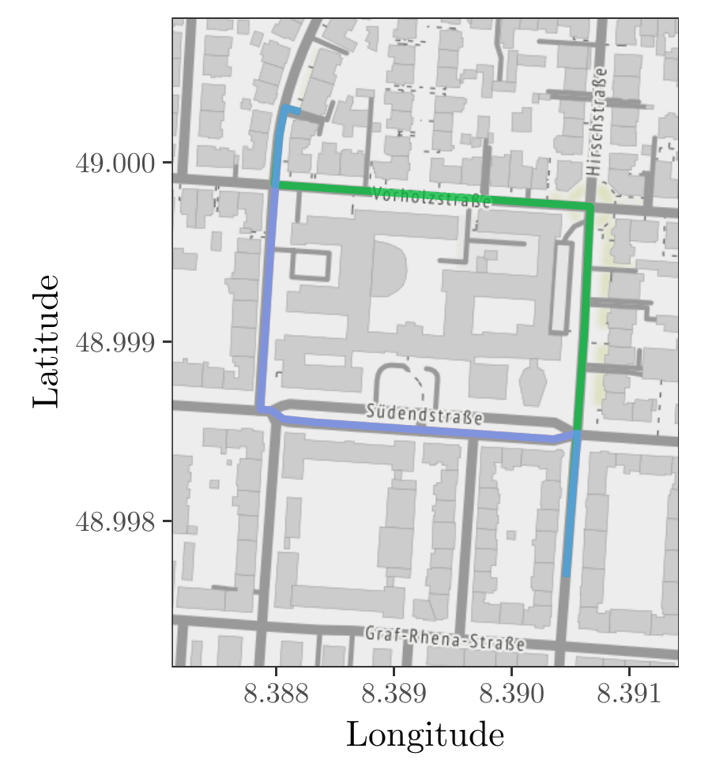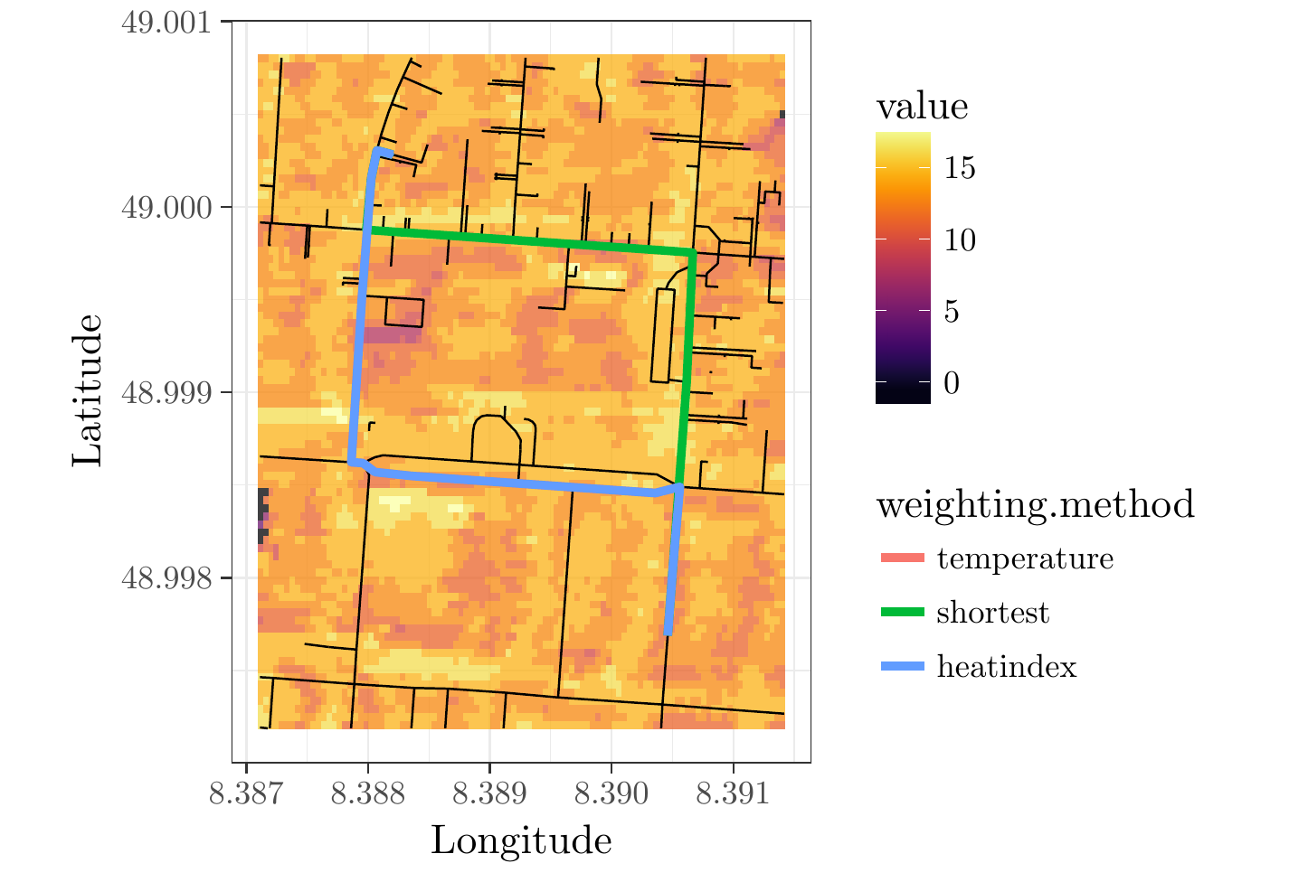

Figure : Routing example: both the temperature and the heatindex weighting found the same route. (Map tiles by Stamen Design (2017), under CC BY 3.0[1]. Map data by OSMF (2016), under ODbL2[2])

### Optimal Time

For the evaluation of optimal time finding procedure we selected 750 random start points. Afterwards, one of the following four search criteria is assigned to each of the start points at random: supermarket, bakery, chemist or pharmacy. For each of the start points a random start time is selected from the period of 8:00 to 20:00. The radius is set to for all start points and the maximum number of results is set to 5. Additionally, for all start points a time buffer of 15 minutes is assumed.

Table : Overview of the results of the combined approach each compared with the reference solution.

|  |  |  |  |
| --- | --- | --- | --- |
|  |  | *temperature* | *heatindex* |
| Reduction of heat exposure | |  |  |
|  | % of cases | 68.43 % | 71.08 % |
| Reduction of heat exposure | |  |  |
|  | average | 8.09 % | 7.73 % |
|  | maximum | 62.29 % | 62.88 % |
| Increase of distance | |  |  |
|  | average | 4.60 % | 4.72 % |

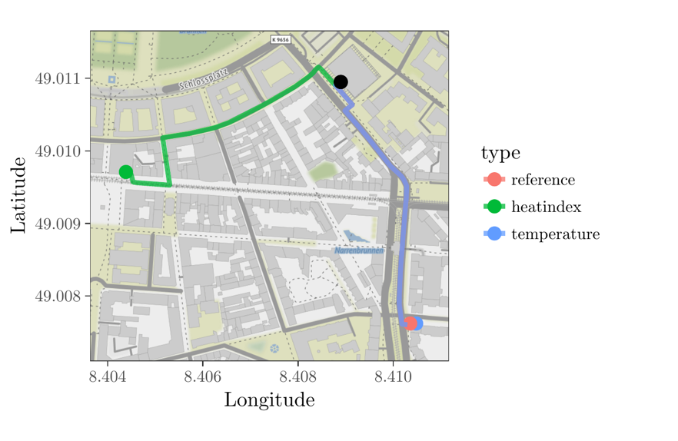

Figure : Example for nearby search: In the graphic, the starting point (black dot) as well as the locations ranked best by the respective method. (Map tiles by Stamen Design (2017), under CC BY 3.0. Map data by OSMF (2016), under ODbL2)

As a reference solution, we use the closest location found during the nearby search, compute the shortest path from the starting point to this location and evaluated the heat exposure at time .

The results for the combined approach are given in Table 2. Here the average reduction compared to the routing approach is significantly higher. This is expected as the heat exposure can vary strongly with the time of the day.

In the example given in Figure 3 the *temperature* weighting selected the same pharmacy and optimal point in time (9:27) as the reference solution. Contrary the *heatindex* weighting selected a different pharmacy which is 476.6 m instead 434.5 of away from the start. Additional the method found a different optimal time (19:39) and those the heat exposure is reduced by 18.49 %.

# Conclusion

In this work, we proposed a two-step approach to reduce the heat stress for individuals. We achieved this goal by creating a decision support system that computes heat-optimal paths to locations as well the optimal points in time to perform a desired action. We evaluated this on typical every-day activities such as grocery shopping. We showed that our approach reduces the heat stress in a vast majority of the cases. This approach is applicable for cities or areas, where walking or cycling are valid alternatives. On average the heat stress can be reduced by ~4.7 % while the trade off in additional distance is also quite low (less than 5.8 % on average). We achieved these results, contrary to the existing work, for relatively small distances which average over ~2 km. The impact of these results is simple, but significant. One can easily compute our approach and decide for themselves the trade-off between additional distance and the heat stress reduction. Thanks to the very small assumptions on the data set, one can apply the approach quite easily to other cities where basic amenities and services are within walking distances. But these assumptions are also the main restriction of this work. Given the rise of smart cities and (hopefully) more available data sources, one could improve the approach with more fine-detailed data. Even more interesting would be the inclusion of intra urban temperature forecasts. By incorporating exact forecasts of future values along possible pathways, the optimal point in time as well as the reduction of the heat stress could be improved. Additionally, the inclusion of more complex heat indices could increase the validity for any potential user. These could include the mode of movability (e.g. walking, jogging, cycling) as well as additional environmental factors like wind or the heat radiated by the sun. Finally, the computation of an overall route which covers a multitude of potential points of interests would be an interesting extension. This could be used for tourists or even worker scheduling. Here not only the time and the route with minimal heat exposure should be considered but also, the ordering of the locations.

# References

Apache Software Foundation. (2016). Commons Math: The Apache Commons Mathematics Library. Retrieved from http://commons.apache.org/proper/commons-math/

Basu, R. (2009). High ambient temperature and mortality: a review of epidemiologic studies from 2001 to 2008. *Environmental Health, 8*, 40. doi:10.1186/1476-069X-8-40

Brent, R. P. (2002). *Algorithms for minimization without derivatives.* Mineola, NY: Dover Publ.

Dang, C., Iwai, M., Tobe, Y., Umeda, K., & Sezaki, K. (2013). A framework for pedestrian comfort navigation using multi-modal environmental sensors. *Pervasive and Mobile Computing, 9*, 421-436. doi:10.1016/j.pmcj.2013.01.002

Davis, S. L., Wilson, T. E., White, A. T., & Frohman, E. M. (2010). Thermoregulation in multiple sclerosis. *Journal of Applied Physiology, 109*, 1531-1537. doi:10.1152/japplphysiol.00460.2010

Delling, D., Sanders, P., Schultes, D., & Wagner, D. (2009). Engineering Route Planning Algorithms. In J. Lerner, D. Wagner, & K. A. Zweig (Eds.), *Algorithmics of Large and Complex Networks* (pp. 117-139). Springer Berlin Heidelberg. doi:10.1007/978-3-642-02094-0_7

Deutscher Wetterdienst. (2016). Aktuelle stündliche Stationsmessung der Lufttemperatur und Luftfeuchte, Qualitätskontrolle noch nicht vollständig durchlaufen. Retrieved from ftp://ftp-cdc.dwd.de/pub/CDC/observations_germany/climate/hourly/air_temperature/recent/stundenwerte_TU_04177_akt.zip

Dijkstra, E. W. (1959). A note on two problems in connexion with graphs. *Numerische Mathematik, 1*, 269-271. doi:10.1007/BF01386390

Fanger, P. O. (1973). Assessment of man's thermal comfort in practice. *British Journal of Industrial Medicine, 30*, 313-324. doi:10.1136/oem.30.4.313

GraphHopper GmbH. (2016). GraphHopper Routing Engine. Retrieved from https://graphhopper.com/

Hübler, M., Klepper, G., & Peterson, S. (2007). *Costs of Climate Change: The Effects of Rising Temperatures on Health and Productivity in Germany.* Kiel Working Paper 1321, Kiel Institute for the World Economy, Kiel. Retrieved from https://www.ifw-members.ifw-kiel.de/publications/costs-of-climate-change-the-effects-of-rising-temperatures-on-health-and-productivity-1/Costs%20of%20Climate%20Change%2009-2007.pdf

Hasenfratz, D. (2015). *Enabling Large-Scale Urban Air Quality Monitoring with Mobile Sensor Nodes.* PhD thesis, ETH-Zürich, Zürich. doi:10.3929/ethz-a-010361120

Jendritzky, G., Bröde, P., Fiala, D., Havenith, G., Weihs, P., Batchvarova, E., & DeDear, R. (2010). The Universal Thermal Climate Index UTCI. In A. Matzarakis, H. Mayer, & F.-M. Chmielewski (Ed.), *Proceedings of the 7th Conference on Biometeorology, Freiburg, Germany, April 12-14th, 2010*, *20*, pp. 184-188. Freibug. Retrieved from http://www.mif.uni-freiburg.de/biomet/bm7/report20.pdf

Jendritzky, G., Staiger, H., Bucher, K., Graetz, A., & Laschewski, G. (2000). The Perceived Temperature: The Method of the Deutscher Wetterdienst for the Assessment of Cold Stress and Heat Load for the Human Body. *Internet Workshop on Windchill, April 3-7, 2000, Meteorological Service of Canada.* Retrieved from http://www.utci.org/isb/documents/perceived_temperature.pdf

Kaufman, D. E., & Smith, R. L. (1993). Fastest Paths in Time-Dependent Networks for Intelligent Vehicle-Highway Systems Application. *I V H S Journal, 1*, 1-11. doi:10.1080/10248079308903779

Oke, T. R. (1982). The energetic basis of the urban heat island. *Quarterly Journal of the Royal Meteorological Society, 108*, 1-24. doi:10.1002/qj.49710845502

OpenStreetMap Foundation. (2016). The OpenStreetMap Project. Retrieved from http://www.openstreetmap.org/

Orda, A., & Rom, R. (1990). Shortest-path and Minimum-delay Algorithms in Networks with Time-dependent Edge-length. *Journal of the {ACM}, 37*, 607-625. doi:10.1145/79147.214078

Prashad, L. (2014). Urban Heat Island. In E. G. Njoku (Ed.), *Encyclopedia of Remote Sensing* (pp. 878-881). Springer New York. doi:10.1007/978-0-387-36699-9_81

Richter, M. (2015). Urban climate change-related effects on extreme heat events in Rostock, Germany. *Urban Ecosystems*, 1-18. doi:10.1007/s11252-015-0508-y

Sharker, M. H., Karimi, H. A., & Zgibor, J. C. (2012). Health-optimal Routing in Pedestrian Navigation Services. *Proceedings of the First ACM SIGSPATIAL International Workshop on Use of GIS in Public Health* (pp. 1-10). New York: ACM. doi:10.1145/2452516.2452518

Staiger, H., Bucher, K., & Jendritzky, G. (1997). Gefühlte Temperatur: Die physiologisch gerechte Bewertung von Wärmebelastung und Kältestreß beim Aufenthalt im Freien mit der Maßzahl Grad Celsius. *Annalen der Meteorologie.* *33*, pp. 100-107. Offenbach: Deutscher Wetterdienst. Retrieved from http://www.dwd.de/DE/leistungen/pbfb_verlag_annalen/pdf_einzelbaende/33_pdf.pdf?__blob=publicationFile&v=3

Staiger, H., Laschewski, G., & Grätz, A. (2012). The perceived temperature - a versatile index for the assessment of the human thermal environment. Part A: scientific basics. *International Journal of Biometeorology, 56*, 165-176. doi:10.1007/s00484-011-0409-6

Stamen Design. (2017). Retrieved from http://stamen.com/

Steadman, R. G. (1979a). The Assessment of Sultriness. Part I: A Temperature-Humidity Index Based on Human Physiology and Clothing Science. *Journal of Applied Meteorology, 18*, 861-873. doi:10.1175/1520-0450(1979)018<0861:TAOSPI>2.0.CO;2

Steadman, R. G. (1979b). The Assessment of Sultriness. Part II: Effects of Wind, Extra Radiation and Barometric Pressure on Apparent Temperature. *Journal of Applied Meteorology, 18*, 874-885. doi:10.1175/1520-0450(1979)018<0874:TAOSPI>2.0.CO;2

Stull, R. (2011). *Meteorology for Scientists and Engineers* (3 ed.). Vancouver: University of British Columbia. Retrieved from https://www.eoas.ubc.ca/books/Practical_Meteorology/mse3.html

1. <http://creativecommons.org/licenses/by/3.0>
2. <http://www.openstreetmap.org/copyright>