Robust RGB-D Semantic Segmentation with Masked Linear Cross-Attention and Efficient Pretrained Extractors
Mónica Abarca¹, Marshall Fernández¹, Joaquin Gonzalez Villarreal¹, Claudia Suárez¹
¹Pontificia Universidad Católica del Perú, Lima, Peru
Corresponding author: [contact e-mail]

1. INTRODUCTION
RGB-D semantic segmentation helps machines understand their surroundings, but depth sensors fail: reflective, dark or sunlit surfaces leave holes, and a sensor can drop out entirely. Current fusion networks degrade sharply in these cases. With 25% of depth pixels set to zero, the best models on DeLiVER lose 19–23 mIoU points, almost as much as without depth [1], and CMNeXt drops from 56.3 to 51.2 mIoU on NYUv2 when depth is missing [2]. Robust methods exist, but most rely on large backbones or on training strategies that add cost.
We ask to what extent a masked linear cross-attention (MLCA) improves the accuracy and robustness of RGB-D segmentation over conventional fusion strategies when depth is noisy, partially missing or absent, while keeping a low computational cost. We hypothesize that a linear cross-attention that explicitly excludes invalid depth positions reduces the loss of segmentation accuracy relative to fusion without masking, with a bounded increase in parameters and latency.

2. METHODOLOGY
Architecture. A frozen EfficientViT-B1 extracts RGB features at low computational cost [3] and a frozen DeFM ResNet-18, a self-supervised depth foundation model [4], extracts geometric features. After a projection, MLCA fuses them: RGB features query and depth features answer. With φ = ReLU the attention is linear, oᵢ = φ(qᵢ)ᵀS / (φ(qᵢ)ᵀz + ε), with S = Σⱼ mⱼ φ(kⱼ) vⱼᵀ and z = Σⱼ mⱼ φ(kⱼ). The validity mask mⱼ = 0 at sensor holes removes them from both the summary and the normalizer at no extra cost. The output projection has no bias, is zero-initialized and is added to the RGB path, so with no valid depth MLCA contributes exactly zero and the decoder receives only the RGB features (Fig. 1).
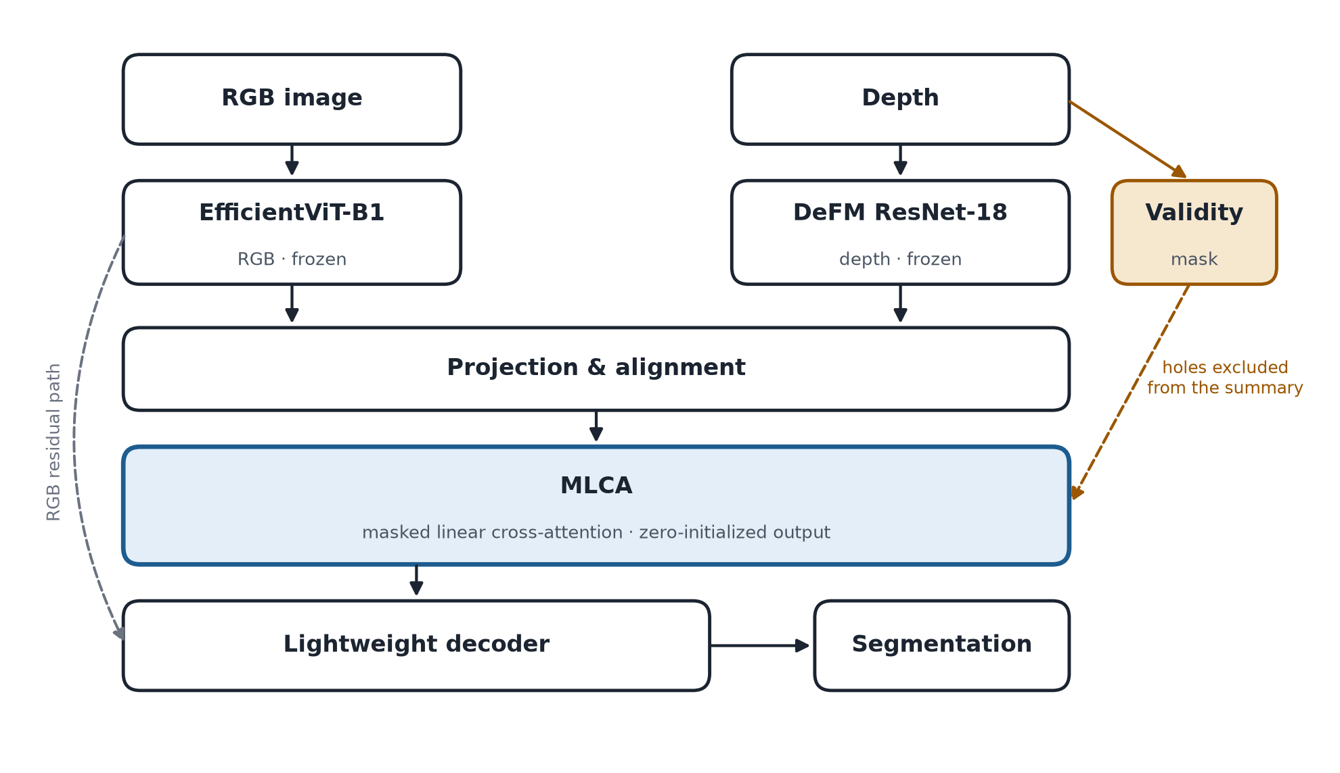
Fig. 1. EfficientViT + DeFM + MLCA. The validity mask removes depth holes from the attention summary; with no valid depth, the zero-initialized output contributes exactly zero.
Experiments. On NYUv2 (795/654 images) we also use the raw depth maps, which keep the real sensor holes (12–14% of the pixels inside the standard crop, our measurement). We compare RGB only (E1); concatenation (E2); linear cross-attention without a mask, as in CMX [5] (E3); MLCA (E4); MLCA with and without modality dropout (E5); and MLCA with a masked softmax attention (E6), as in UCTNet [6], the closest prior work, which masks invalid depth inside a softmax self-attention of the depth branch. A citation-chaining review of about 2,150 papers found no equivalent mechanism. Test conditions: full depth, real holes, random holes (10/30/50%) [1], contiguous missing regions, Gaussian noise and no depth. Metrics: mIoU, mIoU drop, parameters, FLOPs, latency and memory, over three seeds. Cityscapes, whose stereo disparity has invalid pixels, is an optional second domain.

3. RESULTS AND DISCUSSION
Preliminary results. We trained E1 and E2 with frozen extractors (three seeds, NYUv2 test, 40 classes); the team registered its predictions before training. E1 reaches 44.99 ± 0.30 mIoU. E2 improves it with full depth (47.31 ± 0.26) and with the real sensor holes (46.97 ± 0.52), but falls below RGB only when half of the depth pixels are missing (43.90 ± 0.12) and when it receives an empty depth map (42.25 ± 0.45): trained always with depth and without a mask, E2 cannot tell missing depth from a measured value. On synthetic data we verified that, with no valid depth, the MLCA block returns exactly the RGB features; that holes are excluded exactly, even when they contain NaN; and that its cost grows linearly with the number of tokens (log-log slope 1.14, versus 2.00 for softmax cross-attention). Its sums overflow in FP16, so they are accumulated in FP32.
E3–E6 are scheduled for November 2026. If MLCA does not outperform the unmasked fusion or the softmax variant, that negative result will be reported.

4. CONCLUSIONS
Preliminary finding: adding depth without a mask helps only while depth is available; under heavy loss it is worse than ignoring depth. MLCA removes the spurious contribution of missing depth by construction; whether it also keeps the accuracy under partial loss is the hypothesis under test. Limitations: indoor data, and a binary mask detects missing but not noisy depth, which is evaluated separately.
Next steps: E3–E6, latency on an embedded device if available, and an extension to the loss of the RGB stream and to outdoor field data. Take-home message: depth should help when present and do no harm when it fails.

REFERENCES
[1] C. Liao et al., “Benchmarking multi-modal semantic segmentation under sensor failures: Missing and noisy modality robustness,” in CVPR Workshops, 2025.
[2] M. K. Reza, A. Prater-Bennette, and M. S. Asif, “Robust multimodal learning with missing modalities via parameter-efficient adaptation,” IEEE TPAMI, 2025.
[3] H. Cai, J. Li, M. Hu, C. Gan, and S. Han, “EfficientViT: Multi-scale linear attention for high-resolution dense prediction,” in ICCV, 2023.
[4] M. Patel et al., “DeFM: Learning foundation representations from depth for robotics,” IEEE T-RO (conditionally accepted), 2026, arXiv:2601.18923.
[5] J. Zhang et al., “CMX: Cross-modal fusion for RGB-X semantic segmentation with transformers,” IEEE T-ITS, 2023.
[6] X. Ying and M. C. Chuah, “UCTNet: Uncertainty-aware cross-modal transformer network for indoor RGB-D semantic segmentation,” in ECCV, 2022.

