Save time
Do more
Interact



Version Number: 0.3
April 21, 2005
Security Level: IIT-R internal

Scientific committee

Joakim Pettersson | Researcher | +1 (514) 395-2079 | joakim.pettersson@iitelecom.com

Table of Contents

Introduction 3
Background 3
Overview 5
Technology libraries 6
Terminal services 8
The Team service example 9
Information services 12
Interactive environment 14
Service life-cycle example 14
Example services 18
Result 22
Conclusions 22
Recommendations 23

Introduction
At the March 8 scientific committee meeting at IIT-R, I presented my work on 3G and IP services and tools with focus on time-saving and productivity through the use of a Python interpreter written in Java. The title of this document, “Save time – Do more –Interact” is a simplification of the main message of the presentation:

- Basic functionality in network-oriented APIs
- Extendable services in user-oriented APIs
- Interactive environment with Python interpreter

- Very short design time: hours rather than months!
- Higher level and more productive services
- Improved feedback and creativity

At the meeting, we discussed what to do with the work in terms of intellectual property. The question was raised whether it should be protected by patent or shared as open source. The main benefit of open source is that it allows everyone, particularly our students, to use and contribute to its development. The main disadvantage is loosing some control of it. It was decided that a detailed report should be written in order to document the intellectual property. This report focus on the APIs and their underlying software and service architecture. It will also have a section explaining the design choices made, known limitations, and suggested extensions.

Background
Most software libraries in the IT and telecom world are heavily technology-dependent, both in their application programming interfaces (APIs) and documentation. The libraries are therefore useful only to programmers that fall into one of the following categories:

- Experienced from working with very similar technologies.
- Trained on the specific technical vocabulary, concepts and application examples.
- Skilled in guessing relevant design patterns from working code examples.

Commonly, libraries need to address all three categories to have any chance of survival. The functionality, or services, available in these technology libraries can be of varying complexity and levels of abstraction. The libraries can be distributed as black-box units or include source code. Their APIs and implementations can be proprietary solutions or conform to technology standards. Not least, they can be of different level of maturity and more or less compatibility with each other.

Another fact that is important for the success of any software library is that programming focus is different for different people and may change at any time. The person’s background and role is important, but his/her focus and associated dedication may easily change depending on the result and feedback supplied to them. This is a natural process for all creative work, and is very important to stimulate in order to get fast result at high quality. It is also essential to keep routine tasks such as version management, code verification and system validation automated as far as possible in order to liberate the designer from worries about the stability of the overall code base during the development.

Middle-ware or application programmers normally focus on efficient coding and good software libraries. They want simple and well-documented application-programming interfaces (APIs) and their favorite object-oriented (OO) language. Operator technicians, on the other hand, want a simple user interface, interactive sessions and comprehensive examples for managing equipment and services. End users, finally, need a familiar user interface and common means of interaction with their different interconnected devices. These different focuses can at first appear as non-overlapping or even contradictory requirements on the library and its programming process. But there is something important to everyone’s need within service creation for mobile devices: They all want a simple, interactive and familiar interface, in order to be productive and creative with their particular set of interconnected devices. Figure 1 below illustrates how such an interface (the IITAPI, described in the next chapter) could appeal to a Java programmer, Python operator, dataflow modeller as well as an end user.

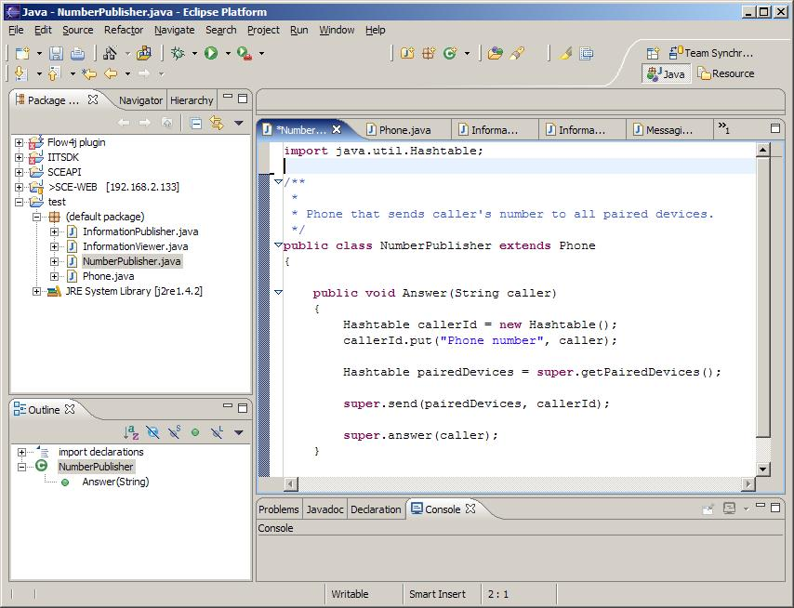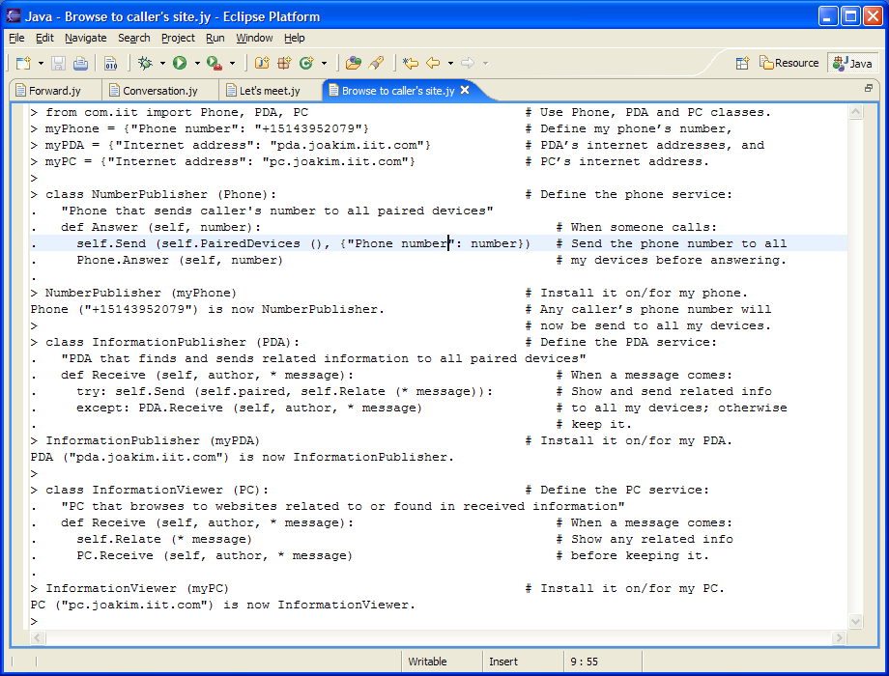
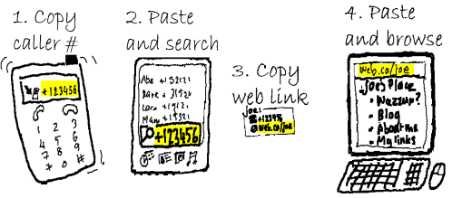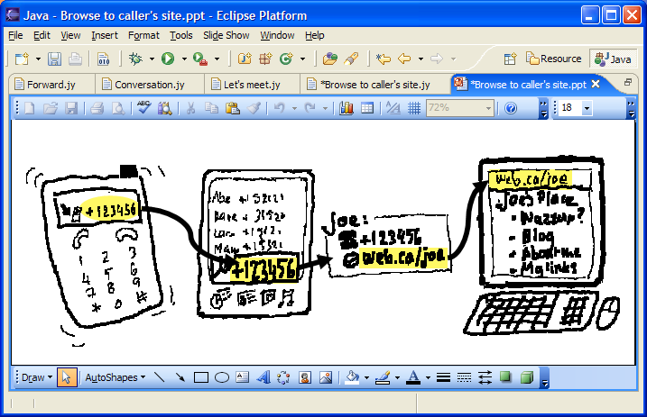
Figure 1 . Example work environments, clockwise from top left: Programmer, operator, modeler and user. All show the same service being defined: Show caller’s card (on a PDA) and website (on a PC) while answering a phone call.

The appearance of the programming interface may be different depending on the mode of operation, something that is commonly handled in integrated development environments (IDEs) using pre-configured “perspective” views. It is essential that the grouping of functionality in each such view is done in a familiar and intuitively understood manner. For example, if the service involves telephony, it should preferably expose phone rather than switchboard objects to the person developing or managing the service. The reason is that most people are familiar with using phones to do common telephony operations while very few know how to operate switchboards to achieve the same:

Objects within the interface should map to common needs, using familiar words or symbolism with well-established interpretation, and should be arranged appropriately for a natural and desired flow-of-thought.

In my opinion, this translates into requirements to use intuition rather than cause disruption. This can be achieved using

- plain and simple language or symbolic which has
- well-established meaning in terms of
- familiarly used real-word objects that
- are easily interacted with to consolidate or correct the initial interpretation.

When related functionality is grouped into familiar objects using plain language, a design becomes much less dependent on the work environment it will be used in. The design will also inherently focus better on more common usage of the service. Both help to improve its relevance and quality. It is this grouping of logic into familiar objects that was the design goal for the service architecture described in the next chapter.

Overview
The service architecture presented here differentiates itself from most IT and telecom libraries by grouping the technology-dependent functionality from the underlying technology libraries into familiar objects with well-understood capabilities also for non-IT and telecom people such as students and vertical-market service creators. This is done in three steps:

- We first hide the infrastructure-dependence inside a large set of technology libraries (called IITSDK/IITLIB).
- The second step also hides the technology-dependence inside a small set of terminal classes: PC, PDA, Phone and Team (in IITAPI).
- The third step hides the terminal-dependence inside a small set of classes handling real-time information: Terminal, Observer, Controller and Logger (also in IITAPI).

The next section gives an overview of the basic functionality in our pre-configured technology libraries (step 1). Subsequent sections detail our extendable services for terminals (step 2) and real-time information (step 3), respectively. Other sections describe our interactive environment, a set of proof-of-concept code examples and a summary of the result obtained. The last section contains a discussion with some important conclusions drawn from the work.

The complete service architecture is illustrated in Figure 2 below. Our terminal and vertical-market libraries are implemented in Python on top of IITSDK, IITLIB and Parlay X (the latter two under construction). They are designed as useful interactive services that are easy to extend in both Python and Java.

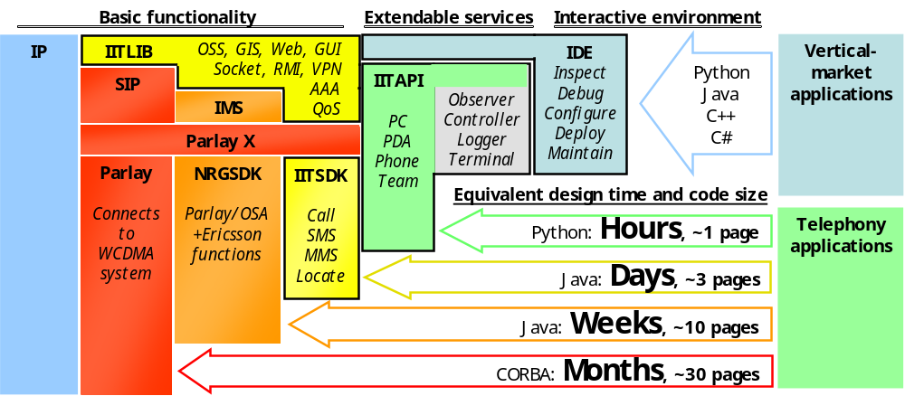
Figure 2 . Service architecture at IIT-R. The basic functionality is grouped into a set of extendable and more user-oriented services within the IITAPI library.

The simple and generalized application programming interfaces (APIs) for our libraries reduce the code size for typical services dramatically – easily a factor of 10-100 shorter at the terminal or vertical-market levels compared to coding on top the underlying protocols (see estimated design time and code size at the bottom of Figure 2 above). This is primarily because our extendable services usually only need to be combined and extended slightly to build new and powerful services, but it is also very much because our technology libraries has been pre-configured so that no implementation details need to be coded into the service to get it up and running on our infrastructure.

Technology libraries
The basic functionality in our technology libraries have simplified APIs where most parameters have useful default values that normally don’t need to be dealt with. The resulting code size reduction (Figure 3) is a factor 3-10 compared to programming for the NRGSDK – mainly due the pre-defined default values inside the IITSDK library – and 10-30 compared to programming directly on top of the Parlay gateway or IP libraries, i.e. CORBA in this case. The latter is because such primitive code would, in addition to default values now hidden in the IITSDK library, also need to include configuration and implementation parameters as well as event handling now coded into the NRGSDK library.

The NRGSDK API was used by student pairs during the autumn 2004 to implement basic telephony and location-based services in approximately 8 weeks, i.e., 16 man-weeks. During this spring, a similar set of students will now for the first time use IITSDK to speed up their work. They are expected to achieve between 2-4 times more functionality as well as significantly higher level services.

SMSController.sendSMS
(
“5148427909”,
“4186578097”,
“Hello World”
);
Using IITSDK
TpHosaUIMessageDeliveryType deliveryType = TpHosaUIMessageDeliveryType.P_HUI_SMS;
// Create a dummy delivery time (send immediately)
TpHosaDeliveryTime deliveryTime = new TpHosaDeliveryTime();
deliveryTime.Dummy((short) 0);
TpAddress originatingAddress = Utilities.createE164Address(srcPhoneNumber);
TpAddress[] dstAddresses = new TpAddress[dstPhoneNumbers.length];
for (int i=0 ; i < dstPhoneNumbers.length ; i++){
dstAddresses[i] =
Utilities.createE164Address(dstPhoneNumbers[i]);
}

TpHosaTerminatingAddressList recipients = new TpHosaTerminatingAddressList();
recipients.ToAddressList = dstAddresses;
TpHosaMessage message = new TpHosaMessage();
message.Text(SMSContent);

// Send message and return the assignmentID
return this.itsUIManager.hosaSendMessageReq(
this.itsAppHosaUIManagerImplementation, // callback
originatingAddress,
recipients,
null, // subject (ignored for SMS)
message,
deliveryType,
this.itsFramework.getConfiguration().getBillingInformation(),
P_UI_RESPONSE_REQUIRED.value,
false, // deliveryNotificationRequested
deliveryTime,
"" // validityTime (not applicable)
);
Using NRGSDK
Figure 3. Code examples for sending an SMS using the NRGSDK and IITSDK, respectively. Notice the large reduction in code size due to the usage of default values and a simpler API in IITSDK.

All our technology libraries, IITSDK (finished 2004) and IITLIB (under construction), are implemented in Java. They are built on top of NRGSDK (an Ericsson library which connects to our WCDMA system through a Parlay gateway) and IP/SIP/IMS libraries (connecting also to our CDMA-2000, wireless mesh and fibre-optic infrastructure).

IITLIB
Parlay

Connects to WCDMA system

NRGSDK

Parlay/OSA
+ Ericsson functions

IITSDK

Call
SMS
MMS
Locate

IMS
IP
Parlay X
SIP
More user-oriented
OSS, GIS, Web, GUI
Socket, RMI, VPN
AAA
QoS

More general
Figure 4. Technology libraries at IIT-R. In the diagram, the libraries are arranged by how user-oriented and general (platform-independent) they are.

In the software architecture illustration in Figure 4, blue (IP) represent software for accessing and configuring the network infrastructure. Such software is usually supplied by different equipment manufacturers and managed by our lab technicians. Red and orange groups (Parlay+NRGSDK, Parlay X, and SIP+IMS) represent software for accessing real-time services on the network. These are usually supplied by consortium members and also managed by our technicians. Yellow groups (IITSDK and IITLIB, the latter under construction) represent software developed or integrated by researchers at IIT-R.

Since each technology in the IITSDK/IITLIB libraries has a unique API to access its functionality, this software layer is oriented towards experienced programmers with knowledge about both the technologies and what can be done with it. One could say that our technology libraries are like a switchboard with many difficult components, and handling the complete switchboard takes a lot of training. The next section focuses on more intuitive APIs that make it much easier, compact and fast to program multi-technology services.

Terminal services
All terminal classes in IITAPI have similar and familiar functionality using a simple and non-technical language that is intuitively understood by everyone because they describe everyday physical objects and everyday operations on them. They can all send and receive messages, some handle voice and video, and they handle information very differently. The current set of methods are listed below.

PC: Handles messaging and browsing on a PC using its internet address. Can Send and Receive messages. Can Add, Remove and Relate to information.
PDA: Handles messaging and information management on a PDA through an internet address. Can Send and Receive messages. Can Add, Remove and Relate to information.
Phone: Handles voice, video, messages, positioning and multimedia sessions for a phone number. Can Send and Receive messages. Can Answer, Call, Talk, Hangup and Leave voice/video conversations. Can Map user locations.
Team: Supplies user locations, meeting arrangements, group conversations and maps through a common phone number. Extends the Phone functionality using special keys in messages or conversations.

PC and PDA services can run on any device that has an IP address, while the telephony services presently require a connection to at least one of the following communication ports:

IIT: Connects to the NRG gateway in the IIT network. MMS-sending, two-part voice/video conversations, email and IP are supported.
SIMULATOR: Connects to an NRG simulator on the PC. SMS, MMS, multi-part voice and locations are supported.
The extendable services above are more user-oriented and much easier to use than the underlying technology libraries described in the previous section. The combined effect is a significant improvement in code size and readability, particularly when coding and testing using the easy-to-read Python language (see example in Figure 5 below).
TpHosaUIMessageDeliveryType deliveryType = TpHosaUIMessageDeliveryType.P_HUI_SMS;
// Create a dummy delivery time (send immediately)
TpHosaDeliveryTime deliveryTime = new TpHosaDeliveryTime();
deliveryTime.Dummy((short) 0);
TpAddress originatingAddress = Utilities.createE164Address(srcPhoneNumber);
TpAddress[] dstAddresses = new TpAddress[dstPhoneNumbers.length];
for (int i=0 ; i < dstPhoneNumbers.length ; i++){
dstAddresses[i] =
Utilities.createE164Address(dstPhoneNumbers[i]);
}

TpHosaTerminatingAddressList recipients = new TpHosaTerminatingAddressList();
recipients.ToAddressList = dstAddresses;
TpHosaMessage message = new TpHosaMessage();
message.Text(SMSContent);

// Send message and return the assignmentID
return this.itsUIManager.hosaSendMessageReq(
this.itsAppHosaUIManagerImplementation, // callback
originatingAddress,
recipients,
null, // subject (ignored for SMS)
message,
deliveryType,
this.itsFramework.getConfiguration().getBillingInformation(),
P_UI_RESPONSE_REQUIRED.value,
false, // deliveryNotificationRequested
deliveryTime,
"" // validityTime (not applicable)
);

SMSController.sendSMS
(
"5148427909",
"4186578097",
"Hi!"
);
Using NRGSDK

teddy.Send (freddy, "Hi!")
Using IITSDK
Using IITAPI
Figure 5. Code examples for sending an SMS using the NRGSDK, IITSDK and IITSDK libraries, respectively. Notice the less technical language in IITAPI.

During the autumn 2005, new associated students will be able to use the IITAPI libraries and a Python or Java interpreter to quickly experiment with and prototype vertical-market services. It will be interesting to compare the result obtained when using these extendable services compared to the more technology-oriented IITSDK and NRGSDK libraries. They are expected to achieve between 10-30 times more functionality and a factor 3-10 more services in the same time, and also use a significantly broader and more advanced combination of technologies due to the usage of standardized and more intuitively understood multi-technology services with much simpler API.

As an example of the internal workings of one of these extendable services, the Team functionality is described below. It was chosen because it is based purely on services defined within the IITAPI library.

The Team service example
Function: Call, message and map generation for a dynamic set of users using push-to-talk and messaging through a single team phone-number

User activities:
- Toggle/multicast some (push/type “1..7”)
- Toggle/broadcast all (push/type “8”)
- Here I am! (push “9” while talking/type “*”)
- Where are we? (push “9” while muted/type nothing)

Example user activity: Toggle some:
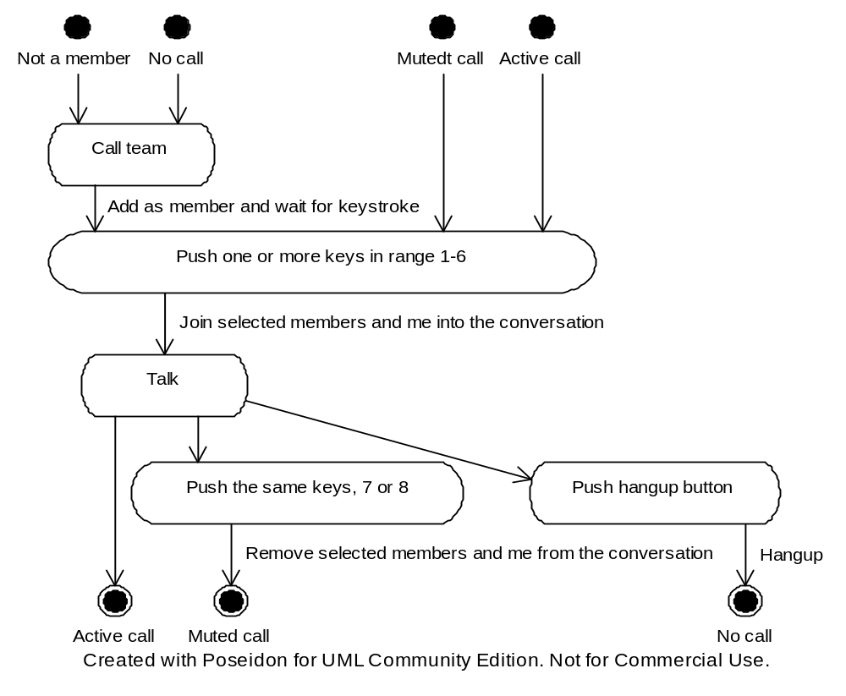

Class diagram:
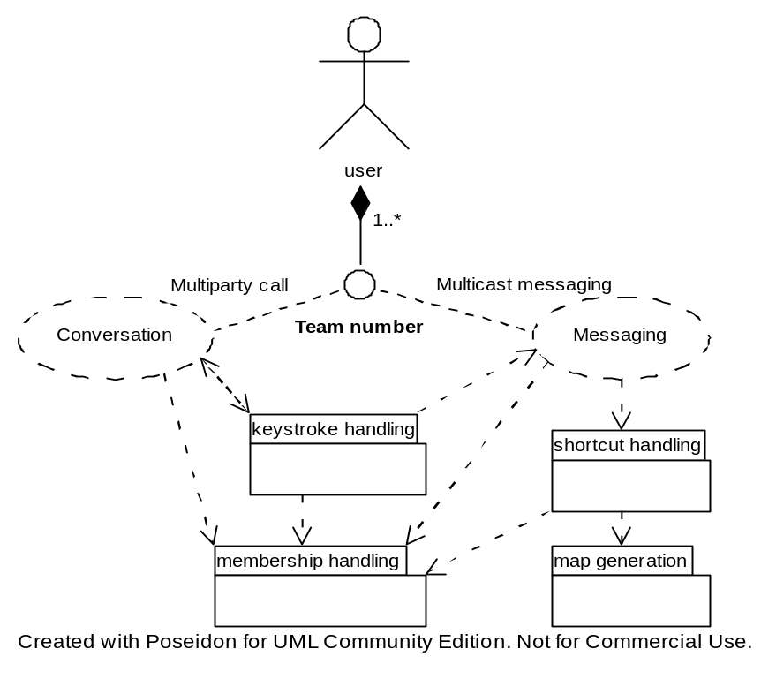

User state diagram:
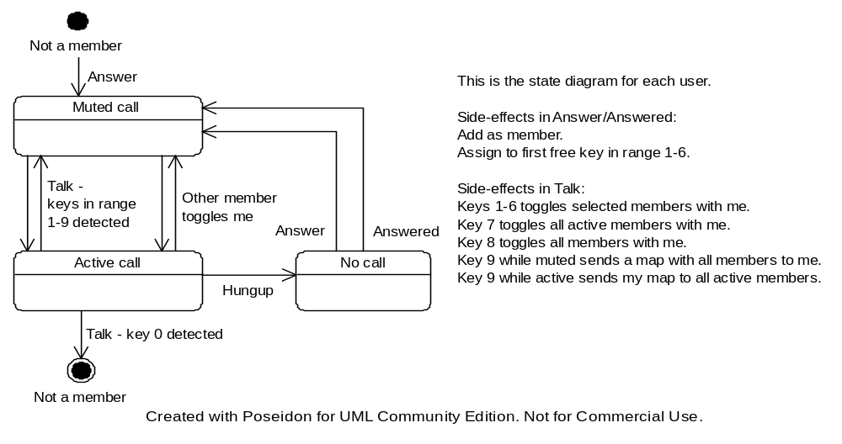
Python implementation:
The service is a phone that also organizes a dynamic set of phone numbers:
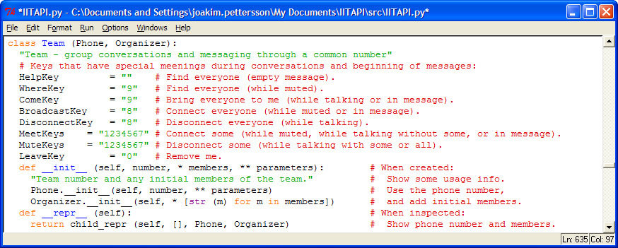
Numbers are added when answering and removed after hung-up:
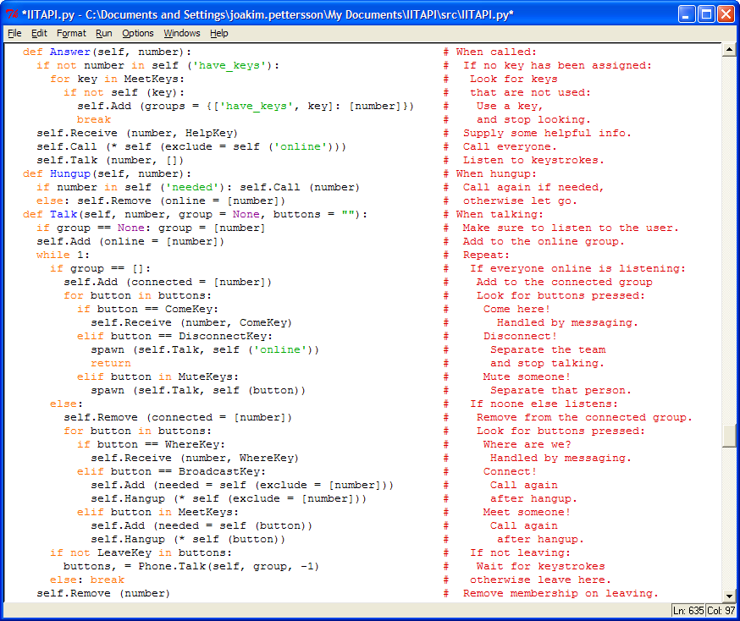
Keys are listened to while talking:
Numbers are added when receiving; beginnings of messages are interpreted:
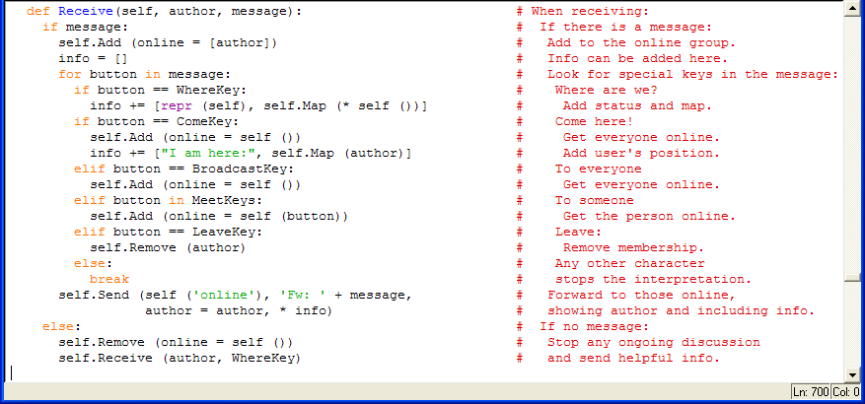

Information services
The remaining classes in IITAPI are under construction. They are built on top of one or more of the terminal classes described in the previous section. The services they implement are oriented towards distributed real-time information, with requirements assembled mainly from telehealth (c.f., Figure 6 below). A significant aim has been to improve mobility for patients, doctors and nurses through ad-hoc connectivity. It does so by using Bluetooth connectivity near patients, WLAN networks when available with sufficient performance and 3G when necessary to fulfill data latency requirements.
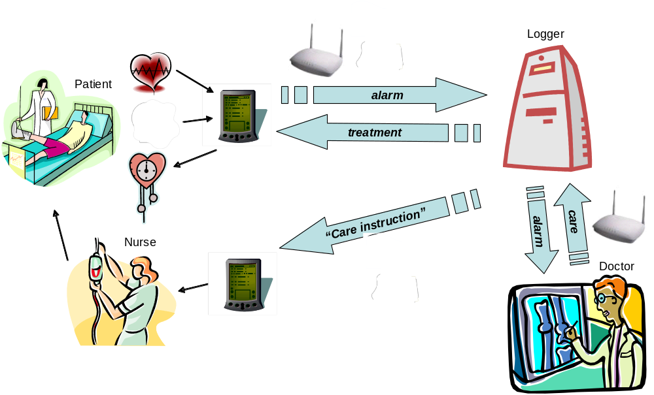
Figure 6. Example distributed service on top of the extendable services in IITAPI.

Another aim with the information services is to handle different sensors, actuators and terminals and associated network topologies more easily and intuitively for non-technicians. For example, services automatically distribute themselves into proxy-server relationships when running between devices, and the language used to configure such relations is taken from common desktop environments (copy, move or create shortcut) rather than the IT community (clone, migrate and publish, respectively).

The functionality of each service is specific to the local needs to reduce traffic between devices as far as possible. The Observer and Controller services automatically connect to local Sensor or Actuator services, respectively. The Terminal handles local needs of a specific person or professional role through his/her/their set of terminals, automatically distributing information to the most appropriate device depending on the type of information. The Logger handles time-stamping of information produced by any of the services, and automatically distributes updated information to all services that has retrieved data. All these very different services have something in common though: They can all add, remove, start, stop, receive and distribute information as well as related services. The basic functionality and methods are listed below:

Observer (normally in a PDA or Phone):
Reports changes in real-time information. Can add and remove sensors and loggers. Can start and stop sensors. Can receive sensor data and alarms and distribute the information timely using associated latency requirements. Observers have at least one Sensor (normally in a Bluetooth device) which supplies real-time information and can send, start and stop data.
Logger (typically in a PC):
Supplies a live history of real-time information. Can add and remove observers, controllers and terminals. Can log and retrieve data.
Controller (normally in the same PDA or Phone as an observer):
Reports changes in real-time control. Can add and remove loggers and actuators. Can start and stop control. Controllers have at least one Actuator which supplies real-time control and can start and stop control.
Terminal (distributed onto an arbitrary set of Phones, PDAs and PCs):
Supplies user-adapted information and control. Can send and receive messages. Can relate to information.

Interactive environment
The extendable services has very limited but familiar set of methods with intuitively understood default behavior. This makes them very easy to extend, validate and experiment with using interpreters or progressive compilers for any favorite language within an interactive and integrated design environment. At IIT-R, we have used Python’s IDLE (see Figure 7 below), IBM’s Eclipse/WebSphere and Sun’s NetBeans environment. Our favorite is currently IDLE within Eclipse, because of IDLE’s excellent interactivity and Python support, the good CVS and Java perspectives in Eclipse, and because both environments are maintained as open-source projects.
All the extendable services as well any other Python or Java library can easily be experimented with in real-time using the lab infrastructure, our network simulators or a combination of both. For example, the first line entered in Figure 7 creates a basic phone and PDA service, where the phone is partly deployed on the real lab infrastructure (voice and MMS) and partly on a simulator (locating and SMS). The blue text is generated by these two objects for immediate feedback and verification of the result. The second line entered sends a message with a map from the phone to the PDA. The interpreter is immediately ready for more test input, source code editing or debugging, within the same or another session.
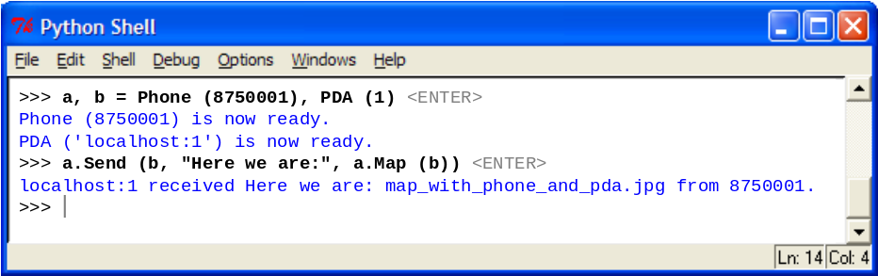
Figure 7 . Interactive session in Python.
Life-cycle management of services is also easy using Python. In the section below, we will illustrate a work-flow for implementation, test, deployment, upgrading and withdrawal of a new telephony service interactively.

Service life-cycle example
This example illustrate a work-flow for services using a Python interpreter. It will define, test, update and withdraw a service, step by step. We start by showing how to deploy two instances of a normal telephone service; one running entirely on a simulator and one using real equipment:

>>> from IITAPI import Phone
>>> s, r = [Phone (n) for n in [111, '8770001']]
Phone (111) is now ready using SIMULATOR.
Phone ('8770001') is now ready using IIT and SIMULATOR.

The first phone, s, uses a Parlay gateway simulator because it was initialized with a phone number that doesn’t work for real phones. The second phone, r, has real voice and MMS functionality through our Ericsson Parlay gateway, while SMS and location services (not yet supported by our infrastructure) still use the simulator. This automatic behavior can easily be overridden by defining explicitly which port each functionality should use. The phones are now ready to be used with the normal behavior for voice, video and messaging, i.e., incoming and outgoing calls and messages are routed to their destination without changes. A user would not notice that the service is running except for a small delay associated with the Parlay gateway.

We will creating a simple call barring service, and the Phone service above is all we need. First step is to define a usage text for the service, intended for end users of the service. Prizing need to be specified also to allow automatic billing.

>>> class Bar (Phone):
... """Call barring (20 cent/call):
... Call yourself and enter a four-digit code to enable barring
... for all incoming calls, or hang-up to disable barring."""
...
>>> Bar (s)
Phone (111) is now extended to Bar (111) with Call barring stopped.
>>> s.Send (s) # This is how to get information about the service.
Bar (111) received """Usage (Re: <empty message>)
Phone 111:
Calling (10 cent/call and minute):
0 calls 0.00 $
0:00 minutes 0.00 $
Messaging (10 cent/message):
1 messages 0.10 $
0.001 MB 0.00 $
Call barring (20 cent/call):
Call yourself and enter a four-digit code to start barring
for all incoming calls, or hang-up to stop barring.
Balance: -0.10 $
Remaining: 9.90 $ before automatic billing
Please deposit: 0.10 $ or more to preserve all services""" from Bar (111).

We upgraded the simulated phone s to the new but incomplete “barring service”. It will get upgraded automatically while we improve the service. Let’s do the implementation: We first check if the user calls, because then we just want to store the code and hang-up. If someone else calls, we ask for a four-digit code (using Talk with parameter -4) and then answer or hang-up depending on the result.

>>> class Bar (Bar): # Add barring logic:
... def Answer(self, caller): # When someone calls:
... if caller == self: # If it’s the owner:
... del self.bar # Disable barring
... self.bar = self.Talk (-4) # and get new key.
... elif self.bar: # Otherwise if there is a key,
... self.Bill (Bar) # get paid for using it.
... if self.Talk (-4) == self.bar: # If it matches:
... self.Leave () # Let the call through,
... return # and exit.
... self.Hangup () # End the call.
...
Bar (111) is now upgraded.
>>>

Let’s try it:

>>> s.Call (s) << "1234" # This should set the key to 1234.
Bar (111) answers 111.
Bar (111) hears "1234".
Bar (111) hangs up.
>>> p = Phone (222)
Phone (222) is now ready using SIMULATOR.
>>> p.Call (s) << "4321" # This should not be accepted.
Bar (111) answers 222.
Bar (111) hears "4321".
Bar (111) hangs up.
>>> p.Call (s) << "1234" # This should be accepted.
Bar (111) answers 222.
Bar (111) hears "1234".
Bar (111) leaves.
>>>

It seems to work fine – the last test should end up in a conversation between p and s. How much could we bill s for that?

>>> print s
Phone number 111:
Calling 1 calls 0.10 $ ENABLED
0:01 minutes 0.01 $
Messaging 1 messages 0.10 $ ENABLED
0.001 MB 0.00 $
Call barring 2 calls 0.40 $ ENABLED
Account balance: -0.23 $
Remaining before billing: 9.77 $
>>>

Looks useful, but is the prize motivated? Let’s add some more value – a forwarding service with cheap flat rate, but available only in combination with barring. We will include messaging and voice messaging to help make it interesting. Here is an add-on service for this:

>>> class Buzy (Bar): # Add forwarding logic:
... """Forwarding (10 cent/day, uses call barring):
... Send yourself a forwarding number to start forwarding of all incoming
... calls and messages, or a text message to be returned or read as a voice
... recording. An empty message stops forwarding. Call yourself to listen
... to or change a recording."""
... def Receive(self, author, message = None)# When a message arrives:
... if author == self: # If it’s the owner:
... self.buzy = message # Use it as enabler.
... if self.buzy and not self.bar: # If enabled and not barring:
... self.Answer (self) << "0000" # Use a default barring code.
... if len (message.split ()) > 1: # If it’s more than one word:
... self.message = message # Use it as return message.
... try: # This may work:
... self.Send (self.buzy, # Inform forwarding number.
... "Please handle also %s’s barred calls and messages." % self)
... Bar.Receive (self, # Inform owner.
... "Barred calls and messages are now forwarded to %s." % self.buzy)
... except:
... Bar.Receive (self, # Inform owner.
... "Barred calls and messages now return "%s". % self.message)
... elif self.buzy: # Otherwise if enabled,
... try: # This may work:
... self.Send (self.buzy, # Send to forwarding number,
... self + ':', message, # put destination in message
... author = author) # use original author.
... except: # If it didn’t work:
... self.Send (author, self.buzy) # Return forward message.
... else: # Otherwise
... Bar.Receive (self, author, message) # handover to parent.
... def Hangup(self, caller): # When barring gives up:
... if caller == self: # If it’s the owner:
... self.message = self.Talk (Recorder) # Edit the recording.
... elif self.forward: # Otherwise if enabled:
... try: # Try this:
... self.Call (self.forward) # Call the forwarding number,
... self.Leave () # leave and
... return # exit.
... except: # It can fail:
... self.Talk (self.message) # Then play the recording.
... Bar.Hangup (self) # Handover to parent.
...
>>>

The example shows a few typical programming patterns in Python – see the getting started section at www.python.org for details. Let’s apply and test this service:

>>> Forward (s)
Bar (111) is now extended to Forward (111) with Forwarding stopped.
>>> p.Send (s, "Hello!")
Forward (111) received "Hello!" from 222.
>>> a = Phone (333); s.Send (s, a); s
Forward (111) with Forwarding started.
>>> p.Send (s, "Hello again!")
Phone (333) is now ready using SIMULATOR.
Phone (333) received "Please handle also 111’s calls and messages." from 111.
Phone (111) received "Calls and messages are now forwarded to 333." from 111.
Phone (333) received "111: Hello again!" from 222.
>>> p.Call (s) << "4321"
Forward (111) hears "4321".
Forward (111) calls 333.
Forward (111) leaves.
Phone (333) answers 222.
>>> print s
Phone number 111:
Calling 1 calls 0.10 $ ENABLED
0:01 minutes 0.01 $
Messaging 2 messages 0.20 $ ENABLED
0.002 MB 0.00 $
Call barring 3 calls 0.60 $ ENABLED
Call forwarding 1 days 0.10 $ ENABLED
Account balance: -1.01 $
Remaining before billing: 8.99 $
>>>

Looks better, but say we got some feedback on this saying people get frustrated by a cost for barring when they only need forwarding. Instead of withdrawing the complete package (losing credibility) and later re-introducing part of it again (raising questions), we will keep the forwarding service and just remove the barring part from it. To do that, we move logic from Hangup to Answer and remove automatic activation of call barring.

>>> shelve (Bar, Buzy)
>>> edit (Buzy)

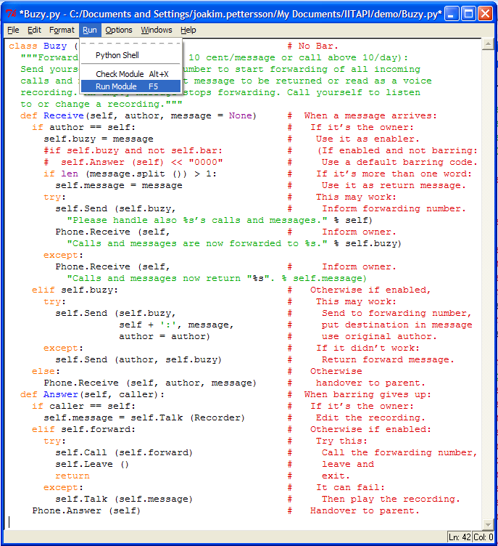

>>>
Buzy (111) is now no Bar - Call barring removed.
>>> p.Call (s) # No barring key needed any more.
Forward (111) calls 333.
Forward (111) leaves.
Phone (333) answers 222.
>>>

The example has illustrated prototyping, implementation, deployment, live upgrade as well as withdrawal of services. Functionality included voice and multimedia messaging with billing and was defined in less than a page. The next section gives more small code examples illustrating the small effort needed to define services using the IITAPI library.

Example services
This section contains proof-of-concept code examples in Python which creates and deploys a number of useful services using the extendable services in the IITAPI library. They could have been implemented in Java also, but the code would have been a factor 3-10 larger due to its requirement to declare all variables, implement all method variants and hide all multiple inheritances. Performance differences would hardly be noticed due to comparably low invocation rate when designing at this high level.

Most of these example services require only a single line of code because they use already defined functionality (first two examples). Typically, more innovative and therefore not pre-predefined services still fit on a single page because only the innovative part need to be coded (all remaining examples). Distributed services, i.e., services that require logic running in parallel on remote terminals, are still under construction. These are marked with a star (*) in the listing.
Team talk (Starts push-to-talk.)
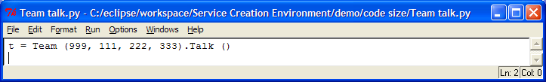
Let’s meet! (Distributes a map.)
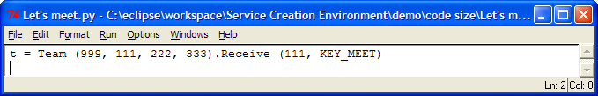
Here you are! (Sends a map.)
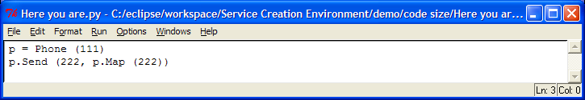
Instruct nurse when an alarm is detected in a patient’s sensor*
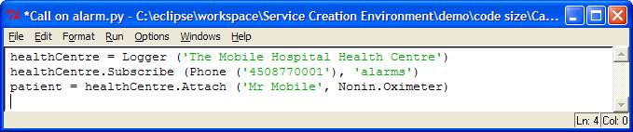
Query service (‘Where am I?’ → map.)
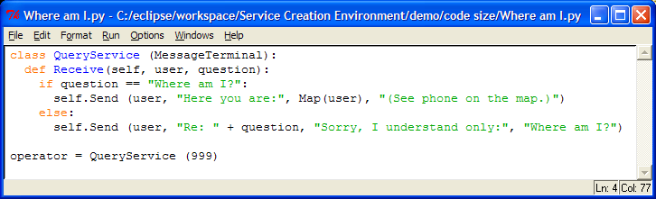
Call and message barring including forwarding
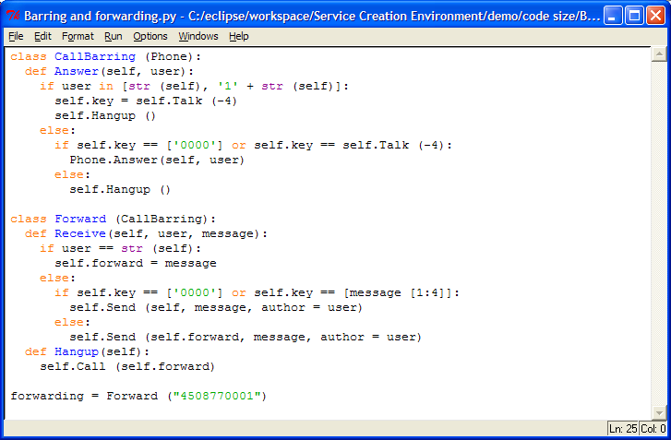
Show caller’s info on my PDA and PCs*
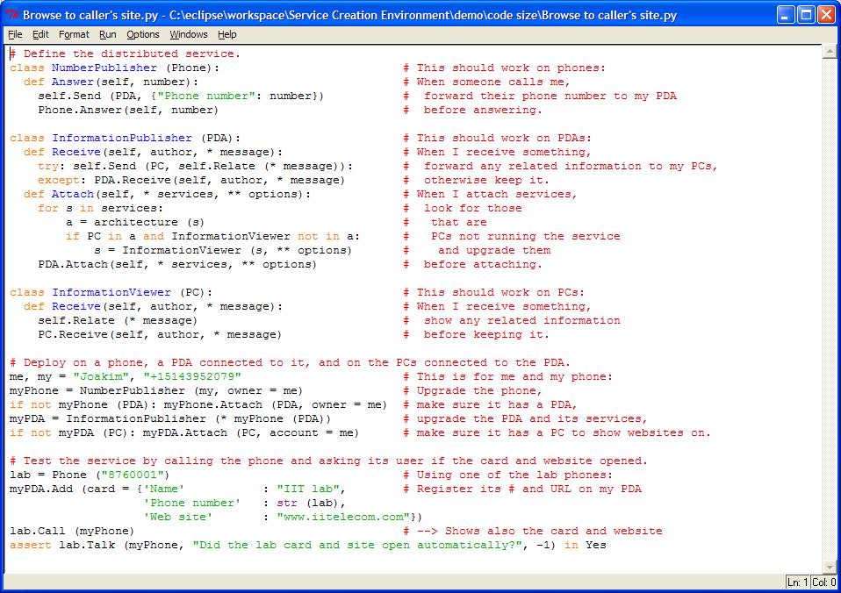

Result
- Code size reduced from several pages to a few lines:

Application | Coding
Team talk (Starts push-to-talk.) | 1 line
Let’s meet! (Distributes a map.) | 1 line
Here you are! (Sends a map.) | 2 lines
Instruct nurse when an alarm is detected in a patient’s sensor | 3* lines
Query service (‘Where am I?’ à map.) | 7 lines
Show caller’s info on my PDA and PC | 16* lines
Call and message barring including forwarding | 23 lines

- Design time potentially reduced from months to hours (estimated from code size reduction).
- Service down-town potentially reduced from hours to seconds/eliminated.
- Demands reduced from master of multiple technologies to understanding of object-oriented programming/scripting.
- Tools cost and size reduced from very high/GB to free/MB.
- Complexity creating distributed services reduced from very difficult to very easy (under construction).
- Complexity generating usage information and billing reduced from difficult to very easy (under construction).
- Time and effort for test and validation of services reduced from weeks to minutes.

Conclusions
- Basic functionality in network-oriented APIs
- New: Packaged with pre-configured parameters suitable for IIT.
- Extendable services in user-oriented APIs
- New: API that does not require user to be a technology freak.
- New: Platform-dependency handled through different implementations (PC, PDA, Phone, Team and [virtual] Terminal) with the same simple API (Send, Talk etc).
- New: Automatic distribution of services (Pyro in Python/Cajo in Java)
- New: Bandwidth and latency reduced through localized information services (Observer, Controller, Logger and Terminal).
- New: Automatic distribution of information to most suitable and accessible platform (Observer, Controller, Logger and Terminal).
- New: Automatic maintenance of information (Logger).
- Interactive environment with Python interpreter
- New: Automatic maintenance of services (requires Python).

- Very short design time: hours rather than months!
- Higher level and more productive services
- Improved feedback and creativity

Recommendations
- Finish automated distribution of service logic (using Pyro RMI).
- Implement automatic billing logic.
- Verify/correct the maintenance scenario.
- Publish Java, Python and doc on SourceForge.
- Install Pyro server on HP iPAQ.
- Implement proxies using Bluetooth sockets (Windows) or Java API (Linux).
- Finish patient monitoring demo.
- Publish journal article(s) about rapid 3G-4G service creation, test and maintenance.

Joakim Pettersson, “3G/IP services & tools” (PowerPoint presentation).
“What is Jython?” (http://www.jython.org/docs/whatis.html).
See for example “Project: Jython: Summary” at SourceForge (http://sourceforge.net/projects/jython/).
In Figure 1, all work environments use the same objects and operations on them to define the service – a phone that answers a call and sends a phone number, a PDA that receives the number and sends information relating to it, and a pc that receives the information and shows it.
This is an implicit behavior for all services in IITAPI. It works through a so called meta-class in the Phone service which automatically upgrades all instances, child classes as well as their instances.

