A Living Foresight Graph
Knowledge-graph technology roadmapping for the RISE Computer Science department
Strategy & build plan — from Ericsson-style “stepping-stone” journeys to a queryable, self-hosted graph that stays alive.

Prepared for Joakim · RISE Research Institutes of Sweden (Digital Systems)
Date 20 July 2026 · Working document v0.1 — a plan to build from, not a finished spec.

Contents
1 Executive summary 3
2 Why a graph, not a slide 3
3 The conceptual model (ontology) 4
4 Keeping it alive: method & cadence 7
5 Architecture & tooling (open-source, self-hosted) 8
6 Governance & operating model 11
7 Rollout: pilot first, then scale 11
8 Success metrics 13
9 Risks & mitigations 13
10 Recommended next steps 13
Appendix A Questions the live graph can answer 14
Appendix B Tools & references 14
Appendix C Sources consulted 14

1 Executive summary
You want to do for RISE Computer Science what Ericsson’s “technology journeys” do for connectivity: place stepping stones on a timeline that converge on a small number of north-star goals — but make it a living knowledge graph that anyone in the department can open, explore and help evolve, rather than a slide that is out of date the moment it is exported.
The central design idea in this plan is to separate two layers and then connect them. The foresight layer is what a roadmap slide already shows — destinations, journeys and stepping stones over Now / Next / Beyond horizons. The reality layer is everything at RISE that the roadmap is really about: projects, competences, people, publications, partners, funding calls and testbeds. A slide can draw the first layer but cannot hold the second. A graph can hold both and link them — and that link is what makes the roadmap alive: it can answer questions, surface gaps, and update itself as the underlying reality changes.
Concretely, the recommendation is to run a pilot on Wikibase (the open-source engine behind Wikidata) as the self-hosted graph store, because it gives non-developers wiki-style editing, built-in provenance and a SPARQL query endpoint with the least custom code; add a lightweight Cytoscape.js front-end for the interactive explorer and the curated “roadmap view”; keep a property-graph option (Neo4j / Memgraph) open for heavier analytics later. Prove it on one topic first, then scale across the department over roughly 18 months.

How this plan meets your four stated requirements
Your requirement | How the plan delivers it
Open-source / self-hostable | Wikibase, Cytoscape.js, Neo4j Community / Memgraph and RDF stores are all open-source and run on RISE infrastructure. Data and IP never leave your control.
Internal graph + curated public views | One internal graph is the source of truth; an explicit “publish” step and sensitivity flags generate read-only public roadmap views — nothing is public until a steward marks it so.
Pilot first, then scale | A four-phase rollout: frame & pilot one topic, harden & prove, scale to 3–5 topics, then institutionalise with a steward role and KPIs.
“Alive”, and open to everyone at RISE | Wiki-style low-friction editing, automated feeds from project/publication systems, living gap and expert queries, and multiple auto-generated views — accessed through the RISE single sign-on.
Table 1 · The plan mapped to your requirements.

2 Why a graph, not a slide
Ericsson’s “Technology journeys” get three things right, and this plan keeps all of them. First, a few memorable destinations (“limitless connectivity”, “the Internet of Senses”) give direction without over-specifying it. Second, each destination is reached by a journey of stepping stones — capability milestones, not products — laid out left-to-right from near-term to long-term. Third, some stones cross between journeys, because a shared enabler (semantic interoperability, say) unlocks more than one destination. That crossing is exactly where a graph beats a drawing.
The problem with the slide is not the picture — it is that the picture is the only artefact. The reasoning behind each stone, the evidence that RISE is actually moving on it, who owns it, which project funds it and what it depends on all live in people’s heads or in scattered documents. So the roadmap ages badly, cannot be queried, and is expensive to redraw. The fix is to store the roadmap as data and treat the slide as one generated view of that data.

2.1 The core reframe: a foresight layer over a reality layer
Model the roadmap as a knowledge graph with two connected layers. The foresight layer is the roadmap you present. The reality layer is the RISE assets the roadmap depends on. Bridging edges connect them — and those bridges are the part a PowerPoint can never carry.
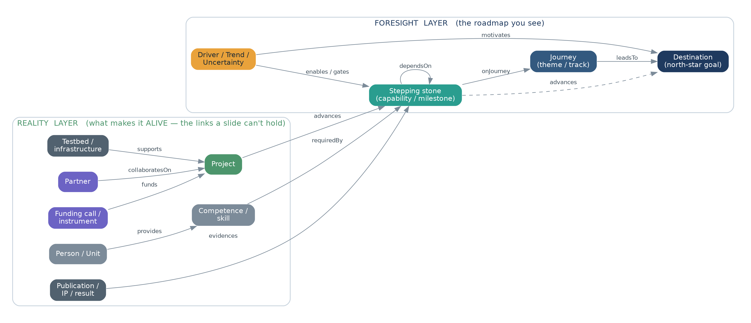
Figure 1 · The meta-model. A thin foresight layer (blue/teal/amber) sits over a reality layer of RISE assets (green/grey/violet); bridging relations make the roadmap queryable.

2.2 Questions a living graph answers that a slide cannot
Once the two layers are linked, the roadmap stops being a picture and becomes something you interrogate. For example:
- Capability gaps: “Which stepping stones have no active project behind them?” — i.e. where our ambition and our activity have drifted apart.
- Funding fit: “Which open Horizon Europe / Vinnova calls map to stones on our Next horizon, and who could lead a bid?”
- Key-person risk: “Which stones depend on a competence held by only one person or unit?”
- Readiness over time: “How has the TRL of this journey moved over the last year?”
- Partner exposure: “If partner X leaves, which journeys are weakened?”
None of these are answerable from a slide, because a slide has no idea what a project, a competence or a funding call is. The graph does — that is the whole point of the reality layer.

3 The conceptual model (ontology)
The ontology is the small, stable vocabulary of node and relationship types that everything else is built on. Keep it deliberately small at the start — a large ontology is the most common way these projects stall. The types below are enough to represent an Ericsson-style roadmap and connect it to RISE reality.

3.1 Node types
Node type | What it is | Layer
Destination | A north-star goal the department orients toward (e.g. “Trustworthy & verifiable AI”). Few of these — 3–6 total. | Foresight
Journey | A themed track of stepping stones converging on a destination. Optional grouping; a stone may serve more than one. | Foresight
Stepping stone | The core node: a capability or milestone to reach, with a time horizon and readiness. The “beads” on the roadmap. | Foresight
Driver / Trend / Uncertainty | External forces that motivate a destination or gate a stone: tech trends, societal drivers, regulation (e.g. the EU AI Act), weak signals. | Foresight
Project | A RISE or EU project that advances one or more stones — the evidence of real activity. | Reality
Competence / Skill | A capability the department has or needs; links people to stones. | Reality
Person / Unit | A researcher, group or department that provides competences and owns stones. | Reality
Publication / Result / IP | A proof point that a stone has been (partly) reached. | Reality
Partner | An external actor — company, university, agency — collaborating on a project or stone. | Reality
Funding call / instrument | A funding opportunity (Horizon Europe, Vinnova, KDT/Chips JU…) that funds projects and maps to stones. | Reality
Testbed / Infrastructure | A RISE testbed or facility (e.g. the ICE datacentre, a cyber range) that supports a project. | Reality
Table 2 · The node types. Start with these; add new types only when a real question needs one.

3.2 Attributes that make a stepping stone useful
Most of the roadmap’s intelligence lives as attributes on the stepping-stone node. These are what the views and the queries read.
Attribute | Purpose / values
Horizon | Now (0–2 yrs) · Next (2–5 yrs) · Beyond (5–10 yrs). Drives the left-to-right position in the roadmap view.
TRL | Technology Readiness Level 1–9 — a shared, fundable language for “how far along is this?”
Status | Aspiration · In progress · Achieved · Parked. Distinguishes ambition from activity.
Confidence | How sure are we this stone matters / arrives on this horizon? (High / Medium / Low, with a rationale + reference.)
Strategic priority | Core · Watch · Optional. Lets a view highlight the few that matter.
Owner | The Person/Unit accountable for keeping this node current.
Sensitivity | Public · Internal · Restricted. Governs whether a node can appear in a public view (see §6.4).
Table 3 · Stepping-stone attributes.

3.3 Relationship types
Relationships carry as much meaning as the nodes. Naming them precisely is what later lets a query distinguish “depends on” from “is evidenced by”.
Relationship | Meaning
Journey → Destination (leadsTo) | The journey converges on this north star.
Stepping stone → Journey (onJourney) | Places a stone on a track.
Stepping stone → Destination (advances) | A stone directly advances a destination (allows cross-journey stones).
Stepping stone → Stepping stone (dependsOn) | Prerequisite ordering — the backbone of the timeline.
Driver/Trend → Destination / stone (motivates / gates) | Why a destination matters; what must be true for a stone to arrive.
Project → Stepping stone (advances) | Real activity moving a stone forward.
Competence → Stepping stone (requiredBy) · Person → Competence (provides) | Connects people and skills to ambition.
Publication → Stepping stone (evidences) | Proof the stone is being reached.
Partner → Project (collaboratesOn) · Funding → Project (funds) · Testbed → Project (supports) | The ecosystem and resources around the work.
Table 4 · Relationship types.

3.4 A worked example
The same content that would be a single box on a slide becomes a small sub-graph. Below, one stepping stone — “Post-quantum crypto migration” — is shown with the reality that surrounds it: what it depends on, what gates it, the project and people advancing it, the partners, funding, testbed and results attached to it.
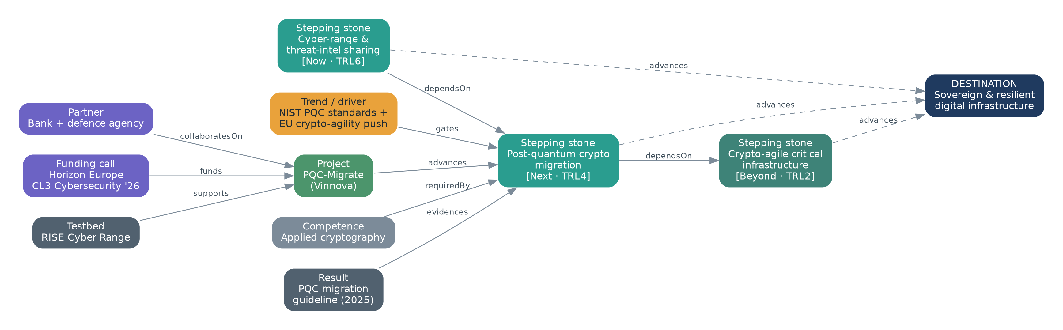
Figure 3 · A worked example sub-graph (illustrative content). Each grey/green/violet node is a link a slide cannot hold; together they let the graph answer “who, with what, funded how, how ready?”

3.5 Design principles for the ontology
- Reuse existing vocabularies. Align to EuroSciVoc / CORDIS for topics, schema.org and SKOS for basic structure, and the standard TRL scale — so the graph can later exchange data instead of being an island.
- Keep it minimal. Ship with the types above; add a type only when a concrete question demands it. Ontology sprawl kills contribution.
- Provenance on every claim. Every non-obvious statement (a horizon, a confidence, a dependency) should carry a source or an owner. This is native in Wikibase and is what keeps the graph trustworthy.
- Sensitivity is a first-class attribute. Because some content is internal, every node carries a sensitivity flag that governs public visibility (§6.4).

4 Keeping it alive: method & cadence
“Alive” is not a feature you install; it is a habit the tool makes easy. The method below borrows from established practice — Phaal, Farrukh & Probert’s technology roadmapping / T-Plan (the layered “why → what → how, over time” structure), horizon scanning from the technology-foresight community, and Technology Readiness Levels as the shared readiness language — and adapts them so the output is a graph that is maintained continuously rather than a report produced once.

4.1 How the graph gets populated
- Seed with a workshop. For the pilot topic, run one or two facilitated sessions (classic T-Plan format) to draft the destinations, journeys and first stepping stones. Capture directly into the graph, not into slides.
- Enrich from reality. Attach the projects, people, publications, partners and funding already in play — much of this can be imported rather than typed (see feeds below).
- Garden continuously. Anyone can add or refine a node any day, wiki-style. Small, frequent edits keep it current far better than an annual redraw.
- Review on a cadence. Quarterly foresight reviews re-check horizons and confidence; an annual re-baseline aligns the graph to the strategy and funding cycle.

4.2 Cadence
Activity | Frequency | Who
Open editing / gardening | Continuous | Anyone at RISE (curated by stewards)
Automated feed refresh | Weekly / nightly | Automated (project DB, CORDIS, DiVA, Git)
Foresight review per topic | Quarterly | Topic steward + domain experts
Cross-topic synthesis | Twice a year | Owner + stewards + department lead
Re-baseline vs strategy & funding | Annually | Owner + department management
Table 5 · An operating cadence that keeps the graph fresh without heavy ceremony.

4.3 The five things that make it “alive”
- It is linked to reality. Automated feeds pull projects, publications and funding calls in, so parts of the graph update themselves and the roadmap tracks what the department actually does.
- It answers live queries. Saved queries/dashboards (capability gaps, key-person risk, funding fit, TRL trend) turn the graph into a decision tool, not a display.
- It offers many views from one source. An executive swimlane, an expert detail view, a gap view and a public view are all generated from the same nodes — no parallel copies to keep in sync.
- Editing is low-friction and social. Web forms, change history, and gentle nudges (“this node hasn’t been touched in 6 months”) make contributing a two-minute act.
- Its vitality is measured. Freshness, edit counts and “% of stones with evidence” are tracked, so a graph starting to die is visible early (§8).

5 Architecture & tooling (open-source, self-hosted)
There are two mature, open-source patterns for the graph core, plus a lightweight starter. All can be self-hosted on RISE infrastructure so data and IP stay in-house.

5.1 The two viable patterns
- A — Semantic / Wikibase pattern. Wikibase is the software that runs Wikidata: collaborative web editing designed for non-developers, provenance and references built in, and a SPARQL endpoint. It is the shortest path to a maintainable, editable, publishable graph with almost no custom code. Best fit for “accessible to anyone” + “internal + curated public” + low-code editing.
- B — Property-graph / developer pattern. Neo4j Community or Memgraph store the same model as a labelled property graph and excel at analytics and path queries (Cypher). More powerful for heavy graph algorithms, but they need a custom editing UI and more developer effort.
- Lightweight starter (optional). A “graph-as-markdown” vault (Logseq / Foam) published as a static site (e.g. Quartz) can stand up a browsable pilot in days at near-zero cost — useful to build momentum, but it does not scale to real querying.

5.2 Recommendation
Build the pilot on Pattern A (Wikibase) as the source of truth, and add a Cytoscape.js front-end for the interactive explorer and the curated roadmap view. Wikibase gives you contribution-by-everyone and public views immediately; Cytoscape.js (MIT-licensed, actively maintained) renders the graph and the Ericsson-style swimlane in the browser. Keep Pattern B in reserve: because the model is explicit, you can export the graph into Neo4j/Memgraph later for heavy analytics without redoing the work. This staged choice minimises upfront build while leaving every door open.
Option | Editing by non-devs | Public views | Analytics power | Build effort
Wikibase (rec.) | Excellent | Native | Good (SPARQL) | Low
Neo4j / Memgraph | Needs custom UI | Needs build | Excellent (Cypher) | High
RDF store + Jena/GraphDB | Needs custom UI | Good | Good (SPARQL) | Medium–High
Logseq/Foam + Quartz | Good (markdown) | Static site | Limited | Very low
Table 6 · Open-source options for the graph core. Wikibase balances editability, public views and effort best for a pilot.

5.3 How it fits together
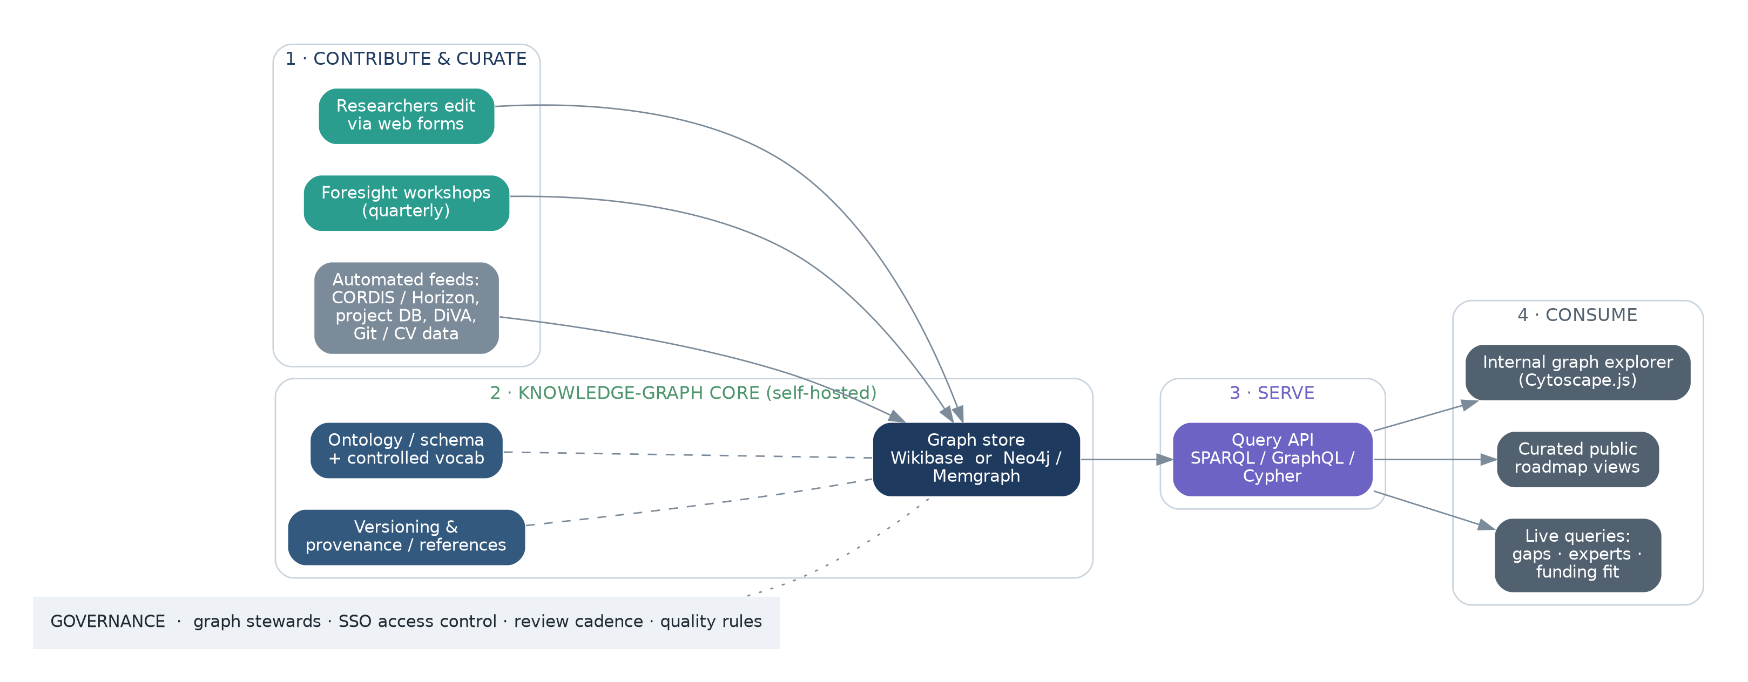
Figure 4 · Reference architecture. Contributions and automated feeds flow into a self-hosted graph core; a query API serves an internal explorer, curated public views and live dashboards; governance wraps the whole.

5.4 The curated view
The visual that looks most like Ericsson’s roadmap is just one rendering of the graph: filter to the chosen destinations, lay stepping stones out by horizon, and draw the journeys. Because it is generated, it never drifts from the underlying data — change a node and the view redraws.
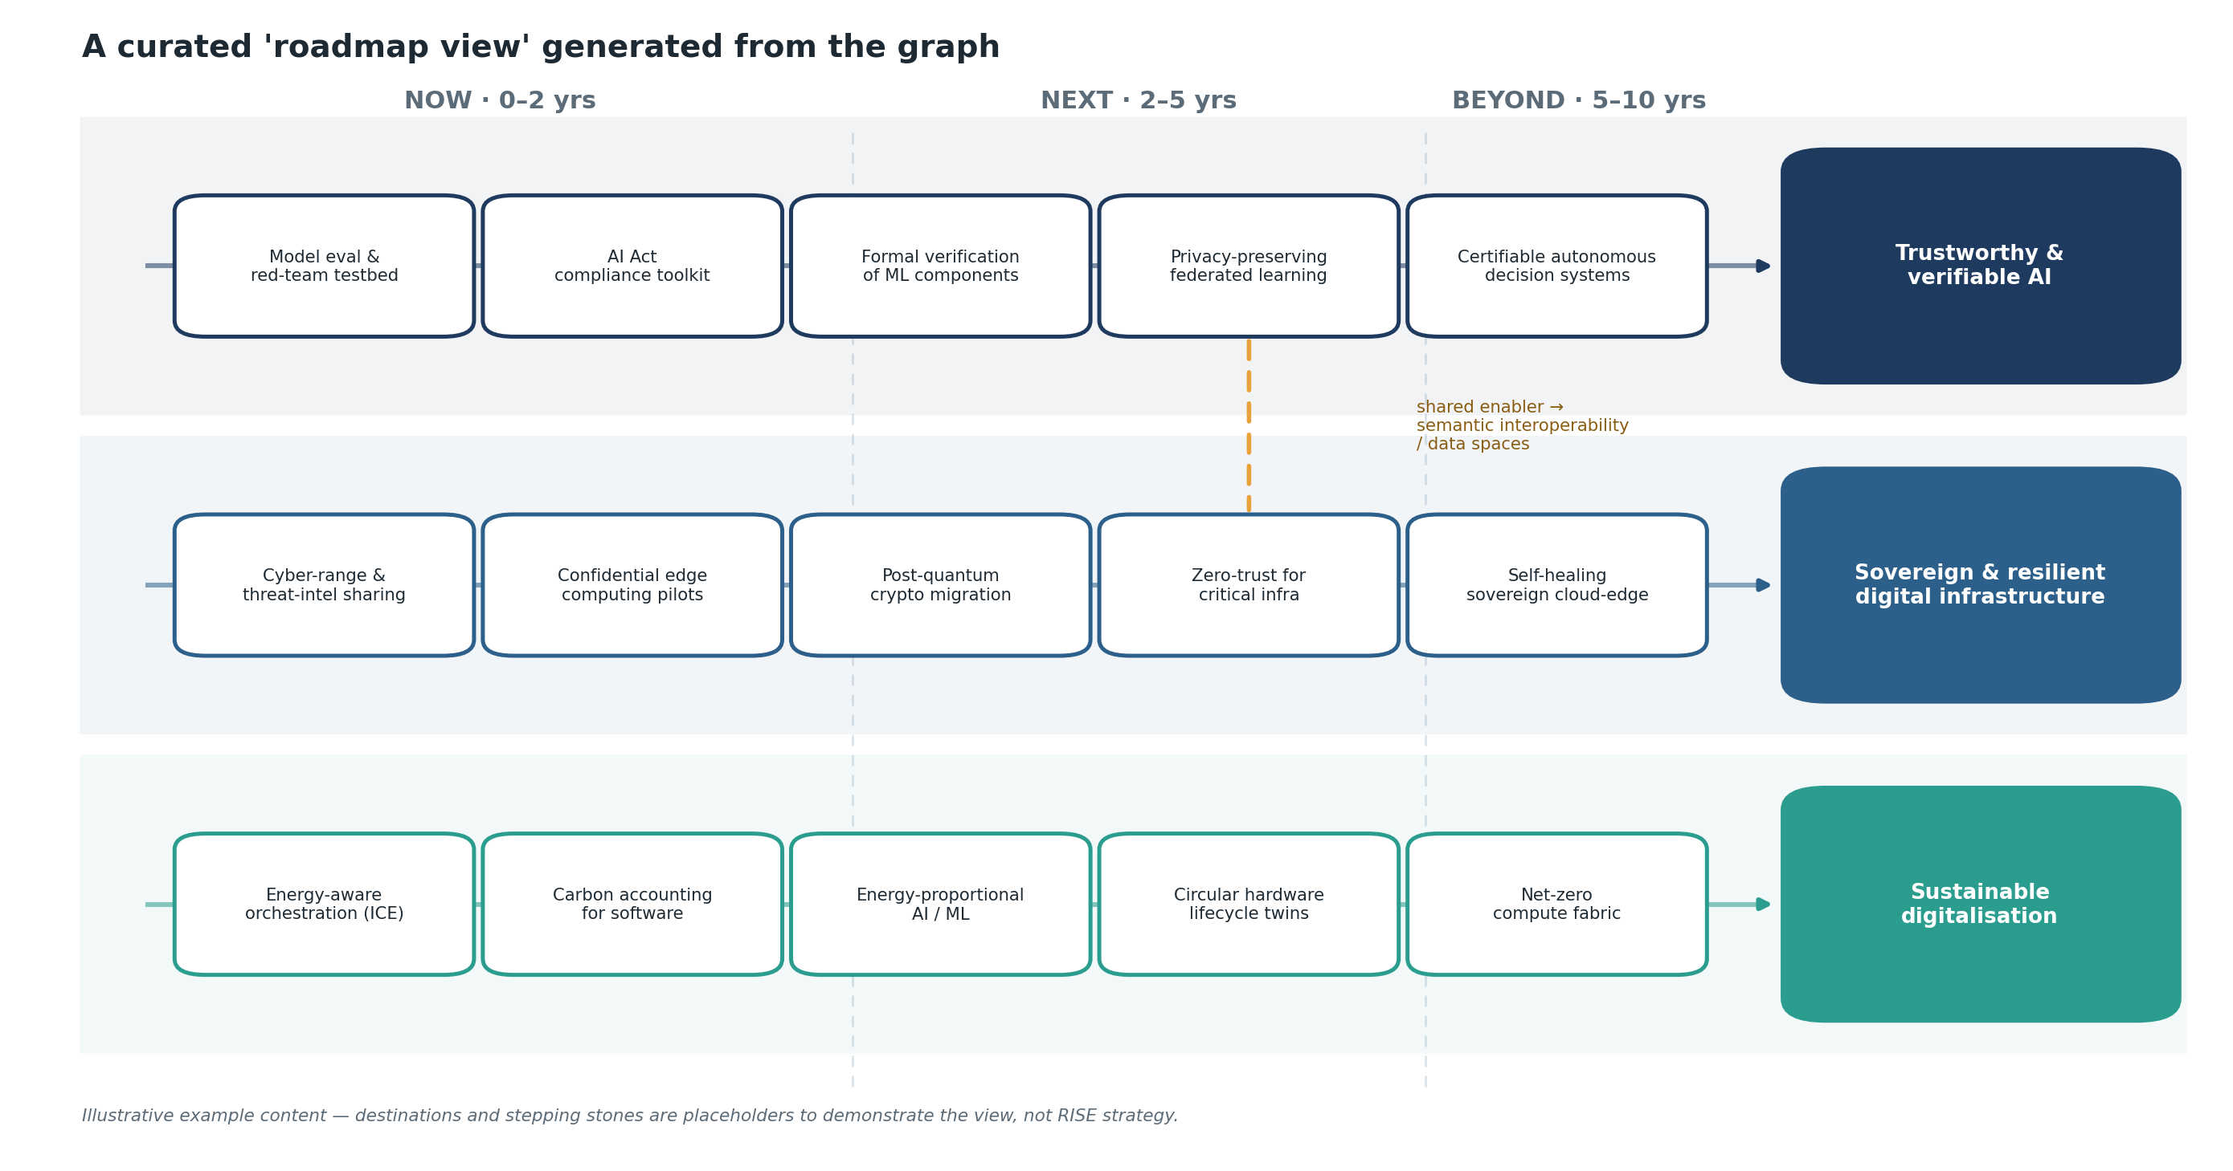
Figure 2 · A curated “roadmap view” generated from the graph (illustrative content). Same familiar picture as a slide — but every box is a live node you can click into, and the amber link shows a shared enabler crossing two journeys.

5.5 Access, hosting and IP
Host the stack on a RISE virtual machine or container platform, behind the RISE single sign-on, so “accessible to anyone at RISE” means simply “log in” — no new accounts. The internal graph is private by default. A separate, read-only public site is generated from only the nodes explicitly marked Public. Because every component is open-source and self-hosted, no roadmap data, and no IP, ever leaves RISE. This directly addresses the concern that some of the material is internal.

5.6 An AI ask-layer (GraphRAG), inspired by Cerebras Knowledge
In July 2026 Cerebras revealed its internal “company brain” — a knowledge base serving ~15,000 queries a day within three months. Tellingly, it is retrieval-augmented generation (RAG), not a knowledge graph: every source (Slack, code, docs) is embedded into one store and answered by hybrid retrieval with cited synthesis, on the principle of “meet data where it already lives.” The lesson for RISE is not to copy the architecture but to borrow the front door: a natural-language ask-box is what drove adoption.
The two approaches are complementary, and the right end-state uses both as layers. Keep the curated foresight graph as the structured backbone (it holds intent — destinations, dependencies, horizons — which cannot be extracted from documents), and add a GraphRAG ask-layer over the reality-layer material so anyone can ask in plain language and get a cited answer grounded in both the graph and the source documents. A practical, open-source shape: embeddings in Postgres/pgvector over DiVA abstracts, project descriptions and reports; hybrid retrieval plus a rerank step; an LLM synthesis step that cites sources; exposed via an MCP endpoint so other tools and agents can query it. One caution: do not RAG the foresight layer — you cannot infer “where we should be in 2032” from documents; that stays human-curated. Sequence this after the graph has real content (Phase 2+ in the rollout).
Borrowed principles: meet data where it lives (reinforces the automated feeds in §4); a natural-language ask front door for accessibility; hybrid retrieval with citations and provenance; and per-team scoping that maps onto the sensitivity flag in §6.4.

6 Governance & operating model
A knowledge graph lives or dies on its operating model, not its technology. The lightest structure that works:

6.1 Roles
- Product owner (1). Accountable for the graph as a product — roadmap, adoption, and the link to department strategy. A part-time role, not a new hire.
- Topic stewards (1 per topic). Domain experts who curate their corner: accept contributions, keep provenance honest, run the quarterly review.
- Contributors (everyone). Any researcher can add or refine nodes. Breadth of contribution is the goal, not gatekeeping.

6.2 Contribution & curation flow
Adopt a wiki model: open contribution with light-touch curation. Anyone can edit; changes are visible immediately; stewards review recent changes and tidy rather than approve-in-advance. This keeps friction near zero while stewards protect quality. Every substantive claim carries a source or an owner.

6.3 What makes a good stepping stone
Give contributors a one-line definition so the graph stays coherent: a stepping stone is a capability milestone (not a product, not a task), phrased as an outcome, placed on a horizon, with a stated confidence and at least one link — to a destination it advances or a stone it depends on. Stones with no links are the backlog to curate, not failures.

6.4 Access control, sensitivity and IP
Every node carries a sensitivity flag (Public / Internal / Restricted). The default is Internal. Publishing to the external view is a deliberate act by a steward, and Restricted nodes are visible only to named groups. This is how you get Ericsson-style outward-facing roadmaps without risking internal detail: the public roadmap is a curated projection, never the raw graph.

6.5 Versioning & auditability
The store keeps full edit history, so every view can be reproduced at a past date (“what did our AI roadmap look like a year ago?”) and every change is attributable. This is native to Wikibase and is a strong argument for Pattern A.

7 Rollout: pilot first, then scale
Prove the model on one topic before spreading it. The indicative path below spans roughly 18 months; each phase produces something usable, so value shows early and the effort can stop or slow at any phase boundary without waste.
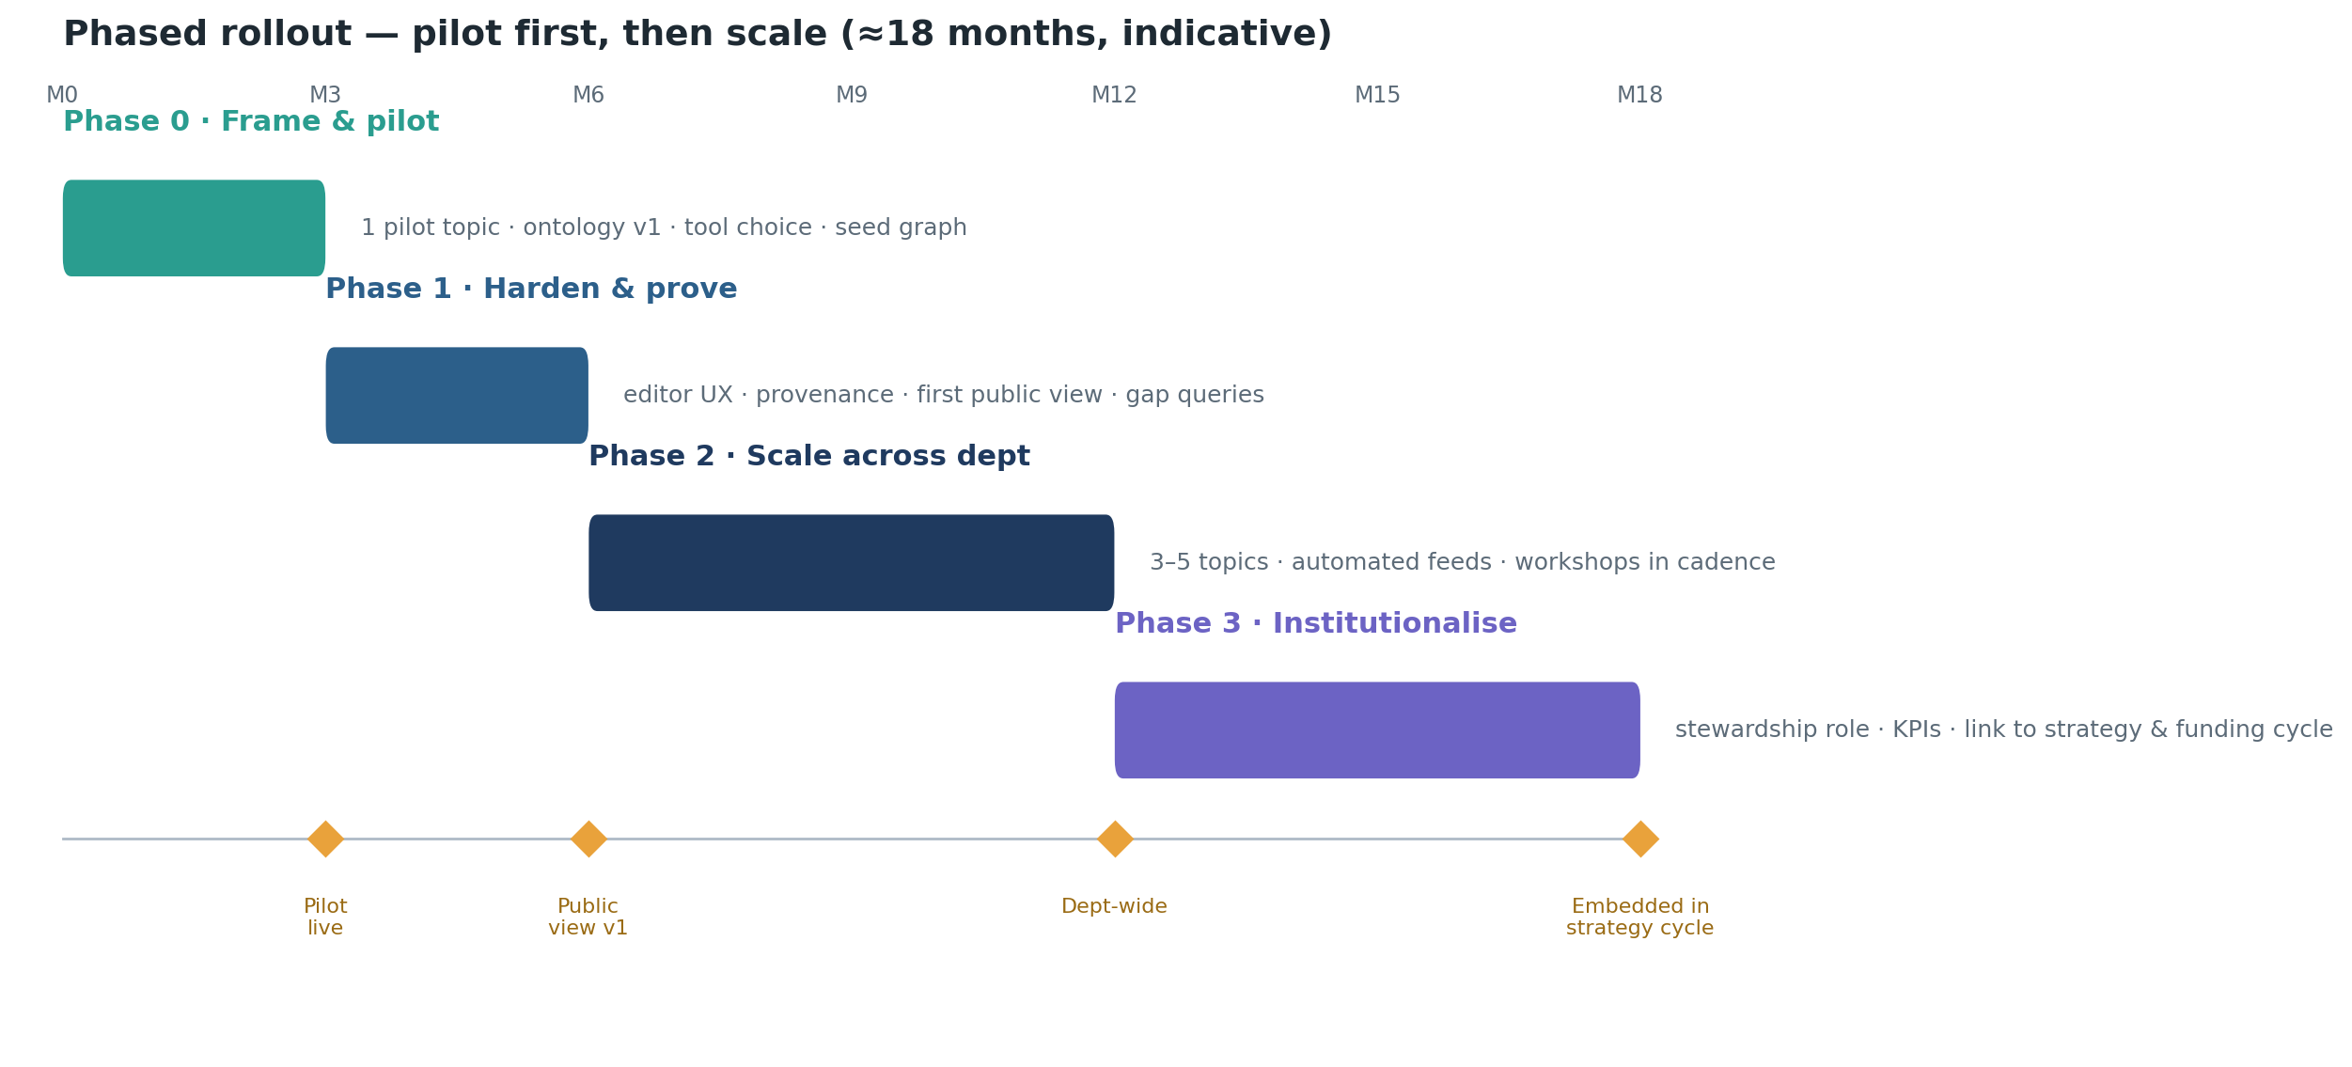
Figure 5 · Indicative phased rollout.
Phase | Focus | Key outputs
0 · Frame & pilot (M0–3) | Choose one pilot topic; draft ontology v1; stand up Wikibase + Cytoscape.js; seed the graph in a workshop. | A clickable internal graph for one topic; ontology v1; a working editing flow.
1 · Harden & prove (M3–6) | Improve the editing UX; add provenance and the first automated feed; ship the first curated public view; write the first gap/expert queries. | First public roadmap view; 2–3 saved live queries; early user feedback.
2 · Scale across dept (M6–12) | Add 3–5 topics; connect automated feeds broadly; put the quarterly reviews into cadence. | Department-wide coverage; feeds running; contribution habit forming.
3 · Institutionalise (M12–18) | Name the steward role formally; adopt KPIs; tie the graph to the strategy and funding cycle. | A durable operating model; KPIs reported; graph used in planning.
Table 7 · Phase detail.

7.1 Choosing the pilot topic
Pick a topic that is important enough to matter, bounded enough to finish, and rich enough in existing projects/people to make the reality layer sing. Good selection criteria: strategic relevance to the department; an engaged expert willing to be steward; enough live projects and partners to populate; and a real upcoming decision (a call, a strategy input) the graph can help with.
On those criteria, a strong default is Trustworthy & verifiable AI — it is central to RISE’s AI agenda, already has active work and roles behind it, and connects naturally to funding calls and regulation (the EU AI Act) that make the reality layer vivid. Cybersecurity / post-quantum readiness is an equally good alternative if a steward there is keener. The method is identical; let the available steward decide, since their engagement matters more than the topic.

8 Success metrics
Measure three things: is it used, is it alive, and does it change decisions? A graph can look busy and still be dying — the vitality metrics catch that.
Dimension | Example metric | Early target
Adoption | Distinct viewers / month; distinct contributors / quarter | ≥30 viewers; ≥10 contributors
Vitality | Median node age; % of stones with ≥1 evidence link; edits / month | <6 months; ≥60%; steady
Coverage | Topics live; stones linked to a project | 3–5 topics; ≥70% linked
Decision impact | Bids / strategy inputs that cite the graph; gaps closed | Referenced in ≥2 decisions / yr
Table 8 · KPIs across adoption, vitality, coverage and impact.

9 Risks & mitigations
Risk | Mitigation
It becomes a stale graveyard | Vitality KPIs + freshness nudges + automated feeds so parts self-update; tie reviews to the funding cycle so there is a reason to keep it current.
Ontology grows too complex | Start minimal; add a type only when a concrete question needs it; stewards guard against sprawl.
Low contribution / “yet another tool” | Single sign-on; two-minute edits; embed in existing rituals (reviews, bid prep) rather than adding new meetings.
Internal detail leaks to public view | Sensitivity flag defaults to Internal; publishing is a deliberate steward action; public site is a projection, never the raw graph.
Key-person dependency (the graph’s own) | Name a product owner + ≥2 stewards; document the ontology; keep everything in open formats with export.
Tool lock-in / maintenance burden | All components open-source and self-hosted; explicit model means the graph can be exported/migrated (e.g. to Neo4j) if needs change.
Table 9 · Principal risks and how the plan manages them.

10 Recommended next steps
Concrete moves for the first few weeks, before any big commitment:
- Pick the pilot topic and its steward — the single most important decision; optimise for an engaged steward.
- Draft ontology v1 on one page, using Tables 2–4 here as the starting point; cut anything not needed for the pilot.
- Stand up Wikibase + Cytoscape.js on a RISE VM behind SSO (a containerised Wikibase Suite gets you running quickly).
- Run one seeding workshop to draft destinations, journeys and the first ~15–20 stepping stones directly into the graph.
- Wire one automated feed (e.g. the project database or DiVA publications) to prove the “self-updating” idea.
- Show two live queries (a capability-gap list and an expert map) to the department to demonstrate what a slide could never do.

Bottom line. Keep Ericsson’s stepping-stone storytelling, but store it as a two-layer knowledge graph so it can be queried, linked to what RISE actually does, published selectively, and kept alive by everyone — all on open-source software you host yourselves. Prove it on one topic, then let it grow.

Appendix A Questions the live graph can answer
Plain-English questions, and the shape of the query behind them. In Wikibase these are SPARQL; in Neo4j, Cypher. The point is that each is a one-click saved view, refreshed automatically.
- Where are our capability gaps? Stepping stones with priority = Core and no incoming ‘advances’ edge from any Project.
- Which funding calls fit our Next horizon? Funding calls whose topic matches stones on horizon = Next, ranked by strategic priority.
- Who could lead this? Persons providing the Competence that a given stone requiredBy, ordered by number of related results.
- What is exposed if a partner leaves? Journeys reachable from Projects a given Partner collaboratesOn.
- How is readiness trending? TRL of stones on a journey, compared across two dated snapshots.

Illustrative SPARQL sketch — “Core stones with no project”:
SELECT ?stone ?label WHERE { ?stone a :SteppingStone ; :priority "Core" ; rdfs:label ?label . FILTER NOT EXISTS { ?project :advances ?stone } }

Appendix B Tools & references
Graph core: Wikibase · Neo4j · Memgraph · Apache Jena
Visualisation: Cytoscape.js · Sigma.js · awesome-knowledge-graph (tool list)
Lightweight starter: Logseq · Foam · Quartz (publish)
Method: Phaal, Farrukh & Probert (2004), Technology roadmapping · EU Competence Centre on Foresight

Appendix C Sources consulted
- RISE — Divisions (Digital Systems) — https://www.ri.se/en/about-rise/rise-in-short/organisation/divisions
- RISE — Cybersecurity RD&I — https://www.ri.se/en/what-we-do/expertises/cybersecurity
- RISE — Data science — https://www.ri.se/en/data-science
- RISE — PhD in Trustworthy & Verifiable AI — https://www.ri.se/en/about-rise/work-with-us/open-job-positions/phd-student-in-trustworthy-and-verifiable-ai
- Technology roadmapping — a planning framework (Phaal et al., 2004) — https://www.sciencedirect.com/science/article/abs/pii/S0040162503000726
- Scenario-driven roadmapping for technology foresight — https://www.sciencedirect.com/science/article/pii/S0040162517305851
- EU Knowledge4Policy — Technology foresight — https://knowledge4policy.ec.europa.eu/tech-foresight_en
- Fraunhofer ISI — Models of horizon scanning — https://www.isi.fraunhofer.de/content/dam/isi/dokumente/ccv/2015/Models-of-Horizon-Scanning.pdf
- Wikibase — open-source knowledge graph software — https://wikiba.se/
- Professional Wiki — Wikibase strengths & weaknesses — https://professional.wiki/en/articles/wikibase-strengths-and-weaknesses
- Memgraph — open-source Neo4j alternatives — https://memgraph.com/blog/neo4j-alternative-what-are-my-open-source-db-options
- Open-source graph databases (overview) — https://www.geeksforgeeks.org/blogs/open-source-graph-databases/
- Cytoscape.js — https://js.cytoscape.org/
- JavaScript graph-visualisation libraries (comparison) — https://linkurious.com/blog/top-javascript-graph-libraries/

