Requirements and Analysis Document

Version:

1.2

Date:

2017-04-05

Author:

**S**anjin Slavnic

**K**evin Brunström

**A**nne Keller

**J**oakim Mattsson

1. Introduction

This application is needed in the business world to make life easier handling expenses. As of today there is no easy way to take care of all your receipts. You need to archive the receipts and manually add all the needed data (expenses on the company) every month. This is time consuming and inefficient.

Our plan is to develop an Android application that allows users to take a photo of your receipt straight away and get all the data organised in the system directly. This application is wanted on the market by mostly traveling businessmen and businesswoman.

The application will be used when a businessman or woman is on the go. They will be able to quickly take a picture of their receipt and document it in the app so that you do not need to sit in the end of the month and do all your expenses at once.

1.2 Definitions, acronyms and abbreviations.

Archive

* List of all saved receipts.

Build graph

* Java class that constructs graphical representation based on saved receipts data.

Build pdf

* Java class that constructs a pdf-document with summarized info from receipts.

BottomNavigationView

* Menu at the bottom in app. Always visible.

R.

Receipt template

* Java class holding required information from receipt.

S.

Scan

* Taking photo of receipt with camera and gathering information from receipt.

T.

Textrecognizer

* Object from Google library that gathers textinformation from photo.

2. Requirements

2.1 Graphical user interface

Our user interface starts with a main page when the app is opened. The main page is where you handle a new post/receipt. You will have the option to do a few different things such as take a picture, continue without attaching a photo or go to your photo gallery to choose an already existing picture.

In the bottom of the app, we have chosen to have a module tab, there is five different options, you can choose to browse your archive, to see your statistics graphically, to manage your different companies, to see your profile and finally go back to the “main” page where you are able to create new post.

In your archive you have different choices to filter your list of receipts and present it in different ways, you can filter by dates, categories and price.

As for the graphs you are able to view your receipts graphically in three different ways, by choosing by three different diagrams which will give you the same information but be presented in three different ways.

You can manage your companies, add or delete a company, add new colleagues and employees and comment on all of the mentioned. The comments will be shown when you choose an employee or a company.

Your profile will be information about yourself only. You will be able to edit cards, company email etc.

We have chosen to use the following 4 colours in our app. Below is also a mockup of our GUI design.



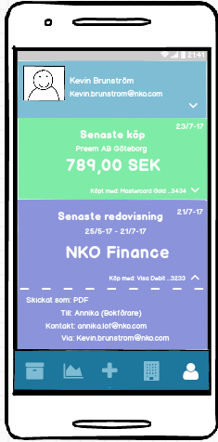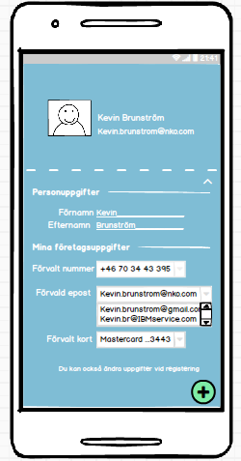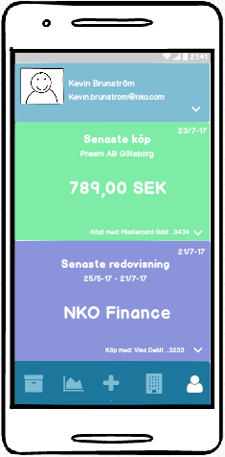

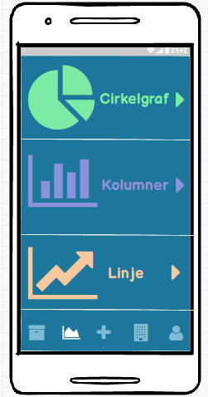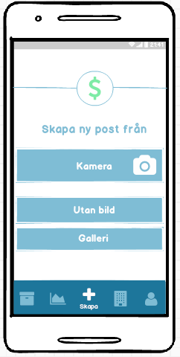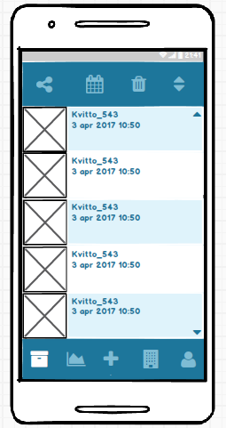

2.2 Functional requirements

The user will be able to take pictures/scan receipts, input data in regards to those receipts and export the scanned information that has been put in the app. The user will also be able to get an overview of the receipts and see the data represented visually in different forms of chart.

The priority of the UC is as follows:

**High:** UC: “Skapa ny”

**Medium:** -

2.3 Non-functional requirements

The applications should be easy to use in the everyday life of a travelling salesman and also ease his work with expenses.

The app should be easy to access and simple to use, few clicks.

Any special considerations besides functionality? Usability, reliability, performance, supportability, legal, implementation, …

NOTE:

Testability: mandatory (must have tests)

3. Use cases

See appendix for UC.

4. Domain model

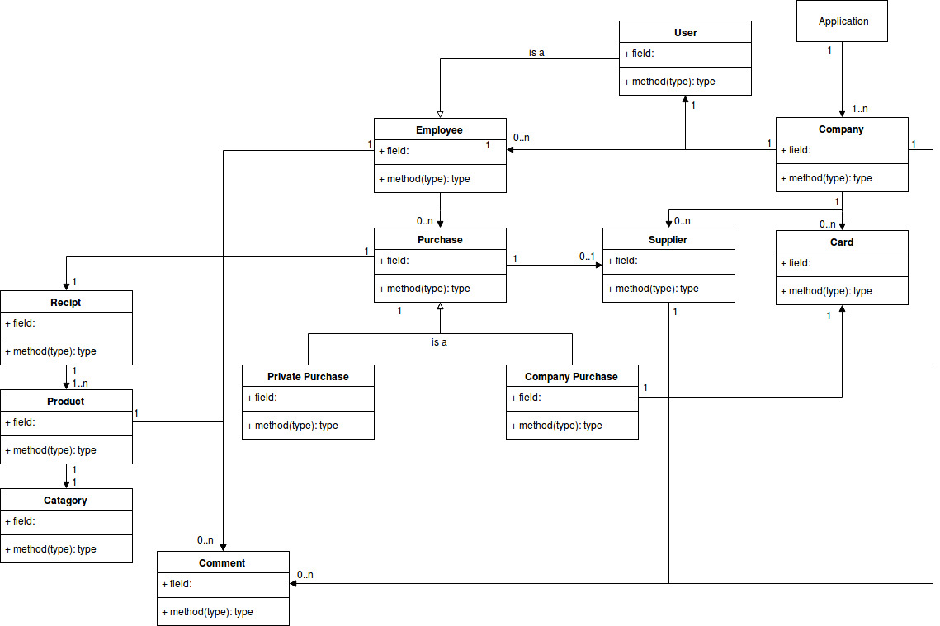

4.1 Class responsibilities

5. References

6. Appendix

UC: “Skapa ny”

**Summary:**

Register new receipt.

**Priority:**

High

**Extends:**

BottomNavigationView (App menu at the bottom of screen. Always visible)

**Includes:**

* “Kamera”
* “Galleri”
* “Ingen bild”

**Participators:**

App user

|  |  |  |
| --- | --- | --- |
| **Normal flow - “Fortsätt” (No business card saved)** | | |
|  | **Actor** | **System** |
| 1 | Press “Skapa ny” |  |
| 2 |  | Camera opens.  User takes a picture of receipt. |
| 3 |  | Gather info from receipt.  Display option:   * “Slitta kvitto” * “Fortsätt” |
| 4 | User selects “Fortsätt” |  |
| 5 |  | Display option:   * “Privat kort” * “Företagskort” |
| 6 | User selects “Företagskort” |  |
| 7 |  | Display options:   * List of companies. |
| 8 | User selects company. |  |
| 9 |  | (If found) System connects last 4 digits from receipt to company.  Display:   * List of categories. |
| 10 | User selects category for receipt. |  |
| 11 |  | Display gathered info based on settings.  Let user edit/add or remove data that will be saved in receipt. |
| 12 | User confirms info. |  |
| 13 |  | Display confirmation. |

|  |  |  |
| --- | --- | --- |
| **Alternate flow - “Fortsätt” (Business card saved)** | | |
|  | **Actor** | **System** |
| 1 | Press “Skapa ny” |  |
| 2 |  | Camera opens.  User takes a picture of receipt. |
| 3 |  | Gather info from receipt.  Display option:   * “Slitta kvitto” * “Fortsätt” |
| 4 | User selects “Fortsätt”. |  |
| 5 |  | Display:   * List of categories. |
| 6 | User selects category for receipt. |  |
| 7 |  | Display gathered info based on settings.  Let user edit/add or remove data that will be saved in receipt. |
| 8 | User confirms info. |  |
| 9 |  | Display confirmation. |

|  |  |  |
| --- | --- | --- |
| **Alternate flow - “Splitta kvitto” (No business card saved)** | | |
|  | **Actor** | **System** |
| 1 | Press “Skapa ny” |  |
| 2 |  | Camera opens.  User takes a picture of receipt. |
| 3 |  | Gather info from receipt.  Display option:   * “Slitta kvitto” * “Fortsätt” |
| 4 | User selects “Splitta kvitto” |  |
| 5 |  | Display:   * Available information from receipt |
| 6 | User selects textbox containing purchased items. |  |
| 7 |  | Display:   * Purchased items. |
| 8 | User selects items to register. |  |
| 9 |  | Display option:   * “Privat kort” * “Företagskort” |
| 10 | User selects “Företagskort” |  |
| 11 |  | Display options:   * List of companies. |
| 12 | User selects company. |  |
| 13 |  | (If found) System connects last 4 digits from receipt to company.  Display:   * List of categories. |
| 14 | User selects category for receipt. |  |
| 15 |  | Display gathered info based on settings.  Let user edit/add or remove data that will be saved in receipt. |
| 16 | User confirms info. |  |
| 17 |  | Display option:   * Return to step 7 to continue “Splitta kvitto” process. * Confirm and end process. |
| 18 |  | (If process ended) Display:   * Confirmation. |

|  |  |  |
| --- | --- | --- |
| **Alternate flow - “Splitta kvitto” (Business card saved)** | | |
|  | **Actor** | **System** |
| 1 | Press “Skapa ny” |  |
| 2 |  | Camera opens.  User takes a picture of receipt. |
| 3 |  | Gather info from receipt.  Display option:   * “Slitta kvitto” * “Fortsätt” |
| 4 | User selects “Splitta kvitto” |  |
| 5 |  | Display:   * Available information from receipt |
| 6 | User selects textbox containing purchased items. |  |
| 7 |  | Display:   * Purchased items. |
| 8 | User selects items to register. |  |
| 9 |  | Display:   * List of categories. |
| 10 | User selects category for receipt. |  |
| 11 |  | Display gathered info based on settings.  Let user edit/add or remove data that will be saved in receipt. |
| 12 | User confirms info. |  |
| 13 |  | Display confirmation. |

|  |  |  |
| --- | --- | --- |
| **Exceptional flow – TODO** | | |
|  | **Actor** | **System** |
| 1 |  |  |
| 2 |  |  |
| 3 |  |  |

UC: Archive

**Summary:**

Overview of all your registered receipts

**Priority:**

High

**Extends:**

BottomNavigationView (App menu at the bottom of screen. Always visible)

**Includes:**

List of receipts

**Participators:**

App user

|  |  |  |
| --- | --- | --- |
| **Normal flow - Export PDF** | | |
|  | **Actor** | **System** |
| 1 | Press archive |  |
| 2 |  | Display:   * List of receipts (sorted by available choice) |
| 3 | User selects export |  |
| 4 |  | Display:   * Available export options   + Email   + Download PDF   + SMS   + ... |
| 5 | User selects option |  |
| 6 |  | System handles request |

|  |  |  |
| --- | --- | --- |
| **Alternate flow - Edit receipt** | | |
|  | **Actor** | **System** |
| 1 | Press archive |  |
| 2 |  | Display:   * List of receipts (sorted by available choice) |
| 3 | User selects receipt |  |
| 4 |  | Display:   * Expanded receipt |
| 5 | User edits receipt |  |
| 6 |  | System saves changes |

|  |  |  |
| --- | --- | --- |
| **Alternate flow - Delete receipt** | | |
|  | **Actor** | **System** |
| 1 | Press archive |  |
| 2 |  | Display:   * List of receipts (sorted by available choice) |
| 3 | User selects receipt |  |
| 4 |  | Display:   * Expanded receipt * Options how to manage receipt |
| 5 | User chooses to delete receipt |  |
| 6 |  | Display:   * “Are you sure you want to delete this receipt?” |
| 7 | User confirms |  |
| 8 |  | Display:   * Receipt is deleted |

|  |  |  |
| --- | --- | --- |
| **Alternate flow – Search** | | |
|  | **Actor** | **System** |
| 1 | Press archive |  |
| 2 |  | Display:   * List of receipts (sorted by available choice) |
| 3 | User types in what to search for in the search bar |  |
| 4 |  | Display:   * List of search result |

|  |  |  |
| --- | --- | --- |
| **Alternate flow - Delete list** | | |
|  | **Actor** | **System** |
| 1 | Press archive |  |
| 2 |  | Display:   * List of receipts (sorted by available choice) |
| 3 | User selects/marks what to delete |  |
| 4 |  | Display:   * Selected receipts is shown |
| 5 | User chooses to delete selected |  |
| 6 |  | Display:   * User is asked to confirm the deletion of receipts |
| 7 | User confirms |  |
| 8 |  | Receipts/list is deleted |

|  |  |  |
| --- | --- | --- |
| **Alternate flow – Sort** | | |
|  | **Actor** | **System** |
| 1 | Press archive |  |
| 2 |  | Display:   * List of receipts (sorted by available choice) |
| 3 | User chooses what to sort the list by |  |
| 4 |  | Display:   * The sorted list is shown |

UC: Company

**Summary:**

Shows the different companies you can interact with

**Priority:**

Medium

**Extends:**

BottomNavigationView (App menu at the bottom of screen. Always visible)

**Includes:**

All companies you are a part of

**Participators:**

App user

|  |  |  |
| --- | --- | --- |
| **Normal flow** | | |
|  | **Actor** | **System** |
| 1 | Press Company |  |
| 2 |  | Display:   * List of employee’s companies shown |
| 3 | User chooses to add a new company |  |
| 4 |  | Display:   * Text fields to be filled in is shown * User is asked to confirm all details |
| 5 | User confirms details |  |
| 6 |  | Display:   * Details about company is saved |
| 7 | User chooses to edit an existing company |  |
| 8 |  | Display:   * Options to edit is shown   + Company name   + Cards   + Employees   + Employee Comment |
| 9 | User chooses what to edit |  |
| 10 |  | Display:   * User is asked to confirm changes |
| 11 | User confirms details |  |
| 12 |  | Display:   * Details are saved |

|  |  |  |
| --- | --- | --- |
| **Alternate flow -  Delete company** | | |
|  | **Actor** | **System** |
| 1 | Press company |  |
| 2 |  | Display:   * List of employee’s companies shown |
| 3 | User chooses company |  |
| 4 |  | Display:   * Company information is shown * Delete company button is shown |
| 5 | User clicks delete company |  |
| 6 |  | Display:   * User is asked to confirm the action |
| 7 | User confirms |  |
| 8 |  | Display:   * Company is deleted |

|  |  |  |
| --- | --- | --- |
| **Alternate flow - Comment about company** | | |
|  | **Actor** | **System** |
| 1 | Press company |  |
| 2 |  | Display:   * List of employee’s companies shown |
| 3 | User selects company |  |
| 4 |  | Display:   * Company information is shown * Delete company button is shown |
| 5 | User add/edits comment about company |  |
| 6 |  | Display:   * User is asked to save the comment |
| 7 | User presses save |  |
| 8 |  | Display:   * Comment is saved |

|  |  |  |
| --- | --- | --- |
| **Exceptional flow - Delete the only existing company** | | |
|  | **Actor** | **System** |
| 1 | Press company |  |
| 2 |  | Display:   * List of employee’s companies shown |
| 3 | User selects company |  |
| 4 |  | Display:   * Company information is shown * Delete company button is shown |
| 5 | User presses delete company |  |
| 6 |  | Display:   * Pop-up is shown, “You can not delete your only company. Company will not be deleted.” |

|  |  |  |
| --- | --- | --- |
| **Exceptional flow - Delete the only existing employee** | | |
|  | **Actor** | **System** |
| 1 | Press company |  |
| 2 |  | Display:   * List of employee’s companies shown |
| 3 | User chooses company |  |
| 4 |  | Display:   * Company information is shown * Delete company button is shown * Delete employee button is shown |
|  | User presses delete employee |  |
|  |  | Display:   * Pop-up is shown, “You can not delete your only employee. Employee will not be deleted.” |

UC: Graphical Representation

**Summary:**

Shows the list of receipts represented graphically

**Priority:**

Low

**Extends:**

BottomNavigationView (App menu at the bottom of screen. Always visible)

**Includes:**

List of receipts

**Participators:**

App user

|  |  |  |
| --- | --- | --- |
| **Normal flow** | | |
|  | **Actor** | **System** |
| 1 | Press Graph |  |
| 2 |  | Display:   * The option to choose between three types of graphs i shown |
| 3 | User chooses type of graph |  |
| 4 |  | Display:   * The graph is displayed as per users choice |

UC: Profile

**Summary:**

Shows the information about the active employee

**Priority:**

Medium

**Extends:**

BottomNavigionView (Appmenu at the bottom of screen. Always visible)

**Includes:**

The user

**Participators:**

App user

|  |  |  |
| --- | --- | --- |
| **Normal flow** | | |
|  | **Actor** | **System** |
| 1 | Press Profile |  |
| 2 |  | Display:   * Profile for the employee is shown |
| 3 |  |  |
| 4 |  |  |
| 5 |  |  |
| 6 |  |  |
| 7 |  |  |
| 8 |  |  |
| 9 |  |  |
| 10 |  |  |
| 11 |  |  |

|  |  |  |
| --- | --- | --- |
| **Alternate flow** | | |
|  | **Actor** | **System** |
| 1 |  |  |
| 2 |  |  |
| 3 |  |  |
| 4 |  |  |
| 5 |  |  |
| 6 |  |  |
| 7 |  |  |
| 8 |  |  |

|  |  |  |
| --- | --- | --- |
| **Exceptional flow** | | |
|  | **Actor** | **System** |
| 1 |  |  |
| 2 |  |  |
| 3 |  |  |
| 4 |  |  |