Requirements and Analysis Document

Version:

1.0

Date:

2017-03-23

Author:

Sanjin Slavnic

Anne Keller

Joakim Mattsson

Kevin Brunström

1 Introduction

This application is needed in the business world to make life easier handling expenses. As of today there is no easy way to take care of all your receipts. You need to archive the receipts and manually add all the needed data (expenses on the company) every month. This is time consuming and inefficient.

Our plan is to program an Android application that allows users to take a photo of your receipt straight away and get all the data organised in the system directly. This application is wanted on the market by mostly traveling businessmen and businesswoman. The application will be used every time the user does a business purchase.

Furthermore we also see a demand in the private area. We want focus on shared economy accounts for two or more people. Mainly expenses for couples , family or groups of friends. We want to offer the user an easy and intuitive way of organizing his or her economy. To achieve this we will use text scanning technologies and easy understood graphical summaries.

In conclusion there will therefore be two separate modes for structuring your data. Private mode and Business mode.

1.2 Definitions, acronyms and abbreviations.

Archive

* List of all saved receipts.

Build graph

* Java class that constructs graphical representation based on saved receipts data.

Build pdf

* Java class that constructs a pdf-document with summarized info from receipts.

R.

Receipt template

* Java class holding required information from receipt.

S.

Scan

* Taking photo of receipt with camera and gathering information from receipt.

T.

Textrecognizer

* Object from Google library that gathers textinformation from photo.

2 Requirements

2.1 User interface

Our user interface will be quite simple. The main screen will include 3 choices to get started and thereafter depending on what choice you made to start with you will be asked to provide information of some kind.

As for scan and manual input you will get directed to either the camera or your camera roll and there from you will need to choose category, total cost and and the date of when the purchase was processed.

You will be able to see all the data you have put in the app under History. There will also be an option to see everything graphicly as diagrams.

Early sketches of different functions to be or not to be included in the app.

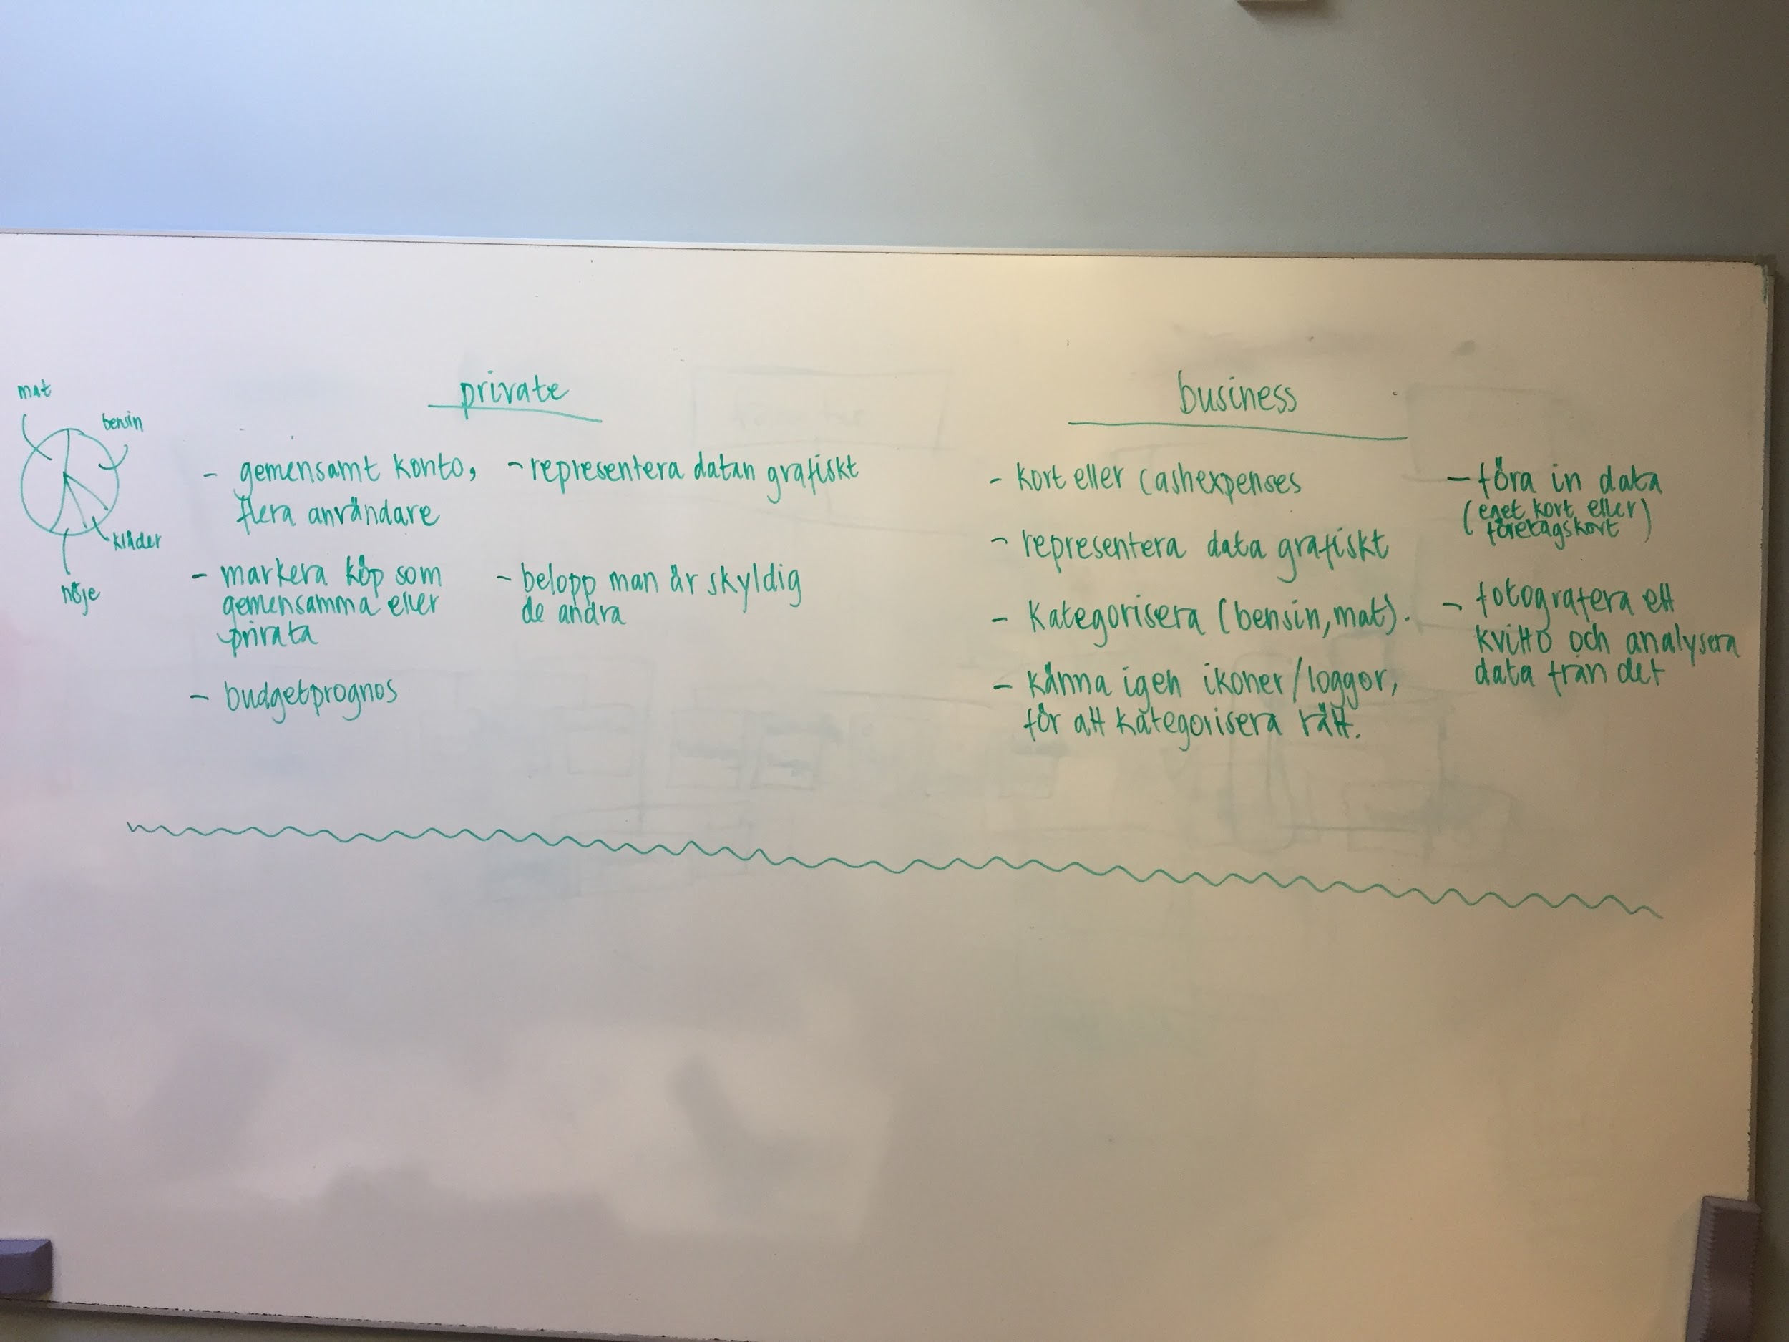

Early sketch of the GUI and how the app will work.

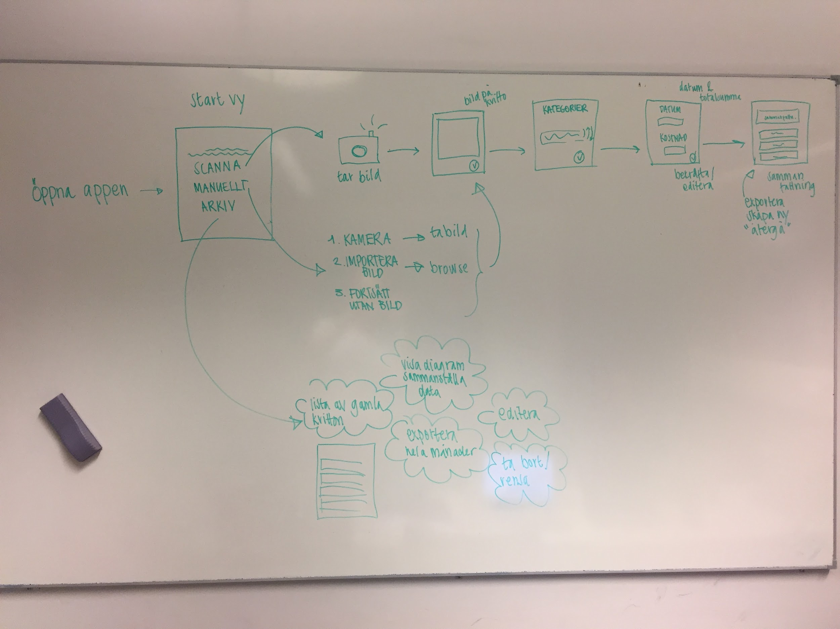

2.2 Functional requirements

The user will be able to take pictures/scan receipts, input data in regards to those receipts and export the scanned information that has been put in the app. The user will also be able to get an overview of the history and see the history represented visually as diagrams.

The different UC will be Scan, Manual Input and History. All the Use Cases is shown below.

The priority of the UC is as follows:

**High:** UC: Scan

**Medium:** UC : History & UC

2.3 Non-functional requirements

The applications should be easy to use in the everyday life of a travelling salesman and also ease his work with expenses.

The app should be easy to access and simple to use, few clicks.

Any special considerations besides functionality? Usability, reliability, performance, supportability, legal, implementation, …

NOTE:

Testability: mandatory (must have tests)

3 Use cases

Use Case flow to be input here…

3.1 User case listing

UC: Scan

UC: Manual

UC: History

Please see appendix for all UC.

4 Domain model

4.1 Class responsibilities

5 References

UC: Scan

**Summary:**

Main function

**Priority:**

High

**Extends:**

Mainscreen

**Includes:**

(Textrecognition)

**Participators:**

Business users

Normal flow

|  |  |  |
| --- | --- | --- |
|  | **Actor** | **System** |
| 1 | Press scan button |  |
| 2 |  | Camera view is shown |
| 3 | Take a picture of receipt |  |
| 4 |  | All info is gathered |
| 5 | User confirms |  |
| 6 |  | Categories are shown |
| 7 | Category is confirmed |  |
| 8 |  | Date and cost is shown |
| 9 | Category, date and cost is confirmed |  |
| 10 |  | View of your choices is shown, choices of what to do with the file is showed |
| 11 | User will choose to export, create new or go back to main page |  |

Alternate flow - System is missing info from user

|  |  |  |
| --- | --- | --- |
|  | **Actor** | **System** |
| 1 | Press scan button |  |
| 2 |  | Camera view is shown |
| 3 | Take a picture of receipt |  |
| 4 |  | Info is missing. User is asked to input missing details |
| 5 |  | Wizard mode with alternatives for missing info. User is asked to fill in all the blanks |
| 6 | Category, date and cost is confirmed. |  |
| 7 |  | View of your choices is shown, choices of what to do with the file is showed |
| 8 | User will choose to export, create new or go back to main page |  |

Exceptional flow

|  |  |  |
| --- | --- | --- |
|  | **Actor** | **System** |
| 1 | Press scan button |  |
| 2 |  | Can’t find any words or numbers |
| 3 |  | Suggest manual input |
| 4 | User fills in all details (see UC for manual input) |  |

UC: Manual Input

**Summary:**

Secondary function. Manually input receipt.

**Priority:**

Medium

**Extends:**

Mainscreen

**Includes:**

-

**Participators:**

Business users

Normal flow

|  |  |  |
| --- | --- | --- |
|  | **Actor** | **System** |
| 1 | Press Manual Input |  |
| 2 |  | User is asked to import picture or take a new picture of receipt |
| 3 | User selects “take new picture” |  |
| 4 |  | Camera is open |
| 5 | Picture is taken |  |
| 6 |  | Picture is shown |
| 7 | Confirm picture. |  |
| 8 |  | Wizard step 1 (select category) |
| 9 | Selects category for receipt |  |
| 10 |  | Wizard step 2 (select date and amount) |
| 11 | Select date and amount. |  |
| 12 |  | Confirmation shown. |
| 13 |  | Alternative options shown:  “Create new receipt”  “Export”  “Resume to mainscreen” |
| 14 | User resumes to mainscreen |  |

Alternate flow - Exporting to email

|  |  |  |
| --- | --- | --- |
|  | **Actor** | **System** |
| 1 | Press Manual Input |  |
| 2 |  | User is asked to import picture or take a new picture of receipt |
| 3 | User selects “take new picture” |  |
| 4 |  | Camera is open |
| 5 | Picture is taken |  |
| 6 |  | Picture is shown |
| 7 | Confirm picture. |  |
| 8 |  | Wizard step 1 (select category) |
| 9 | Selects category for receipt |  |
| 10 |  | Wizard step 2 (select date and amount) |
| 11 | Select date and amount. |  |
| 12 |  | Confirmation shown. |
| 13 |  | Alternative options shown:  “Create new receipt”  “Export”  “Resume to mainscreen” |
| 14 | User selects “export” |  |
| 15 |  | Alternative options shown:  “Via email”  “Export to device” |
| 16 | User selects “via email |  |
| 17 |  | Textfield for email is shown. |
| 18 | User inputs email and confirms. |  |
| 19 |  | Email is sent. Confirmation is shown. |

Exceptional flow -

|  |  |  |
| --- | --- | --- |
|  | **Actor** | **System** |
| 1 |  |  |
| 2 |  |  |
| 3 |  |  |
| 4 |  |  |
| 5 |  |  |

UC: History

**Summary:**

Menu for previous receipts.

**Priority:**

Medium

**Extends:**

Mainscreen

**Includes:**

-

**Participators:**

Business users

Normal flow

|  |  |  |
| --- | --- | --- |
|  | **Actor** | **System** |
| 1 | Press history button |  |
| 2 |  | Chronological list of receipts is shown |
| 3 | User exports summarized pdf file with all the receipts from the selected month |  |
| 4 |  | Alternative save options: send as mail or save on device |
| 5 | User saves pdf on device |  |

Alternate flow - Sorted list

|  |  |  |
| --- | --- | --- |
|  | **Actor** | **System** |
| 1 | Press history button |  |
| 2 |  | Chronological list of receipts is shown |
| 3 | User sorts list by category |  |
| 4 |  | Sorted list is shown |

Alternate flow - Clean History

|  |  |  |
| --- | --- | --- |
|  | **Actor** | **System** |
| 2.0 | Press history button |  |
| 2.1 |  | Chronological list of receipts is shown |
| 2.2 | User cleans history |  |
| 2.3 |  | An empty list is shown |

Alternate - Edit Receipt

|  |  |  |
| --- | --- | --- |
|  | **Actor** | **System** |
| 3.0 | Press history button |  |
| 3.1 |  | Chronological list of receipts is shown |
| 3.2 | User select specific receipt. |  |
| 3.3 |  | Detailed view of receipt |
| 3.4 | User edits receipt |  |
| 3.5 |  | Data is saved |

Alternate flow - Diagram View

|  |  |  |
| --- | --- | --- |
|  | **Actor** | **System** |
| 4.0 | Press history button |  |
| 4.1 |  | Chronological list of receipts is shown |
| 4.2 | User selects “summarized diagram view” for specific month |  |
| 4.3 |  | Diagram is shown for all the expenses. |

Exceptional flow

|  |  |  |
| --- | --- | --- |
|  | **Actor** | **System** |
| 1 | Press history button |  |
| 2 |  | No receipt are shown |
| 3 |  | Suggest adding new receipt |