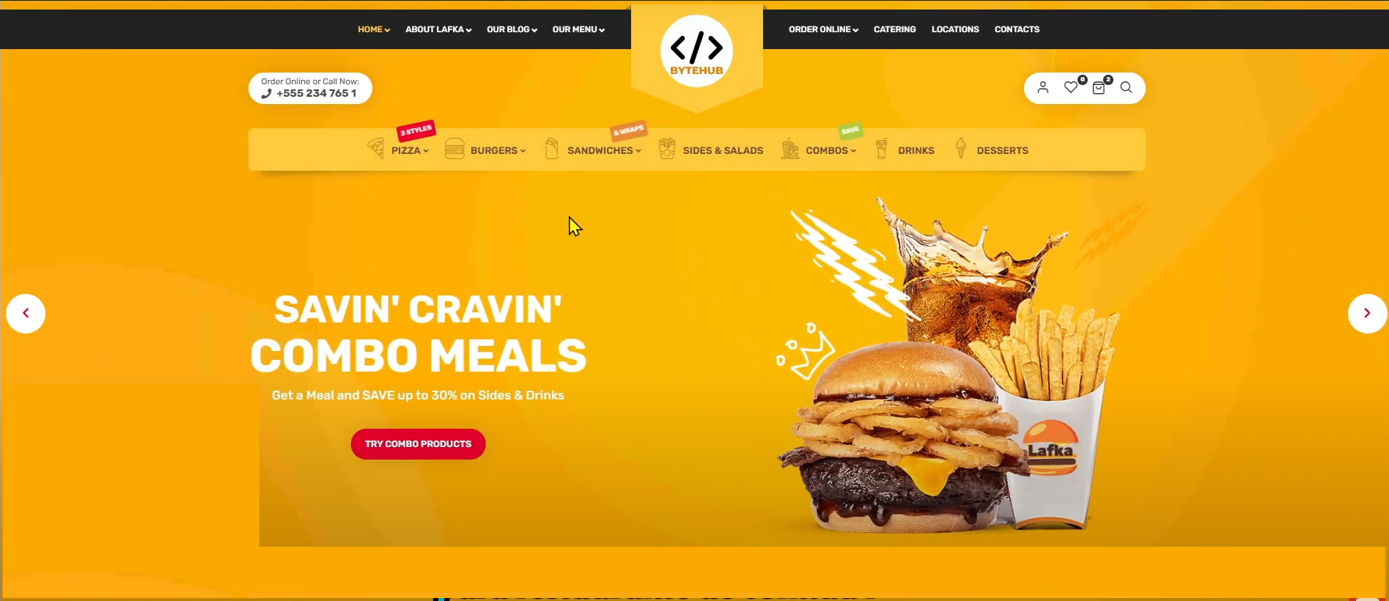
Food preset
Nav-left
Nav-right
banner
social
call
logo
header

Box-shadow
https://getcssscan.com/css-box-shadow-examples

