Analyzing Natural Selection Name __________________________ Name __________________________
Survival of HIV particles (0.1 μM AZT)

1 October 2013 Name __________________________

Infection with the human immunodeficiency virus (HIV) causes the fatal disease called AIDS. The first drug that was effective against HIV was AZT. When AZT was first administered to HIV-infected patients, virus populations dropped dramatically. But with time, HIV populations in the treated patients rebounded and the patients died of AIDS. (Note: inside an infected person, individual HIV particles live for about a day, on average.)

- The data graphed to the right are from virus particles that
were isolated from a patient at different times after AZT therapy began. The virus particles were then exposed to 0.1 μM AZT.
The researchers who did the study claim that it supports the hypothesis that the HIV population in this patient evolved
resistance to AZT. Do you agree? Defend your answer.

Yes—over time, the proportion that survive in the presence
of AZT increases. The data are consistent with the hypothesis that natural selection favored virus particles that can survive in the presence of AZT.

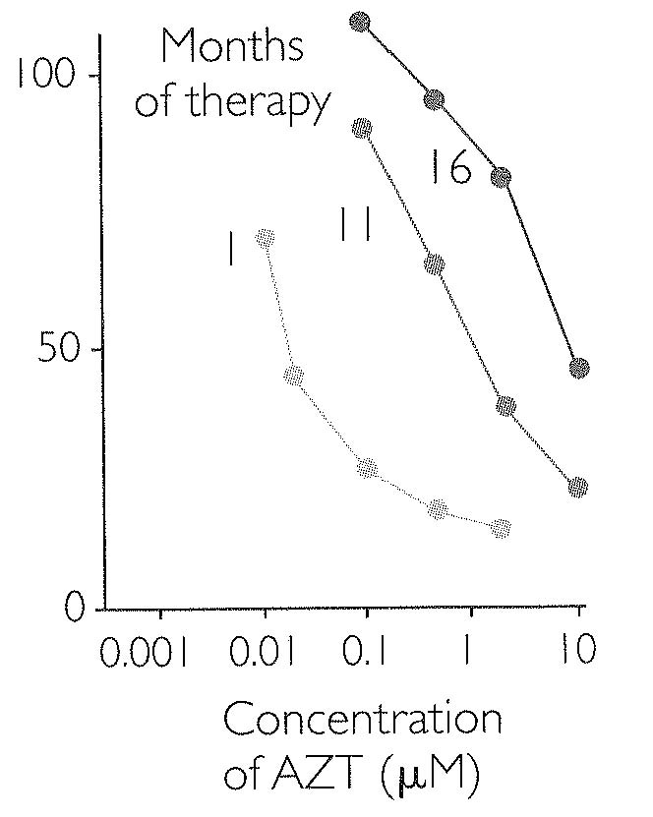
1 11 16
Months of therapy
High

Med.

Low

- AZT and other antiviral drugs work by binding to molecules that help HIV produce offspring inside a host cell. The binding is very specific—if the shape or composition of the target molecule changes, the drug may not work.

AZT binds at a specific location on a molecule called reverse transcriptase. HIV has a gene that contains the information for making reverse transcriptase. But the genetic information varies among HIV particles. As a result, the structure and composition of reverse transcriptase varies among HIV particles.

Based on this information, is there heritable variation in the “resistance to AZT” trait? Explain why or why not.

Yes— because not all genes and versions of reverse transcriptase are alike, there is variation. And because AZT resistance depends on the structure of reverse transcriptase, and because the genetic information for making reverse transcriptase is passed on to offspring, the trait is heritable.

- Using the information in question 2 and the data in the graph, is it reasonable to infer that there is differential reproductive success among HIV with respect to the “resistance to AZT” trait? Explain why or why not.

Yes—HIV particles that have AZT-resistant forms of reverse transcriptase should survive better in the presence of AZT.

- Did forms of reverse transcriptase that were resistant to AZT exist in the HIV population before the patient began receiving AZT? Explain why or why not.

Yes—among all the types of reverse transcriptase present in the population, it is almost certain that by chance some were at least slightly resistant to AZT.

- When AZT is administered to a particular patient, does each individual HIV particle inside that patient change to become more resistant to the drug, so that eventually the HIV population would consist of drug-resistant forms? Defend your answer.

No—the HIV particles themselves don’t change. The resistant individuals simply survive better and leave more offspring than the individuals that have less or no resistance to AZT.
- Physicians now have many drugs that they can prescribe for HIV-infected individuals, in addition to AZT. So if HIV populations begin rebounding in a patient who is receiving AZT, the patient stops taking AZT and switches to different drugs. When the environment inside the patient changes in this way, HIV populations again drop dramatically. Explain why.

Initially, very few HIV particles in the population have resistance to the new drugs—most are susceptible and produce very few or no offspring.

- When a patient stops taking AZT and switches to new drugs, predict whether AZT-resistant forms become more common, less common, or remain at the same frequency, in that patient. Explain your logic.

The AZT-resistant forms should become much less common, as that trait is no longer advantageous in the new environment. Forms that are resistant to the new drugs should become more common.

- Suppose the patient stopped taking AZT after several months and switched to a new drug called a protease inhibitor (PI). On the axes below, use a solid line to predict how the frequency of AZT-resistant forms will change over time. Use a dotted line to predict how the frequency of PI-resistant forms will change over time, and a dotted line to predict the frequency of HIV particles that are resistant to both drugs.

Frequency
(percentage in the total HIV population)
100

50

0

------ AZT-resistant
- - - PI-resistant
….. AZT+PI-resistant

Before therapy
Start AZT
End AZT Start PI

********* Please turn the completed exercise in to your T.A. (and make sure that your names are legible!) *********

If you finish early, consider the following: Some humans have genes that either a) reduce the likelihood of HIV infection or b) delay the onset of AIDS if an infection does occur.

- In human populations where HIV infection is common, are the frequencies of these “resistance genes” increasing, decreasing, or staying about the same? Explain your reasoning.

- In human populations where HIV infection is rare, are the frequencies of these resistance genes increasing, decreasing, or staying about the same? Explain your reasoning.

