###### **Biology 180 Student name: _______________________________ Name ______________________________**

# **Exam 1: October 14th, 2013 TA name (*1 pt*): ______________________________**

1. V1: There is a species of caterpillar that is black with red bands. It has been hypothesized that the red banding deters bird predators by mimicking the coloration of a highly venomous species of snake. (20 *pts*)

V2: There is a species of caterpillar that is black with yellow bands. It has been hypothesized that the yellow banding deters bird predators by mimicking the coloration of a highly venomous species of snake.

a. What is the null hypothesis? (3 pts)

**Sample answer:**

**The rate at which birds eat the caterpillars is not affected by coloration**

**Rubric:**

**1pt: coloration (or color or bands) has**

**1pt: no effect (or eaten at same rate)**

**1pt: on predation (or being eaten)**

b. V1: You have access to a large number of caterpillars, red and black paint, and several large natural enclosures that contain the bird species that eats the caterpillars. To test the hypothesis above, list the treatment groups you will use, and explain why each is important. (6 pts)

b. V2: You have access to a large number of caterpillars, yellow and black paint, and several large natural enclosures that contain the bird species that eats the caterpillars. To test the hypothesis above, list the treatment groups you will use, and explain why each is important. (6 pts)

**Sample answer:**

**1. Caterpillars with their red bands painted black. This treatment will determine the rate at which birds eat the caterpillars in the absence of the red bands.**

**2. Caterpillars with their red bands painted red. This controls for the manipulation.**

**3. Unmanipulated caterpillars. This treatment establishes the baseline predation to determine if the paint is causing weird results.**

**Rubric:**

**1pt: Red bands painted black treatment.**

**1pt: This treatment measures predation without the bands**

**1pt: Red bands painted red treatment.**

**1pt: This treatment controls for the painting manipulation.**

**1pt: Unmanipulated caterpillars.**

**1pt: This treatment controls for the possibility that the paint is driving the results.**

c. What is the independent variable? (1 pt) **Coloration**

d. What is the dependent variable? (1 pt) **How often caterpillars are eaten by birds**

e. To the right, plot results of your experiment that are 

predicted under the hypothesis that the bands deter

predators. (5 pts)

Answer:

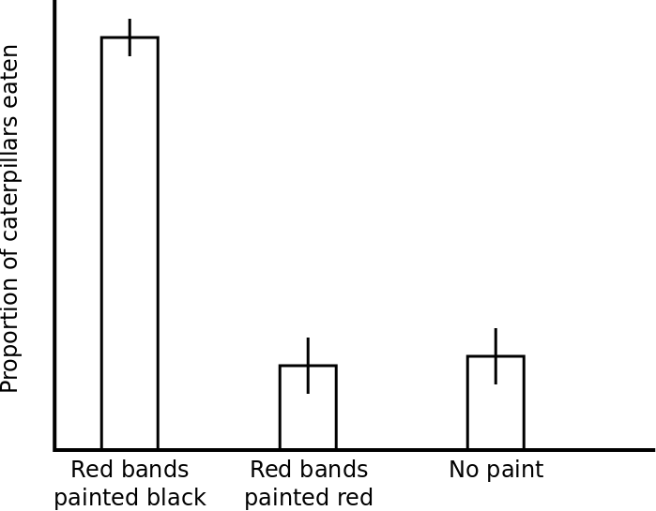

**Rubric:**

**1pt: y-axis label (can be labeled as proportion, percentage, number, or rate)**

**1pt: treatment labels**

**3pt: for the correct relative height of each treatment (1pt per bar)**

**Error bars are not necessary.**

f. Another researcher that is interested in the same question performed the following experiment. On Day 1, they put 100 individuals of a different species of caterpillar that lacks red bands into an enclosure containing birds. On Day 2, they removed any remaining all-black caterpillars and placed 100 individuals of the red-banded species into the same enclosure. List two weaknesses of this experimental design, and explain why each is a problem. (4 pts)

**Sample answer:**

**1. The researcher performed the treatments on subsequent days, so the birds may be less hungry on day two**

**2. The researcher uses two different species of caterpillars; any differences in predation rate could be due to differences between the species other than coloration.**

**3. No replication; Any differences in predation rates could be due to chance**

**Rubric:**

**2pts: 1 for each weakness**

**2pts: 1 for each explanation**

2. V1: Assuming the theory of natural selection, explain how a population of red-banded caterpillars would evolve from a population of caterpillars with red spots? (5 pts)

2. V2: Assuming the theory of natural selection, explain how a population of yellow-banded caterpillars would evolve from a population of caterpillars with yellow spots? (5 pts)

**Sample answer:**

**There is heritable variation in the arrangement of red spots. In the presence of bird predators, individuals with configurations of red spots that are more band like have higher reproductive success. Over generations, banding becomes more prominent in the population.**

**Rubric:**

**1pt: Heritable variation in spots**

**1pt: leads to (causes)**

**1pt: greater reproductive success**

**1pt: in the presence of bird predators (or just predators)**

**1pt: banding increases in population over time.**

3. V1: Assuming Lamarckian evolution, explain how a population of red-banded caterpillars would evolve from a population of caterpillars with red spots? (4 pts)

3. V2: Assuming Lamarckian evolution, explain how a population of yellow-banded caterpillars would evolve from a population of caterpillars with yellow spots? (4 pts)

**Sample answer:**

**When confronted with predators, individuals acquire more band-like spotting, and pass this trait on to their offspring. Over time, the banding becomes more common in the population.**

**Rubric:**

**1pt: In presence of predators**

**1pt: individuals acquire bands**

**1pt: and pass bands to offspring**

**1pt: banding increases in population over time**

4. The species of moth, *Abraxas grossulariata*, has two wing-color phenotypes: gray and white. This trait is controlled by a single gene, and the gray allele (*G*) is dominant to the white allele (*g*). When you perform reciprocal crosses between pure-breeding lines of these two phenotypes, you get different results. **Note, moths**

**have ZW sex chromosomes, where ZZ = male and ZW = female.**

Under the hypothesis that the wing-color gene is on the Z chromosome, predict the results below when you cross a white female and a gray male (the gray male had a white mother). **Below, use the same notation for the Z chromosome as you would for the X chromosome.** (18 pts)

a. Parent genotypes: (2 pts) male X female

**1pt Male: ZGZg**

**1pt Female: ZgW**

b. Gamete genotypes: (2 pts) **Male: ZG , Zg Female: Zg , W**

c. Punnett square: (4 pts)

|  |  |  |
| --- | --- | --- |
|  |  |  |
|  |  |  |
|  |  |  |

|  |  |  |
| --- | --- | --- |
|  | **Zg** | **W** |
| **ZG** | **ZGZg** | **ZGW** |
| **Zg** | **ZgZg** | **ZgW** |

d. Offspring genotype ***ratios***: (4 pts)

**1 ZGZg: 1 ZgZg: 1 ZGW: 1 ZgW**

**Rubric:**

**4pts: 1 for each genotype AND proportion**

**loose 1pt if not a ratio**

e. Offspring phenotype ***frequencies***: (4 pts)

**Females are 50% (or 0.5 or 1/2) gray and 50% white, Males are 50% gray and 50% white.**

**or**

**¼ gray females, ¼ white females, ¼ gray males, ¼ white males.**

**Rubric:**

**4pts: 1 for each phenotype AND proportion**

**loose 1pt if not using frequencies**

f. Which of Mendel's rules did you assume when making your prediction? (2 pt)

**Principle of segregation**

5. V1 In rabbits, cataracts in the eyes (*E* = cataracts; *e* = normal eyes) and fragility of the bones (*B* = fragile; *b* = normal bones) are each caused by dominant alleles. A male with cataracts and fragile bones is mated with a female with normal eyes and normal bones. The father of the male had normal eyes and normal bones. (21 pts)

5. V2 In rabbits, cataracts in the eyes (*E* = cataracts; *e* = normal eyes) and fragility of the bones (*F* = fragile; *f* = normal bones) are each caused by dominant alleles. A male with cataracts and fragile bones is mated with a female with normal eyes and normal bones. The father of the male had normal eyes and normal bones. (21 pts)

a. Under the hypothesis that the eye and bone genes assort independently, fill in the information below.

Parent genotypes: (2 pts) male X female

**1pt Male: EeBb**

**1pt Female: eebb**

Gamete genotypes: (2 pts)

**Male: EB Eb eB eb**

**Female: eb**

Punnett square: (4 pts)

|  |  |  |  |  |
| --- | --- | --- | --- | --- |
|  |  |  |  |  |
|  |  |  |  |  |

|  |  |  |  |  |
| --- | --- | --- | --- | --- |
|  | **EB** | **Eb** | **eB** | **eb** |
| **eb** | **EeBb** | **Eebb** | **eeBb** | **eebb** |

Offspring phenotype ***frequencies***: (4 pts)

**1/4 cataracts-fragile, ¼ cataracts-normal bones, ¼ normal eyes-fragile, ¼ normal eyes-normal bones**

**Rubric:**

**4pts: 1 for each phenotype AND proportion**

**loose 1pt if not using frequencies**

b. After performing the cross above you observe the following frequencies of phenotype frequencies:

cataracts-normal 44%

normal-fragile 44%

normal-normal 6%

cataracts-fragile 6%

Do these results support the hypothesis that the two genes assort independently (circle one): (1 pt)

Yes No

**No.**

Based on these results, what can you say about the location of the two genes (be as specific as possible). (2 pts)

**They are on the same chromosome and are 12 cM apart.**

**Rubric:**

**1pt for linked**

**1pt for 12cM apart**

With your new knowledge of the location of the genes, write the genotype of the male rabbit used in the cross above. (1 pt)

**Eb//eB (or Eb/eB or Eb eB)**

Below, draw out the genotype you wrote for the previous answer (Draw chromosomes in metaphase of meiosis I and label the alleles). (5 pts)

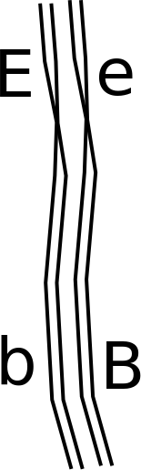

Rubric:

1pt: two homologs

1pt: replicated

1pt: synapsed

2pt: correct allele placement

6. Answer the questions below regarding the cell to the right.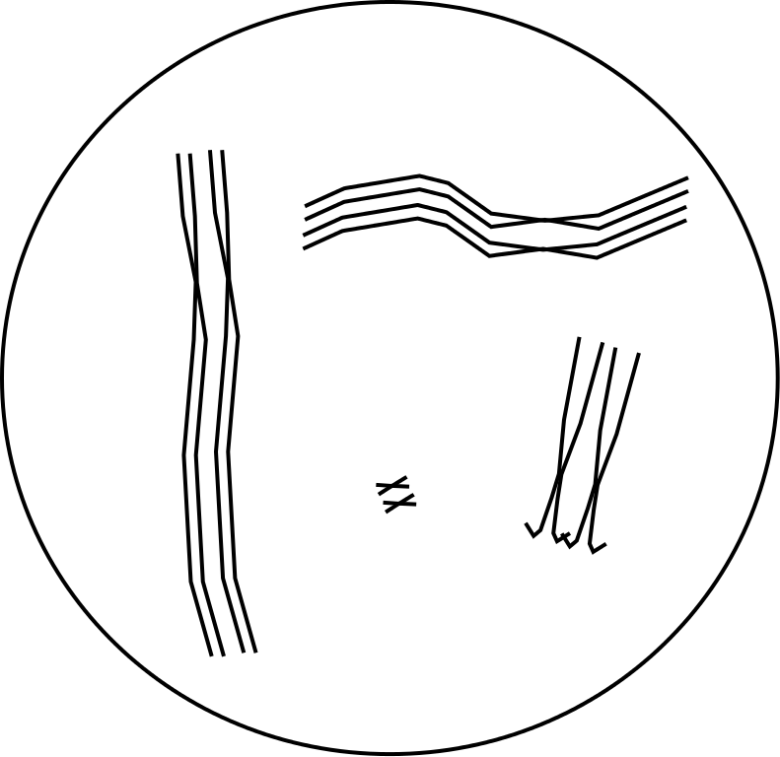

(14 pts)

a. What is the cell's ploidy? (1 pt) **2 or Diploid**

b. What is the cell's haploid number? (1 pt) **4**

c. This cell is undergoing (circle one): (1 pt)

mitosis meiosis I meiosis II

**meiosis I**

d. What phase is the cell in? (1 pt) **Prophase**

e. The cell's genotype is *bAhRG*//*BahRg* *TQD*//*Tqd* *FfYY*.

Place the alleles on the chromosomes (relative to each

other). (8 pts)

**8pts: 1 pt for each chromosome**

f. If crossing over occurs between the *h* and *R* genes,

what are the recombinant gamete genotypes (you only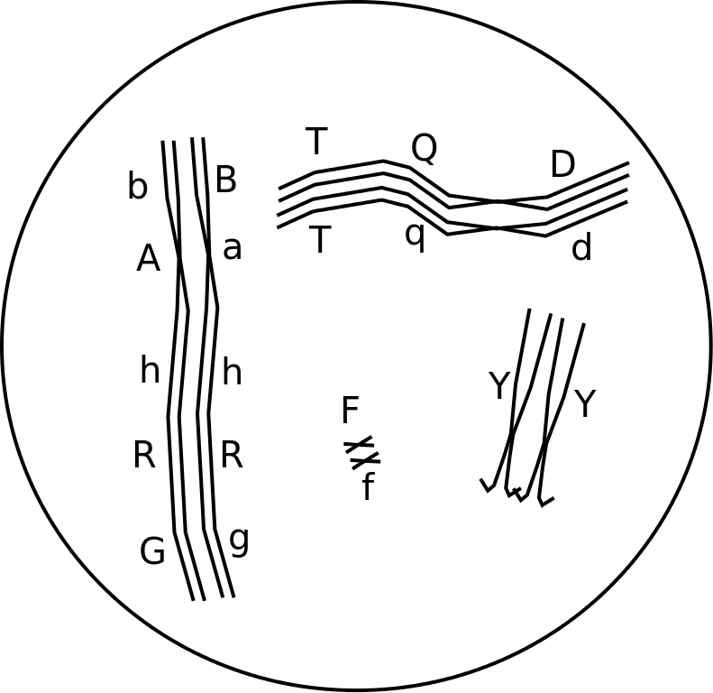

need to write the genotype for the chromosome involved

in the cross over)? (2 pts)

***BahRG* *bAhRg***

**Rubric:**

**1pt: Both alleles listed in correct order**

**1pt: Underlining to show linkage**

7. V1 The pedigree below is for a human genetic disease (square = male, circle = female, gray = normal phenotype, black = disease phenotype). (6 pts)

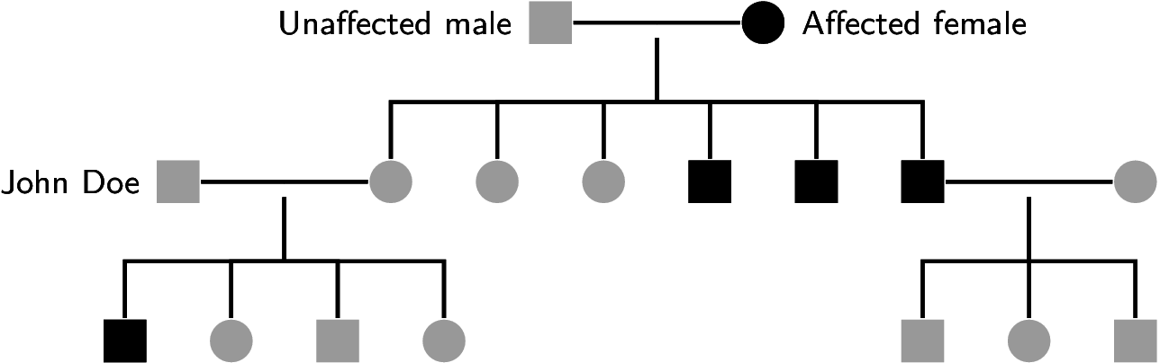

a. The allele that causes the disease is most likely (circle one): (1 pt)

autosomal X-linked

**X-linked**

b. The allele that causes the disease is (circle one): (1 pt)

recessive dominant

**recessive**

c. Using “*A*” to represent the dominant allele and “*a*” to represent the recessive, what are the genotypes for:

The “affected female” at the top of the pedigree? (2 pts) **X*a*X*a***

The individual labeled as “John Doe”? (2 pts) **X*A*Y**

7. V2 The pedigree below is for a human genetic disease (square = male, circle = female, gray = normal phenotype, black = disease phenotype). (6 pts)

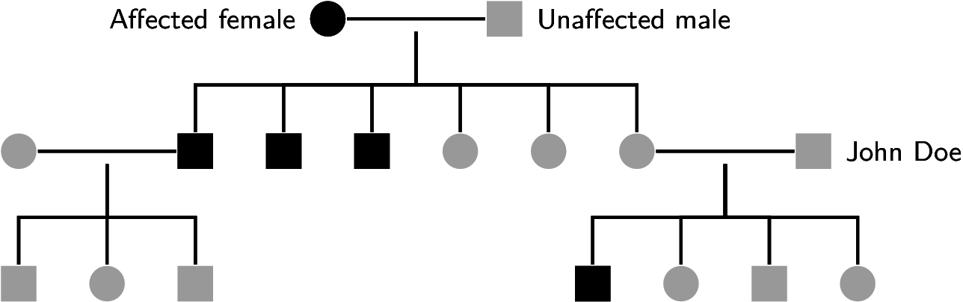

a. The allele that causes the disease is most likely (circle one): (1 pt)

autosomal X-linked

**X-linked**

b. The allele that causes the disease is (circle one): (1 pt)

recessive dominant

**recessive**

c. Using “*A*” to represent the dominant allele and “*a*” to represent the recessive, what are the genotypes for:

The “affected female” at the top of the pedigree? (2 pts) **X*a*X*a***

The individual labeled as “John Doe”? (2 pts) **X*A*Y**

8. Explain how a mutation in the regulatory region of a gene can affect phenotype. (4 pts)

**It can alter if, when, and how much the gene gets expressed.**

**Rubric:**

**2pt: changes**

**2pt: expression**

9. Compare and contrast how independent assortment and crossing over create genetic variation. (8 pts)

**Independent assortment occurs when synapsed homologs are oriented randomly during metaphase of meiosis one; this leads to new combinations of maternal and paternal chromosomes. Crossing over occurs when synapsed homologs exchange genetic material between non-sister chromatids; this leads to new mixtures of maternal and paternal alleles along chromosomes.**

**Rubric:**

**2pt: Independent assortment is caused by randomly aligning of homologs, which leads to**

**2pt: random assortments of maternal and paternal chromosomes (variation among chromosomes)**

**2pt: crossing over occurs when homologs swap sections of DNA, which leads to**

**2pt: new combinations of maternal and paternal alleles along chromosomes (variation within chromosomes).**