Ultrafast nonlinear dynamics
J. Matres, C.J. Otón, G. Ballesteros
I.U. de Tecnología Nanofotónica, Universidad Politécnica de Valencia, Building 8F 1st Floor
Camino de Vera, s/n 46022 Valencia, Spain
Joaquin Matres (joamatab@ntc.upv.es)
ABSTRACT:
In this paper we present a high resolution (1ps) heterodyne technique to characterize the nonlinear amplitude and phase response of any optical system or device. We have used this technique to observe the nonlinear response of a free-carrier-based ultrafast CMOS-compatible all-optical modulator with 10dB extinction ratio and 1/e temporal response of 150 ps.
Keywords: Heterodyne, pump and probe nonlinear characterization; nonlinear silicon photonics; Kerr; free carriers; all-optical modulation; optical switch ; CMOS-compatible; Nonlinear

1.- Introduction
Integrated silicon-based optical devices have recently emerged as a feasible technology to route, switch and modulate signals in optical networks, which are expected to dramatically reduce device costs and provide new functionalities [1]. However the main limitation in these devices is that ultrafast effects, such as Kerr, require so high powers that free-carriers are generated through two-photon absorption (TPA), limiting the speed of commutators [2], logic gates [3], etc.
To solve this limitation there are several techniques to sweep this carriers, the most common of them is to create a reverse biased PN junction.[4]
In this work we present two different nonlinear experiments to characterize the dynamics of nonlinear effects such as Kerr, cross absorption modulation and free-carrier dispersion. In the first experiment we will observe the phase and amplitude response of high power pulses (pump) over low power pulses (probe). The other experiment is optical switching; it is also based on controlling a low-power signal (probe), through high power pulses (pump).

2.- Fabrication
The samples used were fabricated from SOI wafers with 3 μm buried oxide and 250 nm silicon layer. The waveguides were patterned with e-beam lithography and etched with an inductively coupled plasma (ICP) etcher. The structures were covered with 2μm of silica after SEM characterization. The channels are 500 nm wide and 250 nm high, and are coupled to 20μm-radius rings through a 300 nm gap. Light was coupled into the waveguides by butt-coupling with lensed fibers, and was extracted with an objective. The TM transmission spectrum was measured by tuning the laser, and the result is shown in Fig. 1, where one resonance is shown. The response was fitted to the theoretical equation [5] by using the propagation loss and coupling coefficient as parameters. A good agreement was found for propagation loss of 30dB/cm and coupling coefficient of 16%. Full width at half depth (FWHD) of the peak was 174 pm, which corresponds to a Q-factor of 8839.

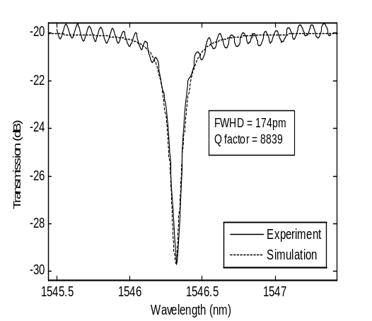
Fig. 1: Transmission spectrum of the ring resonator sample (TM polarization ). Solid line is the experimental data and dashed line is the result of the simulation when setting propagation loss to 30dB/cm and coupling coefficient to 16%.

2.- Experiments

2.1.- Heterodyne characterization
In order to study in with great detail the nonlinear effects response, both in phase and module, we used an heterodyne characterization setup. The set up (Fig. 2) consists of a series of probe pulses that are affected by a high power pulses (pump). Varying the pump pulses with respect to the probe ones we can see the module and phase response of nonlinear effects such as Kerr, cross absorption modulation and Free-carrier dispersion.

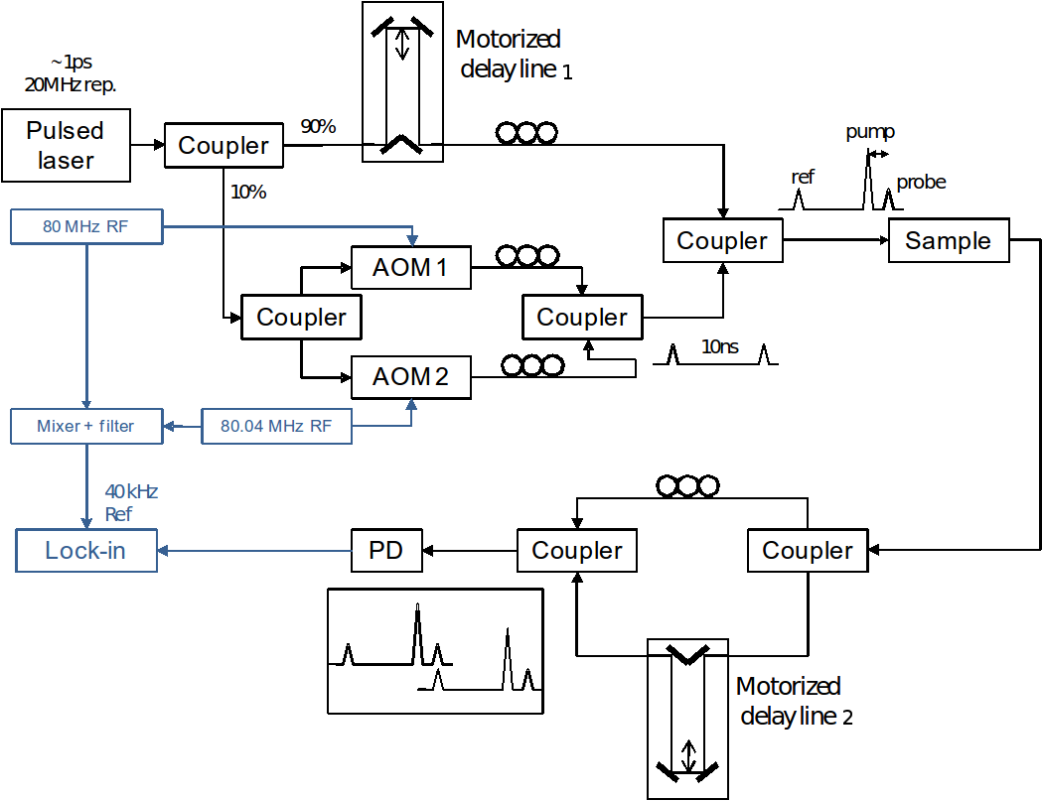
Fig. 2: Characterization setup. Blue: RF signals, black: optical signals. Motorized delay line 1 was used to modify the position of the pump pulses respect the probe ones.
The initial pulse is divided into three pulses: two weak ones (a reference and probe separated 10ns), and one pump pulse, situated close to the probe pulse, and whose temporal position with respect to the probe can be varied. The reference and probe pulses are recombined after passing through the sample, and the beatings they produce are collected in the lock-in. The 40KHz beatings are produced because the wavelengths of probe and reference signals are slightly different, as both are shifted with acusto-optic modulators which work at frequencies that only differ by 40 kHz. The amplitude and the phase of the signals are simultaneously monitored.
The amplitude collected is proportional to the amplitude of the probe pulse with respect to the reference, and the phase of the beatings corresponds to the phase shift produced by the pump to the probe pulse, considering the reference pulse as unaffected by the pump, and thus using it as a reference for the phase measurement.

2.2.- All-optical switching

The setup for the all-optical switching experiment is shown in Fig. 3. A tunable laser was modulated with a LiNbO3 modulator and amplified through Er-doped fiber amplifiers (EDFAs). The pulse train was generated with a 40Gb/s bit pattern generator, where pulses had 45 ps duration and 6.4 ns period. The peak power coupled into the waveguide was estimated to be 85 mW. A continuous-wave (cw) probe signal was mixed with the pump with a 3 dB coupler and sent to the waveguide through the same fiber with an estimated coupled power of 0.5 mW. Wavelengths of pump and probe signals were respectively 1564 and 1554 nm, chosen to match with two resonances of the microring resonator. The output signal was filtered to remove the pump component and amplified before sending the signal to a 50 GHz photodiode and collecting the data with a 40GHz sampling scope.
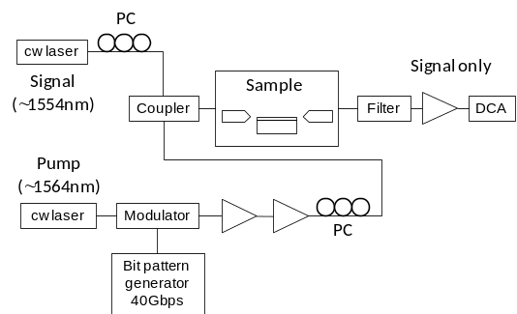
Fig. 3: Characterization setup. Blue: RF signals, black: optical signals. Motorized delay line 1 was used to modify the position of the pump pulses respect the probe ones.

3.- Results

3.1.- Heterodyne experiment
In Fig. 4 we can see observe both Kerr and carriers effect. They produce opposite phase shifts because Kerr produces an increase in refractive index (∆n > 0) and carriers decrease it (∆n < 0).
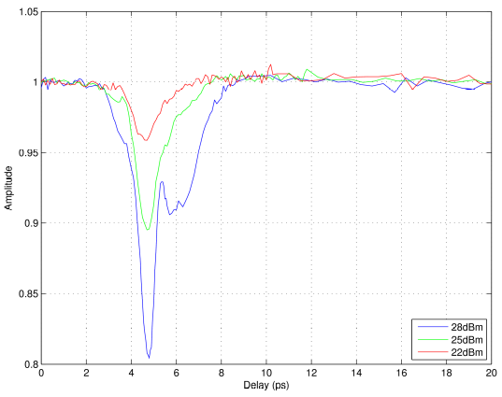
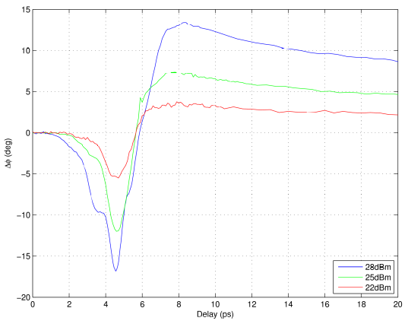
Fig. 4: Sample response for different waveguide pump peak powers
Peak powers in the waveguide are estimated from -11dBm power at the lensed fiber used to inject light into the chip. Assuming 8dB coupling losses per chip facet we obtain -19dBm average power at the input waveguide. To obtain peak powers from average powers we have to multiply by a factor of 50,000 (47dB) because pulses had 1ps width and were separated 50ns.
Fitting the carriers decay time to a double exponential, we can clearly observe two tendencies with different recombination times. One of them is very fast (8ps time constant) whereas the other is much slower (123 ps). (See Fig. 5)

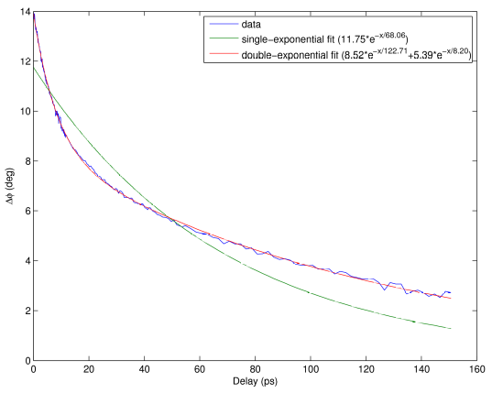
Fig. 5: Free carriers decay in sample NTC02. As we can see two-exponential fit must be done to simulate two very different recombination times. One exponential fit is not able to follow both tendencies.

3.4.- Switching experiment
Figure 6 shows the modulation in the probe signal produced by the pump when both pump and probe are resonant with the microring. Extinction ratio is 10.2 dB and the 1/e recovery time is 150ps. The reason for the modulation is carrier generation through two-photon absorption (TPA), which produces a decrease of refractive index that blueshifts the resonance, taking the cw probe from a resonant to a non-resonant regime.

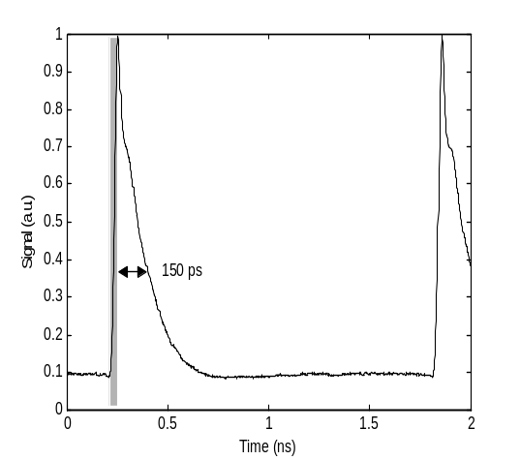
Fig. 6: Variation of the probe signal when both pump and probe are resonant with two different modes of the microring. The grey box marks the pump duration.

An approximate value of the carrier recombination time was extracted from the 1/e recovery time, which is 225 ps. This recombination rate is quite faster than values previously reported [6,7], and defects is the most likely cause. Whether these defects are surface recombination centers or produced by the electron bombardment during SEM is currently under investigation.

4.- Conclusion
We have implemented a time-resolved characterization of the phase and amplitude using an heterodyne setup, that allow us to measure amplitude and phase responses with 1ps resolution. With this technique Kerr effect and cross absorption modulation, which are instantaneous, are clearly distinguished from the free-carrier absorption and dispersion effect, which are slower. This setup also provides a very precise way to characterize the carrier recombination time when it is below 500ps, which would be very difficult to do with a direct technique.
We have used this technique to characterize an integrated all-optical switch based on free carrier dispersion effect with a switch time of 150ps. The device uses a microring resonator to enhance the nonlinear effect and to commute the signal, producing ~10dB of extinction ratio.

Acknowledgements: This work has been sponsored by the Spanish Science and Innovation Ministry through SINADEC (TEC2008-06333) and DEMOTEC (TEC2008-06360) contracts.
References
[1] R. Soref, "The past, present, and future of silicon photonics" IEEE J. Sel. Top. Quantum Electron. 12 (6), pp. 1678-1687 (2006).[1] C. J. Oton, J. Matres et al. ``150 ps all-optical switching in silicon microring resonators”, European Conference on Integrated Optics, Cambridge, April 2010.
[2] C. J. Oton, J. Matres et al. ``150 ps all-optical switching in silicon microring resonators”, European Conference on Integrated Optics, Cambridge, April 2010.
[3] C. J. Oton, J. Matres, A. Martinez, P. Sanchis, J. Marti, ``Ultrafast all-optical logic gates with silicon nanocrystal-based slot waveguides”, IEEE Group IV Photonics Conf., Beijing, China, September 2010.
[4] A. C. Turner-Foster, M. A. Foster, J. S. Levy, C. B. Poitras, R. Salem, A. L. Gaeta, and M. Lipson, ``Ultrashort free-carrier lifetime in low-loss silicon nanowaveguides” Opt. Express 18 (4), 3582-3591 (2010).
[5] J. Heebner, R. Grover, T. A. Ibrahim, “Optical microresonators” Springer Series in Optical Sciences Vol. 138, Springer-Verlag, London 2008.
[6] V. R. Almeida, C. A. Barrios, R. R. Panepucci et al., "All-optical control of light on a silicon chip" Nature 431, pp. 1081-1084 (2004).
[7] Q. F. Xu and M. Lipson, "All-optical logic based on silicon micro-ring resonators" Opt. Express 15 (3), pp. 924-929 (2007).

