COMPOSING IN AMBISONICS
A Guide to Spatial Thinking, Listening, and Working in 3D Audio
ICST — Institute for Computer Music and Sound Technology / ZHdK Zurich
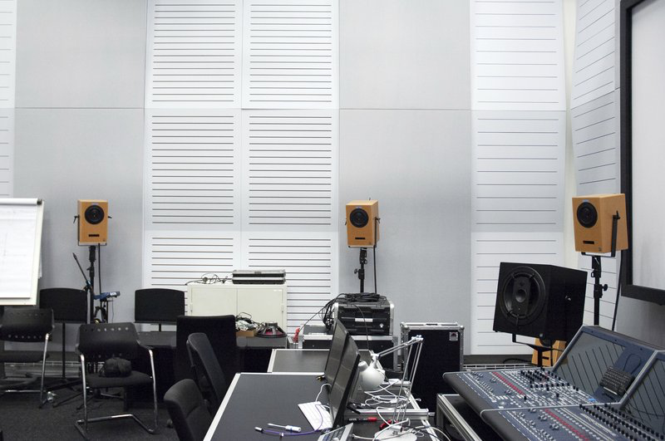
ICST Composer Studio, Zurich University of the Arts
ambisonics.ch

Opening Statement
Ambisonics makes it possible to treat space as an independent compositional material — on equal footing with timbre, time, and dynamics. Sources approach, separate, stratify in height and depth: these are not technical effects but formal decisions.
The B-format decouples a work from any specific loudspeaker layout. The same Ambisonics master can be rendered for a 32-channel dome, an eight-channel ring, binaural headphones, or VR environments — without rebuilding the spatial dramaturgy from scratch. This makes Ambisonics the most sustainable archival format for 3D audio content: a single master that encompasses present and future listening contexts.
Ambisonics is not a format among many. It is a commitment to spatial thinking — now and over time.

This guide covers spatial thinking, listening, and working in Ambisonics — from FOA/HOA context and acoustic gestalt to spatial counterpoint, tools, and studio practice. It is not a linear textbook, but a compositional workspace in text form connecting historical context, compositional questions, and technical toolchains.
Composing in Ambisonics means treating space not merely as a distribution system, but as a form-building parameter. Sources can approach, separate, rise, cluster, or act as independent voices within a shared sound field.
3D Ambisonics offers more freedom than channel-based formats, both artistically and technically. Instead of composing for fixed loudspeaker channels, you work with a continuous sound field in which direction, distance, height, and movement become part of the musical material itself. A single Ambisonics master can be rendered for different loudspeaker systems, dome setups, binaural headphone playback, or immersive contexts — without rebuilding the piece from scratch.

Reading Paths
- For a first entry point: History of Ambisonics: FOA and HOA → 10 Questions in 3D Space → The Acoustic Gestalt of a Sound
- For piece development and composition: 10 Questions → Spatial Counterpoint → Spatial Parameters as Compositional Material → Comparing Compositional Spatial Strategies
- For production and setup: Tools and Software → Ambisonics Studio Practice at ICST
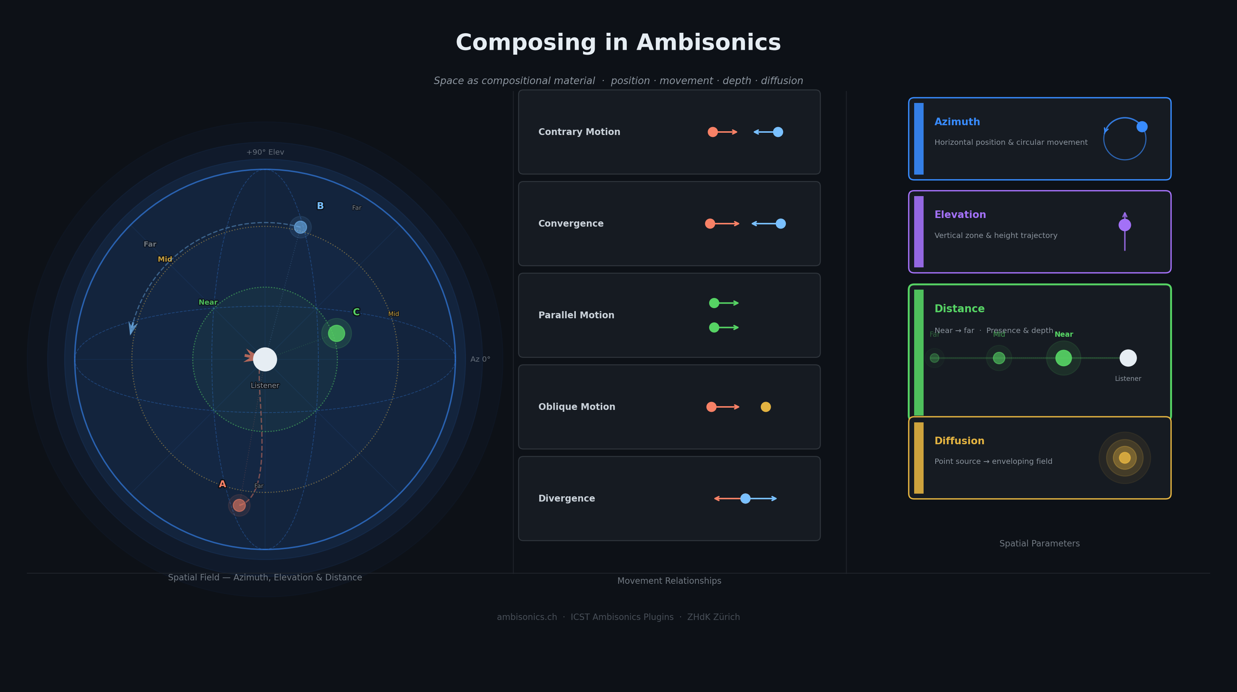
Composing in Ambisonics: spatial field, movement relationships, azimuth, elevation, distance, and diffusion.

1. Analytical Listening
Analytical listening is the prerequisite for compositional action. Before spatial trajectories, layering, and perspectives can be used deliberately, a vocabulary must develop for describing, distinguishing, and translating spatial events into one's own practice.

Three levels of spatial listening: perspectival space, source-bonded space, spectral space.

Listening with Compositional Intent
Listening to music with compositional intent means asking not only: What am I experiencing right now? — but: How was this experience produced? Which parameters were used? What decisions lie behind it?
For spatial music, this means actively opening up an additional layer alongside the familiar dimensions of pitch, rhythm, timbre, and dynamics:
- Where are sounds located at each moment?
- How do they move through space?
- How dense is the space at different moments?
- What relationships exist between several simultaneous sources?

Smalley's Space-Form Categories
Denis Smalley's concept of space-form (1997, 2007) remains one of the most useful frameworks for analysing spatial electroacoustic music. He distinguishes three types of spatial experience:
Perspectival space refers to the experience of an imagined acoustic location: the sense of being inside a cathedral, a forest, a tunnel, or an abstract volume of sound.
Source-bonded space describes space that is tied to recognisable sound objects — the distance of a voice, the position of an instrument, the movement of a footstep. This category is particularly relevant compositionally because it treats localisation as a narrative resource.
Spectral space arises not from localisation but from the spatial distribution of spectral qualities: high frequencies in the upper hemisphere, low frequencies on the floor.

Parameters as Analytical Categories

Dimension | Listening Question | Compositional Parameter
Azimuth / direction | Where does the sound come from horizontally? | Azimuth in the encoder
Elevation | Is the sound above, below, or at ear level? | Elevation in the encoder
Distance | How near or far does the source sound? | Distance / Gain
Diffusion / Spread | Point-like or spread, sharp or cloud-like? | Spread / Diffusion
Movement | Static, rotating, linear, ascending? | Automation, trajectory
Layering | How many levels, how stable? | Groups, layer logic

Analytical Listening Protocol for Composers
Five questions applicable to any piece:
- How is the space organised? Symmetrical or asymmetrical? Are there clear foreground/background relationships?
- What moves, what remains still? Which parameters — azimuth, elevation, distance — are used for movement?
- How is density controlled? Where is the threshold between clarity and cloud — and is it intentional?
- What layering is present? How many simultaneous levels are audibly distinguishable?
- How does space structure time? Which spatial events correspond to formal boundaries, climaxes, transitions?

2. History of Ambisonics: FOA and HOA
Working with Ambisonics means working within a historical field, not just with a technique. For composers, the distinction between FOA and HOA is especially important: FOA is the historical basis and remains a robust production format today; HOA is the later systematic expansion toward higher spatial resolution and more flexible rendering.

Key Reference Points
- FOA is the historical root and remains a practical format for teaching, sketching, production, and distribution.
- HOA effectively emerges as a modern field from around 2000 onward, marking a methodological shift toward higher spatial resolution.
- Compositionally: not every work needs HOA, but many current immersive forms only become truly flexible through it.

Key Institutes and Centers
- Oxford / Michael Gerzon's circle — the historical starting point where the foundations of Ambisonics were decisively shaped in the 1970s.
- IEM Graz — one of the central hubs for HOA, Ambisonics standards, symposia, and the international community around immersive audio research.
- ICST Zurich — connects research, composition, and tools with particular practical depth, through the ICST Ambisonics Tools and Plugins and the Composer Studio.
- IRCAM Paris — important for spatial sound, virtual acoustics, and artistic spatialization workflows.
- ZKM Karlsruhe — central site for spatial sound art and performance practice, with the Sound Dome.
- CCRMA Stanford — major node for research, teaching, and artistic practice in spatial audio.

Key Concert and Production Venues
Important venues where Ambisonics and related spatial audio practices become artistically present:
- ZKM Sound Dome, Karlsruhe — one of the most important concert venues for spatial electroacoustic music.
- IEM CUBE, Graz — central space for HOA projection, research, and artistic presentation.
- ICST Composer Studio, Zurich — production and residency site, internationally relevant for Ambisonics composition.
- IRCAM, Paris — key site for artistic spatial audio practice.
- NOTAM Spatial Audio Studio, Oslo — important production site for artistic Ambisonics work.
- EMS Elektronmusikstudion, Stockholm — central site for electroacoustic music.
- EMPAC, Troy, New York — one of the most important North American sites for large-scale spatial audio.
- Satosphere / SAT, Montreal — globally influential for immersive artistic practice with dome formats.

What This Means Practically for Composers Today
For compositional practice, this history explains why Ambisonics work today almost always mediates between three levels: format and order (FOA or HOA), concrete performance context (dome, studio, binaural, mobile setup), and toolchain (DAW, encoder, decoder, monitoring, automation).
Composing in Ambisonics today means deciding not only about sound material, but also about spatial resolution, playback context, and the transferability of a work to other setups.

3. The Acoustic Gestalt of a Sound
Before turning to Spatial Counterpoint, it helps to pause at a more basic perceptual question: what makes a sound object feel like a coherent gestalt in the first place? In Gestalt psychology, a gestalt is not merely the sum of isolated parts, but a perceivable unity that stands out from its background.
For listening, three principles are especially important:
- Prägnanz / good form: we tend to perceive clear, stable, and well-organised structures
- Proximity and similarity: elements that resemble one another or are close in time and space are more likely to be heard as belonging together
- Continuity: movements and transformations are more readily perceived as connected lines or processes

Sound Gestalt: Spectrum, Envelope, Pitch
In listening, a sound object is usually recognised through three closely linked dimensions:
- Spectrum: the distribution of frequency components, or what we hear as timbre
- Temporal envelope: attack, sustain, and decay
- Pitch or pitch contour: a stable tone, vibrato, glissando, or other pitch movement

Space as a Fourth Dimension
In many older models, space appears only as a neutral container. For Ambisonics, that is too limited. Space often belongs to the constitutive identity of the sound itself.
- Direction: the same sound is perceived differently from the front, back, side, or above
- Distance: nearness and farness change presence, intimacy, brilliance, and function
- Movement: a moving sound has a different identity from a static one, even if spectrum and envelope remain unchanged

Figure and Background
Spatial listening also follows a figure/background logic. A near, sharply localised, or moving sound tends to emerge as figure; a distant, static, or diffuse sound tends to become background. That makes spatial hierarchy composable:
- Foreground voices can be placed close and clearly
- Textures can be pushed back through distance and diffusion
- Transitions between figure and background can become formal events in themselves

Toward Spatial Counterpoint
This is exactly where Spatial Counterpoint begins. If space belongs to the gestalt of a sound, then the spatial relations between several sound gestalts can also be composed: separation and overlap, approach and escape, layering, density, and dissolution.
That shift turns space from a playback condition into a genuine material of voice-leading and form.

4. Psychoacoustic Foundations of Spatial Perception
Spatial composition presupposes that perceptual effects can be achieved reliably. This chapter provides an overview of the key mechanisms of spatial perception and derives concrete consequences for composing in Ambisonics.

The Binaural System: Horizontal Localisation
The first and most fundamental mechanism of spatial perception is binaural: the brain compares the signals reaching both ears and evaluates the differences to determine horizontal positions.
ITD (Interaural Time Difference) refers to the difference in arrival time of a sound event between the left and right ear. It is the dominant localisation cue especially at low frequencies (below approximately 1.5 kHz).
ILD (Interaural Level Difference) describes the level difference between both ears caused by the acoustic shadow of the head. ILD is particularly effective at high frequencies (above approximately 1.5 kHz).
Compositional consequence: Narrow-band low tones are difficult to localise laterally. When compositional clarity is needed — for instance a clearly led counterpoint — it helps to use material with sufficient energy in the mid and high frequency range.

HRTF: Elevation and Front-Back
For elevation (up/down) and for resolving front-back ambiguity, the Head-Related Transfer Function (HRTF) is responsible. HRTFs describe how the outer ear, head, and shoulders colour incoming sound spectrally depending on its direction.
Compositional consequence: Elevation gestures are effective but fragile. For compositional impact, it helps to combine elevation differences with other cues — such as distance or movement changes — to stabilise the percept.

Distance Perception: Multiple Cues
Distance is not determined by a single mechanism, but by the interplay of several cues: D/R ratio (direct-to-reverberant), loudness, air absorption, and spectral brightness.
Compositional consequence: The strongest sense of distance arises from the combined control of D/R ratio, level, and spectral brightness. Only shifting several cues simultaneously makes nearness and farness convincingly perceptible.

Envelopment and Source Width: LEV and ASW
LEV (Listener Envelopment) is the sensation of being surrounded by sound. It is produced primarily by late lateral reflections. ASW (Apparent Source Width) describes how wide a source appears and is determined primarily by early lateral reflections.
Compositional consequence: Envelopment arises only from diffuse energy — from textures, reverberation, and layers arriving from all directions simultaneously.

5. Spatial Parameters as Compositional Material
The concept of Spatial Counterpoint understands space as a relational and form-generating principle of musical organization. The B-format makes it possible to conceive spatial constellations as abstract structures and to fix them independently of any concrete playback system.

Four fundamental parameters of spatial composition: azimuth, elevation, distance, and diffusion.

B-Format as a Compositional Storage Medium
The B-format was developed within the framework of Michael Gerzon's Ambisonics theory and serves as the central signal format for encoding spatial audio data. Its mathematical basis lies in the description of sound fields by means of spherical harmonics. The format functions as an intermediate representation between recording, processing, and playback.
In the narrower sense, the B-format refers to the four-channel first-order Ambisonics format consisting of the channels W, X, Y, and Z. W represents the omnidirectional pressure component; X, Y, and Z encode the directional components along the three spatial axes.

The Five Parameters
Azimuth describes the horizontal position of a sound source. Compositionally, it enables lateral separation, approach, crossing, and contrary motion. Its psychoacoustic basis lies in the interaction of ITD and ILD.
Elevation refers to the vertical position and extends horizontal organisation by an independent layer. Height can serve to separate sound layers, establish hierarchies, or produce specific spatial qualities.
Distance determines the degree of nearness and farness. It affects presence, depth stratification, and perspectival perception — near sounds may be experienced as immediate and bodily, while distant sounds appear withdrawn or atmospheric.
Diffusion refers to the degree of spatial extension or focus. A sound may appear punctual and precise, hover as a diffuse cloud, or spread broadly without clear boundaries.
Movement as Form: Spatial parameters rarely operate in isolation. Movements arise through temporal changes in azimuth, elevation, distance, and diffusion. Movement itself becomes a form-generating process: approach, rotation, ascent, flight, or circling can assume motivic, dramaturgical, and structural functions.

Two perspectives on space: space as effect (left) vs. space as compositional material (right).

6. Spatial Counterpoint
Spatial counterpoint is the attempt to make extension, position, and movement into compositional parameters equal in standing to pitch, time, dynamics, and timbre. Space is not merely a stage or a distribution system; it becomes a formal force in its own right.
Two sound objects may be tonally consonant but spatially dissonant. A perfect fifth remains harmonically stable, but if the two voices are too close spatially, they may blend into an overlap in which neither can be heard as a distinct line.

Principles of Spatial Counterpoint
Spatial counterpoint rests on the independence of voices, organized primarily through:
- Angular separation — how well two sources remain distinguishable laterally
- Height stratification — helps keep voices separate when the horizontal plane is already dense
- Distance — not only a change in level; also shifts brilliance, presence, and perceived intimacy
- Movement — can separate voices, connect them, or cause them to collide deliberately

Movement Types as Spatial Voice-Leading

Movement Type | Description | Spatial Effect
Contrary motion | Source A moves left, source B moves right | Opening, tension, separation
Parallel motion | Both sources move in synchrony | Fusion, mass, coupling
Oblique motion | One source moves, the other stays | Figure/background, asymmetry
Convergence | Sources move toward each other | Sharpening, densification
Divergence | Sources move away from each other | Dissolution, widening

Case Study 1 — Dialogue Between Two Sound Objects
A simple model for spatial counterpoint is a dialogue of two voices: two prepared piano sounds answer each other in a 24-channel ring.
- Phase 1: Question and answer. A makes a short gesture from the left toward center and back; B responds more slowly from the right.
- Phase 2: Approach. Both sources move toward each other and form a momentary spatial condensation at center.
- Phase 3: Dissolution. Both voices rise in elevation and recede into the distance until the dialogue dissolves into a shared diffuse sphere.
The compositional core: when does the dialogue remain two-voiced, and when does it tip into fusion?

Case Study 2 — Three-Voice Spatial Canon
A spatial canon: identical sound material enters multiple times with time offset, but each voice travels a different path through space. This creates a spatial imitation structure — the material stays related, but voices differ through time, position, movement path, and height.

7. Comparing Compositional Spatial Strategies
Once spatial parameters have been defined as individual compositional categories, the question arises of how they are organized within larger formal contexts.

Space as the Separation of Voices
A first fundamental strategy uses space for the differentiation of simultaneous events. Space functions like contrapuntal voice-leading: sources are separated laterally, stratified vertically, or distributed across depth zones so they remain legible as independent lines. Azimuth, elevation, and distance serve primarily to stabilize difference.

Space as Dramaturgy of Movement
A second strategy understands space primarily as temporally shaped movement. Trajectories, transitions, and directional changes move to the foreground: approach, rotation, ascent, flight, convergence, or circling become form-generating processes.

Space as Texture and Envelopment
A third strategy shifts the emphasis from geometry to the texture of space. Diffusion, reverberation character, reflection structure, and field formation come to the foreground. This strategy is particularly productive when space appears less as a path than as a state.

Space as Perspective
A fourth strategy conceives space as an order of perspective. The focus is not only where a sound is, but from which listening situation it is experienced: near or far, inside or outside, frontal or peripheral. Especially in binaural, VR, or interactive contexts, perspective itself becomes a compositional parameter.

Synthesis
Spatial composition cannot be reduced to a single organizational model. A piece may begin with separating voice-leading, move into a dramaturgy of motion, dissolve into diffuse envelopment, and finally be refocused through a changed perspective. It is precisely these transitions that make space an autonomous formal field of musical organization.

8. Ten Questions in 3D Space
The following questions are intended as a compositional worksheet. They are useful not only for analysing existing works, but also for planning your own pieces, during studio sessions, and for documentation.
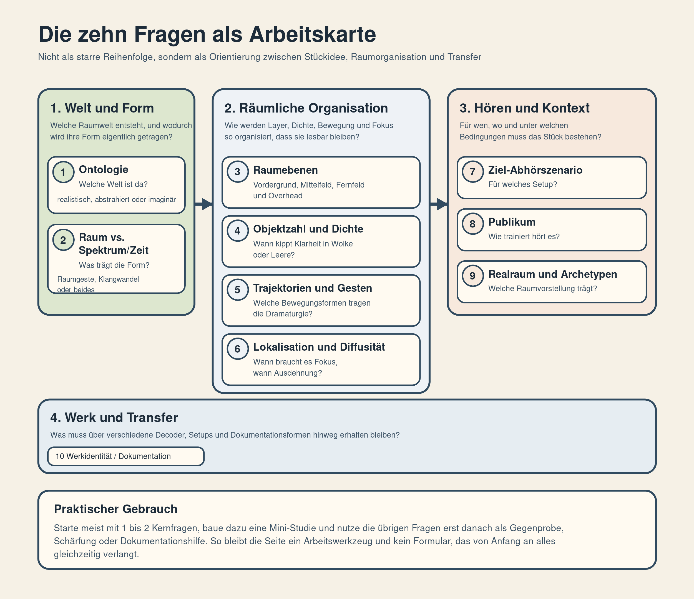
The ten questions mapped as a compositional overview.
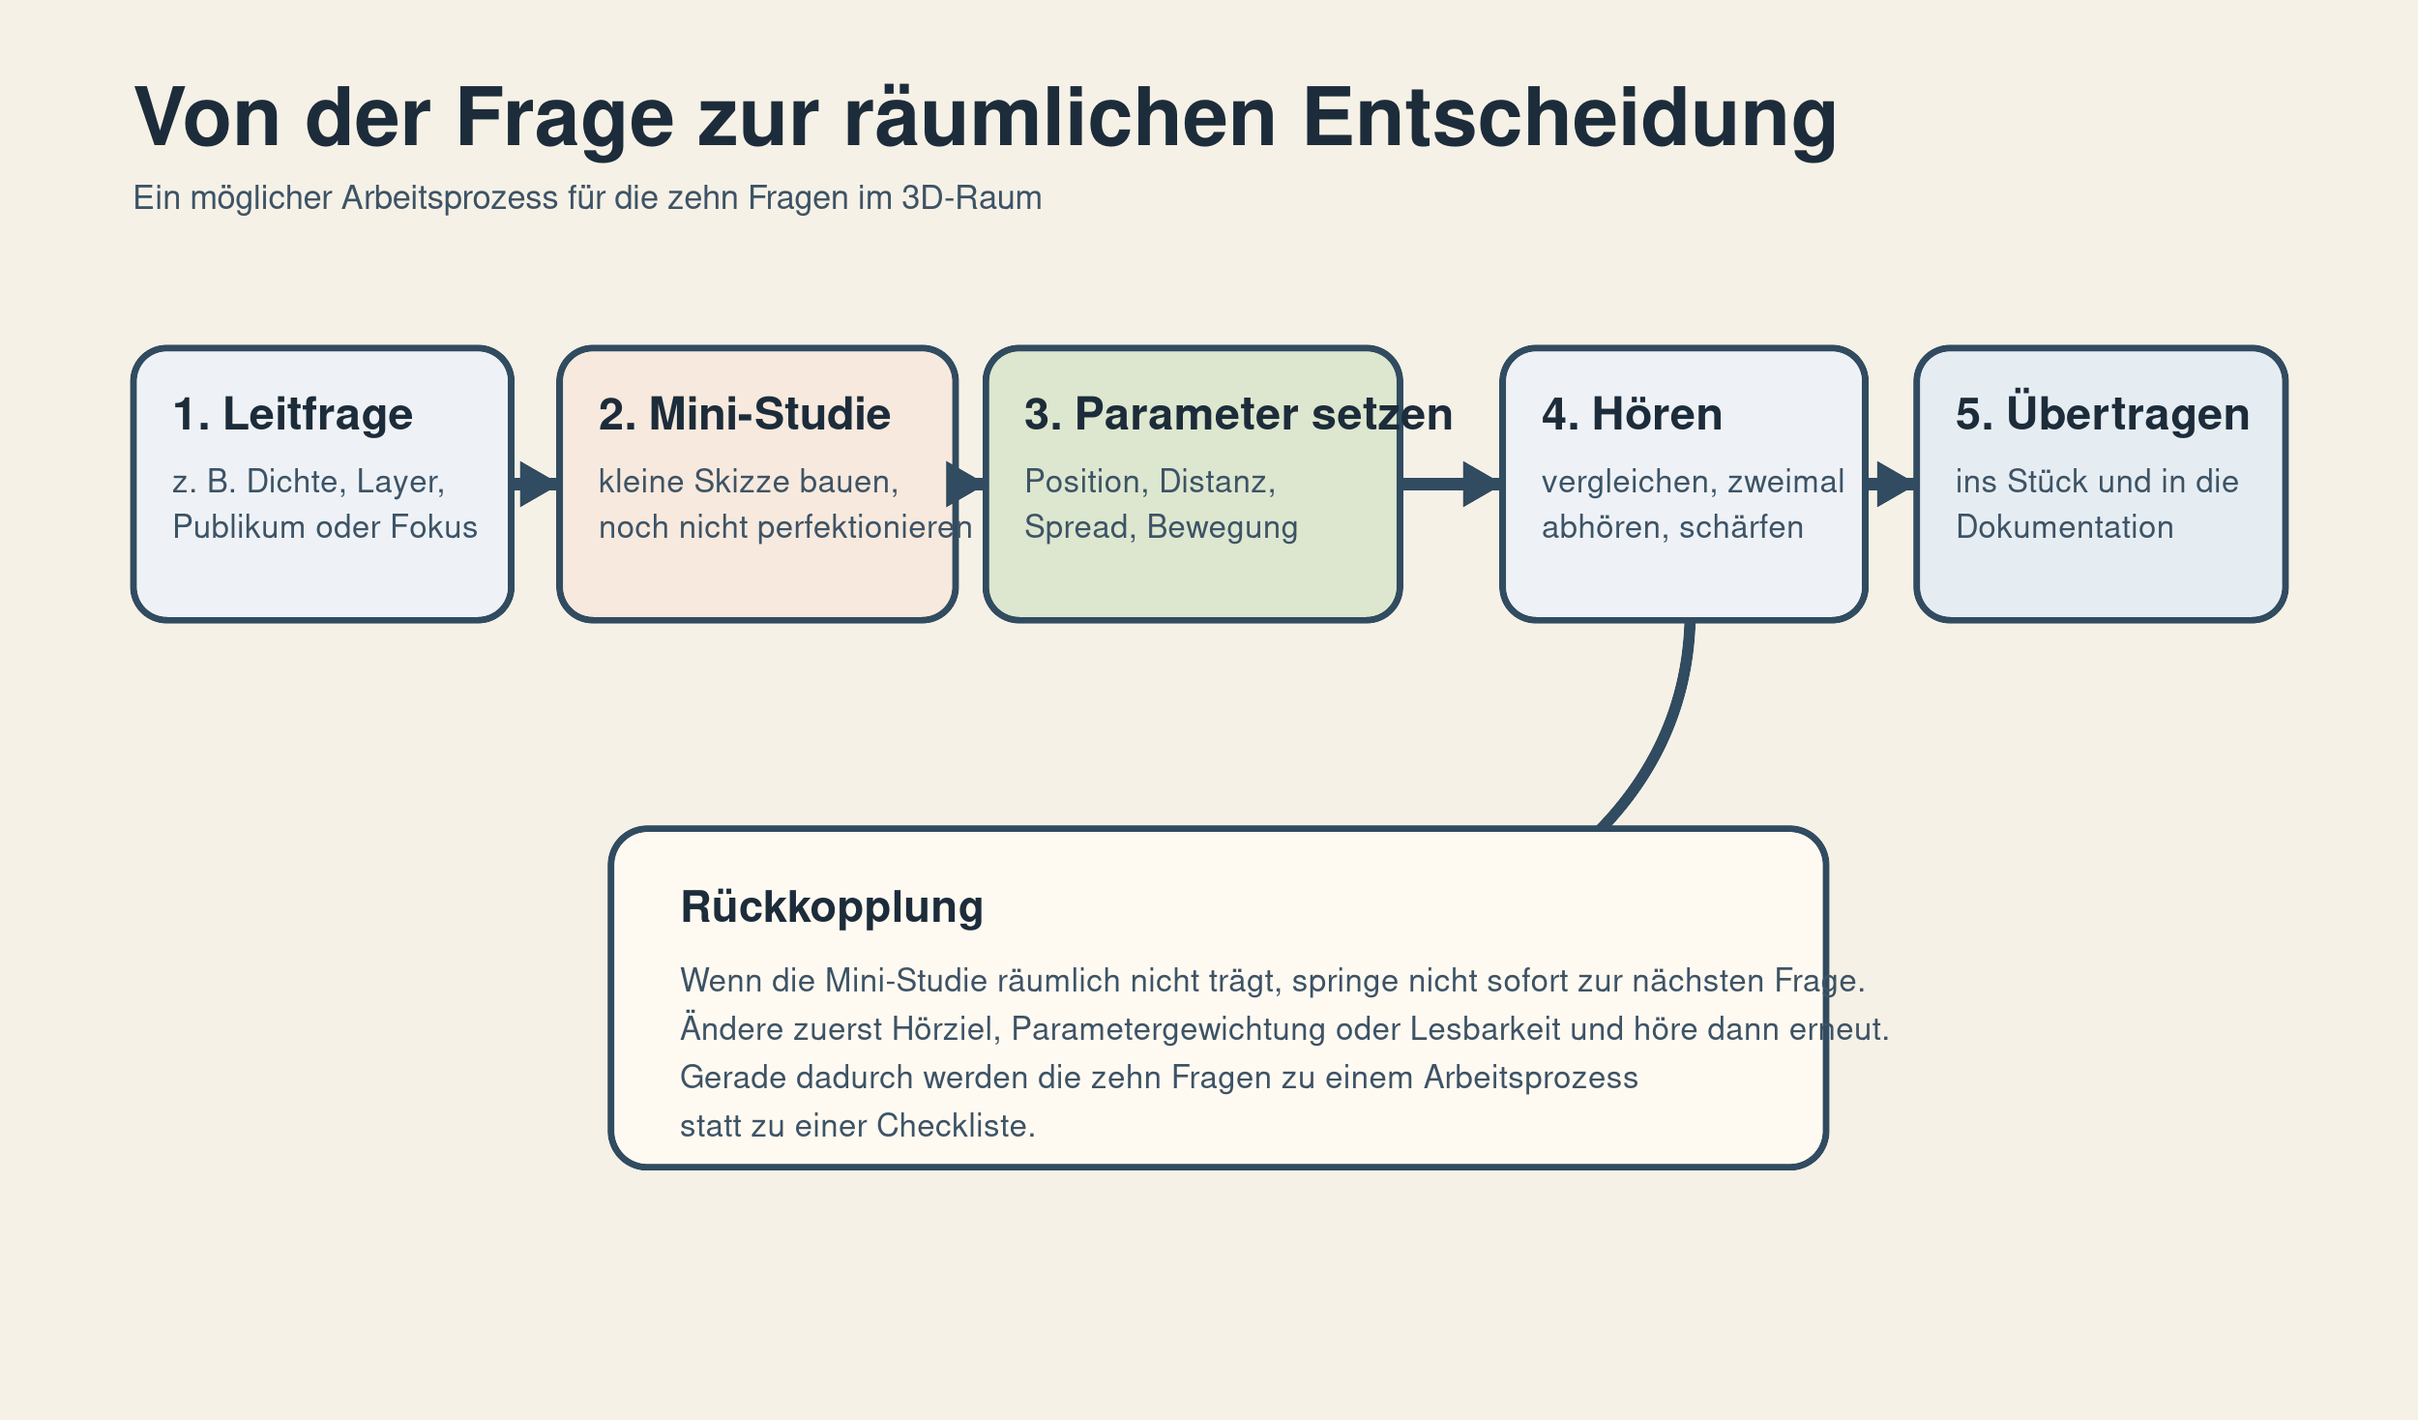
Workflow for applying the ten questions in practice.

Question | Duration | Main Automation | Goal
1. Ontology | 1:30 | Position, Distance, Height | Make material audible in three spatial worlds
2. Space vs. Spectrum/Time | 2:00 | Azimuth, Elevation vs. FX | Compare whether form arises through space or sound transformation
3. Spatial Layers | 1:30 | Distance, Spread, circular motion | Stratify foreground, midfield, and far field
4. Object Count / Density | 2:00 | Number of sources, position | Find the tipping point between clarity and cloud
5. Trajectories | 1:30 | Circle, line, ascent, implosion | Test movement vocabulary as formal markers
6. Localisation vs. Diffuseness | 1:30 | Spread, Distance, Decorrelator | Compose focus and defocus gestures
7. Listening Scenario | 1:00-2:00 | Overhead vs. lateral movement | Make differences between dome and binaural audible
8. Audience | 1:30 | Small vs. large spatial contrasts | Test legibility for different listening habits
9. Real Space / Archetypes | 2:00 | Room character, EQ, reverb | Build tunnel, square, and open sky as archetypes
10. Work Identity | 1:00 | One clear main trajectory | Miniature plus clean documentation for transferability

The Ten Questions in Detail
1. Ontology of the Piece — What kind of world does the piece build in space? Am I working with recognisable places/scenes (city, landscape, interior) or with abstract spatial formations?
2. Role of Space — What primarily carries the form: spatial gestures or spectral-temporal development? Could the piece still work in stereo, or would the form collapse?
3. Spatial Layers — How many distinguishable spatial layers are there? Which zones matter (front, back, above, below, near, far)?
4. Object Count and Density — How full is the space at any given moment? How many active objects can be consciously tracked at once?
5. Trajectories and Gesture Types — Which types of movement appear? Am I using geometric movements (circles, rings, spirals) or gestural movements (approach, flight, circling)?
6. Localisation vs. Diffuseness — When should sounds be pinpoint precise, when diffuse? Are there dramaturgically important moments of maximum sharpness or maximum envelopment?
7. Target Listening Scenario — For which real playback setting am I composing? Which loudspeaker configuration do I have in mind (dome, 5.1/7.1, headphones)?
8. Audience and Listening Experience — How spatially "trained" is the assumed audience? Do contrasts need to be clear and legible, or can they remain subtle?
9. Real-Space Reference and Archetypes — How do I relate to real spaces and spatial metaphors? Am I recreating real spaces, distorting them, or building something physically impossible?
10. Work Identity and Documentation — What actually is the "work" — and how do I document it? Is the HOA master file the actual core, or a specific decoder configuration?

9. Ambisonics Studio Practice at ICST
Composing in Ambisonics does not consist only in selecting individual spatial gestures; it also requires a workflow in which sketching, spatial control, monitoring, archiving, and delivery formats are coordinated with one another.

From Parameter to Session
A piece is conceived as a configuration of sources, groups, trajectories, and perspectives. In the ICST context, work begins with a clear distinction between functions:
- Source tracks for individual sound objects or clearly distinguishable voices
- Groups for related movements or stratifications
- A shared Ambisonics bus as the central spatial working field
- Decoder and monitoring tracks for different listening situations

HOA Order as a Compositional Choice
The HOA order N determines how finely directional information is encoded. As the order increases, the precision of localisation improves; the channel count grows according to (N+1)².

Order | Channels (3D) | Spatial Resolution | Typical Application
1st order (FOA) | 4 | ~45° | Archive, legacy, robust compatibility
3rd order | 16 | ~20° | Standard for production and small dome arrays
5th order | 36 | ~12° | Medium to large dome setups (16–30 speakers)
7th order | 64 | ~8° | High-resolution arrays and precise binaural

ICST recommendation: In the studio context, 3rd order is the standard starting point, as it combines compositional precision, manageable channel counts, and compatibility with most performance venues.

B-Format as Working and Archival Format
The B-format has a double function: it is not only the technical intermediate format of production, but also the central working and archival format. The B-format remains the version in which the spatial relations of the piece are fixed most consistently.
For studio work this means decisions should be tested as early as possible with regard to whether they are coherent in the B-format itself — not only persuasive in one particular decoding. A passage that works convincingly only on one loudspeaker setup, but lacks a clear spatial logic in the Ambisonics master, remains fragile in the long term.

Monitoring as Compositional Control
In Ambisonics, monitoring is not merely a final check, but part of the compositional process itself. A cyclical procedure is helpful:
- Sketch a passage in B-format or through the primary decoding
- Check its legibility, focus, and movement logic through binaural monitoring
- Control its stratification, envelopment, and spatial energy on the loudspeaker setup
- Correct problematic passages within the spatial structure itself, not only at the decoder stage

Multi-Format Delivery and Versioning
A work often requires alongside the Ambisonics master: loudspeaker renders, binaural versions, or documentary derivatives. Useful layers to distinguish:
- Project versions for ongoing compositional work
- The B-format master as the central work and archive version
- Monitoring or performance versions for specific setups (dome, array, binaural)
- Documentation versions for transmission, archive, or teaching

Documentation as Part of Composition
The more strongly a work depends on spatial relations, the more important its documentation becomes. Helpful to record:
- The order and format convention used, for example ACN/SN3D
- Relevant decoder assumptions and monitoring situations
- Central trajectories, group formations, or critical spatial zones
- Screenshots or graphic notes of radar and automation views

10. Tools and Software
Working in Ambisonics almost always means combining a DAW, encoder/decoder plugins, monitoring, analysis, and often binaural or scene-based specialist tools.

Quick Orientation
- For free HOA production: ICST, IEM, SPARTA, ambix, and ATK are the most important ecosystems.
- For composition-oriented work: ICST, IEM, ATK, Audio Brewers, and audioCube bridge precise technical control and creative soundfield manipulation.
- For VR, film, and commercial immersive workflows: SSA, Sound Particles, FLUX:: SPAT, dearVR, Nuendo, and game engines.
- For teaching, DIY, and smaller setups: OAT, ambix, Envelop for Live, and REAPER-based combinations.

Tool | Type | Max. Order | License
ICST Ambisonics Plugins | HOA production, panning, decoding, OSC | Up to 7th (HOA) | Free (ZHdK)
IEM Plug-in Suite | Complete free HOA suite | Up to 7th | Free, open source
SPARTA | Analysis, decoding, DOA, binaural | Up to 7–10th | Free, open source
Ambisonic Toolkit (ATK) | Soundfield kernel composition, FX | 3rd–7th | Free, open source
SSA aX Plugins | Commercial Ambisonics suite | Up to 10th | Commercial
FLUX:: SPAT Revolution | Immersive production & render environment | Up to 7th | Commercial
Envelop for Live | Ableton Live toolchain | HOA | Free, open source
REAPER + plugins | DAW host | Up to 10th | Very affordable

11. References & Further Reading

Books
- Ambisonics: A Practical 3D Audio Theory — Zotter & Frank (2019, Open Access)
- Immersive Sound: The Art and Science of Binaural and Multi-Channel Audio — Rumsey (2012)
- Kompositionen für hörbaren Raum / Compositions for Audible Space — transcript Verlag
- Parametric Time-Frequency Domain Spatial Audio — Pulkki, Delikaris-Manias & Politis (2017)

Key Articles
- Periphony: With-Height Sound Reproduction — Gerzon (JAES, 1973)
- Spectromorphology: explaining sound-shapes — Smalley (Organised Sound, 1997)
- Space-form and the acousmatic image — Smalley (Organised Sound, 2007)
- ambiX — A Suggested Ambisonics Format (IEM, 2011)
- Spatial music composition — Barrett (Oxford Handbook of Computer Music, 2019)

Online Resources
- ambisonics.ch — ICST Ambisonics site with plugins, guide, residencies, and B-format archive
- plugins.iem.at — IEM Plug-in Suite
- ambisonictoolkit.net — Ambisonic Toolkit
- intothesoundfield.music.ox.ac.uk — The Michael Gerzon Story
- github.com/schweizerweb/icst-ambisonics-plugins — ICST Plugins repository

ICST — Institute for Computer Music and Sound Technology
Zurich University of the Arts (ZHdK) | ambisonics.ch

