Project EAL campus

**Background:**

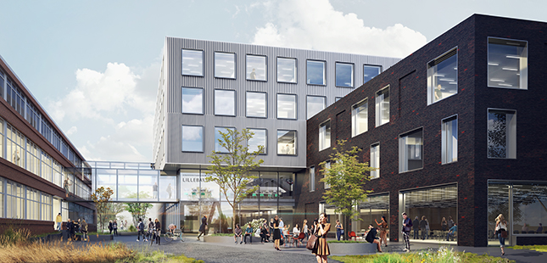

In august 2016 EAL in Odense moved into a brand new campus at Seebladsgade after having been situated in several different locations befor. Now we have been in the campus for some months and as it often turns out there are still some things that could function better. Either there is some unforeseen challenges or maybe things doesn’t work as intended. Anyway, there will always be some issues in a new location.

In this project it is your task to identify problems in the campus, innovate and evolve ideas for solving problems.

Using the skills you have learned you have to describe, analyse, innovate, iterate, work with users, model, prototype, document etc. a problem, your process and solution(s).

The end product will be an exhibition on campus.

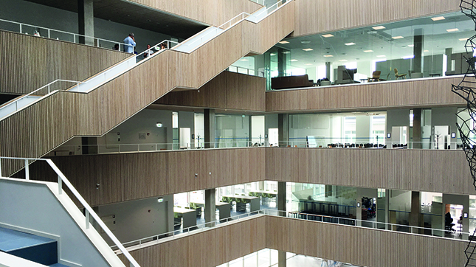

**Purpose:**

The purposes of this project is:

* to provide an opportunity for you to train you skills within the area of planning, business understanding, analysis, innovation, design, modelling and quality assurance.
* to describe ideas for EAL to improve the campus.

**The learning goals from the curriculum included in the project:**

* 1Vf2 Participate in project work
* 1Vf3 Use innovative methods with focus on project work in practical development projects
* 1Vf4 Communicate and explain to both internal and external partners
* 1Vk1 Take part in and understand the relationship between the design of business processes and design of IT systems
* 1Vk2 Collaborate with representatives from the user organisation and the development organisation based on an understanding of business processes and concepts
* 1Vk3 Acquire knowledge about new technology in a business-oriented perspective
* 1Sv1 The importance of experimenting as part of or as supplement to systems development methods
* 1Sv2 The importance of quality criteria for the systems development process and the final systems design
* 1Sf3 Document and communicate product and process – including traceability
* 1Sf4 Ensure quality of product and process
* 1Sf6 Involve users
* 1Sf7 Design relevant user interfaces
* 1Sk1 Participate as a competent member of a development project
* 1Sk2 Reflect on and adapt processes and methods in practice

**The way we work:**

The project should be done in groups of 3-5 persons. It´s the groups own responsibility to manage the time they spent on the project.

tart every project day with a stand up meeting in your group, where you use Round Robin (ordet rundt) to inform the group:

* Topic for the first round: What have I done since last meeting?
* Topic for the second round: What am I expecting to do today?
* Topic for the third round: Which problems do I have/expect to encounter?

By the end of the project day, make sure your project log is up to date. As a minimum the project log has to contain:

* The decisions made during the day
* Contact to counselors/teacher – questions and answers
* Contact to involved persons - questions and answers
* Insights about the problem area

**Make sure that everything you produce in your group is stored in a way that everybody in the group has access to the material at all time.**

***Day 1***

|  |  |
| --- | --- |
| Week 05 | Monday |
| Purpose of the day | Identify Problem to solve |
| Preparation | List all problems we can think off in school |
| Your task | Choose which problem to work with |
| Product of the day | Problem description |

***Day 2***

|  |  |
| --- | --- |
| Week 05 | Tuesday |
| Purpose of the day | Talk to people / groups the problem affects |
| Preparation | Identify people/groups problem affects |
| Your task | Establish communication with the people/ groups the problem is affecting |
| Product of the day | Feedback on problem. |

***Day 3***

|  |  |
| --- | --- |
| Week 05 | Wednesday |
| Purpose of the day | Brainstorm Ideas / Solutions |
| Preparation | Read up on innovation models. |
| Your task | Generate Ideas, using innovation models (Lotus, DIN, Design Thinking, ect…) |
| Product of the day | List of possible solutions. |

***Day 4***

|  |  |
| --- | --- |
| Week 05 | Thursday |
| Purpose of the day | Choose best solution |
| Preparation | Identify weak/strong points for various ideas |
| Your task | Further analyse solutions. |
| Product of the day | A solution, to work with. |

***Day 5***

|  |  |
| --- | --- |
| Week 05 | Friday |
| Purpose of the day | To get feedback from your peers |
| Preparation | A 10 minutes’ presentation of your work until now  Criteria for feedback |
| Your task | Make the presentation. |
| Product of the day | Presentation. |

***Day 6***

|  |  |
| --- | --- |
| Week 06 | Monday |
| Purpose of the day | Expand on solution, and make (another) presentation. |
| Preparation | Gather more information. |
| Your task | Make Presentation for affected people |
| Product of the day | Presentation |

***Day 7***

|  |  |
| --- | --- |
| Week 06 | Tuesday |
| Purpose of the day | Present solution for involved partners, and gather feedback.  Decide if we need a prototype => how to make it |
| Preparation | Think about feedback questions. Think about potential prototype ideas. |
| Your task | Go to affected people and get feedback |
| Product of the day | Feedback on solution |

***Day 8***

|  |  |
| --- | --- |
| Week 06 | Wednesday |
| Purpose of the days | IF(prototype.physical)  Contact.FabLab();  ELSEIF(prototype.software)  MakeSoftware();  ELSE throw new NoIdeaException(); |
| Preparation | Think about how to make the prototype |
| Your task | Go to FabLab / Project room? |
| Product of the day | Prototype |

***Day 9***

|  |  |
| --- | --- |
| Week 06 | Thursday |
| Purpose of the days | Finalise presentation |
| Preparation | Look over work done |
| Your task | Finish the presentation for Friday |
| Product of the day | Finished Presentation |

***Day 10***

|  |  |
| --- | --- |
| Week 06 | Friday |
| Purpose of the day | Presentation of your idea (problem and solution) – poster exhibition  Get feedback. |
| Preparation | Make a poster and a pitch |
| Your task | To exhibit your idea and solution to the rest of campus. |
| Product of the day | FREEDOM |