Project EAL Campus

Operation Free the Project Rooms

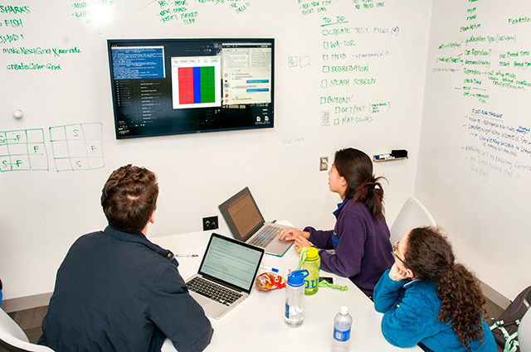

|  |  |  |  |
| --- | --- | --- | --- |
| **By Team Hillary (Group 4)** | | | |
| C:\Users\jlaur\AppData\Local\Microsoft\Windows\INetCacheContent.Word\Roxana_SQUARE.JPG | Roxana Ion | C:\Users\jlaur\AppData\Local\Microsoft\Windows\INetCacheContent.Word\Hedviga_SQUARE.JPG | Hedviga Arta Geriņa |
| C:\Users\jlaur\AppData\Local\Microsoft\Windows\INetCacheContent.Word\Jonas_SQUARE.JPG | Jonas Laursen | C:\Users\jlaur\AppData\Local\Microsoft\Windows\INetCacheContent.Word\Marius_SQUARE.JPG | Marius Šibajevas |