

**ORTEGA TRAMPE JOAN FRANCISCO**

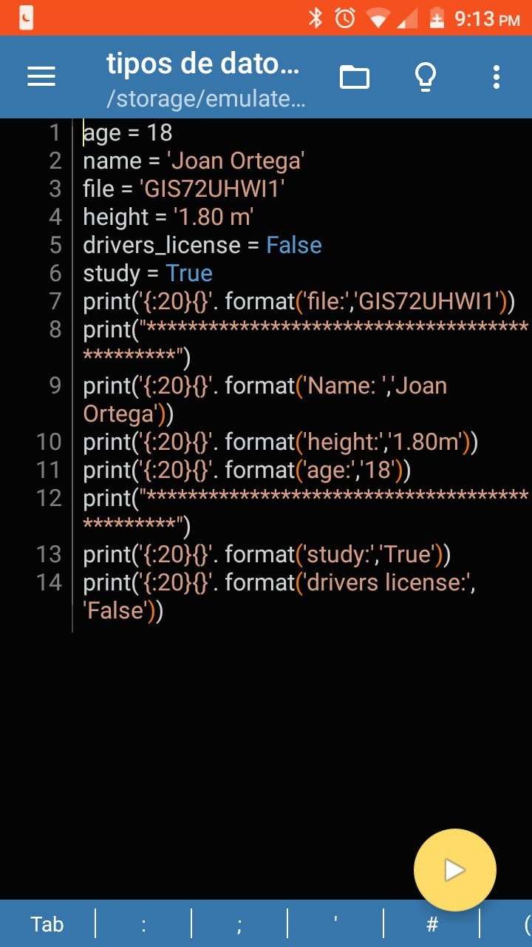

**PYTHON INTRODUCTION**

This is the first code the we did in the clasroom. We can see the diferents forms of the variable and we did a Little program with all of they.

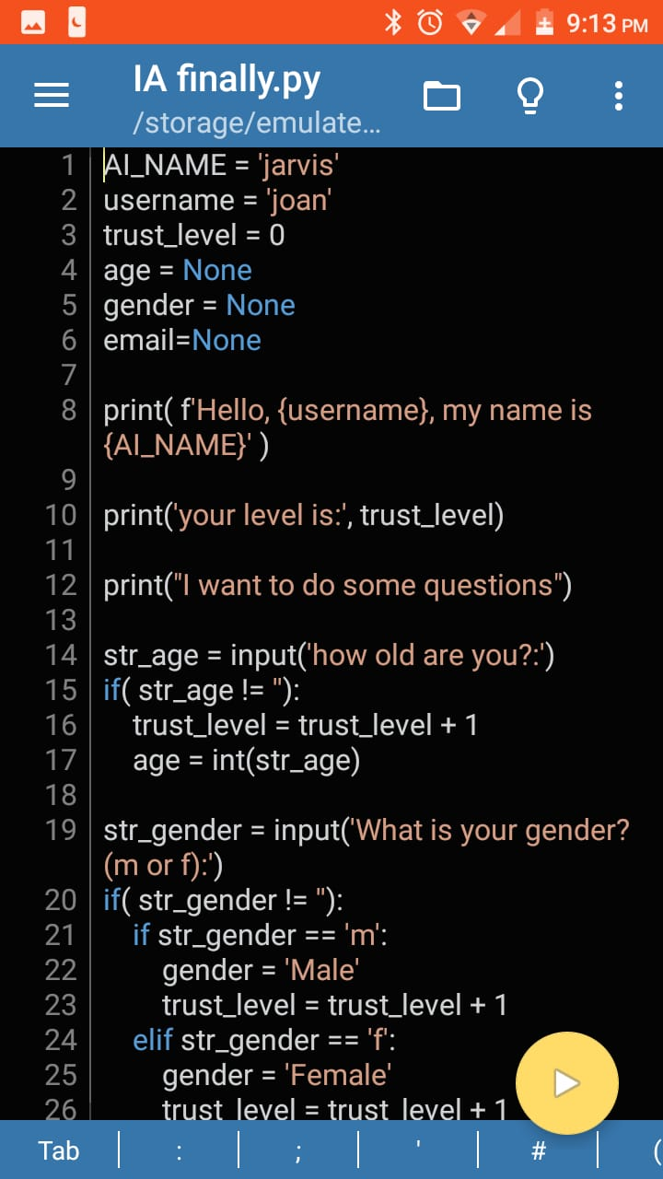

**SIMPLE AI**

In this code we can look some diferents uses for the condicions and the uses with the differents variables.

The objective for this code was do a Little or simple ai that get some information about the user

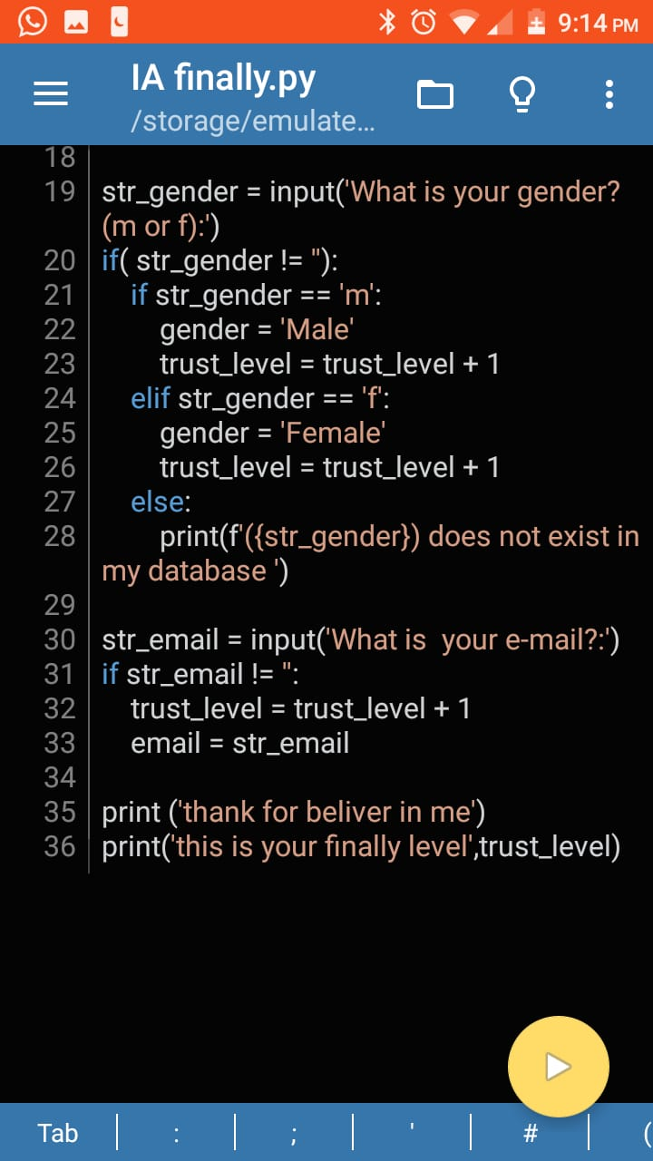

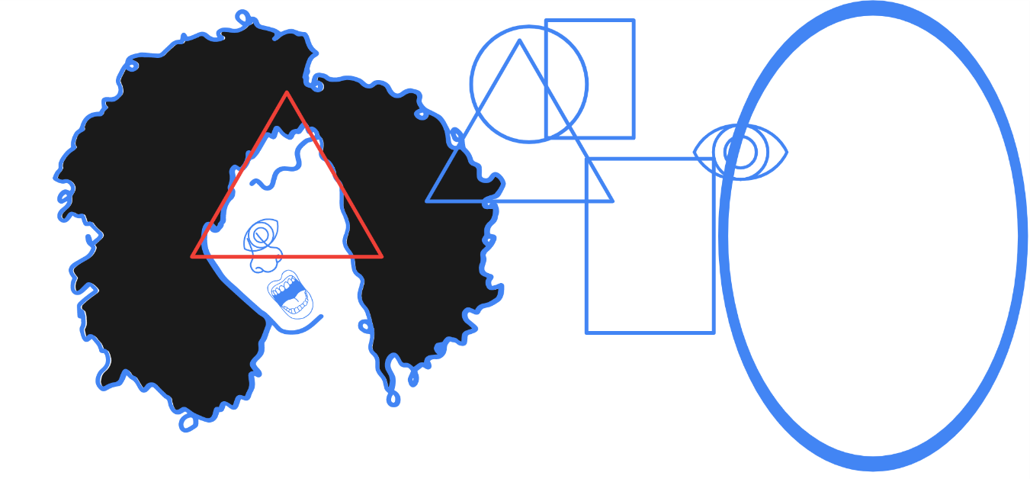

**DRAWN FOR VUFORIA.**

I drawn that imagen for the AR for the differents ways, well maybe it doesn’t have a lot color but I think that is good for the platafor vuforia because it has a lot angles, the differents parts of the drawn or simple, the overlap forms.