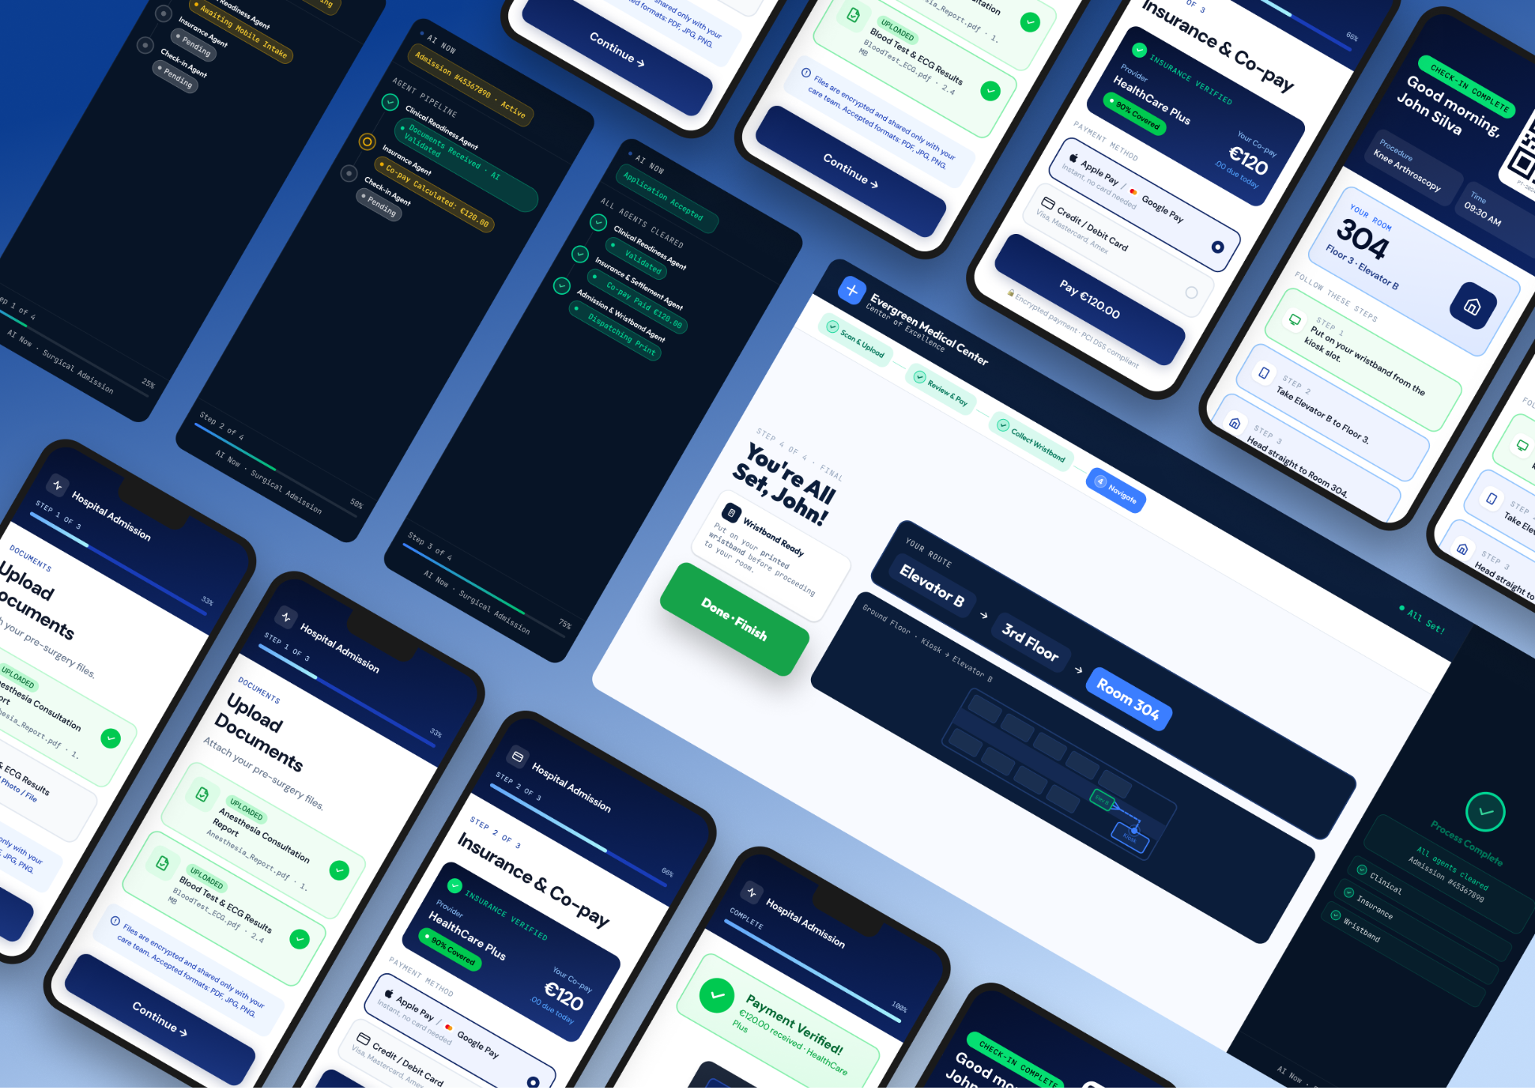

Hero image

Rethinking Hospital Check-In: A multichannel & AI-Driven Experience
Hospital admissions for scheduled surgeries are often stressful, packed with paperwork, unexpected co-pay surprises, and long front-desk queues.
We set out to redesign this journey into a seamless Phygital Experience powered by AI Agents. Guiding the patient from the moment they step into the hospital lobby to the comfort of their room, without standing in line.
Here is John's story:

1️⃣ Arrival & Phygital Sync
John arrives at the hospital for his scheduled Knee Arthroscopy. Instead of taking a paper ticket and waiting for a counter clerk, he walks straight to the self-service admission kiosk.
- The Kiosk displays a clear, high-contrast QR code.
- John scans it with his smartphone, instantly syncing the kiosk with his personal web app.
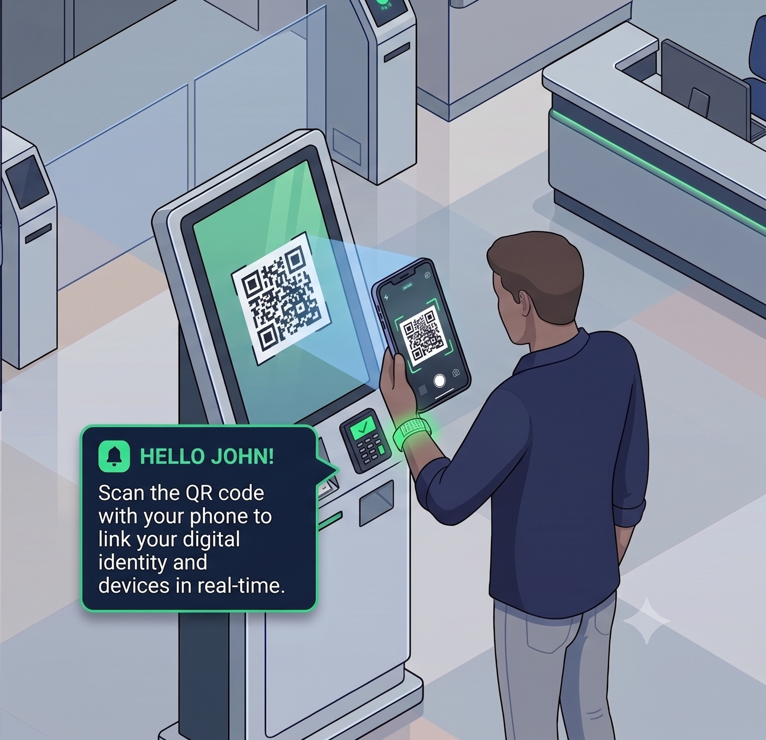
- Description: Isometric illustration showing John standing at the Kiosk scanning the QR code with his phone, establishing the real-time link between devices.

2️⃣ Frictionless Intake & Real-Time AI Orchestration
While John comfortably uses his phone to upload his missing anesthesia report and pay his €120.00 insurance co-pay via Apple Pay, AI Agents run in the background on the kiosk sidebar:
- Clinical Readiness Agent: Scans and validates the uploaded medical documents via OCR.
- Insurance Agent: Verifies coverage with the insurance provider and confirms the co-pay settlement.
- Check-in Agent: Authorizes the admission and triggers physical printing.
No forms to fill out by hand. No manual back-and-forth.
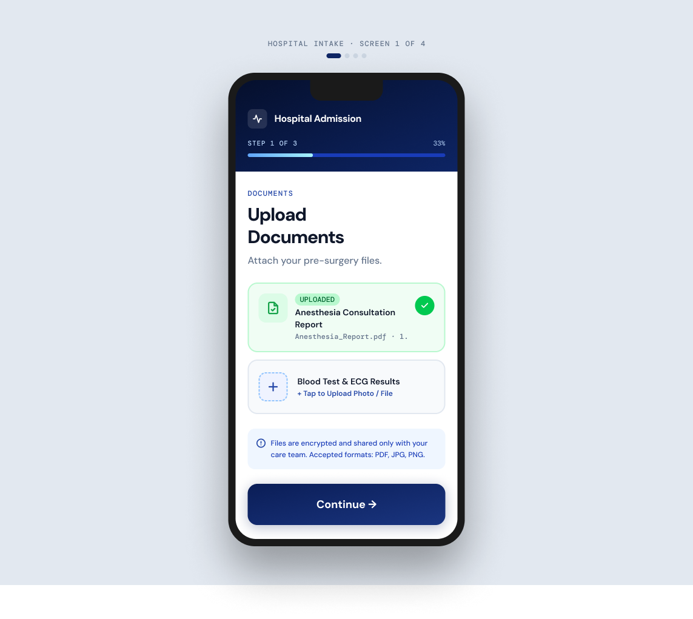
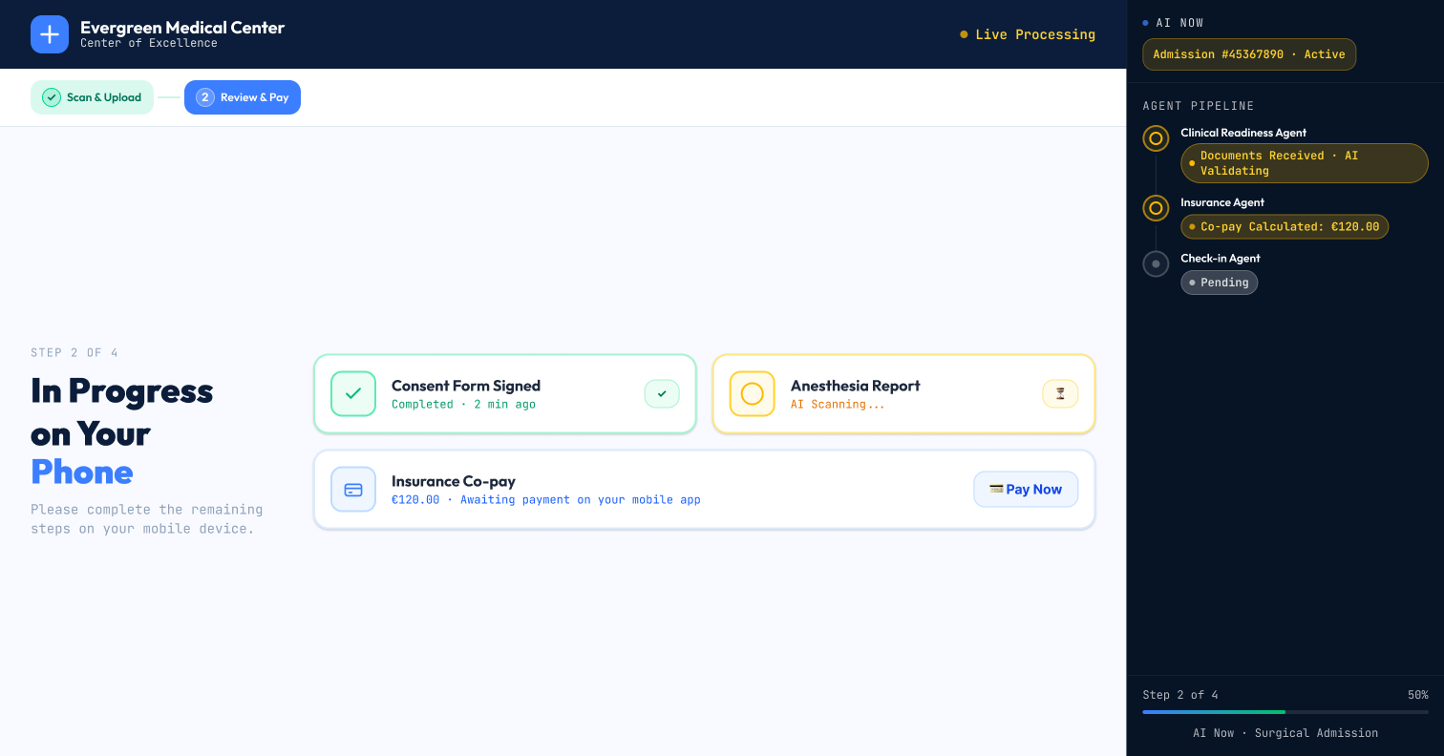
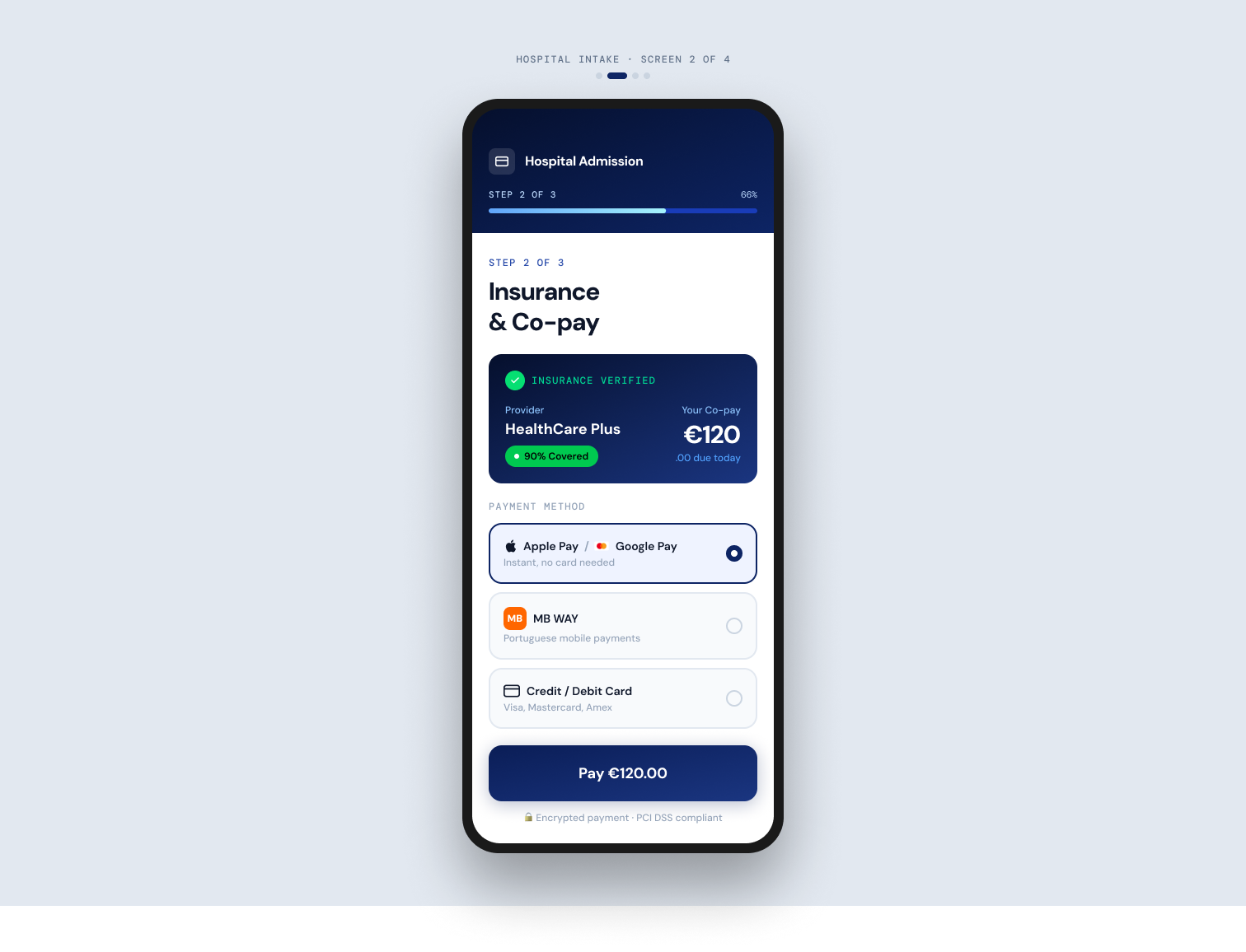

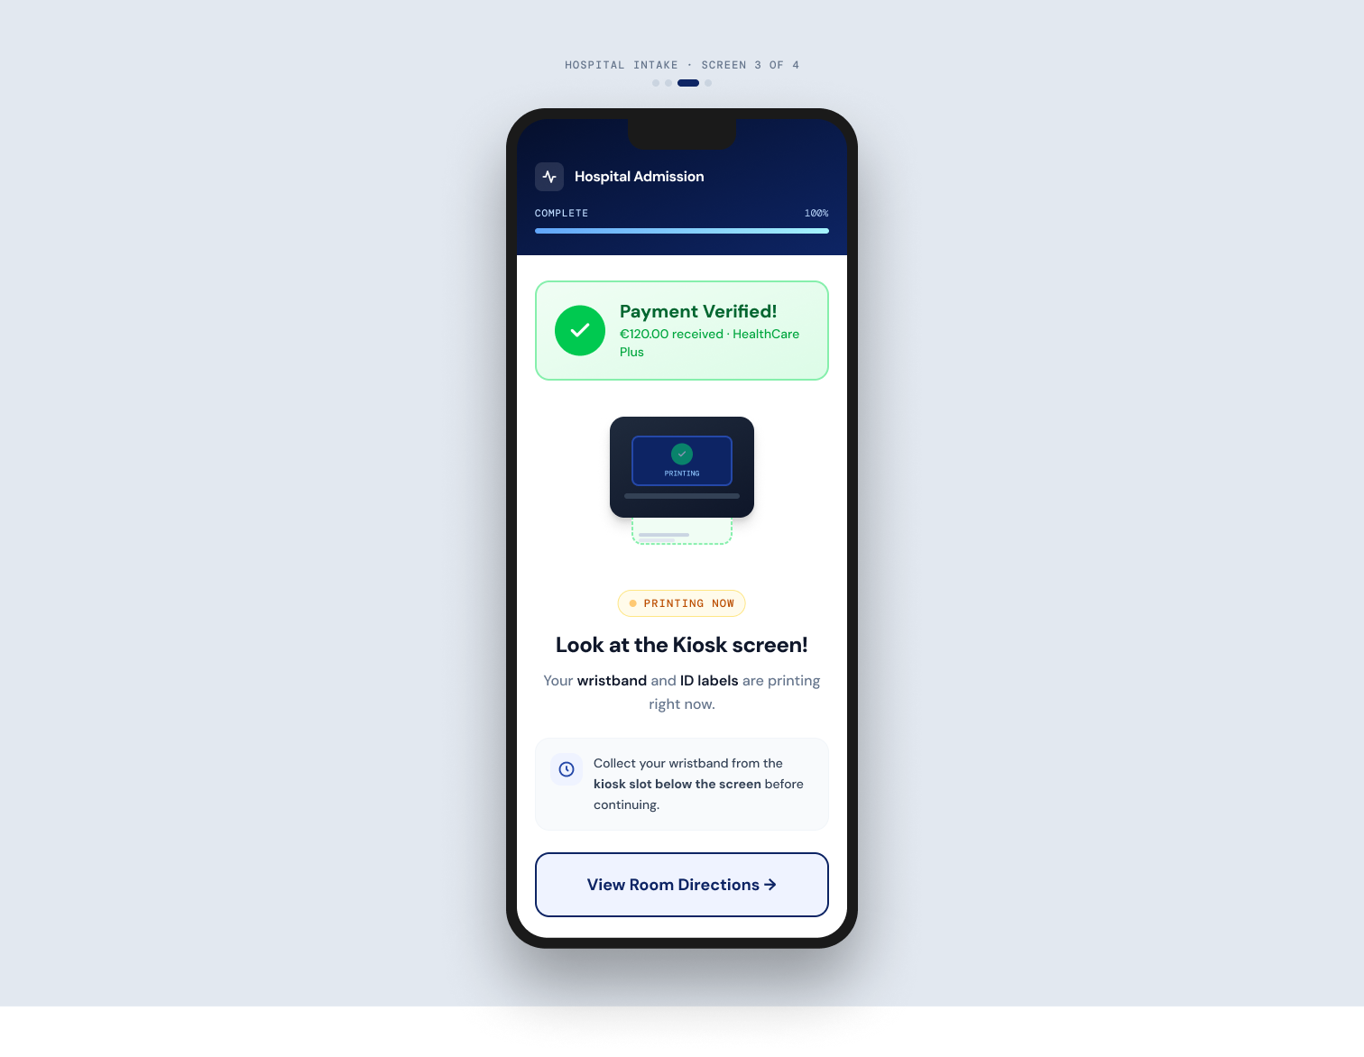

3️⃣ Instant Wristband Dispatch & Direct Navigation
Once the AI Agents validate all steps, the Kiosk dispenses John’s printed patient wristband and ID labels right from the hardware slot.
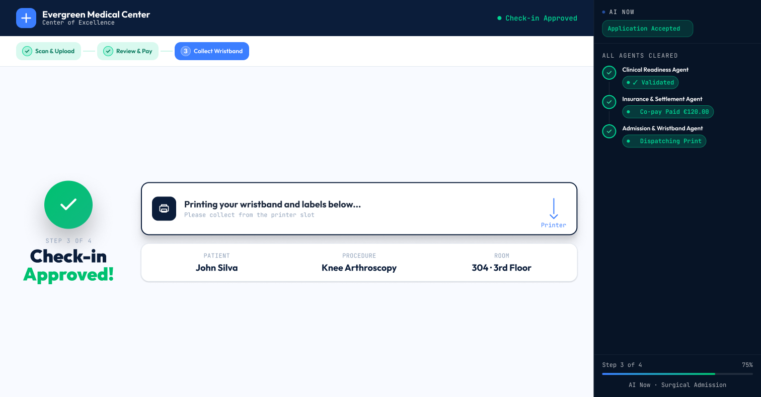
The screen instantly guides him: "Elevator B → 3rd Floor → Room 304".

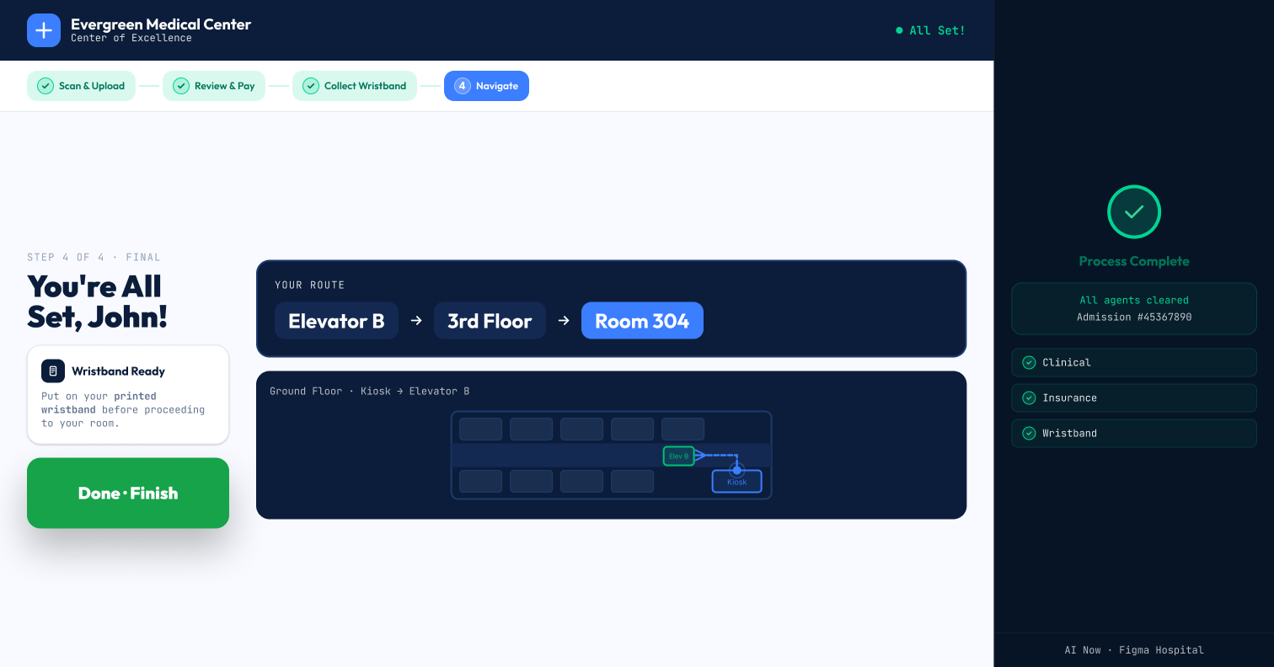
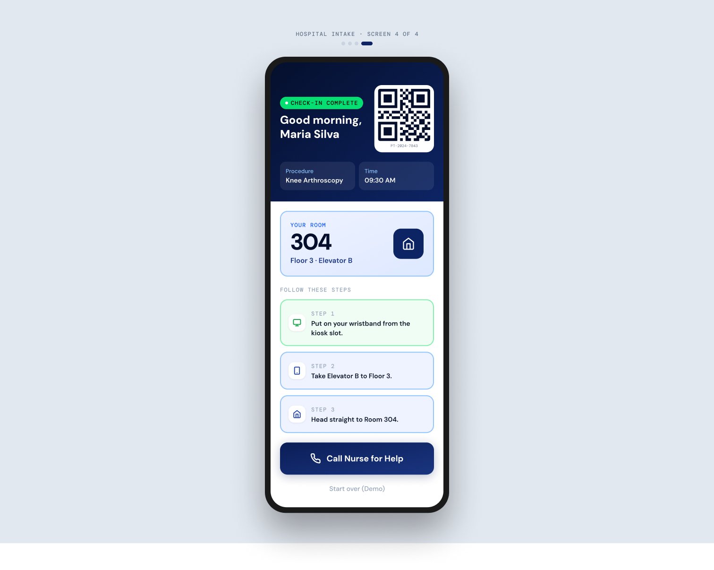

4️⃣ Smart Room Entry & Automated Care
John heads directly to the 3rd floor. Using the QR code on his new wristband, he unlocks the door to Room 304.
- Scanning the door automatically registers his arrival.
- An instant alert is sent to the nursing station: "Patient John Silva has entered Room 304."
- Moments later, his nurse enters the room with his digital chart ready to go!
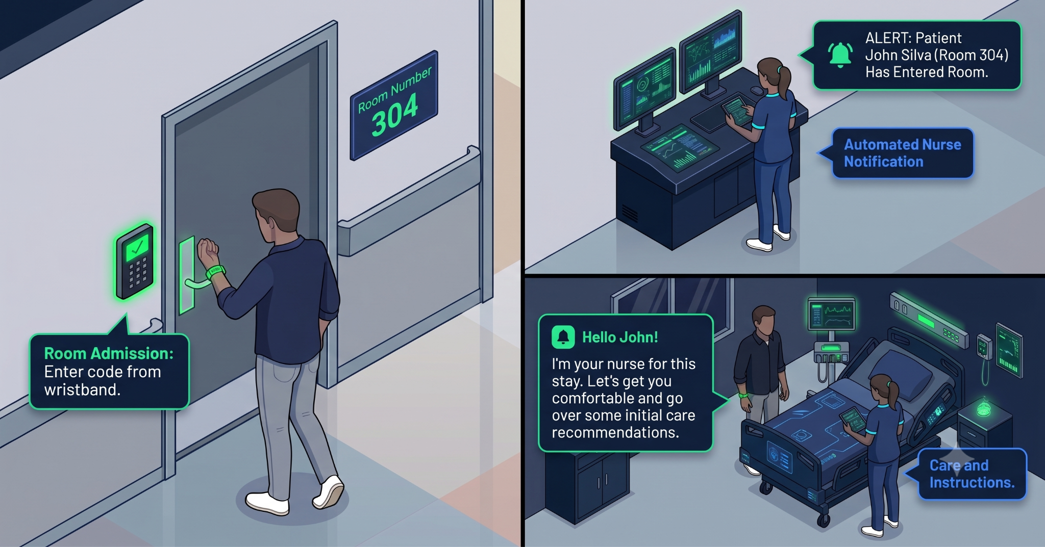
- Description: 3-panel illustration showing: (1) John scanning his wristband at Room 304's door, (2) the nurse receiving the automated notification at her desk, and (3) the nurse welcoming John inside his room.

📈 Measuring the Impact: High Tech, Human Touch
By shifting from a manual front-desk process to an AI-orchestrated Phygital Admission, healthcare providers can transform both the patient experience and hospital operational efficiency:
- UX Strategy: Progressive Disclosure — one clear action at a time, extra-large touch targets, and high contrast.
- Human-in-the-Loop AI — AI can handle routine validations, freeing hospital staff to focus purely on patient care.
⚡ Up to 80% Reduction in Check-in Time: Average admission time can drop from 15–20 minutes at a traditional desk to under 3 minutes at a self-service kiosk.
🎯 Up to 95% Automated Validation Accuracy: AI Agents can handle instant document verification, insurance checks, and co-pay calculations—reducing administrative human error to near zero.
👩‍⚕️ Up to +40% Staff Time Reclaimed: Hospital administrative and nursing staff could save hundreds of hours on manual paperwork, allowing them to focus purely on high-touch patient care.

💬 What do you think of this multichannel approach to healthcare UX? Press "L" if you love it and drop your thoughts in the comments! 👇

