CEBU INSTITUTE OF TECHNOLOGY - UNIVERSITY
COLLEGE OF COMPUTER STUDIES
Software Design Description
for
GIT it! Frontend Command State Contract
Document Version: 1.0
Published: 18 July 2026
Prepared by: GIT it! Project Team
Change History
Version | Date | Description | Author
1.0 | 18 July 2026 | Initial controlled baseline of the SDD for the frontend command state contract. | GIT it! Project Team

Preface
This Software Design Description documents the frontend command state contract that allows authored GIT it! story levels to complete reliably through the real browser terminal while preserving the backend as the security and persistence boundary.
Normative language follows these rules: SHALL identifies a mandatory requirement; SHOULD identifies a recommended requirement that may be waived with documented justification; and MAY identifies an optional capability.
All diagrams in this document use UML 2.x notation. Non-UML diagram conventions—including flowchart input/output symbols, database cylinders, and crow's-foot relationships—are intentionally excluded.

Table of Contents
1 Introduction 5
1.1 Purpose 5
1.2 Scope 5
1.3 Design Objectives 5
1.4 Definitions and References 5
2 Architectural Design 5
2.1 Architectural Style 5
2.2 Component View 6
2.3 Deployment View 7
2.4 Architectural Invariants 7
3 Detailed Design 7
3.1 Canonical State and Snapshot Design 7
3.1.1 Canonical State Shape 8
3.1.2 Snapshot Algorithm 8
3.1.3 Service Structure 8
3.2 Optimistic Browser Execution 9
3.2.1 Responsibilities 9
3.2.2 Mutating Command Interaction 9
3.3 Backend Trust Boundary and Transition Verification 9
3.3.1 Payload Validation 9
3.3.2 Diagnostic Evidence 10
3.3.3 Mutating Transition Families 10
3.3.4 Failed Command Rules 11
3.4 Evaluation, Accounting, and Persistence 11
3.4.1 Command Orchestration 11
3.4.2 Persistence Class Model 11
3.4.3 Attempt Lifecycle 12
3.5 Authored Workspace Actions and QA Harness 12
4 Cross-cutting Design 12
4.1 Error Handling 12
4.2 Security Design 13
4.3 Performance Design 13
4.4 Maintainability and DRY Design 13
5 Verification and Traceability 13
5.1 Verification Strategy 13
5.2 Current Quality Baseline 14
5.3 SRS-to-Design Traceability 14
5.4 UML Conformance Statement 14

1 Introduction

1.1 Purpose
This Software Design Description defines the architecture, component ownership, runtime interactions, canonical state design, backend verification boundary, persistence model, and verification strategy used to implement the GIT it! frontend command state contract.

1.2 Scope
The design covers the React adventure/challenge workspaces, the browser Git simulator, shared frontend snapshots and optimistic command hook, command REST endpoints, Django command orchestration, client execution validation, transition verification, evaluation, persistence, and generated browser acceptance harness.

1.3 Design Objectives
- Preserve all command-relevant repository state losslessly across browser, API, backend, persistence, and evaluation boundaries.
- Keep the terminal responsive through optimistic browser execution.
- Keep reward-affecting state authoritative by validating and verifying client-submitted transitions.
- Represent diagnostics as read-only operations with backend-derived evidence where needed.
- Eliminate duplicated frontend optimistic lifecycle code and keep mirrored transition semantics testable.
- Complete every authored target sequence through the production browser path.

1.4 Definitions and References
Canonical state, derived display state, diagnostic command, mutating command, authored sequence, revision, and target state have the meanings defined in the companion SRS.
ID | Reference | Location
REF-01 | Project goal | docs/goals/frontend-command-state-contract/GOAL.md
REF-02 | Approved implementation plan and acceptance record | docs/goals/frontend-command-state-contract/PLAN.md
REF-03 | Backend execution boundary | backend/common/git/client_command_execution.py
REF-04 | Backend transition verifier | backend/common/git/verification/verifier.py and verification mixins
REF-05 | Backend canonical state and snapshots | backend/simulator/state.py; backend/simulator/services/core.py
REF-06 | Frontend Git engine and snapshots | frontend/src/shared/git/simulator/engine.ts; frontend/src/shared/git/simulator/state/snapshot.ts
REF-07 | Optimistic lifecycle | frontend/src/shared/level-runtime/useOptimisticGitCommand.ts
REF-08 | UML notation | Object Management Group, Unified Modeling Language 2.5.1

2 Architectural Design

2.1 Architectural Style
The runtime uses a client-simulation/server-verification architecture. The browser is the latency-sensitive semantic executor: it produces terminal output and a proposed next state. The backend is the security and persistence boundary: it validates metadata, reconstructs canonical state, verifies that the proposed transition is plausible for the exact command, evaluates authored rules, and commits the accepted outcome atomically.
This split avoids server-side shell execution while preventing an arbitrary browser next_state from directly earning progress or rewards. The state contract—not a database entity or UI tree—is the integration boundary.

2.2 Component View
Figure 1. Frontend command state contract components
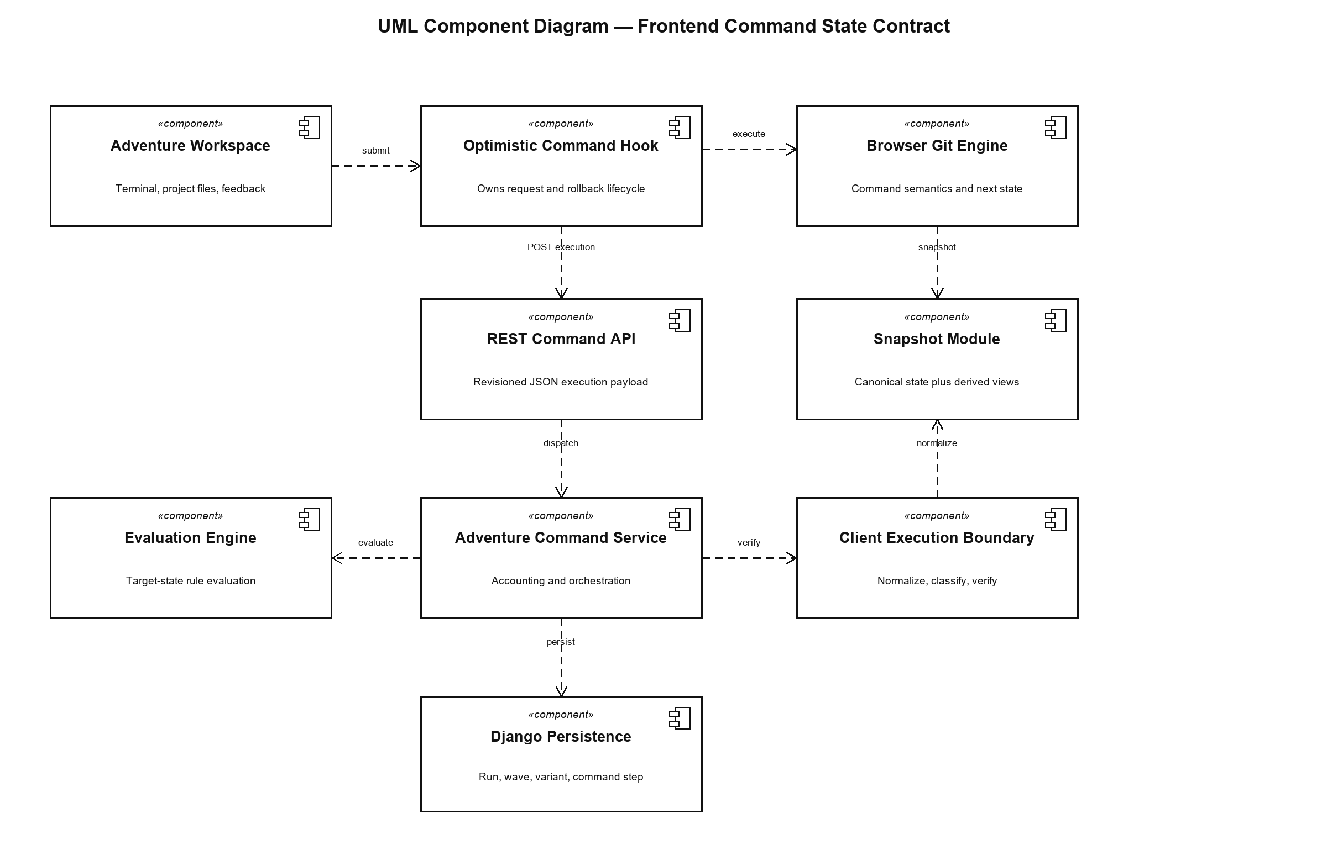
Component | Responsibility | Primary implementation
Adventure Workspace | Presents terminal, project files, and feedback; adapts run data to the shared optimistic hook. | frontend/src/features/adventures and shared level runtime
Optimistic Command Hook | Owns mutation setup, pending execution reuse, optimistic cache update, rollback, and success reconciliation. | frontend/src/shared/level-runtime/useOptimisticGitCommand.ts
Browser Git Engine | Parses, classifies, and executes supported commands against canonical state. | frontend/src/shared/git/simulator
Snapshot Module | Clones/normalizes state and derives presentation trees. | frontend snapshot.ts; backend RepositorySnapshotService
REST Command API | Transports raw command and revisioned execution payload. | Adventure/challenge command endpoints
Client Execution Boundary | Validates metadata, derives diagnostics, verifies transitions, and caps accepted state. | backend/common/git/client_command_execution.py
Adventure Command Service | Coordinates accounting, evaluation, step creation, state persistence, and wave transitions. | backend/adventures/services/commands.py
Evaluation Engine | Evaluates compiled authored rules against accepted state and history. | backend/evaluation
Django Persistence | Stores variants, runs, wave progress, command steps, counters, and canonical JSON state. | backend Django models

2.3 Deployment View
Figure 2. Runtime deployment topology
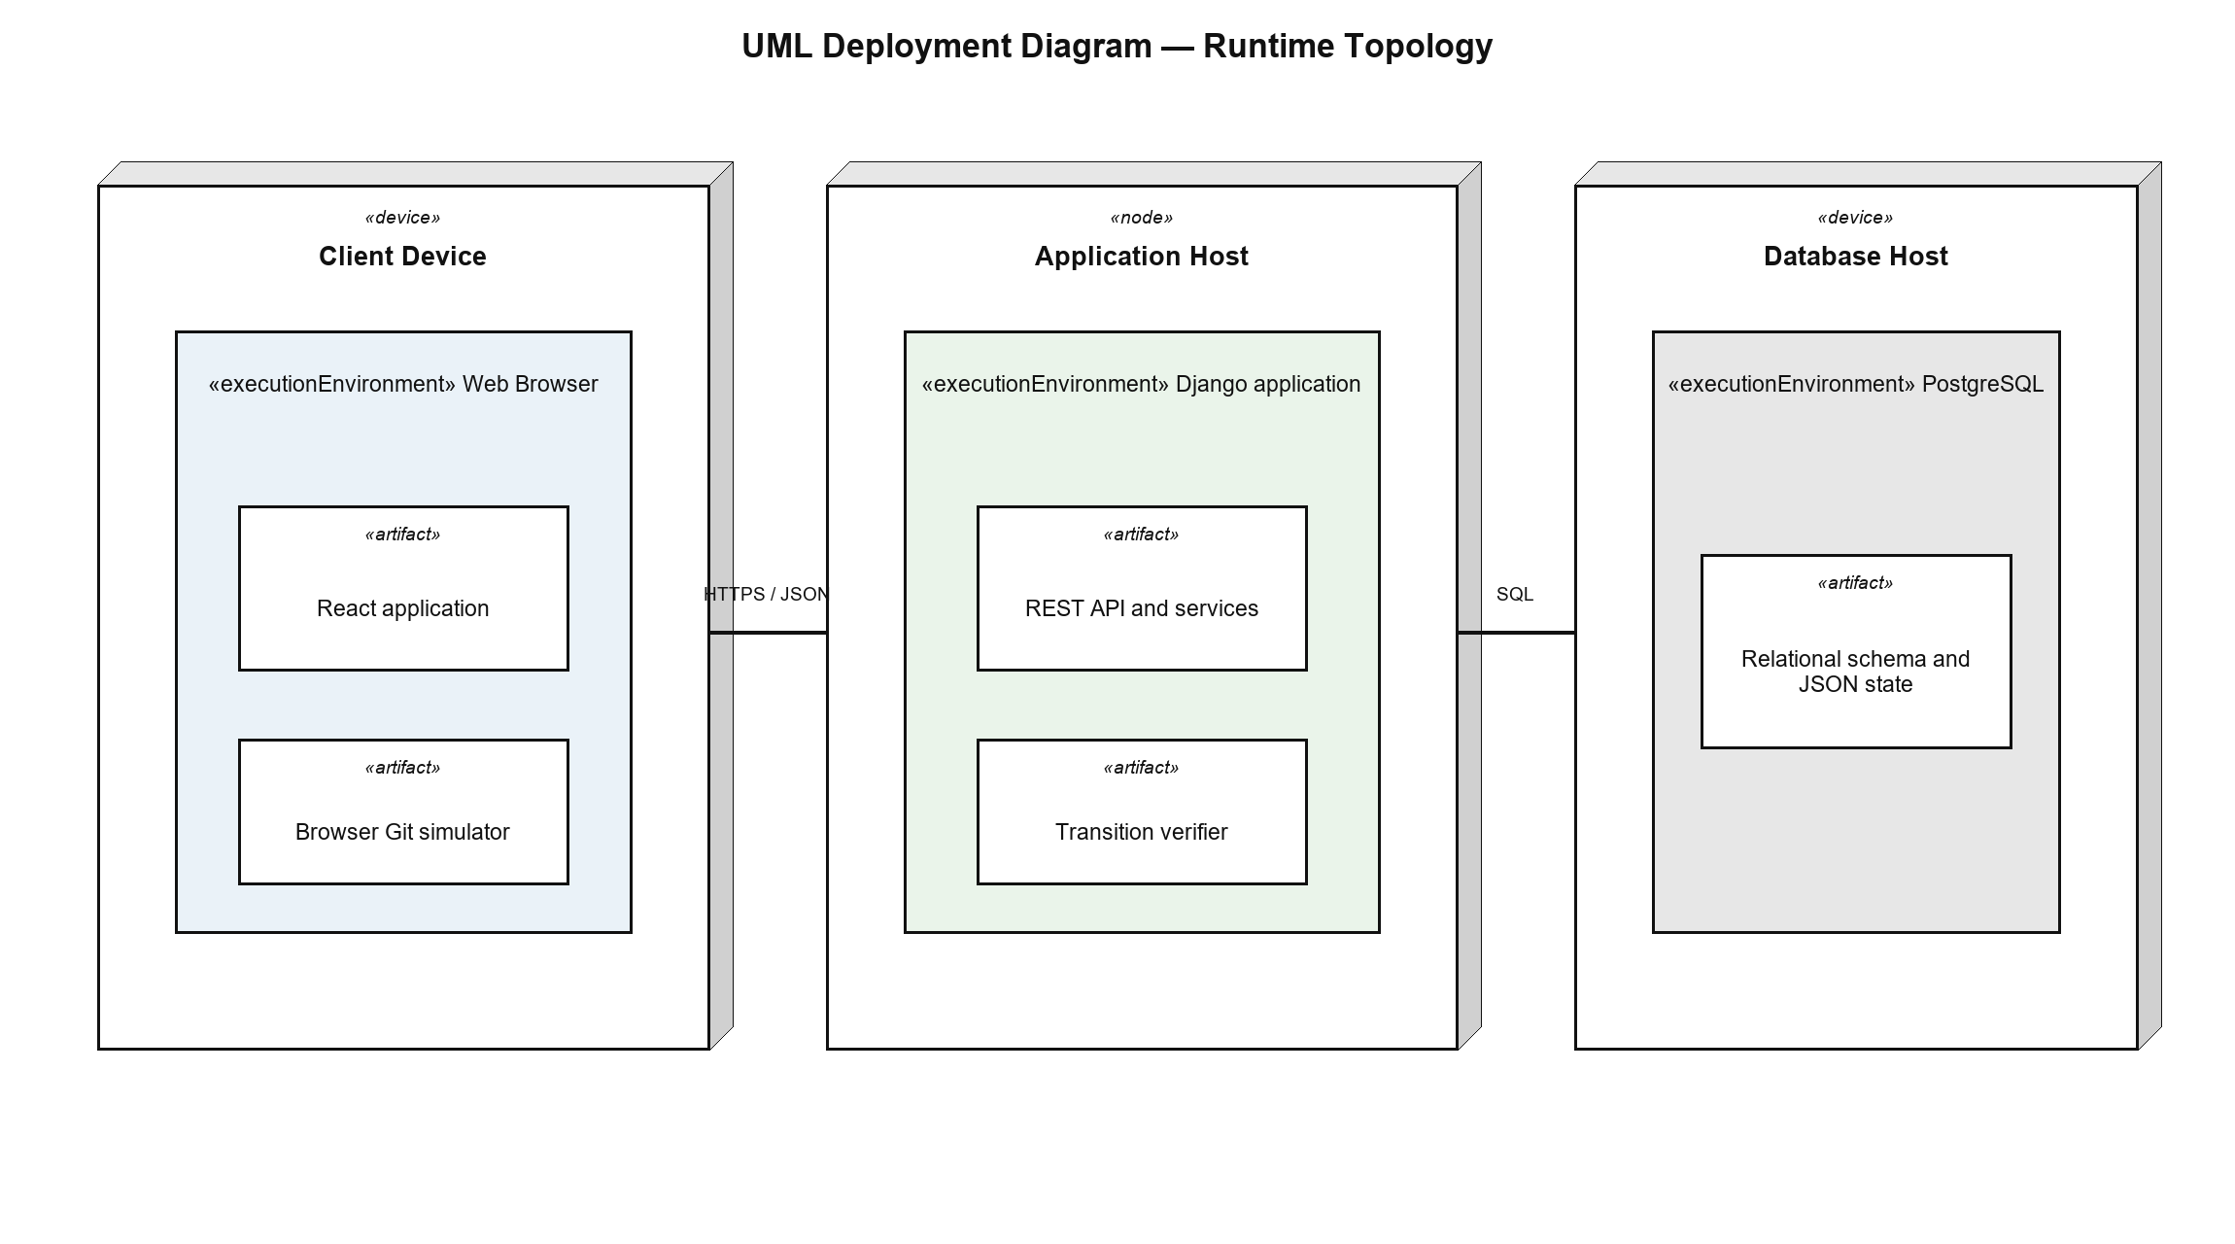
The deployment design requires no shared filesystem and no server-side Git working copy. The browser simulator is delivered with the React artifact; the backend verifier and REST services are delivered with the Django artifact; persistent state crosses the application/database communication path as relational fields and bounded JSON.

2.4 Architectural Invariants
Invariant | Design enforcement
INV-01 Canonical losslessness | Deep copy before normalization; preserve command-relevant and extension fields; exclude only project_tree and visible_tree.
INV-02 One submitted command, one revision | client_run_revision must equal the run command count at the execution boundary.
INV-03 Client state is proposed, never authoritative | Mutating next_state is normalized and verified; diagnostic and unprocessable next_state is ignored.
INV-04 Diagnostics do not consume budget | Backend-known diagnostic classification produces increment zero and derives evidence from previous state.
INV-05 Evaluation follows verification | AdventureCommandService evaluates only the ExecutedCommand next_state returned by the boundary.
INV-06 Derived views do not affect completion | Hashing, evaluation, verification, and persistence operate on canonical state.
INV-07 State growth is bounded | Accepted serialized next_state is rejected above 256 KiB.

3 Detailed Design

3.1 Canonical State and Snapshot Design
RepositoryStateNormalizer is the backend compatibility boundary for persisted and submitted repository state. The frontend snapshot module mirrors the same normalization shape for browser execution. Both implementations deep-clone input so nested maps and lists cannot alias the original run state.

3.1.1 Canonical State Shape
State group | Representative fields | Rule
Repository identity | repository_initialized, head, branches, commits | Normalized and preserved for all command families.
Index/worktree | staging, working_tree, partial_hunks | Lossless path/content and hunk representation.
Conflict/operation | conflicts, conflict_details, operation_metadata, merge_abort_state | Preserved across conflict, continue, abort, and squash flows.
Refs/remotes | remotes, remote_branches, upstream_tracking, tags, remote_tags | Normalized without deriving presentation trees.
History/evidence | stash_stack, reflog, replaced_commits, config | Available to command semantics and diagnostics.
Display only | project_tree, visible_tree | Removed from canonical command snapshots and recomputed for responses.

3.1.2 Snapshot Algorithm
- Deep-clone input state and remove project_tree and visible_tree.
- Apply compatibility defaults and normalize commit, branch, HEAD, index, worktree, conflict, remote, tag, stash, reflog, partial-hunk, operation, configuration, and merge-abort shapes.
- Use the canonical result for execution payloads, verification, hashing, evaluation, and persistence.
- For a response or optimistic UI snapshot, compute project_tree and visible_tree from the canonical result and return them as derived fields.

3.1.3 Service Structure
Figure 3. Command contract service classes
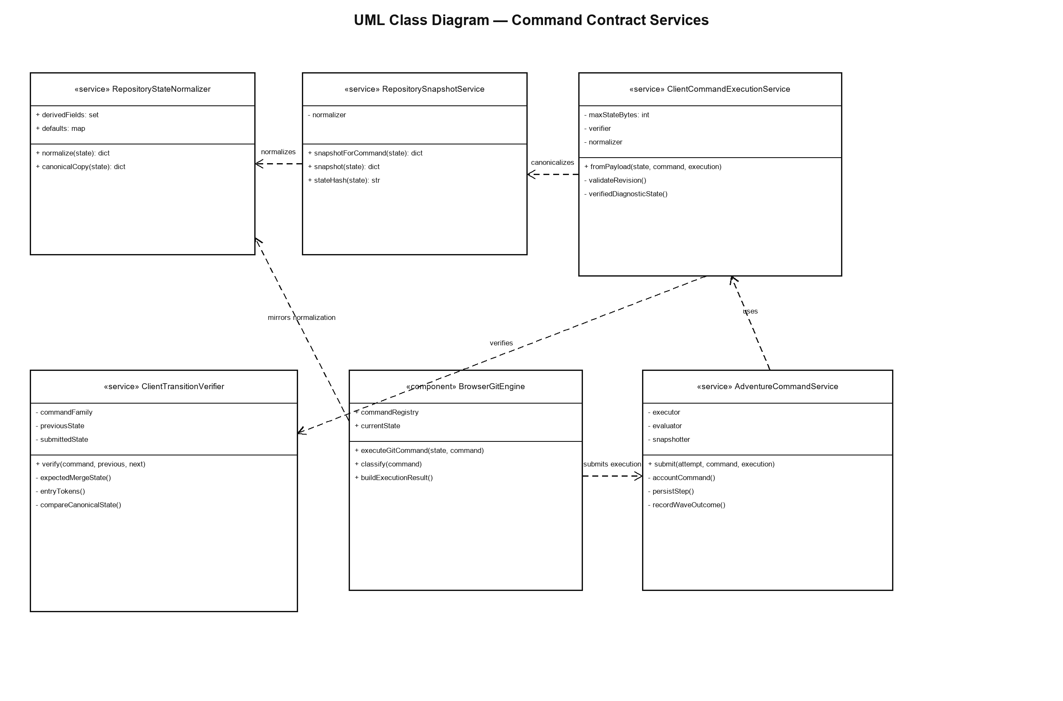

3.2 Optimistic Browser Execution

3.2.1 Responsibilities
- Read the current canonical repository state and revision from the query cache.
- Execute the command exactly once during onMutate and retain the payload for mutationFn.
- Apply snapshot(execution.next_state, true) to the cached run and create a local or pending terminal step.
- On success, replace optimistic data with the authoritative response through the feature adapter.
- On rejection, restore the previous run, remove ephemeral steps, and append a safe error step.

3.2.2 Mutating Command Interaction
Figure 4. Mutating command submission sequence
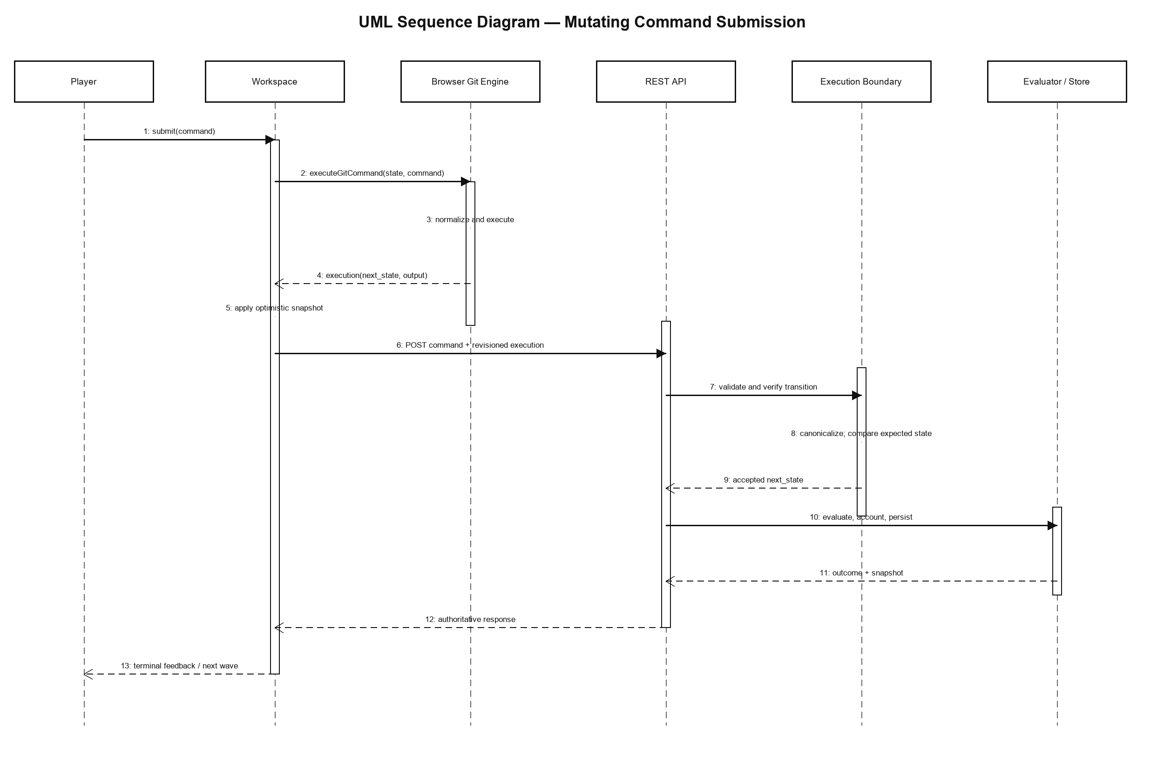
The execution result is generated before the network call and reused by mutationFn. This prevents a second simulation from observing an already-optimistic state and producing a divergent payload. The server response remains authoritative even when the optimistic state was visually correct.

3.3 Backend Trust Boundary and Transition Verification

3.3.1 Payload Validation
Check | Accepted rule | Rejection effect
Repository schema | Previous and submitted state satisfy the repository JSON schema. | Bad request before persistence.
Boolean flags | processed and diagnostic are actual booleans. | Bad request.
Normalized command | Matches normalization of the raw submitted command. | Bad request.
Revision | client_run_revision equals expected run command_count. | Stale request rejected.
Classification | Only Git commands and supported shell no-ops may be processed; diagnostic flag matches backend-known command shape. | Bad request.
Command family | Matches the parsed Git subcommand or supported cd no-op. | Bad request.
Transition | Next state is plausible for exactly one supported command from previous state. | Bad request; no progress.
Size | Accepted serialized next state is at most 256 KiB. | PayloadTooLarge; retry run guidance.

3.3.2 Diagnostic Evidence
Figure 5. Diagnostic command evidence sequence
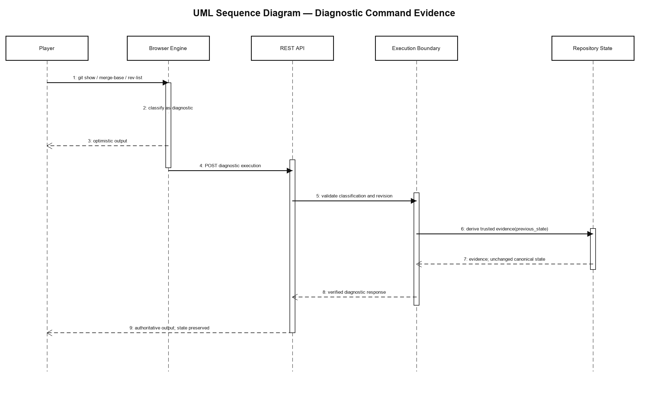
For diagnostic and unprocessable input, ClientCommandExecutionService deliberately ignores the submitted next_state and begins with backend-owned previous_state. Supported diagnostic metadata is recomputed by ClientTransitionVerifier. This design allows merge-base, rev-list, config listing, historical file inspection, and related authored evidence without trusting a client mutation.

3.3.3 Mutating Transition Families
Family | Verifier focus | Regression-sensitive behavior
Staging | Index/worktree deltas and immutable history/refs | Partial add compares explicit hunk tokens when present; otherwise uses one canonical content token.
Reset/restore | Reference, index, and worktree effects by supported mode | Soft/mixed/hard and path-scoped behavior must mirror the browser.
Refs/remotes | Branch, tag, tracking, fetch, pull, and push deltas | Unrelated state groups remain immutable.
Commit/history | Commit creation, parentage, cherry-pick, revert, rebase | Commit IDs and history relationships remain deterministic.
Merge/stash | Fast-forward, merge commit, conflicts, abort, continue, squash, stash | Empty abort snapshots use the frontend fallback; squash records staged result without creating a merge commit.

3.3.4 Failed Command Rules
A non-zero exit code normally requires previous_state and next_state to be identical. Merge and pull are the narrow exception because a verified conflict transition may intentionally change the index and working tree while returning failure. If conflict verification fails, the boundary accepts only an unchanged state.

3.4 Evaluation, Accounting, and Persistence

3.4.1 Command Orchestration
- Lock the active attempt within a transaction and reject ended runs.
- Resolve the selected variant and current wave, then pass persisted state and the browser payload through ClientCommandExecutionService.
- Classify and account the command; assign the accepted next_state to the attempt.
- For processed commands, evaluate the previous state and accepted next state against the compiled variant specification and executed-command history.
- Create one CommandStep containing raw/normalized command, output, classification, attempt number, and counted total.
- Save changed attempt fields and record the wave outcome if solved or budget-exhausted; otherwise build a response snapshot with derived trees.

3.4.2 Persistence Class Model
Figure 6. Adventure runtime persistence classes
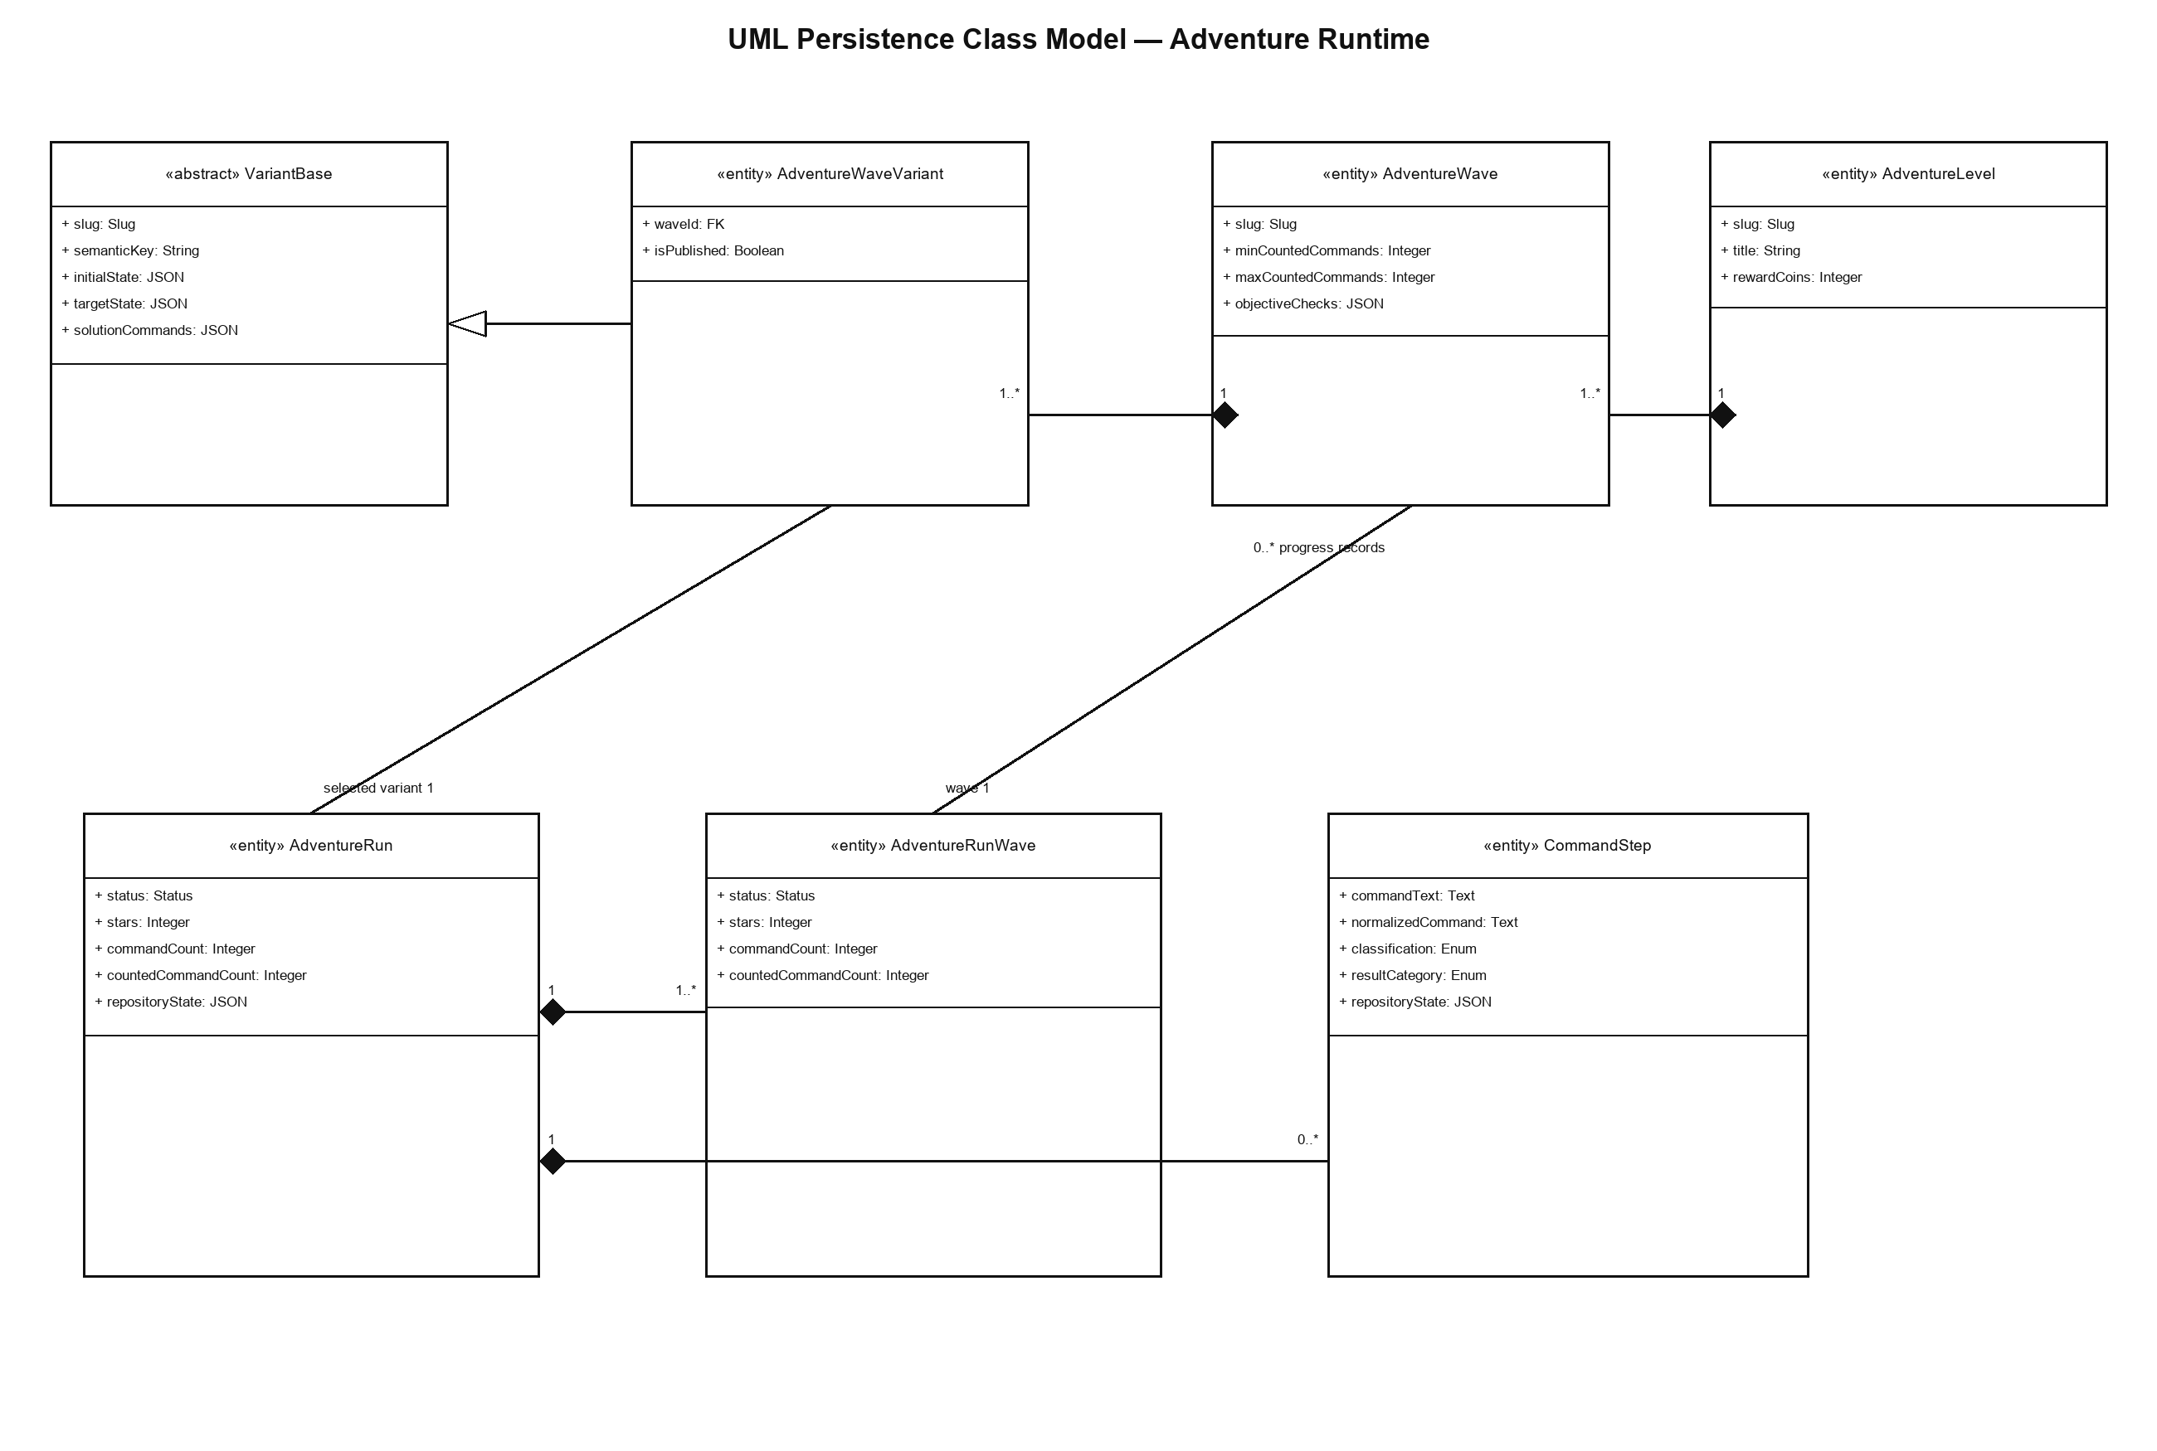
VariantBase is an abstract Django model that defines authored initial state, evaluation specification, target state, solution commands, scenario metadata, and publication policy. AdventureWaveVariant adds the owning wave. AdventureRun holds the selected variant, current wave, canonical repository state, counters, and aggregate status. AdventureRunWave stores per-wave outcome. CommandStep stores the auditable command result and belongs to exactly one adventure attempt or challenge run through a database check constraint.

3.4.3 Attempt Lifecycle
Figure 7. Command attempt lifecycle
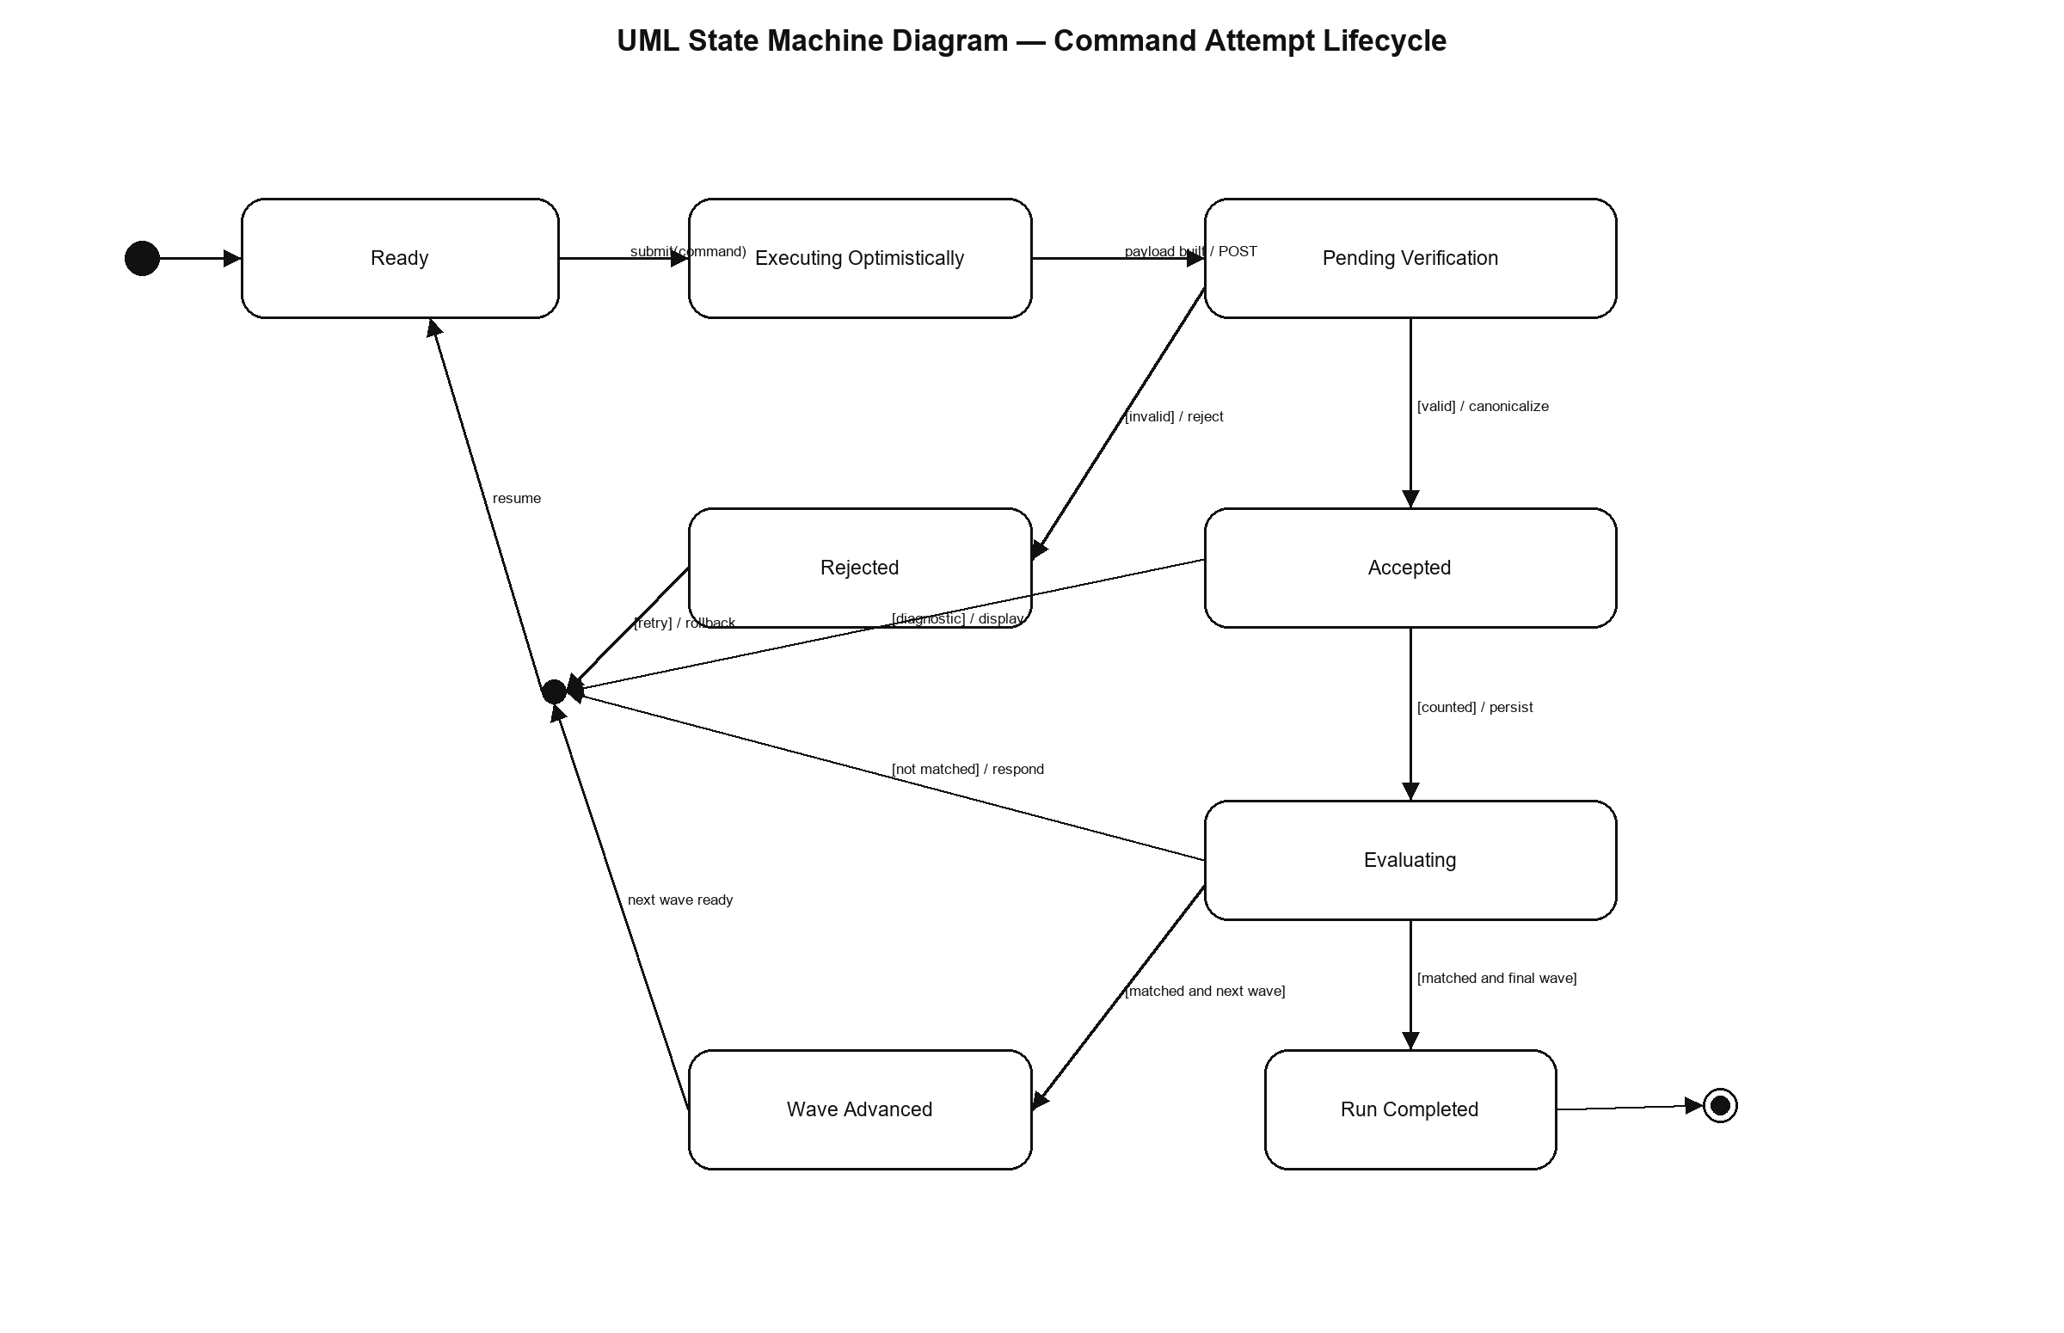

3.5 Authored Workspace Actions and QA Harness
The generated sequence formatter treats solution_workspace_files as first-class authored actions. Each action is inserted after its after_command_index and rendered as a visible instruction to edit or replace file content and activate Save. The browser harness performs the same visible interactions a player uses, so a passing sequence proves integration across workspace state, terminal execution, API submission, evaluation, and progression.
Harness stage | Evidence
Case discovery | Enumerates published adventure/challenge target cases and their authored variants.
Sequence assembly | Interleaves solution commands and workspace-file actions deterministically.
Browser execution | Uses the real workspace and terminal UI, not direct state mutation.
Completion assertion | Observes target completion/wave advancement through the API-backed UI.
Release gate | Requires all 284 authored target sequences to pass.

4 Cross-cutting Design

4.1 Error Handling
Condition | Backend behavior | Frontend behavior
Malformed execution | Return a client error with safe detail; no write. | Restore prior run and display the rejection detail.
Stale revision | Reject before transition verification. | Restore authoritative data and prompt retry.
Forged/impossible transition | ClientTransitionVerifier raises BadRequest; transaction makes no progress. | Rollback optimistic state.
Oversized state | Raise PayloadTooLarge with clean-run guidance. | Display actionable client-safe message.
Server failure | Transaction rolls back. | Restore prior run and display generic retry guidance.
Command non-zero exit | Require unchanged state except verified conflict transition. | Display command output; accepted state remains authoritative.

4.2 Security Design
- No command string is executed by a server shell or passed to a real Git process.
- The execution boundary validates types, normalized command, command family, diagnostic classification, revision, transition plausibility, and payload size.
- Diagnostic and unprocessable client next_state values are ignored.
- Reward-affecting evaluation receives only the boundary's accepted canonical state.
- Database constraints enforce one active adventure run per player/level, bounded stars, valid command budgets, unique wave progress, and exactly one CommandStep parent.

4.3 Performance Design
- Browser simulation and optimistic cache update remove network latency from immediate terminal feedback.
- The pending execution is retained and reused so one submission is simulated once.
- Backend verification uses deterministic dictionary/list operations and command-family handlers rather than process startup.
- Compiled evaluation specs, target hashes, and command histories use application caches.
- Diagnostic and unchanged submissions may skip full repository_state persistence when state_mutated is false.
- Repository JSON is capped at 256 KiB to bound row and response growth.

4.4 Maintainability and DRY Design
- useOptimisticGitCommand is shared by adventure and challenge runtimes; feature adapters provide only data-shape differences.
- RepositoryStateNormalizer and RepositorySnapshotService centralize backend state compatibility and display derivation.
- ClientTransitionVerifier delegates to command-family mixins instead of one monolithic switch or duplicate endpoint logic.
- AdventureCommandService delegates run progression, history caching, evaluation compilation, state hashing, and response snapshot concerns to focused services.
- Frontend semantics and backend verification intentionally mirror rather than share code because they execute in different languages and trust domains; parity tests are the synchronization mechanism.

5 Verification and Traceability

5.1 Verification Strategy
Layer | Verification
State unit | Canonical cloning, normalization defaults, derived-field exclusion, hashing, and immutability.
Command unit | Supported parse/execute behavior, output, exit codes, diagnostics, and command-family metadata.
Verifier unit | Expected transition for each command family, immutable groups, partial add, reset, merge/squash/abort, and conflict failures.
Service integration | Revision checks, payload validation, command accounting, evaluation, persistence, and wave/run transitions.
Frontend integration | Optimistic execution reuse, rollback, authoritative reconciliation, and visible workspace-file actions.
System acceptance | Generated target cases and 284 authored sequences through the real browser/API path.

5.2 Current Quality Baseline
At the documentation baseline, the cleaned codebase passes 1,773 backend tests, 415 frontend tests, 2,056 generated target cases, Python and TypeScript lint/static checks, frontend dead-code analysis, the production build, fresh Django migrations, and deployment checks. The authored browser acceptance criterion remains 284 of 284 sequences.

5.3 SRS-to-Design Traceability
SRS requirement | Design element | Primary verification
FR-001–FR-002 | Section 3.1; RepositoryStateNormalizer; Snapshot Module | Snapshot and normalization parity suites
FR-003–FR-004 | Section 3.2; Figure 4; Optimistic Command Hook | Optimistic lifecycle and payload tests
FR-005–FR-006 | Section 3.3; Figures 3 and 5; Execution Boundary | Integrity, diagnostic, and transition verifier suites
FR-007–FR-010 | Section 3.3.3 command-family verification | Diagnostic, staging, reset, and merge regressions
FR-011 | Section 3.5 workspace actions and browser harness | Visible file-edit sequence tests
FR-012 | Section 3.4 orchestration and persistence | Adventure command/evaluation integration tests
FR-013–FR-016 | Sections 3.3.1 and 4.1–4.3 | Boundary, failure, classifier, and size-cap tests
FR-017 | Section 3.5 and Section 5.1 system acceptance | 284/284 authored browser matrix

5.4 UML Conformance Statement
Figures 1 through 7 use UML 2.x component, deployment, class, sequence, and state-machine notation. Structural views use stereotypes, class compartments, dependency/generalization/composition relationships, roles, and multiplicities. Behavioral views use participants, lifelines, activation specifications, messages, states, pseudostates, a junction, guards, and effects. Deployment uses nodes, execution environments, artifacts, and communication paths. The persistence view is a UML class model and deliberately does not use ER or crow's-foot symbols.

