CEBU INSTITUTE OF TECHNOLOGY - UNIVERSITY
COLLEGE OF COMPUTER STUDIES
Software Requirements Specification
for
GIT it! Frontend Command State Contract
Document Version: 1.0
Published: 18 July 2026
Prepared by: GIT it! Project Team
Change History
Version | Date | Description | Author
1.0 | 18 July 2026 | Initial controlled baseline of the SRS for the frontend command state contract. | GIT it! Project Team

Preface
This Software Requirements Specification documents the frontend command state contract that allows authored GIT it! story levels to complete reliably through the real browser terminal while preserving the backend as the security and persistence boundary.
Normative language follows these rules: SHALL identifies a mandatory requirement; SHOULD identifies a recommended requirement that may be waived with documented justification; and MAY identifies an optional capability.
All diagrams in this document use UML 2.x notation. Non-UML diagram conventions—including flowchart input/output symbols, database cylinders, and crow's-foot relationships—are intentionally excluded.

Table of Contents
1 Introduction 5
1.1 Purpose 5
1.2 Scope 5
1.3 Definitions and Acronyms 5
1.4 References 5
2 Overall Description 6
2.1 Product Perspective 6
2.2 Product Functions 6
2.3 User Classes and Characteristics 6
2.4 Operating Environment 6
2.5 Constraints 6
2.6 Assumptions and Dependencies 7
3 Specific Requirements 7
3.1 External Interface Requirements 7
3.1.1 User Interface 7
3.1.2 Software Interface 7
3.1.3 Communications Interface 7
3.2 Functional Requirements 7
3.3 Use Case Model 8
3.3.1 UC-01 — Execute a Mutating Command 8
3.3.2 UC-02 — Edit an Authored Project File 9
3.3.3 UC-03 — Execute a Diagnostic Command 9
3.3.4 UC-04 — Verify the Authored Curriculum Matrix 9
3.4 Activity Model 10
3.5 Non-functional Requirements 10
4 Acceptance and Traceability 11
4.1 Acceptance Criteria 11
4.2 Requirement Traceability Matrix 11
4.3 UML Conformance Statement 11

1 Introduction

1.1 Purpose
This Software Requirements Specification defines the functional, interface, quality, security, and acceptance requirements for the GIT it! frontend command state contract. The contract governs how browser-simulated Git commands become verified backend state and how that state is evaluated to progress authored adventure waves and challenges.

1.2 Scope
The scope begins when a player submits a command or saves an authored workspace-file change and ends when the browser displays the authoritative response, the backend persists the accepted state, and the evaluator either keeps the current wave active, advances to the next wave, or completes the run.
The scope includes canonical repository snapshots, optimistic browser execution, revisioned command payloads, backend validation and transition verification, diagnostic evidence, command accounting, target-state evaluation, persistence, authored workspace-file steps, and automated curriculum-sequence verification.
The scope excludes a terminal visual redesign, curriculum difficulty or wording changes, execution against a real server-side Git repository, trust in arbitrary client state, and unrelated product features.

1.3 Definitions and Acronyms
Term | Definition
API | Application Programming Interface.
Authored sequence | A curriculum-defined ordered series of terminal commands and optional workspace-file changes used to solve a target.
Canonical repository state | The normalized, lossless state used for execution, verification, hashing, evaluation, and persistence.
Derived display state | The project_tree and visible_tree views computed for presentation and excluded from canonical command state.
Diagnostic command | A supported read-only command whose output or evidence is derived without trusting a client mutation.
DRY | Do not Repeat Yourself; one behavior or invariant should have one authoritative implementation where practical.
JSON | JavaScript Object Notation.
Mutating command | A processed command that may change canonical repository state.
Revision | The expected command-count value attached to a client execution to reject stale submissions.
SRS | Software Requirements Specification.
Target state | The authored evaluation condition that defines completion of a variant.
UML | Unified Modeling Language.

1.4 References
ID | Reference | Location
REF-01 | Project goal | docs/goals/frontend-command-state-contract/GOAL.md
REF-02 | Approved implementation plan and acceptance record | docs/goals/frontend-command-state-contract/PLAN.md
REF-03 | Backend execution boundary | backend/common/git/client_command_execution.py
REF-04 | Backend transition verifier | backend/common/git/verification/verifier.py and verification mixins
REF-05 | Backend canonical state and snapshots | backend/simulator/state.py; backend/simulator/services/core.py
REF-06 | Frontend Git engine and snapshots | frontend/src/shared/git/simulator/engine.ts; frontend/src/shared/git/simulator/state/snapshot.ts
REF-07 | Optimistic lifecycle | frontend/src/shared/level-runtime/useOptimisticGitCommand.ts
REF-08 | UML notation | Object Management Group, Unified Modeling Language 2.5.1

2 Overall Description

2.1 Product Perspective
GIT it! is a browser-based Git learning application. The browser simulator owns immediate command semantics and responsive terminal feedback. The Django backend owns the trust boundary, accounting, evaluation, persistence, and reward-affecting outcomes. Both sides share the same canonical repository-state contract while derived visual trees remain presentation-only.

2.2 Product Functions
- Normalize persisted or client-supplied repository state without dropping command-relevant fields.
- Execute supported Git commands in the browser and apply an optimistic snapshot.
- Submit a revisioned execution result to the REST API.
- Validate payload metadata and verify mutating transitions at the backend boundary.
- Derive trusted evidence for supported diagnostics while preserving canonical state unless an approved evidence field is produced.
- Evaluate the accepted repository state against the selected authored variant.
- Persist command history and state, account command budgets, and advance the wave or run.
- Replay authored commands and workspace-file actions through a real browser QA harness.

2.3 User Classes and Characteristics
User class | Characteristics | Primary goals
Player | Learner using the terminal and project-file editor; no knowledge of internal state is assumed. | Receive immediate, accurate feedback and complete authored levels.
Curriculum Author | Creates initial states, target rules, solution commands, and optional file-edit actions. | Author deterministic, executable learning sequences.
QA Maintainer | Runs generated matrices, investigates contract mismatches, and maintains mirrored semantics. | Detect regressions before deployment.
Backend Maintainer | Maintains validation, transition verification, evaluation, and persistence. | Keep the trust boundary correct, secure, and understandable.
Frontend Maintainer | Maintains the browser engine, snapshots, optimistic lifecycle, and workspace UI. | Keep command semantics complete and responsive.

2.4 Operating Environment
The client executes in a web browser running the React application. The server executes the Django REST application and persists relational data and JSON repository state in the configured database. Communication uses the application's authenticated HTTP(S) JSON API. The contract does not require a server-side Git executable.

2.5 Constraints
- The browser remains the command-semantics owner for immediate feedback.
- The backend must not trust arbitrary next_state payloads and must not shell out to Git for transition verification.
- Only project_tree and visible_tree are presentation-derived exclusions from canonical command state.
- Frontend and backend normalization and transition expectations must remain semantically equivalent.
- Serialized accepted repository state must not exceed 256 KiB.
- Existing API response and persistence contracts must remain compatible with adventure and challenge runtimes.

2.6 Assumptions and Dependencies
- Authored variants contain valid initial state, evaluation rules, solution commands, and file-edit metadata.
- The command API receives the current run revision and authenticated run context.
- The frontend and backend deploy from the same compatible contract baseline.
- Database transactions and model constraints remain available to protect command accounting and run progress.

3 Specific Requirements

3.1 External Interface Requirements

3.1.1 User Interface
- The terminal shall accept authored Git commands and display stdout, stderr, errors, and completion feedback as text.
- The project-file workspace shall support authored create/edit/content-replacement actions and a visible Save operation.
- When a backend submission fails, the client shall restore the authoritative prior session and show a specific safe rejection message for client errors or a generic retry message for server failures.
- Successful responses shall replace optimistic state with the authoritative snapshot and current wave or run status.

3.1.2 Software Interface
Interface | Required data | Contract
Browser engine result | processed, diagnostic, command_family, normalized_command, next_state, output, stdout, stderr, exit_code, diagnostic_metadata | Produced deterministically from the current canonical state and raw command.
Command request | raw command plus browser engine result and client_run_revision | Submitted through the adventure or challenge command API.
Command response | classification, terminal output, authoritative repository snapshot, command outcome, wave/run transition | Applied as the server-authoritative result.
Persistence | normalized repository state, command step, counters, selected variant, wave/run status | Written atomically for accepted submissions.

3.1.3 Communications Interface
The web client and backend shall exchange authenticated JSON over the application's HTTP(S) API. Requests shall be revisioned to prevent out-of-order or replayed client executions from overwriting newer state.

3.2 Functional Requirements
ID | Normative requirement | Verification
FR-001 | The system SHALL create a deep, lossless canonical copy of repository state before command execution, verification, hashing, evaluation, or persistence. | Backend and frontend snapshot/normalizer tests.
FR-002 | The system SHALL exclude only project_tree and visible_tree from canonical command state and SHALL recompute those fields for display snapshots. | Cross-runtime snapshot parity tests.
FR-003 | The browser SHALL execute supported commands immediately and apply the resulting snapshot optimistically before the network response completes. | Optimistic hook tests and browser sequence tests.
FR-004 | Every processed submission SHALL include a normalized command, command family, diagnostic flag, exit code, next state, output streams, and the current client run revision. | API schema and service validation tests.
FR-005 | The backend SHALL normalize previous and submitted state and SHALL verify every supported mutating transition before evaluation or persistence. | ClientTransitionVerifier test suite.
FR-006 | The backend SHALL ignore client next_state for diagnostic and unprocessable submissions and SHALL derive supported diagnostic evidence from backend-owned previous state. | Diagnostic integrity tests.
FR-007 | The command engine SHALL support authored diagnostic forms required by the curriculum, including git config --list/-l and git show <revision>:<path>. | Command family and authored-sequence tests.
FR-008 | Frontend execution and backend verification SHALL produce equivalent staged results for full-file and partial-hunk git add operations. | Partial-add parity tests.
FR-009 | Frontend execution and backend verification SHALL agree on supported git reset modes, reference movement, index state, and working-tree effects. | Reset parity tests.
FR-010 | Frontend execution and backend verification SHALL agree on merge conflict, --abort, --continue, fast-forward, no-fast-forward, and --squash transitions. | Merge parity and regression tests.
FR-011 | The authored-sequence runner SHALL interleave solution_workspace_files actions at their authored after_command_index and SHALL perform those actions through the visible project-file UI. | Browser QA harness tests.
FR-012 | For every processed submission, the backend SHALL evaluate the accepted next state, update command accounting, persist a CommandStep, and advance or complete the run when the target matches. | AdventureCommandService tests.
FR-013 | The backend SHALL reject a client_run_revision that differs from the current run command count. | Stale-revision tests.
FR-014 | The backend SHALL reject an accepted serialized repository state larger than 256 KiB. | Payload-size boundary tests.
FR-015 | A failed command SHALL preserve state unless a supported merge or pull failure is verified as an intentional conflict transition. | Failure immutability and conflict tests.
FR-016 | Non-empty unprocessable input SHALL consume one counted command; empty input SHALL remain uncounted. | Command classifier tests.
FR-017 | Release acceptance SHALL complete all 284 authored target sequences through the real browser harness with no target mismatch. | Generated frontend level sequence matrix.

3.3 Use Case Model
Figure 1. Authored command completion use cases
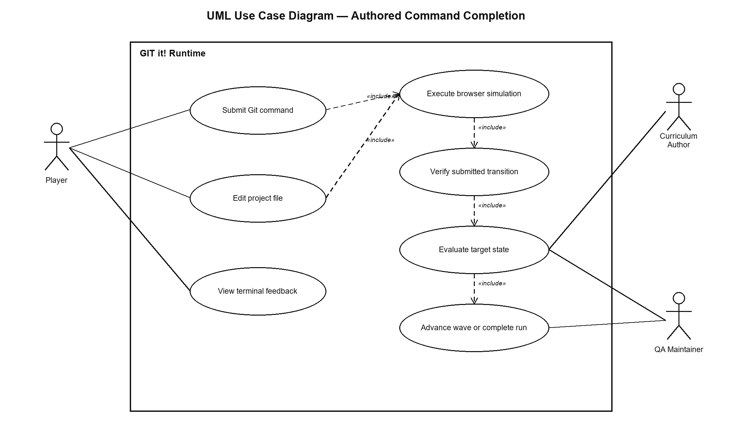

3.3.1 UC-01 — Execute a Mutating Command
Property | Description
Primary actor | Player
Preconditions | An authenticated run is started; a wave and variant are selected; the browser holds the current authoritative repository snapshot and revision.
Trigger | The player submits a non-diagnostic Git command.
Main flow | 1. Browser normalizes and executes. 2. UI applies optimistic state. 3. Client posts the revisioned execution. 4. Backend validates and verifies. 5. Backend evaluates and persists. 6. UI applies the authoritative response.
Alternative flow | If the payload, revision, or transition is invalid, the backend rejects it; the client restores the prior authoritative session and displays an error.
Postconditions | Exactly one accepted command step is recorded; counters and repository state are consistent; the wave remains active, advances, fails, or completes according to evaluation and budget.

3.3.2 UC-02 — Edit an Authored Project File
Property | Description
Primary actor | Player; automated QA harness during acceptance.
Preconditions | The active authored sequence contains a workspace-file action whose after_command_index has been reached.
Trigger | The actor opens the named file, applies the authored edit or content replacement, and activates Save.
Main flow | The visible workspace updates working_tree content; the next authored command executes against the updated canonical state.
Postconditions | The file content is represented losslessly in canonical state and may be staged, committed, inspected, or evaluated by subsequent steps.

3.3.3 UC-03 — Execute a Diagnostic Command
Property | Description
Primary actor | Player
Preconditions | A run is active and the submitted command is a supported diagnostic form.
Trigger | The player submits a read-only command such as git show, git config --list, merge-base, or rev-list.
Main flow | The browser shows immediate output; the backend verifies the diagnostic classification, derives any trusted evidence from previous state, returns authoritative output/state, and does not increment the counted-command budget.
Postconditions | Repository state is unchanged except for explicitly supported backend-derived evidence metadata.

3.3.4 UC-04 — Verify the Authored Curriculum Matrix
Property | Description
Primary actor | QA Maintainer
Preconditions | Frontend and backend are running from the candidate contract baseline; authored content is loaded.
Trigger | The maintainer runs the generated frontend level-sequence verifier.
Main flow | The harness opens each target, performs terminal commands and visible workspace-file actions in authored order, and asserts completion through the production UI/API path.
Success criterion | 284 of 284 target sequences complete with zero mismatch, crash, or unexpected rejection.

3.4 Activity Model
Figure 2. Command submission and evaluation activity
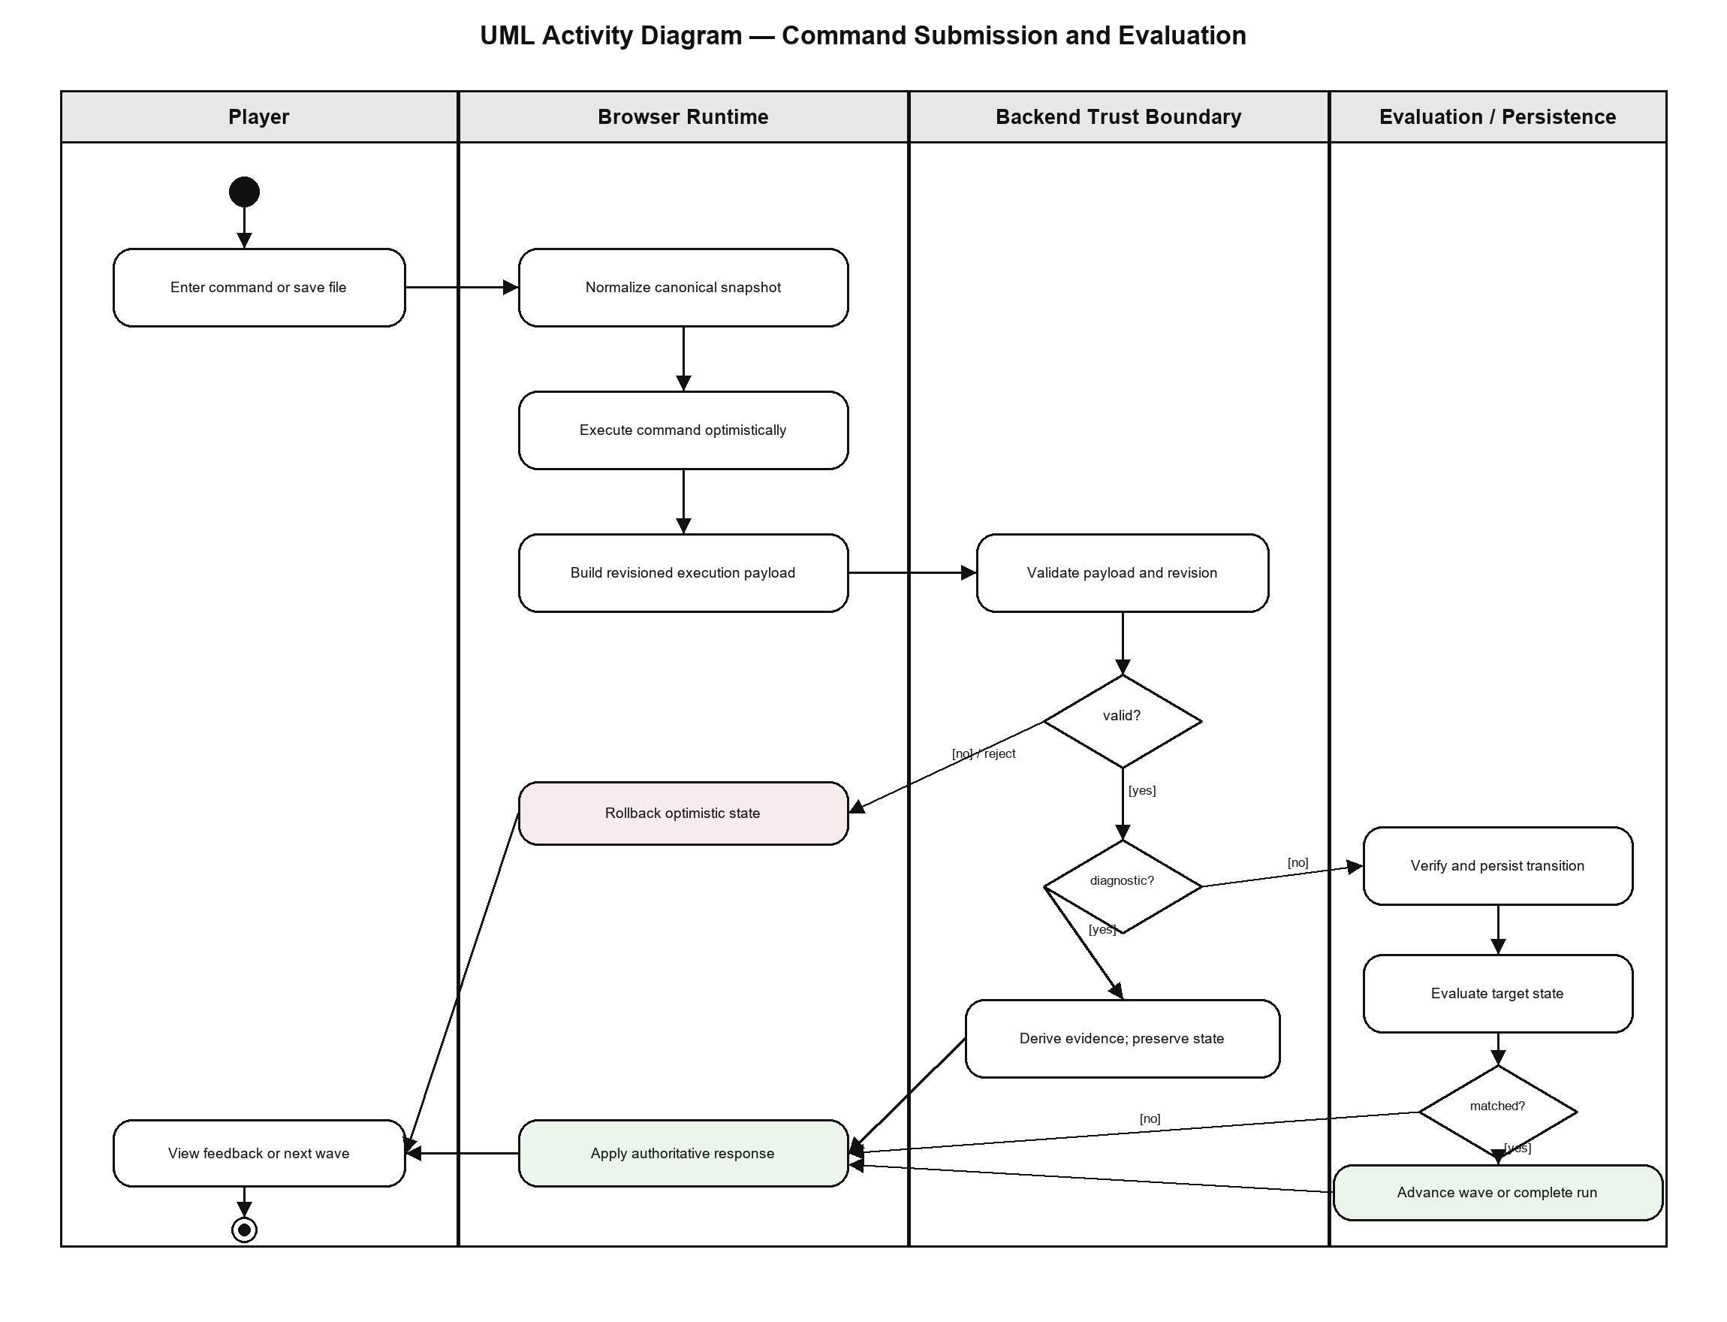

3.5 Non-functional Requirements
ID | Requirement
NFR-001 Performance | The UI SHALL apply local command output and optimistic state before awaiting the server response. Verification SHALL use deterministic state operations and SHALL NOT spawn a real Git process.
NFR-002 Security | The backend SHALL treat all client execution fields as untrusted, validate schema and metadata, verify mutating transitions, derive diagnostic evidence, enforce the revision, and cap state size.
NFR-003 Reliability | Rejected submissions SHALL leave persisted state and counters unchanged. Accepted command orchestration SHALL execute within one database transaction.
NFR-004 Integrity | Canonical hashing, persistence, evaluation, and verification SHALL operate on the same normalized state shape; derived presentation trees SHALL not influence completion.
NFR-005 Maintainability | Shared optimistic lifecycle, canonical snapshot logic, and verification families SHOULD remain modular and DRY. Mirrored frontend/backend behavior SHALL be protected by parity tests.
NFR-006 Testability | Every supported command family and authored regression SHALL have deterministic unit or integration coverage; release acceptance SHALL include the generated real-browser matrix.
NFR-007 Accessibility | Terminal outcomes and errors SHALL be available as text and SHALL not rely on color alone. Diagrams and figures in controlled documentation SHALL include alternative text.
NFR-008 Compatibility | The contract SHALL remain serializable as JSON and SHALL preserve unknown command-relevant extension fields during lossless cloning and normalization.

4 Acceptance and Traceability

4.1 Acceptance Criteria
- All backend and frontend automated tests pass without ignored contract failures.
- Static analysis, linting, dead-code analysis, and production builds pass.
- Fresh database migrations and deployment checks pass.
- The generated target-case suite passes and all 284 authored frontend sequences complete through the real browser harness.
- No canonical repository field is lost, and only project_tree and visible_tree are excluded as derived display state.
- Mutating, diagnostic, partial-add, reset, merge, squash, abort, and authored workspace-file regressions are covered.

4.2 Requirement Traceability Matrix
Requirements | Design ownership | Acceptance evidence
FR-001–FR-002 | RepositoryStateNormalizer; RepositorySnapshotService; frontend snapshot module | Normalizer/snapshot parity suites
FR-003–FR-004 | useOptimisticGitCommand; BrowserGitEngine; command API | Optimistic lifecycle and API payload tests
FR-005–FR-006 | ClientCommandExecutionService; ClientTransitionVerifier | Integrity, diagnostic, and verifier tests
FR-007–FR-010 | Frontend command handlers; backend verification mixins | Command-family parity regressions
FR-011 | Project-file workspace; generated sequence harness | Visible browser file-action tests
FR-012 | AdventureCommandService; EvaluationEngine; AdventureRunService | Adventure command/evaluation tests
FR-013–FR-016 | Execution boundary; classifier; payload cap | Boundary/security tests
FR-017 | verify_frontend_level_sequences.py | 284/284 browser acceptance matrix

4.3 UML Conformance Statement
Figures 1 and 2 use UML 2.x use-case and activity notation respectively. The use-case view uses actors, use-case ellipses, a system boundary, associations, and include dependencies. The activity view uses activity partitions, initial/activity-final nodes, actions, decisions, guards, and control flows. No non-UML diagram symbol is used.

