
IT342-Section
SYSTEMS INTEGRATION AND ARCHITECTURE 1

FUNCTIONAL REQUIREMENTS SPECIFICATION (FRS)

Project Title: BrainBox - A Centralized Learning and Knowledge Tool
Prepared By: Joana Carla Gako
Date of Submission: January 30, 2026
Version: 1

Table of Contents
1. Introduction 3
1.1. Purpose 3
1.2. Scope 3
1.3. Definitions, Acronyms, and Abbreviations 3
2. Overall Description 3
2.1. System Perspective 3
2.2. User Classes and Characteristics 3
2.3. Operating Environment 3
2.4. Assumptions and Dependencies 3
3. System Features and Functional Requirements 3
3.1. Authentication and Account Access
3.2. Profile and Settings Management
3.3. Notebook Management
3.4. Category Management
3.5. AI Configuration and Conversations
3.6. Quiz Management and Study
3.7. Flashcard Management and Study
3.8. Playlist Management
3.9. Playback Queue and Audio Study
4. Non-Functional Requirements 3
5. System Models (Diagrams) 4
5.1. ERD 4
5.2. Use Case Diagram 4
5.3. Activity Diagram 4
5.4. Class Diagram 4
5.5. Sequence Diagram 4
6. Appendices 4

Introduction

Purpose
This document describes the functional and non-functional requirements of BrainBox. It is intended for the project developer, instructor, testers, and evaluators who need to understand what the system must do and what constraints the system must satisfy.

Scope
BrainBox is a multi-platform study application that allows users to manage notebooks, generate and study quizzes and flashcards, organize study materials, use AI-assisted notebook features, maintain playlists and playback queues, and recover previous notebook content through version history.

The system includes a Spring Boot backend API, a React/Vite web application, and an Android/Kotlin mobile application. The system covers authentication, profile and settings management, notebook management, notebook content versioning, categories, AI configuration and conversations, quizzes, flashcards, playlists, playback queue, and mobile audio playback.

The system does not cover payment processing, real-time collaborative editing, public social sharing, production analytics dashboards, offline mobile study mode, or admin management workflows.

Definitions, Acronyms, and Abbreviations

Term | Definition
AI | Artificial intelligence support used for notebook assistance and generated study materials.
API | Application Programming Interface.
Client Mutation ID | Client-generated identifier used to make selected write operations idempotent.
DTO | Data Transfer Object used for API request and response payloads.
JWT | JSON Web Token used for authenticated API access.
SDD | System Design Document.
SRS | Software Requirements Specification.
Version History | Saved notebook content snapshots that users can list, preview, and restore.

Overall Description

System Perspective
BrainBox is a client-server system. The web and mobile clients communicate with the Spring Boot backend through REST API endpoints. The backend handles authentication, user-owned study data, generated study content, AI configuration, notebook versioning, and playback queue state. The web application provides the full notebook editor, profile/settings surfaces, study management screens, and playback queue UI. The Android application provides authenticated mobile screens, quiz and flashcard study screens, playlist screens, profile access, and audio playback behavior through backend-provided data.

User Classes and Characteristics

User Class | Characteristics
Guest User | Can register, verify email, log in, use Google sign-in, and request password recovery.
Authenticated User | Can manage profile, notebooks, notebook versions, categories, AI settings, AI conversations, quizzes, flashcards, playlists, playback queue, exports, and mobile study flows.
External Service | Email and AI provider services used by the backend for verification, reset, and AI workflows.

Operating Environment

Component | Operating Environment
Backend | Java 21, Spring Boot, Maven, PostgreSQL, REST over HTTP.
Web Frontend | React, Vite, React Router, TanStack Query, TipTap editor, modern browser.
Mobile Application | Android API 24 or higher, Kotlin, Jetpack Compose, Retrofit, Media3.
Development Tools | Git, Maven wrapper, Gradle wrapper, Node.js/npm, Android Studio or compatible IDE.

Assumptions and Dependencies
- Users need internet access for authentication, API access, and AI requests.
- The backend depends on a configured PostgreSQL database.
- Email verification and password recovery depend on a configured email sender.
- Google sign-in depends on a valid Google web client ID.
- AI features depend on configured AI model, proxy URL, and API key values.

System Features and Functional Requirements
Describe each major feature of the system and its functional requirements.

Feature 1: Authentication and Account Access
Description: The system allows guest users to create an account, verify identity, log in, refresh sessions, log out, use Google sign-in, and recover forgotten passwords.
Functional Requirements:
FR-AUTH-01: The system shall allow a guest user to register using username, email, and password.
FR-AUTH-02: The system shall support email verification for registered users.
FR-AUTH-03: The system shall allow a registered user to log in using valid credentials.
FR-AUTH-04: The system shall issue access and refresh tokens after successful login.
FR-AUTH-05: The system shall allow token refresh using a valid refresh token.
FR-AUTH-06: The system shall allow a user to log out and end the active session.
FR-AUTH-07: The system shall support forgot password, verification code, and reset password steps.
FR-AUTH-08: The system shall support Google sign-in using a valid Google identity token.

Feature 2: Profile and Settings Management
Description: The system allows authenticated users to view profile information and manage account settings.
Functional Requirements:

FR-PROF-01: The system shall allow an authenticated user to retrieve their profile.
FR-PROF-02: The system shall allow an authenticated user to update editable profile information.
FR-PROF-03: The system shall allow an authenticated user to change their password.
FR-PROF-04: The web application shall provide a Profile page that displays account information and account actions.
FR-PROF-05: The web application shall provide a Settings modal with Profile, Password, and AI Provider tabs.
FR-PROF-06: The system shall allow an authenticated user to configure AI provider settings from the Settings modal.

Feature 3: Notebook Management
Description: The system allows authenticated users to create, edit, review, organize, export, version, restore, and delete notebooks.
Functional Requirements:
FR-NOTE-01: The system shall allow an authenticated user to create a notebook.
FR-NOTE-02: The system shall allow an authenticated user to retrieve their notebook list.
FR-NOTE-03: The system shall allow an authenticated user to retrieve recently edited notebooks.
FR-NOTE-04: The system shall allow an authenticated user to retrieve recently reviewed notebooks.
FR-NOTE-05: The system shall allow an authenticated user to retrieve a notebook by UUID.
FR-NOTE-06: The system shall allow an authenticated user to update notebook metadata.
FR-NOTE-07: The system shall allow an authenticated user to save notebook content.
FR-NOTE-08: The system shall allow an authenticated user to update notebook review state.
FR-NOTE-09: The system shall create version snapshots when notebook content is saved.
FR-NOTE-10: The system shall allow an authenticated user to view notebook version history.
FR-NOTE-11: The system shall allow an authenticated user to preview a previous notebook version before restoration.
FR-NOTE-12: The system shall allow an authenticated user to delete a notebook they own.
FR-NOTE-13: The system shall allow an authenticated user to restore a previous notebook version.
FR-NOTE-14: The system shall allow an authenticated user to manually create a notebook version snapshot.
FR-NOTE-15: The system shall detect stale notebook content updates through version information and return a conflict response with the latest notebook data.
FR-NOTE-16: The web editor shall allow notebook content export to PDF/print, Word .docx, and text .txt formats.
FR-NOTE-17: The web editor shall provide formatting, table, math, page break, outline navigation, and review-mode controls where supported by the implemented editor.

Feature 4: Category Management
Description: The system allows authenticated users to organize notebooks using categories.
Functional Requirements:
FR-CAT-01: The system shall allow an authenticated user to retrieve categories.
FR-CAT-02: The system shall allow an authenticated user to create a category.
FR-CAT-03: The system shall allow an authenticated user to retrieve a category by ID.
FR-CAT-04: The system shall allow an authenticated user to delete a category.
FR-CAT-05: The system shall update affected notebooks when a category is deleted.
FR-CAT-06: The system shall allow notebook records to reference a user-owned category.

Feature 5: AI Configuration and Conversations
Description: The system allows authenticated users to configure AI access and use AI assistance in notebook workflows.

Functional Requirements:
FR-AI-01: The system shall allow an authenticated user to view the selected AI configuration.
FR-AI-02: The system shall allow an authenticated user to list saved AI configurations.
FR-AI-03: The system shall allow an authenticated user to create or update an AI configuration.
FR-AI-04: The system shall allow an authenticated user to select an AI configuration.
FR-AI-05: The system shall allow an authenticated user to delete an AI configuration.
FR-AI-06: The system shall allow an authenticated user to submit an AI query.
FR-AI-07: The system shall allow an authenticated user to list, create, update, and delete AI conversations for a notebook.
FR-AI-08: The system shall support AI-assisted notebook editing, review, quiz creation, and flashcard creation when configured.
FR-AI-09: The system shall support selected text and multiple AI selection targets in AI requests where provided by the editor.
FR-AI-10: The system shall keep AI provider keys server-side and prevent them from being exposed in client-visible source code.
FR-AI-11: Editor mode AI shall provide Chat, Improve, Expand, Summarize, Explain, Quiz, and Flashcards tools for authoring and study-material creation.
FR-AI-12: Review mode AI shall provide Chat, Study Guide, Summarize, Explain, Quiz, and Flashcards tools for study and review workflows.
FR-AI-13: Review mode AI shall be read-only for notebook content and shall not directly insert, append, replace, rewrite, or otherwise modify notebook content.
FR-AI-14: The backend shall sanitize review-mode AI responses by changing content mutation actions to none and removing editorContent or selectionEdits before returning the response.
FR-AI-15: The system shall persist AI conversation titles and message history by notebook so users can continue notebook-specific AI chats.
FR-AI-16: The system shall support AI response actions for none, add_to_editor, replace_editor, replace_selection, replace_ai_selections, create_quiz, and create_flashcard, subject to the selected assistant mode.

Feature 6: Quiz Management and Study
Description: The system allows authenticated users to create quizzes, study them, and record quiz attempts.
Functional Requirements:
FR-QUIZ-01: The system shall allow an authenticated user to create a quiz.
FR-QUIZ-02: The system shall allow an authenticated user to list their quizzes.
FR-QUIZ-03: The system shall allow an authenticated user to retrieve a quiz by UUID.
FR-QUIZ-04: The system shall allow an authenticated user to update a quiz.
FR-QUIZ-05: The system shall allow an authenticated user to delete a quiz.
FR-QUIZ-06: The system shall allow an authenticated user to record quiz attempts and scores.
FR-QUIZ-07: The system shall associate quizzes with notebooks when a notebook UUID is provided.
FR-QUIZ-08: The web and mobile clients shall allow users to study quizzes and submit attempts.

Feature 7: Flashcard Management and Study
Description: The system allows authenticated users to create flashcard decks, study them, and record flashcard attempts.
Functional Requirements:
FR-FLASH-01: The system shall allow an authenticated user to create a flashcard deck.
FR-FLASH-02: The system shall allow an authenticated user to list their flashcard decks.
FR-FLASH-03: The system shall allow an authenticated user to retrieve a flashcard deck by UUID.
FR-FLASH-04: The system shall allow an authenticated user to update a flashcard deck.
FR-FLASH-05: The system shall allow an authenticated user to delete a flashcard deck.
FR-FLASH-06: The system shall allow an authenticated user to record flashcard attempts and mastery.
FR-FLASH-07: The system shall associate flashcard decks with notebooks when a notebook UUID is provided.
FR-FLASH-08: The web and mobile clients shall allow users to study flashcard decks and submit mastery attempts.

Feature 8: Playlist Management
Description: The system allows authenticated users to organize notebooks into ordered study playlists.
Functional Requirements:
FR-PLAYLIST-01: The system shall allow an authenticated user to create a playlist.
FR-PLAYLIST-02: The system shall allow an authenticated user to list playlists.
FR-PLAYLIST-03: The system shall allow an authenticated user to retrieve a playlist by UUID.
FR-PLAYLIST-04: The system shall allow an authenticated user to update playlist metadata.
FR-PLAYLIST-05: The system shall allow an authenticated user to delete a playlist.
FR-PLAYLIST-06: The system shall allow an authenticated user to add notebooks to a playlist.
FR-PLAYLIST-07: The system shall allow an authenticated user to remove notebooks from a playlist.
FR-PLAYLIST-08: The system shall allow an authenticated user to reorder playlist notebooks.
FR-PLAYLIST-09: The system shall allow an authenticated user to update the playlist current index.

Feature 9: Playback Queue and Audio Study
Description: The system allows authenticated users to build and control a notebook playback queue.
Functional Requirements:
FR-QUEUE-01: The system shall allow an authenticated user to retrieve the current playback queue.
FR-QUEUE-02: The system shall allow an authenticated user to add notebooks to the current playback queue.
FR-QUEUE-03: The system shall allow an authenticated user to select a playlist as the current queue source.
FR-QUEUE-04: The system shall allow an authenticated user to remove notebooks from the current playback queue.
FR-QUEUE-05: The system shall allow an authenticated user to clear the current playback queue.
FR-QUEUE-06: The system shall allow an authenticated user to update the queue current index.
FR-QUEUE-07: The system shall allow an authenticated user to reorder the queue.
FR-QUEUE-08: The mobile application shall provide playback controls for play, pause, skip, loop, shuffle, speech rate, playback position resume, and notebook review-state updates where supported.
FR-QUEUE-09: The web application shall provide a player bar and queue panel for current queue visibility and playback control.
FR-QUEUE-10: The system shall keep playlist and playback queue endpoints consistent through supported alias paths.

Non-Functional Requirements

Security and Privacy
NFR-01 Authentication: The system shall require authenticated access for all protected user, notebook, category, quiz, flashcard, playlist, playback queue, AI configuration, and profile endpoints. Unauthenticated requests to protected endpoints shall be rejected with 401 Unauthorized.
NFR-02 Authorization and Ownership: The system shall prevent users from accessing, modifying, or deleting records owned by another user. Unauthorized cross-user access shall be rejected with 403 Forbidden or 404 Not Found.
NFR-03 Password Protection: The system shall store user passwords using one-way password hashing. Plain-text passwords shall never be stored or returned by the API.
NFR-04 Session Expiry: The system shall store refresh tokens with expiry information and reject expired or invalid refresh tokens during token refresh.
NFR-05 Secret Management: The system shall keep AI provider keys, email credentials, JWT secrets, and environment-specific configuration outside client-visible source code.

Performance and Responsiveness
NFR-06 API Response Time: Under normal development/demo conditions, common backend operations such as login, listing notebooks, creating study items, updating notebook content, and loading study lists should complete within 2 seconds for typical test data.
NFR-07 Response Time Under Load: Under normal demo/test data volume and up to 20 concurrent active users, common API operations should return responses within 2 seconds for typical requests. Heavier operations that depend on external AI providers should either complete within 5 seconds or show a clear loading/failure state.
NFR-08 Concurrent User Support: The backend shall support at least 20 concurrent active users performing common actions such as login, loading notebooks, saving notebook content, and viewing quizzes or flashcards without server errors caused by normal traffic.
NFR-09 Paginated Study Lists: Study list screens that can contain many records shall use pagination or equivalent bounded loading to avoid loading the entire dataset at once.
NFR-10 Web Route Loading: The web application shall lazy-load major routes where appropriate and display a fallback state while route content is loading.

NFR-11 Mobile Audio Processing: The mobile application shall split long notebook text into bounded text-to-speech chunks so playback can start and continue without requiring the full notebook to be processed as a single audio unit.

Reliability and Data Integrity
NFR-12 Availability: During scheduled demonstration and evaluation periods, the backend API and database should remain available for the full testing session, excluding planned maintenance, local development environment failures, hosting provider outages, and third-party service outages.
NFR-13 Notebook Version Safety: The system shall use notebook version information to prevent stale clients from overwriting newer notebook content.
NFR-14 Idempotent Write Safety: For supported notebook, quiz, and flashcard attempt operations, the system shall use client mutation IDs or an equivalent mechanism to reduce duplicate effects caused by repeated requests.
NFR-15 Error Recovery: The web and mobile clients shall display clear recovery or fallback states for invalid input, unauthorized access, missing records, route load failures, and failed external service requests.
NFR-16 Playback Continuity: The mobile application shall preserve playback state sufficiently to allow users to resume supported audio study sessions after navigation or temporary interruption.

Compatibility and Portability
NFR-17 Web Compatibility: The web application shall run in modern browsers supported by the React/Vite toolchain. If a stricter compatibility target is required, BrainBox shall support the latest two major versions of Chrome, Edge, Firefox, and Safari.
NFR-18 Android Compatibility: The Android application shall support Android API level 24 and higher.

Usability
NFR-19 Navigation Clarity: The system shall provide clear navigation to authentication, dashboard, library, notebook editor, quizzes, flashcards, playlists, playback, profile, and settings workflows.
NFR-20 Editor Discoverability: The notebook editor shall provide visible controls for editing, AI assistance, export, outline navigation, review mode, and version history.
NFR-21 Mobile Touch Usability: The mobile application shall provide touch-friendly navigation, study screens, and playback controls suitable for common Android phone screen sizes.
NFR-22 Error Message Clarity: Error messages shown to users shall be human-readable and shall identify the type of problem, such as invalid input, unauthorized access, missing record, version conflict, or external service failure.

Maintainability and Testability
NFR-23 Automated Test Coverage: The project shall include automated tests for major backend services/controllers, web interaction logic, and mobile application logic related to authentication, notebook management, study workflows, playback, and data integrity.
NFR-24 Architectural Separation: The Android and web applications shall keep feature, shared UI, networking/session, and app orchestration responsibilities separated to make future maintenance and feature changes easier.

System Models (Diagrams)
Insert the necessary diagrams for the system:

ERD
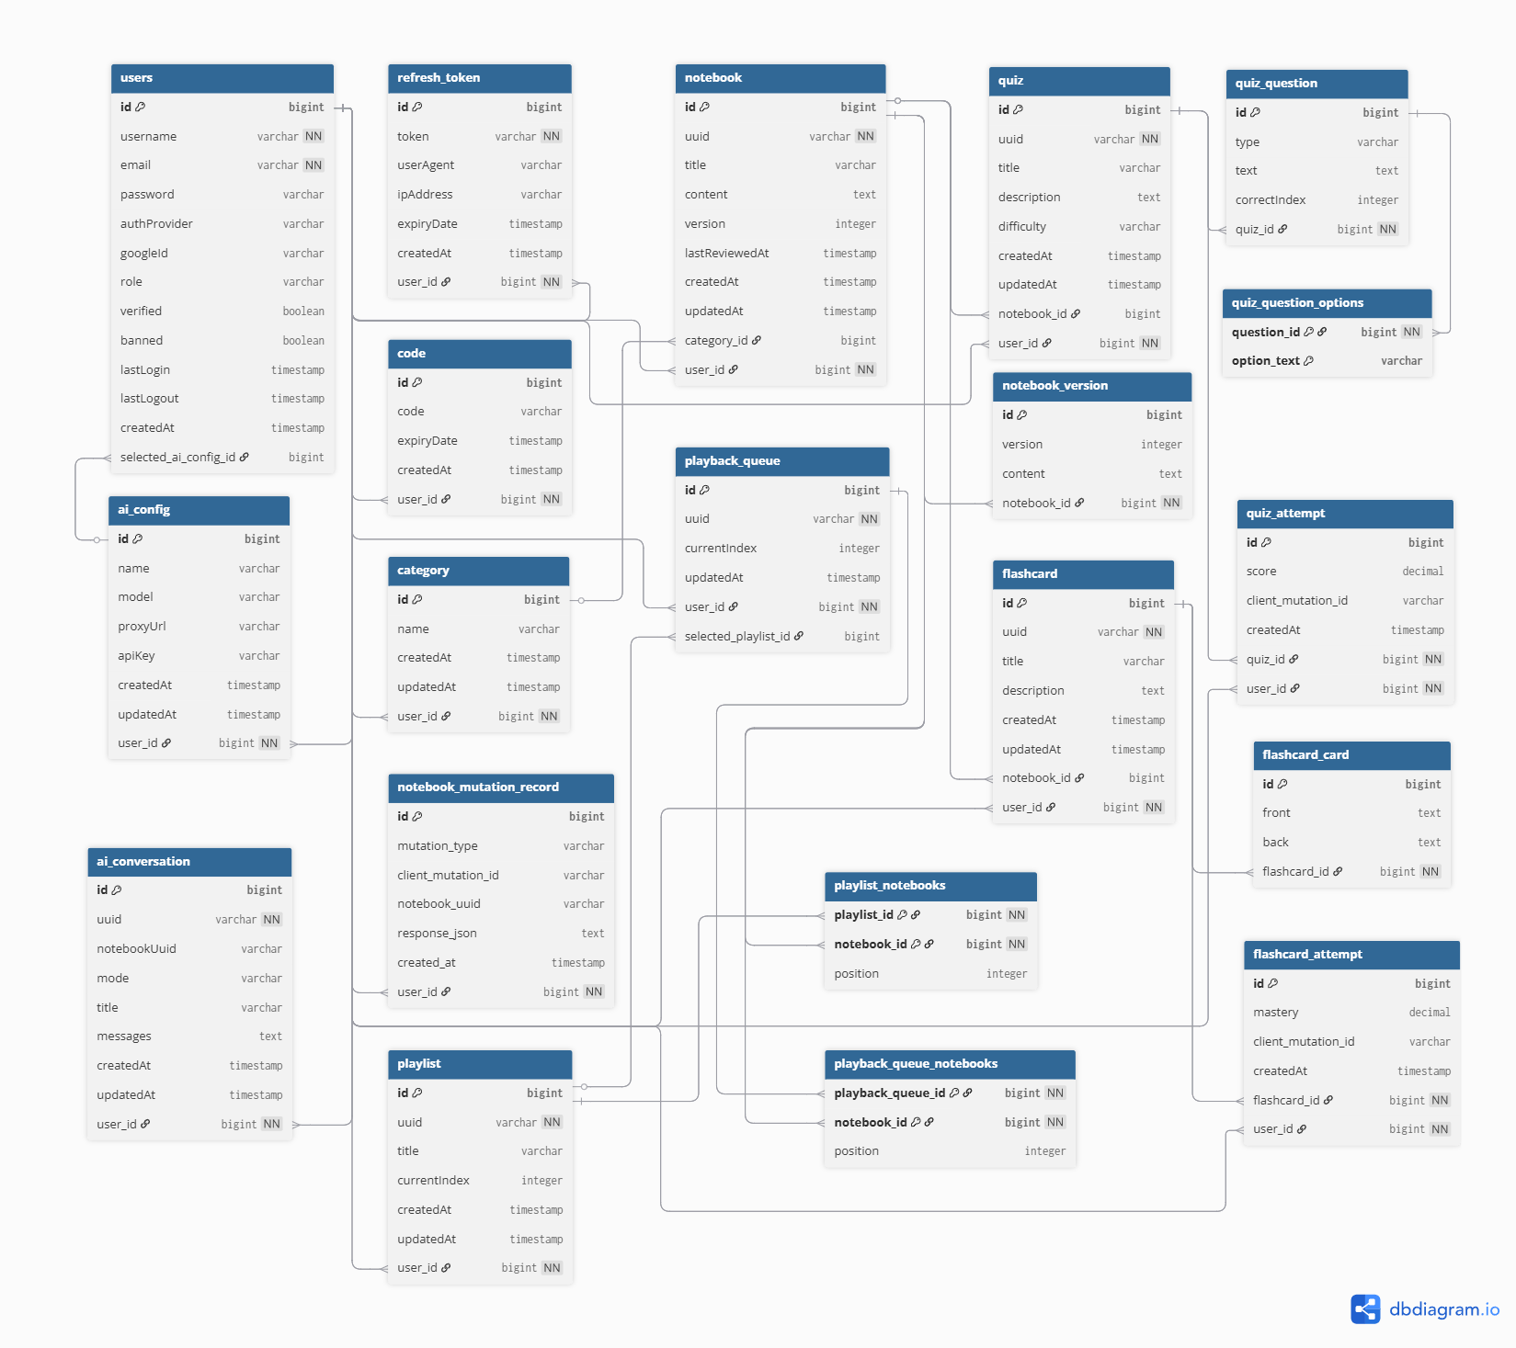

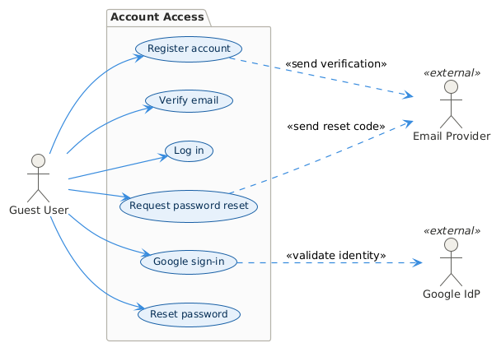
Use Case Diagram
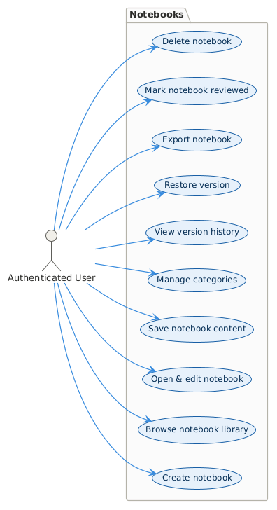
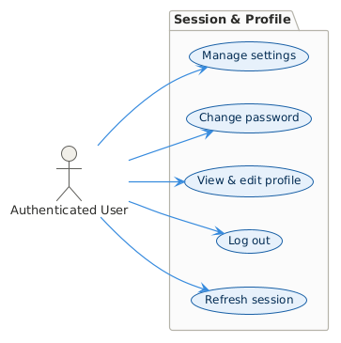
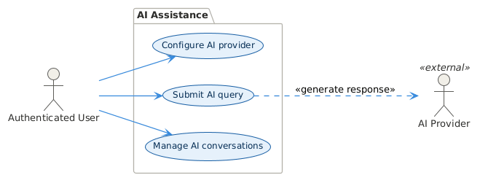
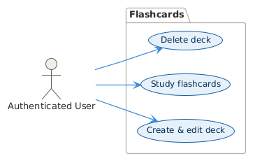

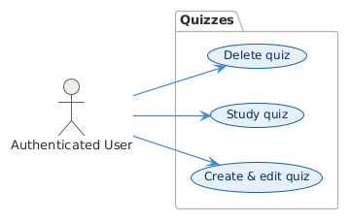
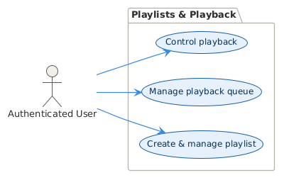

Activity Diagram

Authentication & Session Entry
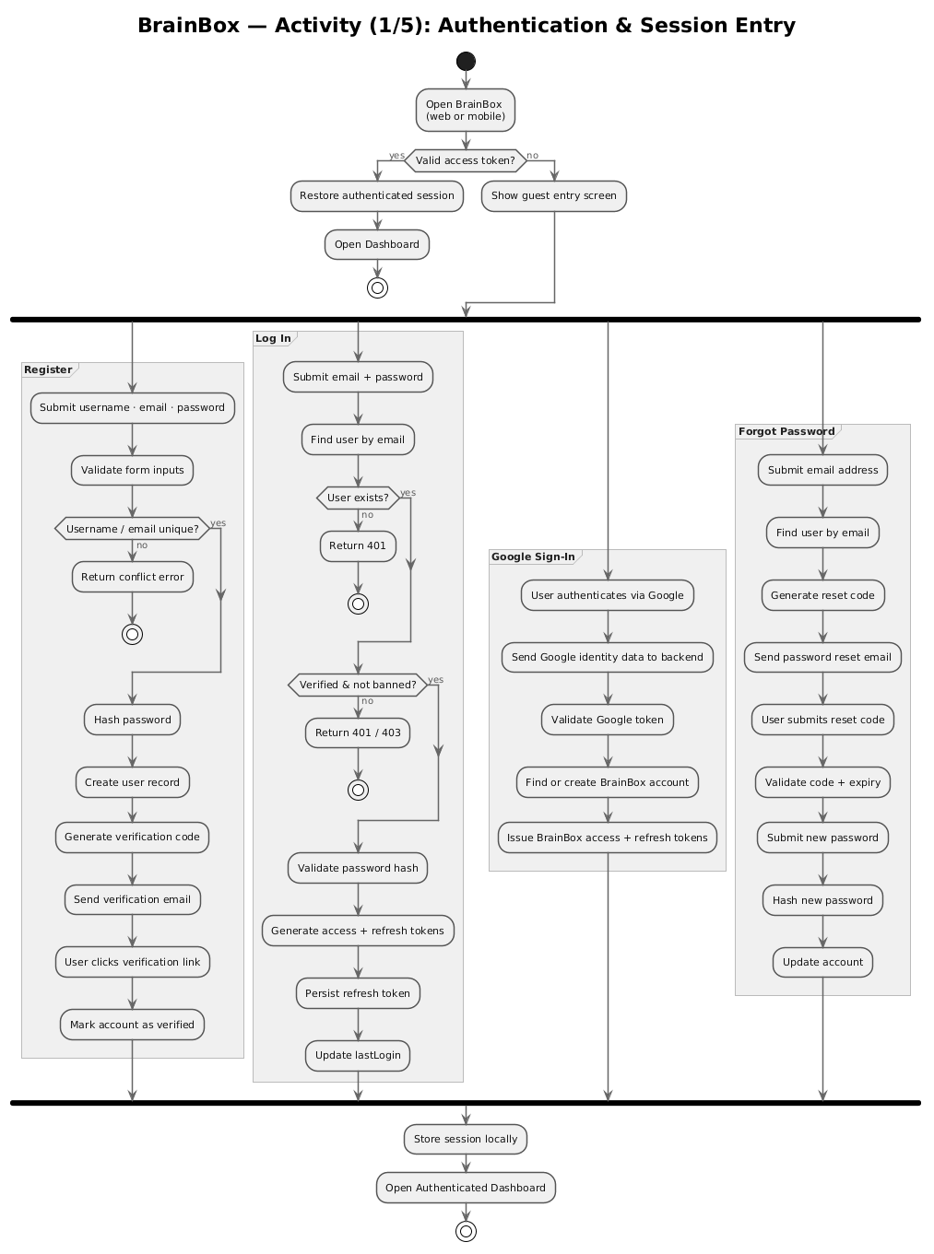
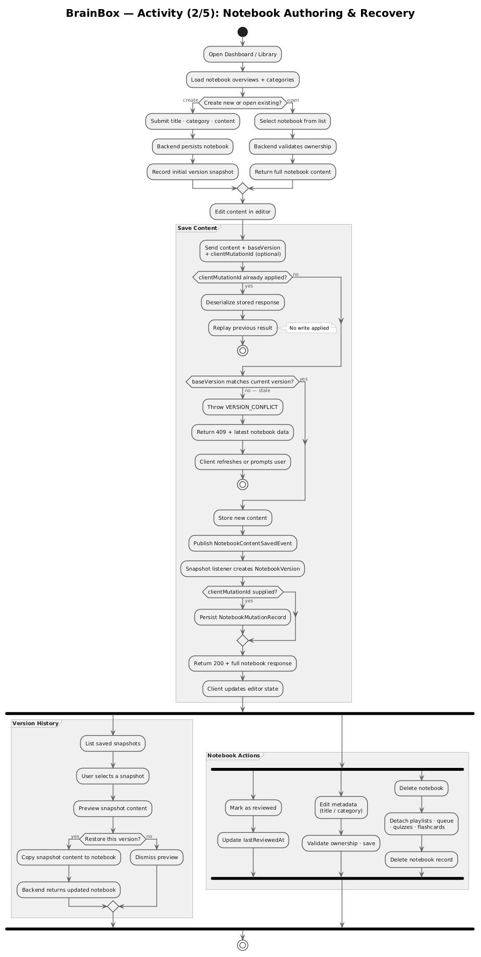
Notebook Authoring & Recovery
AI Assistance
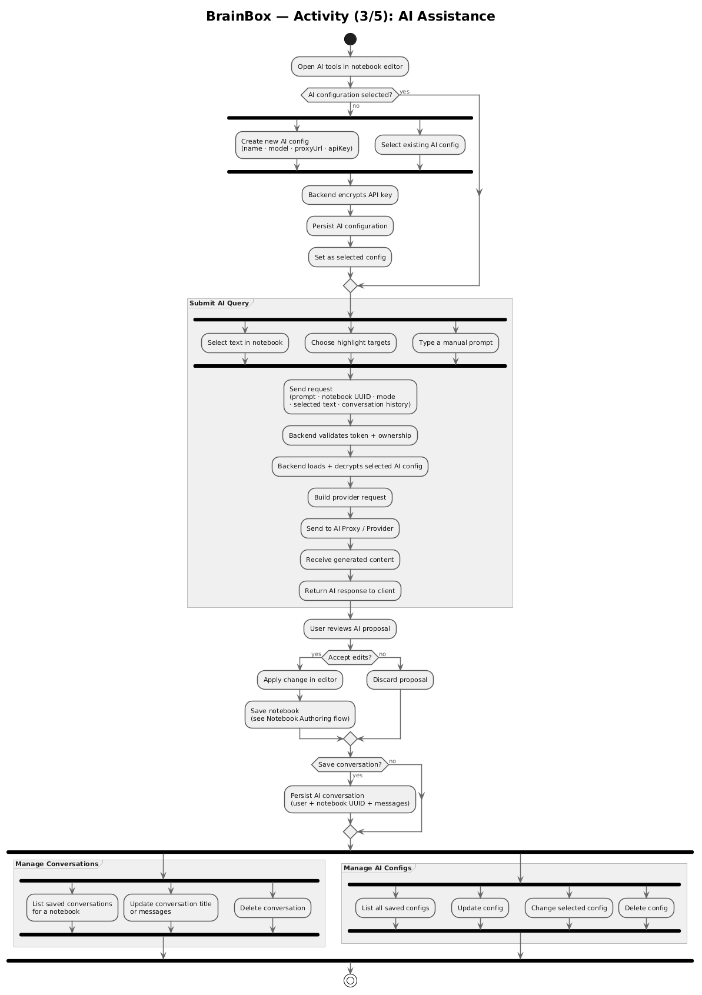
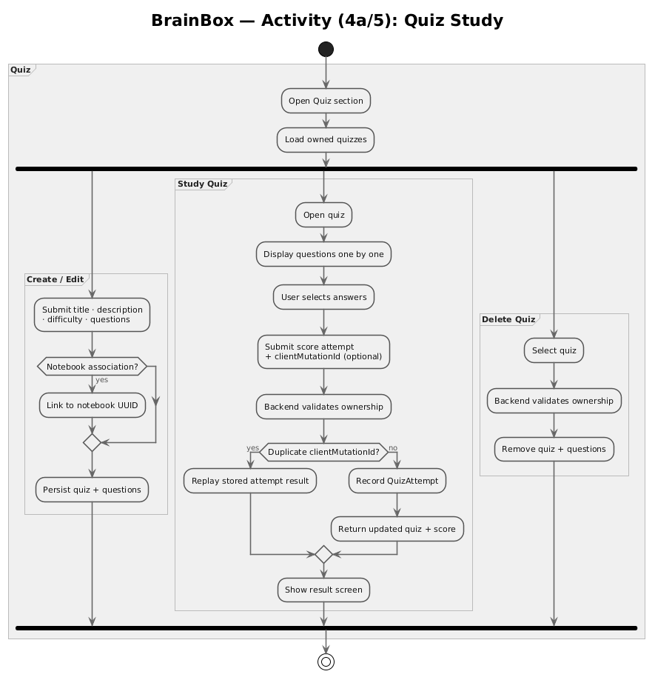
Quiz
Flashcards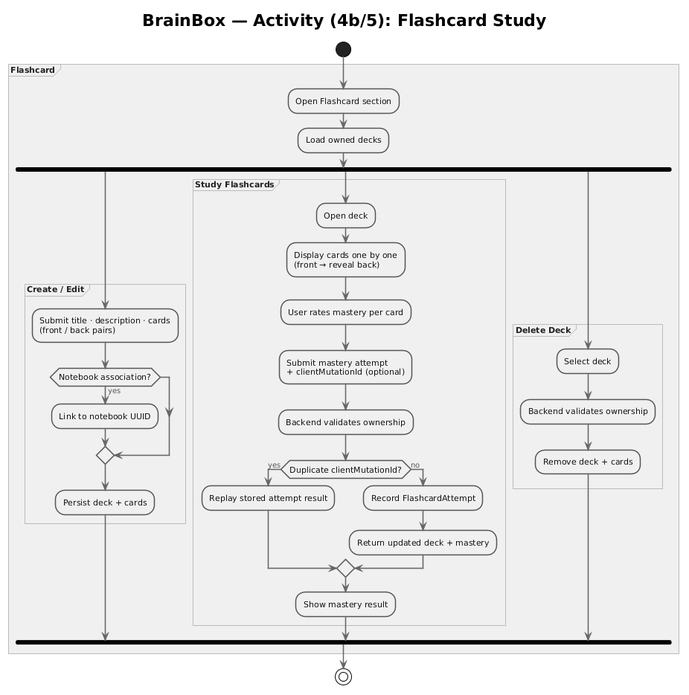
Manage Playlists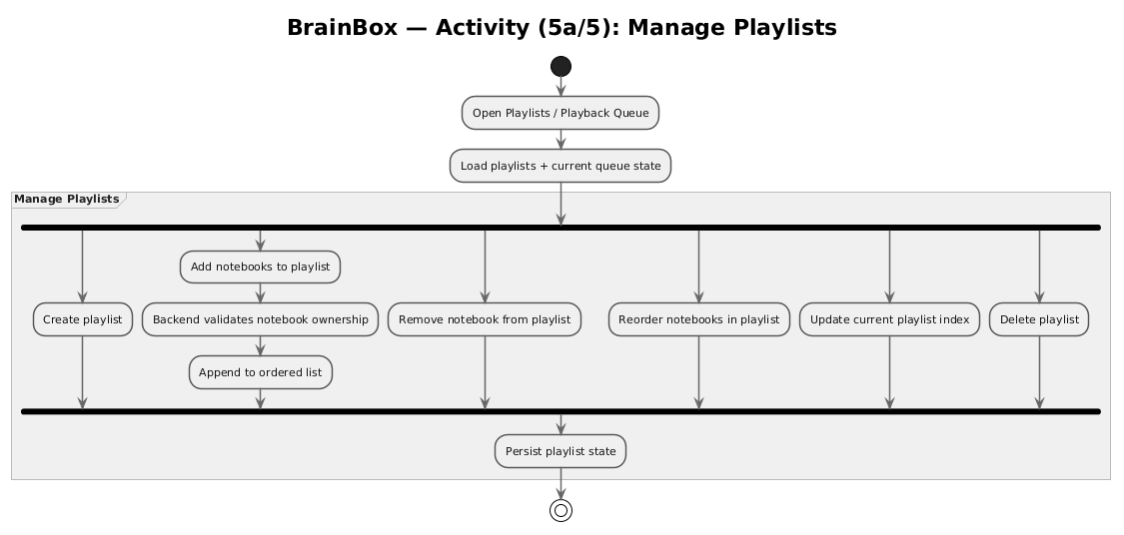
Manage Playlist Queue
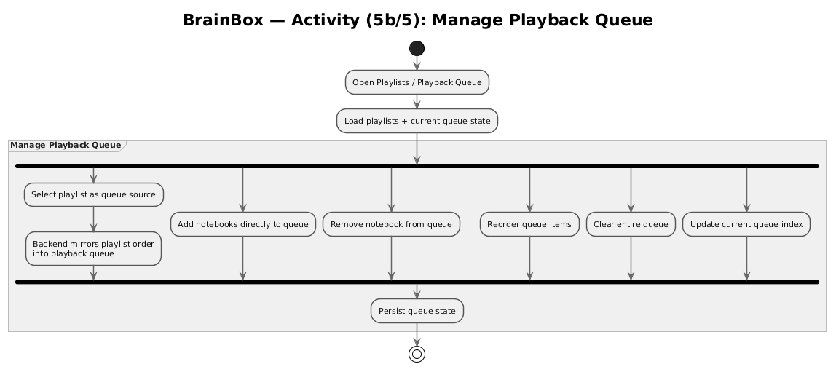
Playback Controls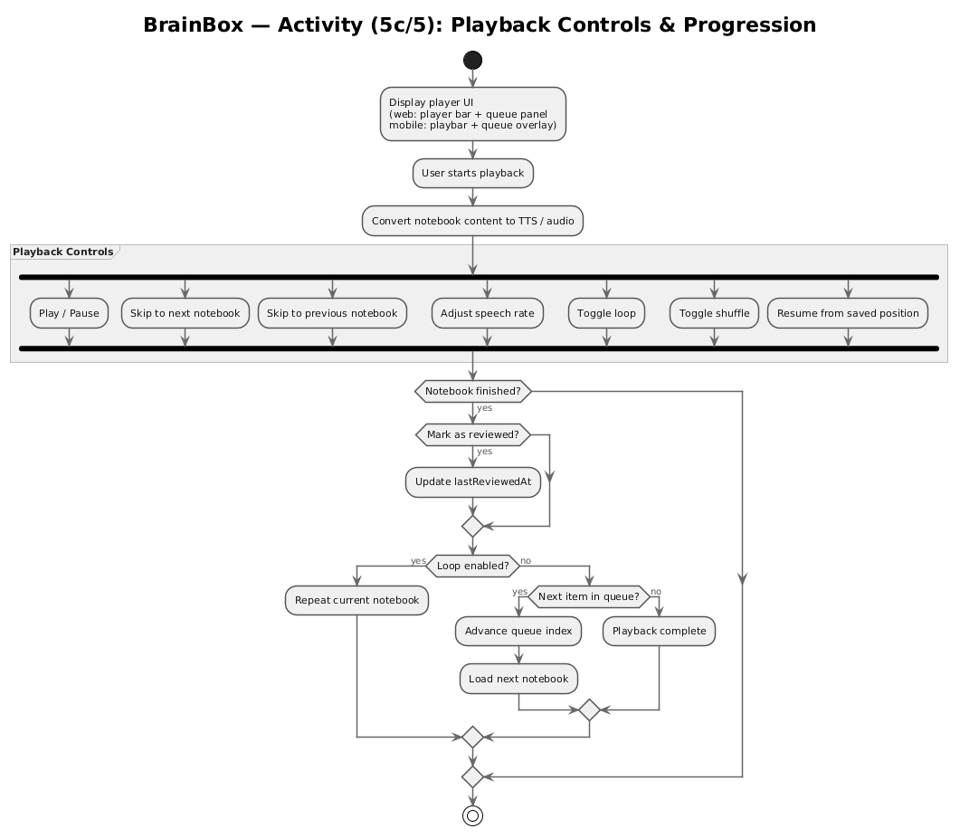

Class Diagram
Platform & Shared Layer
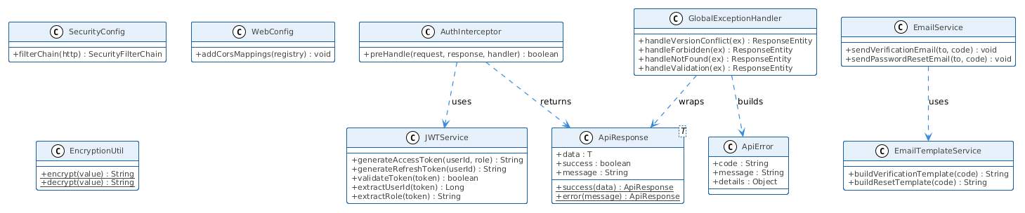
Authentication
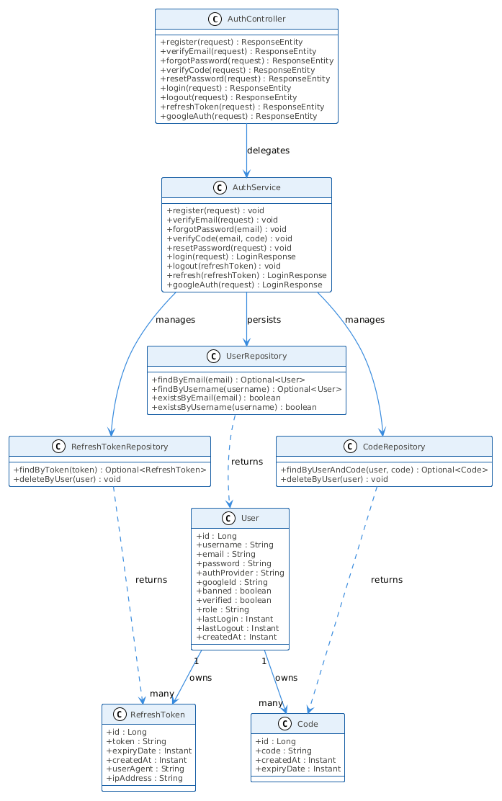
Profile
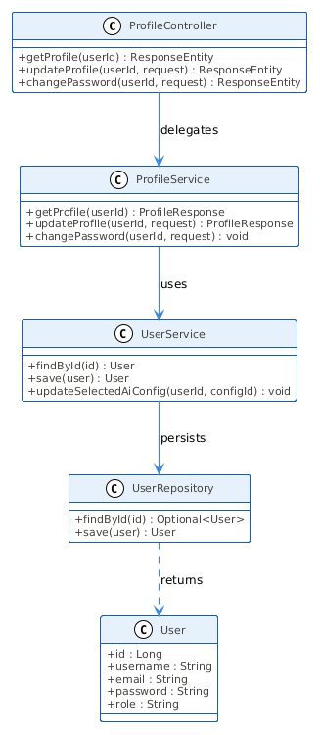
Notebooks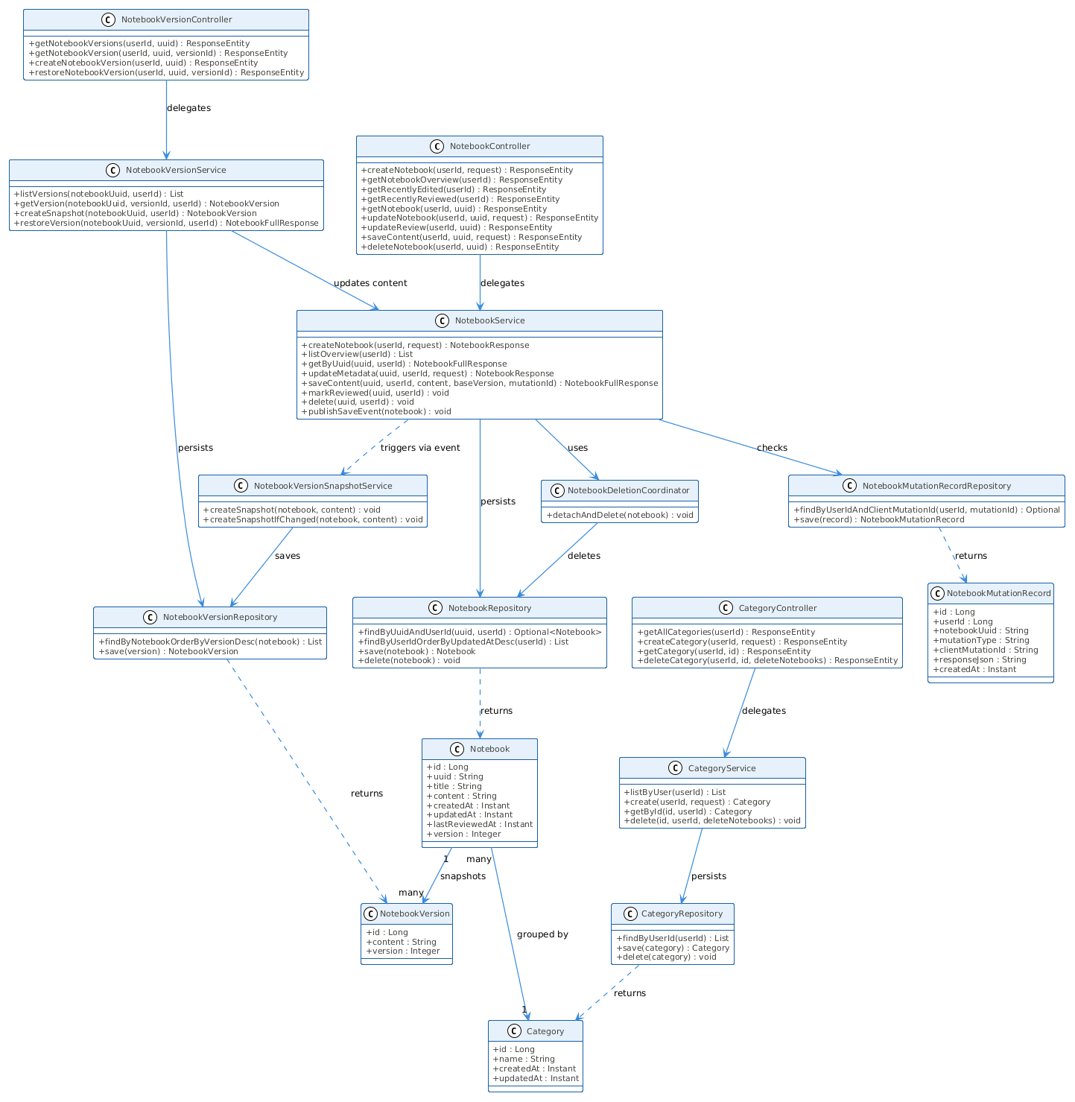

AI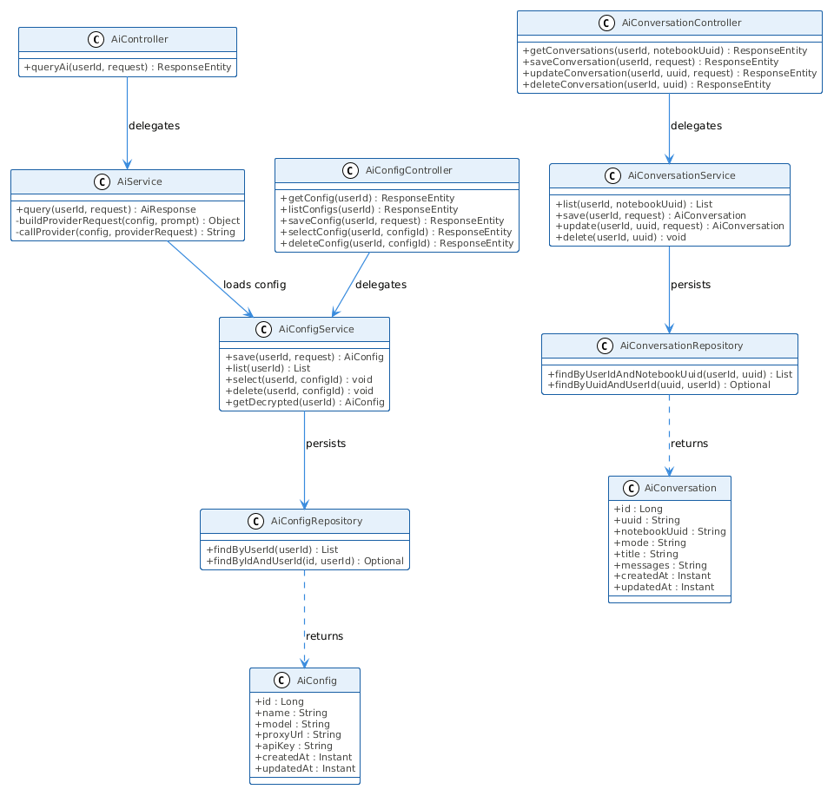

Quizzes & Flashcards 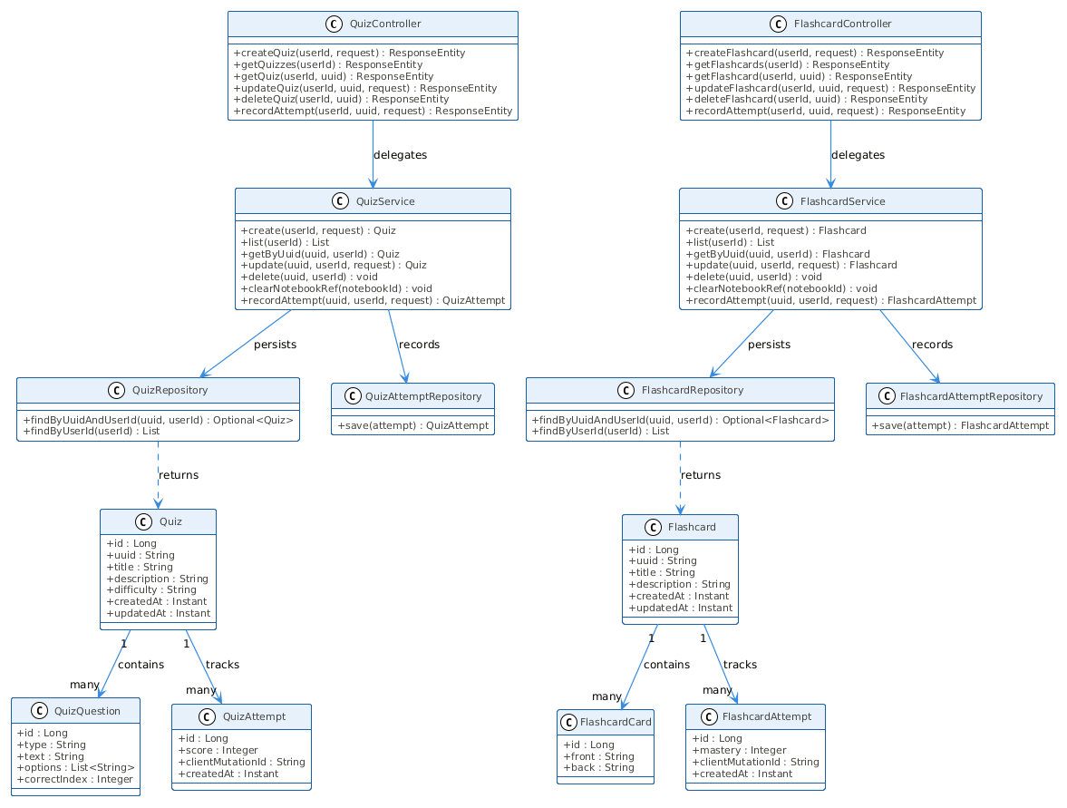
Playlists & Playback Queue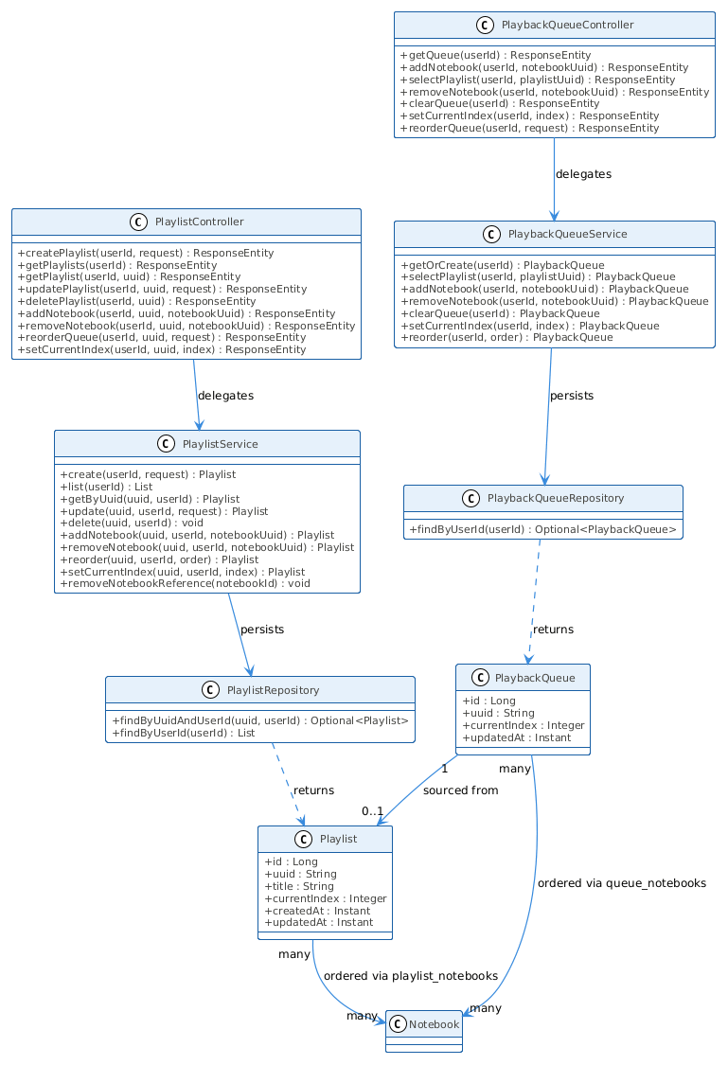

Sequence Diagram
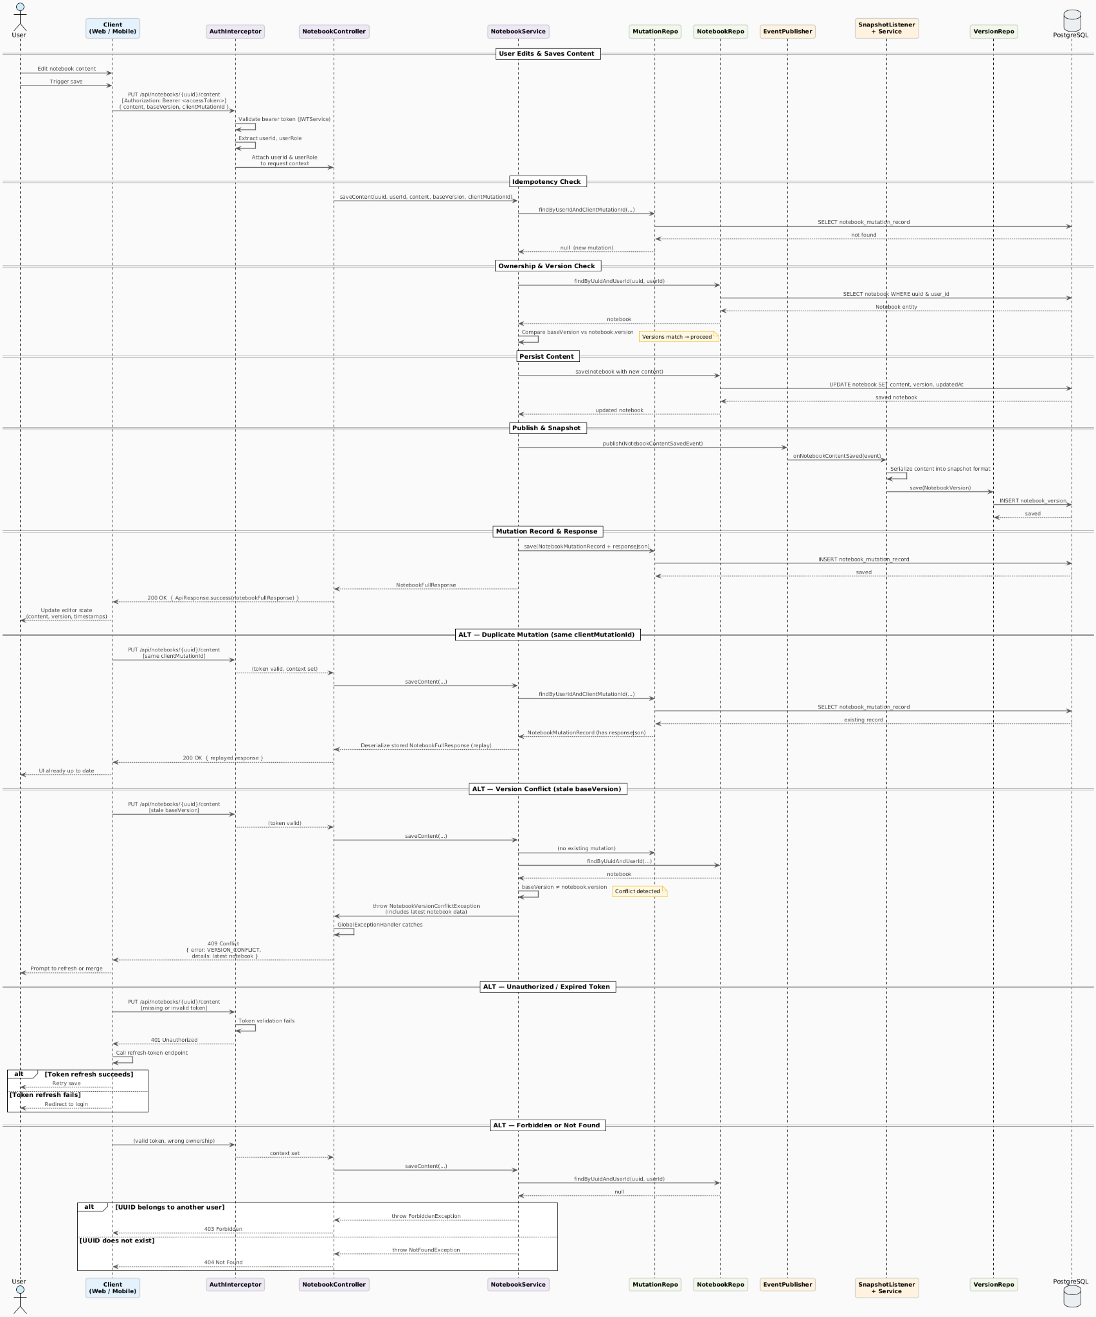

Appendices
Include any additional information, references, or support materials.

