

IT342-[Section]
System Integration and Architecture

System Design Document (SDD)

Project Title: Brainbox:
Prepared By: Gako, Joana Carla D.

Version: 3.0
Date: February 27, 2026
Status: Final

REVISION HISTORY TABLE
Version | Date | Author | Changes Made | Status
0.1 | February 20, 2026 | Gako, Joana Carla D. | Created initial outline. | Draft
0.2 | March 7, 2026 | Gako, Joana Carla D. | Added feature design. | Review
0.3 | March 22, 2026 | Gako, Joana Carla D. | Updated API and database notes. | Review
0.4 | April 8, 2026 | Gako, Joana Carla D. | Added system architecture section. | Revised
0.5 | April 28, 2026 | Gako, Joana Carla D. | Added UI/UX and plan sections. | Revised
1.0 | May 1, 2026 | Gako, Joana Carla D. | Finalized SDD content. | Final

TABLE OF CONTENTS
Contents
- EXECUTIVE SUMMARY
1.1 Project Overview
1.2 Objectives
1.3 Scope
- 1.0 INTRODUCTION
1.1 Purpose
- 2.0 FUNCTIONAL REQUIREMENTS SPECIFICATION
2.1 Project Overview
2.2 Core User Journeys
2.3 Feature List (MoSCoW)
2.4 Detailed Feature Specifications
2.5 Acceptance Criteria
- 3.0 NON-FUNCTIONAL REQUIREMENTS
3.1 Performance Requirements
3.2 Security Requirements
3.3 Compatibility Requirements
3.4 Usability Requirements
- 4.0 SYSTEM ARCHITECTURE
4.1 Component Diagram
- 5.0 API CONTRACT & COMMUNICATION
5.1 API Standards
5.2 Endpoint Specifications
Authentication Endpoints
5.3 Error Handling
- 6.0 DATABASE DESIGN
6.1 Entity Relationship Diagram
- 7.0 UI/UX DESIGN
7.1 Web Application Wireframes
7.2 Mobile Application Wireframes
- 8.0 PLAN
8.1 Project Timeline

EXECUTIVE SUMMARY
1.1 Project Overview
BrainBox is a multi-platform study application that helps users create notebooks, organize study materials, recover notebook content through version history, generate quizzes and flashcards, maintain playlists and playback queues, and use AI-assisted notebook features. The system includes a Spring Boot backend API, a React/Vite web application, and an Android/Kotlin mobile application integrated to provide a consistent study experience across platforms.
1.2 Objectives
- Provide secure account access for BrainBox users.
- Allow users to create, organize, edit, review, export, version, and restore notebooks.
- Support quiz and flashcard study workflows generated from user learning materials.
- Provide playlist, queue, and playback features for audio-based study.
- Support mobile study screens and playback controls.
- Maintain consistent web and mobile user experiences.
1.3 Scope
Included Features:
- User registration, login, logout, token refresh, email verification, password reset, and Google sign-in.
- User profile retrieval, profile update, password change, settings modal, and AI provider settings access.
- Notebook creation, listing, content editing, review tracking, deletion, version history, version preview, manual snapshots, stale-version conflict handling, and version restore.
- Category creation, listing, lookup, and deletion.
- AI configuration, selected AI provider management, AI query, and AI conversations.
- Quiz creation, editing, listing, studying, deletion, and attempt recording.
- Flashcard deck creation, editing, listing, studying, deletion, and attempt recording.
- Playlist creation, notebook queue management, reorder, deletion, and current index updates.
- Playback queue management and web/mobile playback controls.
- Web notebook editor formatting, outline navigation, review mode, and PDF/Word/text export.
Excluded Features:
- Real-time collaborative editing.
- Payment or subscription processing.
- Public content sharing platform.
- Production analytics dashboard.
- Admin management screens.
- Offline mobile study mode.

1.0 INTRODUCTION
1.1 Purpose
This document serves as the comprehensive design specification for the BrainBox system. It provides detailed requirements, architectural decisions, API contracts, database design, UI/UX design, and implementation plan to guide development and ensure all components integrate properly.

2.0 FUNCTIONAL REQUIREMENTS SPECIFICATION
2.1 Project Overview
Project Name: BrainBox
Domain: EdTech / Personal Knowledge Management
Primary Users:
- Students, self-directed learners.
- Professionals studying reference material.
Problem Statement: Students need a focused way to create notes, organize learning materials, generate study activities, review content through quizzes and flashcards, and continue studying across web and mobile devices.
Solution: BrainBox provides a notebook-centered study platform with authentication, profile/settings management, notebook management, version history, AI-assisted study support, quizzes, flashcards, playlists, playback queue management, and mobile study/playback support.
2.2 Core User Journeys
Journey 1: Account Access and Session Recovery
- User opens the web or mobile application.
- User registers with username, email, and password, or signs in with existing credentials.
- System sends or validates verification/reset information where required.
- System issues access and refresh tokens after successful login.
- User reaches the dashboard/home shell.
- If the access token expires, the client uses the refresh-token endpoint before asking the user to sign in again.
Journey 2: Profile and Settings Management
- User opens the Profile page from the authenticated navigation.
- System displays account identity details such as username, email, and joined date where available.
- User opens Settings from the profile actions or profile dropdown.
- User edits profile information in the Profile tab and saves changes.
- User changes the account password in the Password tab.
- User configures AI provider information in the AI Provider tab.
- User may log out after confirming the logout action.
Journey 3: Notebook Authoring, Version History, and Restore
- User opens the dashboard or library.
- User creates a notebook and optionally assigns it to a category.
- User edits content in the TipTap editor with formatting, table, math, outline, and page-layout controls.
- User saves content; the backend persists the notebook and records a version snapshot.
- User opens Version History, filters versions by date, previews an older version, and compares it in the preview overlay.
- User restores a selected version when needed; the backend updates the notebook and returns the restored content.
- If a stale base version is submitted, the backend returns a conflict response with the latest notebook data.
Journey 4: AI-Assisted Notebook and Study Material Creation
- User opens a notebook in edit or review mode.
- User opens AI settings and selects or saves an AI configuration.
- User sends a prompt, selected text, or multiple AI highlight targets to the AI endpoint.
- System stores or updates the AI conversation for the notebook.
- User reviews the AI proposal, accepts useful edits, and saves the result.
- User can create or refine quizzes and flashcards from notebook content.
Journey 5: Quiz and Flashcard Study
- User opens the quizzes or flashcards section on web or mobile.
- User creates, edits, searches, or opens existing study material tied to a notebook.
- User answers quiz questions or studies flashcard prompts.
- User submits the attempt.
- Backend records the score or mastery result and returns updated study data.
Journey 6: Playlist and Audio Playback
- User creates or opens a playlist.
- User adds notebooks, removes notebooks, reorders items, and updates the current index.
- User selects the playlist as the current playback queue or adds notebooks directly to the queue.
- User starts playback from the web player bar or Android global playbar.
- User controls play, pause, skip, loop, shuffle, speech rate, queue overlay, and resume position.
- Playback marks notebooks as reviewed where supported by the client flow.
2.3 Feature List (MoSCoW)
MUST HAVE
- Authentication and protected API access.
- Profile and settings management.
- Notebook CRUD, content save, review state, editor formatting, version history, version preview, and version restore.
- Category management.
- Quiz and flashcard management with attempt recording.
- Playlist and playback queue management.
- Web and mobile access to major study workflows.
- Mobile playback controls and background playback service.
SHOULD HAVE
- AI configuration and notebook AI assistance.
- Editor export to PDF/print, Word .docx, and text .txt.
COULD HAVE
- Expanded study analytics.
- Additional AI prompt modes.
- Additional export formats.
WON'T HAVE
- Payment processing.
- Real-time collaborative editing.
- Public content sharing platform.
- Offline mobile study mode.
- Admin management workflows.
2.4 Detailed Feature Specifications
Feature: User Authentication
- Screens: Registration, Login, Forgot Password
- Fields: Username, Email, Password, Confirm Password, Verification Code
- Validation: Email format, required fields, password confirmation, valid reset code, unique username/email
- API Endpoints: POST /api/auth/register, GET /api/auth/verify-email, POST /api/auth/login, POST /api/auth/logout, POST /api/auth/refresh-token, POST /api/auth/tokens/refresh, POST /api/auth/forgot-password, POST /api/auth/verify-code, POST /api/auth/reset-password, POST /api/auth/google
- Security: JWT tokens, refresh tokens, password hashing, protected routes
Feature: Profile and Settings Management
- Screens: Profile, Settings Modal
- Fields: Username, Email, Current Password, New Password, Confirm Password, AI Config Name, AI Model, Proxy URL, API Key
- Validation: Authenticated user required, valid profile values, valid current password for password changes, matching new password confirmation, valid AI provider values when configuring AI
- API Endpoints: GET /api/user/me, GET /api/users/me, PUT /api/user/me, PUT /api/users/me, POST /api/user/me/change-password, POST /api/users/me/password
- Settings Functions: View account summary, edit profile, change password, open AI Provider settings, save/select/delete AI provider configuration, and log out after confirmation
- Security: User can only access and update their own profile and settings
Feature: Notebook Management
- Screens: Dashboard, Library, Notebook Editor, Version History
- Fields: Notebook Title, Content, Category, Review Status, Version, Base Version, Client Mutation ID
- Validation: Authenticated user required, notebook ownership, valid notebook UUID, category ownership, stale version conflict handling
- API Endpoints: POST /api/notebooks, GET /api/notebooks, GET /api/notebooks/recently-edited, GET /api/notebooks/recently-reviewed, GET /api/notebooks/{uuid}, PUT /api/notebooks/{uuid}, PUT /api/notebooks/{uuid}/content, PATCH /api/notebooks/{uuid}/review, PATCH /api/notebooks/update-review/{uuid}, DELETE /api/notebooks/{uuid}
- Version Endpoints: GET /api/notebooks/{notebookUuid}/versions, GET /api/notebooks/{notebookUuid}/versions/{versionId}, POST /api/notebooks/{notebookUuid}/versions, POST /api/notebooks/{notebookUuid}/versions/{versionId}/restore
- Editor Functions: Format rich text, create tables and math content, use outline navigation, enter review mode, export PDF/print, export Word .docx, export text .txt, preview versions, and restore versions
- Persistence: Database storage per user with notebook version snapshots and notebook mutation records for idempotent write handling
Feature: Category Management
- Screens: Library, Category Filter, Category Actions
- Fields: Category Name
- Validation: Authenticated user required, category ownership, non-empty category name
- API Endpoints: GET /api/categories, POST /api/categories, GET /api/categories/{id}, DELETE /api/categories/{id}
- Process: Organize notebooks by category and update affected notebooks when a category is deleted
Feature: AI Assistance
- Screens: AI Config Panel, Notebook Editor AI Sidebar, AI Conversation Panel
- Fields: Config Name, Model, Proxy URL, API Key, Prompt, Conversation Title, Notebook UUID, Selected Text, AI Selection Targets, Mode
- Validation: Authenticated user required, selected AI configuration, valid config values
- API Endpoints: GET /api/ai/config, GET /api/ai/configs/selected, GET /api/ai/config/list, GET /api/ai/configs, PUT /api/ai/config, PUT /api/ai/configs, PUT /api/ai/config/{id}/select, PUT /api/ai/configs/{id}/selected, DELETE /api/ai/config/{id}, DELETE /api/ai/configs/{id}, POST /api/ai/query, GET/POST/PUT/DELETE /api/ai/conversations
- Functions: AI-assisted notebook editing in editor mode, read-only AI assistance in review mode, selected-text prompts, multi-highlight selection prompts, quiz generation, flashcard generation, and per-notebook conversation persistence
Feature: Quiz Management
- Screens: Quizzes, Create Quiz, Edit Quiz, Quiz Study, Quiz Results
- Fields: Quiz Title, Description, Difficulty, Notebook UUID, Question Type, Question Text, Options, Correct Answer, Client Mutation ID
- Validation: Authenticated user required, quiz ownership, valid questions and answers
- API Endpoints: POST /api/quizzes, GET /api/quizzes, GET /api/quizzes/{uuid}, PUT /api/quizzes/{uuid}, DELETE /api/quizzes/{uuid}, POST /api/quizzes/{uuid}/attempts
- Functions: Create quizzes from notebooks, study questions on web or mobile, record scores, and show attempt/best-score information
Feature: Flashcard Management
- Screens: Flashcards, Create Deck, Edit Deck, Flashcard Study, Flashcard Results
- Fields: Deck Title, Description, Notebook UUID, Card Front, Card Back, Mastery, Client Mutation ID
- Validation: Authenticated user required, deck ownership, valid card front/back values
- API Endpoints: POST /api/flashcards, GET /api/flashcards, GET /api/flashcards/{uuid}, PUT /api/flashcards/{uuid}, DELETE /api/flashcards/{uuid}, POST /api/flashcards/{uuid}/attempts
- Functions: Create flashcard decks from notebooks, study cards on web or mobile, record mastery, and show attempt/best-mastery information
Feature: Playlist and Playback Queue
- Screens: Playlists, Playlist Detail, Playback Queue, Mobile Playbar
- Fields: Playlist Title, Notebook Order, Current Index, Queue Items
- Validation: Authenticated user required, playlist ownership, notebook ownership, valid queue order
- API Endpoints: POST /api/playlists, GET /api/playlists, GET /api/playlists/{uuid}, PUT /api/playlists/{uuid}, DELETE /api/playlists/{uuid}, POST /api/playlists/{uuid}/notebooks, DELETE /api/playlists/{uuid}/notebooks/{notebookUuid}, PUT /api/playlists/{uuid}/reorder, PATCH /api/playlists/{uuid}/current-index, GET /api/queue, GET /api/playback-queues/current, POST /api/queue/notebooks, POST /api/playback-queues/current/notebooks, PUT /api/queue/playlist/{playlistUuid}, PUT /api/playback-queues/current/playlist/{playlistUuid}, DELETE /api/queue, DELETE /api/playback-queues/current, PUT /api/queue/reorder, PUT /api/playback-queues/current/reorder
- Functions: Add notebooks, remove notebooks, reorder playlists, persist current index, start queue playback, skip items, control queue from the web player bar and Android global playbar
2.5 Acceptance Criteria
AC-1: Successful User Registration
- Given I am a new user
- When I enter a unique username, valid email, and valid password
- And confirm password matches
- And click "Create Account"
- Then my account should be created
- And I should be able to log in using the new account
AC-2: Successful User Login
- Given I am a registered user
- When I enter valid login credentials
- And click "Sign In"
- Then I should receive an authenticated session
- And I should be redirected to the dashboard or mobile home shell
AC-3: Profile and Settings Management
- Given I am logged in as an authenticated user
- When I open the Profile page
- Then I should see my account information
- When I open Settings
- Then I should be able to update profile details, change password, and configure the AI provider from the available settings tabs
AC-4: Notebook Creation and Editing
- Given I am logged in as an authenticated user
- When I create a notebook with valid details
- And edit and save notebook content
- Then the notebook should appear in my library
- And the saved content should be available when I reopen the notebook
- And a notebook version should be recorded
AC-5: Notebook Version Preview and Restore
- Given I am logged in as an authenticated user
- And my notebook has saved versions
- When I open Version History
- And select a previous version
- Then I should see a preview of that version
- When I restore the selected version
- Then the notebook should return the restored content
- And a later save should continue the notebook version sequence
AC-6: Notebook Version Conflict
- Given I am editing an outdated notebook version
- When I submit a save with a stale base version
- Then the backend should reject the save with a conflict response
- And the response should include the latest notebook data.
AC-7: AI Assistance
- Given I am logged in and have a selected AI configuration
- When I submit an AI query for a notebook in editor mode or review mode
- Then the system should return an AI response
- And the conversation should be available for that notebook
- And review mode must remain read-only and must not return notebook-edit actions or notebook-content mutations
AC-8: Quiz Study Flow
- Given I am logged in as an authenticated user
- And I have an existing quiz
- When I answer the quiz questions
- And submit the quiz attempt
- Then my score should be recorded
- And the quiz result should be shown
AC-9: Flashcard Study Flow
- Given I am logged in as an authenticated user
- And I have an existing flashcard deck
- When I study the cards
- And record my mastery result
- Then the flashcard attempt should be saved
- And the updated mastery result should be shown
AC-10: Playlist Playback Flow
- Given I am logged in as an authenticated user
- When I create a playlist
- And add notebooks to the playlist
- And start the playback queue
- Then the selected notebooks should appear in playback order
- And I should be able to skip between queue items

3.0 NON-FUNCTIONAL REQUIREMENTS
3.1 Security and Privacy Requirements
- The system shall require authenticated access for all protected user, notebook, category, quiz, flashcard, playlist, playback queue, AI configuration, and profile endpoints. Unauthenticated requests to protected endpoints shall be rejected with `401 Unauthorized`.
- The system shall prevent users from accessing, modifying, or deleting records owned by another user. Unauthorized cross-user access shall be rejected with `403 Forbidden` or `404 Not Found`.
- The system shall store user passwords using one-way password hashing. Plain-text passwords shall never be stored or returned by the API.
- The system shall store refresh tokens with expiry information and reject expired or invalid refresh tokens during token refresh.
- The system shall keep AI provider keys, email credentials, JWT secrets, and environment-specific configuration outside client-visible source code.
3.2 Performance and Scalability Requirements
- Under normal deployed demo/test conditions, common backend operations such as login, listing notebooks, creating study items, updating notebook content, and loading study lists should complete within 2 seconds for typical test data.
- Under normal demo/test data volume and up to 20 concurrent active users, common API operations should return responses within 2 seconds for typical requests. Heavier operations that depend on external AI providers should either complete within 5 seconds or show a clear loading/failure state. Cold starts from free-tier hosting are excluded from the normal response-time target.
- The deployed backend shall support at least 20 concurrent active users performing common actions such as login, loading notebooks, saving notebook content, and viewing quizzes or flashcards without server errors caused by normal traffic.
- Study list screens that can contain many records shall use pagination or equivalent bounded loading to avoid loading the entire dataset at once.
- The web application shall lazy-load major routes where appropriate and display a fallback state while route content is loading.
- The mobile application shall split long notebook text into bounded text-to-speech chunks so playback can start and continue without requiring the full notebook to be processed as a single audio unit.
3.3 Availability, Reliability, and Data Integrity Requirements
- The deployed frontend, backend API, and database should remain publicly accessible during scheduled demonstration and evaluation periods, excluding planned maintenance, free-tier platform limits, hosting provider outages, local network issues, and third-party service outages.
- The system shall use notebook version information to prevent stale clients from overwriting newer notebook content.
- For supported notebook, quiz, and flashcard attempt operations, the system shall use client mutation IDs or an equivalent mechanism to reduce duplicate effects caused by repeated requests.
- The web and mobile clients shall display clear recovery or fallback states for invalid input, unauthorized access, missing records, route load failures, and failed external service requests.
- The mobile application shall preserve playback state sufficiently to allow users to resume supported audio study sessions after navigation or temporary interruption.
3.4 Compatibility and Portability Requirements
- The web application shall run in modern browsers supported by the React/Vite toolchain. If a stricter compatibility target is required, BrainBox shall support the latest two major versions of Chrome, Edge, Firefox, and Safari.
- The Android application shall support Android API level 24 and higher.
3.5 Usability Requirements
- The system shall provide clear navigation to authentication, dashboard, library, notebook editor, quizzes, flashcards, playlists, playback, profile, and settings workflows.
- The notebook editor shall provide visible controls for editing, AI assistance, export, outline navigation, review mode, and version history.
- The Android application shall provide touch-friendly navigation, study screens, and playback controls suitable for common Android phone screen sizes.
- Error messages shown to users shall be human-readable and shall identify the type of problem, such as invalid input, unauthorized access, missing record, version conflict, or external service failure.
3.5 Maintainability and Testability Requirements
- The project shall include automated tests for major backend services/controllers, web interaction logic, and mobile application logic related to authentication, notebook management, study workflows, playback, and data integrity.
- The Android and web applications shall keep feature, shared UI, networking/session, and app orchestration responsibilities separated to make future maintenance and feature changes easier.

4.0 SYSTEM ARCHITECTURE

4.1 Component Diagram
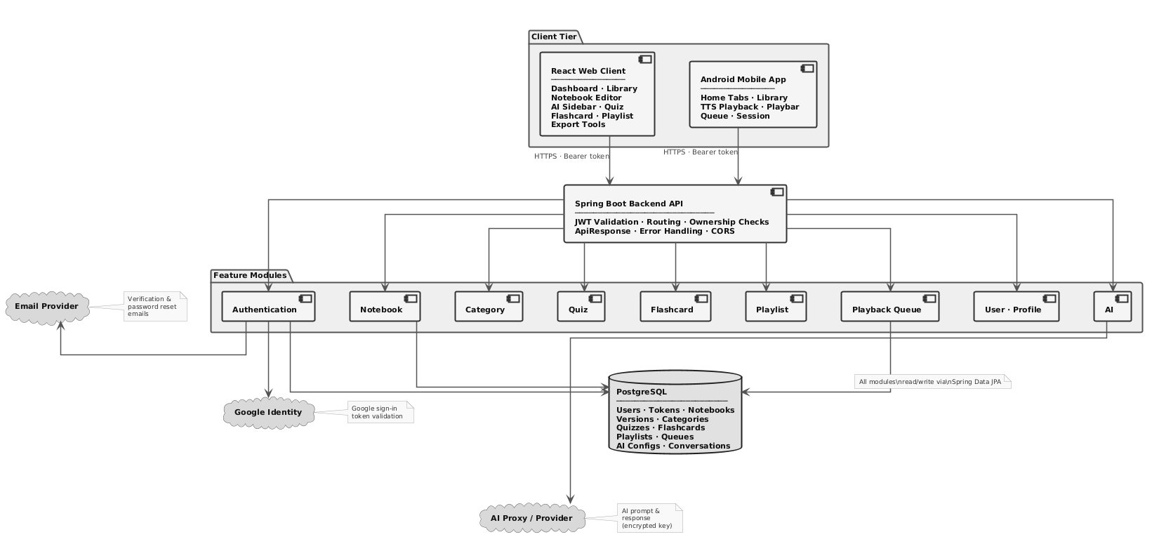

Technology Stack:
- Backend: Java 21, Spring Boot, Spring Security, Spring Data JPA, Maven
- Database: PostgreSQL (Supabase)
- Web Frontend: React, Vite, React Router, TanStack Query, Tiptap, npm
- Mobile: Kotlin, Android Jetpack Compose, Retrofit, Media3, Gradle
- External Services: Email service, Google sign-in, AI proxy provider
- Deployment: Backend API server, web build hosting, Android APK

5.0 API CONTRACT & COMMUNICATION
5.1 API Standards
Base URL | https://[server_hostname]:[port]/api
Format | JSON for all requests and responses.
Authentication | Bearer token in the Authorization header for protected endpoints.
Response Structure | {  "success": true,  "data": {},  "error": null,  "timestamp": "2026-05-01T00:00:00Z"  }

5.2 Endpoint Specifications

Authentication Endpoints

User Registration
Description | User Registration
API URL | /api/auth/register
HTTP Request Method | POST
Format | JSON for all requests and responses
Authentication | None
Request Payload | { "username": "<username>", "email": "<email>", "password": "<password>" }
Response Structure | { "success": true, "data": null, "error": null, "timestamp": "2026-05-01T00:00:00Z" }

User Login
Description | User Login
API URL | /api/auth/login
HTTP Request Method | POST
Format | JSON for all requests and responses
Authentication | None
Request Payload | { "username": "<username_or_email>", "password": "<password>" }
Response Structure | { "success": true, "data": { "user": { "username": "<username>", "email": "<email>", "role": "<role>" }, "accessToken": "<token>", "refreshToken": "<token>" }, "error": null, "timestamp": "2026-05-01T00:00:00Z" }

Additional Endpoint Groups

Authentication Endpoint Table
Method | Endpoint | Authentication | Request / Parameters (JSON) | Response / Result (JSON)
POST | /api/auth/register | None | {  "username": "student01",  "email": "student01@example.com",  "password": "P@ssw0rd!"  } | {  "success": true,  "data": null,  "error": null,  "timestamp": "2026-05-01T00:00:00Z"  }
GET | /api/auth/verify-email | None | {  "query": {  "token": "verify-email-token"  }  } | {  "success": true,  "data": null,  "error": null,  "timestamp": "2026-05-01T00:00:00Z"  }
POST | /api/auth/forgot-password | None | {  "email": "student01@example.com"  } | {  "success": true,  "data": null,  "error": null,  "timestamp": "2026-05-01T00:00:00Z"  }
POST | /api/auth/verify-code | None | {  "email": "student01@example.com",  "code": "123456"  } | {  "success": true,  "data": {  "valid": true  },  "error": null,  "timestamp": "2026-05-01T00:00:00Z"  }
POST | /api/auth/reset-password | None | {  "token": "reset-password-token",  "newPassword": "N3wP@ssw0rd!"  } | {  "success": true,  "data": null,  "error": null,  "timestamp": "2026-05-01T00:00:00Z"  }
POST | /api/auth/login | None | {  "username": "student01",  "password": "P@ssw0rd!"  } | {  "success": true,  "data": {  "user": {  "username": "student01",  "email": "student01@example.com",  "role": "USER"  },  "accessToken": "access-token",  "refreshToken": "refresh-token"  },  "error": null,  "timestamp": "2026-05-01T00:00:00Z"  }
POST | /api/auth/logout | None | {  "refreshToken": "refresh-token"  } | {  "success": true,  "data": null,  "error": null,  "timestamp": "2026-05-01T00:00:00Z"  }
POST | /api/auth/refresh-token  /api/auth/tokens/refresh | None | {  "refreshToken": "refresh-token"  } | {  "success": true,  "data": {  "accessToken": "new-access-token",  "refreshToken": "new-refresh-token"  },  "error": null,  "timestamp": "2026-05-01T00:00:00Z"  }
POST | /api/auth/google | None | {  "idToken": "google-id-token",  "accessToken": "google-access-token"  } | {  "success": true,  "data": {  "user": {  "username": "student01",  "email": "student01@example.com",  "role": "USER"  },  "accessToken": "access-token",  "refreshToken": "refresh-token"  },  "error": null,  "timestamp": "2026-05-01T00:00:00Z"  }

Profile Endpoint Table
Method | Endpoint | Authentication | Request / Parameters (JSON) | Response / Result (JSON)
GET | /api/user/me  /api/users/me | User token | {  "path": {},  "query": {}  } | {  "success": true,  "data": {  "username": "student01",  "email": "student01@example.com"  },  "error": null,  "timestamp": "2026-05-01T00:00:00Z"  }
PUT | /api/user/me  /api/users/me | User token | {  "username": "student01",  "email": "student01@example.com"  } | {  "success": true,  "data": {  "username": "student01",  "email": "student01@example.com"  },  "error": null,  "timestamp": "2026-05-01T00:00:00Z"  }
POST | /api/user/me/change-password  /api/users/me/password | User token | {  "currentPassword": "P@ssw0rd!",  "newPassword": "N3wP@ssw0rd!"  } | {  "success": true,  "data": null,  "error": null,  "timestamp": "2026-05-01T00:00:00Z"  }

Notebook Endpoint Table
Method | Endpoint | Authentication | Request / Parameters (JSON) | Response / Result (JSON)
POST | /api/notebooks | User token | {  "title": "Biology Review Notes",  "categoryId": 1,  "content": "<p>Initial content</p>",  "baseVersion": 0,  "clientMutationId": "mut-001"  } | {  "success": true,  "data": {  "uuid": "nb-uuid-001",  "title": "Biology Review Notes",  "content": "<p>Initial content</p>",  "version": 1,  "categoryId": 1  },  "error": null,  "timestamp": "2026-05-01T00:00:00Z"  }
GET | /api/notebooks | User token | {  "path": {},  "query": {}  } | {  "success": true,  "data": [  {  "uuid": "nb-uuid-001",  "title": "Biology Review Notes",  "version": 1  }  ],  "error": null,  "timestamp": "2026-05-01T00:00:00Z"  }
GET | /api/notebooks/recently-edited | User token | {  "path": {},  "query": {}  } | {  "success": true,  "data": [  {  "uuid": "nb-uuid-001",  "title": "Biology Review Notes",  "version": 1  }  ],  "error": null,  "timestamp": "2026-05-01T00:00:00Z"  }
GET | /api/notebooks/recently-reviewed | User token | {  "path": {},  "query": {}  } | {  "success": true,  "data": [  {  "uuid": "nb-uuid-002",  "title": "Chemistry Review Notes",  "version": 3  }  ],  "error": null,  "timestamp": "2026-05-01T00:00:00Z"  }
GET | /api/notebooks/{uuid} | User token | {  "path": {  "uuid": "nb-uuid-001"  }  } | {  "success": true,  "data": {  "uuid": "nb-uuid-001",  "title": "Biology Review Notes",  "content": "<p>Initial content</p>",  "version": 1,  "categoryId": 1  },  "error": null,  "timestamp": "2026-05-01T00:00:00Z"  }
PUT | /api/notebooks/{uuid} | User token | {  "path": {  "uuid": "nb-uuid-001"  },  "body": {  "title": "Biology Review Notes (Updated)",  "categoryId": 1,  "content": "<p>Updated content</p>",  "baseVersion": 1,  "clientMutationId": "mut-002"  }  } | {  "success": true,  "data": {  "uuid": "nb-uuid-001",  "title": "Biology Review Notes (Updated)",  "content": "<p>Updated content</p>",  "version": 2,  "categoryId": 1  },  "error": null,  "timestamp": "2026-05-01T00:00:00Z"  }

Category Endpoint Table
Method | Endpoint | Authentication | Request / Parameters (JSON) | Response / Result (JSON)
GET | /api/categories | User token | {  "path": {},  "query": {}  } | {  "success": true,  "data": [  { "id": 1, "name": "Science" }  ],  "error": null,  "timestamp": "2026-05-01T00:00:00Z"  }
POST | /api/categories | User token | {  "name": "Science"  } | {  "success": true,  "data": { "id": 1, "name": "Science" },  "error": null,  "timestamp": "2026-05-01T00:00:00Z"  }
GET | /api/categories/{id} | User token | {  "path": { "id": 1 }  } | {  "success": true,  "data": { "id": 1, "name": "Science" },  "error": null,  "timestamp": "2026-05-01T00:00:00Z"  }
DELETE | /api/categories/{id} | User token | {  "path": { "id": 1 },  "query": { "deleteNotebooks": false }  } | {  "success": true,  "data": null,  "error": null,  "timestamp": "2026-05-01T00:00:00Z"  }

AI Endpoint Table
Method | Endpoint | Authentication | Request / Parameters (JSON) | Response / Result (JSON)
POST | /api/ai/query | User token | {  "query": "Summarize the selected content.",  "notebookUuid": "nb-uuid-001",  "conversationHistory": [  { "role": "user", "content": "Help me study this topic." },  { "role": "assistant", "content": "Sure, what part do you want to focus on?" }  ],  "selectedText": "Photosynthesis converts light energy into chemical energy.",  "aiSelections": [  {  "id": "sel-001",  "text": "Photosynthesis converts light energy into chemical energy."  }  ],  "selectionMode": "single_selection",  "mode": "editor"  } | {  "success": true,  "data": {  "response": "Photosynthesis is the process plants use to convert light energy into stored chemical energy.",  "action": "none",  "editorContent": null,  "conversationTitle": "Photosynthesis Summary",  "selectionEdits": null,  "quizData": null,  "flashcardData": null  },  "error": null,  "timestamp": "2026-05-01T00:00:00Z"  }
GET | /api/ai/config  /api/ai/configs/selected | User token | {  "path": {},  "query": {}  } | {  "success": true,  "data": {  "id": 1,  "name": "Primary OpenAI Config",  "model": "gpt-4.1",  "proxyUrl": "https://api.openai.com/v1",  "hasApiKey": true,  "createdAt": "2026-05-01T00:00:00Z",  "updatedAt": "2026-05-01T00:00:00Z"  },  "error": null,  "timestamp": "2026-05-01T00:00:00Z"  }
GET | /api/ai/config/list  /api/ai/configs | User token | {  "path": {},  "query": {}  } | {  "success": true,  "data": {  "configs": [  {  "id": 1,  "name": "Primary OpenAI Config",  "model": "gpt-4.1",  "proxyUrl": "https://api.openai.com/v1",  "hasApiKey": true,  "createdAt": "2026-05-01T00:00:00Z",  "updatedAt": "2026-05-01T00:00:00Z"  }  ],  "selectedConfigId": 1  },  "error": null,  "timestamp": "2026-05-01T00:00:00Z"  }
PUT | /api/ai/config  /api/ai/configs | User token | {  "id": null,  "name": "Primary OpenAI Config",  "model": "gpt-4.1",  "proxyUrl": "https://api.openai.com/v1",  "apiKey": "sk-example-key"  } | {  "success": true,  "data": {  "id": 1,  "name": "Primary OpenAI Config",  "model": "gpt-4.1",  "proxyUrl": "https://api.openai.com/v1",  "hasApiKey": true,  "createdAt": "2026-05-01T00:00:00Z",  "updatedAt": "2026-05-01T00:00:00Z"  },  "error": null,  "timestamp": "2026-05-01T00:00:00Z"  }
PUT | /api/ai/config/{id}/select  /api/ai/configs/{id}/selected | User token | {  "path": { "id": 1 }  } | {  "success": true,  "data": {  "id": 1,  "name": "Primary OpenAI Config",  "model": "gpt-4.1",  "proxyUrl": "https://api.openai.com/v1",  "hasApiKey": true,  "createdAt": "2026-05-01T00:00:00Z",  "updatedAt": "2026-05-01T00:00:00Z"  },  "error": null,  "timestamp": "2026-05-01T00:00:00Z"  }
DELETE | /api/ai/config/{id}  /api/ai/configs/{id} | User token | {  "path": { "id": 1 }  } | {  "success": true,  "data": null,  "error": null,  "timestamp": "2026-05-01T00:00:00Z"  }
GET | /api/ai/conversations | User token | {  "query": {  "notebookUuid": "nb-uuid-001"  }  } | {  "success": true,  "data": [  {  "uuid": "conv-uuid-001",  "notebookUuid": "nb-uuid-001",  "mode": "editor",  "title": "Photosynthesis Summary",  "messages": "[{\"role\":\"user\",\"content\":\"Summarize this notebook.\"},{\"role\":\"assistant\",\"content\":\"Here is a concise summary.\"}]",  "createdAt": "2026-05-01T00:00:00Z",  "updatedAt": "2026-05-01T00:00:00Z"  }  ],  "error": null,  "timestamp": "2026-05-01T00:00:00Z"  }
POST | /api/ai/conversations | User token | {  "notebookUuid": "nb-uuid-001",  "mode": "editor",  "title": "Photosynthesis Summary",  "messages": "[{\"role\":\"user\",\"content\":\"Summarize this notebook.\"},{\"role\":\"assistant\",\"content\":\"Here is a concise summary.\"}]"  } | {  "success": true,  "data": {  "uuid": "conv-uuid-001",  "notebookUuid": "nb-uuid-001",  "mode": "editor",  "title": "Photosynthesis Summary",  "messages": "[{\"role\":\"user\",\"content\":\"Summarize this notebook.\"},{\"role\":\"assistant\",\"content\":\"Here is a concise summary.\"}]",  "createdAt": "2026-05-01T00:00:00Z",  "updatedAt": "2026-05-01T00:00:00Z"  },  "error": null,  "timestamp": "2026-05-01T00:00:00Z"  }
PUT | /api/ai/conversations/{uuid} | User token | {  "path": { "uuid": "conv-uuid-001" },  "body": {  "title": "Updated Photosynthesis Summary",  "messages": "[{\"role\":\"user\",\"content\":\"Summarize this notebook.\"},{\"role\":\"assistant\",\"content\":\"Here is a concise summary.\"},{\"role\":\"user\",\"content\":\"Add key terms.\"}]"  }  } | {  "success": true,  "data": {  "uuid": "conv-uuid-001",  "notebookUuid": "nb-uuid-001",  "mode": "editor",  "title": "Updated Photosynthesis Summary",  "messages": "[{\"role\":\"user\",\"content\":\"Summarize this notebook.\"},{\"role\":\"assistant\",\"content\":\"Here is a concise summary.\"},{\"role\":\"user\",\"content\":\"Add key terms.\"}]",  "createdAt": "2026-05-01T00:00:00Z",  "updatedAt": "2026-05-01T00:00:00Z"  },  "error": null,  "timestamp": "2026-05-01T00:00:00Z"  }
DELETE | /api/ai/conversations/{uuid} | User token | {  "path": { "uuid": "conv-uuid-001" }  } | {  "success": true,  "data": null,  "error": null,  "timestamp": "2026-05-01T00:00:00Z"

Quiz Endpoint Table
Method | Endpoint | Authentication | Request / Parameters (JSON) | Response / Result (JSON)
POST | /api/quizzes | User token | {  "title": "Biology Quiz",  "description": "Quiz from Biology Review Notes",  "difficulty": "easy",  "notebookUuid": "nb-uuid-001",  "questions": [  {  "type": "multiple_choice",  "text": "What is photosynthesis?",  "options": ["A", "B", "C", "D"],  "correctIndex": 0  }  ]  } | {  "success": true,  "data": {  "uuid": "quiz-uuid-001",  "title": "Biology Quiz",  "description": "Quiz from Biology Review Notes",  "difficulty": "easy",  "notebookUuid": "nb-uuid-001",  "questions": [  {  "type": "multiple_choice",  "text": "What is photosynthesis?",  "options": ["A", "B", "C", "D"],  "correctIndex": 0  }  ]  },  "error": null,  "timestamp": "2026-05-01T00:00:00Z"  }
GET | /api/quizzes | User token | {  "path": {},  "query": {}  } | {  "success": true,  "data": [  {  "uuid": "quiz-uuid-001",  "title": "Biology Quiz",  "difficulty": "easy",  "notebookUuid": "nb-uuid-001"  }  ],  "error": null,  "timestamp": "2026-05-01T00:00:00Z"  }
GET | /api/quizzes/{uuid} | User token | {  "path": { "uuid": "quiz-uuid-001" }  } | {  "success": true,  "data": {  "uuid": "quiz-uuid-001",  "title": "Biology Quiz",  "description": "Quiz from Biology Review Notes",  "difficulty": "easy",  "notebookUuid": "nb-uuid-001",  "questions": [  {  "type": "multiple_choice",  "text": "What is photosynthesis?",  "options": ["A", "B", "C", "D"],  "correctIndex": 0  }  ]  },  "error": null,  "timestamp": "2026-05-01T00:00:00Z"  }
PUT | /api/quizzes/{uuid} | User token | {  "path": { "uuid": "quiz-uuid-001" },  "body": {  "title": "Biology Quiz (Updated)",  "description": "Updated description",  "difficulty": "medium",  "notebookUuid": "nb-uuid-001",  "questions": [  {  "type": "multiple_choice",  "text": "What is photosynthesis?",  "options": ["A", "B", "C", "D"],  "correctIndex": 0  }  ]  }  } | {  "success": true,  "data": {  "uuid": "quiz-uuid-001",  "title": "Biology Quiz (Updated)",  "description": "Updated description",  "difficulty": "medium",  "notebookUuid": "nb-uuid-001",  "questions": [  {  "type": "multiple_choice",  "text": "What is photosynthesis?",  "options": ["A", "B", "C", "D"],  "correctIndex": 0  }  ]  },  "error": null,  "timestamp": "2026-05-01T00:00:00Z"  }
DELETE | /api/quizzes/{uuid} | User token | {  "path": { "uuid": "quiz-uuid-001" }  } | {  "success": true,  "data": null,  "error": null,  "timestamp": "2026-05-01T00:00:00Z"  }
POST | /api/quizzes/{uuid}/attempts | User token | {  "path": { "uuid": "quiz-uuid-001" },  "body": {  "score": 8,  "clientMutationId": "mut-quiz-attempt-001"  }  } | {  "success": true,  "data": {  "uuid": "quiz-uuid-001",  "lastAttempt": {  "score": 8,  "createdAt": "2026-05-01T00:00:00Z"  }  },  "error": null,  "timestamp": "2026-05-01T00:00:00Z"  }

Flashcard Endpoint Table
Method | Endpoint | Authentication | Request / Parameters (JSON) | Response / Result (JSON)
POST | /api/flashcards | User token | {  "title": "Biology Flashcards",  "description": "Deck from Biology Review Notes",  "notebookUuid": "nb-uuid-001",  "cards": [  { "front": "Photosynthesis", "back": "Process of converting light energy into chemical energy." }  ]  } | {  "success": true,  "data": {  "uuid": "deck-uuid-001",  "title": "Biology Flashcards",  "description": "Deck from Biology Review Notes",  "notebookUuid": "nb-uuid-001",  "cards": [  { "front": "Photosynthesis", "back": "Process of converting light energy into chemical energy." }  ]  },  "error": null,  "timestamp": "2026-05-01T00:00:00Z"  }
GET | /api/flashcards | User token | {  "path": {},  "query": {}  } | {  "success": true,  "data": [  {  "uuid": "deck-uuid-001",  "title": "Biology Flashcards",  "notebookUuid": "nb-uuid-001"  }  ],  "error": null,  "timestamp": "2026-05-01T00:00:00Z"  }
GET | /api/flashcards/{uuid} | User token | {  "path": { "uuid": "deck-uuid-001" }  } | {  "success": true,  "data": {  "uuid": "deck-uuid-001",  "title": "Biology Flashcards",  "description": "Deck from Biology Review Notes",  "notebookUuid": "nb-uuid-001",  "cards": [  { "front": "Photosynthesis", "back": "Process of converting light energy into chemical energy." }  ]  },  "error": null,  "timestamp": "2026-05-01T00:00:00Z"  }
PUT | /api/flashcards/{uuid} | User token | {  "path": { "uuid": "deck-uuid-001" },  "body": {  "title": "Biology Flashcards (Updated)",  "description": "Updated description",  "notebookUuid": "nb-uuid-001",  "cards": [  { "front": "Photosynthesis", "back": "Process of converting light energy into chemical energy." }  ]  }  } | {  "success": true,  "data": {  "uuid": "deck-uuid-001",  "title": "Biology Flashcards (Updated)",  "description": "Updated description",  "notebookUuid": "nb-uuid-001",  "cards": [  { "front": "Photosynthesis", "back": "Process of converting light energy into chemical energy." }  ]  },  "error": null,  "timestamp": "2026-05-01T00:00:00Z"  }
DELETE | /api/flashcards/{uuid} | User token | {  "path": { "uuid": "deck-uuid-001" }  } | {  "success": true,  "data": null,  "error": null,  "timestamp": "2026-05-01T00:00:00Z"  }
POST | /api/flashcards/{uuid}/attempts | User token | {  "path": { "uuid": "deck-uuid-001" },  "body": {  "mastery": 0.75,  "clientMutationId": "mut-deck-attempt-001"  }  } | {  "success": true,  "data": {  "uuid": "deck-uuid-001",  "lastAttempt": {  "mastery": 0.75,  "createdAt": "2026-05-01T00:00:00Z"  }  },  "error": null,  "timestamp": "2026-05-01T00:00:00Z"  }

Playlist Endpoint Table
Method | Endpoint | Authentication | Request / Parameters (JSON) | Response / Result (JSON)
POST | /api/playlists | User token | {  "title": "Study Playlist"  } | {  "success": true,  "data": {  "uuid": "pl-uuid-001",  "title": "Study Playlist",  "queue": [],  "currentIndex": 0  },  "error": null,  "timestamp": "2026-05-01T00:00:00Z"  }
GET | /api/playlists | User token | {  "path": {},  "query": {}  } | {  "success": true,  "data": [  {  "uuid": "pl-uuid-001",  "title": "Study Playlist",  "currentIndex": 0  }  ],  "error": null,  "timestamp": "2026-05-01T00:00:00Z"  }
GET | /api/playlists/{uuid} | User token | {  "path": { "uuid": "pl-uuid-001" }  } | {  "success": true,  "data": {  "uuid": "pl-uuid-001",  "title": "Study Playlist",  "queue": [  { "uuid": "nb-uuid-001", "title": "Biology Review Notes" }  ],  "currentIndex": 0  },  "error": null,  "timestamp": "2026-05-01T00:00:00Z"  }
PUT | /api/playlists/{uuid} | User token | {  "path": { "uuid": "pl-uuid-001" },  "body": { "title": "Study Playlist (Updated)" }  } | {  "success": true,  "data": {  "uuid": "pl-uuid-001",  "title": "Study Playlist (Updated)",  "queue": [],  "currentIndex": 0  },  "error": null,  "timestamp": "2026-05-01T00:00:00Z"  }
DELETE | /api/playlists/{uuid} | User token | {  "path": { "uuid": "pl-uuid-001" }  } | {  "success": true,  "data": null,  "error": null,  "timestamp": "2026-05-01T00:00:00Z"  }
POST | /api/playlists/{uuid}/notebooks | User token | {  "path": { "uuid": "pl-uuid-001" },  "body": { "notebookUuid": "nb-uuid-001" }  } | {  "success": true,  "data": {  "uuid": "pl-uuid-001",  "title": "Study Playlist",  "queue": [  { "uuid": "nb-uuid-001", "title": "Biology Review Notes" }  ],  "currentIndex": 0  },  "error": null,  "timestamp": "2026-05-01T00:00:00Z"  }
DELETE | /api/playlists/{uuid}/notebooks/{notebookUuid} | User token | {  "path": { "uuid": "pl-uuid-001", "notebookUuid": "nb-uuid-001" }  } | {  "success": true,  "data": {  "uuid": "pl-uuid-001",  "title": "Study Playlist",  "queue": [],  "currentIndex": 0  },  "error": null,  "timestamp": "2026-05-01T00:00:00Z"  }
PUT | /api/playlists/{uuid}/reorder | User token | {  "path": { "uuid": "pl-uuid-001" },  "body": { "notebookUuids": ["nb-uuid-002", "nb-uuid-001"] }  } | {  "success": true,  "data": {  "uuid": "pl-uuid-001",  "title": "Study Playlist",  "queue": [  { "uuid": "nb-uuid-002", "title": "Chemistry Review Notes" },  { "uuid": "nb-uuid-001", "title": "Biology Review Notes" }  ],  "currentIndex": 0  },  "error": null,  "timestamp": "2026-05-01T00:00:00Z"  }
PATCH | /api/playlists/{uuid}/current-index | User token | {  "path": { "uuid": "pl-uuid-001" },  "body": { "currentIndex": 1 }  } | {  "success": true,  "data": {  "uuid": "pl-uuid-001",  "title": "Study Playlist",  "queue": [  { "uuid": "nb-uuid-002", "title": "Chemistry Review Notes" },  { "uuid": "nb-uuid-001", "title": "Biology Review Notes" }  ],  "currentIndex": 1  },  "error": null,  "timestamp": "2026-05-01T00:00:00Z"  }

Playback Queue Endpoint Table
Method | Endpoint | Authentication | Request / Parameters (JSON) | Response / Result (JSON)
GET | /api/queue  /api/playback-queues/current | User token | {  "path": {},  "query": {}  } | {  "success": true,  "data": {  "items": [  { "uuid": "nb-uuid-001", "title": "Biology Review Notes" }  ],  "currentIndex": 0  },  "error": null,  "timestamp": "2026-05-01T00:00:00Z"  }
POST | /api/queue/notebooks  /api/playback-queues/current/notebooks | User token | {  "notebookUuid": "nb-uuid-001"  } | {  "success": true,  "data": {  "items": [  { "uuid": "nb-uuid-001", "title": "Biology Review Notes" }  ],  "currentIndex": 0  },  "error": null,  "timestamp": "2026-05-01T00:00:00Z"  }
PUT | /api/queue/playlist/{playlistUuid}  /api/playback-queues/current/playlist/{playlistUuid} | User token | {  "path": { "playlistUuid": "pl-uuid-001" }  } | {  "success": true,  "data": {  "items": [  { "uuid": "nb-uuid-002", "title": "Chemistry Review Notes" },  { "uuid": "nb-uuid-001", "title": "Biology Review Notes" }  ],  "currentIndex": 0,  "playlistUuid": "pl-uuid-001"  },  "error": null,  "timestamp": "2026-05-01T00:00:00Z"  }
DELETE | /api/queue/notebooks/{notebookUuid}  /api/playback-queues/current/notebooks/{notebookUuid} | User token | {  "path": { "notebookUuid": "nb-uuid-001" }  } | {  "success": true,  "data": {  "items": [],  "currentIndex": 0  },  "error": null,  "timestamp": "2026-05-01T00:00:00Z"  }
DELETE | /api/queue  /api/playback-queues/current | User token | {  "path": {},  "query": {}  } | {  "success": true,  "data": null,  "error": null,  "timestamp": "2026-05-01T00:00:00Z"  }
PATCH | /api/queue/current-index  /api/playback-queues/current/index | User token | {  "body": { "currentIndex": 1 }  } | {  "success": true,  "data": {  "items": [  { "uuid": "nb-uuid-002", "title": "Chemistry Review Notes" },  { "uuid": "nb-uuid-001", "title": "Biology Review Notes" }  ],  "currentIndex": 1  },  "error": null,  "timestamp": "2026-05-01T00:00:00Z"  }
PUT | /api/queue/reorder  /api/playback-queues/current/reorder | User token | {  "notebookUuids": ["nb-uuid-001", "nb-uuid-002"]  } | {  "success": true,  "data": {  "items": [  { "uuid": "nb-uuid-001", "title": "Biology Review Notes" },  { "uuid": "nb-uuid-002", "title": "Chemistry Review Notes" }  ],  "currentIndex": 0  },  "error": null,  "timestamp": "2026-05-01T00:00:00Z"  }

5.3 Error Handling
HTTP Status Codes
- 200 OK - Successful request
- 201 Created - Resource created
- 400 Bad Request - Invalid input
- 401 Unauthorized - Authentication required/failed
- 403 Forbidden - Insufficient permissions
- 404 Not Found - Resource doesn't exist
- 409 Conflict - Duplicate resource
- 500 Internal Server Error - Server error

Error Code Examples

Example 1 | {  "success": false,  "data": null,  "error": {  "code": "BAD_REQUEST",  "message": "Invalid request data",  "details": null  },  "timestamp": "2026-05-01T00:00:00Z"  }
Example 2 | {  "success": false,  "data": null,  "error": {  "code": "VERSION_CONFLICT",  "message": "Notebook has been updated by another request",  "details": {  "latestNotebook": {  "id": 12,  "title": "Biology Review Notes",  "version": 4  }  }  },  "timestamp": "2026-05-01T00:00:00Z"  }
Common Error Codes
- BAD_REQUEST: Invalid input, invalid operation, or invalid request state.
- NOT_FOUND: Requested record does not exist.
- FORBIDDEN: Authenticated user is not allowed to access the requested resource.
- VERSION_CONFLICT: Notebook update uses an outdated version and must be retried with the latest data.
- INTERNAL_SERVER_ERROR: Unexpected server-side error.
- Unauthorized: Current authentication interceptor response for missing, invalid, or expired bearer tokens.

6.0 DATABASE DESIGN
6.1 Entity Relationship Diagram
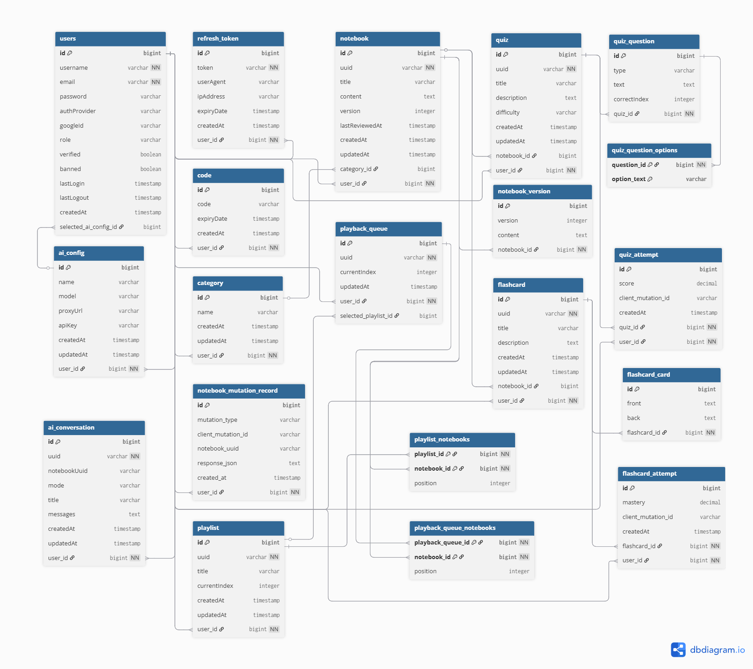
Detailed Relationships:
One-to-Many:
- User -> Notebooks. A user can own multiple notebooks.
- User -> Categories. A user can create multiple categories.
- User -> RefreshTokens. A user can have multiple refresh token sessions.
- User -> AiConfigs. A user can create multiple AI provider configurations.
- User -> AiConversations. A user can save multiple AI conversations by notebook UUID.
- Notebook -> NotebookVersions. A notebook can have multiple saved content snapshots.
- Quiz -> QuizQuestions. A quiz can contain multiple questions.
- Quiz -> QuizAttempts. A quiz can have multiple recorded attempts.
- Flashcard -> FlashcardCards. A flashcard deck can contain multiple cards.
- Flashcard -> FlashcardAttempts. A flashcard deck can have multiple recorded attempts.
Many-to-One:
- Notebook -> User. Each notebook belongs to one user.
- Notebook -> Category. A notebook may belong to one category.
- Quiz -> User. Each quiz belongs to one user.
- Quiz -> Notebook. A quiz may be associated with one notebook.
- Flashcard -> User. Each flashcard deck belongs to one user.
- Flashcard -> Notebook. A flashcard deck may be associated with one notebook.
- Playlist -> User. Each playlist belongs to one user.
- PlaybackQueue -> User. Each playback queue belongs to one user.
- AiConfig -> User. Each AI configuration belongs to one user.
- AiConversation -> User. Each AI conversation belongs to one user and stores a notebook UUID.
Many-to-Many:
- Playlist -> Notebooks. A playlist can contain many notebooks, and a notebook can appear in multiple playlists.
- PlaybackQueue -> Notebooks. A playback queue can contain many notebooks in a selected order.
Key Entities and Tables:
- users - Explicit table for user accounts, authentication fields, roles, verification state, provider identity, and selected AI config.
- RefreshToken / Code - Refresh token sessions and email verification/password reset codes.
- Category - User-owned notebook categories.
- Notebook - Notebook metadata, HTML content, owner, category, review time, and numeric version.
- NotebookVersion - Notebook content snapshots with timestamped version records.
- notebook_mutation_record - Explicit table for notebook mutation idempotency metadata.
- Quiz, QuizQuestion, QuizAttempt - Quiz metadata, ordered questions/options, and score attempts.
- Flashcard, FlashcardCard, FlashcardAttempt - Flashcard deck metadata, ordered cards, and mastery attempts.
- Playlist and playlist_notebooks - Ordered notebook playlists and join table positions.
- PlaybackQueue and playback_queue_notebooks - Current playback queue, selected playlist, and ordered notebook join data.
- ai_config - Explicit table for user-owned AI provider configuration.
- ai_conversation - Explicit table for AI conversation metadata and JSON/text messages by notebook UUID.

7.0 UI/UX DESIGN
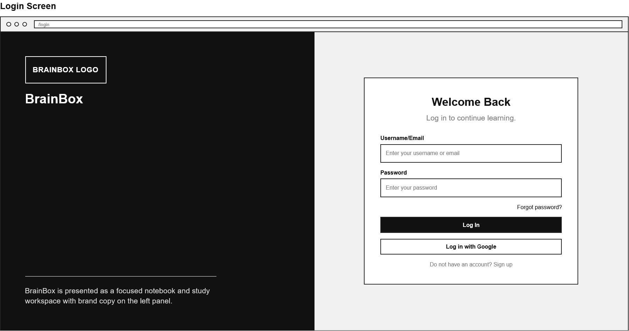
7.1 Web Application Wireframes
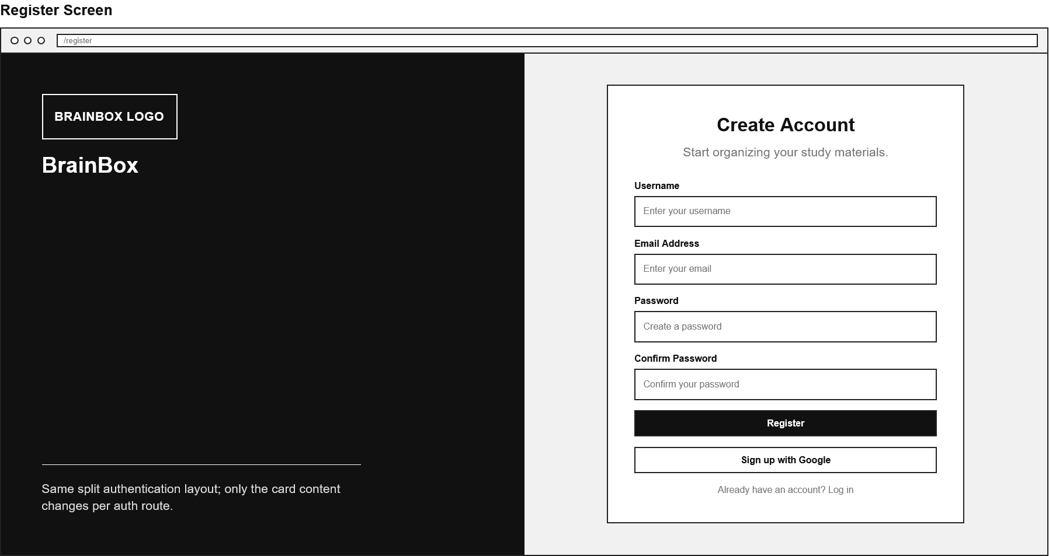
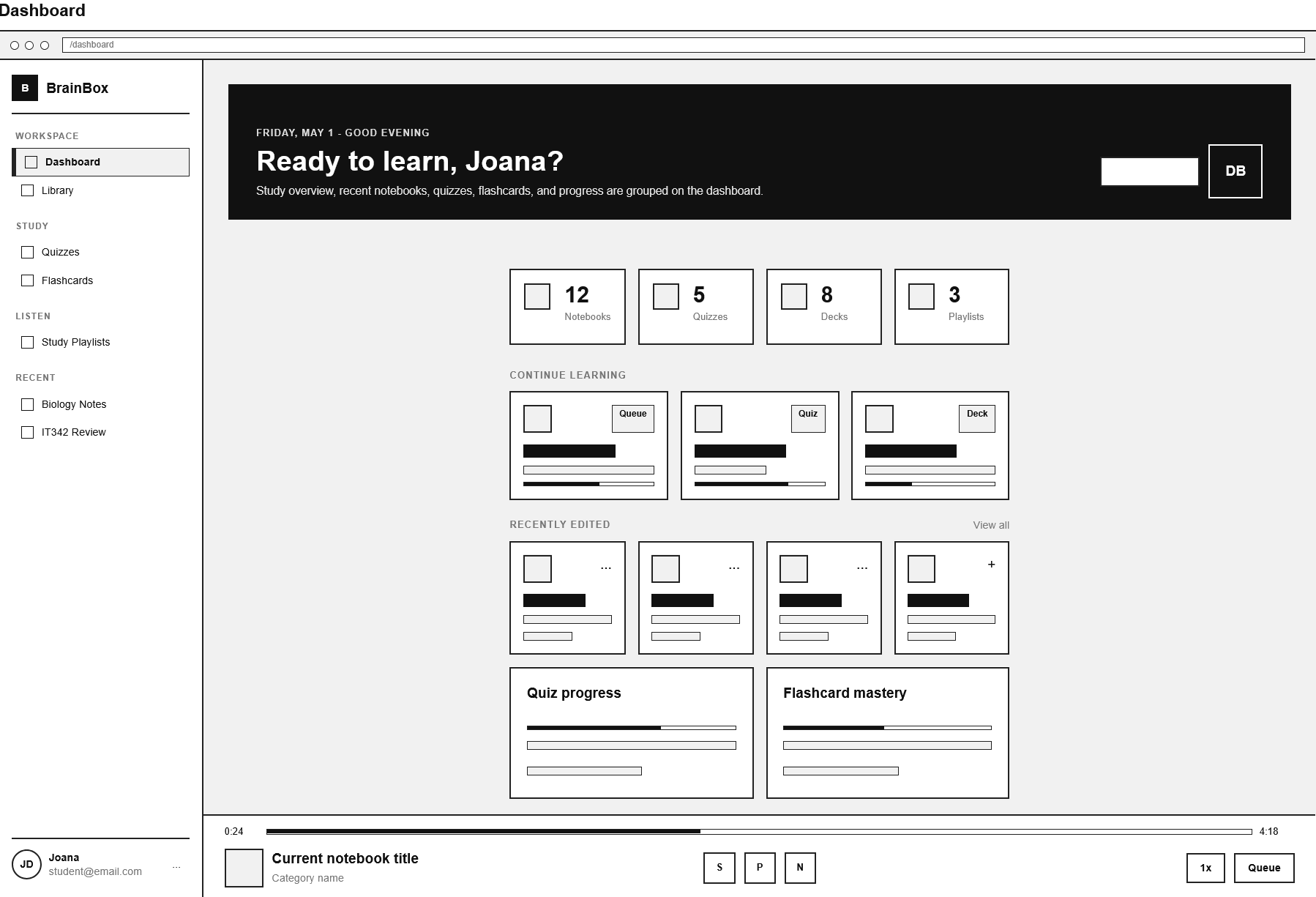
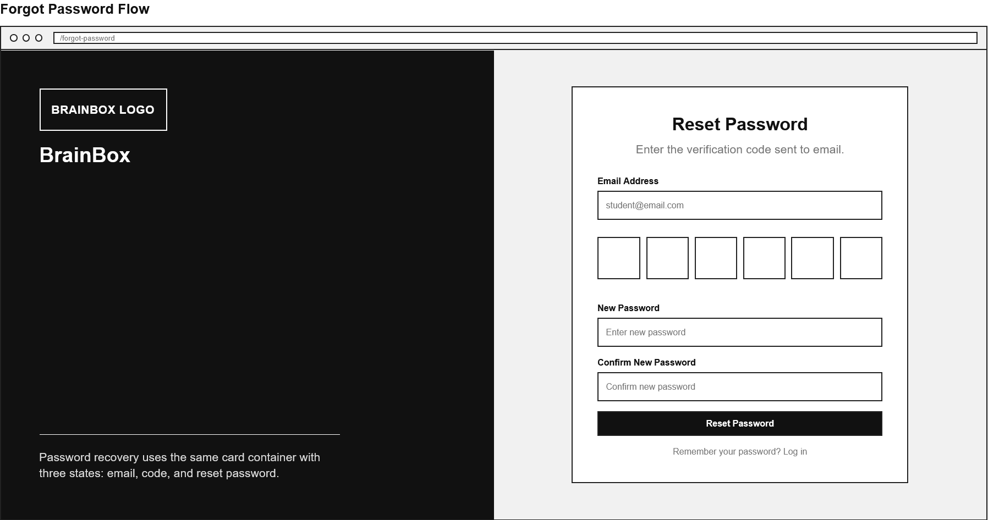
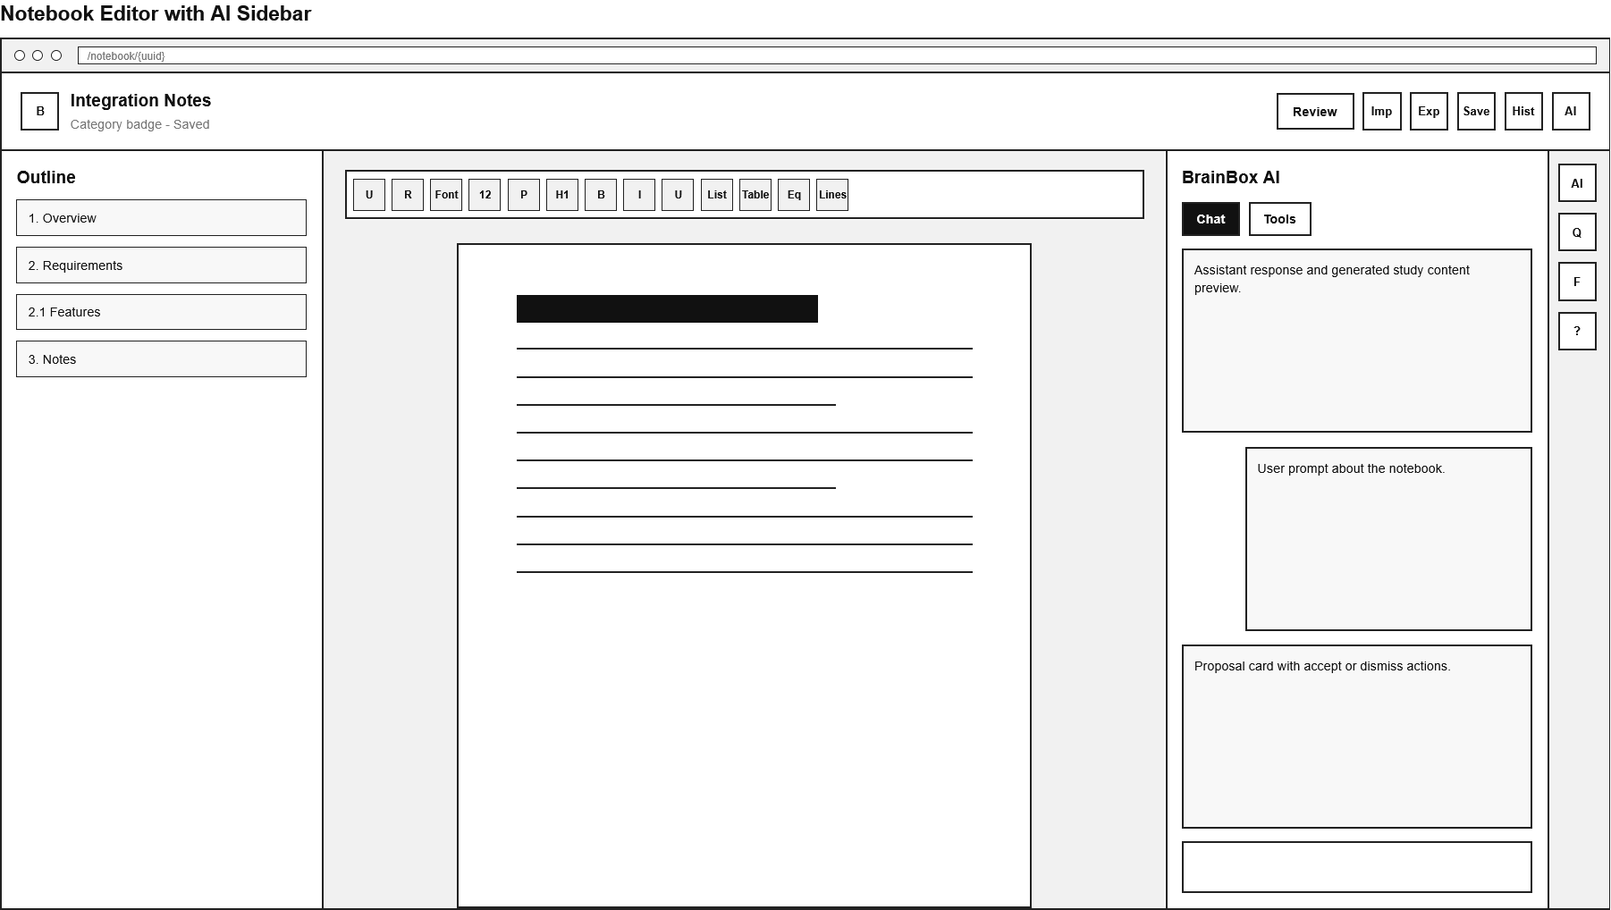
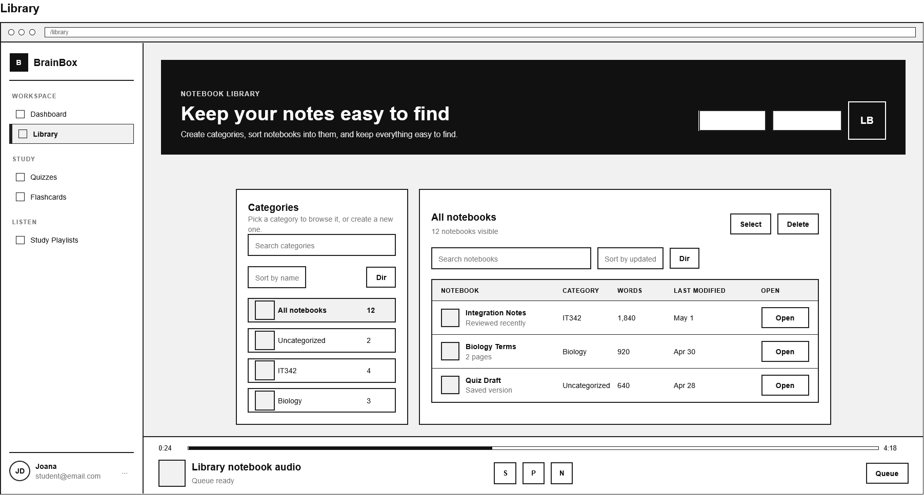
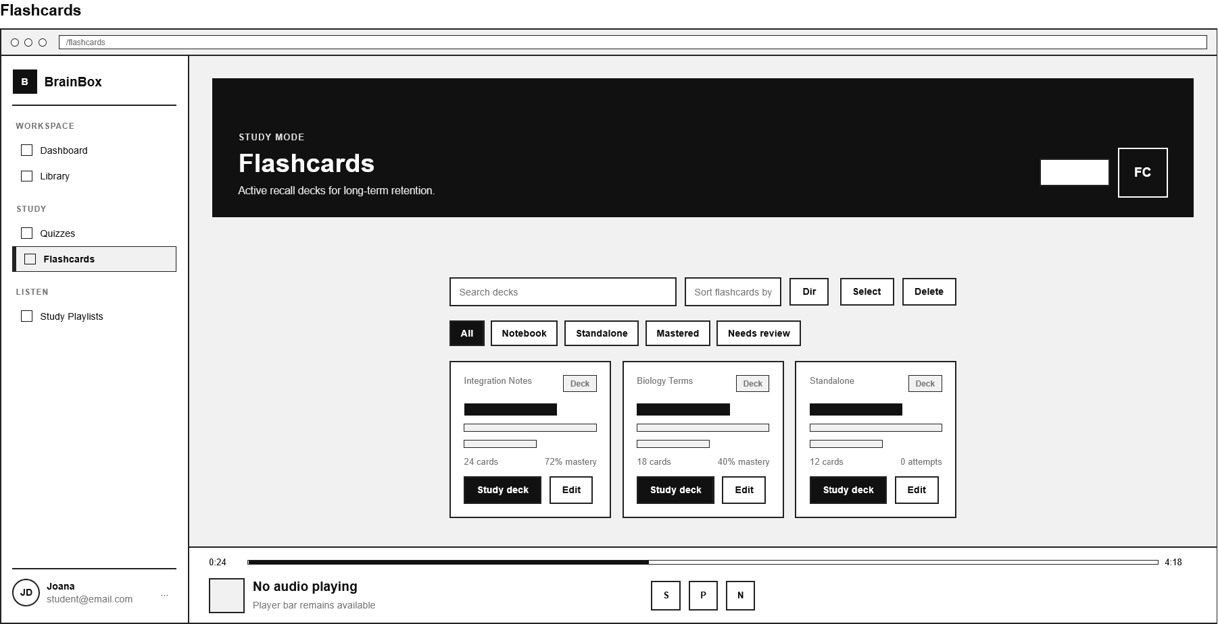
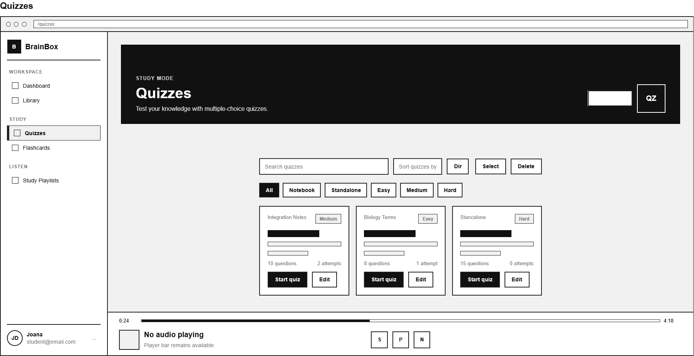
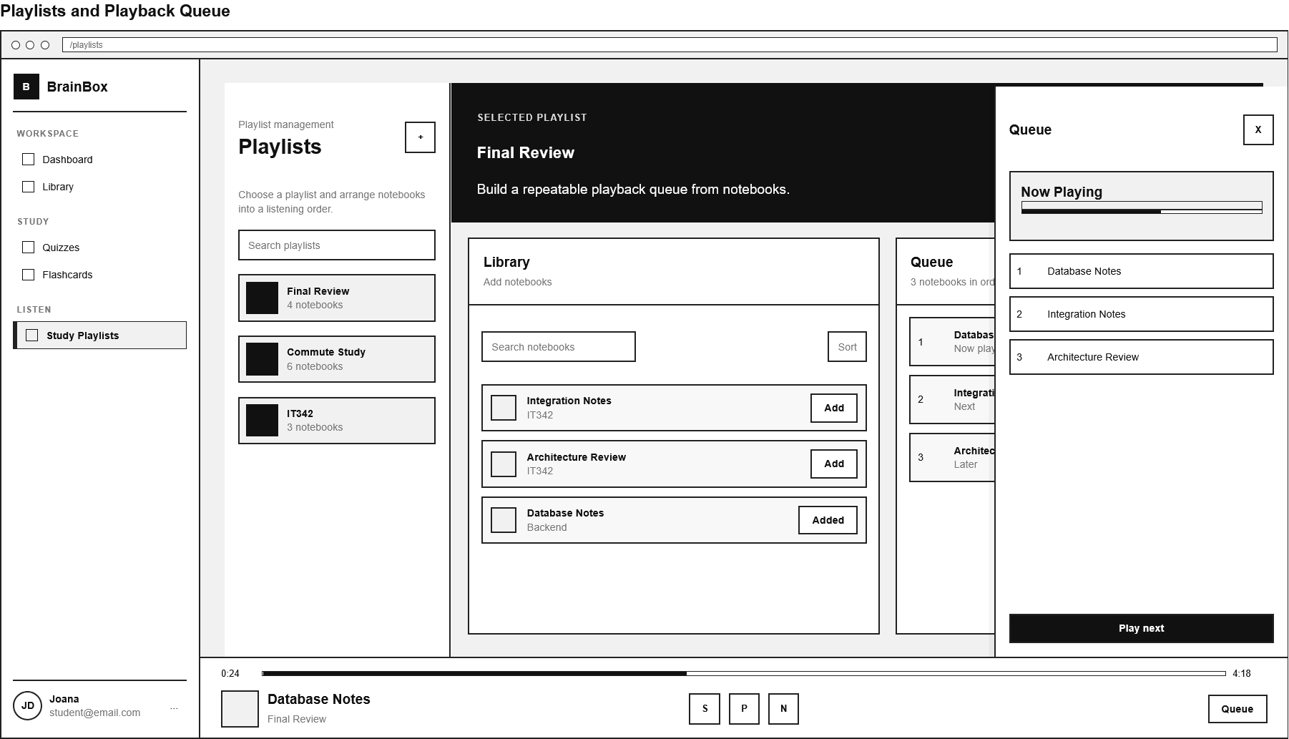
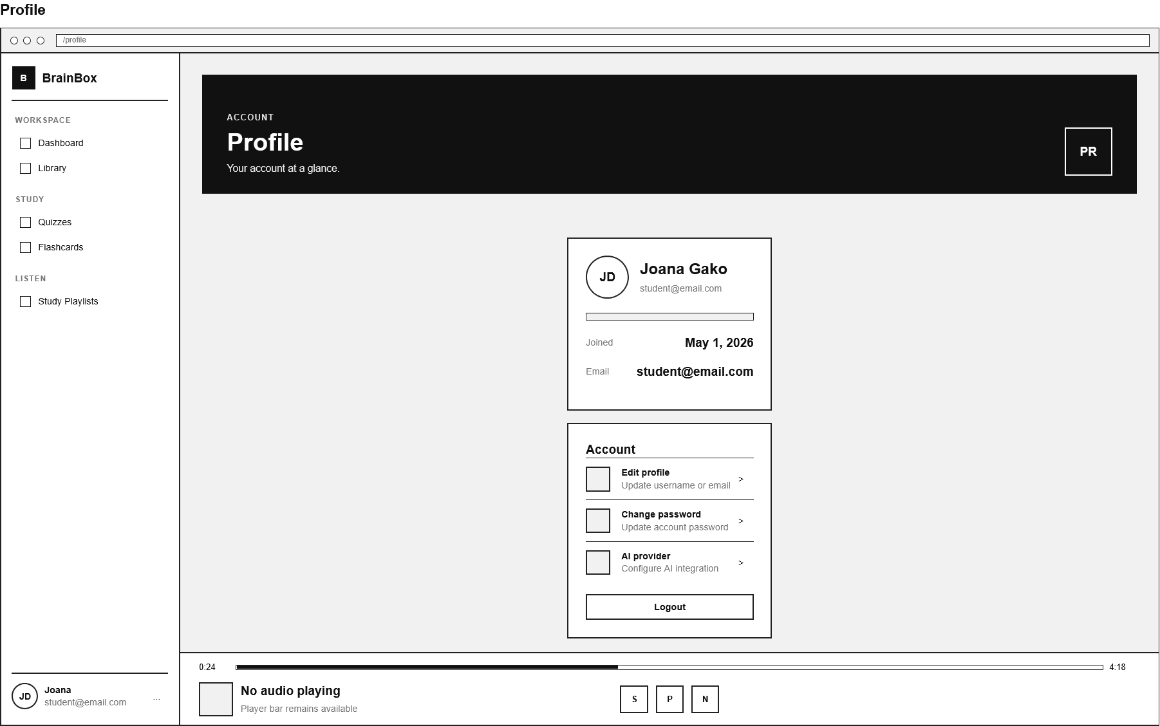

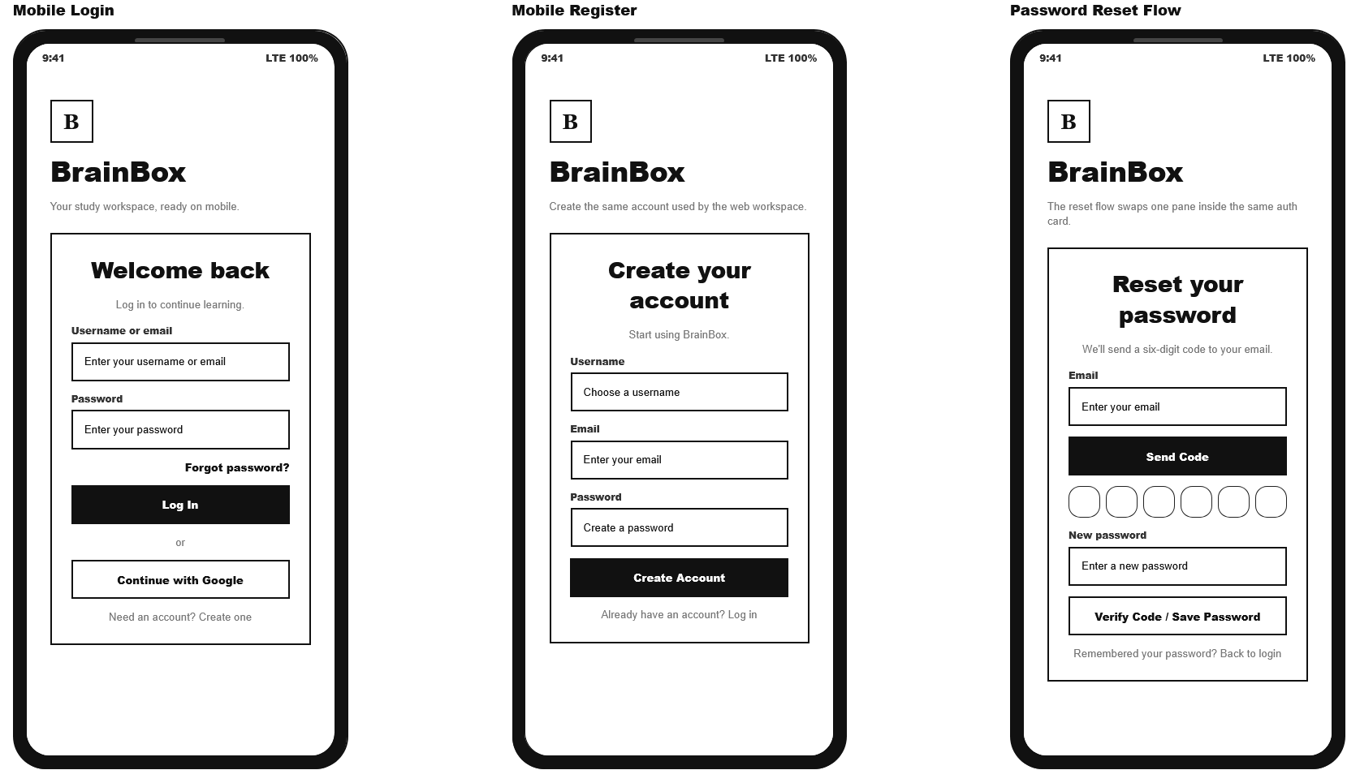
7.2 Mobile Application Wireframes
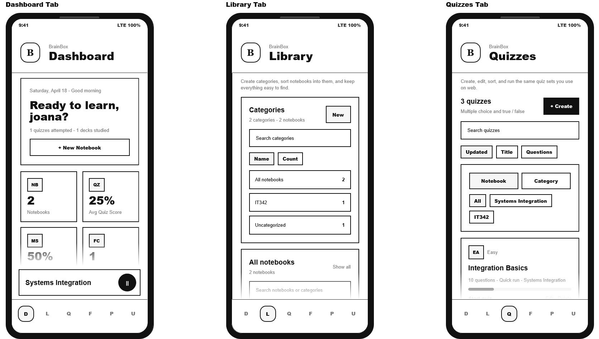
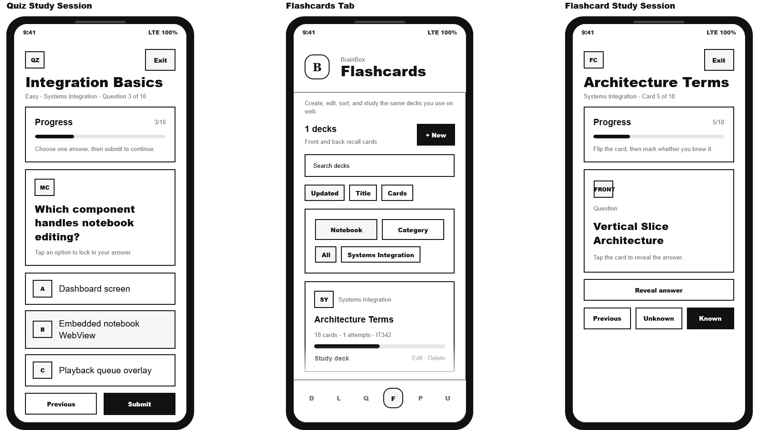
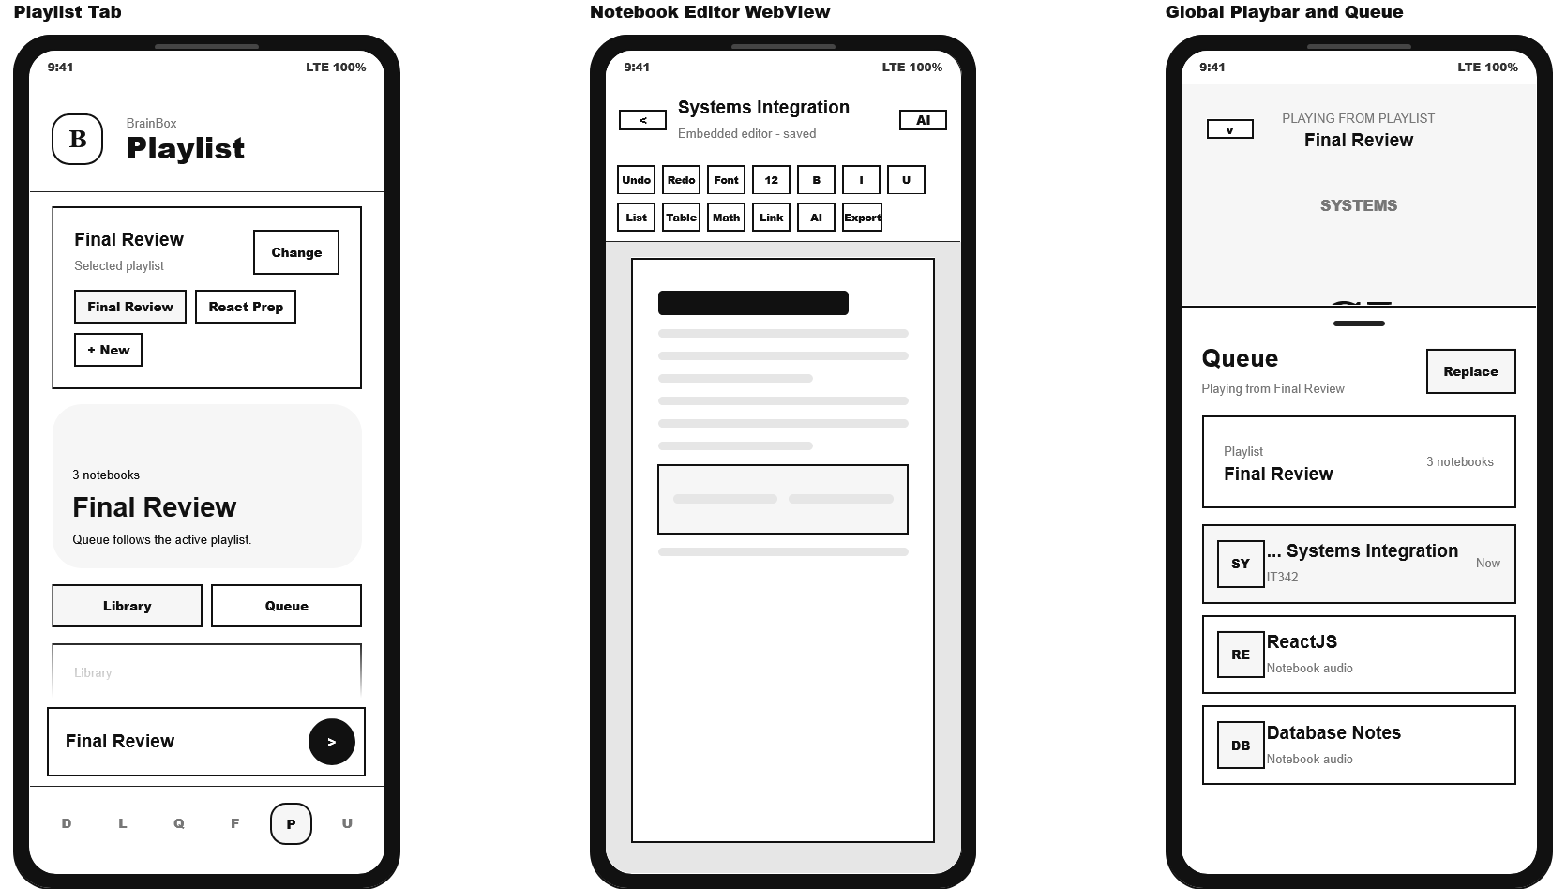
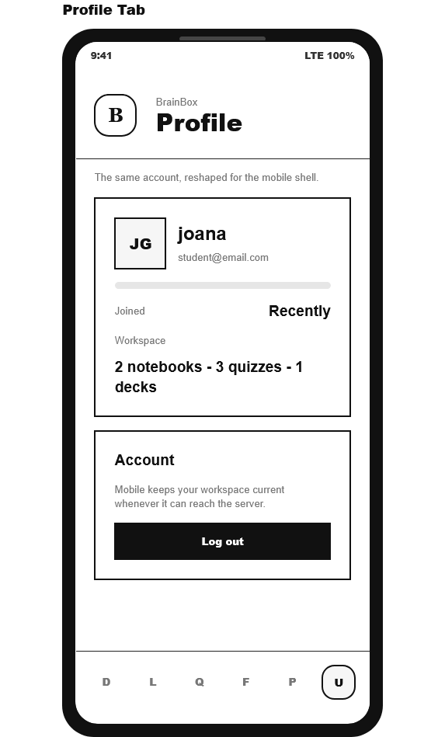

8.0 PLAN
8.1 Project Timeline
Phase 1: Planning & Design (Week 1-2)
Week 1: Requirements & Architecture
Day 1-2: Project setup and documentation.
Day 3-4: Complete FRS/SRS and non-functional requirements.
Day 5-7: System architecture design.

Week 2: Detailed Design
Day 1-2: API specification.
Day 3-4: Database design.
Day 5-6: UI/UX wireframes.
Day 7: Implementation plan finalization.

Phase 2: Backend Development (Week 3-4)
Week 3: Foundation
Day 1: Spring Boot setup with dependencies.
Day 2: Database configuration and entities.
Day 3: JWT authentication implementation.
Day 4: User and profile endpoints.
Day 5: Notebook and category endpoints.

Week 4: Core Features
Day 1: Quiz endpoints.
Day 2: Flashcard endpoints.
Day 3: Notebook version history, restore, and conflict handling.
Day 4: Playlist and playback queue endpoints.
Day 5: AI configuration, conversation, validation, and API testing.

Phase 3: Web Application (Week 5-6)
Week 5: Frontend Foundation
Day 1: React and Vite setup.
Day 2: Authentication pages.
Day 3: Dashboard and library pages.
Day 4: Notebook editor integration.
Day 5: API integration, editor version history, and state handling.

Week 6: Complete Web Features
Day 1: Quiz screens.
Day 2: Flashcard screens.
Day 3: Playlist and playback queue screens.
Day 4: Profile, AI settings, export, and review/version UI polish.
Day 5: Responsive design and web testing.

Phase 4: Mobile Application (Week 7-8)
Week 7: Android Foundation
Day 1: Android project setup and dependencies.
Day 2: Authentication screens.
Day 3: Home tabs and library screen.
Day 4: Notebook API integration and mobile library behavior.
Day 5: API service layer, token refresh, and playback service setup.

Week 8: Complete Mobile App
Day 1: Quiz study screen.
Day 2: Flashcard study screen.
Day 3: Playlist and playback controls.
Day 4: Mobile polish and integration testing.
Day 5: Emulator/device testing and APK generation.

Phase 5: Integration & Deployment (Week 9-10)
Week 9: Integration Testing
Day 1: End-to-end testing across backend, web, and mobile.
Day 2: Bug fixes and optimization.
Day 3: Security review.
Day 4: Performance and compatibility testing.
Day 5: Documentation updates.

Week 10: Deployment
Day 1: Backend deployment.
Day 2: Web application deployment.
Day 3: Mobile APK distribution.
Day 4: Final system testing.
Day 5: Project submission.
Milestones:
- M1 (End Week 2): All design documents complete
- M2 (End Week 4): Backend API fully functional
- M3 (End Week 6): Web application complete
- M4 (End Week 8): Mobile application complete
- M5 (End Week 10): Full system deployed and integrated
Critical Path:
- Authentication system.
- Notebook, category, version history, and restore management.
- Quiz and flashcard study workflows.
- Playlist and playback queue workflows.
- Android playback service integration.
- Cross-platform testing.
Risk Mitigation:
- Start with simplest working version of each feature
- Test AI integration points early to handle latency
- Maintain robust error handling for external LLM calls
- Focus on core notebook/review flow before secondary features

