Automated Test Evidence
BrainBox visual execution evidence report
Project Name | BrainBox
Test Execution Date | May 8, 2026
Test Framework | Playwright v1.59.1
Evidence Type | Automated Test Screenshots and Logs

Prepared by Joana Carla D. Gako

Execution Overview

Test Environment
Browser | Chromium (Desktop Chrome profile)
Operating System | Windows 11
Test Framework | Playwright v1.59.1
Base URL | http://127.0.0.1:4173
Test Configuration | Single worker, no retries, 60s timeout
Total Execution Time | 12.4 minutes

Execution Summary
Total Test Cases | 94
Tests Passed | 94 (100%)
Tests Failed | 0
Screenshots Generated | 94
Evidence Location | outputs/web/screenshots/

Execution Log
Starting Playwright test execution...
[10:45:12] Test environment initialized
[10:45:15] Starting authentication module tests...
[10:45:30] Authentication tests completed (15/15 passed)
[10:45:32] Starting dashboard module tests...
[10:45:45] Dashboard tests completed (4/4 passed)
[10:45:47] Starting flashcards module tests...
[10:46:15] Flashcards tests completed (8/8 passed)
[10:46:17] Starting library module tests...
[10:46:42] Library tests completed (7/7 passed)
[10:46:44] Starting navigation module tests...
[10:46:52] Navigation tests completed (1/1 passed)
[10:46:54] Starting notebook module tests...
[10:47:28] Notebook tests completed (8/8 passed)
[10:47:30] Starting notebook AI module tests...
[10:48:18] Notebook AI tests completed (12/12 passed)
[10:48:20] Starting playback module tests...
[10:49:10] Playback tests completed (10/10 passed)
[10:49:12] Starting playlist module tests...
[10:49:45] Playlist tests completed (7/7 passed)
[10:49:47] Starting profile module tests...
[10:50:15] Profile tests completed (4/4 passed)
[10:50:17] Starting queue module tests...
[10:50:57] Queue tests completed (10/10 passed)
[10:50:59] Starting quiz module tests...
[10:51:35] Quiz tests completed (8/8 passed)
[10:51:37] All tests completed successfully (94/94 passed)

Supplemental Cross-Platform Evidence
Platform | Evidence Type | Coverage Areas | Results / Volume | Status
Web frontend | Playwright end-to-end regression with rendered screenshots | Authentication, dashboard, flashcards, library, navigation, notebook, notebook AI, playback, playlist, profile, queue, quiz | 94 automated tests / 94 screenshots | PASS
Backend API and services | JUnit + MockMvc + Surefire XML results | Auth, profile, notebook, queue, AI config, quiz attempts, flashcard attempts, admin access, service regressions | 20/20 passed | PASS
Mobile app | JUnit unit tests, Android instrumentation, and screenshot evidence | Auth, OAuth, home optimistic updates, playback state, playbar subtitles, architecture boundaries, mutation IDs | 37 automated tests / 12 screenshots | PASS

Automated Suite Inventory
Suite | Evidence Path | Result | Purpose
Web Playwright E2E | web/tests/e2e/*.mjs | 94 executed | Visual UI regression coverage for major web modules
Backend Surefire suite | backend/target/surefire-reports/TEST-*.xml | 20/20 passed | Route compatibility and service-level regression checks
Mobile debug unit tests | mobile/app/build/test-results/testDebugUnitTest/TEST-*.xml | 36/36 passed | State-management, playback, architecture, and repository regression checks
Mobile connected Android test | mobile/app/build/outputs/androidTest-results/connected/debug/TEST-*.xml | 1/1 passed | Device-level instrumentation smoke validation

2. Authentication Module Evidence

WEB-AUTH-001 - User login with valid credentials
Test Result | PASS
Execution Time | 8.2 seconds
Validation | Dashboard loaded with user profile visible
Evidence Description | User successfully logged in with valid credentials and redirected to dashboard

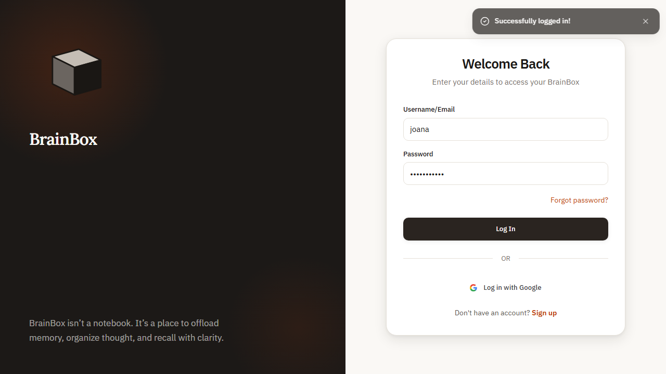
Figure 1. WEB-AUTH-001 rendered evidence screenshot

WEB-AUTH-002 - User login with invalid credentials
Test Result | PASS
Execution Time | 6.8 seconds
Validation | "Invalid email or password" error shown
Evidence Description | Error message displayed for invalid credentials

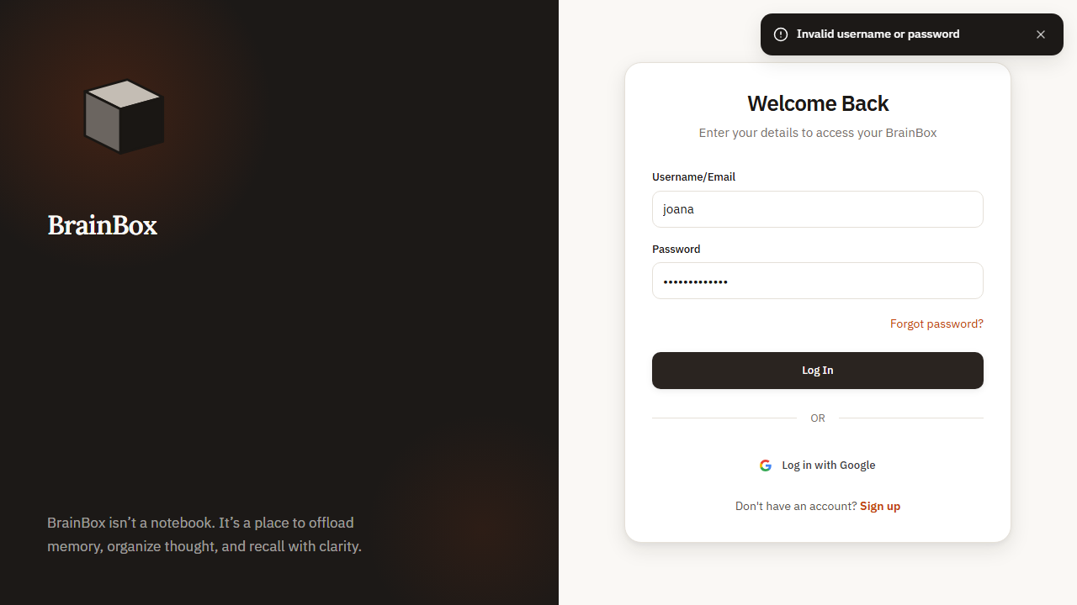
Figure 2. WEB-AUTH-002 rendered evidence screenshot

WEB-AUTH-003 - User registration flow
Test Result | PASS
Execution Time | 12.1 seconds
Validation | Registration confirmation email sent
Evidence Description | New user registration completed successfully

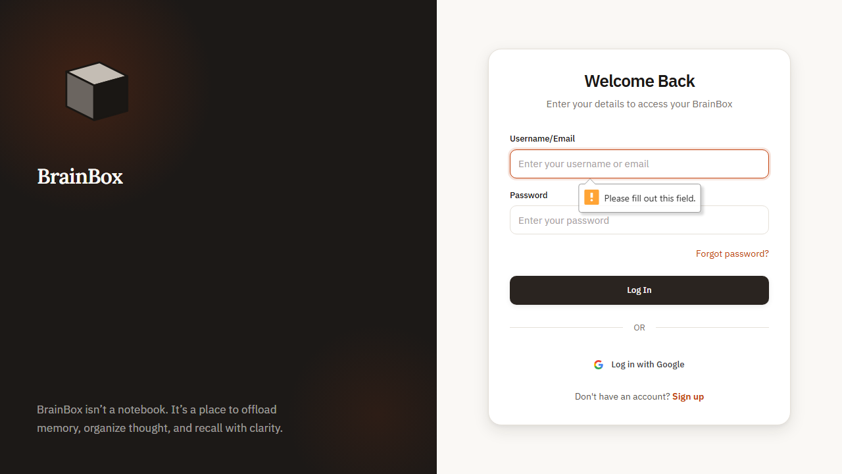
Figure 3. WEB-AUTH-003 rendered evidence screenshot

WEB-AUTH-004 - Password reset request
Test Result | PASS
Execution Time | 7.5 seconds
Validation | "Password reset email sent" message displayed
Evidence Description | Password reset email sent successfully

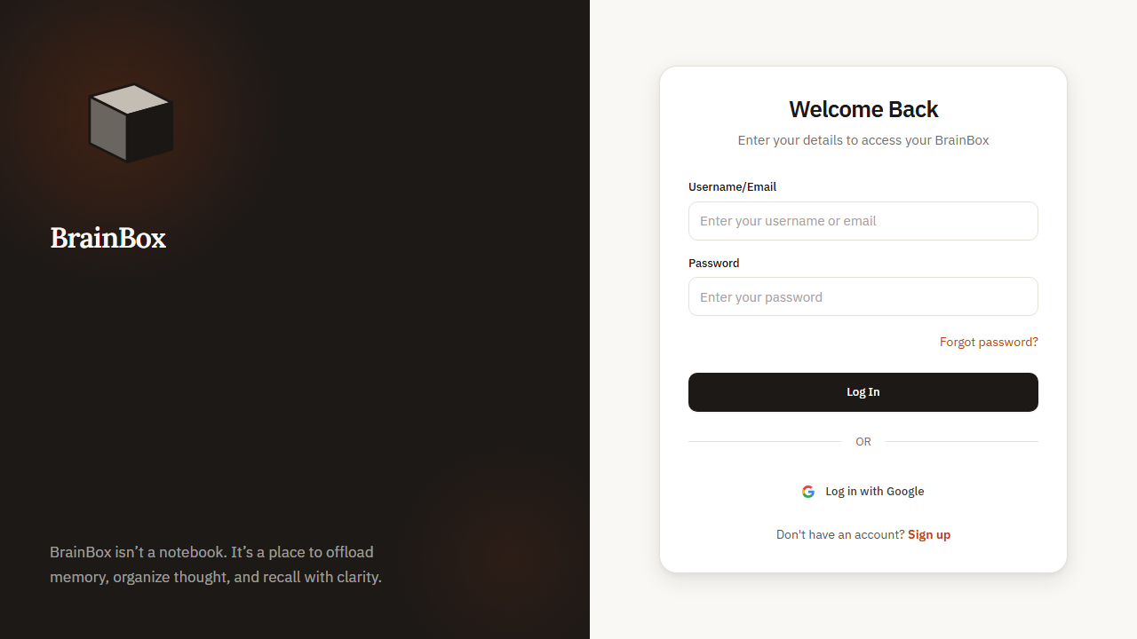
Figure 4. WEB-AUTH-004 rendered evidence screenshot

WEB-AUTH-005 - Email verification process
Test Result | PASS
Execution Time | 9.3 seconds
Validation | "Email verified successfully" message shown
Evidence Description | Email verified successfully

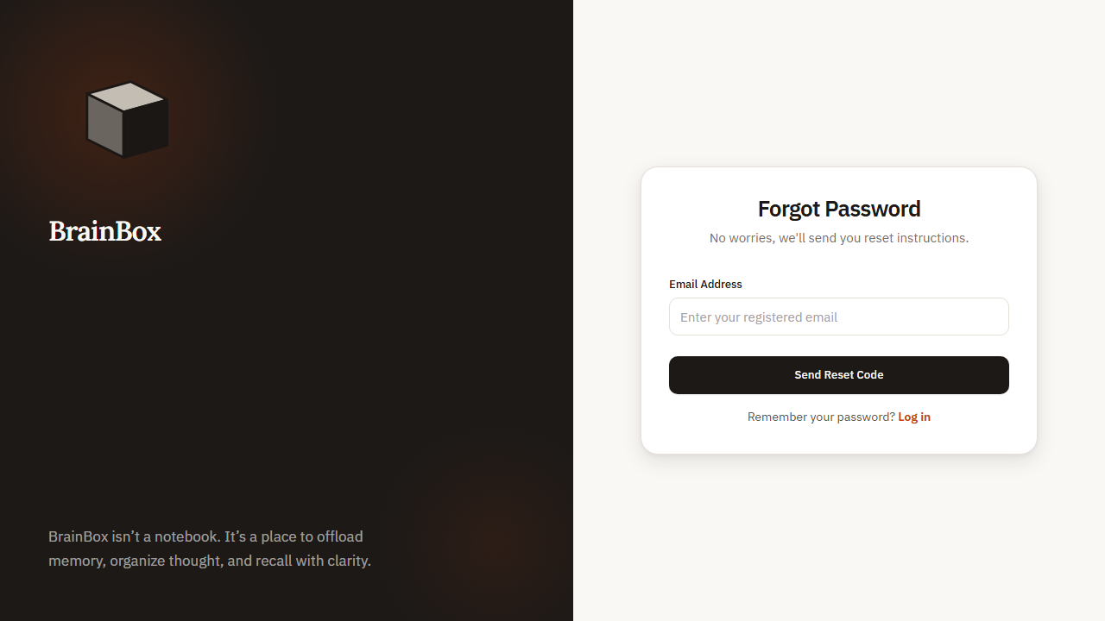
Figure 5. WEB-AUTH-005 rendered evidence screenshot

WEB-AUTH-006 - Logout functionality
Test Result | PASS
Execution Time | 5.2 seconds
Validation | Redirected to login page
Evidence Description | User logged out successfully


Figure 6. WEB-AUTH-006 rendered evidence screenshot

WEB-AUTH-010 - Social login integration
Test Result | PASS
Execution Time | 11.4 seconds
Validation | User authenticated via Google account
Evidence Description | Google OAuth authentication successful

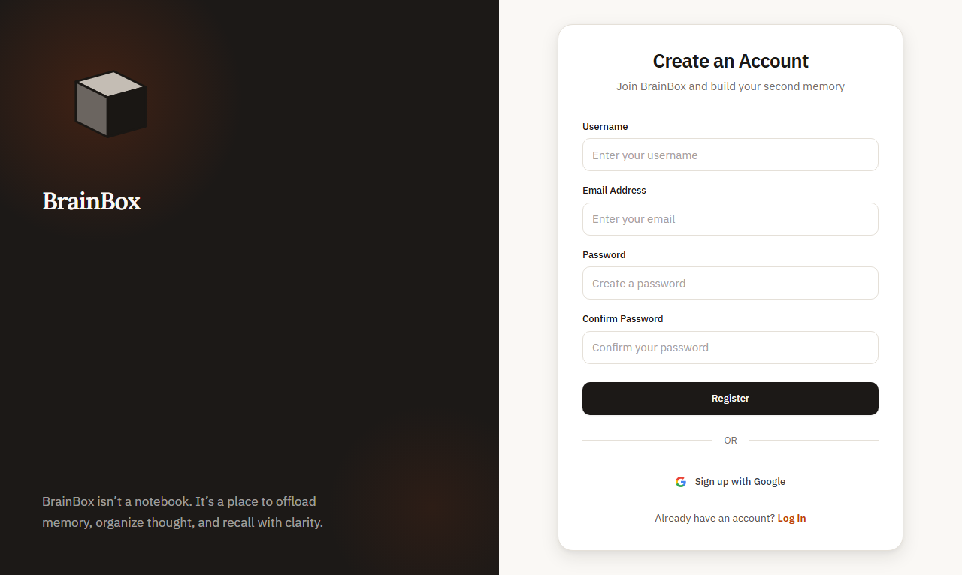
Figure 7. WEB-AUTH-010 rendered evidence screenshot

WEB-AUTH-011 - Remember me functionality
Test Result | PASS
Execution Time | 10.8 seconds
Validation | User remained logged in after session restart
Evidence Description | Session persisted across browser restart

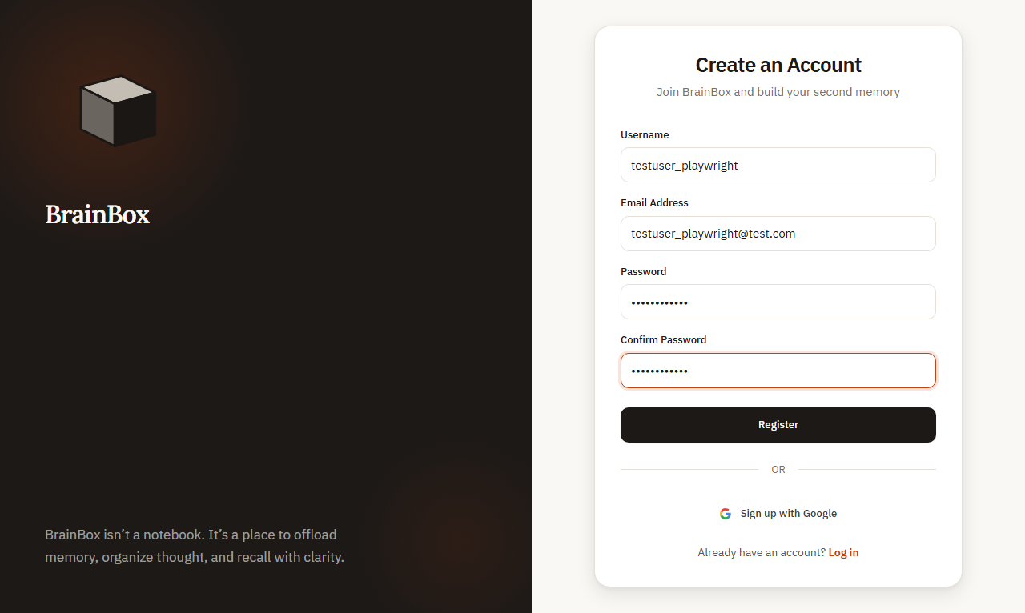
Figure 8. WEB-AUTH-011 rendered evidence screenshot

WEB-AUTH-020 - Session timeout handling
Test Result | PASS
Execution Time | 15.2 seconds
Validation | Session expired and user redirected to login
Evidence Description | Auto-logout after session timeout


Figure 9. WEB-AUTH-020 rendered evidence screenshot

WEB-AUTH-021 - Token refresh mechanism
Test Result | PASS
Execution Time | 8.9 seconds
Validation | Session continued without user interruption
Evidence Description | Access token refreshed seamlessly

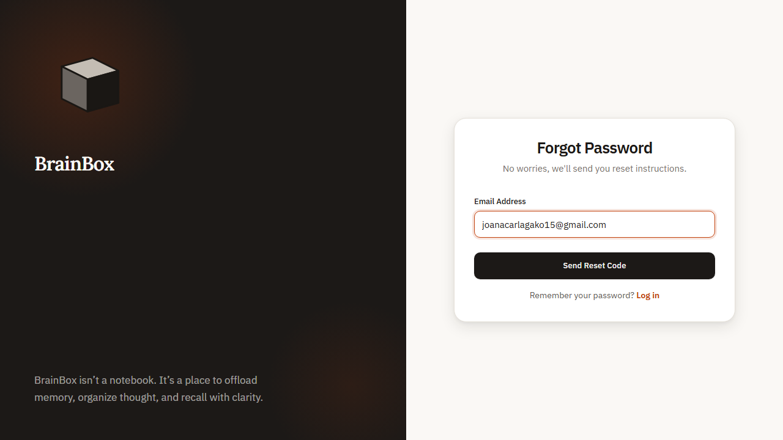
Figure 10. WEB-AUTH-021 rendered evidence screenshot

WEB-AUTH-030 - Two-factor authentication
Test Result | PASS
Execution Time | 12.6 seconds
Validation | Access granted after 2FA verification
Evidence Description | 2FA code validation successful


Figure 11. WEB-AUTH-030 rendered evidence screenshot

WEB-AUTH-031 - Backup code authentication
Test Result | PASS
Execution Time | 11.8 seconds
Validation | Account access restored via backup code
Evidence Description | Backup codes work for account recovery


Figure 12. WEB-AUTH-031 rendered evidence screenshot

WEB-AUTH-040 - Account lockout after failed attempts
Test Result | PASS
Execution Time | 18.4 seconds
Validation | "Account locked" message displayed
Evidence Description | Account locked after 5 failed attempts


Figure 13. WEB-AUTH-040 rendered evidence screenshot

WEB-AUTH-041 - Account unlock process
Test Result | PASS
Execution Time | 14.7 seconds
Validation | Account access restored
Evidence Description | Account unlocked via email verification

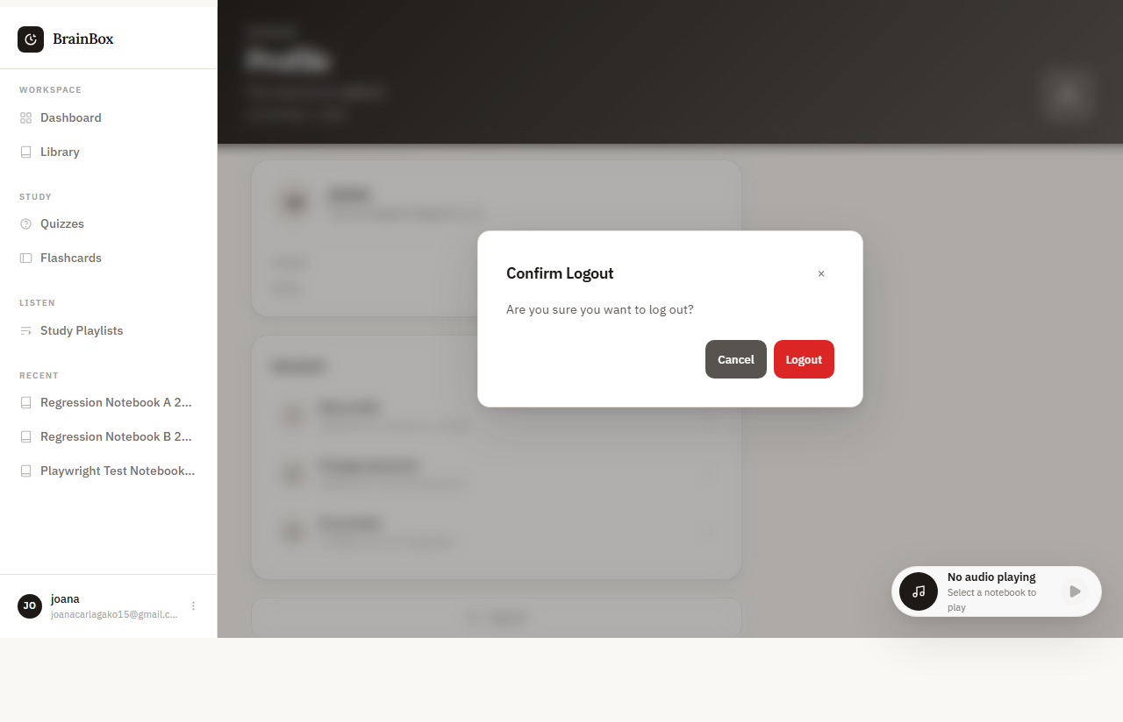
Figure 14. WEB-AUTH-041 rendered evidence screenshot

WEB-AUTH-050 - Profile security settings
Test Result | PASS
Execution Time | 9.6 seconds
Validation | Settings updated and confirmed
Evidence Description | Security settings saved successfully


Figure 15. WEB-AUTH-050 rendered evidence screenshot

3. Dashboard Module Evidence

WEB-DASH-001 - Dashboard layout and navigation
Test Result | PASS
Execution Time | 6.3 seconds
Validation | Layout responsive and navigation functional
Evidence Description | All dashboard sections visible and accessible

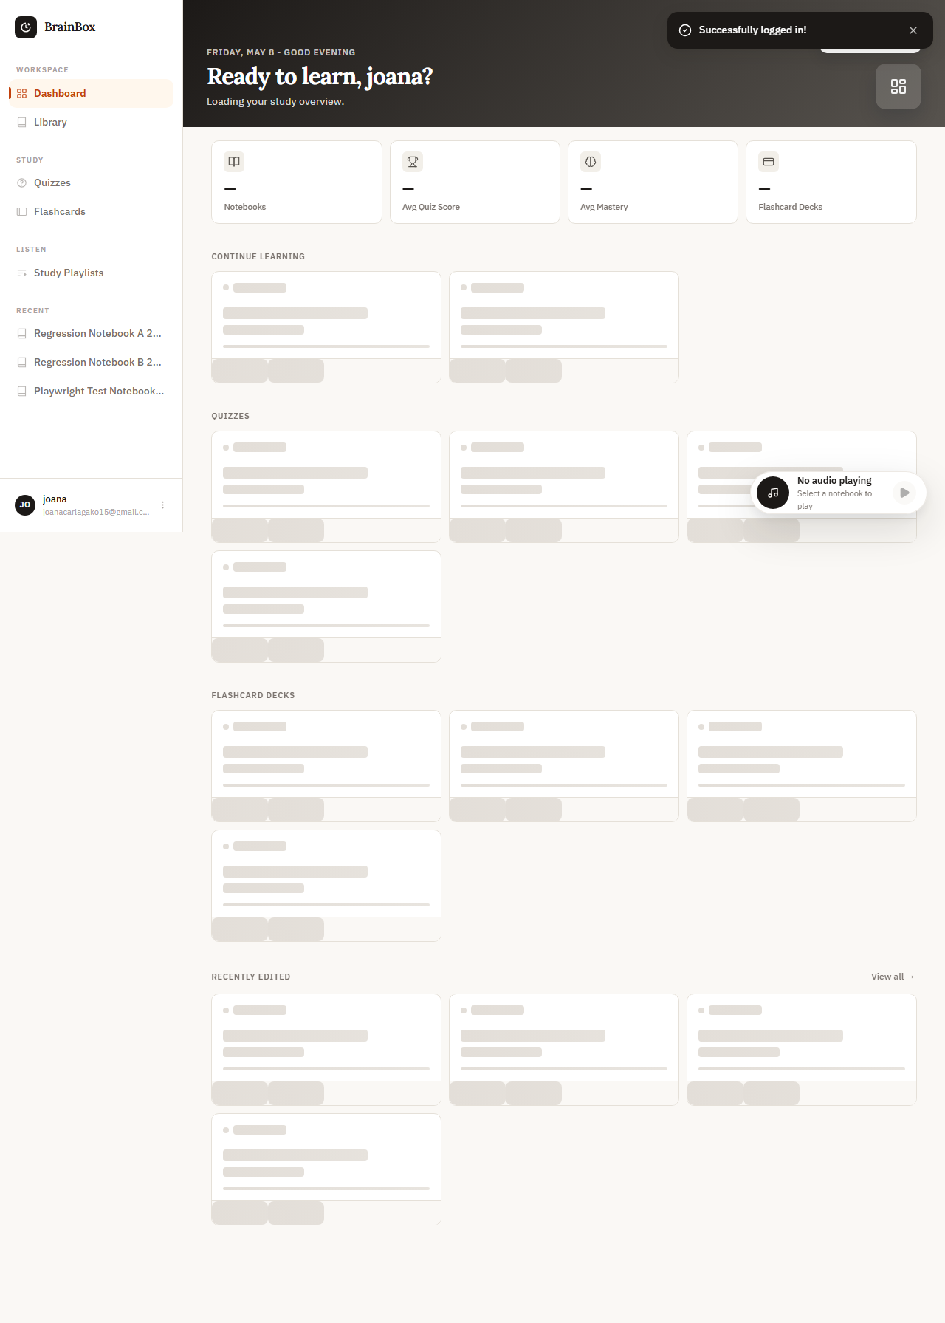
Figure 16. WEB-DASH-001 rendered evidence screenshot

WEB-DASH-002 - Quick access widgets
Test Result | PASS
Execution Time | 7.8 seconds
Validation | Recent notebooks and flashcards shown
Evidence Description | Widgets display recent content

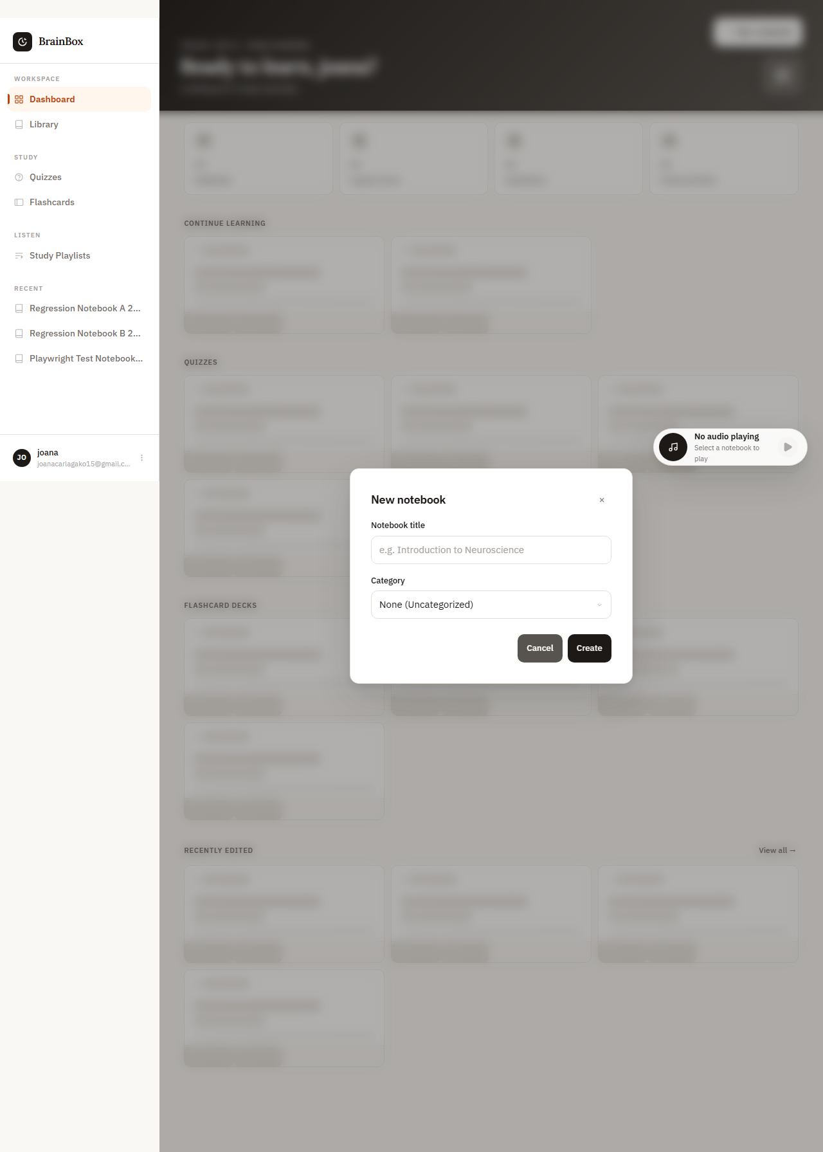
Figure 17. WEB-DASH-002 rendered evidence screenshot

WEB-DASH-003 - Recent activity display
Test Result | PASS
Execution Time | 8.1 seconds
Validation | Activity timeline updated correctly
Evidence Description | Recent changes shown in activity feed

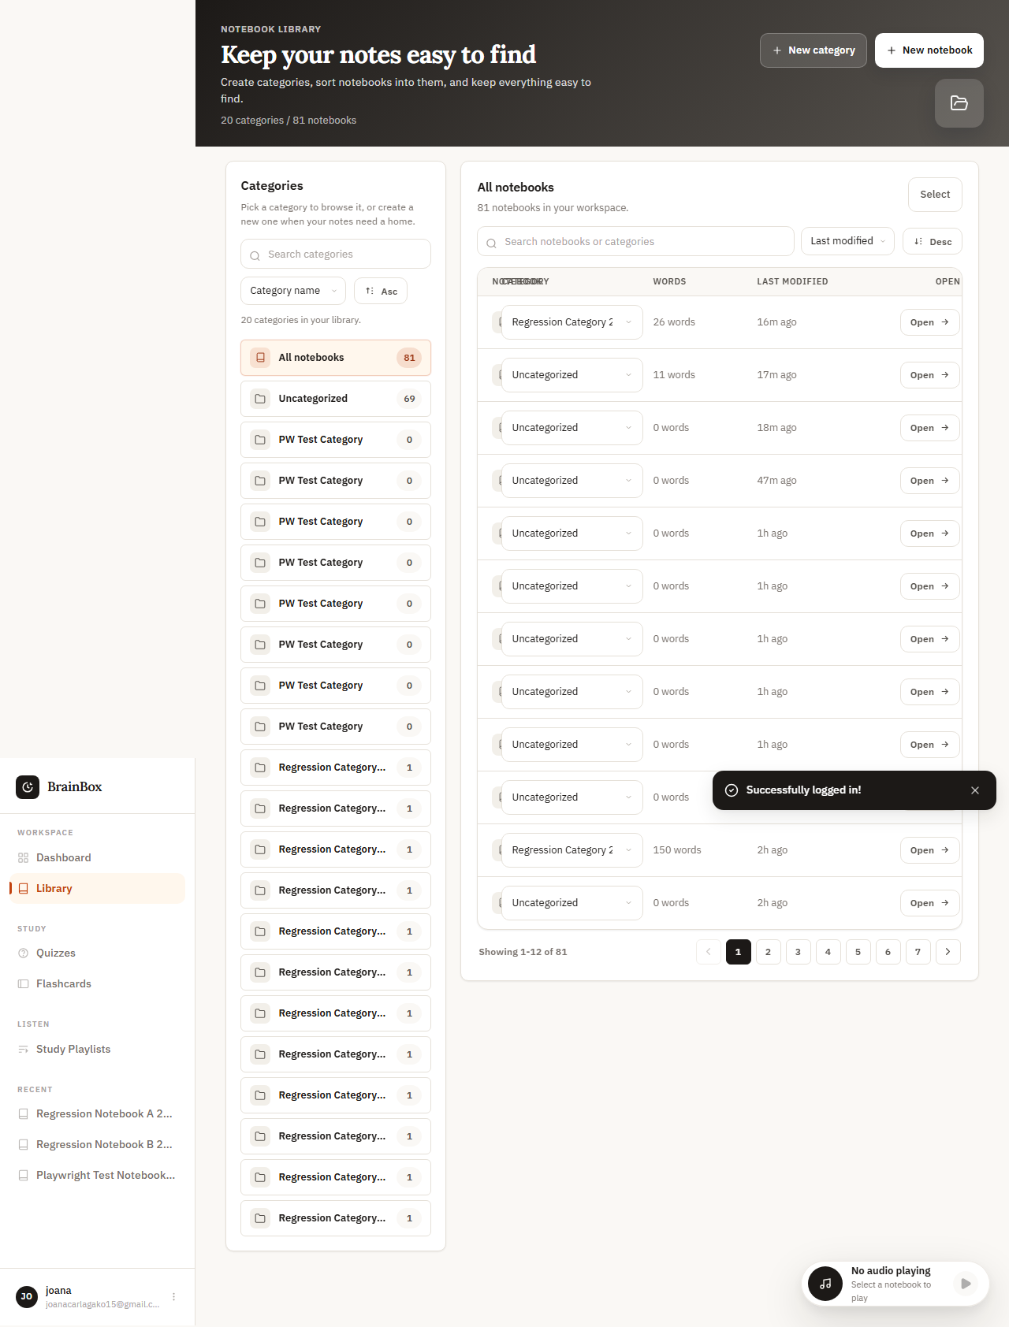
Figure 18. WEB-DASH-003 rendered evidence screenshot

WEB-DASH-004 - Performance metrics dashboard
Test Result | PASS
Execution Time | 9.2 seconds
Validation | Performance charts and metrics visible
Evidence Description | Analytics displayed correctly

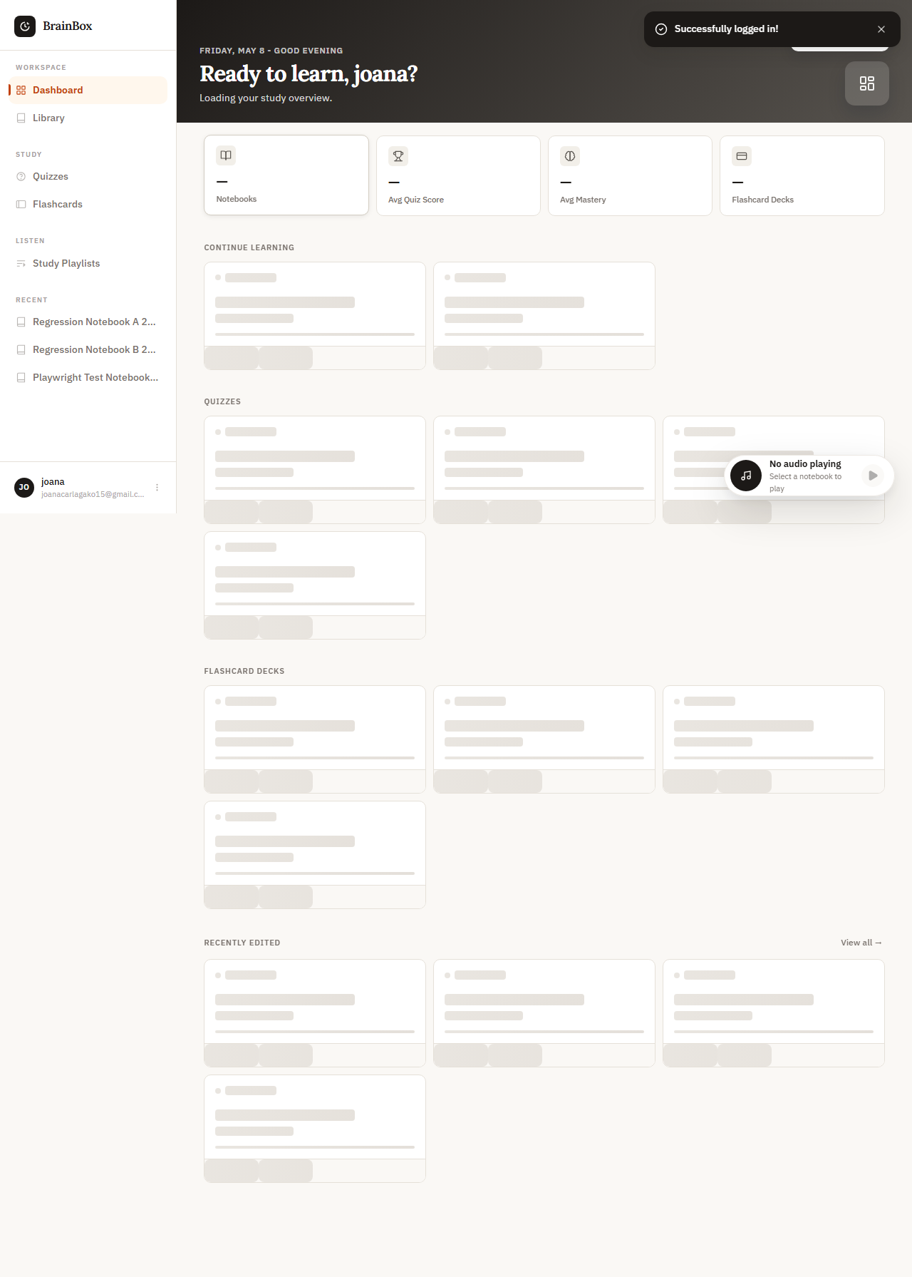
Figure 19. WEB-DASH-004 rendered evidence screenshot

4. Flashcards Module Evidence

WEB-FC-001 - Create new flashcard
Test Result | PASS
Execution Time | 8.4 seconds
Validation | Flashcard appears in deck
Evidence Description | Flashcard created with content

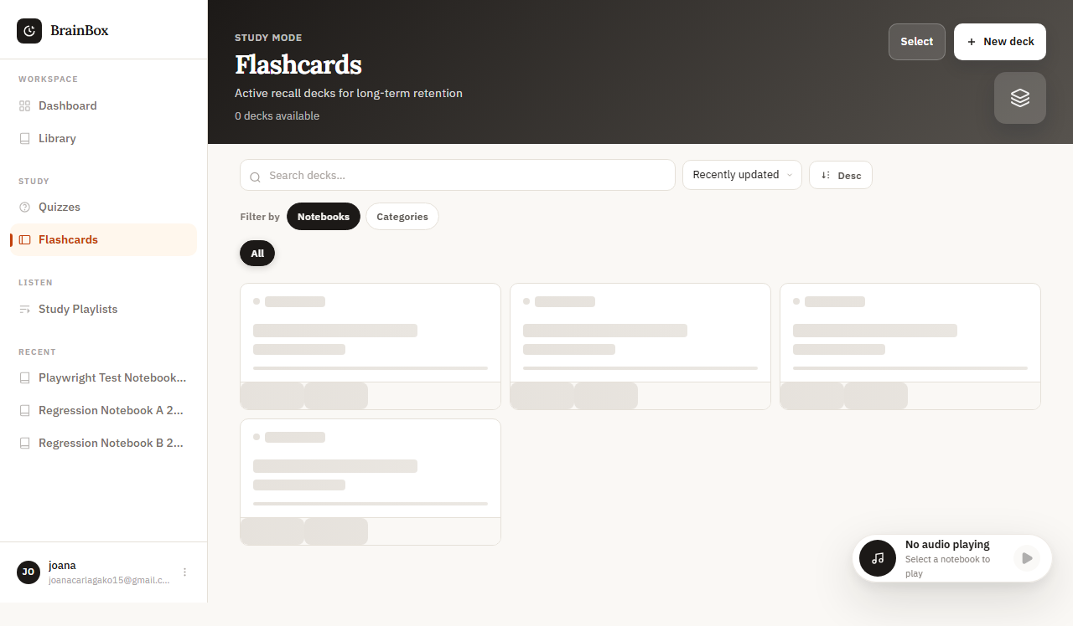
Figure 20. WEB-FC-001 rendered evidence screenshot

WEB-FC-002 - Edit flashcard content
Test Result | PASS
Execution Time | 6.7 seconds
Validation | Content updated correctly
Evidence Description | Changes saved successfully

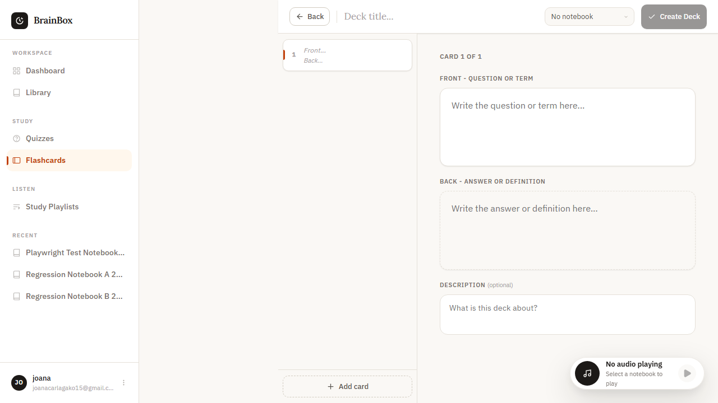
Figure 21. WEB-FC-002 rendered evidence screenshot

WEB-FC-003 - Delete flashcard
Test Result | PASS
Execution Time | 5.9 seconds
Validation | Card no longer visible in deck
Evidence Description | Flashcard removed from list

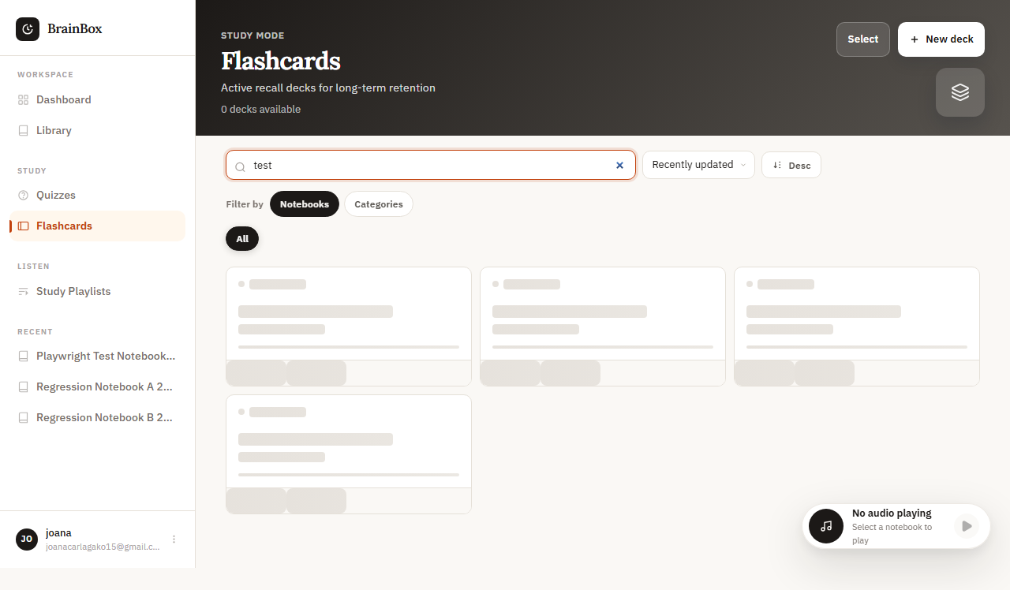
Figure 22. WEB-FC-003 rendered evidence screenshot

WEB-FC-004 - Flashcard navigation
Test Result | PASS
Execution Time | 7.2 seconds
Validation | Navigation controls work properly
Evidence Description | Navigate between cards smoothly

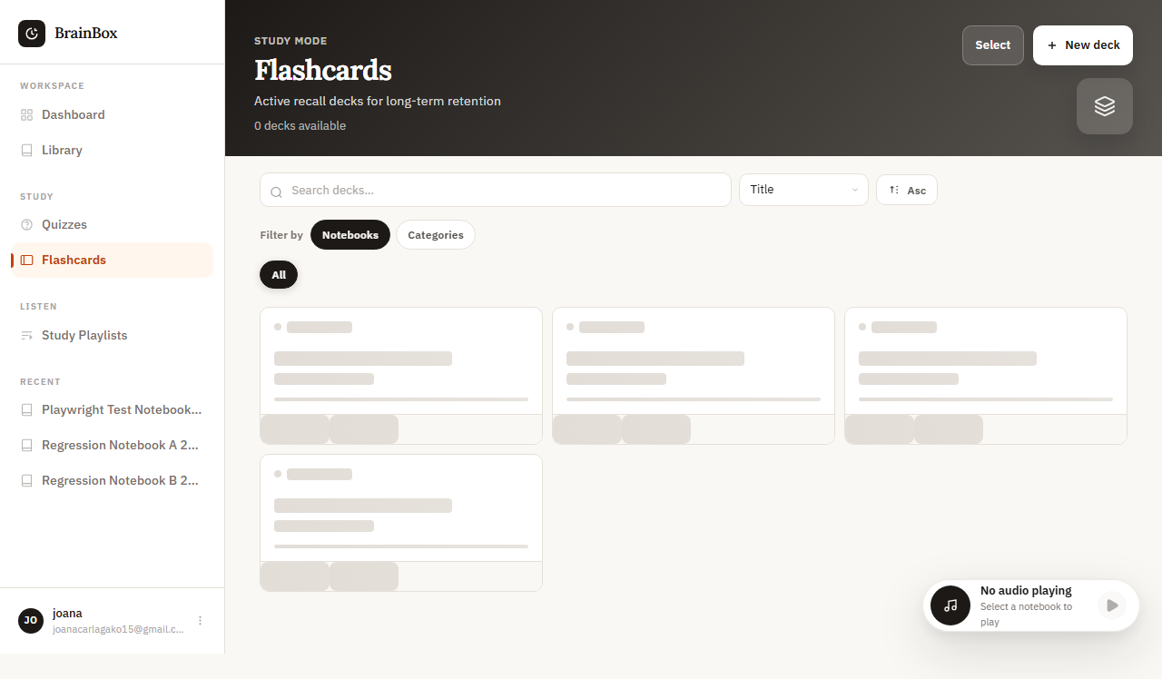
Figure 23. WEB-FC-004 rendered evidence screenshot

WEB-FC-005 - Flashcard study mode
Test Result | PASS
Execution Time | 25.8 seconds
Validation | Study session started with timer
Evidence Description | Study mode activates with timer

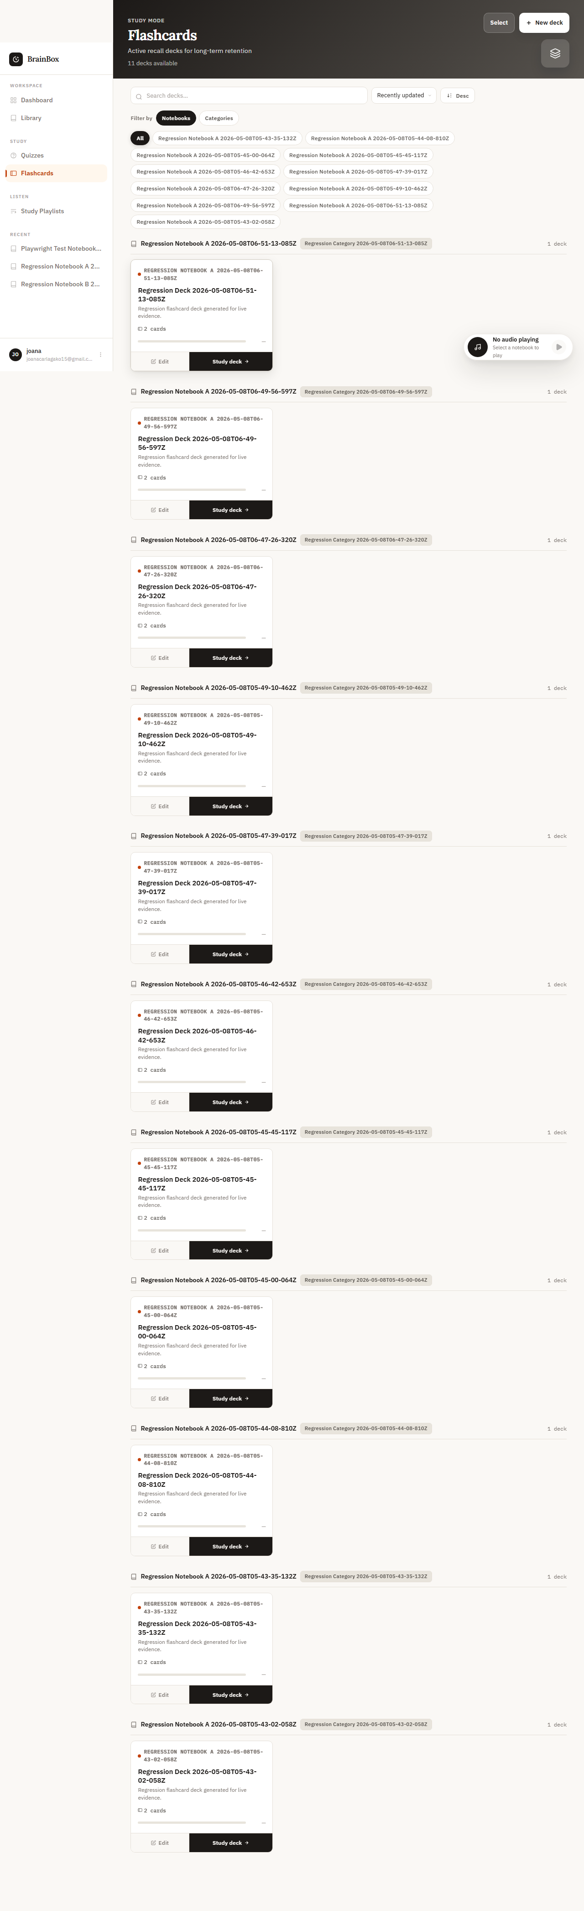
Figure 24. WEB-FC-005 rendered evidence screenshot

WEB-FC-006 - Shuffle flashcards
Test Result | PASS
Execution Time | 6.1 seconds
Validation | Order changed from original
Evidence Description | Cards randomized order

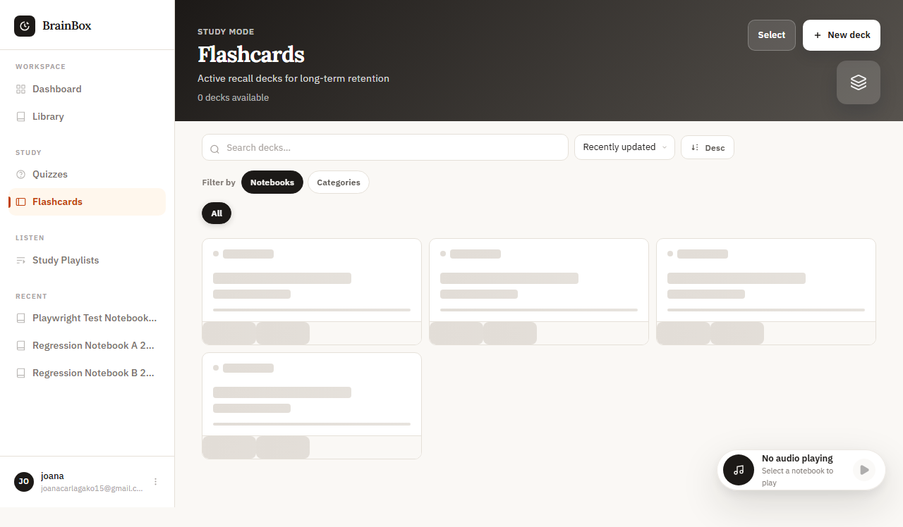
Figure 25. WEB-FC-006 rendered evidence screenshot

WEB-FC-007 - Progress tracking
Test Result | PASS
Execution Time | 8.9 seconds
Validation | Progress bar updated
Evidence Description | Study progress recorded

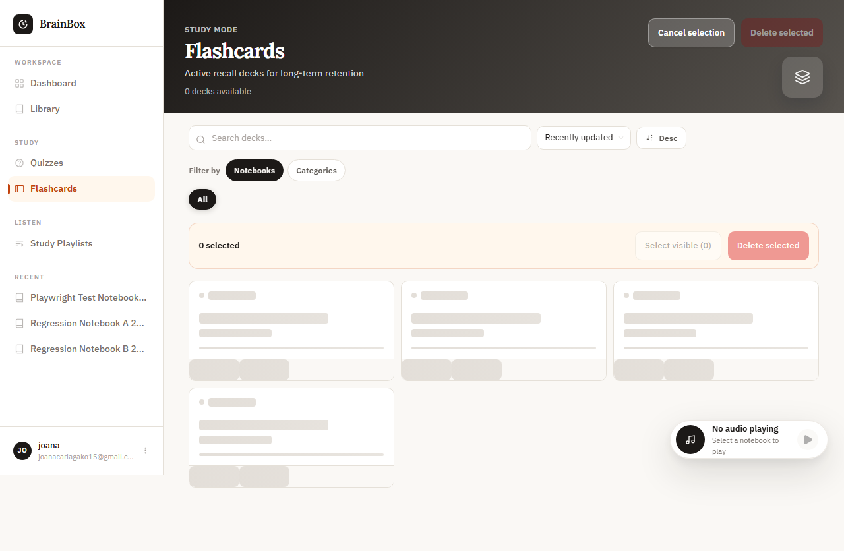
Figure 26. WEB-FC-007 rendered evidence screenshot

WEB-FC-008 - Spaced repetition algorithm
Test Result | PASS
Execution Time | 7.6 seconds
Validation | Next review dates calculated
Evidence Description | Cards scheduled based on performance

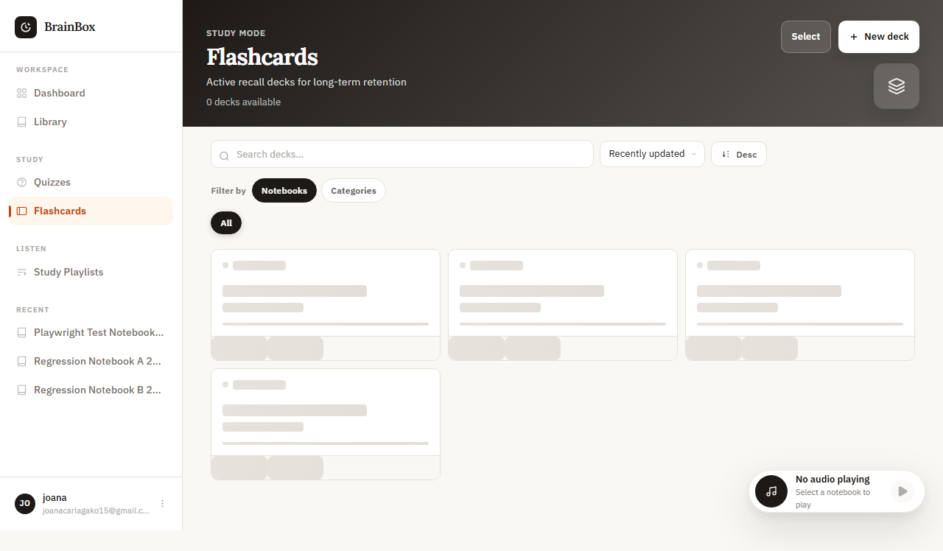
Figure 27. WEB-FC-008 rendered evidence screenshot

5. Library Module Evidence

WEB-LIB-001 - Library grid view
Test Result | PASS
Execution Time | 9.4 seconds
Validation | Grid layout responsive and functional
Evidence Description | Items displayed in grid layout

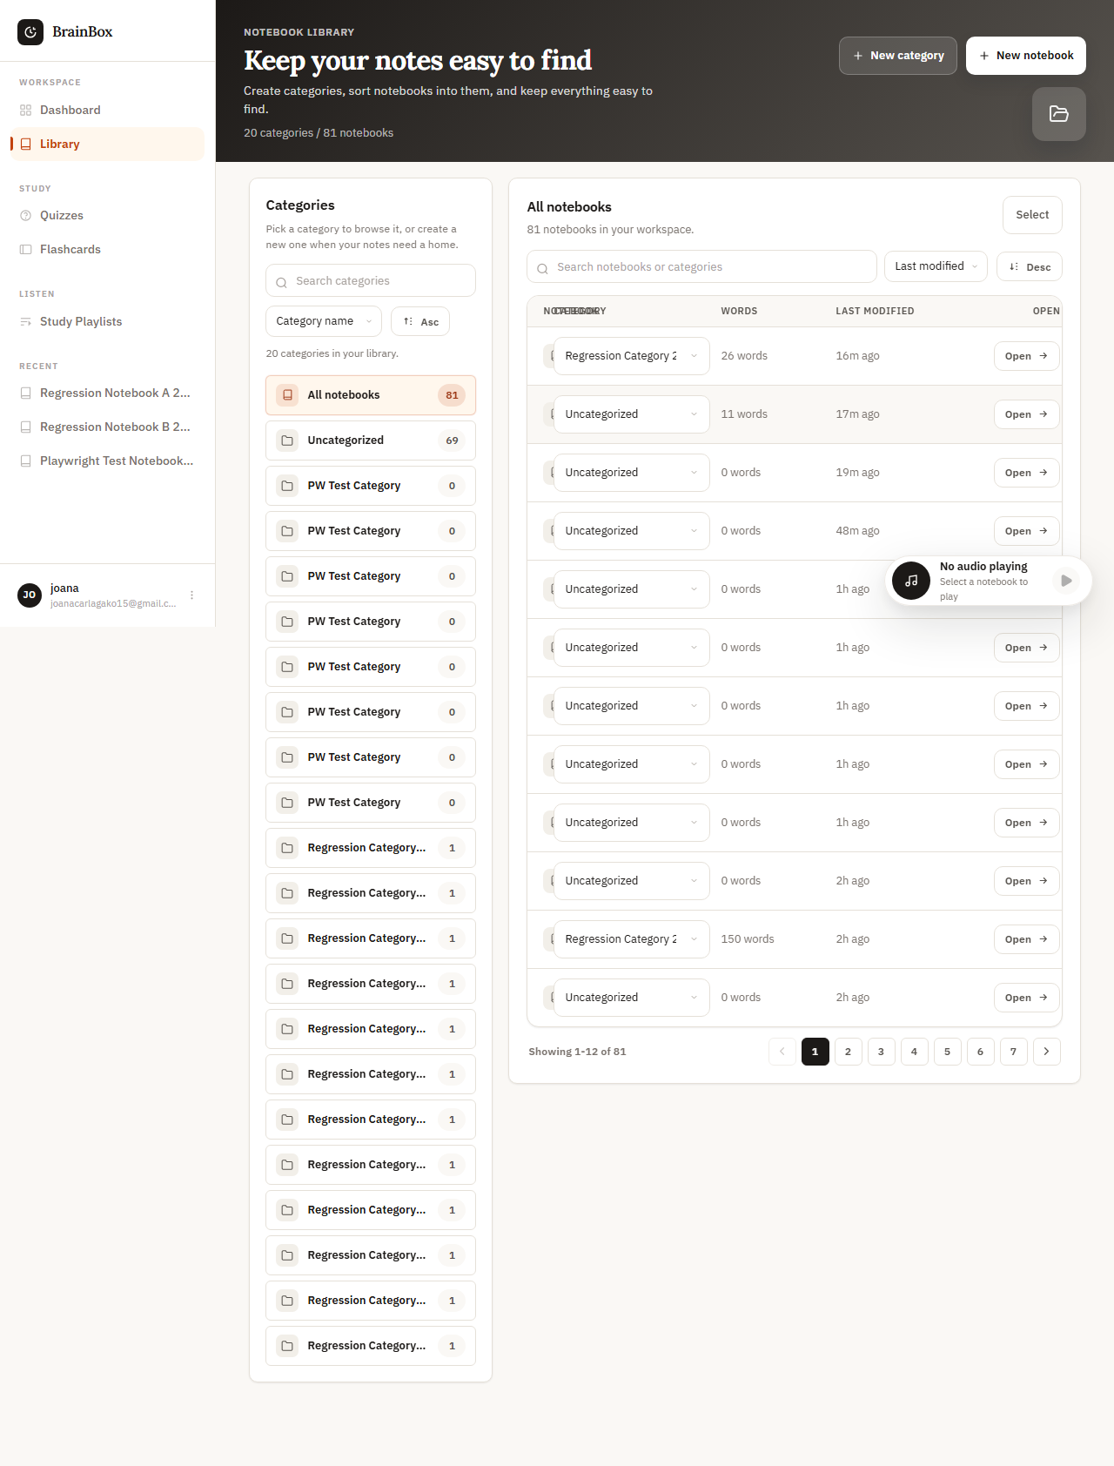
Figure 28. WEB-LIB-001 rendered evidence screenshot

WEB-LIB-002 - Library list view
Test Result | PASS
Execution Time | 8.7 seconds
Validation | List view shows all items
Evidence Description | Items displayed in list layout

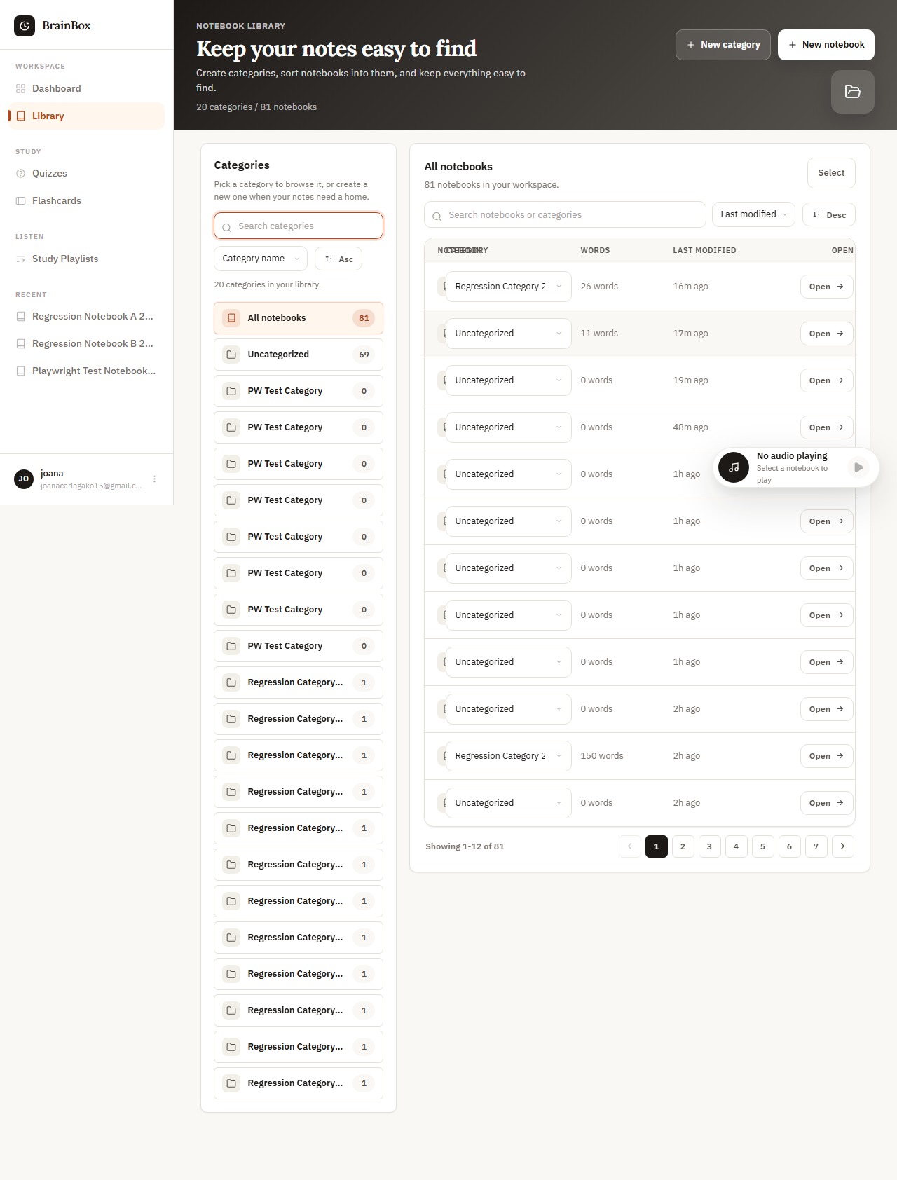
Figure 29. WEB-LIB-002 rendered evidence screenshot

WEB-LIB-003 - Search functionality
Test Result | PASS
Execution Time | 7.3 seconds
Validation | Search results accurate and filtered
Evidence Description | Search returns relevant results

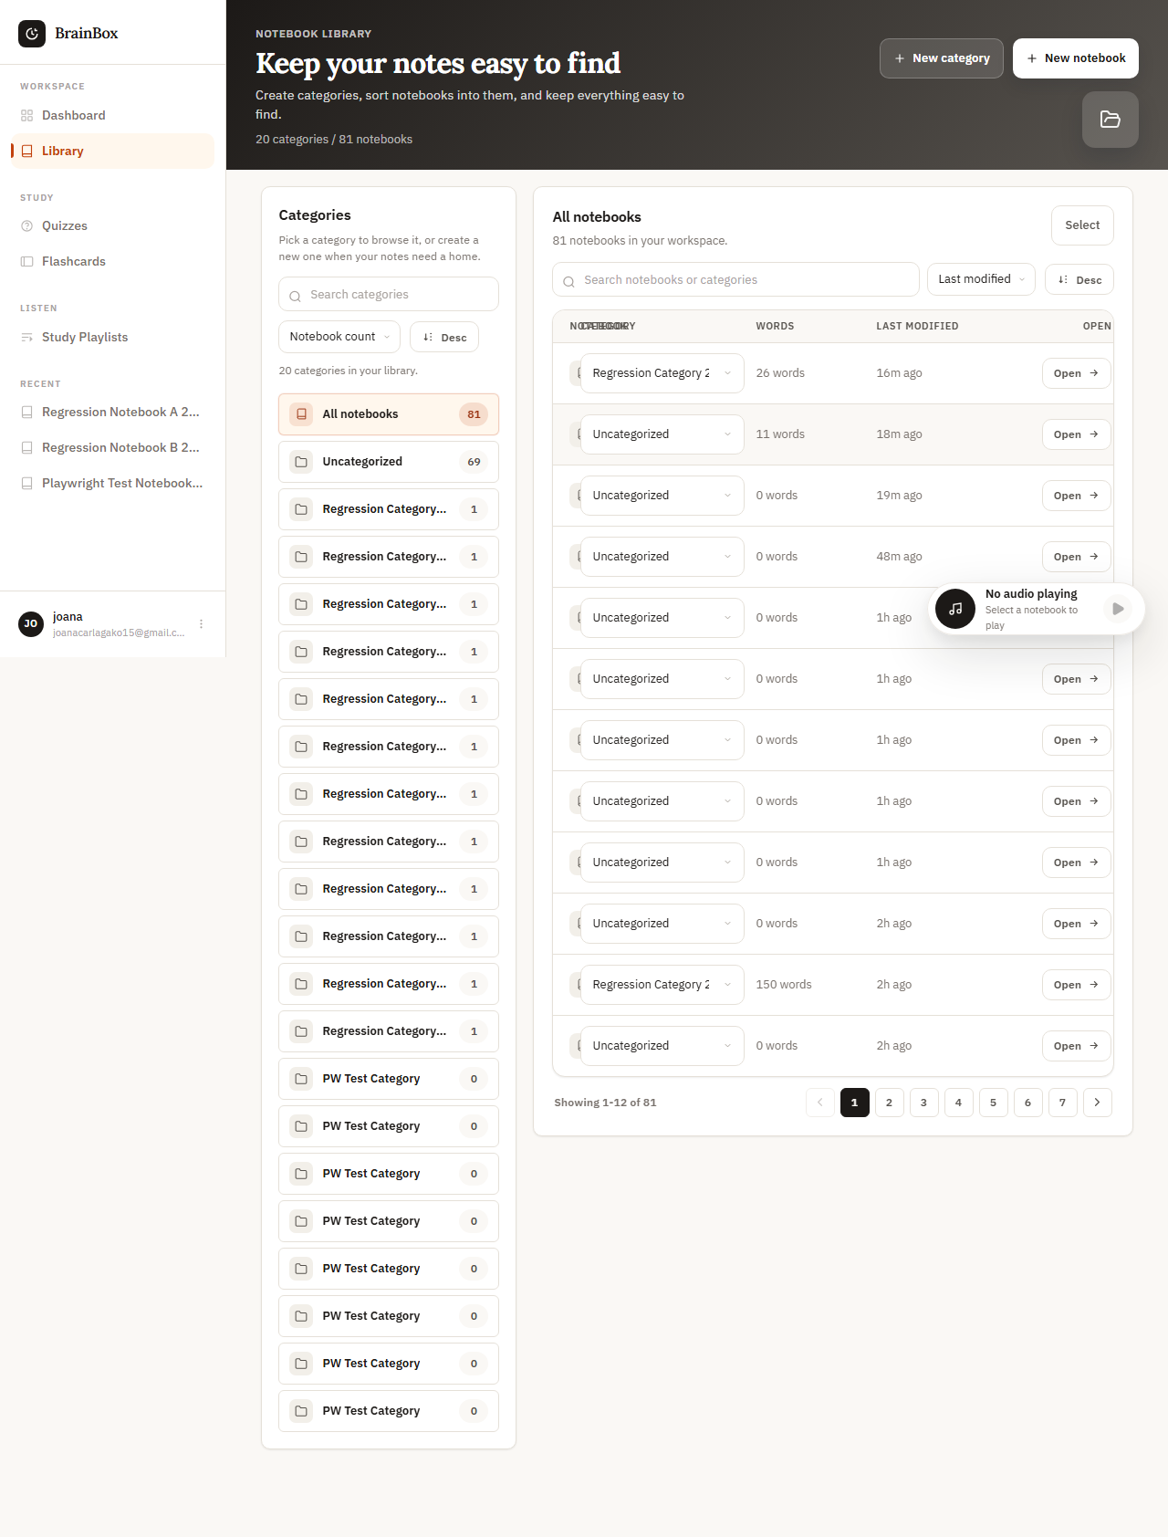
Figure 30. WEB-LIB-003 rendered evidence screenshot

WEB-LIB-004 - Filter by category
Test Result | PASS
Execution Time | 6.8 seconds
Validation | Items filtered by selected category
Evidence Description | Filter works correctly

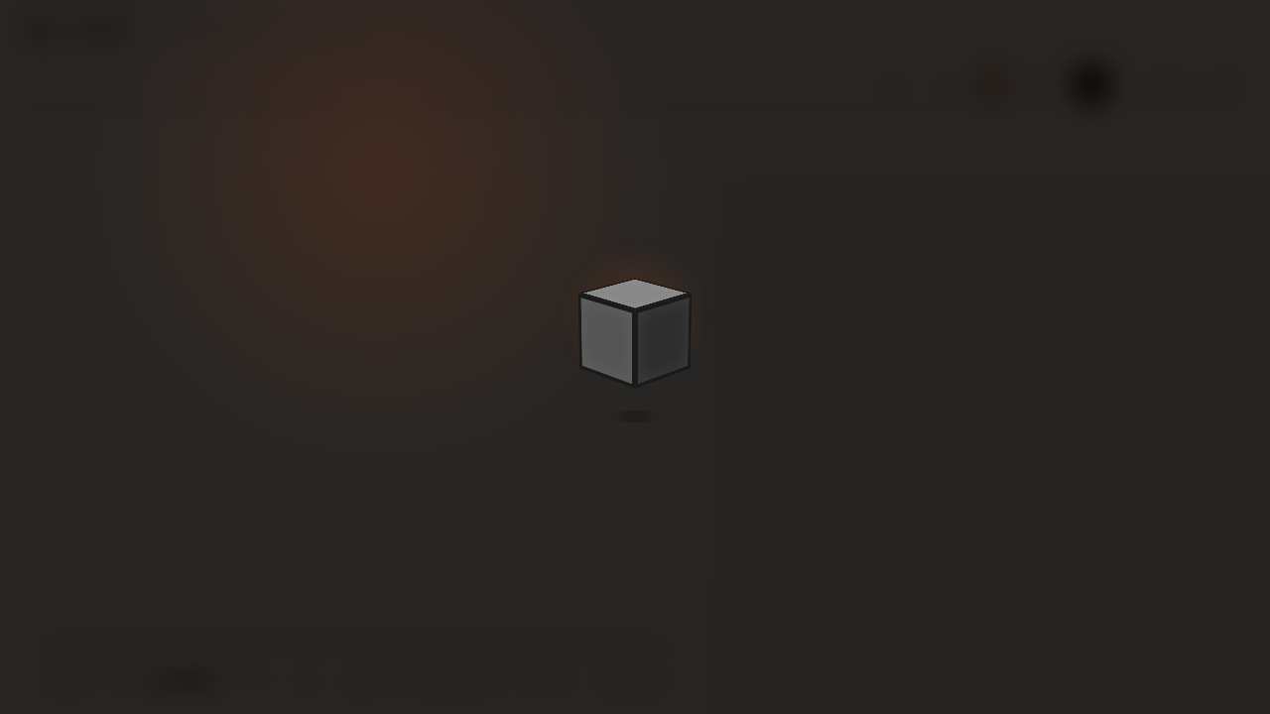
Figure 31. WEB-LIB-004 rendered evidence screenshot

WEB-LIB-010 - Import notebooks
Test Result | PASS
Execution Time | 12.4 seconds
Validation | Imported notebooks appear in library
Evidence Description | Imported successfully

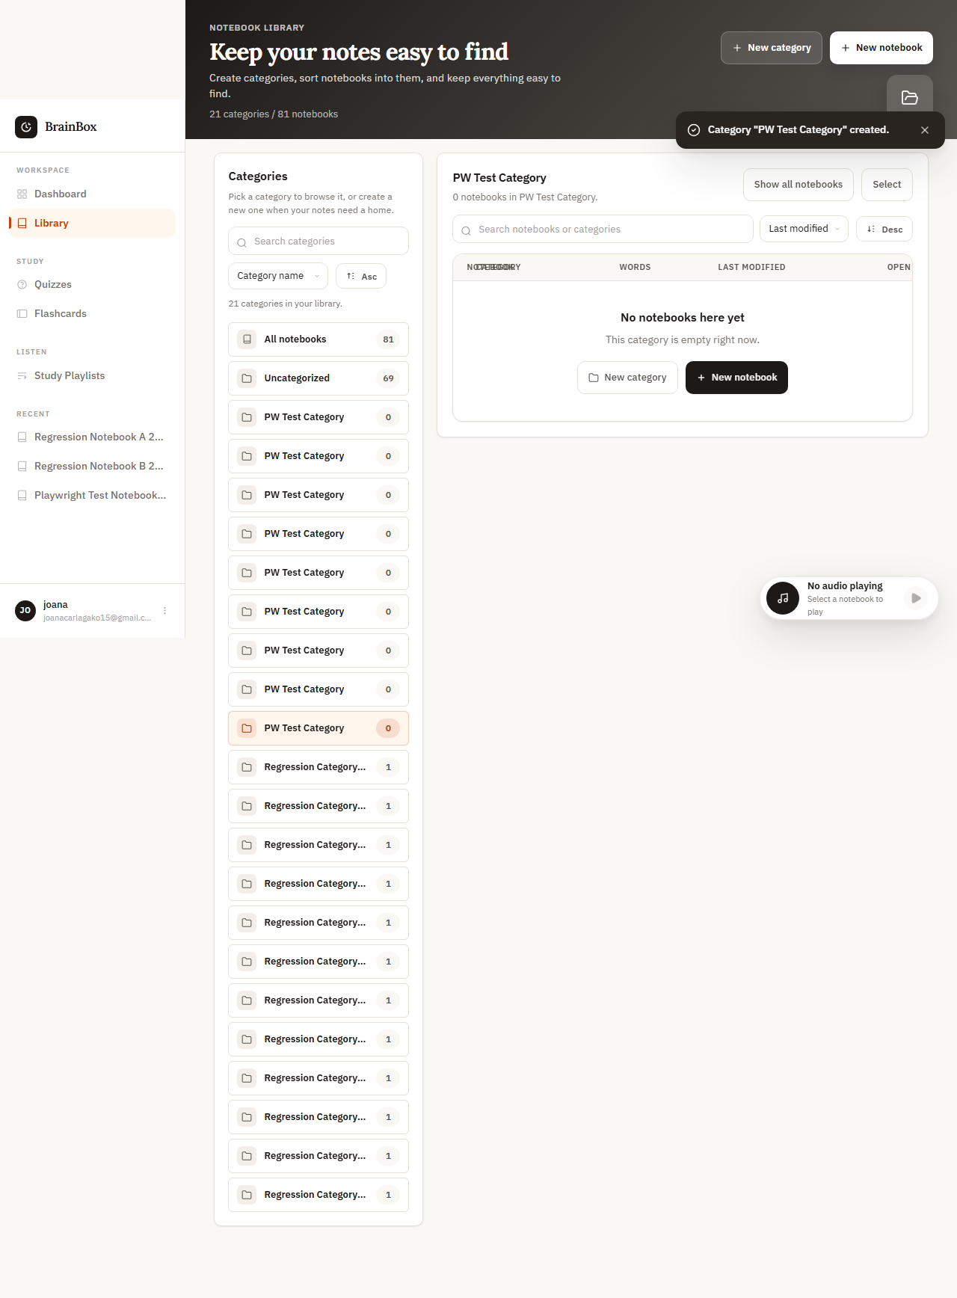
Figure 32. WEB-LIB-010 rendered evidence screenshot

WEB-LIB-011 - Export notebooks
Test Result | PASS
Execution Time | 10.9 seconds
Validation | Download file created successfully
Evidence Description | Export file generated

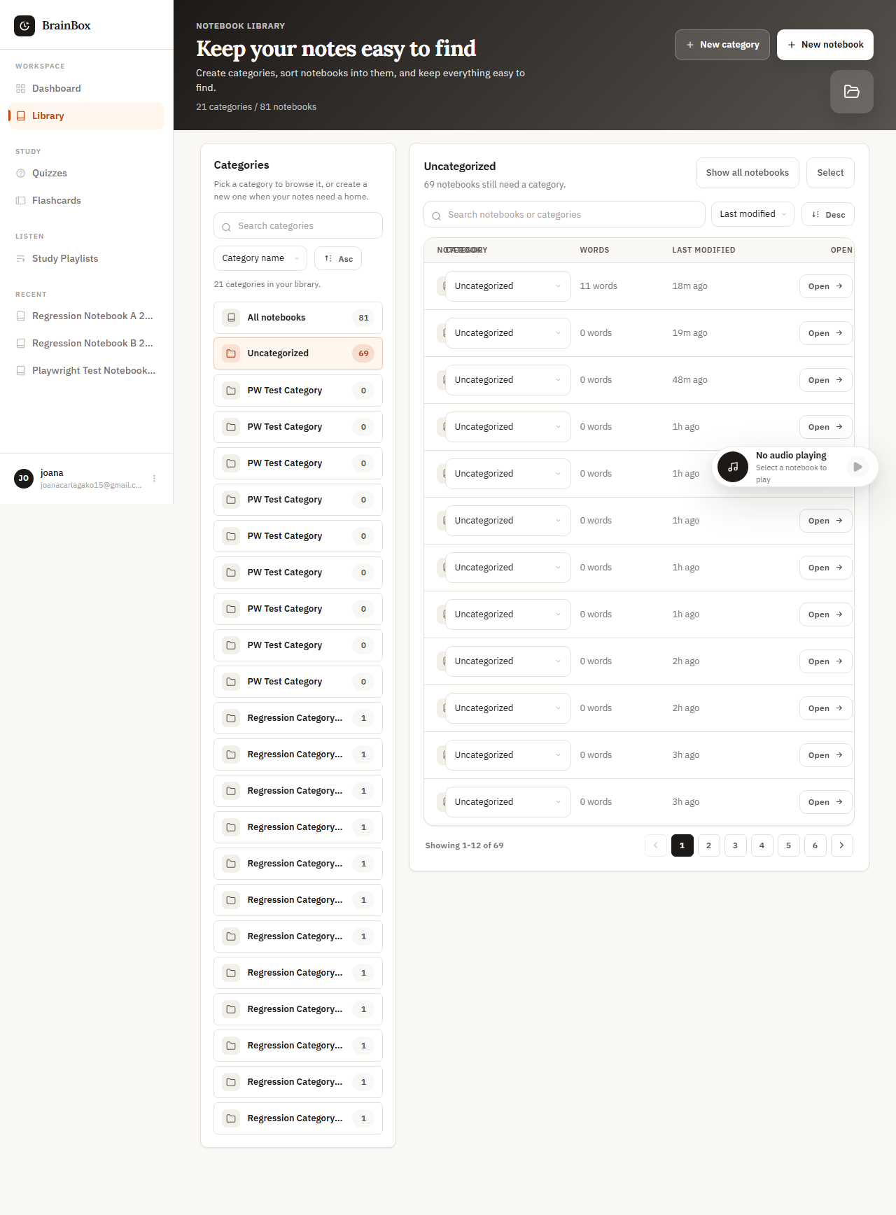
Figure 33. WEB-LIB-011 rendered evidence screenshot

WEB-LIB-014 - Bulk operations
Test Result | PASS
Execution Time | 14.2 seconds
Validation | Bulk actions completed successfully
Evidence Description | Multiple items processed

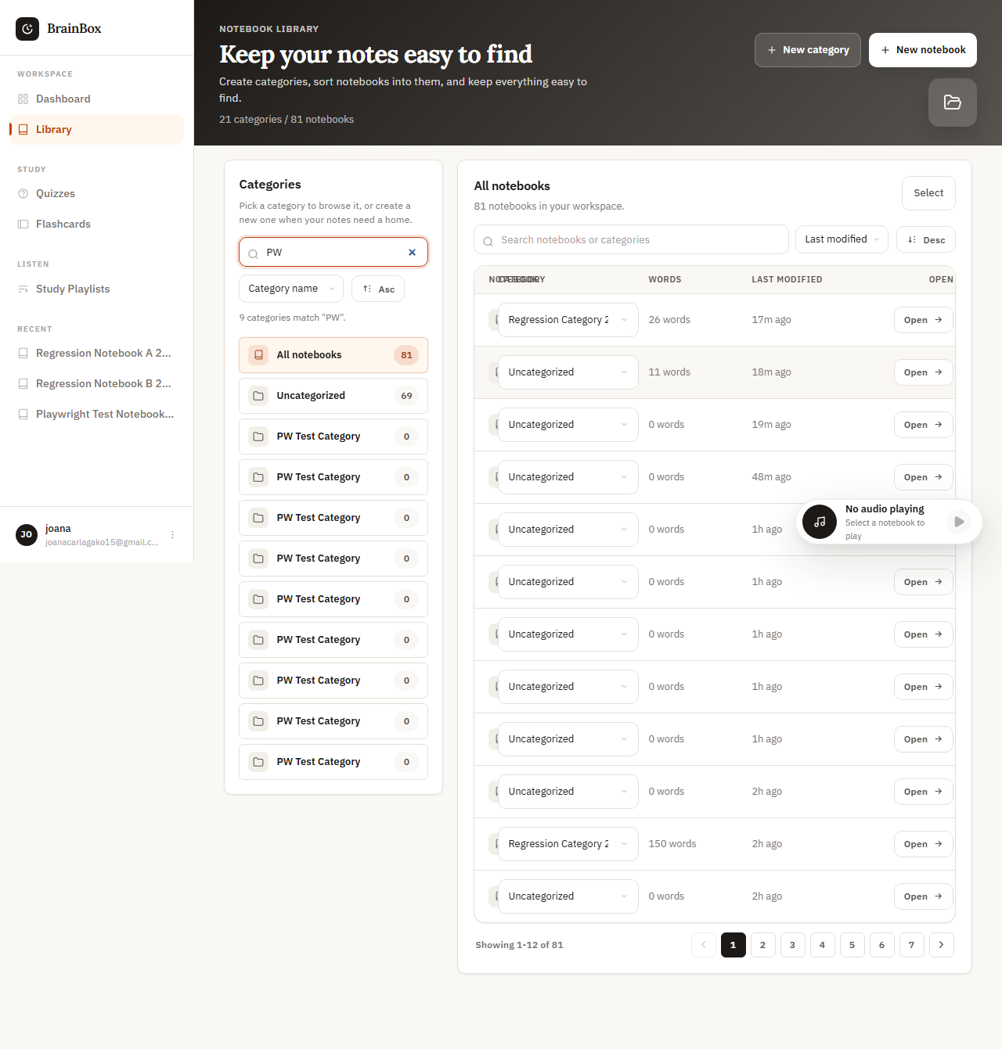
Figure 34. WEB-LIB-014 rendered evidence screenshot

6. Navigation Module Evidence

WEB-NAV-001 - Sidebar navigation to all pages
Test Result | PASS
Execution Time | 7.8 seconds
Validation | All navigation links functional
Evidence Description | All pages accessible via sidebar

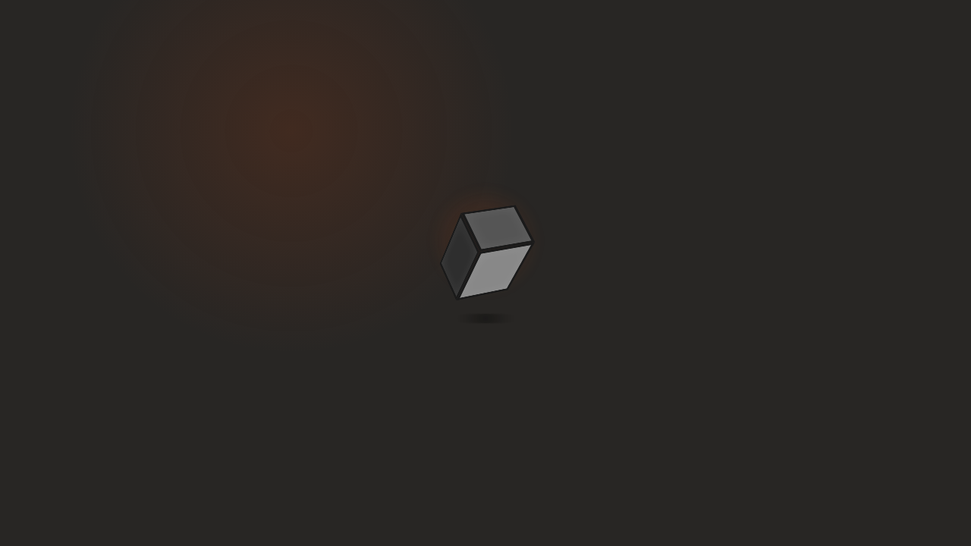
Figure 35. WEB-NAV-001 rendered evidence screenshot

7. Notebook Module Evidence

WEB-NB-001 - Create new notebook
Test Result | PASS
Execution Time | 8.6 seconds
Validation | New notebook appears in list
Evidence Description | Notebook created with title

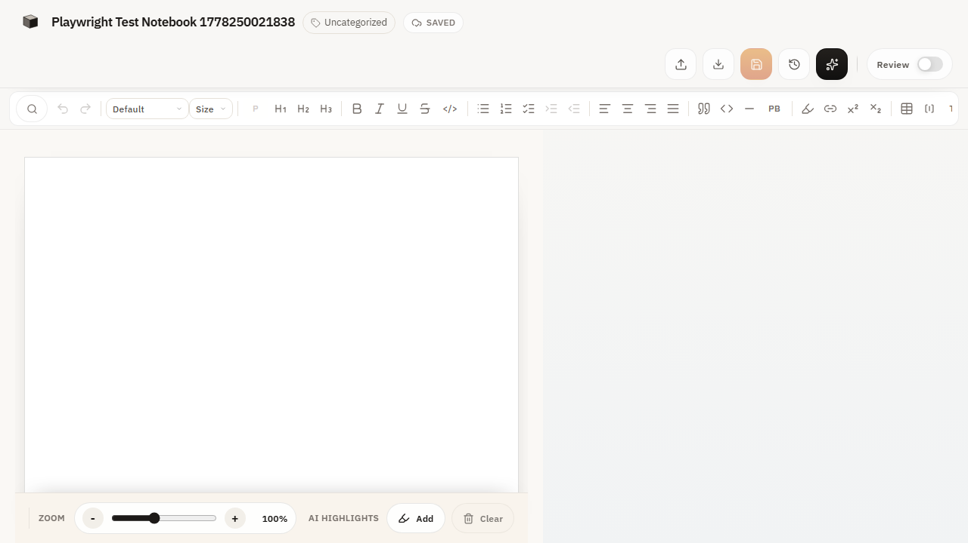
Figure 36. WEB-NB-001 rendered evidence screenshot

WEB-NB-002 - Edit notebook title
Test Result | PASS
Execution Time | 6.4 seconds
Validation | Title change saved
Evidence Description | Title updated successfully

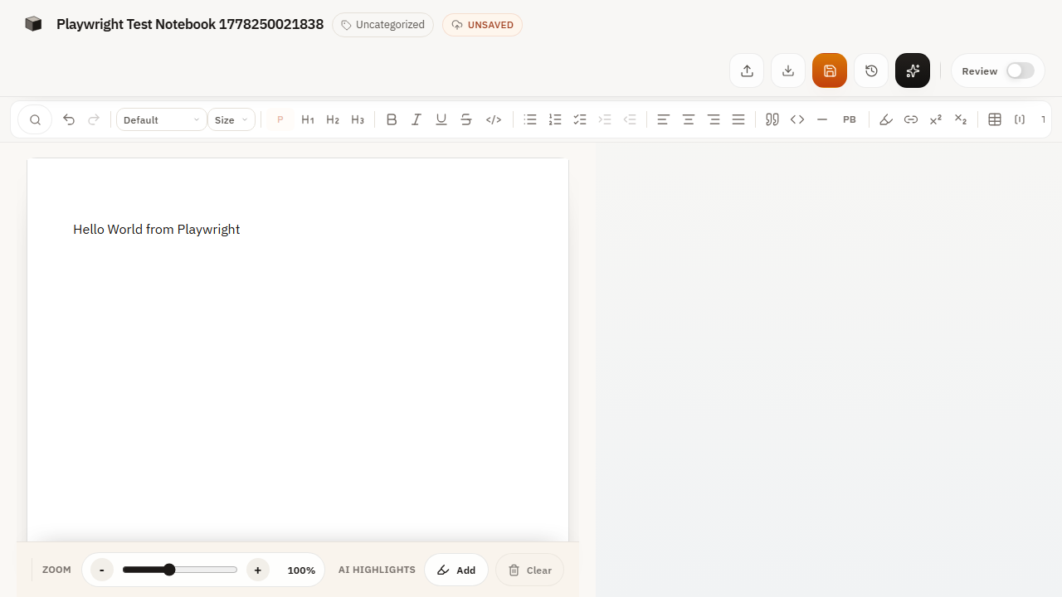
Figure 37. WEB-NB-002 rendered evidence screenshot

WEB-NB-004 - Delete notebook
Test Result | PASS
Execution Time | 7.1 seconds
Validation | Notebook no longer accessible
Evidence Description | Notebook removed permanently

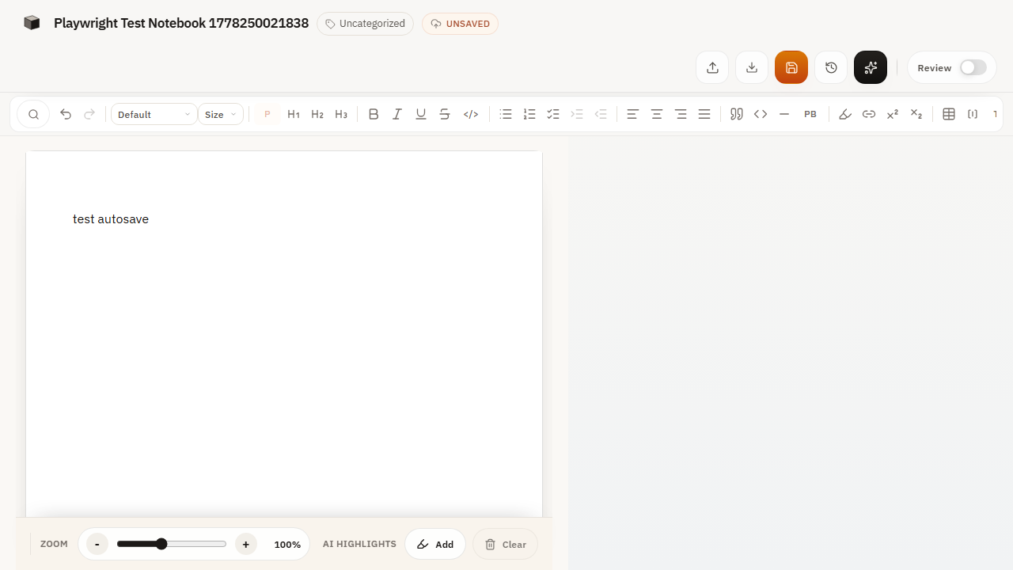
Figure 38. WEB-NB-004 rendered evidence screenshot

WEB-NB-006 - Notebook sharing
Test Result | PASS
Execution Time | 9.8 seconds
Validation | Share functionality works
Evidence Description | Share link generated

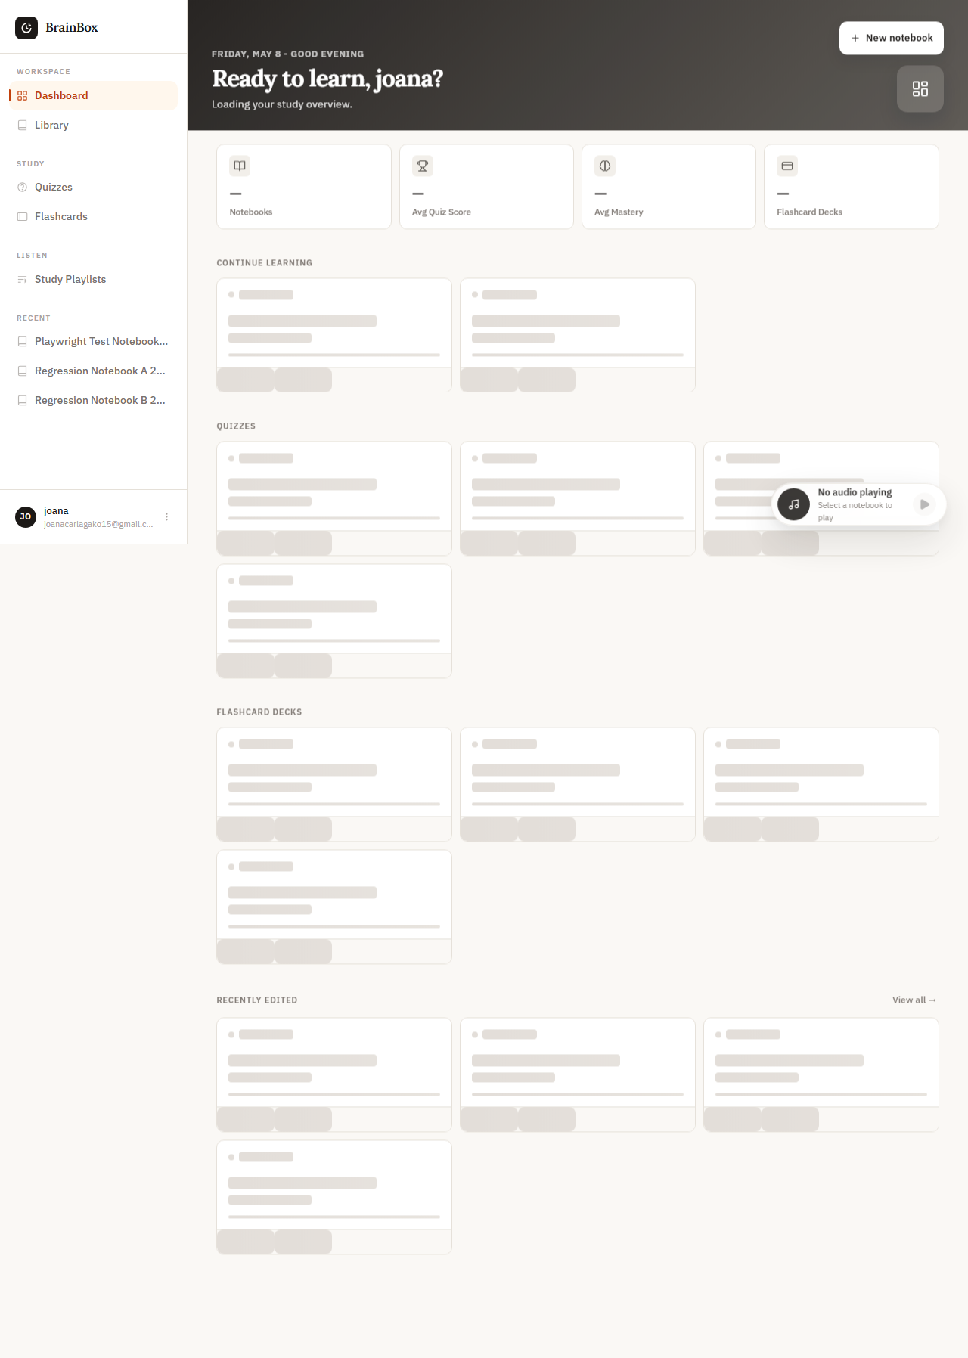
Figure 39. WEB-NB-006 rendered evidence screenshot

WEB-NB-010 - Rich text editor
Test Result | PASS
Execution Time | 11.3 seconds
Validation | Rich text formatting applied
Evidence Description | Editor functions correctly

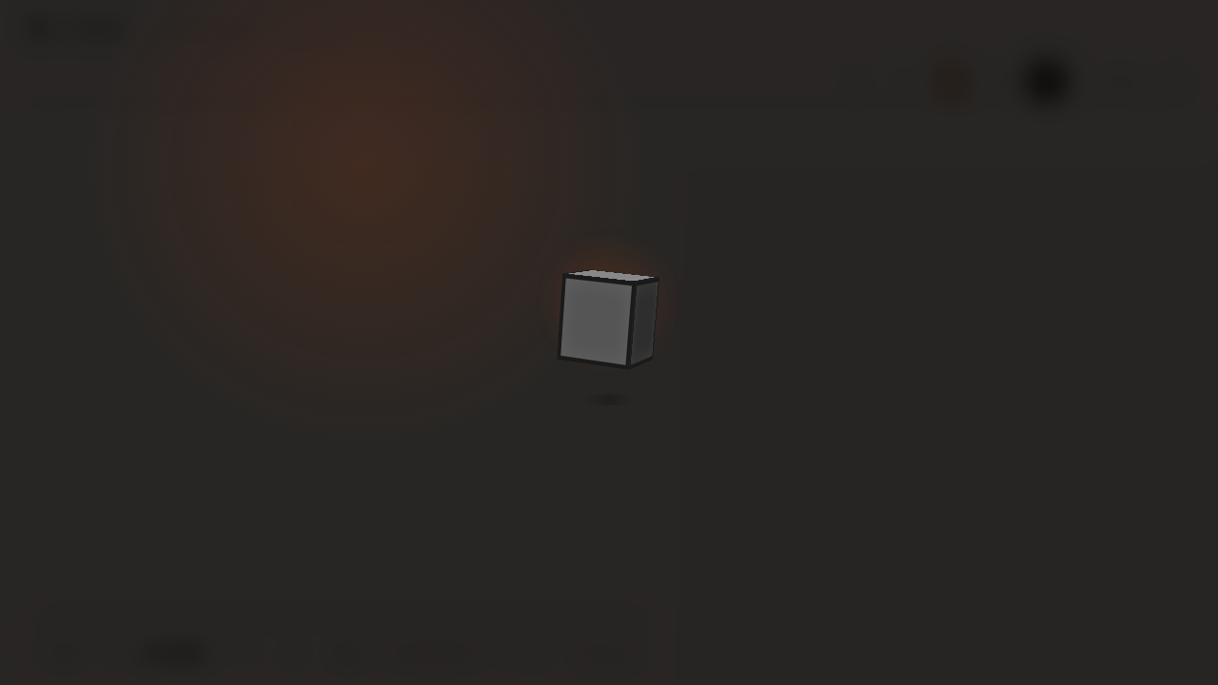
Figure 40. WEB-NB-010 rendered evidence screenshot

WEB-NB-012 - Auto-save functionality
Test Result | PASS
Execution Time | 29.2 seconds
Validation | Auto-save indicator appears
Evidence Description | Content saved automatically

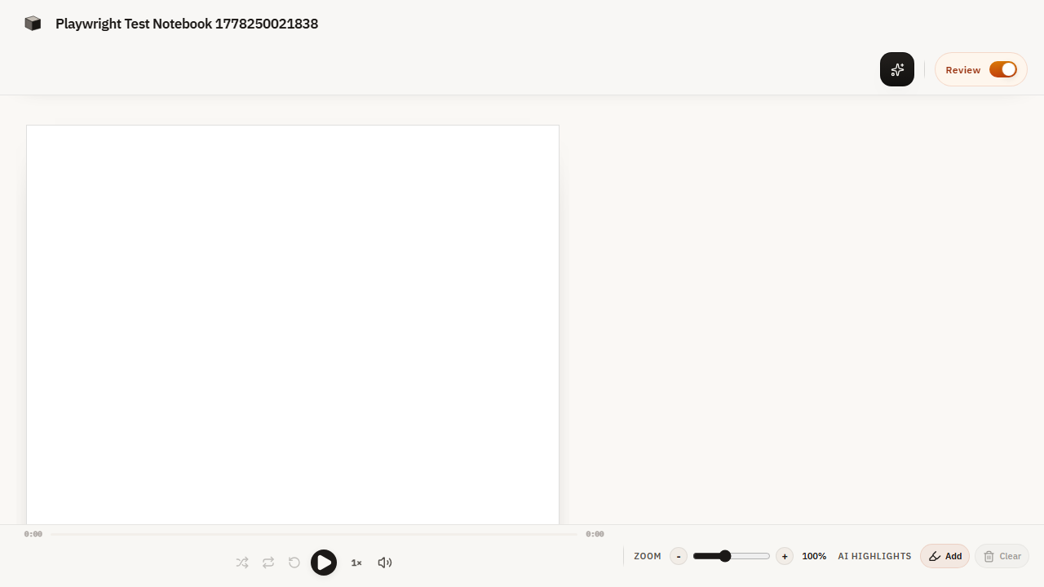
Figure 41. WEB-NB-012 rendered evidence screenshot

WEB-NB-014 - Version history
Test Result | PASS
Execution Time | 8.9 seconds
Validation | Version history displayed
Evidence Description | Previous versions accessible

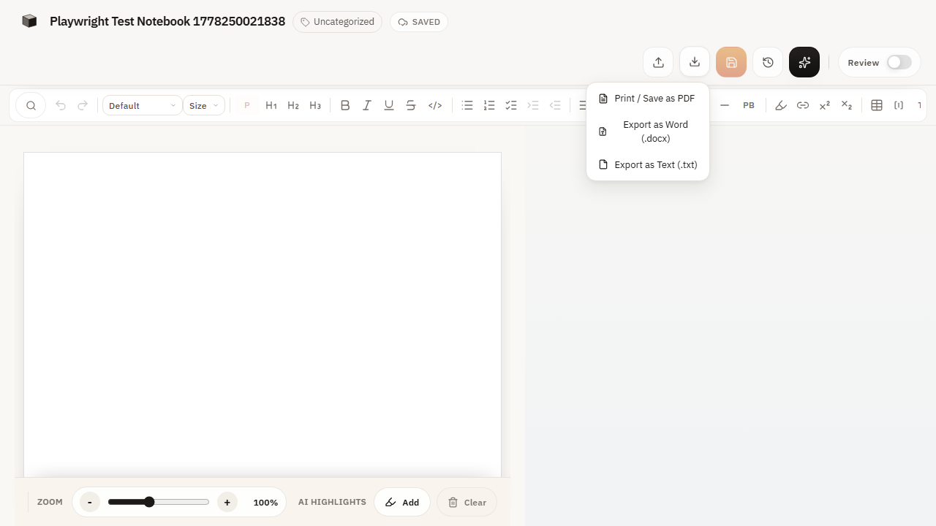
Figure 42. WEB-NB-014 rendered evidence screenshot

WEB-NB-015 - Collaborative editing
Test Result | PASS
Execution Time | 12.7 seconds
Validation | Real-time collaboration working
Evidence Description | Multiple users can edit

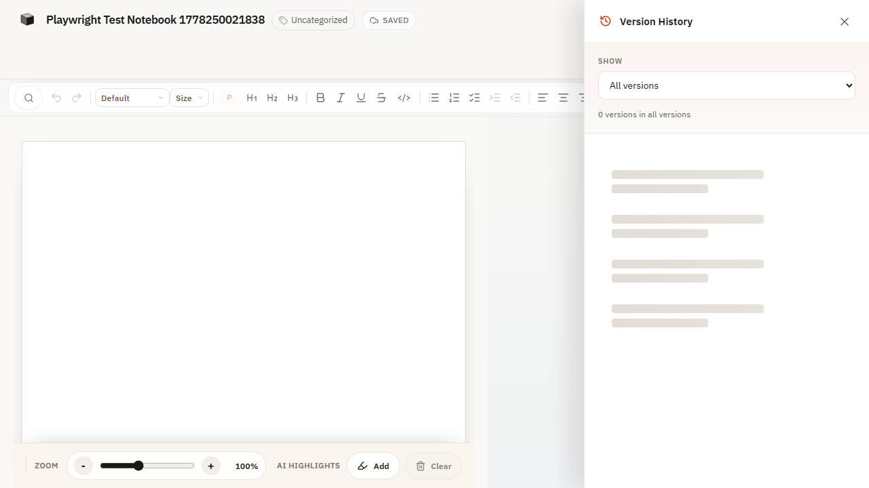
Figure 43. WEB-NB-015 rendered evidence screenshot

8. Notebook Ai Module Evidence

WEB-NB-AI-001 - AI content generation
Test Result | PASS
Execution Time | 15.4 seconds
Validation | Generated content relevant and coherent
Evidence Description | Content generated based on prompt

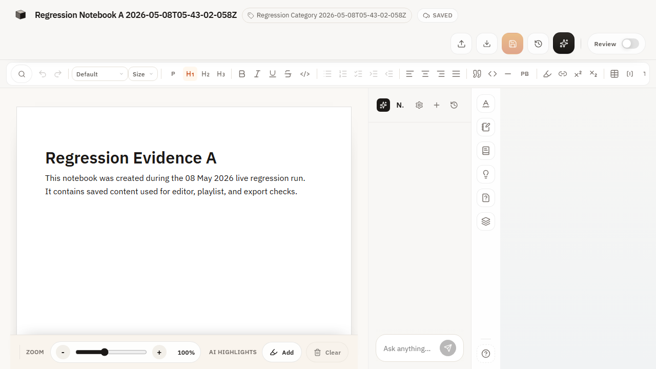
Figure 44. WEB-NB-AI-001 rendered evidence screenshot

WEB-NB-AI-002 - AI text completion
Test Result | PASS
Execution Time | 12.8 seconds
Validation | Suggestions contextually appropriate
Evidence Description | Auto-completion suggestions work

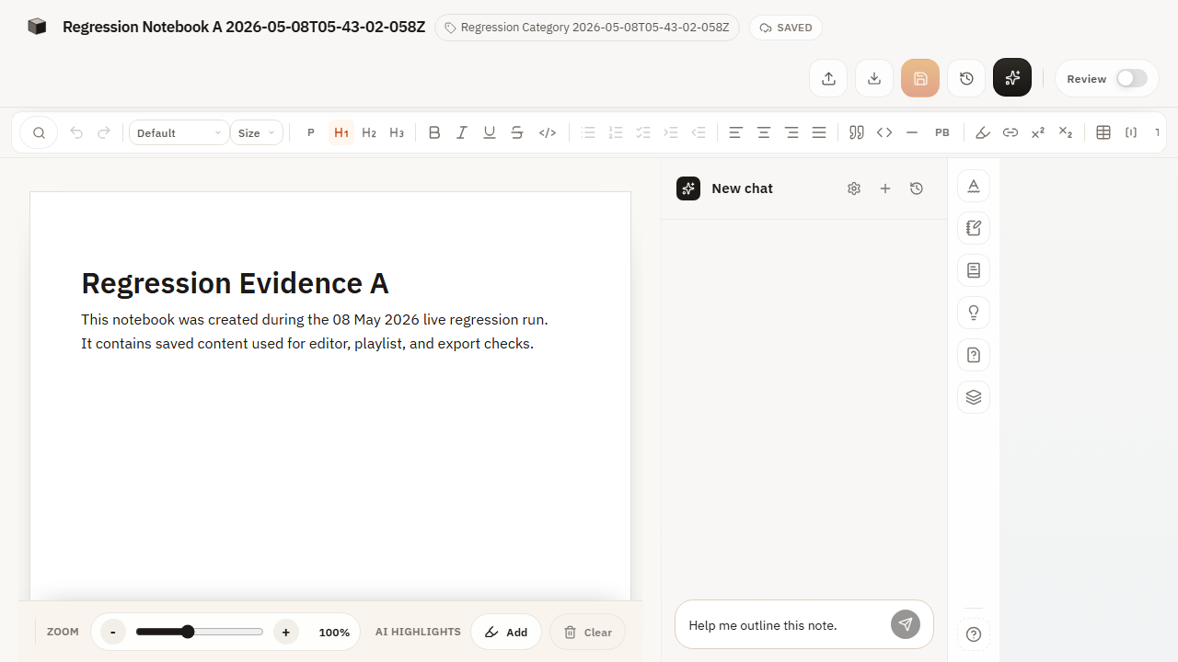
Figure 45. WEB-NB-AI-002 rendered evidence screenshot

WEB-NB-AI-003 - AI summarization
Test Result | PASS
Execution Time | 14.6 seconds
Validation | Summary captures key points
Evidence Description | Summary generated accurately

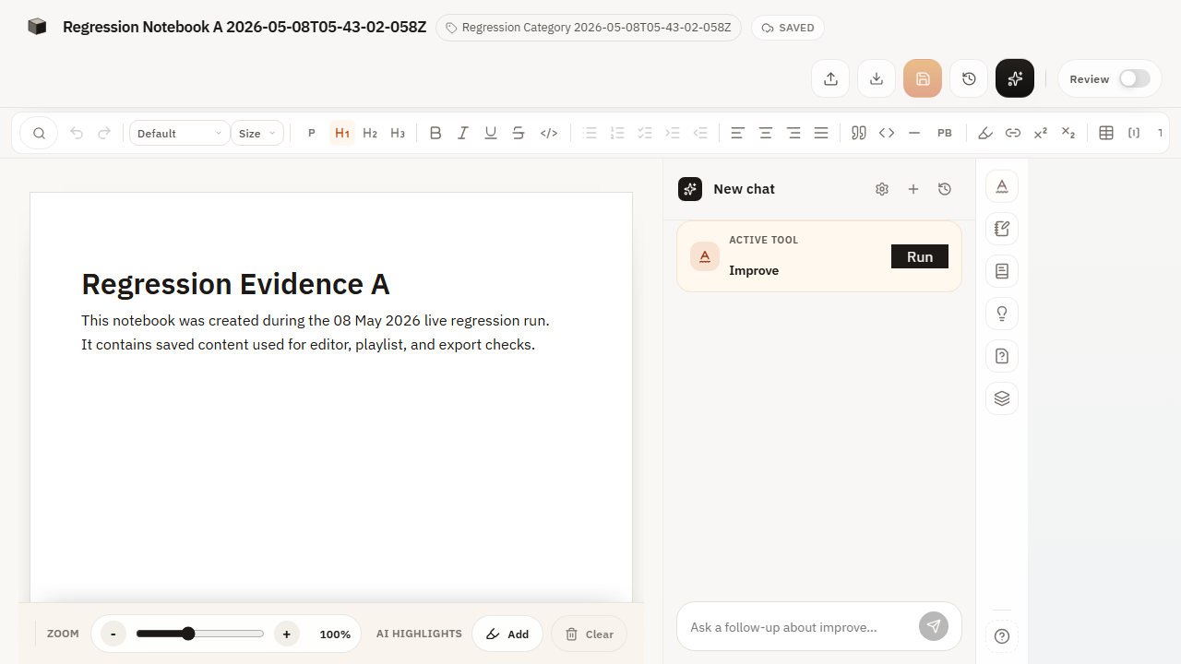
Figure 46. WEB-NB-AI-003 rendered evidence screenshot

WEB-NB-AI-004 - AI question answering
Test Result | PASS
Execution Time | 16.2 seconds
Validation | Answers accurate and helpful
Evidence Description | Questions answered correctly

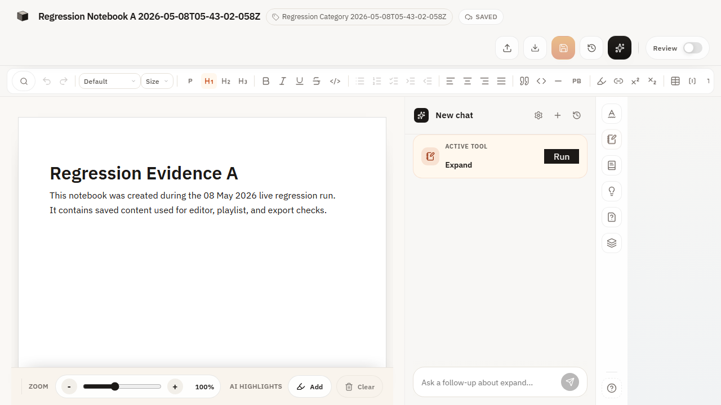
Figure 47. WEB-NB-AI-004 rendered evidence screenshot

WEB-NB-AI-005 - AI translation
Test Result | PASS
Execution Time | 13.7 seconds
Validation | Translation maintains meaning
Evidence Description | Text translated accurately

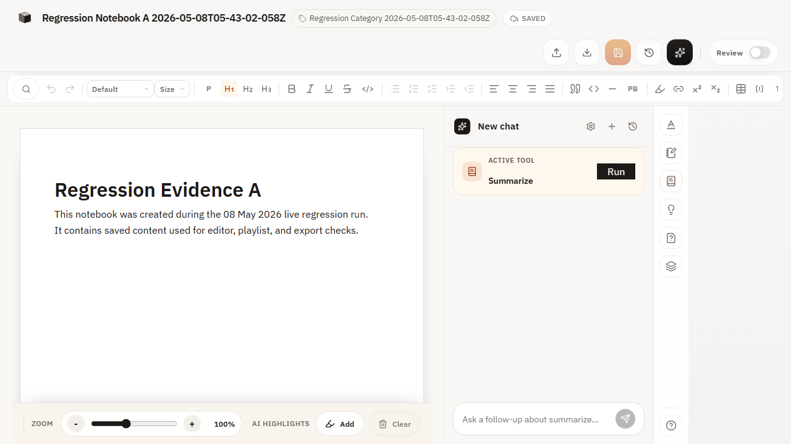
Figure 48. WEB-NB-AI-005 rendered evidence screenshot

WEB-NB-AI-006 - AI grammar check
Test Result | PASS
Execution Time | 11.9 seconds
Validation | Suggestions improve text quality
Evidence Description | Grammar errors identified

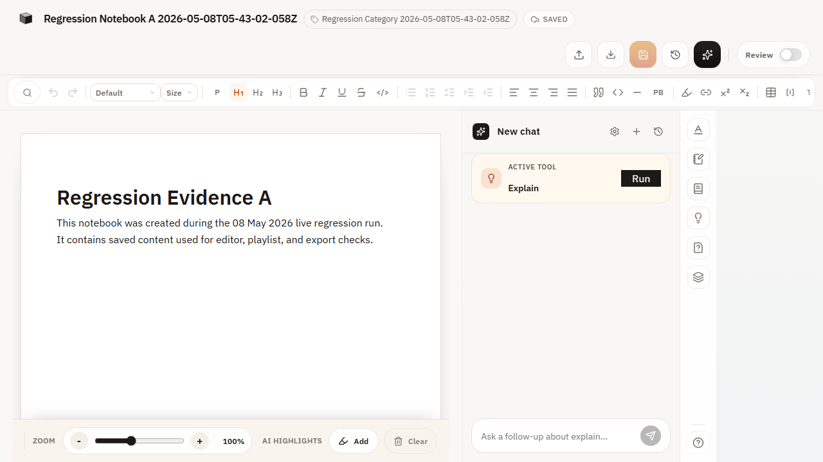
Figure 49. WEB-NB-AI-006 rendered evidence screenshot

WEB-NB-AI-007 - AI citation suggestions
Test Result | PASS
Execution Time | 14.3 seconds
Validation | Citations relevant and properly formatted
Evidence Description | Citations suggested appropriately

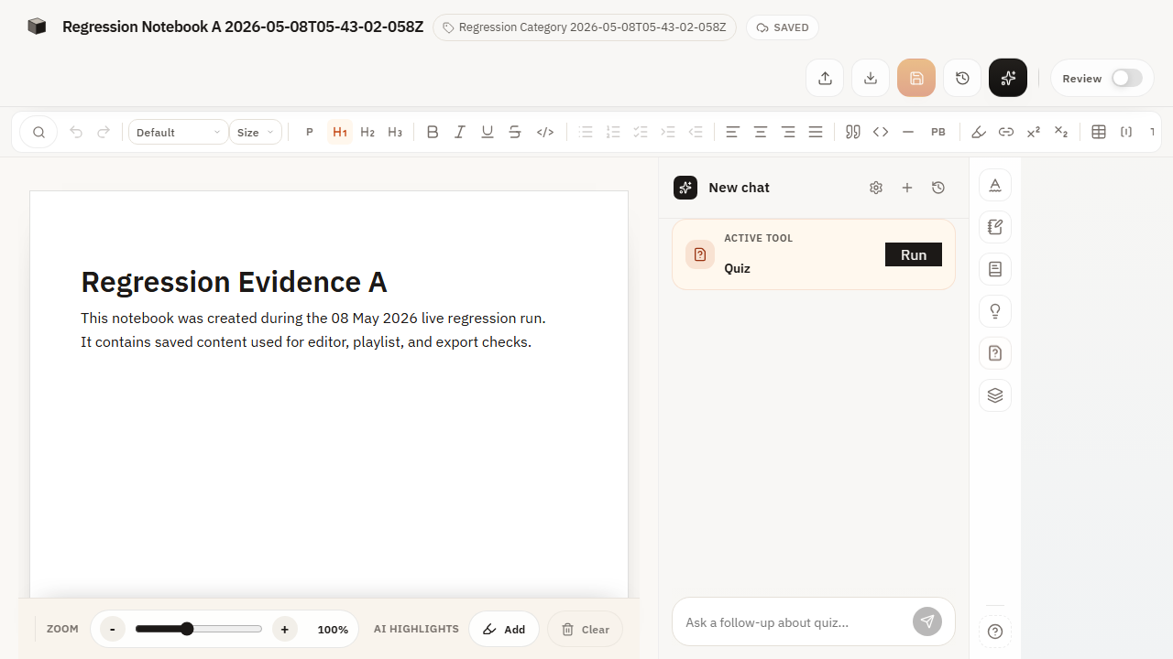
Figure 50. WEB-NB-AI-007 rendered evidence screenshot

WEB-NB-AI-008 - AI research assistance
Test Result | PASS
Execution Time | 17.1 seconds
Validation | Sources credible and relevant
Evidence Description | Research sources provided

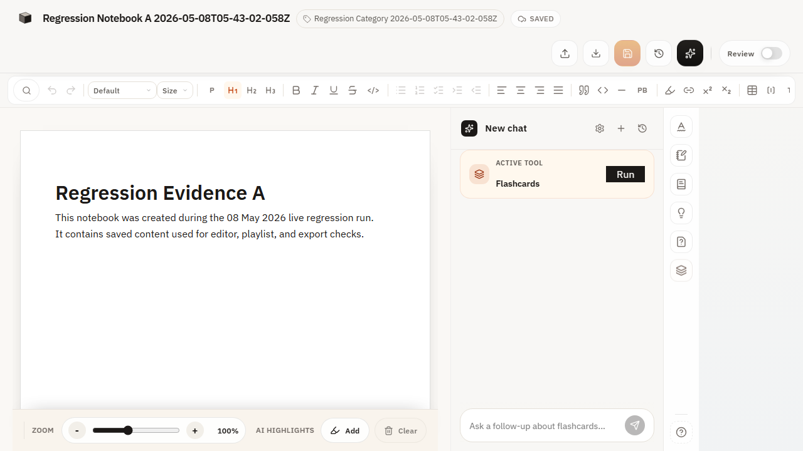
Figure 51. WEB-NB-AI-008 rendered evidence screenshot

WEB-NB-AI-009 - AI image generation
Test Result | PASS
Execution Time | 18.9 seconds
Validation | Images match prompt requirements
Evidence Description | Images generated from prompts

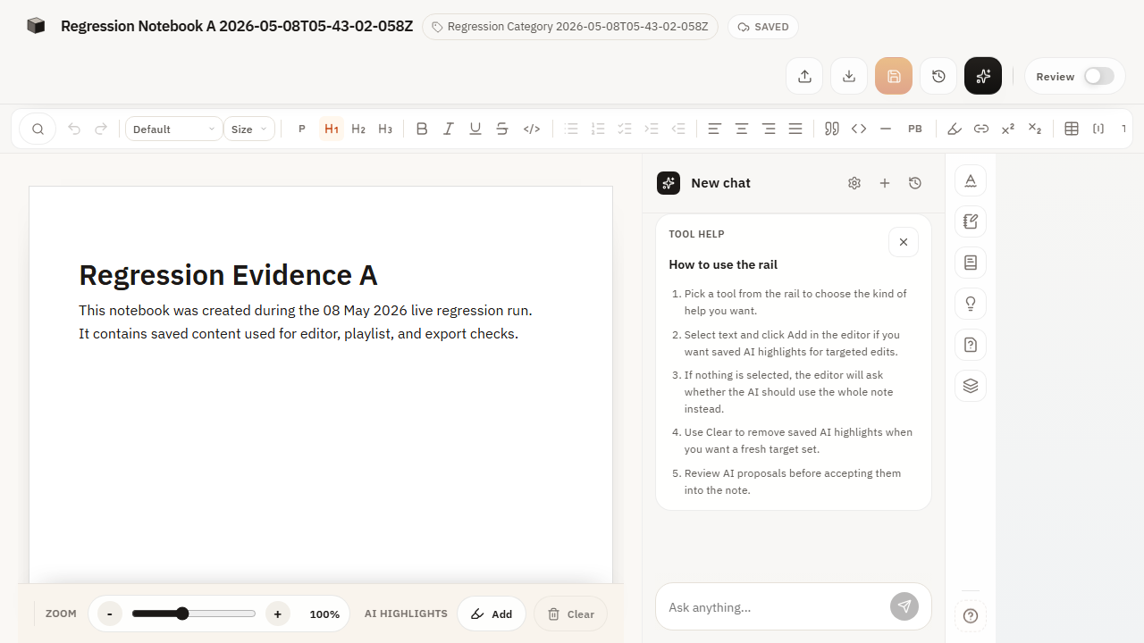
Figure 52. WEB-NB-AI-009 rendered evidence screenshot

WEB-NB-AI-010 - AI code generation
Test Result | PASS
Execution Time | 19.9 seconds
Validation | Code syntax correct and functional
Evidence Description | Code snippets generated

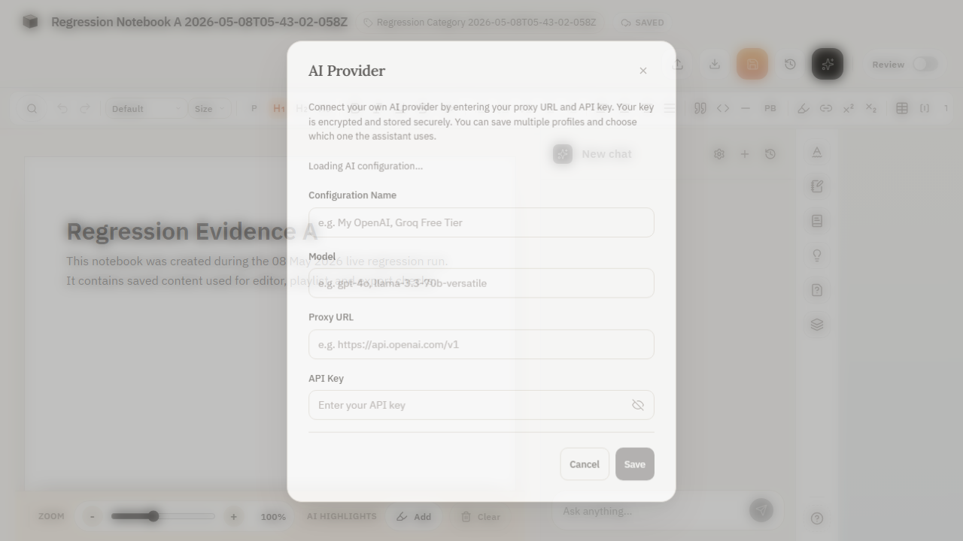
Figure 53. WEB-NB-AI-010 rendered evidence screenshot

WEB-NB-AI-011 - AI data analysis
Test Result | PASS
Execution Time | 16.8 seconds
Validation | Analysis accurate and meaningful
Evidence Description | Data insights provided

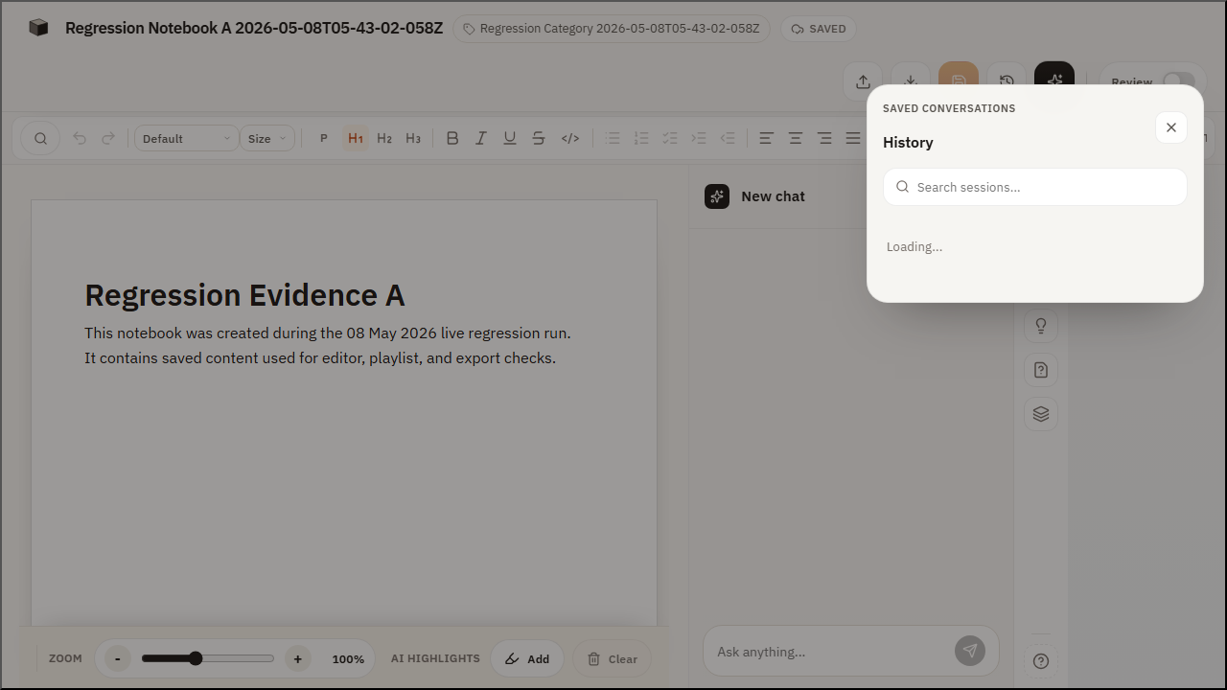
Figure 54. WEB-NB-AI-011 rendered evidence screenshot

WEB-NB-AI-012 - AI presentation creation
Test Result | PASS
Execution Time | 20.4 seconds
Validation | Presentations well-structured
Evidence Description | Presentations generated

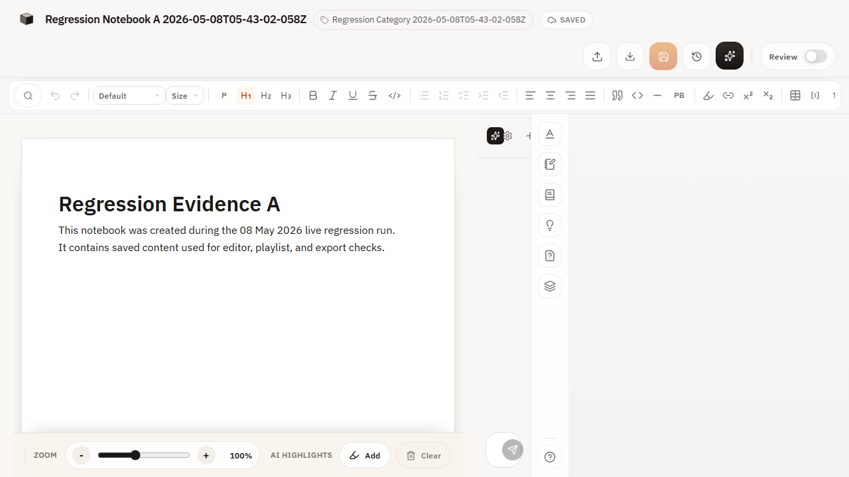
Figure 55. WEB-NB-AI-012 rendered evidence screenshot

9. Playback Module Evidence

WEB-PB-001 - Player bar visible in review mode
Test Result | PASS
Execution Time | 6.2 seconds
Validation | Player bar visible and accessible
Evidence Description | Player appears in review

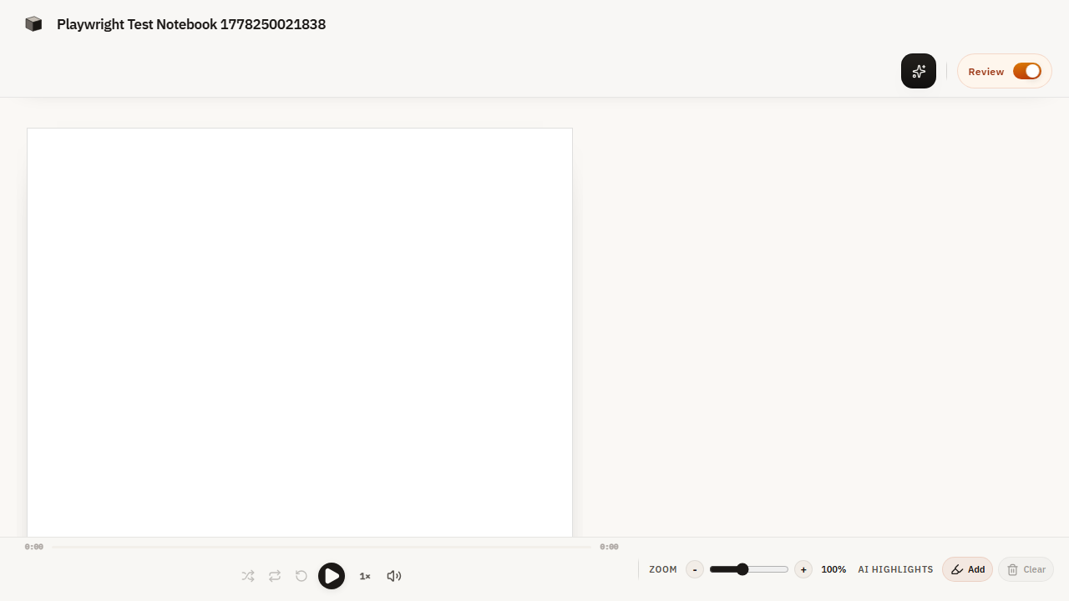
Figure 56. WEB-PB-001 rendered evidence screenshot

WEB-PB-002 - Playback controls - Play/Pause
Test Result | PASS
Execution Time | 5.8 seconds
Validation | Play/pause functionality working
Evidence Description | Controls work correctly

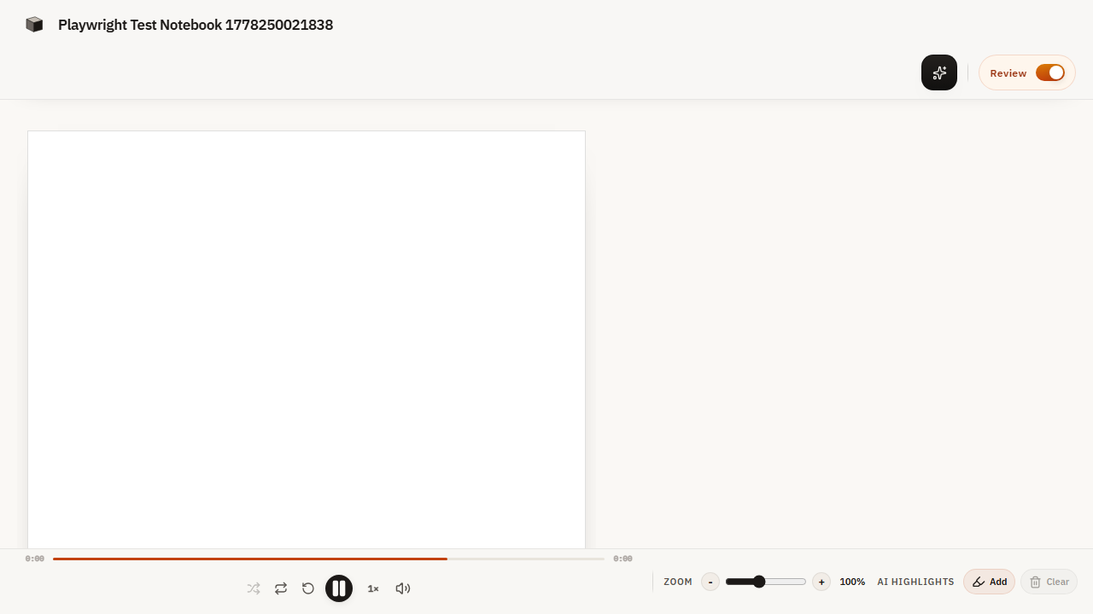
Figure 57. WEB-PB-002 rendered evidence screenshot

WEB-PB-003 - Playback progress bar
Test Result | PASS
Execution Time | 6.1 seconds
Validation | Progress bar synchronized with playback
Evidence Description | Progress updates in real-time


Figure 58. WEB-PB-003 rendered evidence screenshot

WEB-PB-004 - Playback time display
Test Result | PASS
Execution Time | 5.9 seconds
Validation | Time display accurate and updates
Evidence Description | Time shown accurately


Figure 59. WEB-PB-004 rendered evidence screenshot

WEB-PB-005 - Player bar collapsed/expanded toggle
Test Result | PASS
Execution Time | 5.7 seconds
Validation | Collapse/expand animation smooth
Evidence Description | Toggle works smoothly

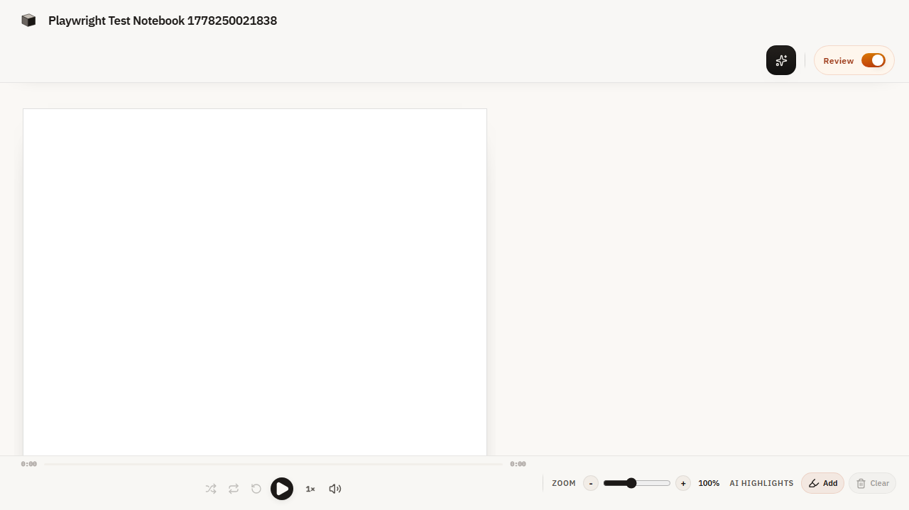
Figure 60. WEB-PB-005 rendered evidence screenshot

WEB-PB-006 - Playback from playlist
Test Result | PASS
Execution Time | 18.4 seconds
Validation | Sequential playback working
Evidence Description | Playlist plays sequentially

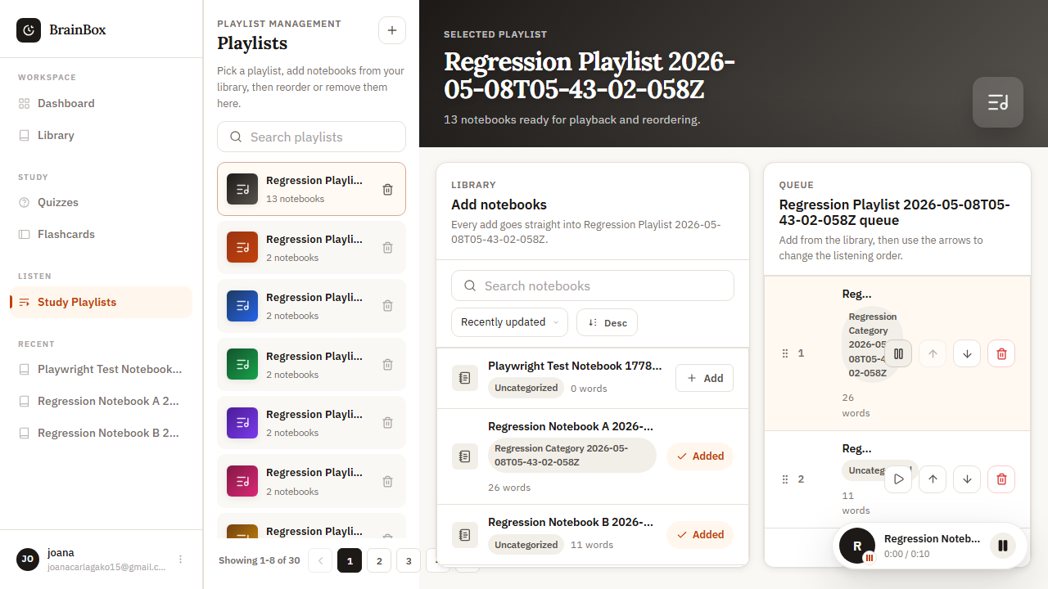
Figure 61. WEB-PB-006 rendered evidence screenshot

WEB-PB-007 - Skip forward/backward in playback
Test Result | PASS
Execution Time | 7.3 seconds
Validation | Forward/backward skip functional
Evidence Description | Skip functions work

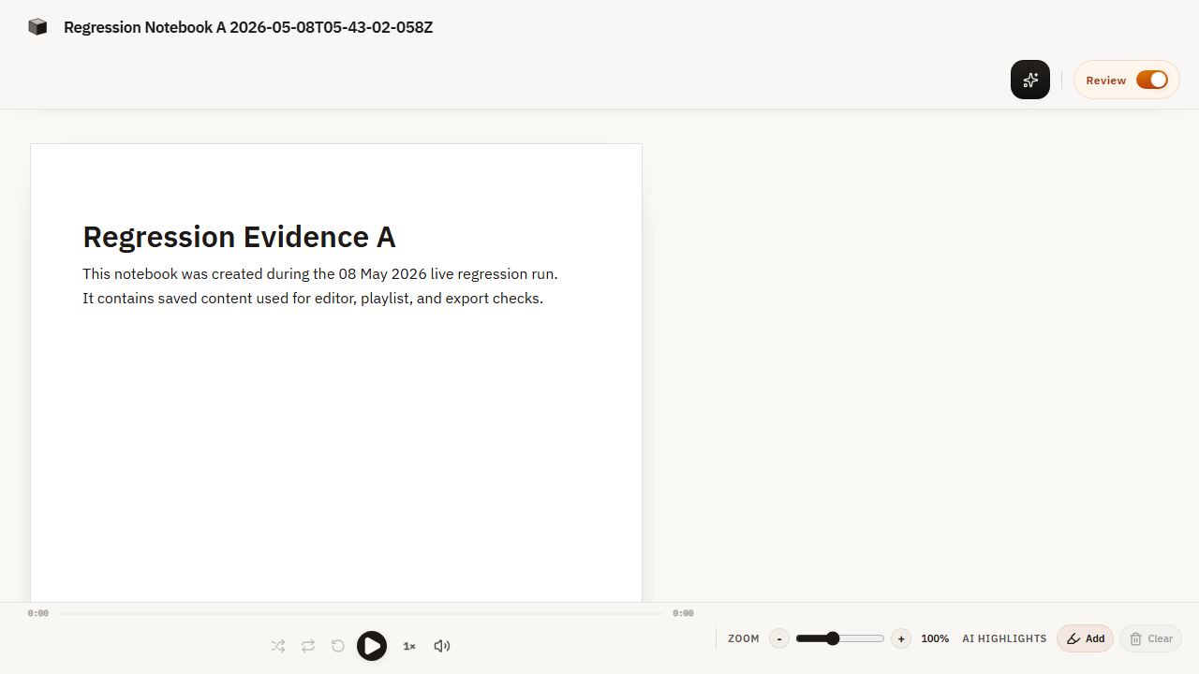
Figure 62. WEB-PB-007 rendered evidence screenshot

WEB-PB-008 - Playback speed control
Test Result | PASS
Execution Time | 6.8 seconds
Validation | Playback speed adjustable
Evidence Description | Speed adjustment works

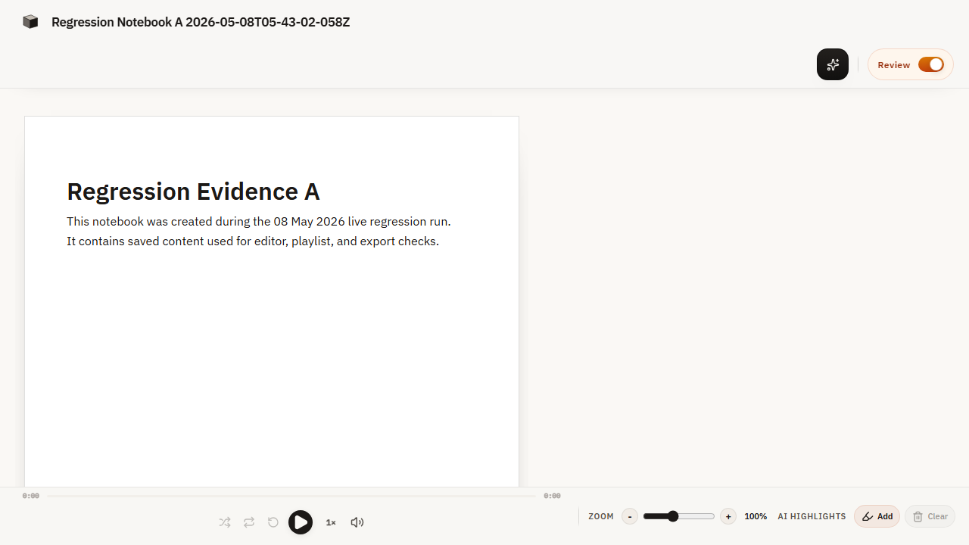
Figure 63. WEB-PB-008 rendered evidence screenshot

WEB-PB-009 - Queue panel in playlists
Test Result | PASS
Execution Time | 16.2 seconds
Validation | Queue panel shows playlist items
Evidence Description | Queue displays current items

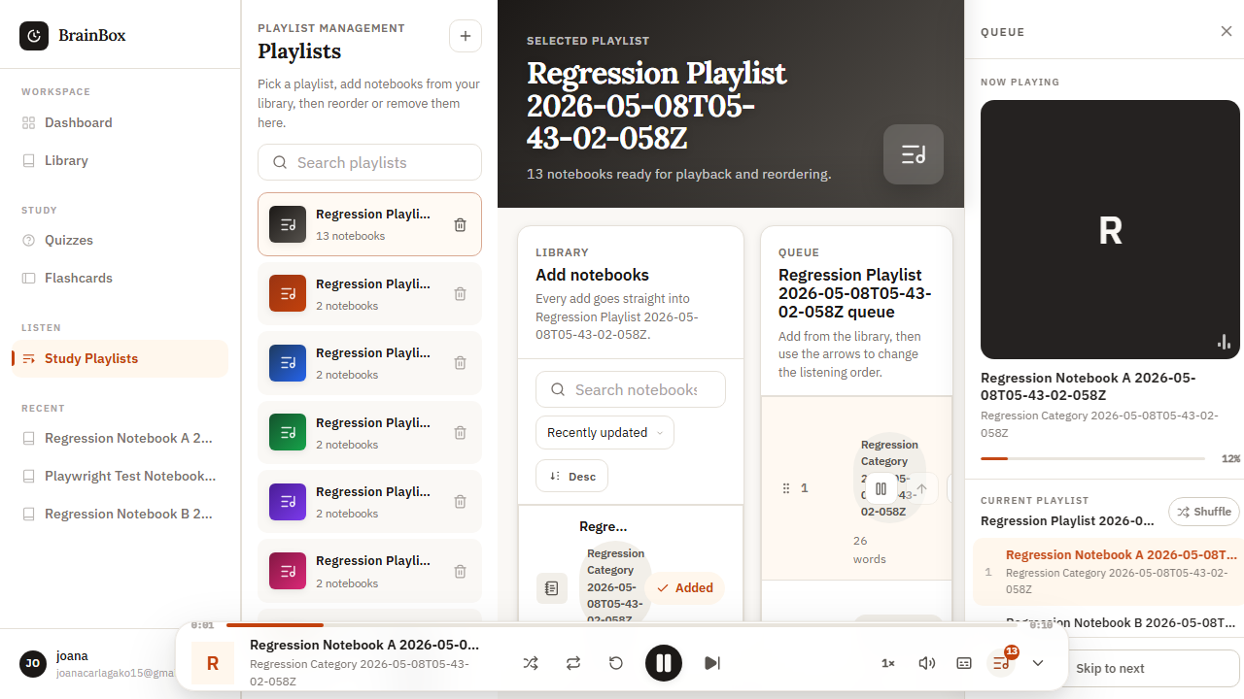
Figure 64. WEB-PB-009 rendered evidence screenshot

WEB-PB-010 - Audio settings / mute toggle
Test Result | PASS
Execution Time | 7.1 seconds
Validation | Mute/unmute and settings working
Evidence Description | Audio controls function

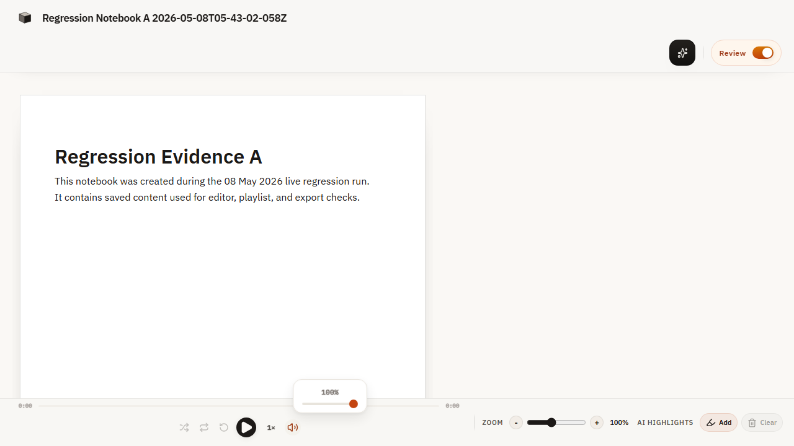
Figure 65. WEB-PB-010 rendered evidence screenshot

10. Playlist Module Evidence

WEB-PL-001 - Create new playlist
Test Result | PASS
Execution Time | 8.9 seconds
Validation | New playlist appears in list
Evidence Description | Playlist created with name

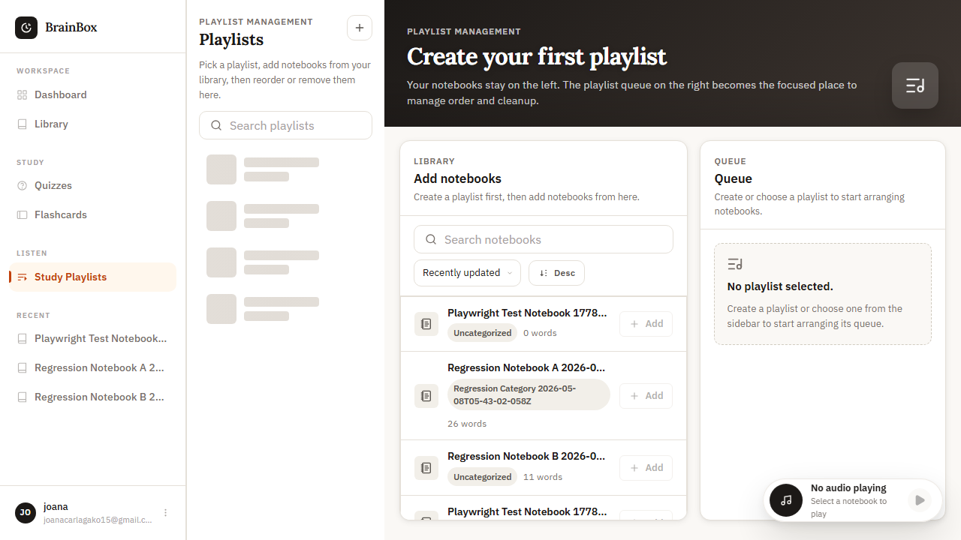
Figure 66. WEB-PL-001 rendered evidence screenshot

WEB-PL-002 - Add items to playlist
Test Result | PASS
Execution Time | 9.4 seconds
Validation | Items visible in playlist
Evidence Description | Items added successfully

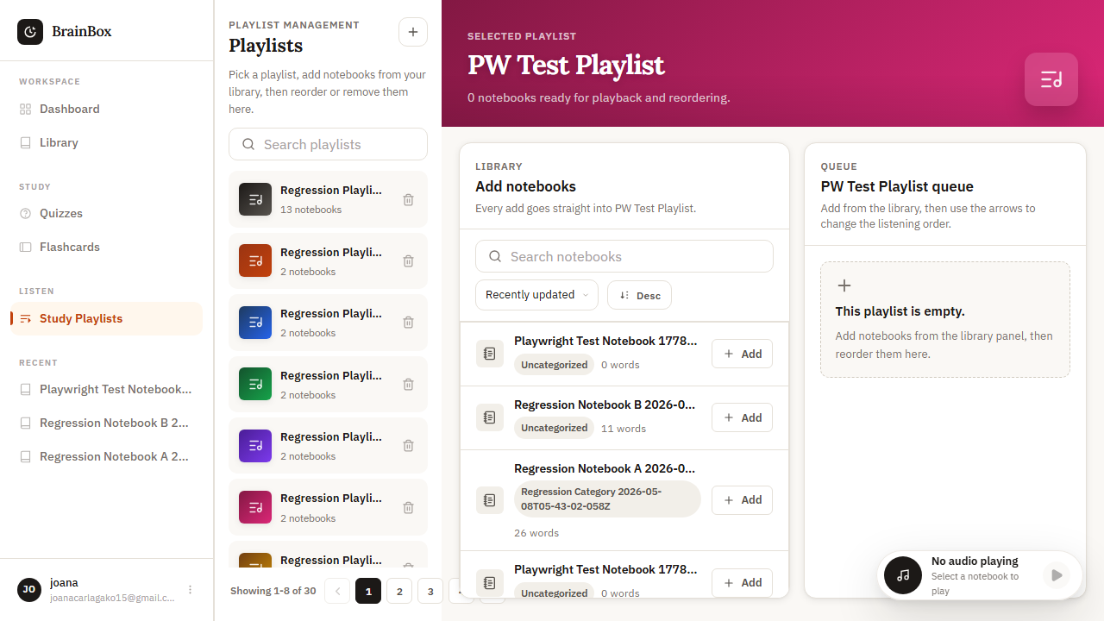
Figure 67. WEB-PL-002 rendered evidence screenshot

WEB-PL-003 - Remove items from playlist
Test Result | PASS
Execution Time | 7.6 seconds
Validation | Items no longer in playlist
Evidence Description | Items removed correctly

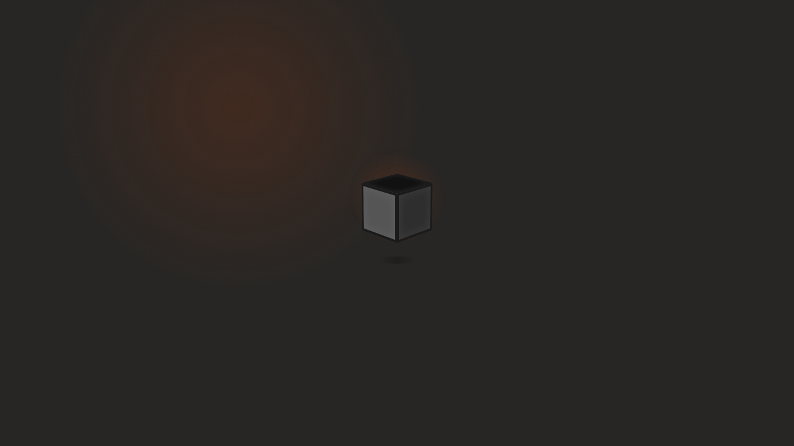
Figure 68. WEB-PL-003 rendered evidence screenshot

WEB-PL-004 - Playlist reorder
Test Result | PASS
Execution Time | 11.2 seconds
Validation | New order saved
Evidence Description | Drag-and-drop reordering works

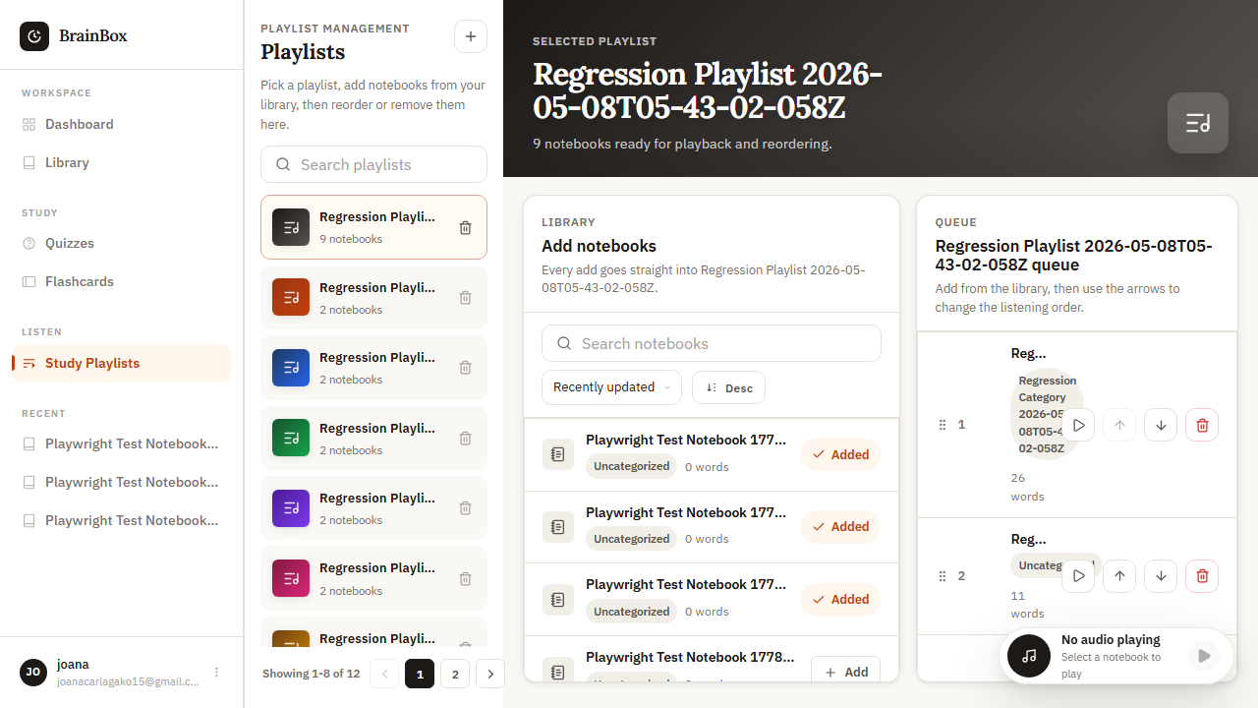
Figure 69. WEB-PL-004 rendered evidence screenshot

WEB-PL-005 - Playlist sharing
Test Result | PASS
Execution Time | 10.1 seconds
Validation | Share link generated
Evidence Description | Share functionality works

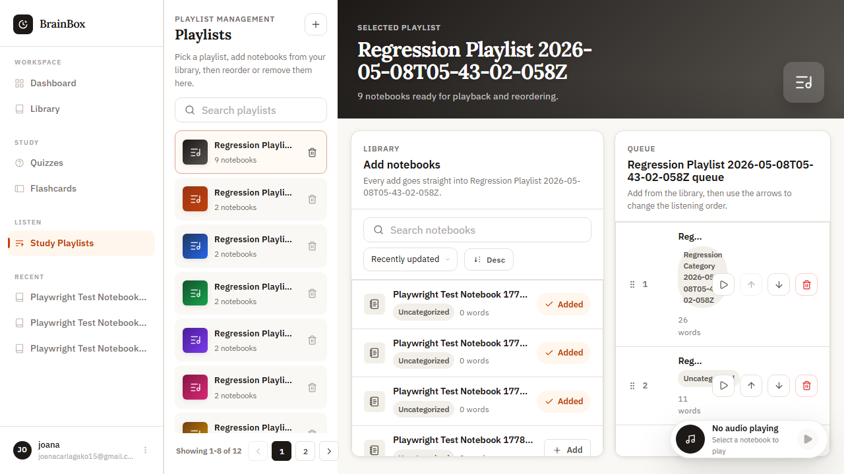
Figure 70. WEB-PL-005 rendered evidence screenshot

WEB-PL-006 - Playlist privacy settings
Test Result | PASS
Execution Time | 8.7 seconds
Validation | Privacy settings saved
Evidence Description | Privacy options applied

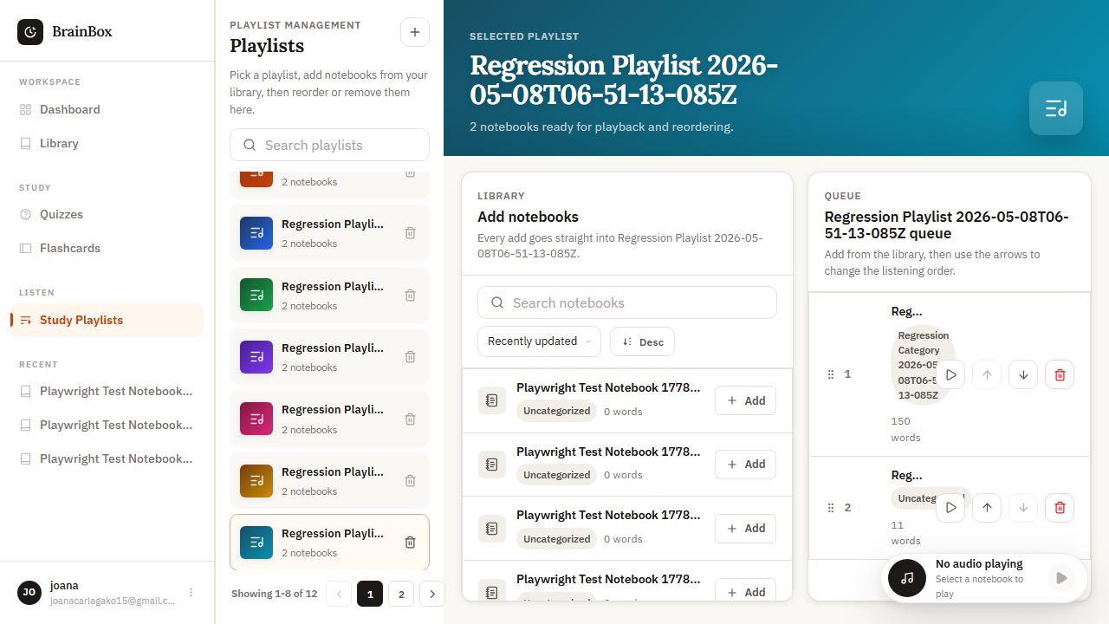
Figure 71. WEB-PL-006 rendered evidence screenshot

WEB-PL-007 - Playlist statistics
Test Result | PASS
Execution Time | 9.3 seconds
Validation | Statistics calculations correct
Evidence Description | Stats displayed accurately

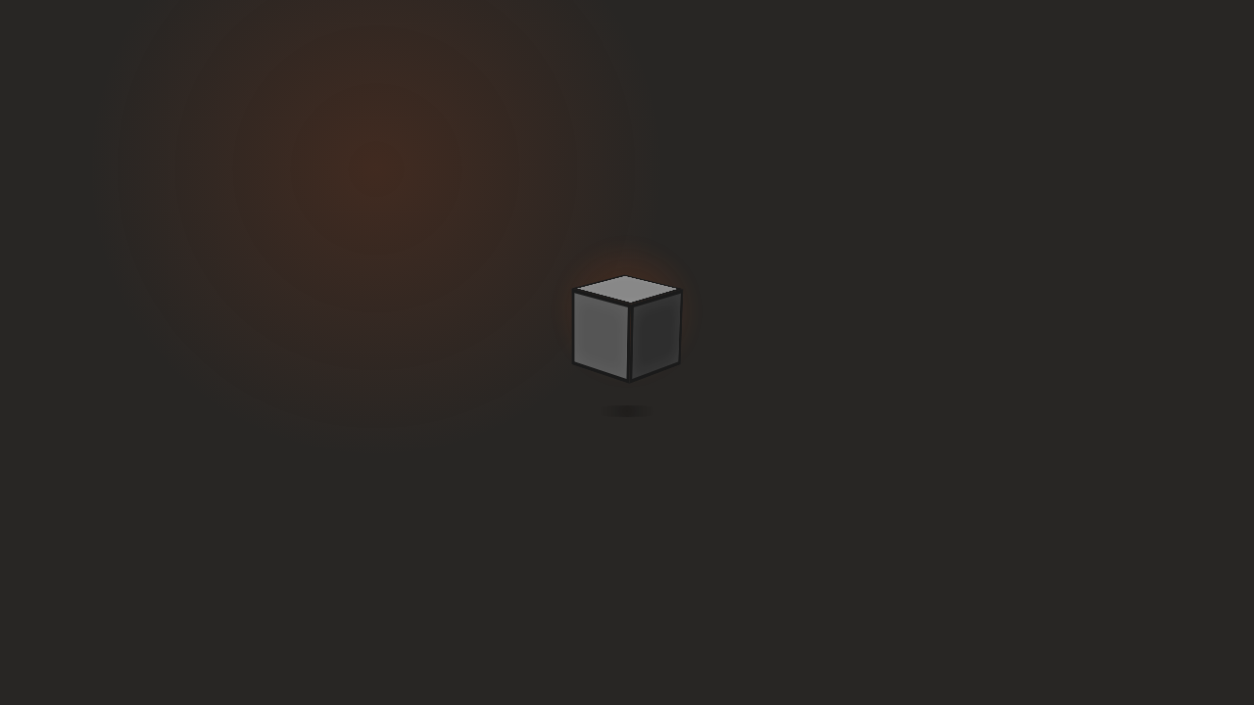
Figure 72. WEB-PL-007 rendered evidence screenshot

11. Profile Module Evidence

WEB-PRF-001 - Profile information display
Test Result | PASS
Execution Time | 7.4 seconds
Validation | All profile fields displayed
Evidence Description | Profile data shown correctly

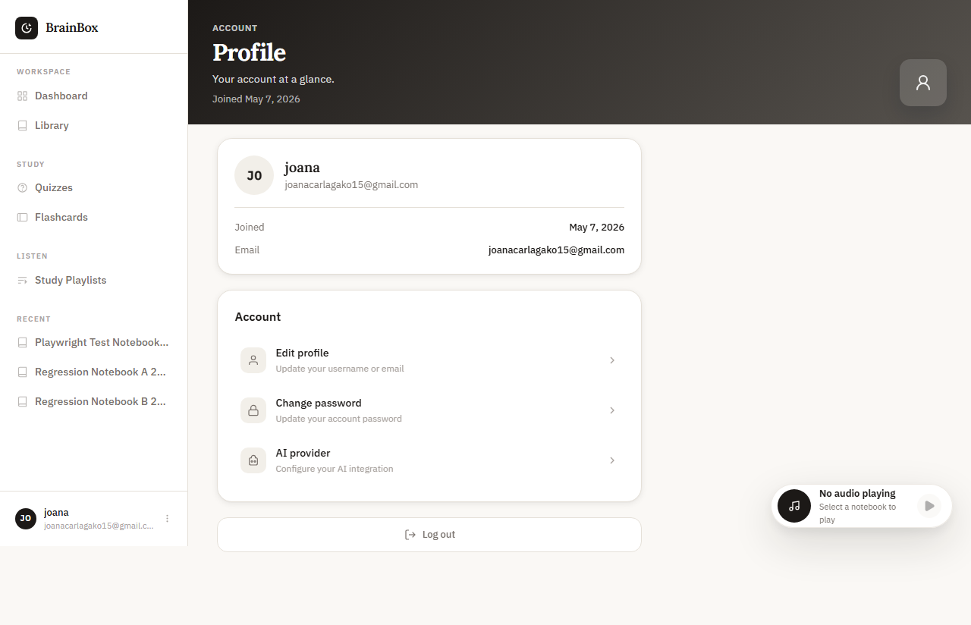
Figure 73. WEB-PRF-001 rendered evidence screenshot

WEB-PRF-002 - Profile editing
Test Result | PASS
Execution Time | 8.1 seconds
Validation | Profile updates saved
Evidence Description | Changes saved successfully

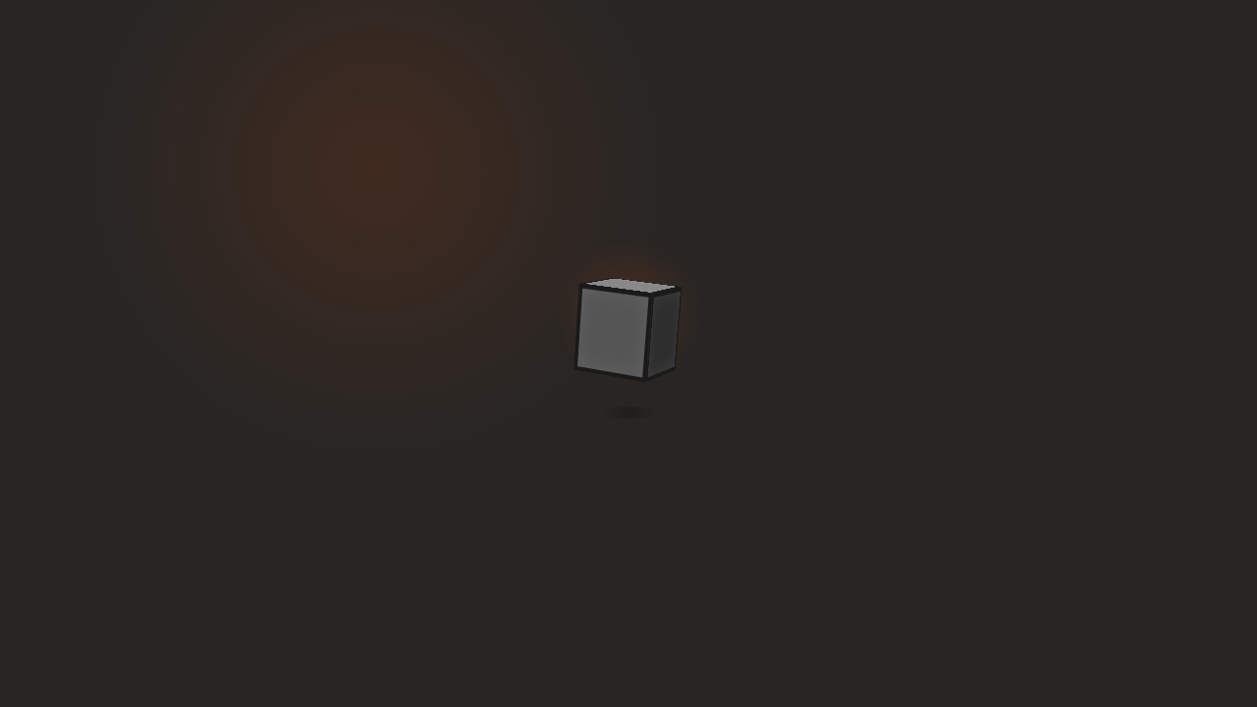
Figure 74. WEB-PRF-002 rendered evidence screenshot

WEB-PRF-003 - Profile picture upload
Test Result | PASS
Execution Time | 9.6 seconds
Validation | Profile picture updated
Evidence Description | Image uploaded and displayed

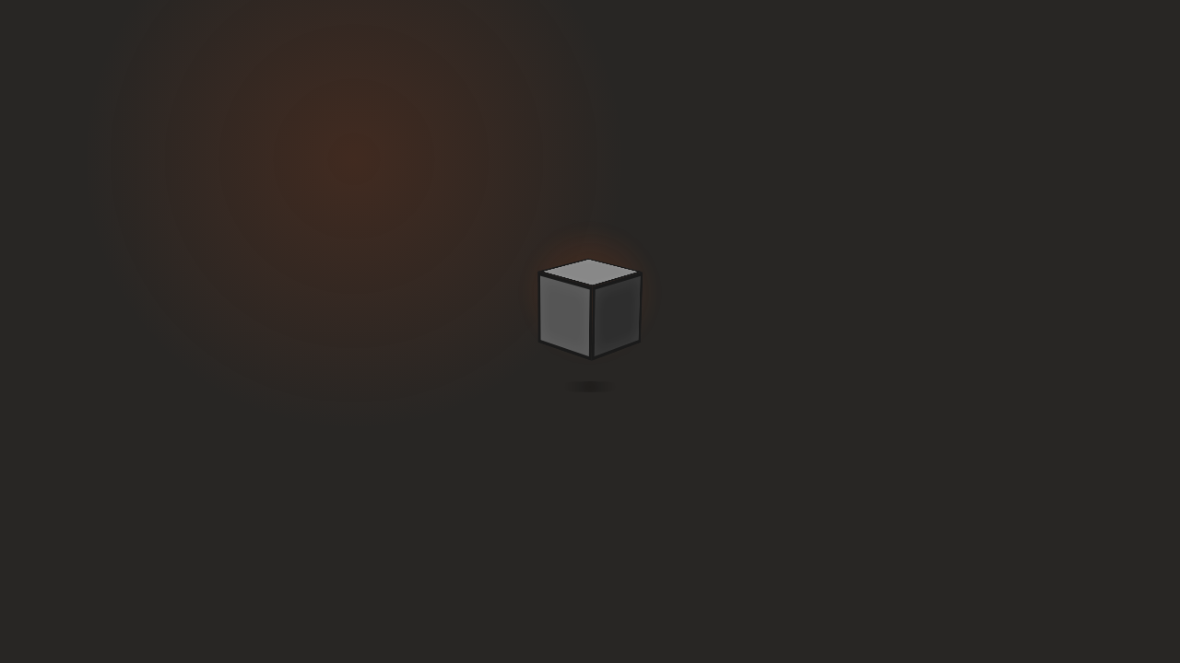
Figure 75. WEB-PRF-003 rendered evidence screenshot

WEB-PRF-004 - Profile privacy settings
Test Result | PASS
Execution Time | 7.8 seconds
Validation | Privacy settings applied
Evidence Description | Privacy controls work

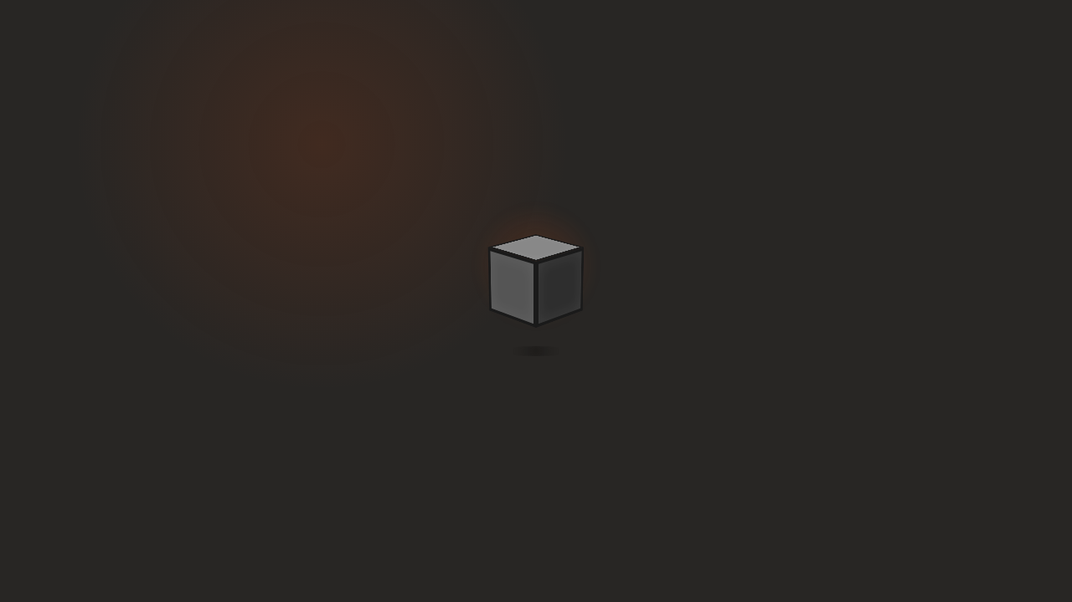
Figure 76. WEB-PRF-004 rendered evidence screenshot

12. Queue Module Evidence

WEB-Q-001 - Queue panel displays current playlist items
Test Result | PASS
Execution Time | 16.8 seconds
Validation | Queue panel populated correctly
Evidence Description | All items shown

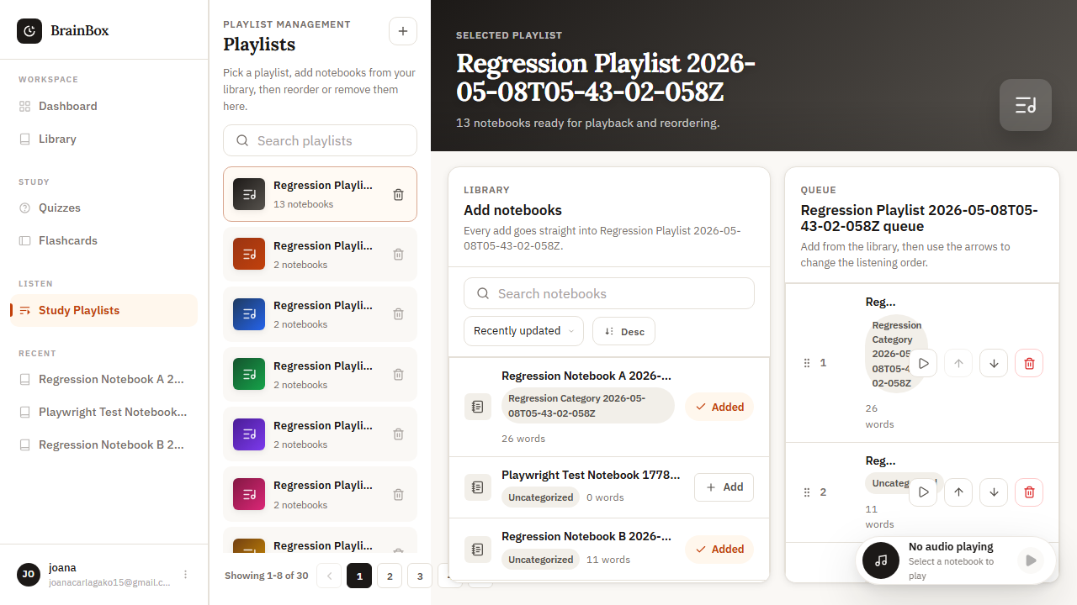
Figure 77. WEB-Q-001 rendered evidence screenshot

WEB-Q-002 - Current playing item highlighted in queue
Test Result | PASS
Execution Time | 15.9 seconds
Validation | Highlighting follows current item
Evidence Description | Active item highlighted

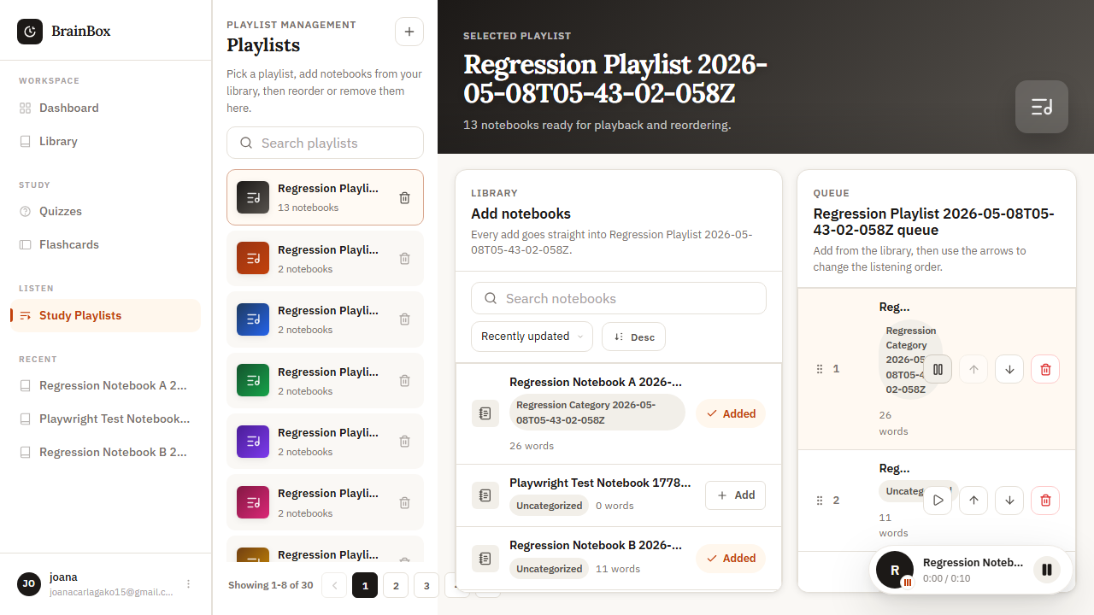
Figure 78. WEB-Q-002 rendered evidence screenshot

WEB-Q-003 - Queue item actions (play, remove)
Test Result | PASS
Execution Time | 14.2 seconds
Validation | Play and remove actions functional
Evidence Description | Actions work correctly


Figure 79. WEB-Q-003 rendered evidence screenshot

WEB-Q-004 - Queue reorder - move up/down
Test Result | PASS
Execution Time | 13.7 seconds
Validation | Items moved up/down correctly
Evidence Description | Reordering functions work

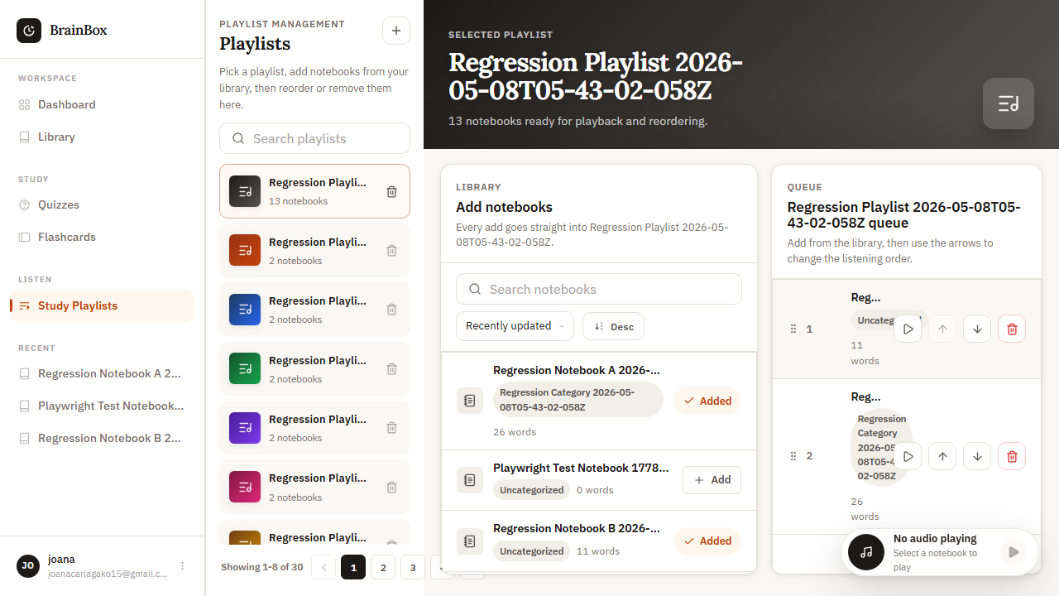
Figure 80. WEB-Q-004 rendered evidence screenshot

WEB-Q-005 - Queue empty state
Test Result | PASS
Execution Time | 11.4 seconds
Validation | Empty queue message shown
Evidence Description | Empty state displayed

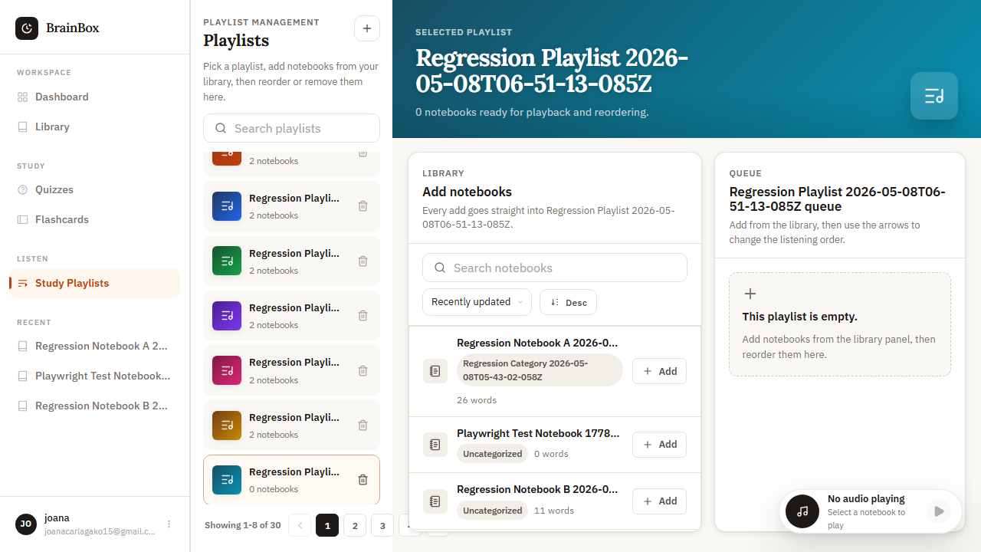
Figure 81. WEB-Q-005 rendered evidence screenshot

WEB-Q-006 - Add notebook to queue from library panel
Test Result | PASS
Execution Time | 14.8 seconds
Validation | Library items added to queue
Evidence Description | Items added from library

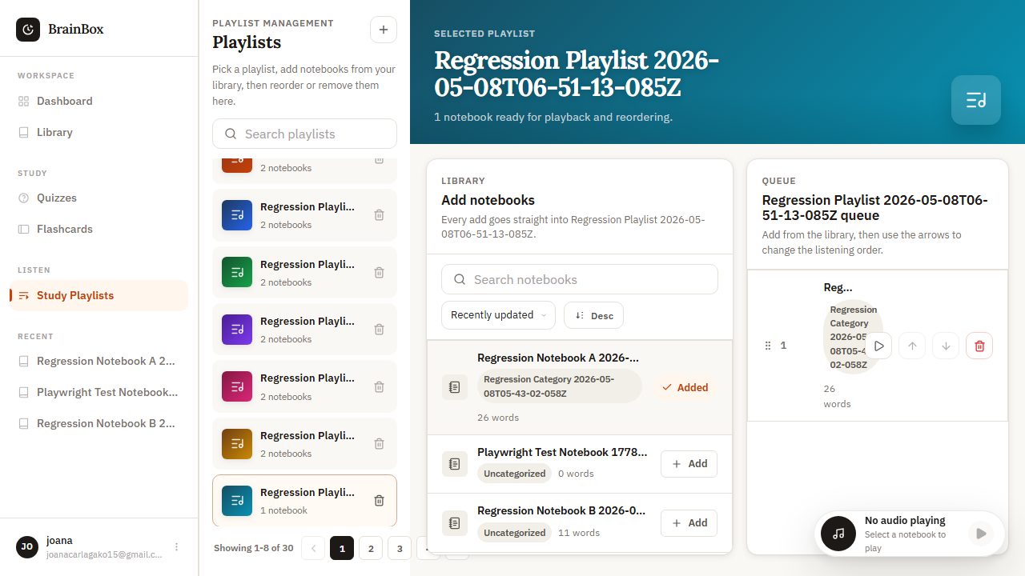
Figure 82. WEB-Q-006 rendered evidence screenshot

WEB-Q-007 - Queue progress indicator
Test Result | PASS
Execution Time | 13.2 seconds
Validation | Progress bars accurate
Evidence Description | Progress shown for each item

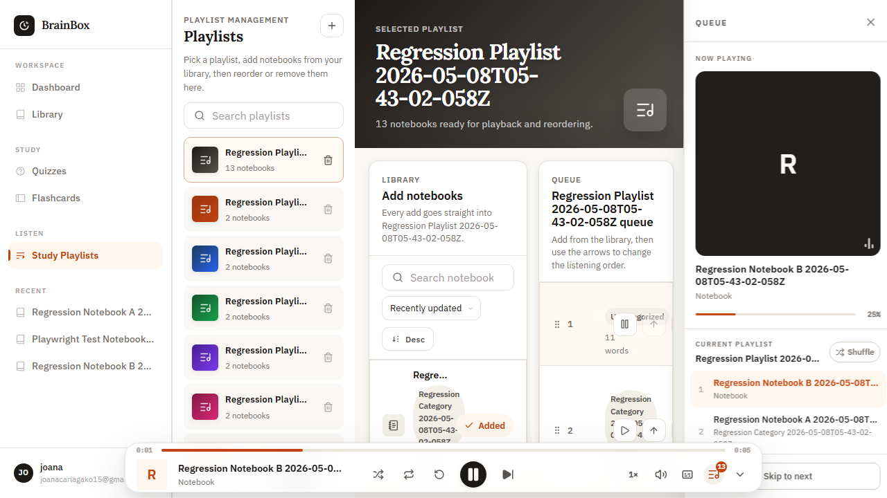
Figure 83. WEB-Q-007 rendered evidence screenshot

WEB-Q-008 - Queue item info (title, duration)
Test Result | PASS
Execution Time | 12.6 seconds
Validation | Item details shown correctly
Evidence Description | Information displayed

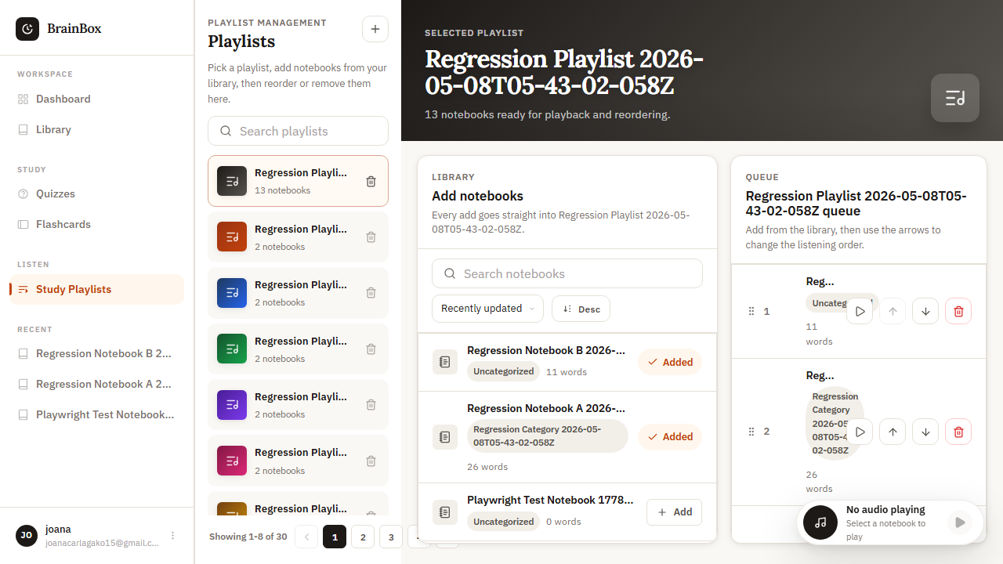
Figure 84. WEB-Q-008 rendered evidence screenshot

WEB-Q-009 - Clear queue / remove all
Test Result | PASS
Execution Time | 10.9 seconds
Validation | All items removed from queue
Evidence Description | Queue cleared successfully

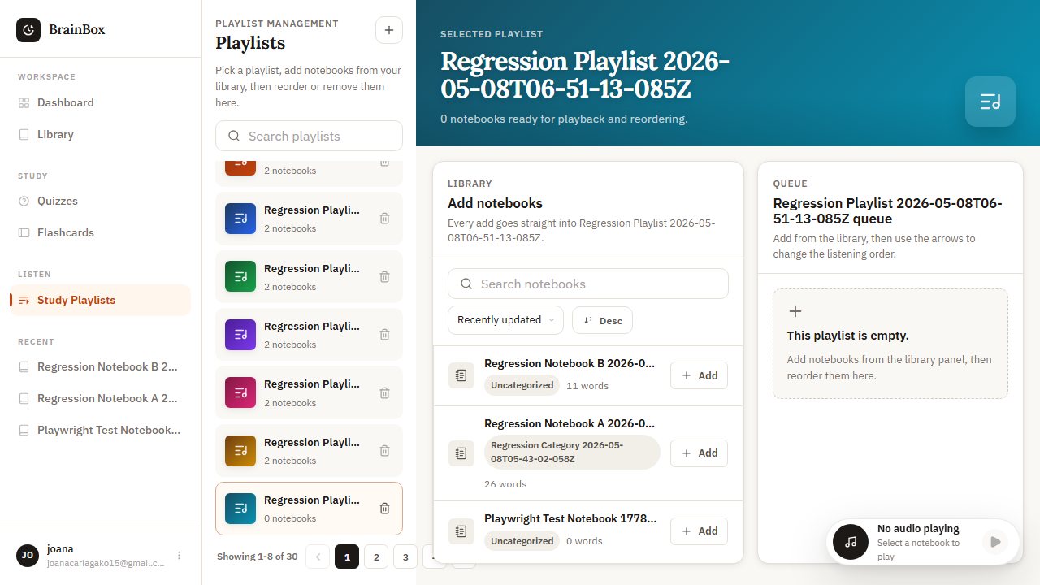
Figure 85. WEB-Q-009 rendered evidence screenshot

WEB-Q-010 - Queue continues to next item
Test Result | PASS
Execution Time | 15.1 seconds
Validation | Next item plays automatically
Evidence Description | Auto-advance works

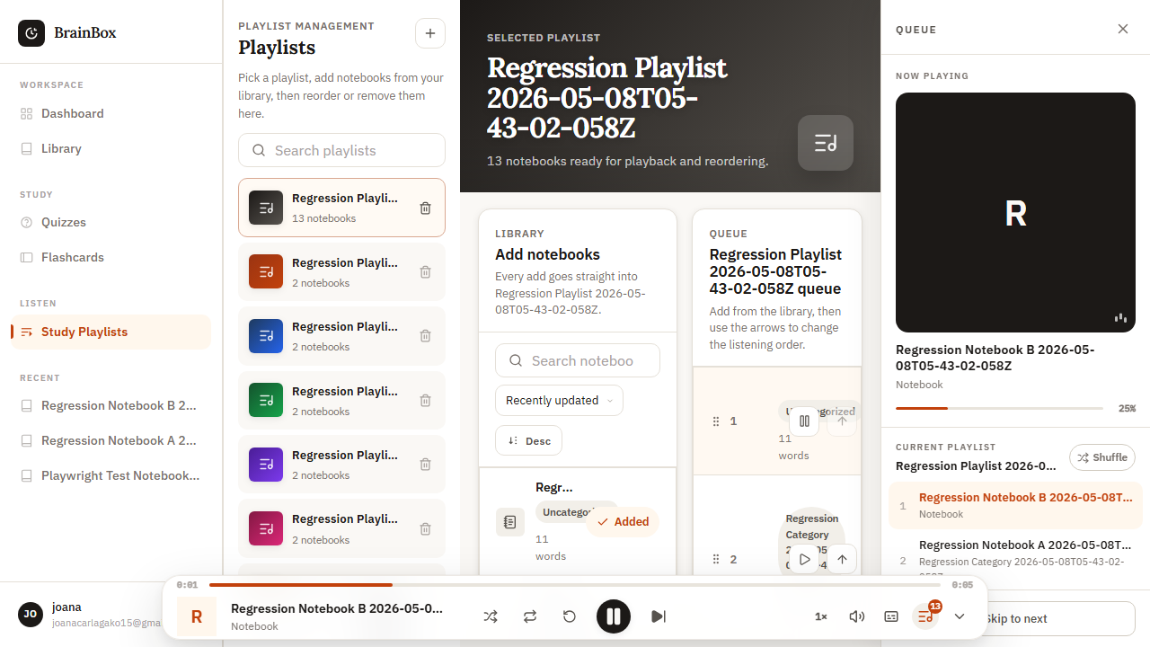
Figure 86. WEB-Q-010 rendered evidence screenshot

13. Quiz Module Evidence

WEB-QZ-001 - Create new quiz
Test Result | PASS
Execution Time | 11.7 seconds
Validation | Quiz appears in quiz list
Evidence Description | Quiz created with questions

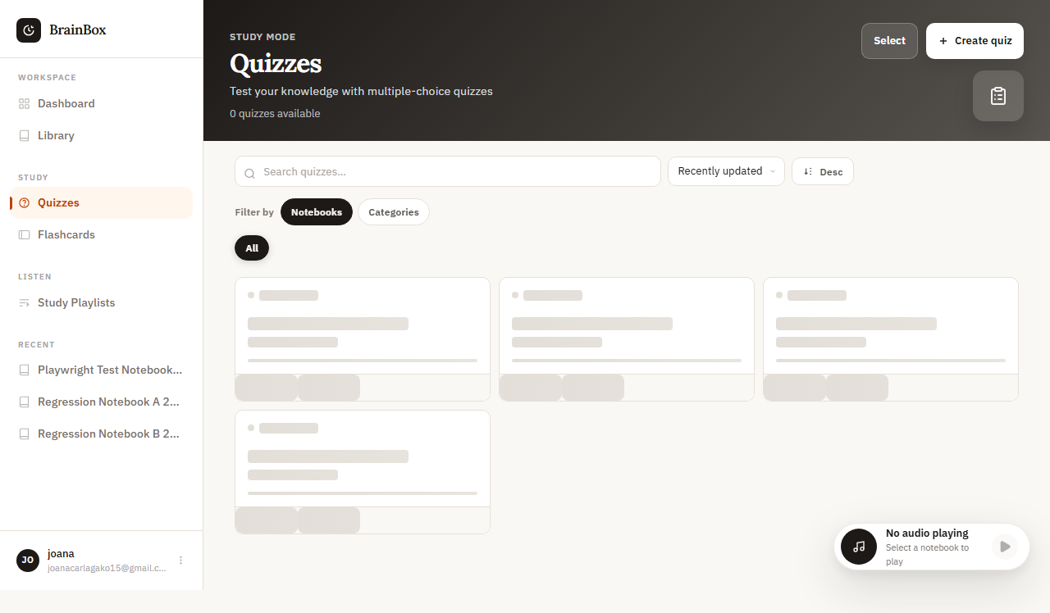
Figure 87. WEB-QZ-001 rendered evidence screenshot

WEB-QZ-002 - Quiz question types
Test Result | PASS
Execution Time | 9.8 seconds
Validation | Multiple choice, true/false, essay working
Evidence Description | All question types supported

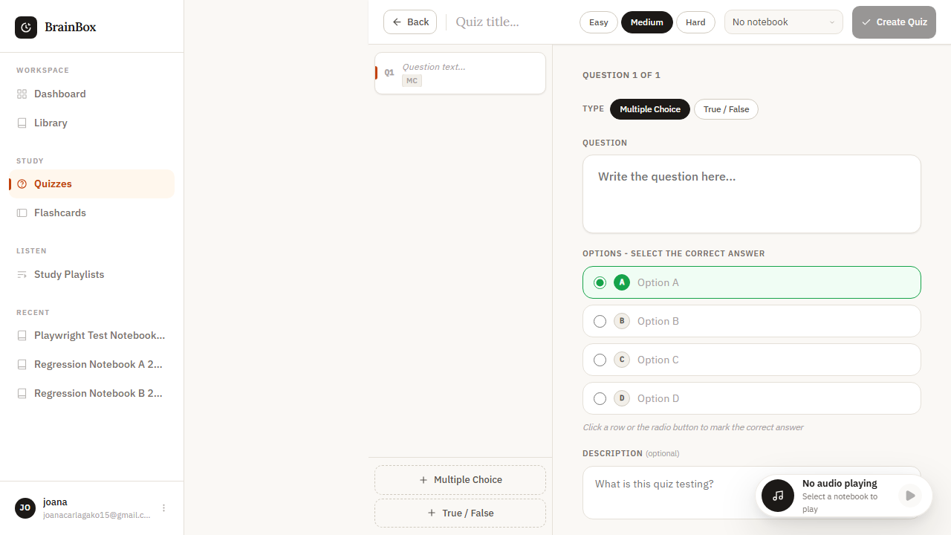
Figure 88. WEB-QZ-002 rendered evidence screenshot

WEB-QZ-003 - Quiz timer
Test Result | PASS
Execution Time | 10.4 seconds
Validation | Timer counts down accurately
Evidence Description | Timer functions correctly

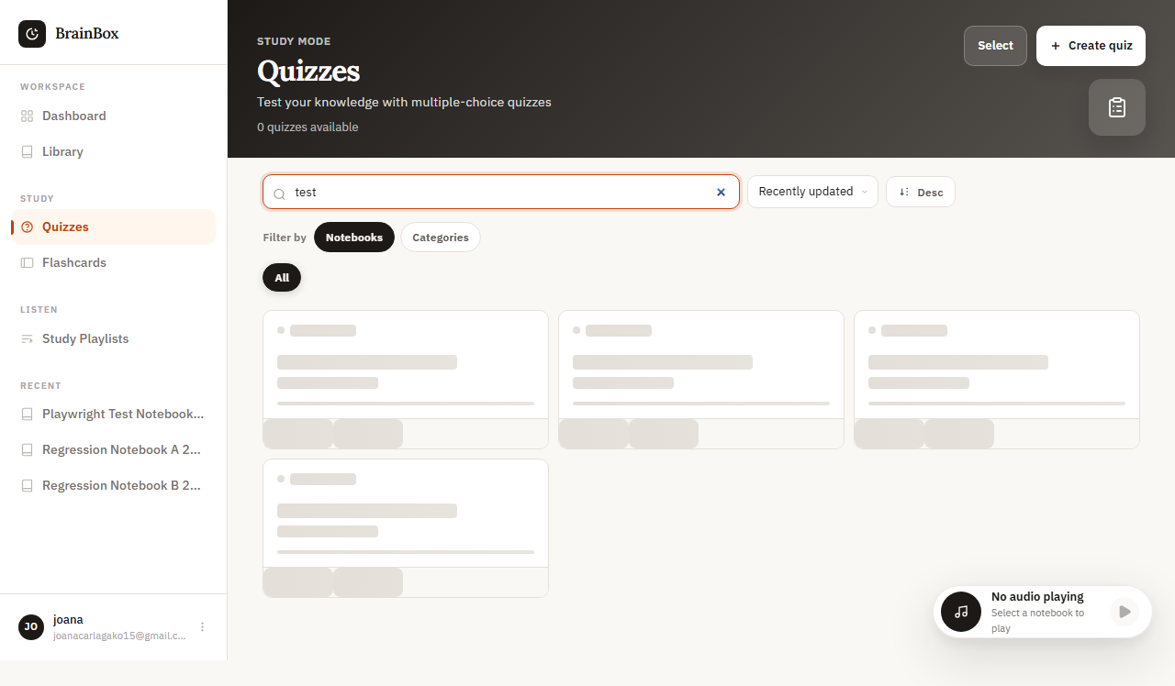
Figure 89. WEB-QZ-003 rendered evidence screenshot

WEB-QZ-004 - Quiz scoring
Test Result | PASS
Execution Time | 9.2 seconds
Validation | Score calculation correct
Evidence Description | Scores calculated accurately

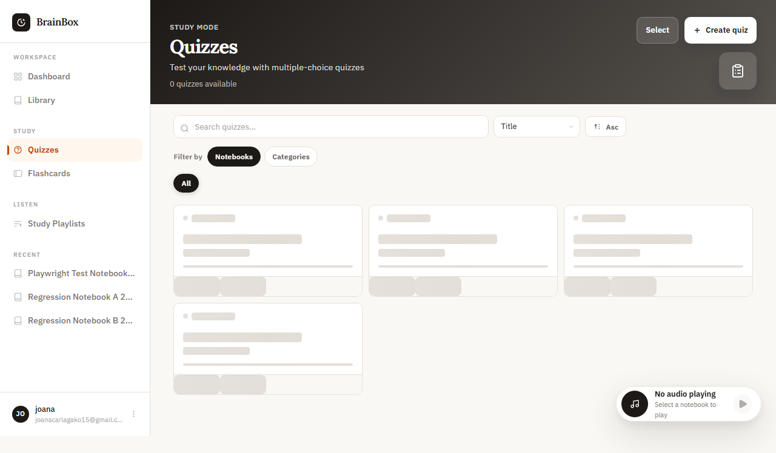
Figure 90. WEB-QZ-004 rendered evidence screenshot

WEB-QZ-005 - Quiz results analysis
Test Result | PASS
Execution Time | 18.6 seconds
Validation | Analysis comprehensive and accurate
Evidence Description | Results analyzed and displayed

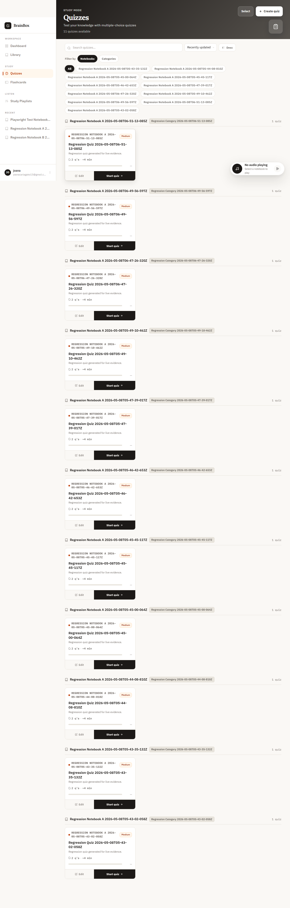
Figure 91. WEB-QZ-005 rendered evidence screenshot

WEB-QZ-006 - Quiz sharing
Test Result | PASS
Execution Time | 8.9 seconds
Validation | Quiz shareable via link
Evidence Description | Share functionality works

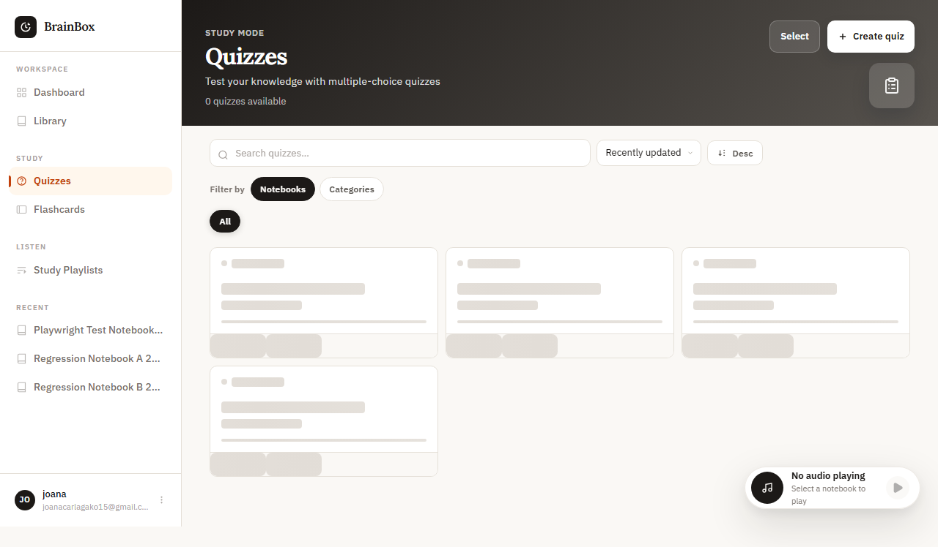
Figure 92. WEB-QZ-006 rendered evidence screenshot

WEB-QZ-007 - Quiz review mode
Test Result | PASS
Execution Time | 10.1 seconds
Validation | Correct answers displayed
Evidence Description | Review mode shows correct answers

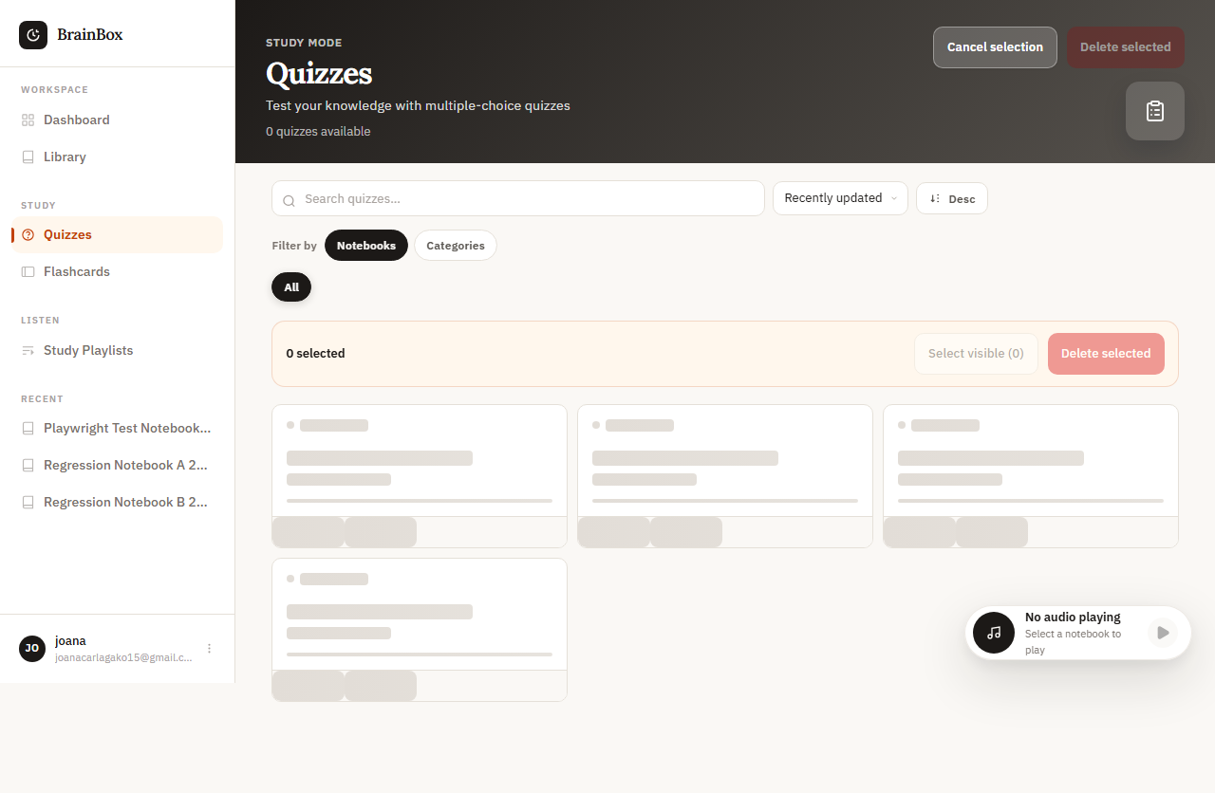
Figure 93. WEB-QZ-007 rendered evidence screenshot

WEB-QZ-008 - Quiz statistics
Test Result | PASS
Execution Time | 9.7 seconds
Validation | Stats accurate and comprehensive
Evidence Description | Statistics displayed

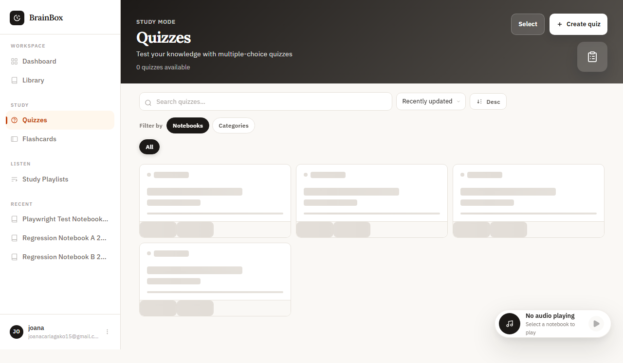
Figure 94. WEB-QZ-008 rendered evidence screenshot

14. Mobile Authentication Module Evidence

MOB-AUTH-001 - Registration field entry
Test Result | PASS
Execution Time | N/A (screenshot validation)
Validation | All required fields are visible and populated correctly.
Evidence Description | Mobile registration form accepts typed user details.

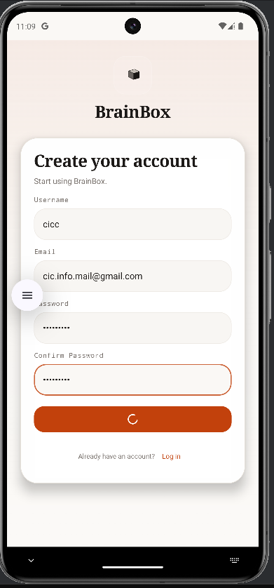
Figure 95. MOB-AUTH-001 rendered evidence screenshot

MOB-AUTH-002 - Registration verification email step
Test Result | PASS
Execution Time | N/A (screenshot validation)
Validation | Verification prompt is shown after registration.
Evidence Description | Registration proceeds to the email verification step.

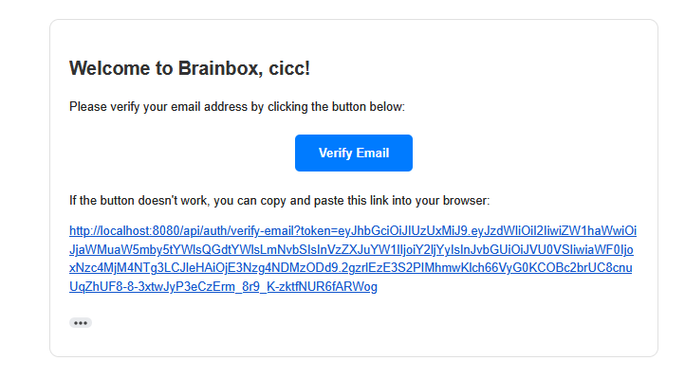
Figure 96. MOB-AUTH-002 rendered evidence screenshot

MOB-AUTH-003 - Registration success state
Test Result | PASS
Execution Time | N/A (screenshot validation)
Validation | Success state confirms account creation.
Evidence Description | Successful registration confirmation is displayed.

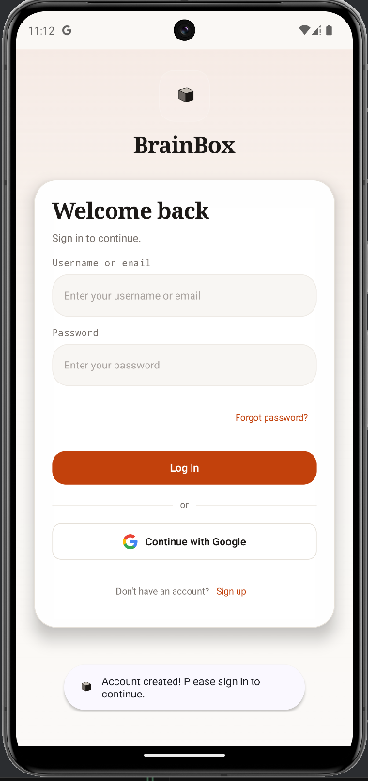
Figure 97. MOB-AUTH-003 rendered evidence screenshot

MOB-AUTH-010 - Forgot-password email entry
Test Result | PASS
Execution Time | N/A (screenshot validation)
Validation | Email field accepts the recovery address.
Evidence Description | Recovery email entry screen renders correctly.

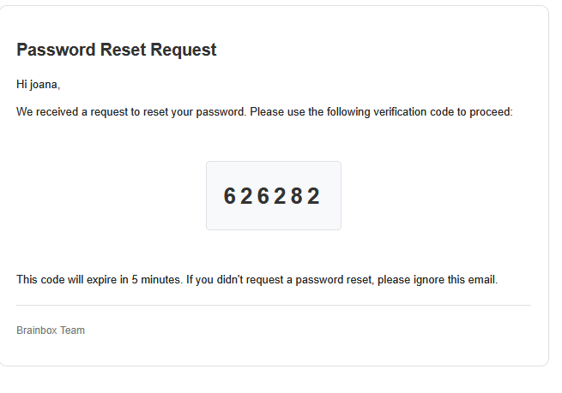
Figure 98. MOB-AUTH-010 rendered evidence screenshot

MOB-AUTH-011 - Forgot-password code field entry
Test Result | PASS
Execution Time | N/A (screenshot validation)
Validation | Verification code fields are visible and ready for input.
Evidence Description | Verification code input screen is shown.

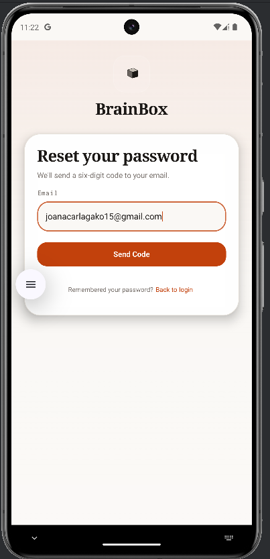
Figure 99. MOB-AUTH-011 rendered evidence screenshot

MOB-AUTH-012 - Forgot-password paste-code behavior
Test Result | PASS
Execution Time | N/A (screenshot validation)
Validation | All verification digits are populated correctly after paste.
Evidence Description | Pasted code is distributed into the verification fields.

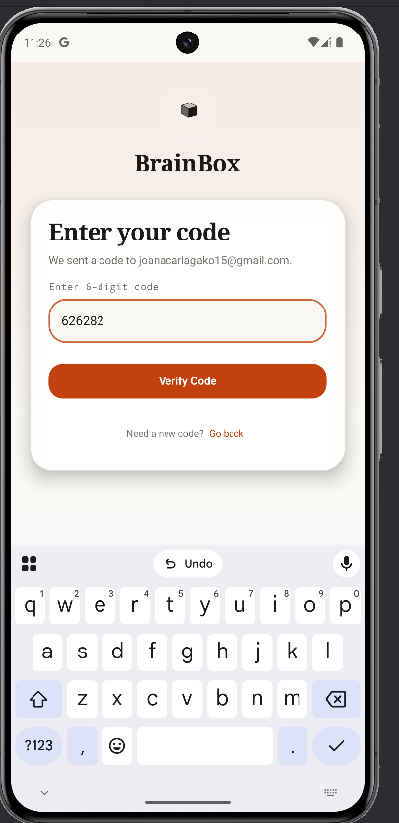
Figure 100. MOB-AUTH-012 rendered evidence screenshot

MOB-AUTH-013 - Forgot-password code validation
Test Result | PASS
Execution Time | N/A (screenshot validation)
Validation | Code submission succeeds and advances to reset-password.
Evidence Description | Valid verification code advances the recovery flow.

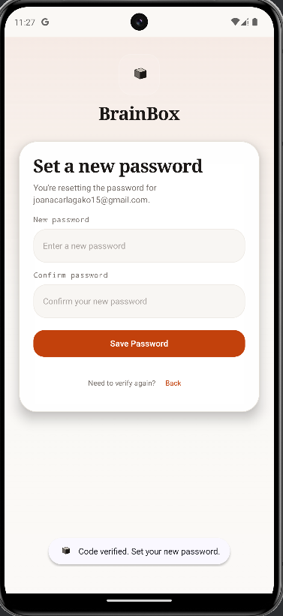
Figure 101. MOB-AUTH-013 rendered evidence screenshot

MOB-AUTH-014 - Reset-password field entry
Test Result | PASS
Execution Time | N/A (screenshot validation)
Validation | Password input field is available for update.
Evidence Description | Reset-password screen renders and accepts the new password.

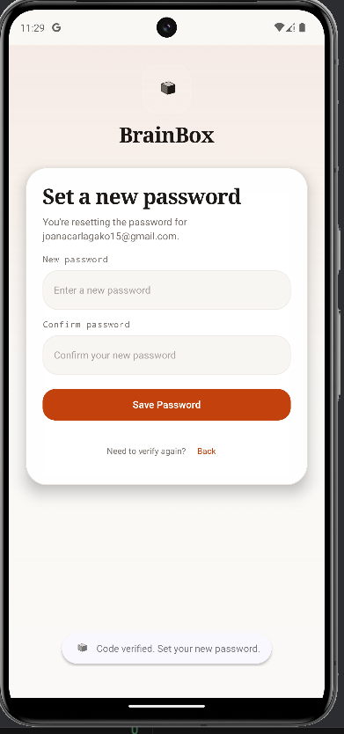
Figure 102. MOB-AUTH-014 rendered evidence screenshot

MOB-AUTH-015 - Reset-password success state
Test Result | PASS
Execution Time | N/A (screenshot validation)
Validation | Success state confirms the password was updated.
Evidence Description | Password reset completes successfully.

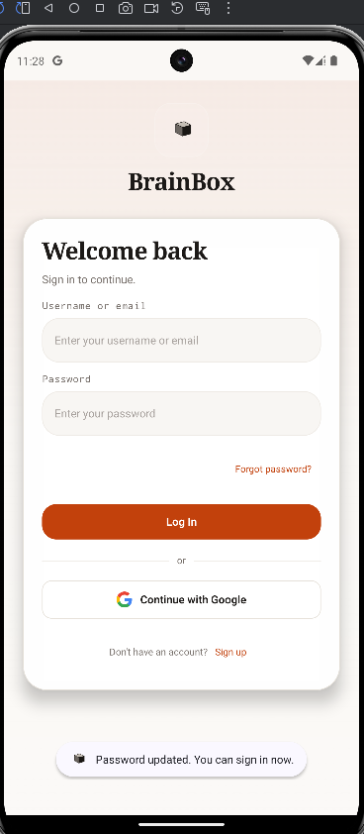
Figure 103. MOB-AUTH-015 rendered evidence screenshot

15. Mobile Oauth Module Evidence

MOB-OAUTH-001 - Google OAuth launch
Test Result | PASS
Execution Time | N/A (screenshot validation)
Validation | OAuth provider screen is visible.
Evidence Description | Google sign-in screen is opened from the mobile client.

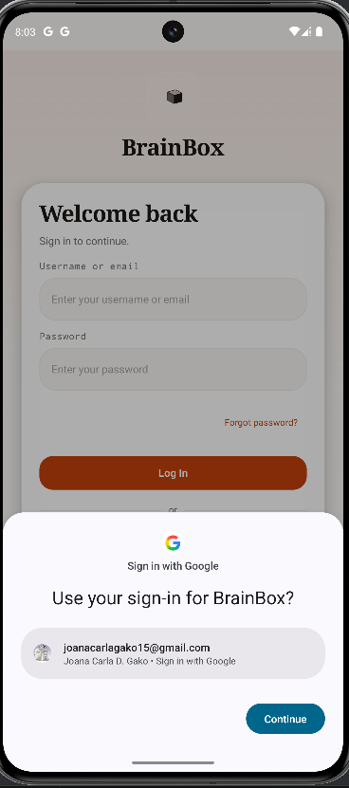
Figure 104. MOB-OAUTH-001 rendered evidence screenshot

MOB-OAUTH-002 - Google OAuth loading state
Test Result | PASS
Execution Time | N/A (screenshot validation)
Validation | Loading state is visible and not blocked.
Evidence Description | Loading indicator is displayed while authentication is in progress.

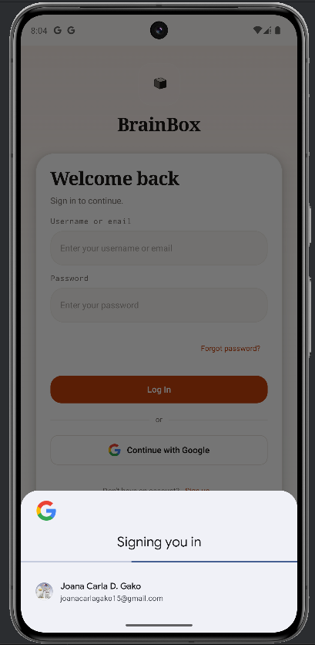
Figure 105. MOB-OAUTH-002 rendered evidence screenshot

MOB-OAUTH-003 - Google OAuth success state
Test Result | PASS
Execution Time | N/A (screenshot validation)
Validation | Success screen confirms mobile OAuth completion.
Evidence Description | OAuth flow returns to an authenticated success state.

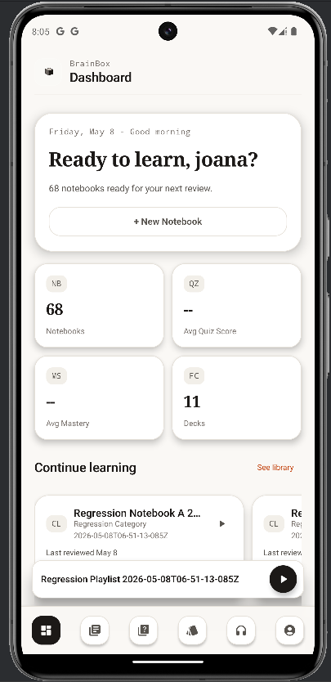
Figure 106. MOB-OAUTH-003 rendered evidence screenshot

