M4D, a Research CFD Code
for the Calculation of Classical and Turbulent Flows

by Joan G. Moore

M4D is a 3-d, optionally time dependent, CFD program. It is written like a language. I.e., commands are read from an input file, initially standard input. The list of commands and the associated input set up both the CFD example considered and the solution procedure used: steady or unsteady, inviscid, laminar or turbulent including transitional flows. M4D is easily expanded, and nothing is hidden - all the C source code is openly available.

Why
The reasons for writing M4D and making it available are:
(1) to demonstrate the advantages of variable, adaptive, convection biased, control volumes (with a fixed grid) so that the need for adding artificial dissipation is eliminated. Tri-linear profiles in space for convected properties gives 3-d compact second order accuracy.
(2) to demonstrate the implementation of the MARV (or MARVS) Reynolds stress model.
Neither of these is easy to code, so that without an available CFD program to demonstrate their usefulness, the ideas are less unlikely to be tried. These ideas also go together, since artificial dissipation can easily obscure the results of turbulence models, and Reynolds stress models do not provide the same computational stability as Boussinesq (2-Eq.) turbulence models.
The third reason for writing M4D is:
(3) to provide a framework to test both steady and time accurate calculation procedures.

Geometry
M4D uses a single block ijk grid but with the option of coincident points and lines, so that it may look like and have some of the advantages of a block structured grid, but also retain simplicity. The location of each grid point is specified in Cartesian coordinates. Each grid point is also assigned a type, f-flow, w-wall, s-solid, or some other character chosen by the user. The types are used to affect the control volume choice, and whether or not equations for particular points should be solved.
The discretization using tri-linear property profiles frees M4D from the artificial numerical constraint of nearly orthogonal, nearly uniform spaced grid points. Think of it as a curve fitting exercise – the grid needs to be adequate so that linear profiles can adequately represent the physics.
A grid for a 2-d turbine cascade is shown in Fig. 1. Grid lines in the i-grid direction are shown in red and go from the inlet at left to the flow exit at the bottom right. Grid lines in the j-grid direction are in blue and span the pitch from repeating-boundary to repeating-boundary. A c-grid around the leading edge is formed by collapsing volumes along ‘corner’ diagonals, which are both i and j grid lines. The portions of the grid lines which pass through the solid blade are not shown.
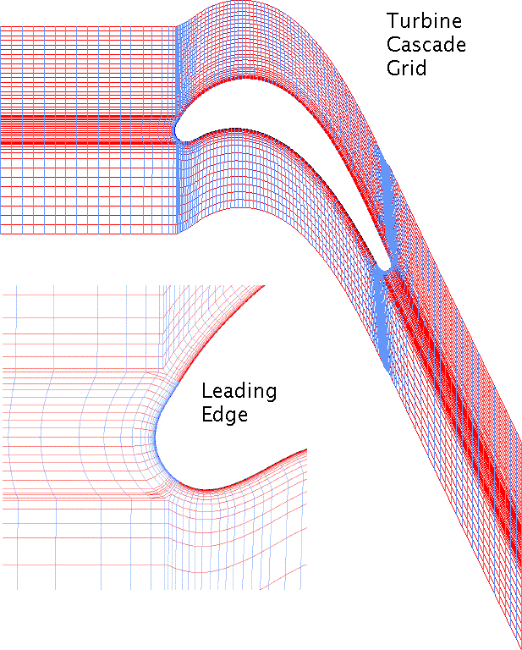
Fig. 1. Turbine Cascade Grid
Differential Equations
The current scope of M4D includes:

(1) Incompressible or steady flow continuity,

.

The equations are integrated over the between-the-points volumes and satisfied using a pressure-correction method. A simple but flexible multi-block approach is available to iteratively solve the pressure-correction equations, as well as center-point update and TDMA line solvers.

(2) Conservation equations for:
(a) momentum, , with the option of frame rotation about the z-axis;
(b) the 7-Eq. MARV (Moore and Moore, 2006) and MARVS (Moore and Moore, 2015) Reynolds stress models, q, , and ;
(c) a Coakley 2-Eq. turbulence model, q and (Moore and Moore, 2009, slide 2.6);
(d) and any conserved species including an EVM model (Moore and Moore, 2010) for turbulent mixing of thermal energy.
The conservation equations take the generic form

.

The equations are integrated over the adapted control volumes, Moore and Moore, 2014, (but not in time) to form equations for the property at the individual grid points. Individual commands give spatial coefficient sets of for each of the terms on the left hand side.
In general, iterative procedures are used to satisfy the conservation equations for both steady and unsteady flows. The equations are rewritten for the change in over an iteration ( not shown for simplicity),

,

with the addition of a center-point term which is used to provide relaxation for non-linear instabilities. Individual commands calculate appropriate coefficients C for each property. The equations are solved with center-point update and/or TDMA line solvers.
Note that density, , and laminar viscosity, , are stored as arrays, and the equations are written consistent with compressible flow. However, M4D, does not currently include an equation of state or a compressible energy equation. So far heat transfer calculations have relied on the conserved species equation with appropriate boundary conditions.

Boundary Conditions
Repeating boundaries may be set in the i, j, and/or k grid directions. Symmetry planes may also be set at each of the (6) ends of the i, j, and/or k grid directions. The restriction is that these must be flat planes of constant x, y, or z, so that the velocity components and components of are appropriately restricted.
Fixed values of primary properties, , may be set anywhere. This is used for inlet and fixed-value wall boundary conditions. The default wall boundary condition, if the equations are solved for these points, is no viscous flux across the wall. An exception is the command which will impose a uniform wall heat flux for a temperature/energy equation. The turbulence model equations for and are solved with fixed wall values, then separate commands reset the wall values appropriate to the model.
Exit pressure boundary condition choices are (a) no change in pressure at the specified exit, (b) a uniform change in pressure at the specific exit to obtain a specified flow rate across the exit, (c) a uniform difference in pressure between the exit and neighboring interior plane with either a specified flow rate across the exit, or one pressure point on the exit plane fixed.

Output and Imbedded Plot Package
All variables (other than temporary ones) are stored in named arrays. These are available at the command level and may be modified, printed, or dumped to a file to be reread or saved for another program.
The imbedded plot package creates:
(1) line plots using either linear or log scales. These can be used to monitor convergence or plot line results of one variable against another.
(2) vector, color-fill contour and/or grid plots of properties on grid planes, flat cut planes, or an unwrapped blade view. This can be used to plot final results, monitor convergence, or save images during a time accurate calculation which can be turned into a video.
Plot images are exported as individual .gif files. External software from the web can be used to combine the images to form animated .gif files, or to create standard .mp4 videos.

Working Examples
Input files and sample output for several working examples are available. The CPU times listed are for a 2010 Mac Mini with a 2.4 GHz Intel Core 2 Duo running Mac OS X Version 10.6.4.

Box Cavity Unsteady inviscid transient of a conserved species convected around a 180 degree bend, Fig. 2. Demonstrates the adaptive control volume method. CPU 2.4 secs. Example from Moore and Moore, 2014; video on M&M homepage.
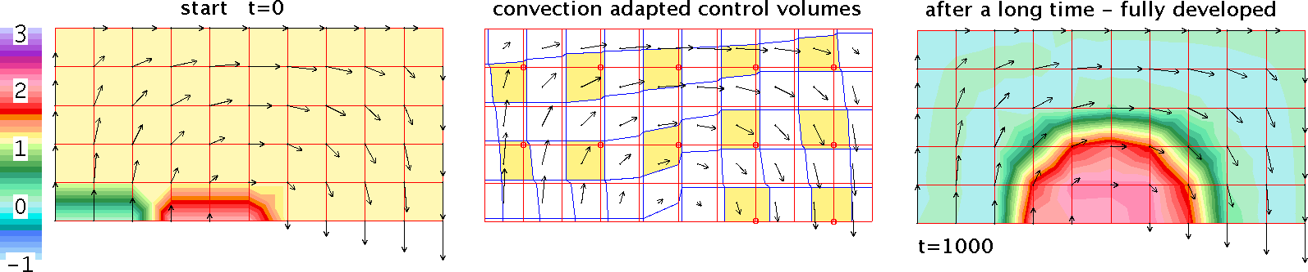
Fig. 2. Box Cavity example.
Kelvin-Hemholtz Instability The development of an inviscid shear layer, as it wobbles then rolls up into a vortex, Fig. 3. Equations: Incompressible continuity, 2-d inviscid time-accurate momentum, and for comparison vorticity as a conserved species. The adaptive control volumes change as the flow develops. CPU 31 min. Example from Moore and Moore, 2014; videos on M&M homepage.

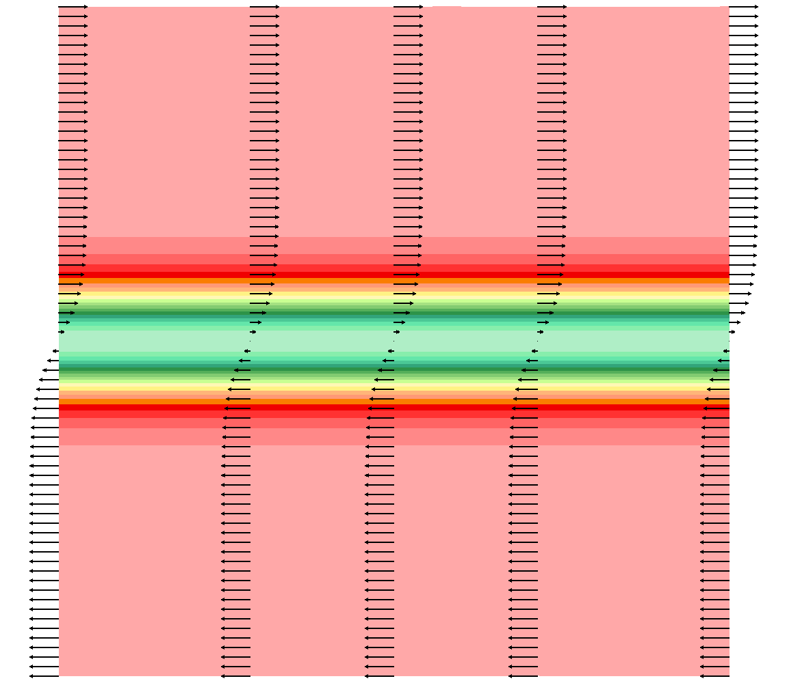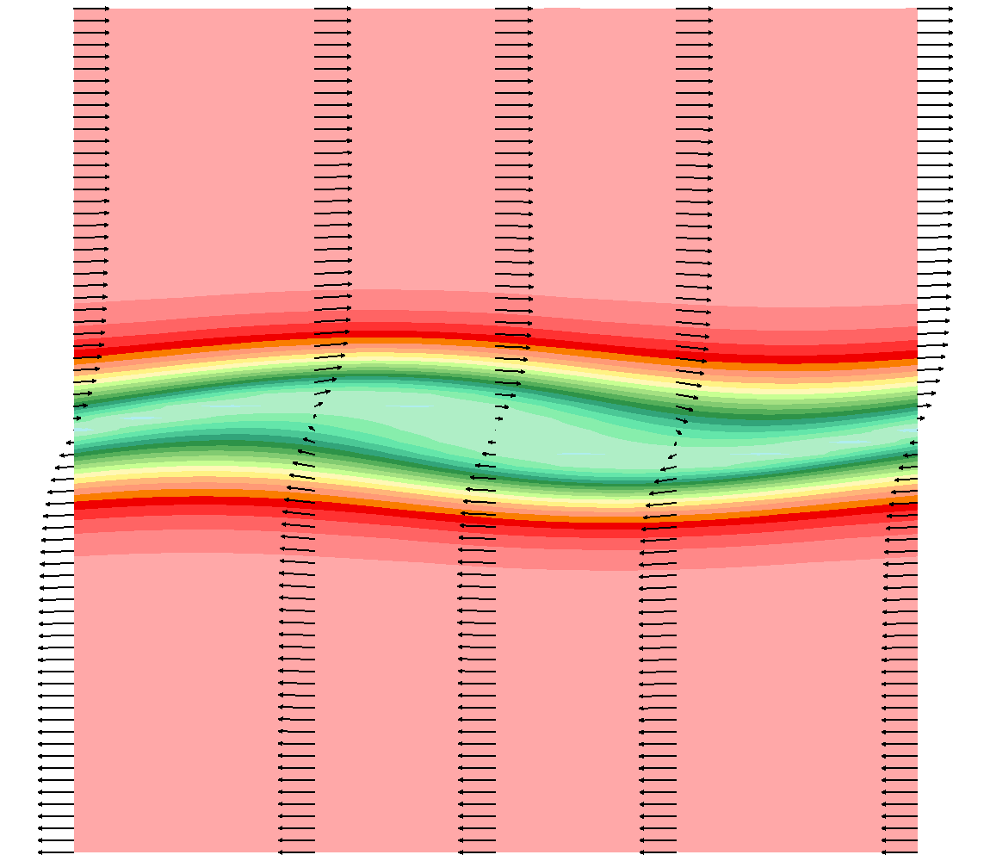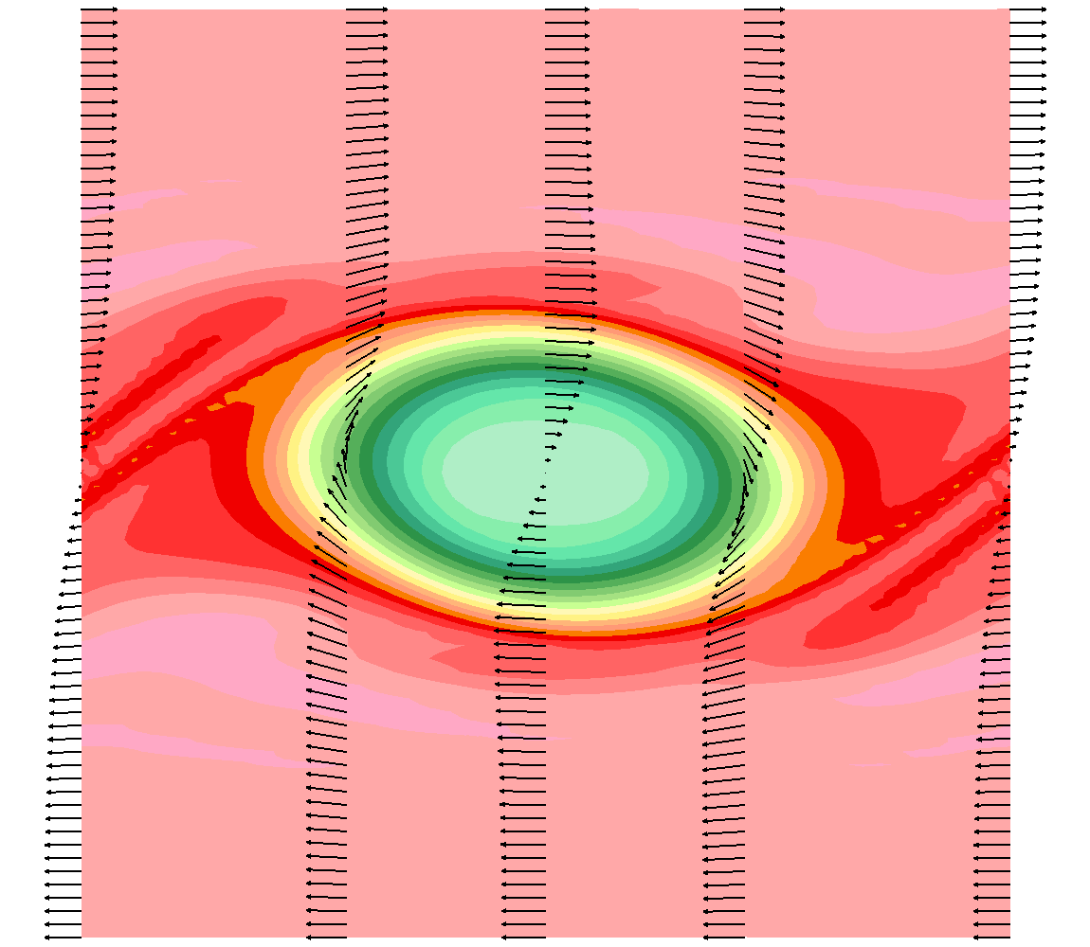
t=0 t=20 t=50

Fig. 3. Kelvin-Helmholtz Instability. Vorticity and selected lines of velocity vectors.
Near-DNS of Flow in a Square Channel 3-d laminar time-accurate calculation for , Fig. 4. Like the example from Moore and Moore, 2014, except redone from uniform flow and a very coarse grid, 14x27x27. Then 2 finer grids, 14x35x35 and 26x35x35 for a domain =6,2,2. (The duct width is 2.) CPU 6.3 hours.
This calculation has implications for LES. The adaptive control volumes give stable discretization of convection so that there is no need to add a Boussinesq sub-grid scale model to stabilize the numerical procedure (in fact it would be an embarrassment). This means that a more physics based sub-grid scale model could be considered.
Video of results from Moore and Moore, 2014, on M&M homepage.

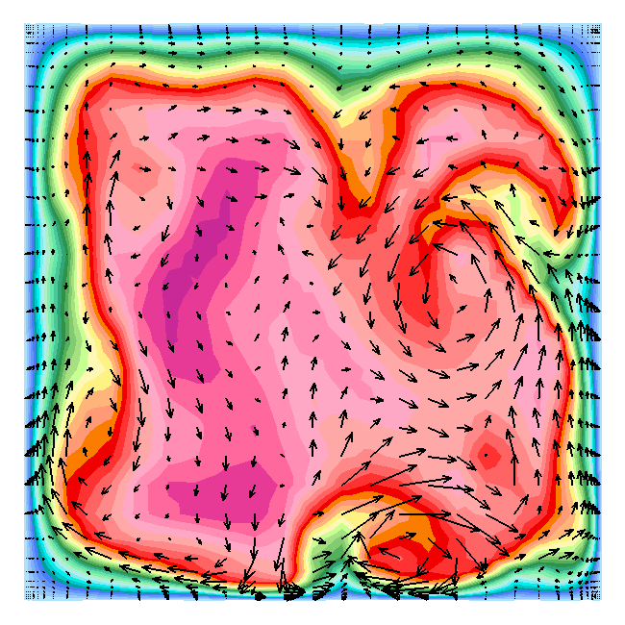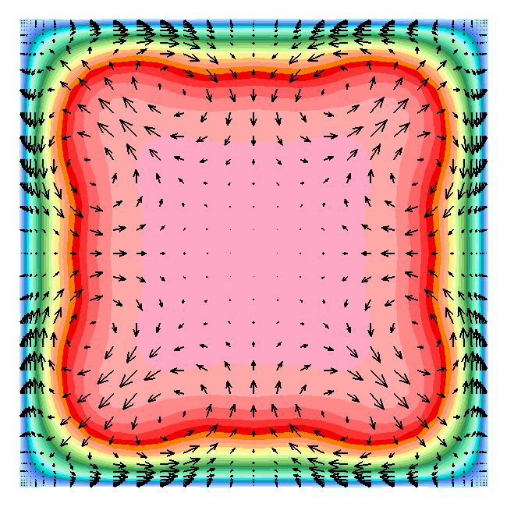
Sample instantaneous, Time-, x-, and octant-average,
dt for vectors = 0.8. dt for vectors = 5.

Fig. 4. Near-DNS in square channel. U_{x} velocity contours with U_{y} U_{z} velocity vectors.

2-D Fully Developed Rotating Channel This is a basic test case to check that the Reynolds stress model is correctly implemented. , to 0.5, Fig. 5, as for the DNS of Kristoffersen and Andersson, 1993. Like in Moore and Moore, 2006, except for the MARVS Reynolds stress model. Equations: steady x-momentum (with a specified dp/dx), and the Reynolds stress model properties. CPU 11 secs.
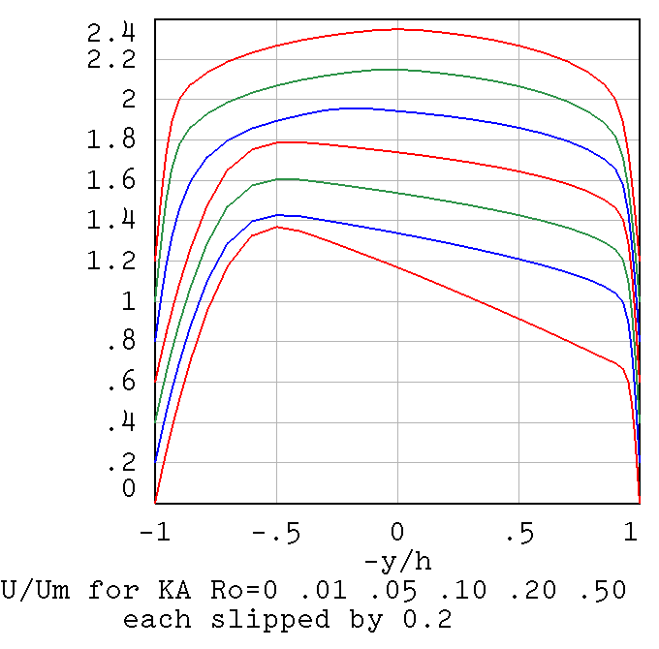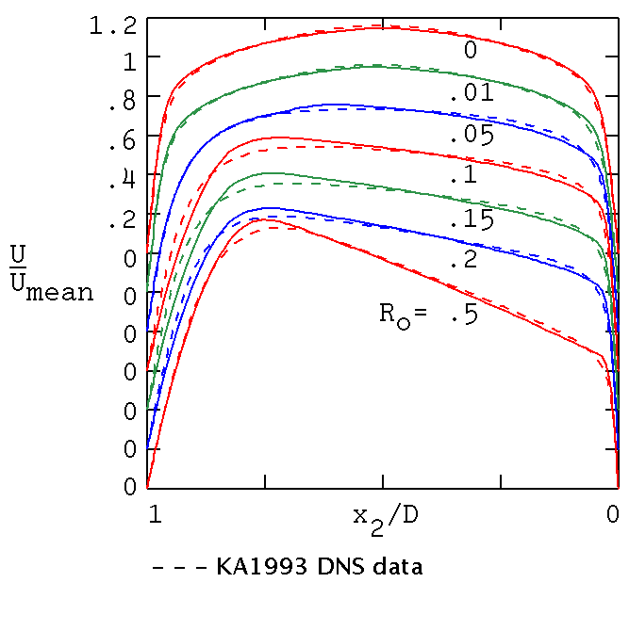
MARVS model using M4D MARV model, MM2006, Fig. 13.4.1
Fig. 5. Mean velocity profiles for rotating channel.
Kasagi Backstep 2:1 backstep, , Fig. 6. As in Moore and Moore, 2009, slide 2.8, but using the MARVS Reynolds stress model and a coarser grid. Steady 2-d flow calculation. Fully developed channel flow inlet (fixed properties) at 4 step heights upstream of the step, and exit boundary condition (c) with fixed mass flow rate at 15 step heights downstream of the step. CPU 4 minutes.
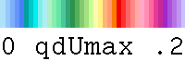
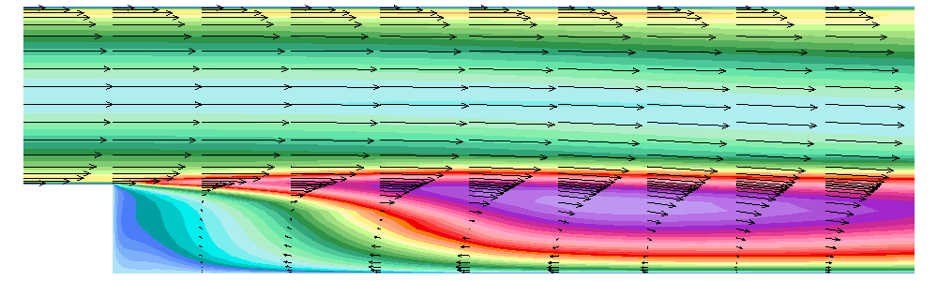

Fig. 6. Kasagi Backstep. Contours of q/U_{max} and selected lines of vectors.
2-D Turbine Cascade with Heat Transfer Steady 2-d flow with Reynolds stress model as in Moore and Moore 2010, except using the MARVS model and the grid in Fig. 1. After the flow and turbulence model properties are converged (CPU 13 minutes) a conserved species equation with a uniform heat flux boundary condition is satisfied to obtain the wall Nusselt numbers, Fig. 7, left (CPU 8 secs).
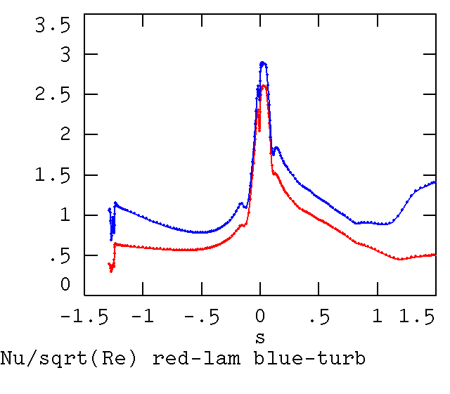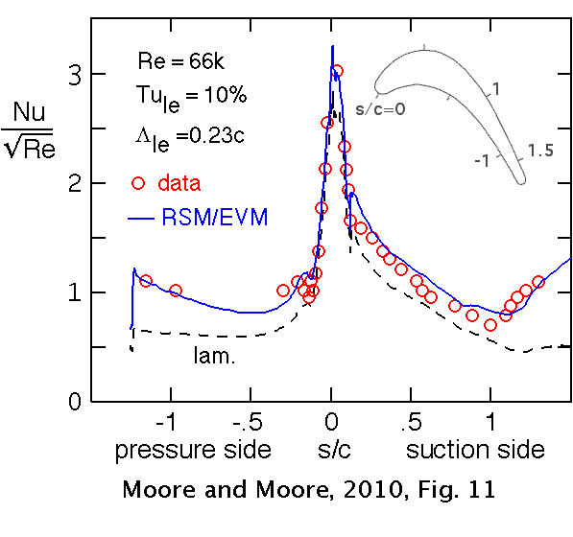
Fig. 7. Transitional Turbine Cascade Nusselt numbers.

Who, When
M4D has been written by Joan G. Moore. Writing began in earnest in 2010 with a 'clean sheet of paper', but with 40 years experience both writing and using steady 3-d CFD codes. It is written entirely in C to distinguish it from her earlier codes which were in Fortran. It has been written with a lot of support and ideas from her husband, John Moore, and no external sponsorship either commercial or government.
It is NOT an entry level “let's use the simplest discretization, we can always use a better/finer grid” code. It comes with no guarantees or warrantees, just the hope that it will be useful to students and others interested in fluid mechanics, fluid dynamics, turbulence, CFD and CFD methods.

References
Moore, J.G., and Moore, J., 2006, Functional Reynolds Stress Modeling, Pocahontas Press, Blacksburg, Virginia, 2006. (Available on Amazon.com)
Moore, J.G., and Moore, J., 2009, “Reynolds Stress Models – Lecture 2”, Numerical Investigations in Turbomachinery: The State-of-the-Art, VKI Lecture Series 2009-08, edited by T. Arts and M. Manna, 2010.
Moore, J.G., and Moore, J., 2010, “An RSM/EVM Flow/Heat Transfer Model Applied to Pre-Transitional and Turbulent Boundary Layers”, AIAA paper No. AIAA-2010-4314.
Moore, J.G., and Moore, J., 2014, “Using Multi-Dimensional Linear Discretization Over Unsteady Convection Adapted Control Volumes”, AIAA paper No. AIAA-2014-2780.
Moore, J.G., and Moore, J., 2015, “Transition Calculations with the MARVS Reynolds Stress Model”, 11th European Turbomachinery Conference, Paper ETC2015-113.

M&M homepage: moore64.home.comcast.net
Click on Papers and Presentations
to find either the papers or presentations
for the above references

Joan G. Moore, May 2015
frsmodeling@comcast.net
M4D version: 2015.2

