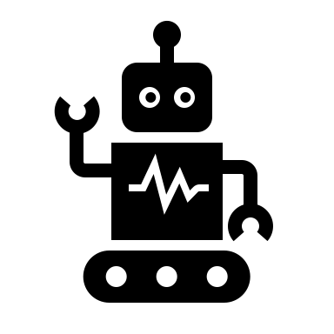

Initialize

set of particles



Robot Controller

Optional

Update particles state

Calculate particles weight

Resample particles

Particles Filter