**OCA Oracle Certified Associate – Java SE 8 – Recap**

**Chapter 1** : Java Building Blocks

*Java Class Structure*

An object is a runtime instance of a class in memory. All the objects of different classes represent the state of the program.

Members of the class → Fields(Variables) + Methods

Variable → hold the state of the program.

Methods → Operate on variables state.

Keyword: A word with special meaning.

Method: Operation that can be called from other classes.

Method signature: full declaration of a method

*Main method*

A Java program begins execution with its main() method. Main method is the gateway between the startup of a Java process (managed by JVM) and the beginning of the programmer’s code. JVM calls on the underlying system to allocate memory and CPU time, access files and so on.

Example:

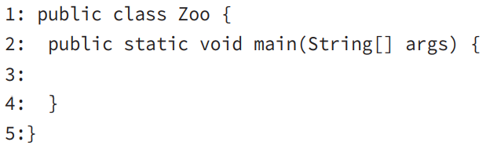

To compile and run the code we type it in a file with name **Zoo.java** and we execute:

$ **javac** Zoo.java

$ **java** Zoo

To compile Java Code the file must have the extension: **.java** , while the **name of the file must be the same as the name of the class**. The result of the compilation is a file of ***bytecode*** by the same name, but with the **.class** extension instead of **.java**. **Bytecode** consists of **instructions** that the **JVM** knows how to **execute**.

Main() →

|  |  |  |  |  |  |
| --- | --- | --- | --- | --- | --- |
| public | static | void | main | (String[] | args) |
| Access modifier, declares the method’s level of exposure to potential callers in the program | Binds the method to the class so it can be called by just the class name ( no objects is needed to be created by Java to call main method) |  |  |  |  |