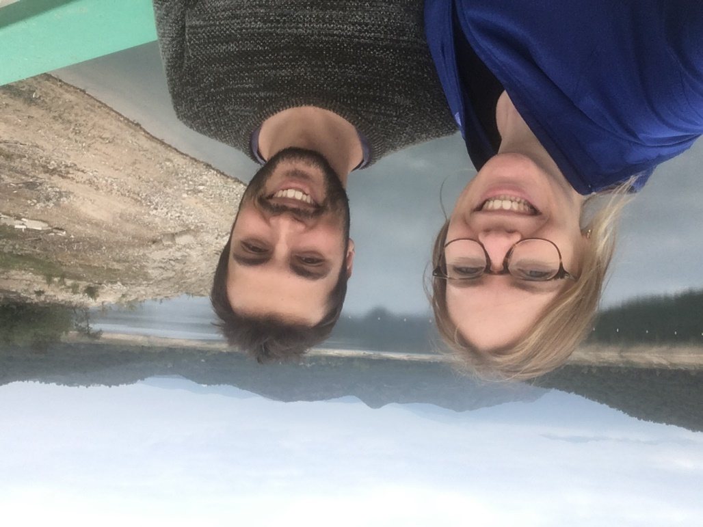**Joan Martí Carreras**

6th September 1993, Llers (Spain)

  
+34 653614415; +32 478950442  
BE3010 Kessel-Lo, Belgium; 17706 Pont de Molins, Spain  
[joan.marti@kuleuven.be](mailto:joan.marti@kuleuven.be); [joan.marti.carreras@gmail.com](mailto:joan.marti.carreras@gmail.com)

**Expert in Sequencing, Genomics, Bioinformatics, Molecular Biology and Infectious Diseases**

Employment

**May 2020 – Present**: **Freelance Consultant** at **BioExpert Network/Capital Cell** (Barcelona, Spain)  
**Panel Research Expert on Virology/Immunology/Oncology**

< Marc Sastre ([marcsastre@capitalcell.net](mailto:marcsastre@capitalcell.net)) >

**Sep 2017 – Present**: **Doctoral researcher** at the **Rega Institute**, **KU Leuven** (Leuven, Belgium)  
**Third-generation sequencing and herpesvirus genome diversity: Towards complete large dsDNA virus genomes**

< Piet Maes ([piet.maes@kuleuven.be](mailto:piet.maes@kuleuven.be)) >

**Jul 2016 – Jun 2017**: **Research Assistant** at the **ICM-CSIC** (Barcelona, Spain)  
**Biogeography of genes related to methyl-mercury degradation by comparative analyses of deep ocean metagenomes and metatranscriptomes**

< Silvia G. Acinas ([sacinas@icm.csic.es](mailto:sacinas@icm.csic.es))>

**Jun 2014 – Aug 2014**: **Freelance Molecular Biologist** at **ICTA-UAB** (Barcelona, Spain)  
**Phylogeographic reconstruction of *Rhynchophorus ferrugineus* world-wide populations for pest control**

< Victor Sarto i Monteys ([victor.sarto@uab.cat](mailto:victor.sarto@uab.cat)) >

Education

**2017-Present: PhD in Biomedical Sciences (Virology)**, Rega Institute - KU Leuven (Leuven, Belgium).

**2015-2017:** **Master’s in Bioinformatics for Health Science**, Universitat Pompeu Fabra (UPF, Barcelona, Spain).

**2011 - 2015: Bachelor in Genetics**, Universitat Autònoma de Barcelona (UAB, Barcelona, Spain).

Courses

* **Outbreak Antenna Setting** and **Media training**, 13-15/11/2017, **KU Leuven**, Leuven, **Belgium**.
* **Infectious Diseases**, 18-22/11/2017, **AMC**, Amsterdam, **The Netherlands**.
* **Flavivirus serology** and **routine diagnostics**, 07-09/12/2017, **IFIK**, Bern, **Switzerland**.
* Unbiased **Next-generation sequencing** with **IonTorrent** after shearing, 18-22/11/2018, **FLI**, Greifswald, **Germany**.
* Advanced diagnosis through **RT-qPCR** and **oligo degeneration**, 25-29/11/2018, **Charité** **Institute**, Berlin, **Germany**.
* **Primate non-human animal models**, 22-25/10/2018, **BPRC**, Rijswijk, **The Netherlands**.
* Optimization of **next-generation protocols**: **VIDISCA**, 26-02/11/2018, **AMC**, Amsterdam**, The Netherlands**.
* **Novel diagnostics**, 21-23/01/2019, **University of Leeds**, Leeds, **UK**.
* **Microarrays** for virus detection, 06-08/05/2019, **FLI**, Greifswald, **Germany**.
* **Protein production**, 08-11/10/2019, **Ingenasa-Eurofins**, Madrid, **Spain**
* **Vaccine design** and **commercialization**, 18-22/12/2019, **MSD Animal Health**, Boxmeer, **The Netherlands**.

Skills

**Sequencing**: Sanger, Illumina (NexteraXT, Westburg, Agilent SureSelect hybrid-capture), Nanopore (rapid, ligation, ultra-long read libraries). Some experience with IonTorrent.  
**Molecular biology**: Cloning techniques (currently learning TAR cloning), PCR, RT-qPCR, FACs.   
**Cell culture**: *E. coli*, primary and immortalized lines (HFF, MRC-5, VeroE, Huh-7, THP-1, …), transduction, production and titration of viral strains (human cytomegalovirus and SARS-CoV-2).   
**BSL 1-3**: Currently under BSL-3 training at the Rega Institute, KU Leuven.

**Catalan & Spanish:** Native, **English:** C1, **Dutch:** A2.

**Office**: Experience in **Windows** (Microsoft Office) and **Ubuntu**. Basic graphic design (**Inkscape**). Project managing (**Scinote**).  
  
**Binary**: Data-analysis and data visualization with **R** (Rstudio, tidyverse, vegan, etc). Fluent in **Bash** and **Python**, some Perl, SQL and BigQuery. Project managing and accounting (**git,** https://github.com/joanmarticarreras/), pipeline managers (**Nextflow** and Snakemake) and virtualization (Docker and **Singularity**). Basic web-app design and development (SQL and Django).

Academics

**Publications:** 14 international peer-reviewed articles (3 first author, 1 corresponding author, 11 as co-author).

 **Teachings**: 3 supervised students (1 master thesis), Computational Genomics Course (2018-2020, 3 days/year, Prague, Czech Republic), Nanopore sequencing and data-analysis (2018-2019, 2 days/year, Leuven, Belgium).

**Grants:** 3 grants (2 undergraduate research grants in Spain, 1 Marie Sklodowska-Curie in Belgium for the PhD).

**International:** 5 international conferences, 3 international coding working sessions (2 NCBI-NIH in USA, 1 EUvsVirus in Europe), Belgian SARS-CoV-2 genomic surveillance (in the GISAID EpiCoV group).

Detailed CV available at [www.joanmarticarreras.com](http://www.joanmarticarreras.com)