**Computational Neuroscience Coursework 2 Report**

Feifei Rong (ID: 1347322)

# The spike position of each neuron compared to rat different speed positions and large firing rate position

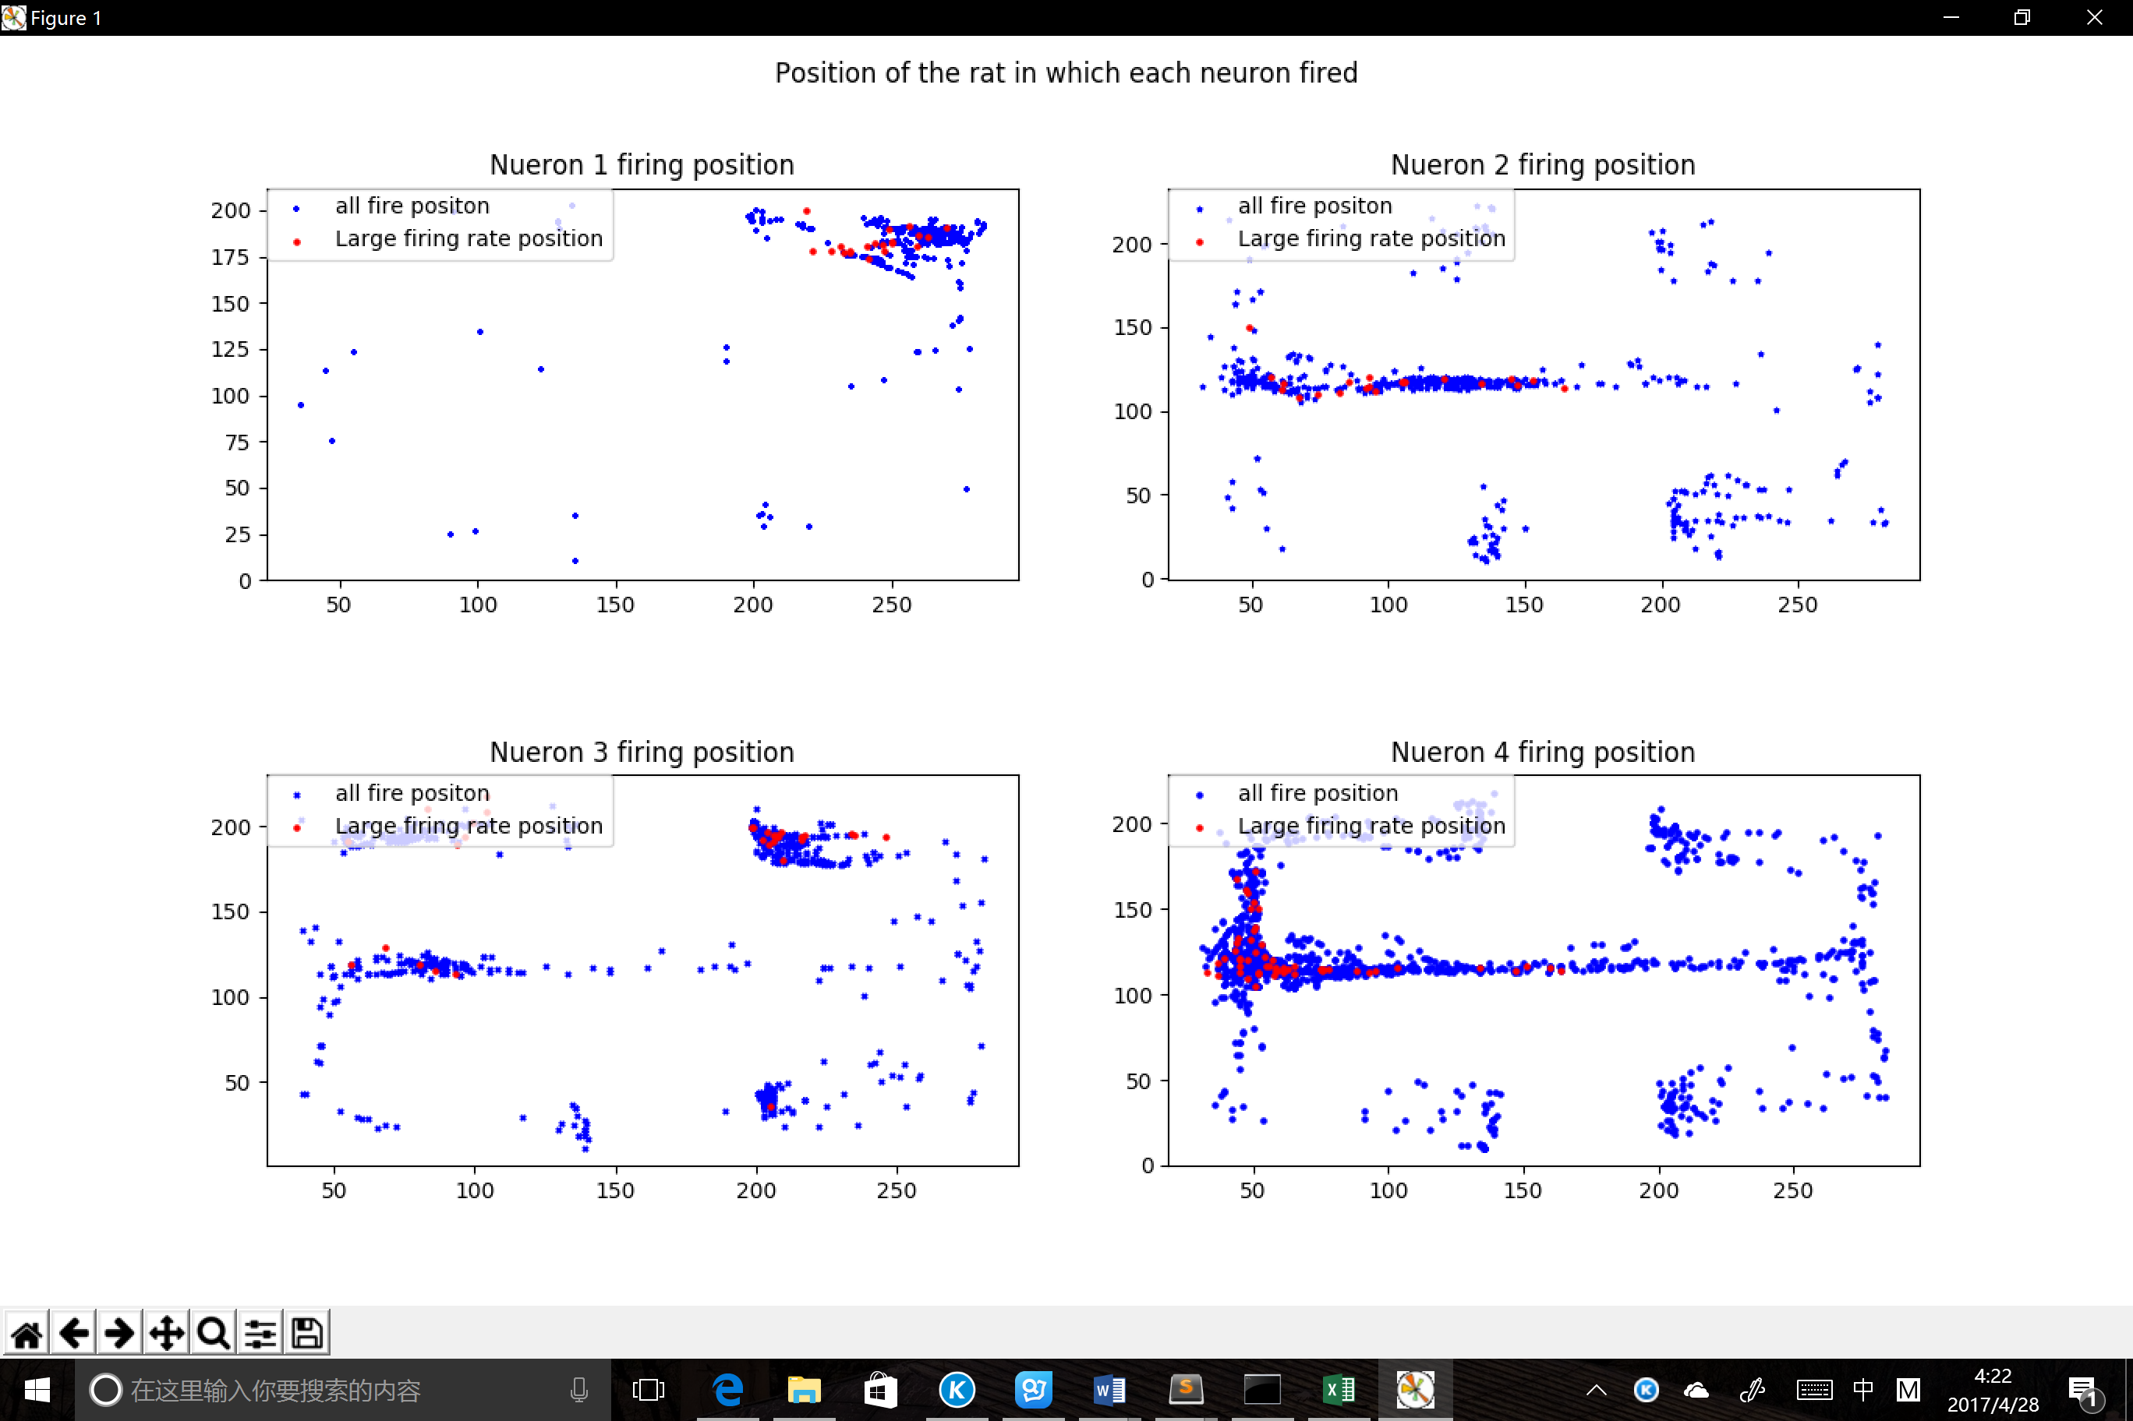 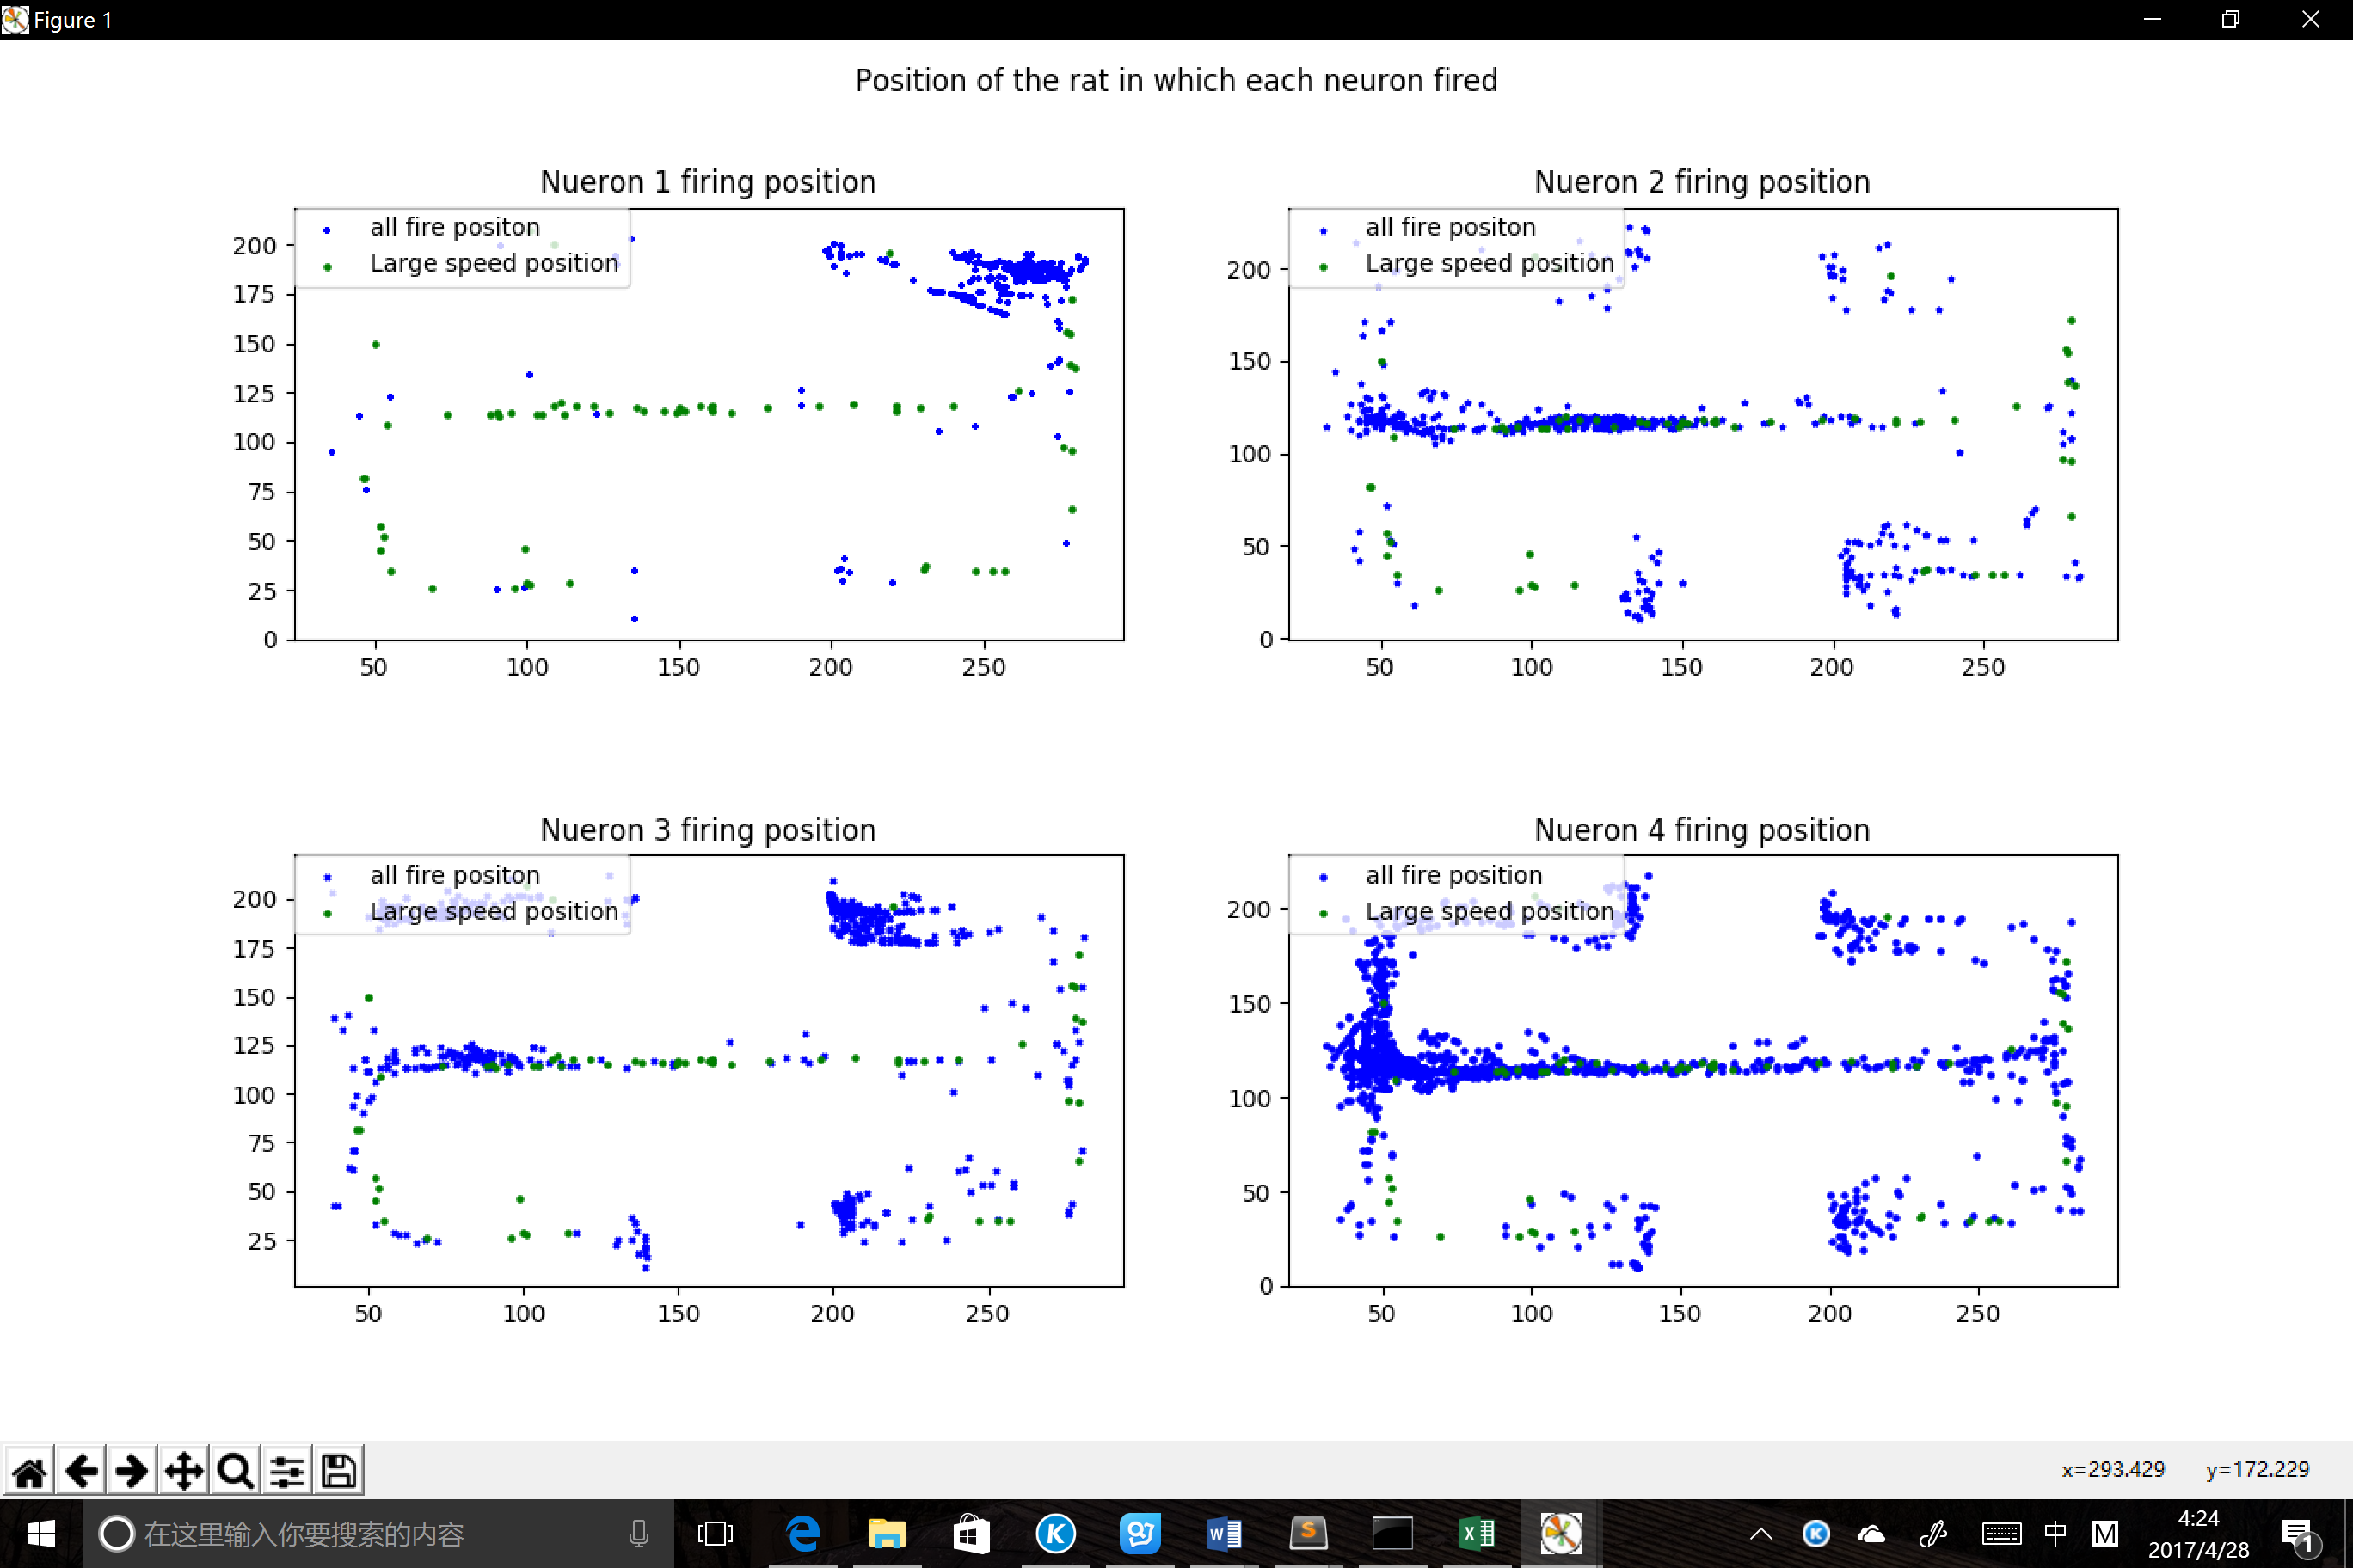

( a ) ( b )

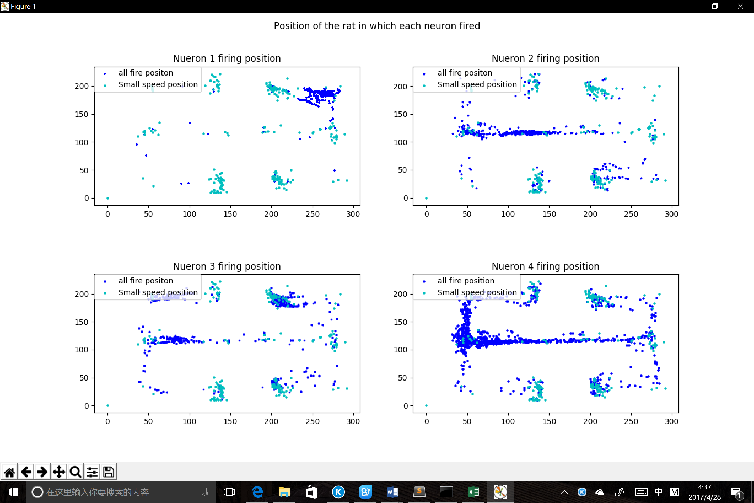 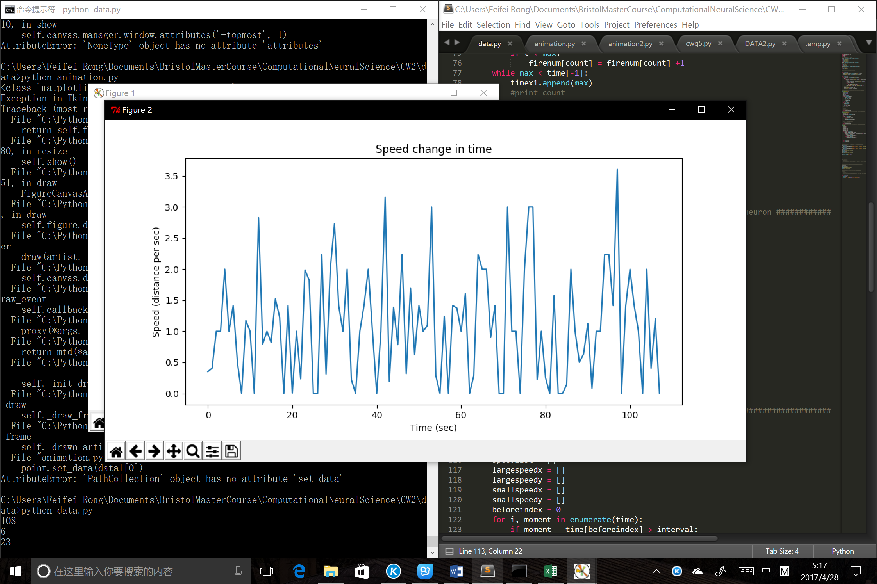

( c ) ( d )

Figure 1. (a) All spike positions of neurons and positions with large firing rate. (b) All spike positions of neurons and rat large speed positions. (c) All spike positions of neurons and rat small speed positions. (d) Speed change of rat throughout the time.

From (a) in figure 1, neuron 1 tends to spike the most at the top right corner of the map. Neuron 2 tends to spike at the left part of the middle tunnel. Neuron 3 tends to spike at the top right end of the map. And Neuron 4 tends to spike at the left crossroad. The large firing rate positions demonstrate the same results. In (b), high speed positions mostly locate at the long tunnel in the map. Compared to (b), small speed positons mostly locate at the four ends and crossroads of the map. This makes sense, since the rat has to think where to go at the crossroads and the four ends of the map, where they will have lower speed. However, in the long and straight tunnel, there is only one way to go. Therefore, the speed tends to be a lot higher. According to the figure in (d), the threshold for large and small speed are chosen as 3 and 0.2 (distance/sec).

# The Auto-Correlograms of four neurons ranges in 1 sec

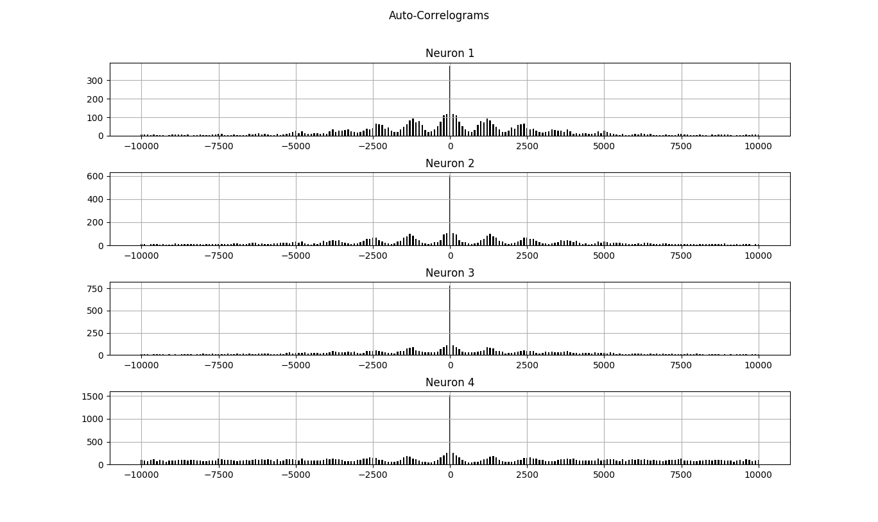

Figure 2 Auto Correlograms of the four neurons

The auto correlograms of each neuron shows the relationship of moments of the spike in one neuron. From the figure above we can see that the number of the condition that the two moments with only very small time difference are more than those with large differences. A decreasing tendency in time difference is shown from the centre to two the left and right ends of the figure and it is in a wave pattern. Though, the pattern of neuron is not obvious outside the [-5000,5000] range, where they all have the same time difference.

# The Cross-Correlograms of the four neurons ranges in 1 sec

# 

Figure 3 Cross-Correlograms of 4 neurons with each other.

# Histograms of firing rate during the whole experiment time

Figure 4 The firing rates (times per sec) histograms for 4 neurons

In the figure 3 we can see that the cross-correlograms of neuron1 and neuron2 are very neat. In Figure 4, we can find the peak value in neuron 2 can often find the one similar in neuron 1. They have 5000 phase shift with each other according to figure 3. From the neuron 1 and neuron 4 cross-correlograms in figure 3, the very peak value locates around 0 for time difference, which means, these two neurons are synchronized. Also for the neuron1 to neuron 3 cross-correlograms, peak value correspond to the one second lag of neuron 3.

# Animations of the rat moving in the map with spike demonstration for each neuron

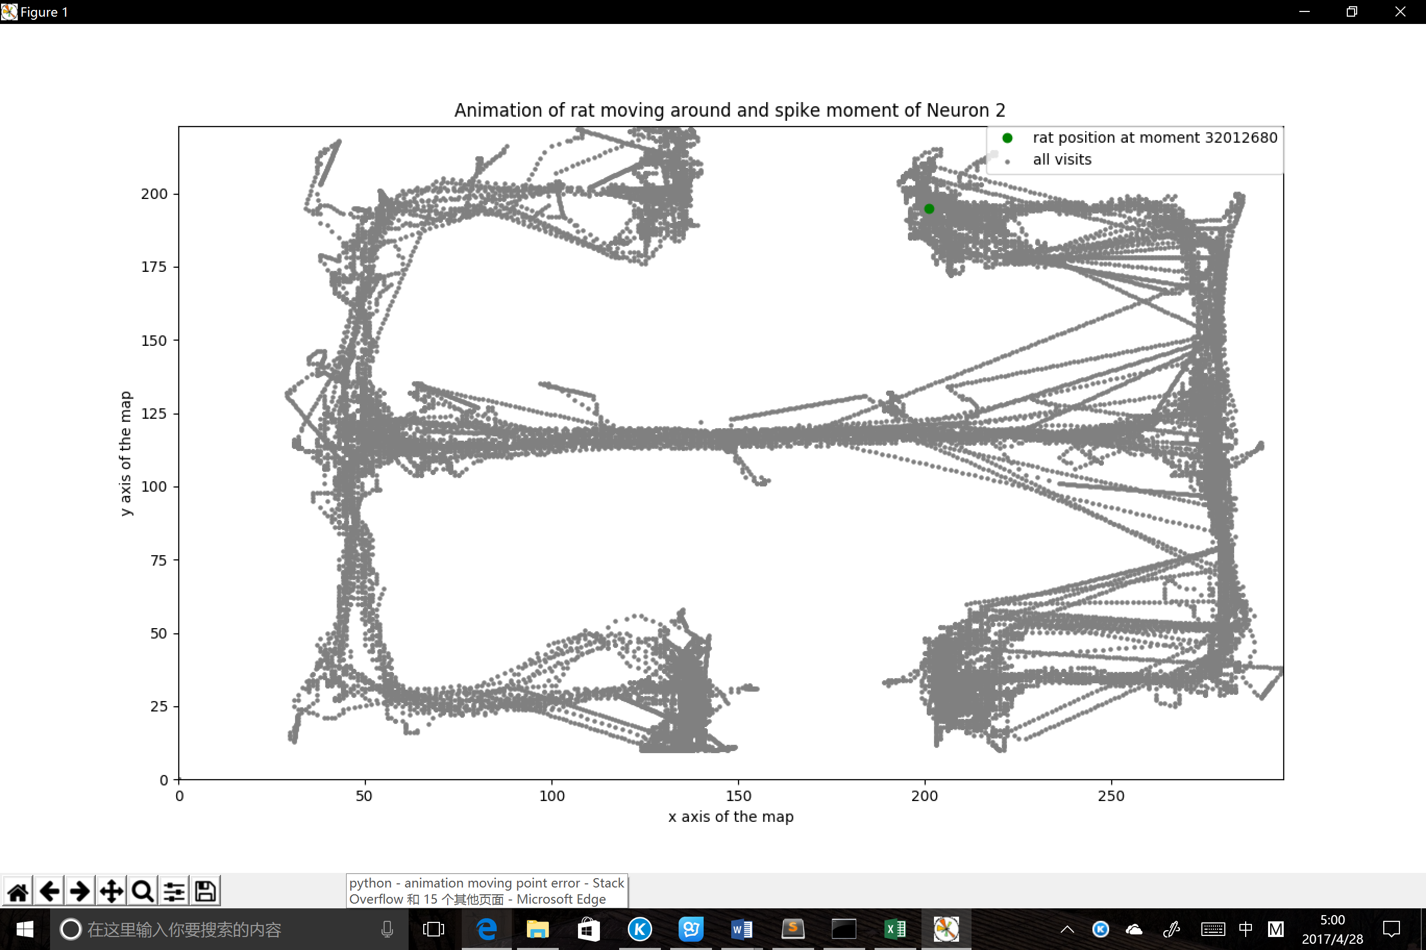

Figure 5 Animation capture of the rat moving around the map.

An animation of the whole moving process has been generated in python. The green dot corresponds to the current position of the rat. The current moment time shows on the top right. A parameter at the very beginning of the program is modified for showing different target neurons. When the target neuron spikes, the green dot will turn red.