**Computational Neuroscience**

**Coursework 1 Report**

Feifei Rong

Candidate Number: 33063

# Q1

According to the equation of Integrate and Fire Model, V satisfies:

$$τ_{m}\frac{dV}{dt}=E_{L}-V+R_{m}I_{e}$$

If $V≥V_{T}$ a spike will happen and the voltage is set to a reset value ${ V}_{R}$,the solution to this equation is:

$$V\left(t\right)=E_{L}+R_{m}I_{e}+\left(V\left(t_{0}\right)-E_{L}-R_{m}I_{e}\right)exp⁡(-\frac{t-t_{0}}{τ_{m}})$$

$$V\left(t+∆t\right)=E_{L}+R_{m}I_{e}(i)+\left(V\left(t\right)-E_{L}-R_{m}I_{e}(t)\right)exp⁡(-\frac{∆t}{τ_{m}})$$

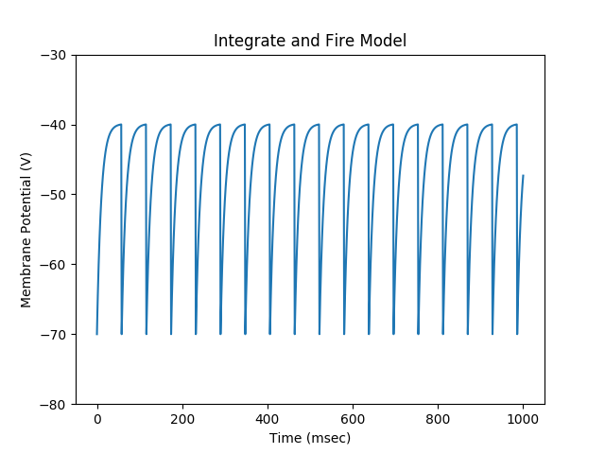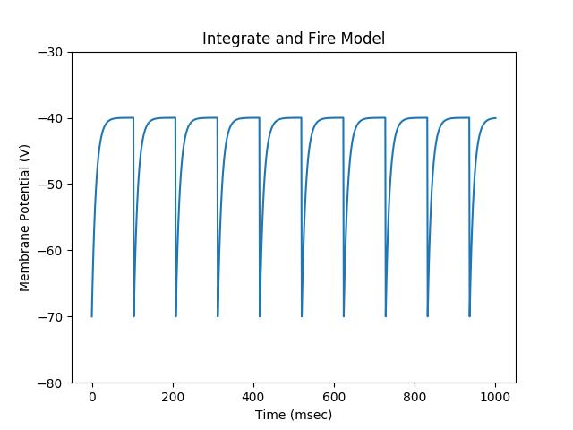

Figure 1 Integrate and Fire Model for Q1 Figure 2 Integrate and Fire Model for Q2 when Ie = 3.0001

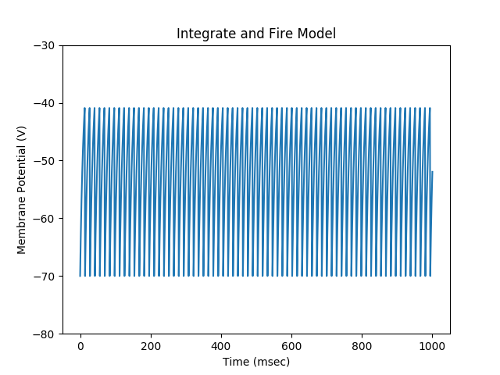

Figure 3 Integrate and Fire Model for Q2 when Ie=3 Figure 4 Integrate and Fire Model for Q2 when Ie = 4

# Q2

According to the model in Q1, we can generate:

$$I_{e}=\frac{V_{th}-E_{L}}{R_{m}}=3$$

The result shows that any value of Ie larger than 3 will make spike happen in the neuron, and any value of Ie smaller or equal to 3 will result to no spikes. As Figure 2, Figure 3 , Figure 4 show above.

# Q3

The result of Q3 shows below in Figure 5.

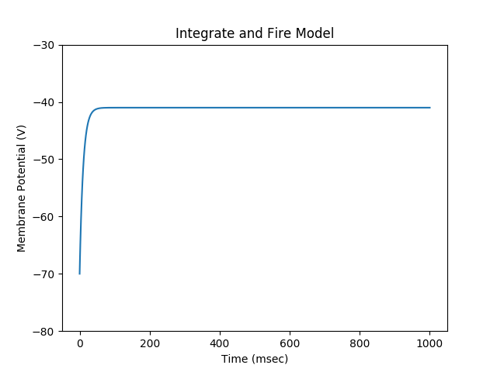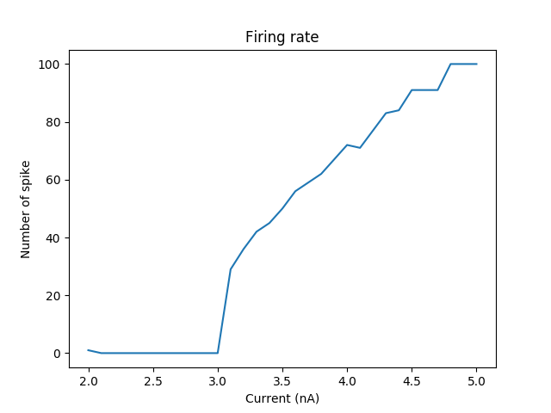

Figure 5 Integrate and Fire Model for Q3 when Ie=2.9 Figure 6 Integrate and Fire Model for Q4

# Q4

The result of Q4 shows above in Figure 6. When the input current become larger, the Number of spike will increase, which indicates higher current will result to more frequent happening of spikes.

# Q5

Initial Value

V

V

V

V

Neuron 1

Neuron 2

Synaptic 1

Synaptic 2

Figure 7 Two neurons with synaptic between each other Figure 8 Voltage update demonstration

The two neurons model is shown in Figure 7. The program first generates a voltage value of neuron1 from the initial value set by person. The voltage of neuron2 then can be calculated from the voltage of neuron1. Then in the next time slot, the voltage of neuron 1 can be calculated using the voltage of neuron2 from the previous time slot.

According to the equation in Q1, We have:

$$V\left(t\right)=E_{L}+R_{m}I_{e}+R_{m}I_{s}+\left(V\left(t_{0}\right)-E_{L}-R_{m}I_{e}\right)exp⁡(-\frac{t-t_{0}}{τ_{m}})$$

$I_{s}\left(t\right)=g_{s}s(t)(E_{s}-V)$, $s\left(t\right)=exp(-\frac{t}{τ_{s}})$

$$V\left(t\right)=E_{L}+R_{m}I_{e}+R_{m}({ g}_{s}\left(E_{s}-V\right)exp(-\frac{t}{τ_{s}}) )+\left(V\left(t_{0}\right)-E_{L}-R_{m}I_{e}\right)exp⁡(-\frac{t-t_{0}}{τ_{m}})$$

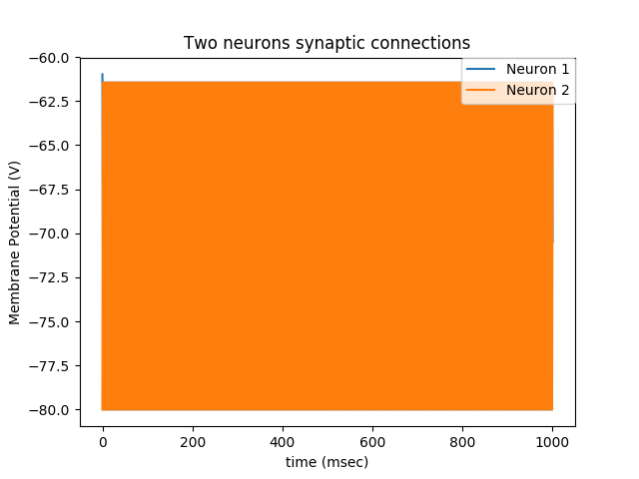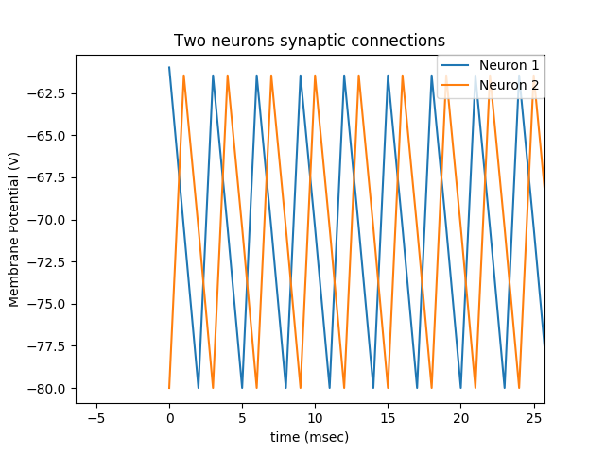

Figure 9 Two neurons model with initial value = -60 Es =0 Figure 10 Zoom-in of Figure 9

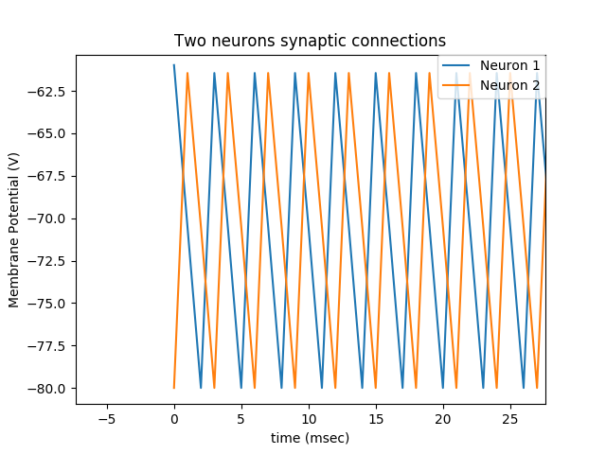

Figure 11 Two neurons model with initial value = -60 Es =-80 Figure 12 Zoom-in of Figure 11

# Q7

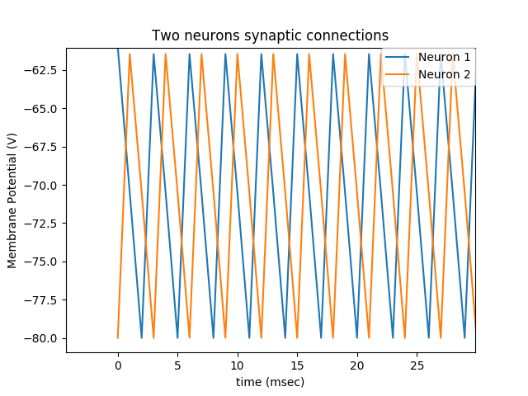

Figure 13 Two neurons model with alpha function Figure 14 Zoom-in of Figure13