Problem 1

a) joint likelihood:
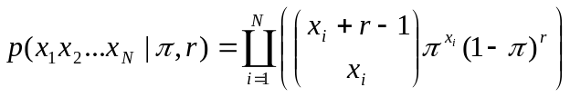

b) Derive the maximum likelihood estimate for π:
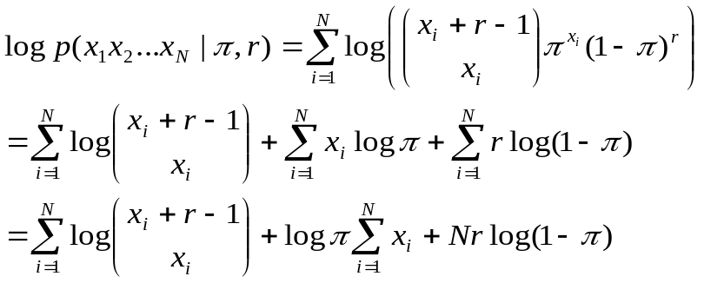
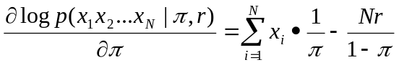
Set 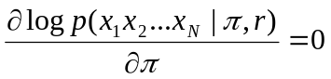 => 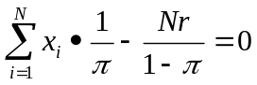 =>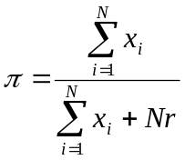
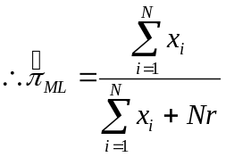

c) Derive MAP for π:
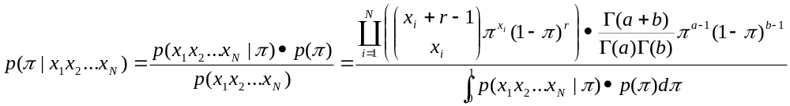The denominator is irrelevant of π, so
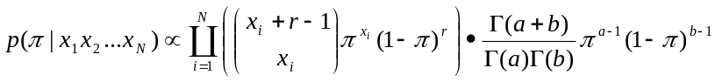
Let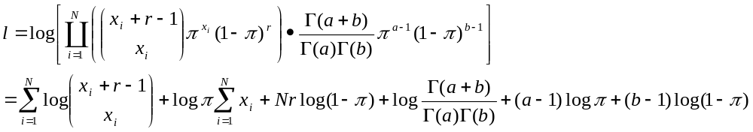
Set 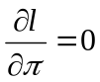 => 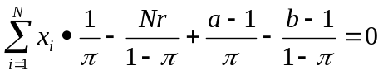=> 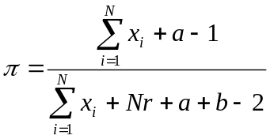
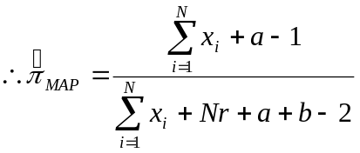

d) derive the posterior distribution of π:
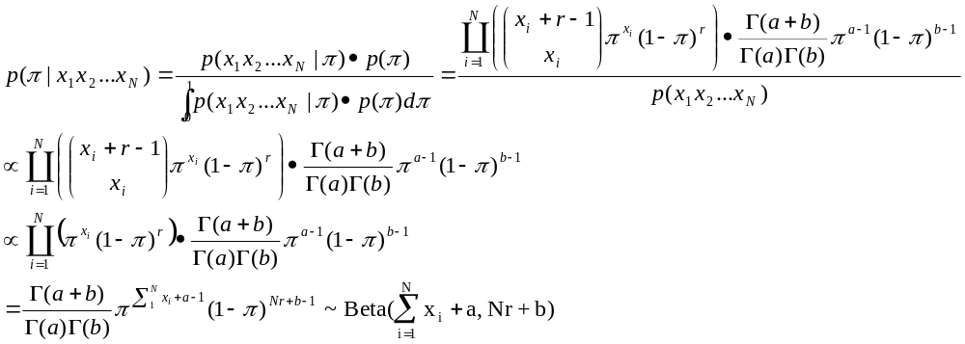

e) the mean and variance of 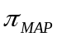:
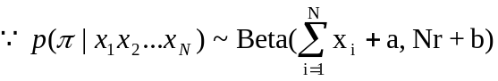
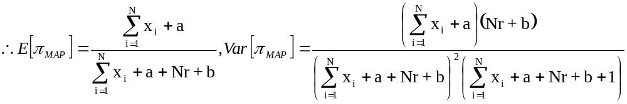

The mean of is very similar to 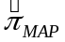. depends not only on given data, but also on the prior distribution of π. While as for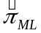, it only depends on the given data.

Problem 2

a)
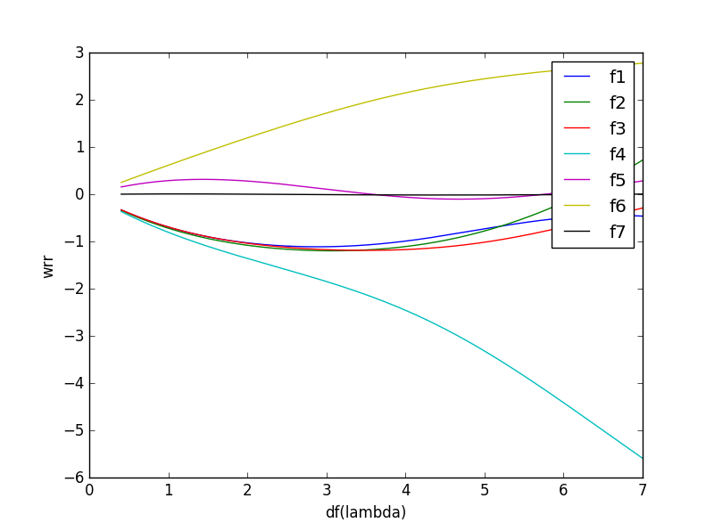

b)
Feature 4 and Feature 6 have a greater impact on the predictive value y, for they have larger absolute values.

c)

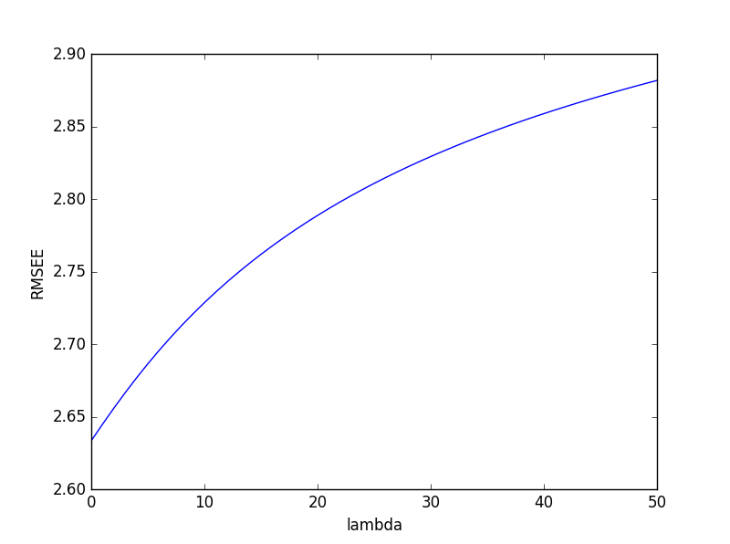

RMSE increases when λ become larger, so we should choose λ= 0. That’s to calculate w_{LS}

