Problem 1
b)
+---------------+
| RMSE |
+---------------+
| 1.96627609591 |
| 1.93313534319 |
| 1.92342020368 |
| 1.92219759607 |
| 1.92476911509 |
| 1.92921254653 |
| 1.93463406769 |
| 1.94058309861 |
| 1.94681993595 |
| 1.95321250125 |
| 1.92016325832 |
| 1.9048765174 |
| 1.90808032792 |
| 1.91590167624 |
| 1.92480407564 |
| 1.93370139922 |
| 1.94225376685 |
| 1.95038003768 |
| 1.95809306541 |
| 1.96543803863 |
| 1.89764875193 |
| 1.90251912976 |
| 1.91764768944 |
| 1.93251433041 |
| 1.94569947287 |
| 1.957234791 |
| 1.9674032573 |
| 1.97649174935 |
| 1.98474077166 |
| 1.99234121105 |
| 1.89050711498 |
| 1.91498100877 |
| 1.93884877947 |
| 1.95793624544 |
| 1.97321582488 |
| 1.98576420798 |
| 1.996375139 |
| 2.00560321943 |
| 2.01383544465 |
| 2.02134479974 |
| 1.89584850116 |
| 1.93558590067 |
| 1.96459732112 |
| 1.9855019944 |
| 2.00131427327 |
| 2.01387845082 |
| 2.02431037883 |
| 2.03330677928 |
| 2.0413174914 |
| 2.04864155177 |
| 1.90960321608 |
| 1.95954883215 |
| 1.99080358539 |
| 2.01191545332 |
| 2.02737028478 |
| 2.03946516631 |
| 2.04946337921 |
| 2.05810489069 |
| 2.06584526946 |
| 2.07297605879 |
+---------------+

c) The best value comes from 31st iteration, that’s b = 11, σ=0.1, RMSE = 1.89050711498. It’s less than that in homework 1. However, the drawback of this approach is that we should assume that the data is Gaussian distributed, and computing the kernel is a bit time-consuming.
d)
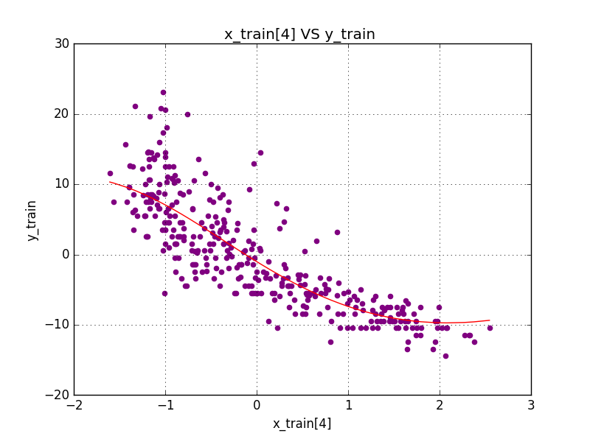

Problem 2
a)
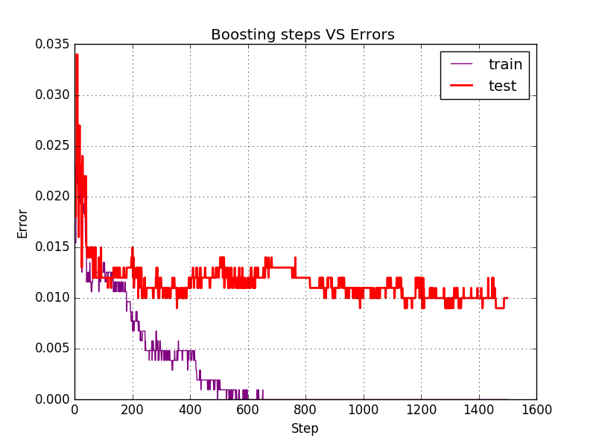

b)
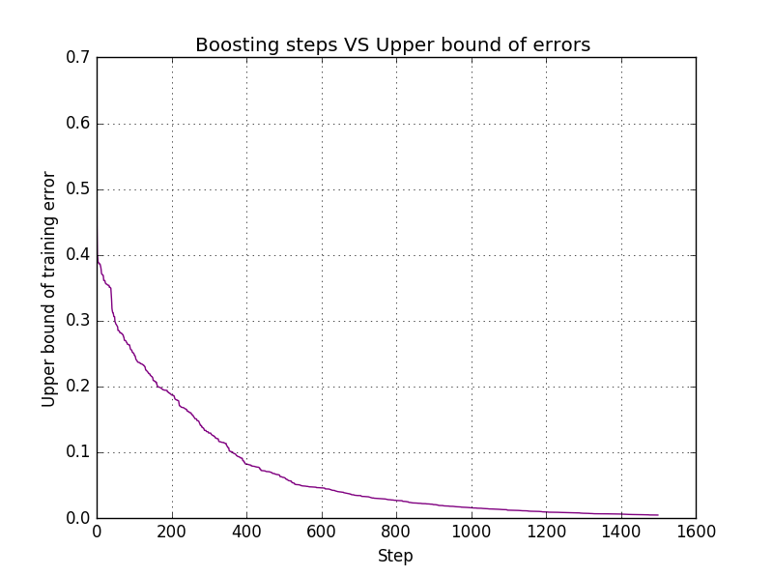
c)
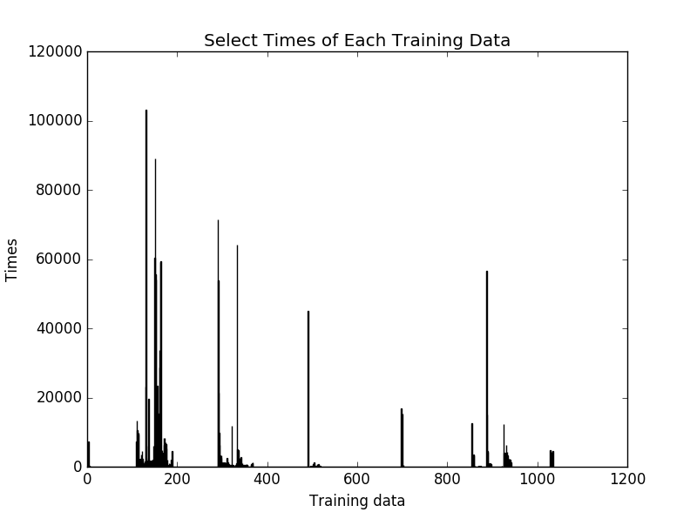
d)
