Colorado Car Accident Severity Prediction

By

Joanna Johnson

Applied Data Science Capstone

Course 9 of IBM Data Science Professional Certificate

Table of Contents

Introduction / business problem 2

Data 3

Data Source 3

Data Cleaning 5

Methodology 7

Exploratory Data Analysis 7

Feature Selection 14

Classification Algorithms 14

Results 15

Discussion 16

Conclusion 17

acknowledgement 18

# Introduction / business problem

Here’s the scenario, you are driving to work. It’s cloudy and windy, the roads are wet and slushy from last night’s snow. Traffic is slow as expected but it’s not too bad (you already left home earlier anticipating slow traffic), until you get on the highway. Long lines of cars barely moving, police cars and ambulances passing by. You turn on the radio, there’s an accident happening about 10 miles ahead of you. Now your navigation system shows the highway segments ahead of you all jammed and marked in dark red. You are wondering if you should get off the highway at next exit to take an alternative route (longer way to work, it usually takes more time, but probably faster than the jammed highway now). But what if the accident ahead of you is not that bad after all and will be cleared soon?

Wouldn’t it be great if there’s something in place that could warn you, given the weather, road conditions and other information about the severity of the accident, so you can make an informed decision?

That’s exactly what I’m going to work on in this project. It will help all drivers, as well as companies who provide navigation services to make better informed decisions in this situation. Also redirect traffic from the scene of the accident to minimize its impact to the traffic.

# Data

### Data Source

The data I’m going to use for this project is called Colorado-Accidents, a subset of US-Accidents dataset, which covers Colorado traffic events data from February 2016 to June 2020. There are **49,731** accident records in this dataset. It’s in csv format. Below is the table of attributes.

| **#** | **Attribute** | **Description** | **Nullable** |
| --- | --- | --- | --- |
| 1 | Rush_Hour | Indicates if the accident happens in rush hour (1-yes, 0-no). It’s derived from Start_Time. Rush hours are 6:00-10:00 and 15:00-19:00. | No |
| 2 | Duration_in_Hour | Shows how long (in hours) the impact on traffic caused by the accident. It’s calculated as (End_Time – Start_Time) | No |
| 3 | Interstate | Shows if the accident happens on an interstate highway (1-yes, 0-no). It’s derived from Street attribute. | No |
| 4 | ID | This is a unique identifier of the accident record. | No |
| 5 | Source | Indicates source of the accident report (i.e. the API which reported the accident.). | No |
| 6 | TMC | A traffic accident may have a [Traffic Message Channel (TMC)](https://wiki.openstreetmap.org/wiki/TMC/Event_Code_List) code which provides more detailed description of the event. | Yes |
| 7 | Severity | Shows the severity of the accident, a number between 1 and 4, where 1 indicates the least impact on traffic (i.e., short delay as a result of the accident) and 4 indicates a significant impact on traffic (i.e., long delay). | No |
| 8 | Start_Time | Shows start time of the accident in local time zone. | No |
| 9 | End_Time | Shows end time of the accident in local time zone. End time here refers to when the impact of accident on traffic flow was dismissed. | No |
| 10 | Start_Lat | Shows latitude in GPS coordinate of the start point. | No |
| 11 | Start_Lng | Shows longitude in GPS coordinate of the start point. | No |
| 12 | End_Lat | Shows latitude in GPS coordinate of the end point. | Yes |
| 13 | End_Lng | Shows longitude in GPS coordinate of the end point. | Yes |
| 14 | Distance(mi) | The length of the road extent affected by the accident. | No |
| 15 | Description | Shows natural language description of the accident. | No |
| 16 | Number | Shows the street number in address field. | Yes |
| 17 | Street | Shows the street name in address field. | Yes |
| 18 | Side | Shows the relative side of the street (Right/Left) in address field. | Yes |
| 19 | City | Shows the city in address field. | Yes |
| 20 | County | Shows the county in address field. | Yes |
| 21 | State | Shows the state in address field. | Yes |
| 22 | Zipcode | Shows the zipcode in address field. | Yes |
| 23 | Country | Shows the country in address field. | Yes |
| 24 | Timezone | Shows timezone based on the location of the accident (eastern, central, etc.). | Yes |
| 25 | Airport_Code | Denotes an airport-based weather station which is the closest one to location of the accident. | Yes |
| 26 | Weather_Timestamp | Shows the time-stamp of weather observation record (in local time). | Yes |
| 27 | Temperature(F) | Shows the temperature (in Fahrenheit). | Yes |
| 28 | Wind_Chill(F) | Shows the wind chill (in Fahrenheit). | Yes |
| 29 | Humidity(%) | Shows the humidity (in percentage). | Yes |
| 30 | Pressure(in) | Shows the air pressure (in inches). | Yes |
| 31 | Visibility(mi) | Shows visibility (in miles). | Yes |
| 32 | Wind_Direction | Shows wind direction. | Yes |
| 33 | Wind_Speed(mph) | Shows wind speed (in miles per hour). | Yes |
| 34 | Precipitation(in) | Shows precipitation amount in inches, if there is any. | Yes |
| 35 | Weather_Condition | Shows the weather condition (rain, snow, thunderstorm, fog, etc.) | Yes |
| 36 | Amenity | A [POI](https://wiki.openstreetmap.org/wiki/Points_of_interest) annotation which indicates presence of [amenity](https://wiki.openstreetmap.org/wiki/Key:amenity) in a nearby location. | No |
| 37 | Bump | A POI annotation which indicates presence of speed bump or hump in a nearby location. | No |
| 38 | Crossing | A POI annotation which indicates presence of [crossing](https://wiki.openstreetmap.org/wiki/Key:crossing) in a nearby location. | No |
| 39 | Give_Way | A POI annotation which indicates presence of [give_way](https://wiki.openstreetmap.org/wiki/Tag:highway%3Dgive_way) in a nearby location. | No |
| 40 | Junction | A POI annotation which indicates presence of [junction](https://wiki.openstreetmap.org/wiki/Key:junction) in a nearby location. | No |
| 41 | No_Exit | A POI annotation which indicates presence of [no_exit](https://wiki.openstreetmap.org/wiki/Key:noexit) in a nearby location. | No |
| 42 | Railway | A POI annotation which indicates presence of [railway](https://wiki.openstreetmap.org/wiki/Key:railway) in a nearby location. | No |
| 43 | Roundabout | A POI annotation which indicates presence of [roundabout](https://wiki.openstreetmap.org/wiki/Tag:junction%3Droundabout) in a nearby location. | No |
| 44 | Station | A POI annotation which indicates presence of [station](https://wiki.openstreetmap.org/wiki/Key:station) in a nearby location. | No |
| 45 | Stop | A POI annotation which indicates presence of [stop](https://wiki.openstreetmap.org/wiki/Key:stop) in a nearby location. | No |
| 46 | Traffic_Calming | A POI annotation which indicates presence of [traffic_calming](https://wiki.openstreetmap.org/wiki/Key:traffic_calming) in a nearby location. | No |
| 47 | Traffic_Signal | A POI annotation which indicates presence of [traffic_signal](https://wiki.openstreetmap.org/wiki/Tag:highway%3Dtraffic_signals) in a nearby location. | No |
| 48 | Turning_Loop | A POI annotation which indicates presence of [turning_loop](https://wiki.openstreetmap.org/wiki/Tag:highway%3Dturning_loop) in a nearby location. | No |
| 49 | Sunrise_Sunset | Shows the period of day (i.e. day or night) based on sunrise/sunset. | Yes |
| 50 | Civil_Twilight | Shows the period of day (i.e. day or night) based on [civil twilight](https://en.wikipedia.org/wiki/Twilight#Civil_twilight). | Yes |
| 51 | Nautical_Twilight | Shows the period of day (i.e. day or night) based on [nautical twilight](https://en.wikipedia.org/wiki/Twilight#Nautical_twilight). | Yes |
| 52 | Astronomical_Twilight | Shows the period of day (i.e. day or night) based on [astronomical twilight](https://en.wikipedia.org/wiki/Twilight#Astronomical_twilight). | Yes |

I will use the traffic events (e.g., accident, lane closed, congestion, etc), weather (e.g., visibility, wind speed, weather condition), and time (e.g., day of week, hour of day, and period of day) to build a machine learning model for live prediction of car accidents’ severity level (1-4) in terms of impact on traffic, level 1 indicates the least impact on traffic (e.g., short delay), level 4 indicates a significant impact on traffic (e.g., long delay).

### Data Cleaning

This dataset has total 51 independent attributes, there’re quite some will not be used in this project. I kept 23 of them for further analysis.

| **#** | **Attribute** | **Drop / Keep** | **Reason to Drop** |
| --- | --- | --- | --- |
| 1 | Rush_Hour | Keep |  |
| 2 | Duration_in_Hour | Keep |  |
| 3 | Interstate | Keep |  |
| 4 | ID | Drop | This is just an identification number. Drop |
| 5 | Source | Drop | It shows source of the record, not useful for the prediction. Drop |
| 6 | TMC | Drop | There’re too many missing data (38%), Drop |
| 7 | Severity | Keep |  |
| 8 | Start_Time | Drop | Rush_Hour and Duration_in_Hour are derived from Start_Time, End_Time, Drop |
| 9 | End_Time | Drop | Rush_Hour and Duration_in_Hour are derived from Start_Time, End_Time, Drop |
| 10 | Start_Lat | Drop | No information on Road Segments’ latitude longitude, Drop |
| 11 | Start_Lng | Drop | No information on Road Segments’ latitude longitude, Drop |
| 12 | End_Lat | Drop | No information on Road Segments’ latitude longitude, Drop |
| 13 | End_Lng | Drop | No information on Road Segments’ latitude longitude, Drop |
| 14 | Distance(mi) | Keep |  |
| 15 | Description | Drop | Descriptive Text, hard to use in prediction. Drop |
| 16 | Number | Drop | Street number is not useful, Drop |
| 17 | Street | Drop | Interstate is derived from this column, Drop (potentially it can be used to derive Road_Type attribute if a mapping can be found) |
| 18 | Side | Drop | Not useful, Drop |
| 19 | City | Drop | Will not use for this project, Drop |
| 20 | County | Drop | Will not use for this project, Drop |
| 21 | State | Drop | Not useful in Colorado_Accidents dataset because they are all in one value “CO”, Drop |
| 22 | Zipcode | Drop | Will not use for this project, Drop |
| 23 | Country | Drop | Not useful in Colorado_Accidents dataset because they are all in one value “US”, Drop |
| 24 | Timezone | Drop | Not useful in Colorado_Accidents dataset because they are all in one value “US/Mountain”, Drop |
| 25 | Airport_Code | Drop | Will not use for this project, Drop |
| 26 | Weather_Timestamp | Drop | Will not use for this project, Drop |
| 27 | Temperature(F) | Keep |  |
| 28 | Wind_Chill(F) | Drop | Will not use, Drop |
| 29 | Humidity(%) | Keep |  |
| 30 | Pressure(in) | Keep |  |
| 31 | Visibility(mi) | Keep |  |
| 32 | Wind_Direction | Drop | Will not use for this project, Drop |
| 33 | Wind_Speed(mph) | Keep |  |
| 34 | Precipitation(in) | Drop | Will not use for this project, Drop |
| 35 | Weather_Condition | Keep |  |
| 36 | Amenity | Drop | Will not use for this project, Drop |
| 37 | Bump | Keep |  |
| 38 | Crossing | Keep |  |
| 39 | Give_Way | Keep |  |
| 40 | Junction | Keep |  |
| 41 | No_Exit | Keep |  |
| 42 | Railway | Keep |  |
| 43 | Roundabout | Keep |  |
| 44 | Station | Keep |  |
| 45 | Stop | Keep |  |
| 46 | Traffic_Calming | Keep |  |
| 47 | Traffic_Signal | Keep |  |
| 48 | Turning_Loop | Keep |  |
| 49 | Sunrise_Sunset | Drop | Will use Astronomical_Twilight for day or night, this attribute is duplicate, Drop |
| 50 | Civil_Twilight | Drop | Will use Astronomical_Twilight for day or night, this attribute is duplicate, Drop |
| 51 | Nautical_Twilight | Drop | Will use Astronomical_Twilight for day or night, this attribute is duplicate, Drop |
| 52 | Astronomical_Twilight | Keep |  |

# Methodology

### Exploratory Data Analysis

Target variable is obvious, “Severity”

Now let’s look at the relationship between each independent variable and the target variable “Severity”.

1. Relationship between Severity and Interstate

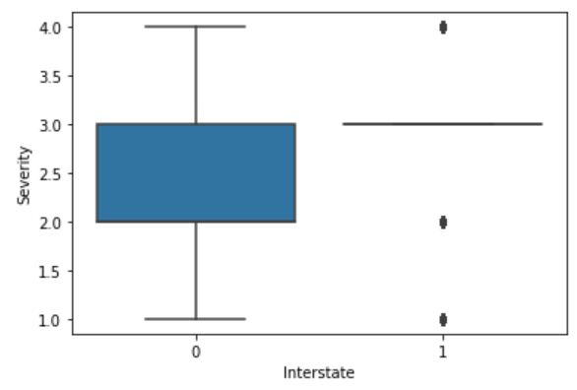

1. Relationship between Severity and Rush_Hour

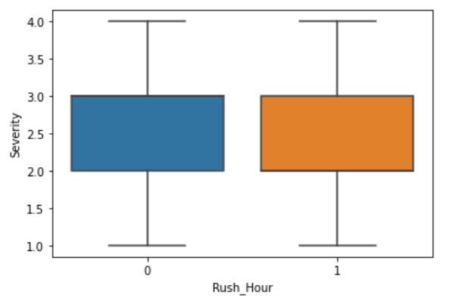

1. Relationship between Severity and Crossing

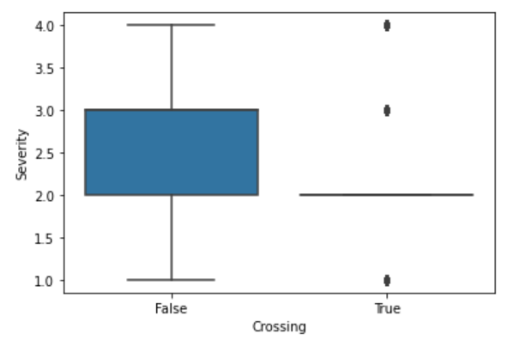

1. Relationship between Severity and Stop

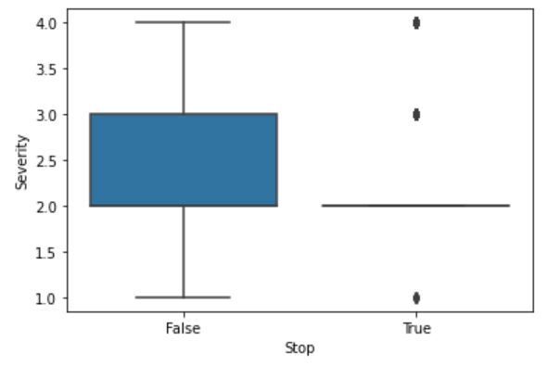

1. Relationship between Severity and Traffic_Signal

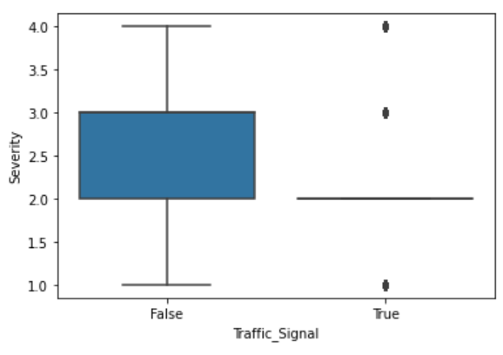

1. Relationship between Severity and Junction

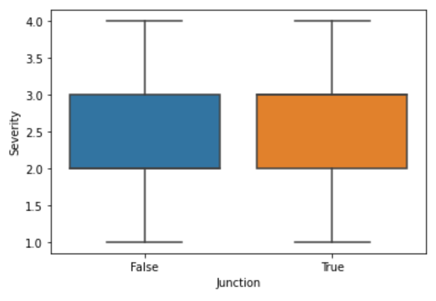

1. Relationship between Severity and Give_Way

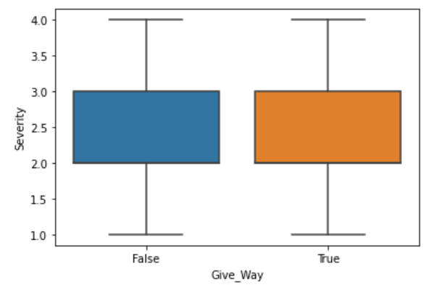

1. Relationship between Severity and Duration_in_Hour

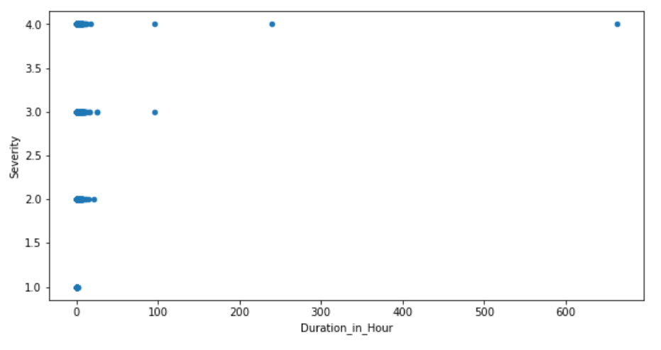

1. Relationship between Severity and Distance_mi

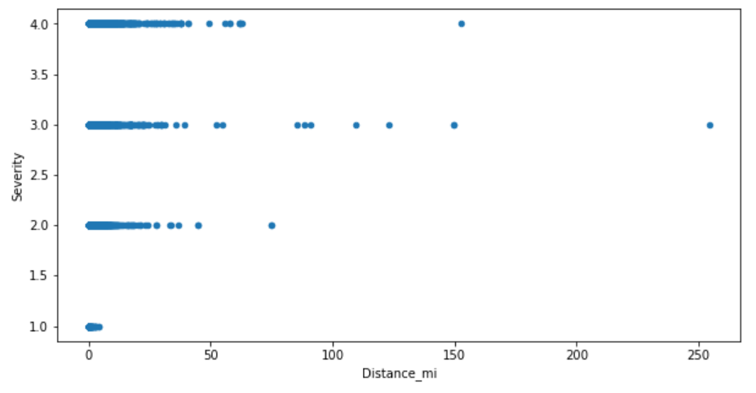

1. Relationship between Severity and Visibility_mi

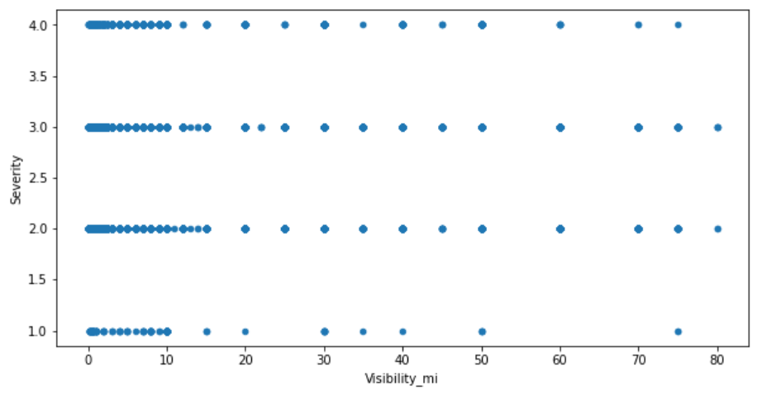

1. Relationship between Severity and Wind_Speed_mph

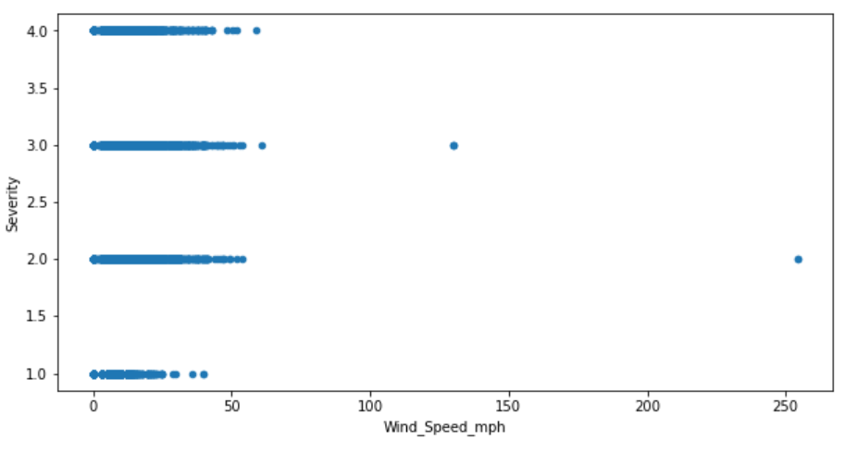

1. Relationship between Severity and Temperature_F

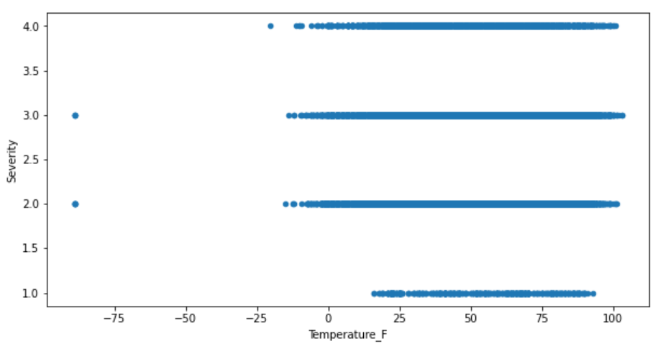

1. Relationship between Severity and Humidity_percent

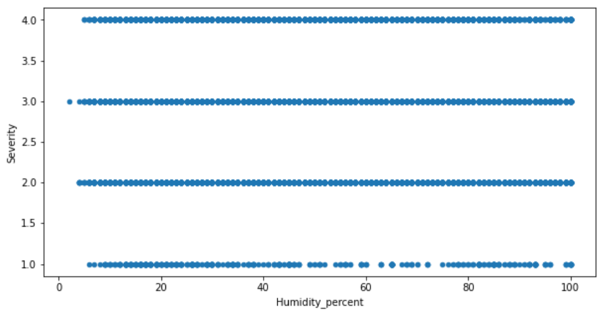

1. Relationship between Severity and Pressure_in

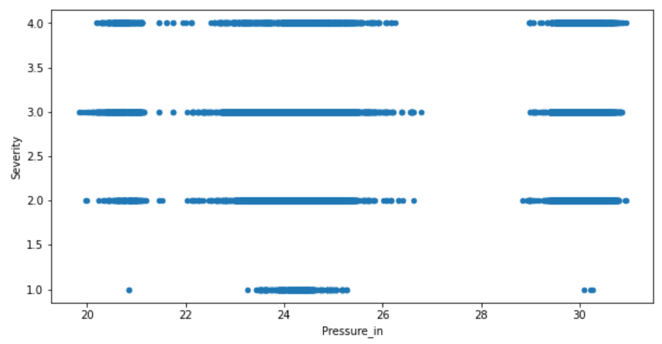

1. Relationship between Severity and Bump

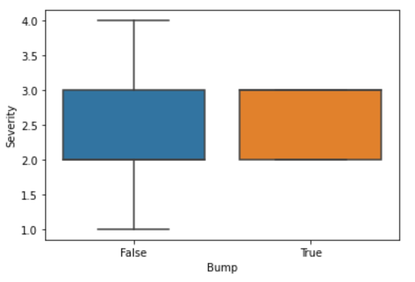

1. Relationship between Severity and No_Exit

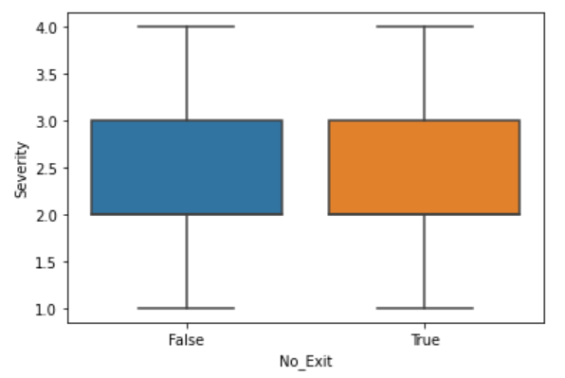

1. Relationship between Severity and Railway

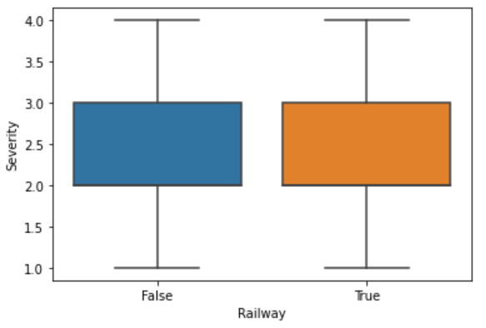

1. Relationship between Severity and Roundabout

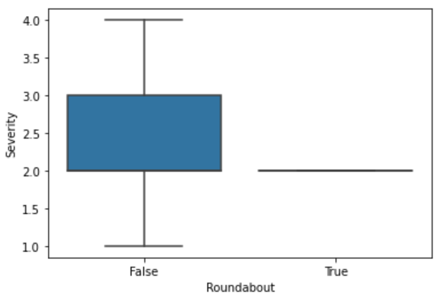

1. Relationship between Severity and Station

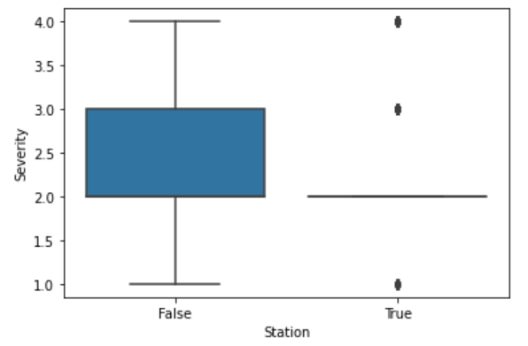

1. Relationship between Severity and Traffic_Calming

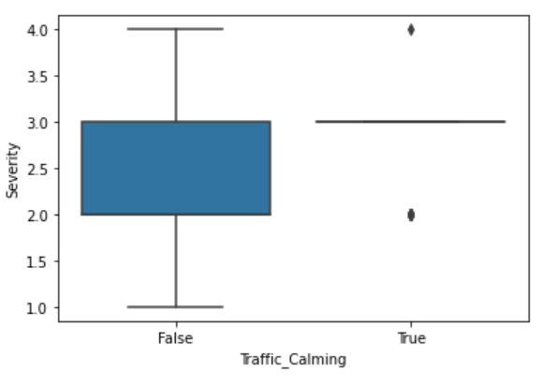

1. Relationship between Severity and Turning_Loop

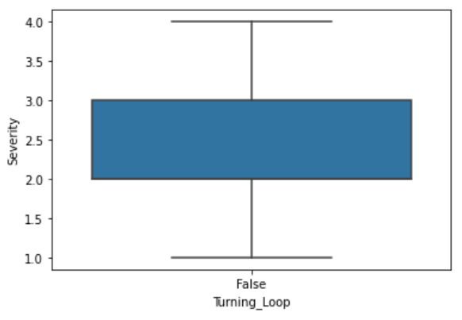

1. Relationship between Severity and Astronomical_Twilight

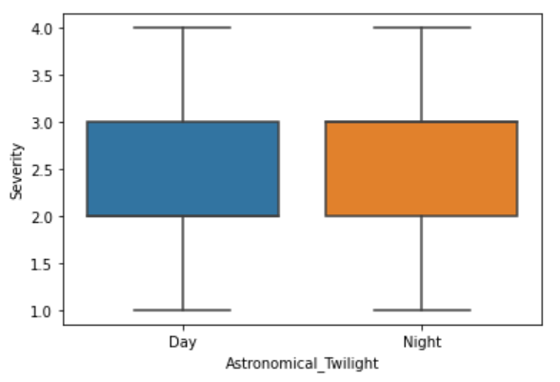

### Feature Selection

After reviewing above relationships between Severity and the independent variables, the following 10 features are selected for car accident severity prediction.

Duration_in_Hour

Interstate

Distance_mi

Crossing

Give_Way

Railway

Station

Stop

Traffic_Calming

Traffic_Signal

### Classification Algorithms

Target variable “Severity” has 4 possible values 1-4, it is multi-class classification. Therefore the binary classification algorithms “Logistic Regression” and “Support Vector Machine” cannot be used.

I used “K-Nearest Neighbors” and “Decision Trees” algorithms to build prediction models.

# Results

The dataset was split into training set (80%) and test set (20%). Train set was used to train the models, while test set was used for accuracy evaluation.

**KNN**

The best accuracy is 0.7469588820749975 with K=13

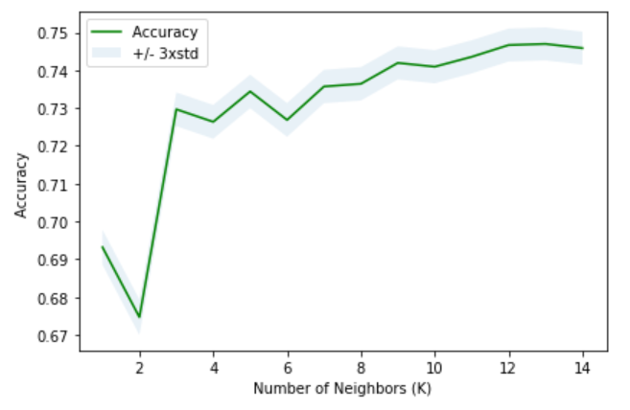

**Decision Tree**

Decision Tree’s accuracy is 0.7532924499849201

**Comparison**

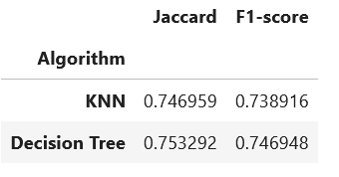

**Model Selection**

The two models have very similar accuracy. Decision Tree model performs slight better than KNN. Therefore, I chose *Decision Tree* model for Colorado Car Accident Severity Prediction.

# Discussion

The dataset Colorado_Accidents is a subset of US_Accidents, comparing with California or New York, it’s a small-scale dataset. If we can get more data for model training, it will sure help improving the model’s accuracy.

There’re more attributes can contribute to accident severity (in terms of impact on traffic), such as number of lanes, construction, police on site, ambulance on site, etc. If they can also be included in the dataset, it will help more accurate prediction for sure.

TMC code tells a lot, unfortunately it’s missing from all records from source “Bing”, it’s 38% missing in Colorado_Accidents dataset, which makes it not usable.

# Conclusion

Traffic Jam is always a challenge for big cities due to population density and aged highway networks. How to redirect traffic when an accident happens to minimize its impact on traffic is a big rewarding problem. This project is just a start, which I hope will lead to a more depth research, to truly help people to get their destination sooner safely.

# acknowledgement

* Moosavi, Sobhan, Mohammad Hossein Samavatian, Srinivasan Parthasarathy, and Rajiv Ramnath. [“A Countrywide Traffic Accident Dataset.”](https://arxiv.org/abs/1906.05409), arXiv preprint arXiv:1906.05409 (2019).
* Moosavi, Sobhan, Mohammad Hossein Samavatian, Srinivasan Parthasarathy, Radu Teodorescu, and Rajiv Ramnath. [“Accident Risk Prediction based on Heterogeneous Sparse Data: New Dataset and Insights.”](https://arxiv.org/abs/1909.09638)