transactionsIDs – Lista idkow transakcji

firstshardingindicator – Boolean list z trzeb=ma wartosiami w zaleznosci gdzie ma byc shardowanie

expected responses - lista oczekiwanych resultow dla kazdego przypadku (5 opcji)

referencepointid – id of reference point created on trunk

txidsList.add( do tx with metadata and move them to shard: firstshardingindicator->0, edits on trunk before project branch )

create project branch and merge doing edits from two lists: firstshardingindicator->1, edits on trunk after project branch, edits on project branch

txidsList.add( do tx with metadata (edits on trunk after project branch, ))

txidsList.add( do tx with metadata and move them to shard: firstshardingindicator->2, edits on trunk after project branch was merged)



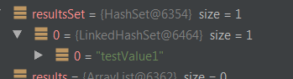

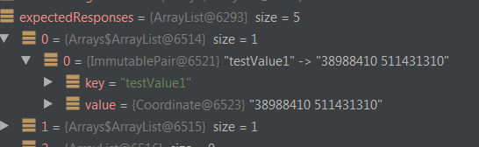

Params daje jakby request do MetadataResultList

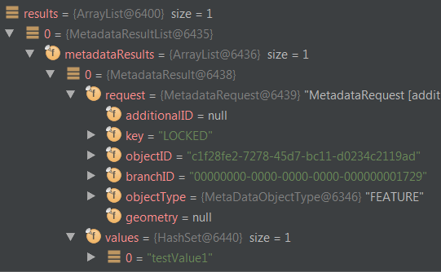

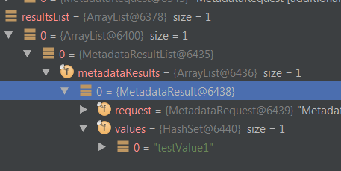

|  |  |
| --- | --- |
| GetAllMetadataInTransactionWithFunnelsTest | Set<String> |
| GetMetadataBatchInTransactionWithFunnelsTest | MetadataResultList |
| GetMetadataBatchWithFunnelsTest | MetadataResultList |
| GetMetadataInTransactionWithFunnelsTest | MetadataResultList |
| GetVersionMetadataWithFunnelsTest | MetadataContainer |