DMCS
Computer Aided Design of Electronic Circuits

REPORT 6
Operational amplifiers

Joanna Klinkiewicz
190097
IFE, TCS 2016

Basic configurations of operational amplifiers
DC ANALYSIS

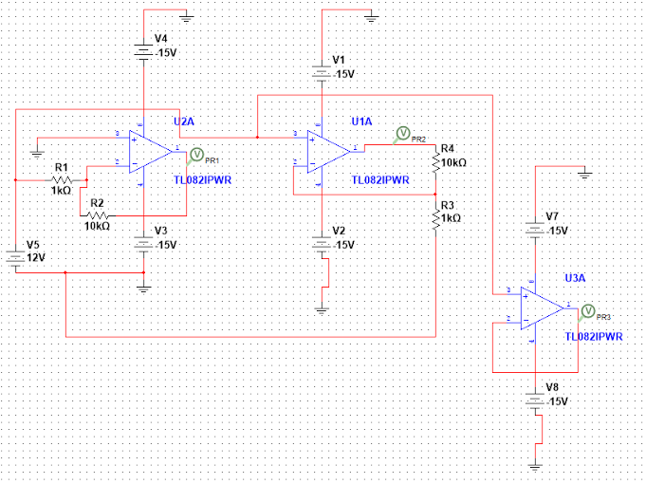
Plot. Circuit with operational amplifiers with both RAX and RBX resistors.

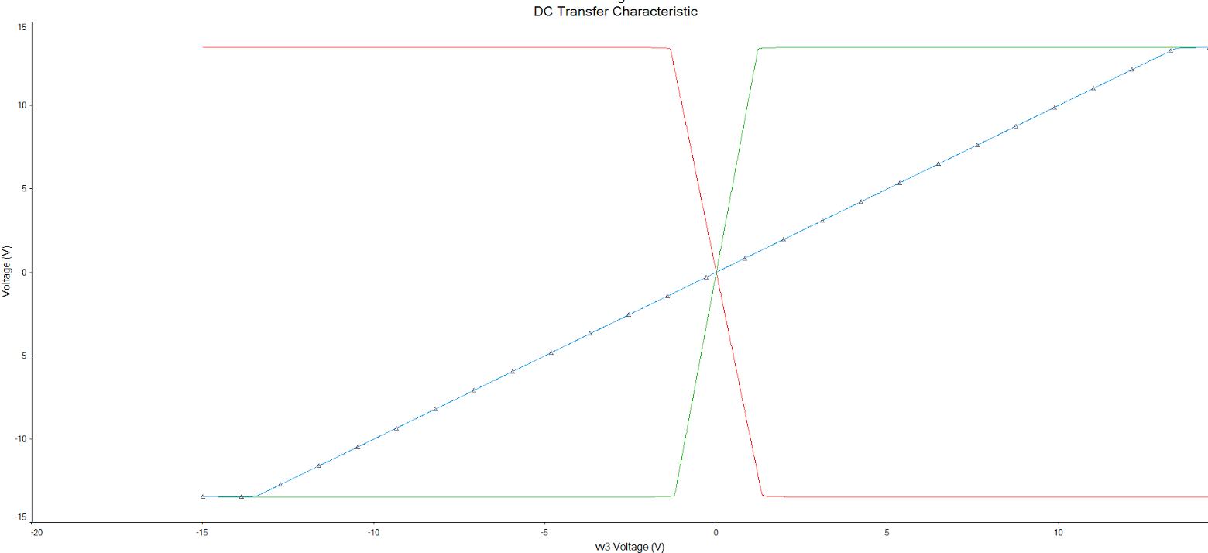
Plot. DC characteristics of operational amplifiers with both RAX and RBX resistors.

The plot presents 3 curves that represents as follows:
(red line) high voltage drastically going down is an inverting amplifier
(green line) low voltage drastically going up is an non-inverting amplifier
(blue line) linear voltage curve is a voltage follower

One can see that the plot presents correct curves. Amplifiers are getting saturated at the level of +-14V (straight line) and one cause voltage grow up (non-inverting amplifier), whereas another makes it drastically go down (inverting amplifier). The voltage follower curve looks like characteristic of voltage source – it follows input voltage.
Voltage follower – is also known as a buffer amplifier, is an op-amp circuit which has a voltage gain of 1. This means that the op amp does not provide any amplification to the signal. The reason it is called a voltage follower is because the output voltage directly follows the input voltage, meaning it is the same. A voltage follower acts as a buffer, providing no amplification or attenuation to the signal.
An op amp circuit is a circuit with a very high input impedance. This high input impedance is the reason voltage followers are used. The power of the circuit isn't affected when current is feeding a high impedance load.

AC ANALYSIS

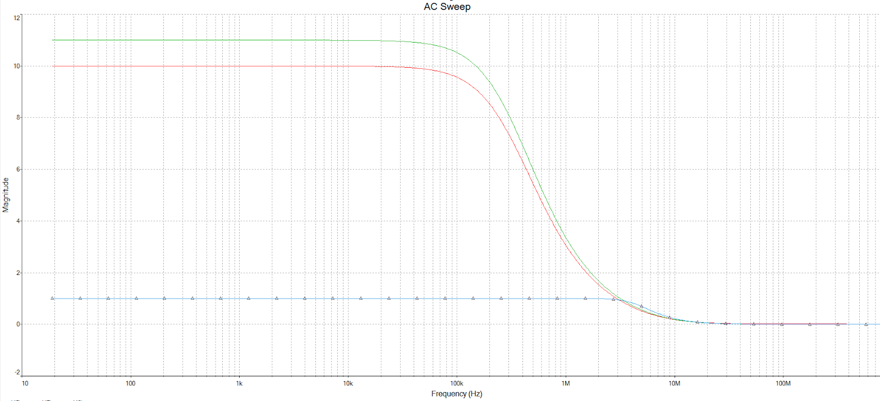
Plot. AC analysis – magnitude characteristics of operational amplifiers.

The plot presents 3 curves that represents as follows:
(green line) non-inverting amplifier
(red line) an inverting amplifier
(blue line) a voltage follower

The voltage gain for amplifiers might be described with following equations:
inverting amplifier G = - (RB/RA) = -10
non-inverting amplifier G = 1 + (RB/RA) = 11

The cut-off frequency that appears at the signal diminution to 3dBcan be read from a plot and is the following:
non-inverting amplifier: 11 V => 567 kHz
inverting amplifier: -10 V => 574 kHz
Voltage follower: 1*0,707 = 0,707 V => 17,8 MHz

TRANSIENT ANALYSIS

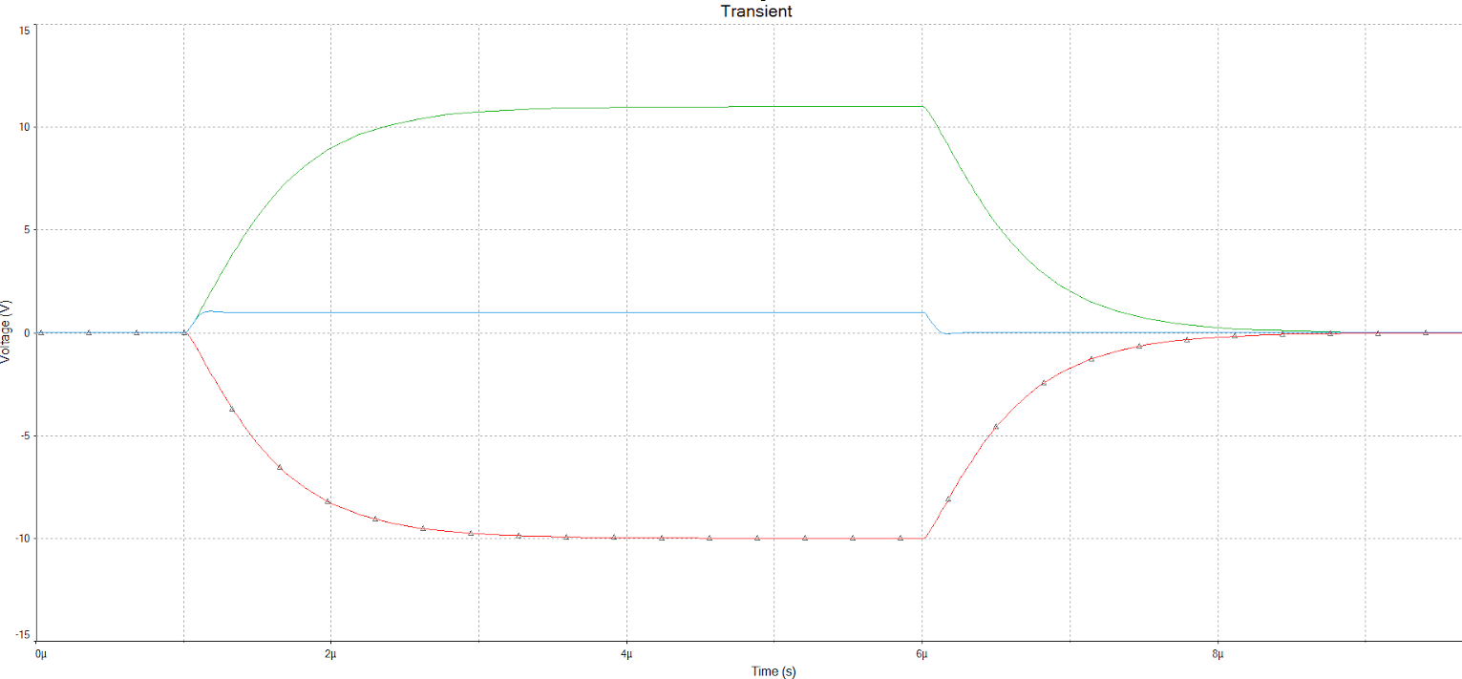
Plot. Transient characteristics of operational amplifiers.
The plot presents 3 curves that represents as follows:
(green line) non-inverting amplifier
(blue line) a voltage follower
(red line) an inverting amplifier

The Slew Rate of an op amp describes how fast the output voltage can change in response to an immediate change in voltage at the input. The higher the value (in V/µs) of slew rate, the faster the output can change and the more easily it can reproduce high frequency signals. However the fast rising and falling edges of the square wave can tend to cause the amplifier to oscillate for a short time after the rise or fall. To prevent this effect, the op amp’s internal circuitry contains a small amount of compensation capacitance that slows down the rate of change, so that very fast transient voltages do not trigger oscillation, but this compensation also limits the slew rate of the op amp, as shown in the plot above. We can see the rise and fall time are not very sharp, be there are no oscillations.
In some op amps, because this compensation is internal, there is no way of altering the slew rate, but others use an external compensation capacitor, and therefore provide the means to control slew rate to some degree.

PROJECT I

It is not possible to design an inverting/non-inverting amplifier having the voltage gain of 10000 V/V and the bandwidth of 10 kHz.

According to the datasheet the gain bandwidth of the device used in simulations is GBW = 13 V/us.
Therefore:
GBW = A * f
GBW 10000 V/V * 10000Hz = 100 V/us

The result is higher than the device parameters can be.

Circuits with op-amps

AC AND TRANSIENT ANALYSIS

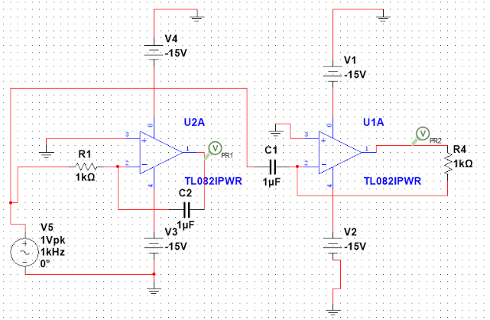
Plot. Schema of circuits.

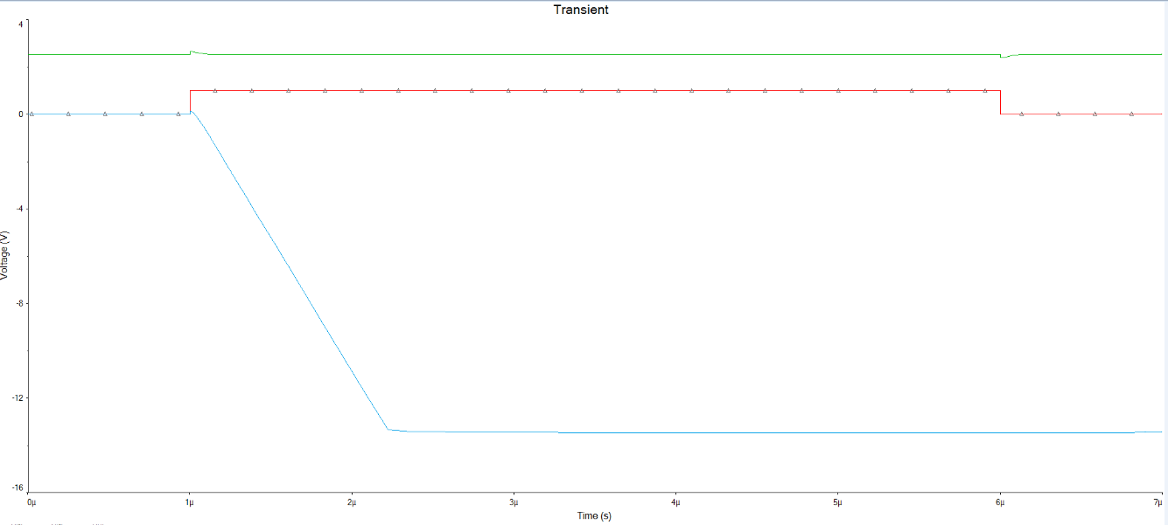
Plot. Transient analysis for a circuit showed above – incorrect plot.

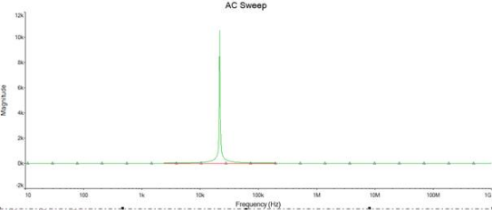
Plot. AC analysis of the operational amplifiers.

As one can see the presented plot is faulty, therefore one can see that the circuit is lacking some additional elements enabling correct voltage output for a signal.
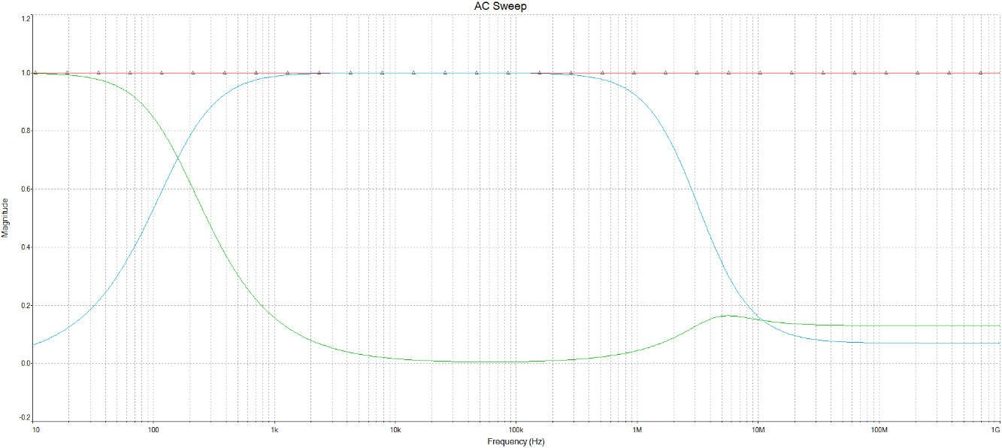
Plot. AC analysis (linear scale) for a circuit with additional resistors.
The above plot presents offset compensation which means we added two resistors – one to each circuit (one in parallel and one is series)
Therefore, two resistors were added to the circuit, as follows:
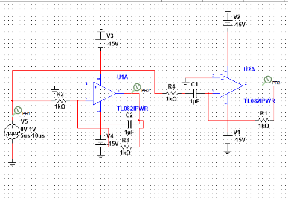
Now as we added to resistors – one in parallel and one in series, the circuit works properly.

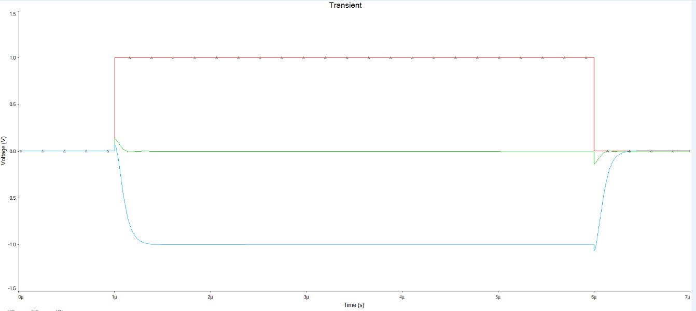
Plot. Transient analysis for a circuit showed above – correct plot.

As we can see the plots present two different mathematical functions, namely we have integrator and differentiator.The fundamental integrator circuit is constructed by placing a capacitor C, in the feedback loop of an inverting amplifier. The output voltage is thus the integral of the input. The voltage is the constant of integration and corresponds to the capacitor voltage at time t = 0. It is low pass filter. A differentiator circuit may be obtained by putting inductor in the feedback. In practice this is rarely done since inductors are expensive, inefficient devices. In our case differentiator circuit is constructed with a capacitor and a resistor. The output is thus proportional to the derivative of the input. It is high pass filter.
As the integrator is sensitive to DC drifts, the differentiator is sensitive to high frequency noise. The differentiator thus is a great way to search for transients, but will add noise. The integrator will decrease noise.

PROJECT I
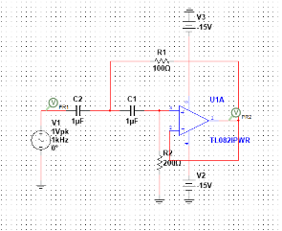
Plot. Butterworth filter schema.
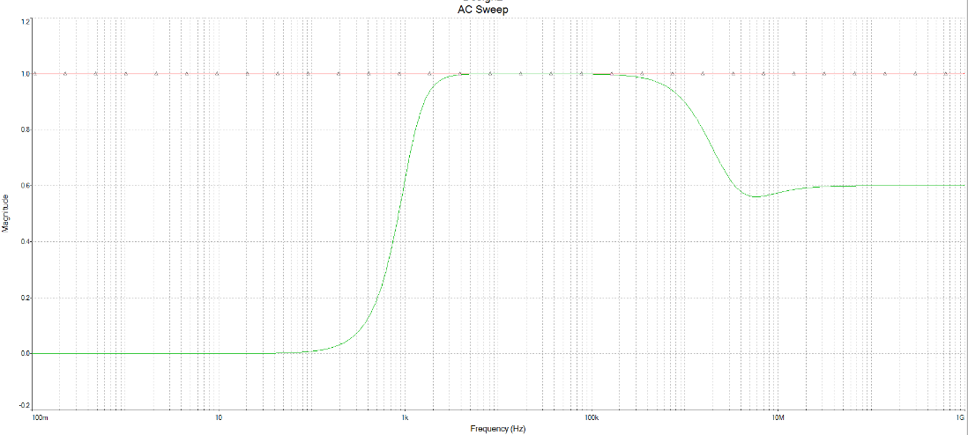
Plot. AC analysis (linear scale) of Butterworth filter (red line – input, green line - output).

Filter types can be implemented using the simple Sallen-Key configuration. The Sallen-Key design biquad type filter, meaning there are two poles defined by the circuit transfer function
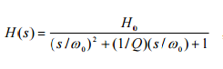where H0 is the DC gain of the biquad circuit.
The quantity Q is called the quality factor and is a direct measure of the flatness of the passband (in particular, a large value of Q indicates peaking at the edge of the passband.)
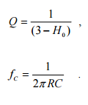
The Butterworth filter is an optimal filter with maximally flat response in the passband. The magnitude of the frequency response of this family of filters can be written as
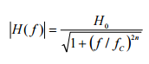where n is the order of the filter and fc is the cutoff frequency.

However, one main disadvantage of the Butterworth filter is that it achieves this pass band flatness at the expense of a wide transition band as the filter changes from the pass band to the stop band. It also has poor phase characteristics as well.

