DMCS
Computer Aided Design of Electronic Circuits

REPORT 2

EXERCISE 2 – RC Circuit with Controlled Sources

Joanna Klinkiewicz
190097
IFE, TCS 2016
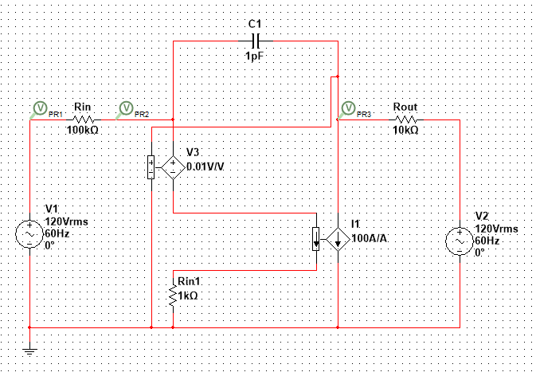
Plot 1. Circuit scheme.

DC ANALYSIS
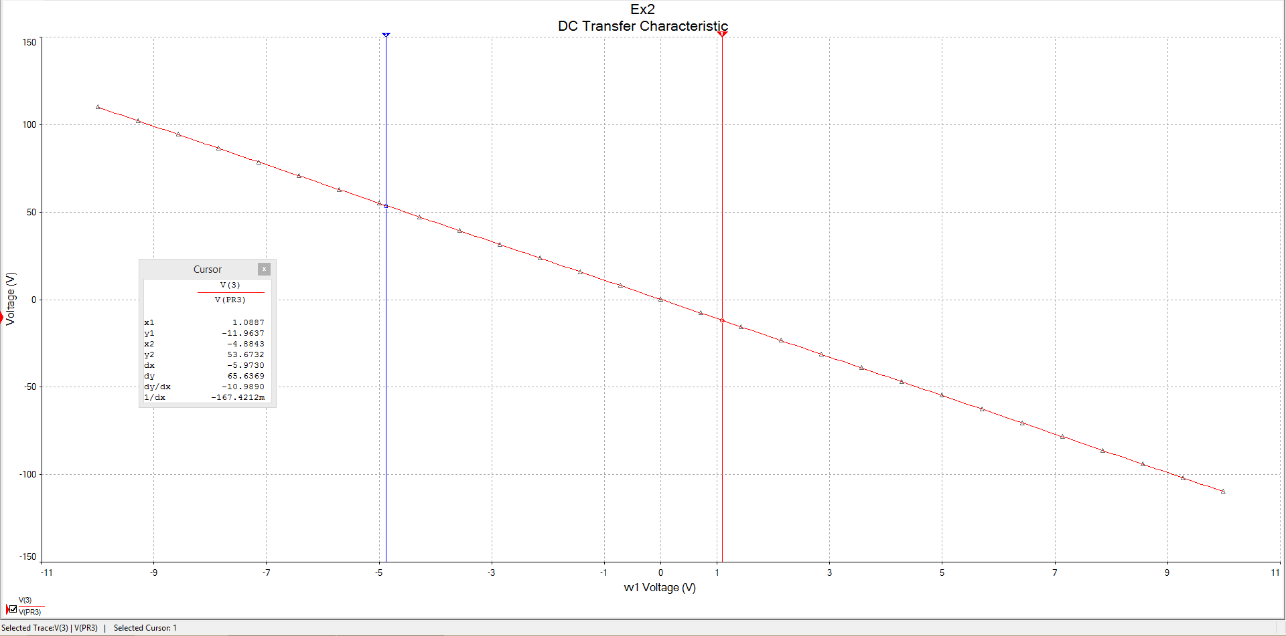
Plot 2. Vout as a function of Vin.

Voltage gain was determined graphically from the plot using cursors.
Vgain=Vout/Vin
Vgain=-10,909 therefore Vgain=-11

AC ANALYSIS

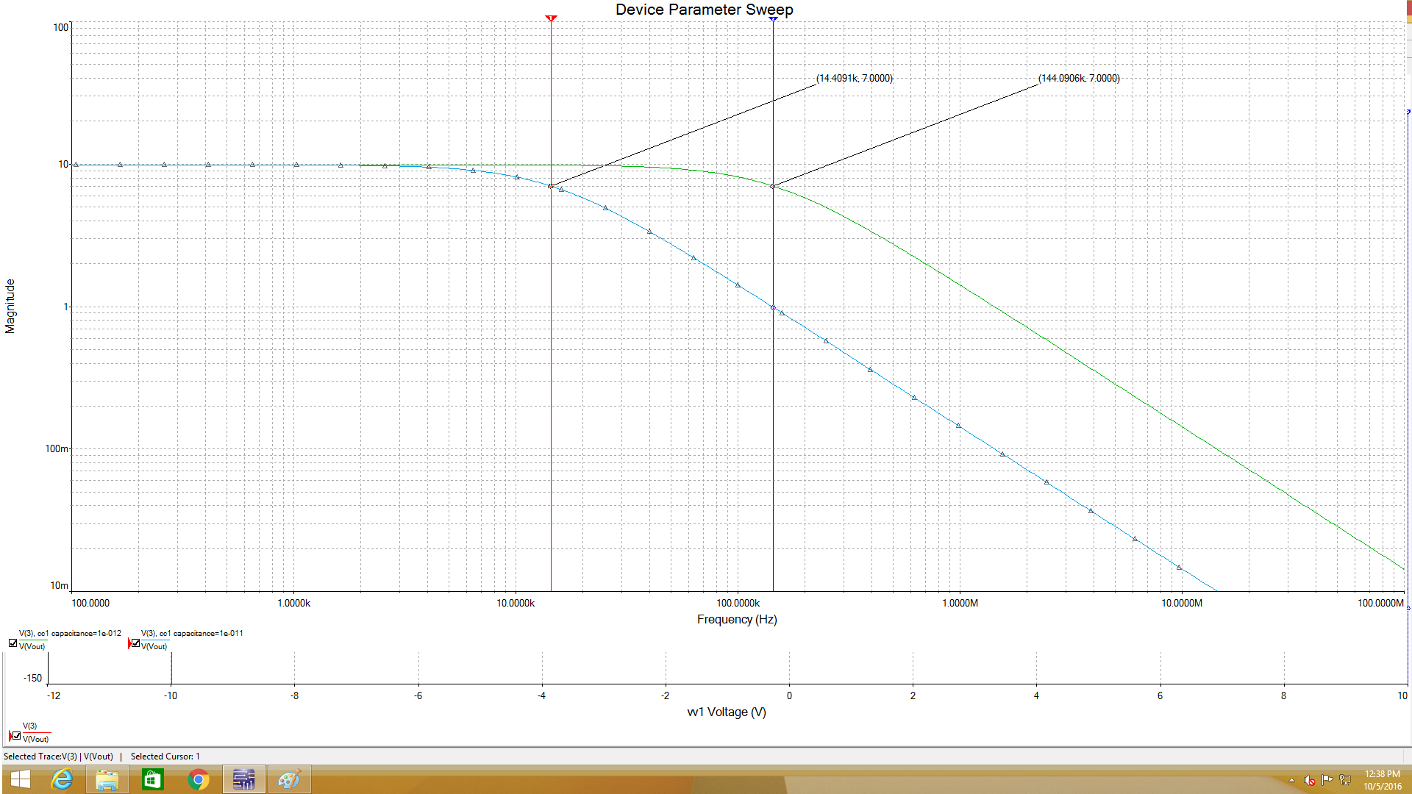
Plot 3. Ac magnitude analysis for both Cs=1 pF (blue curve) and Cs=10pF (green curve).

Capacitance Cs has an impact on magnitude analysis. The biggest Cs, the smallest cutoff frequency.
The decrease of the signal voltage to its halt value is at the -3dB and thus it specifies cutoff frequency Fcut that is:
0.707*10V=7,07V
Fcut= 144 kHz for circuit with Cs= 1 pF
0.707*10V=7,07V
Fcut= 14 kHz for circuit with Cs= 10 pF
Capacitor C1, VCVS and h12 affects values of cut-off frequency.
According to the plot one can assume, those are low – pass filters. For decreasing C1, cut-off frequency is increasing and finally for C1=0 the plot of magnitude analysis will become straight line, which means that the circuit is then all-pass filter. Changing h12 has similar effects.

PROJECT I DC
Applying Kirchhoff’s Voltage and Current Law:

And knowing:

We can obtain:
= -80*

Having R=45kΩ we obtain characteristics of voltage gain equal to -80.
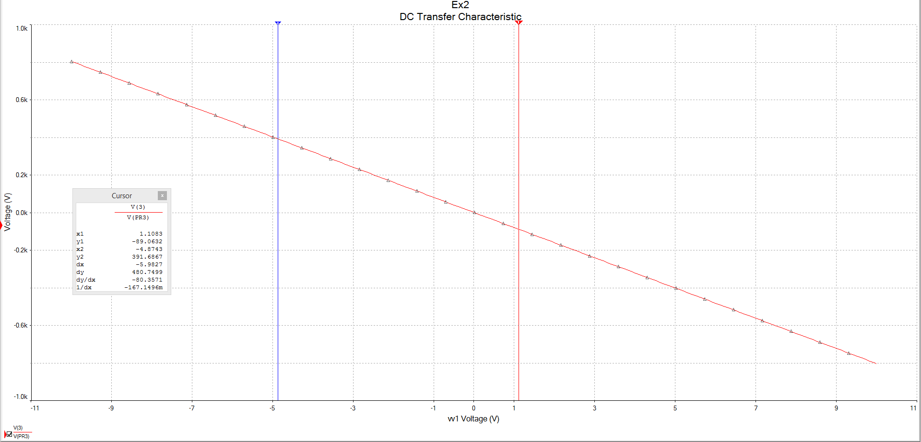
Plot. 4 DC characteristics having voltage gain kv= -80.
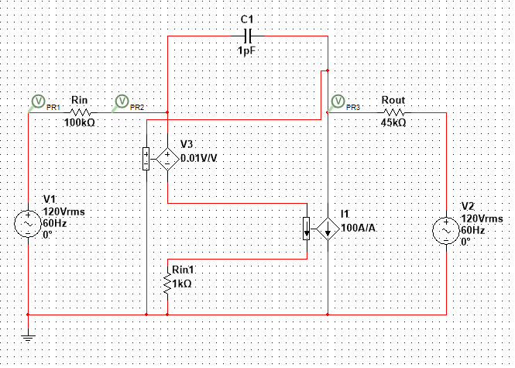
Plot 5. Circuit with elements having new values.

PROJECT II AC
According to the Miller’s formula:
C2=C1 * (1-kv) or , where kv is voltage gain. For C1= 10pF we have:

C2=1.1nF.
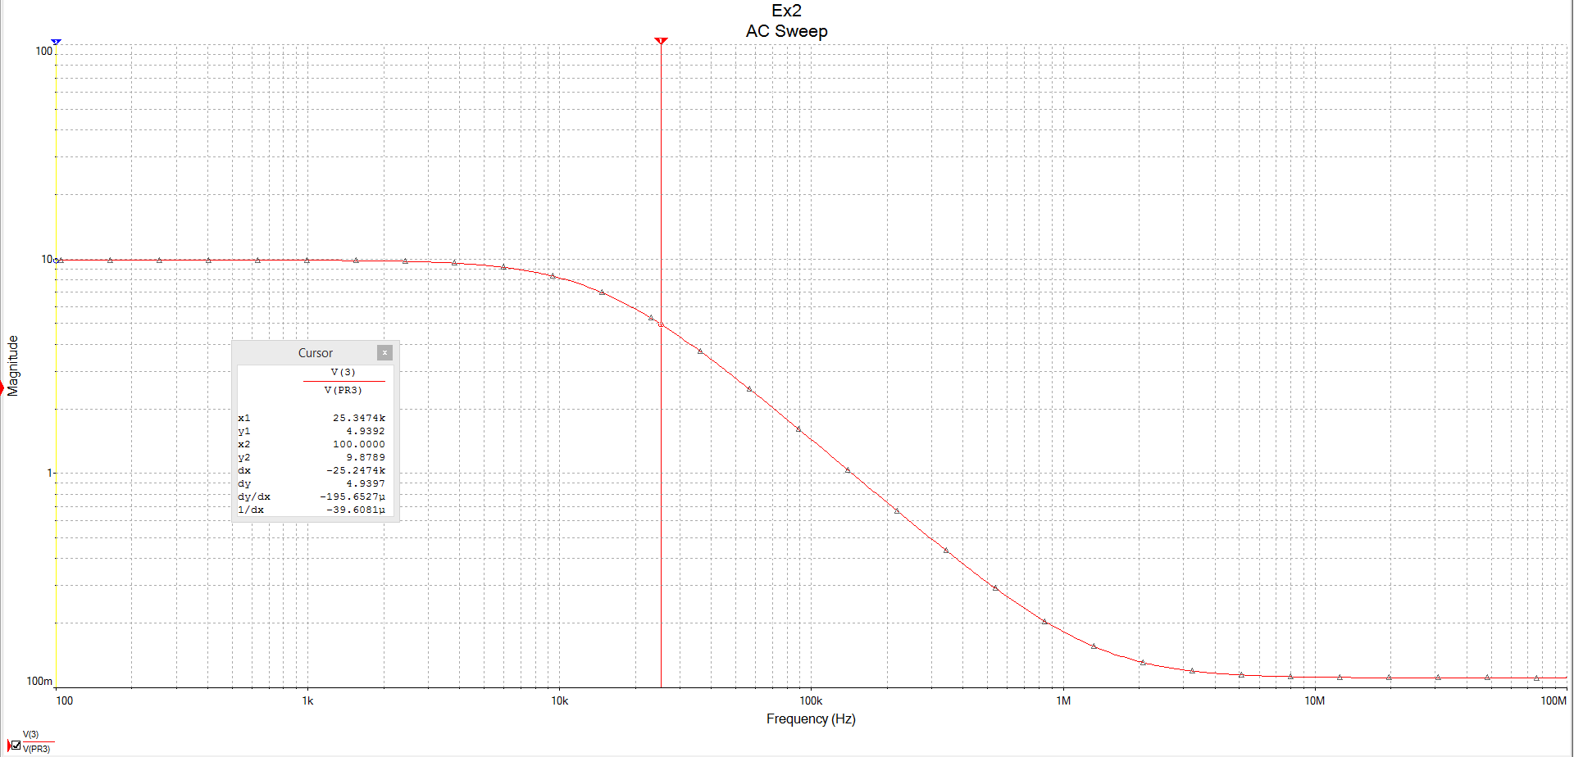
Plot. 6 Curve for C2=1.1nF proving same cut-off frequency 14kHz.
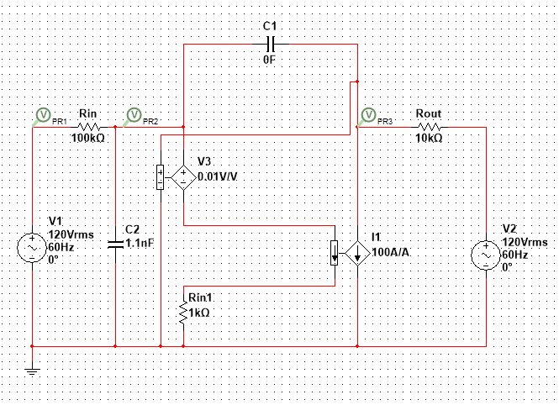
Plot. 7 New circuit with capacitance C2.
According to Miller’s formula, C2=C1 * (1-kv), therefore:

Voltage gain depends on this ratio.

SENSITIVITY

variable | sensitivity
kv | 121,9659
Rin | -12,07582u
Rin2 | -12,07583u
Rout | 121,96582u
V1 | 10,98901
V2 | 1,10989

The table shows circuit’s elements influence on voltage and current. We can also foresee circuit reaction due to temperature changes, parameters changes etc. Check if some element elimination will not cause problems to the circuit is possible also. One can detect if there are no redundant elements that can be omitted or find tolerance of the elements. Finally, thanks to the tool we can optimize parameters to obtain better more idealized circuit.

PROJECT
The value Rout is calculated using the formula derived before. This time kv should equal -50.
Therefore:

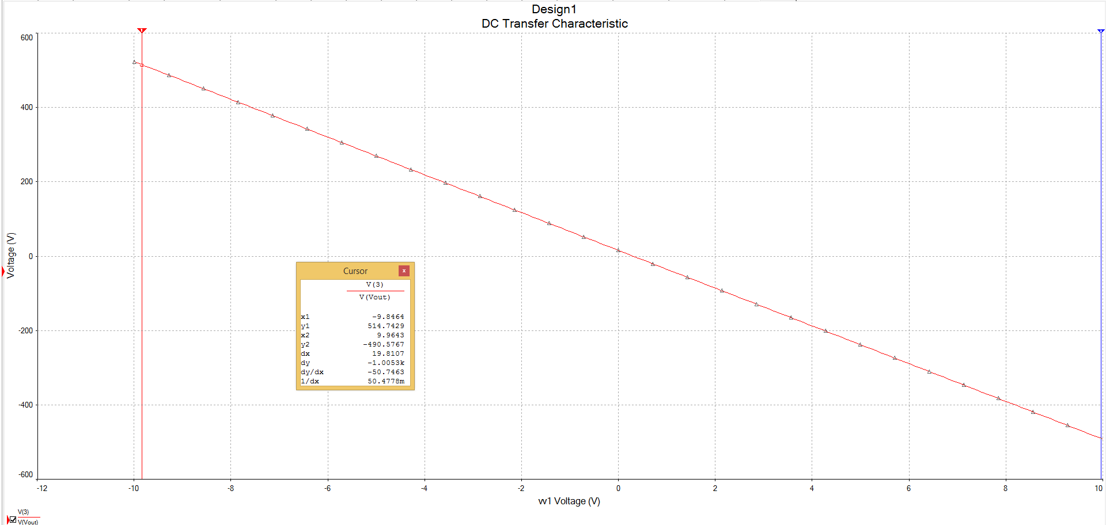
Plot. 8 Voltage gain kv=-50 for Rout=34k

