DOCUMENTATION OF NATIVE CC

By: JOANNA MARY LIMBAGA

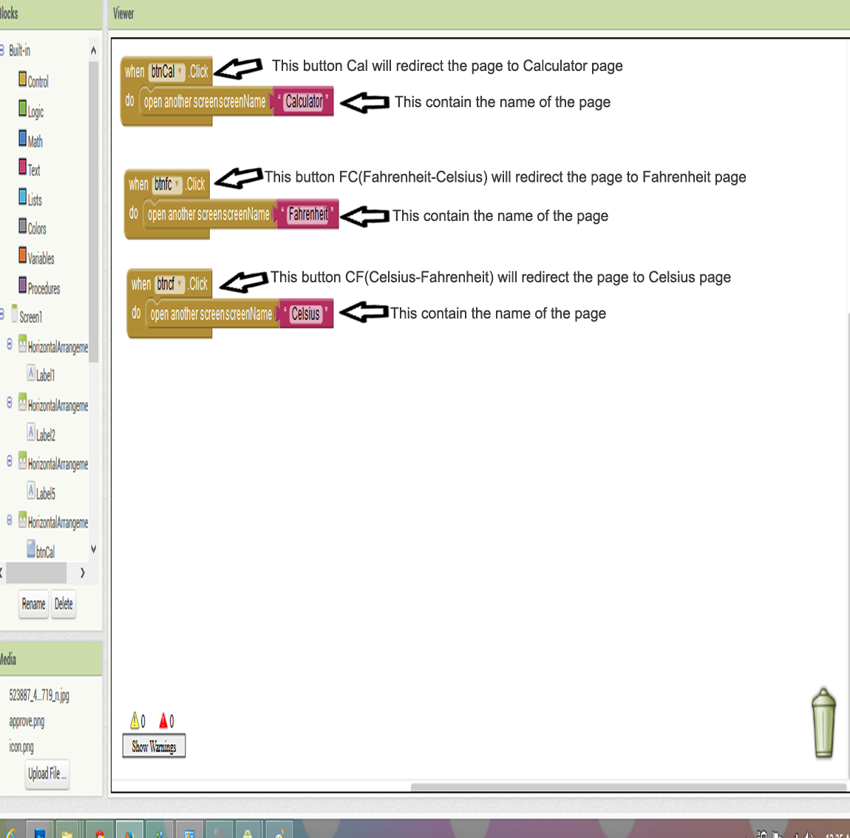HOME PAGE

CALCULATOR PAGE

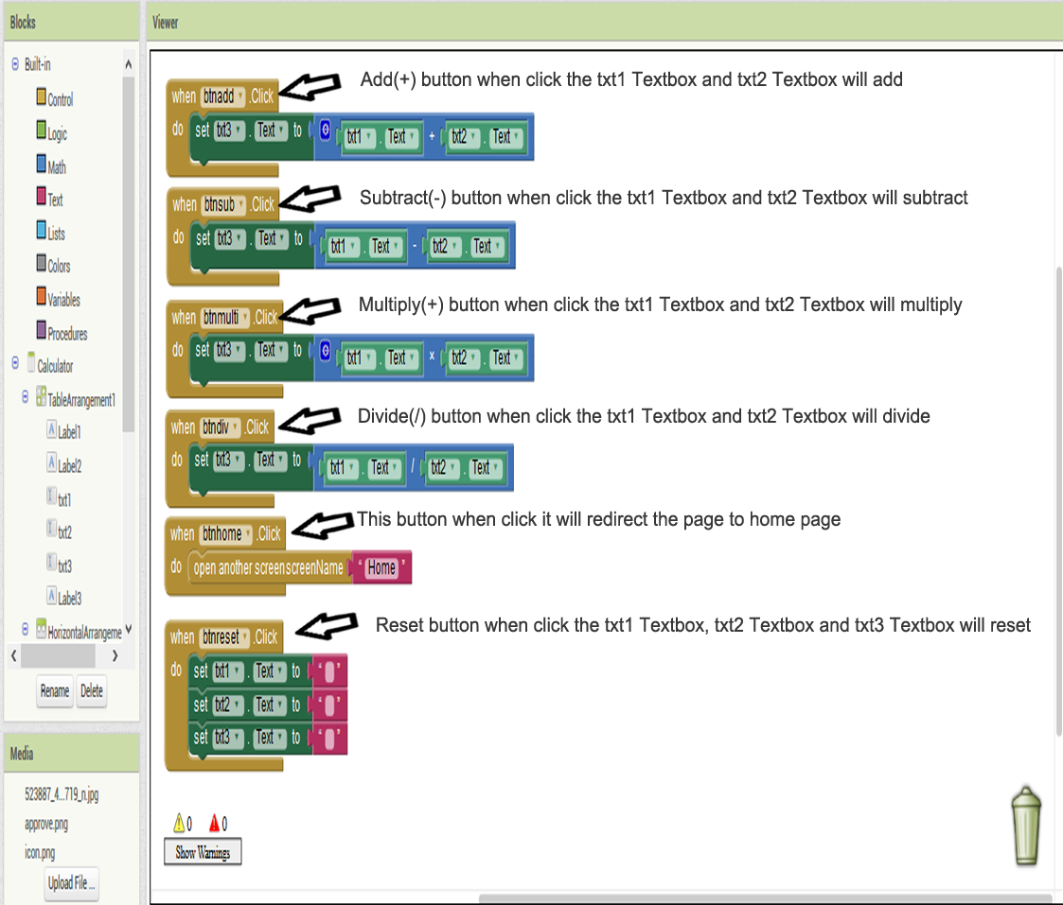

FAHRENHEIT PAGE

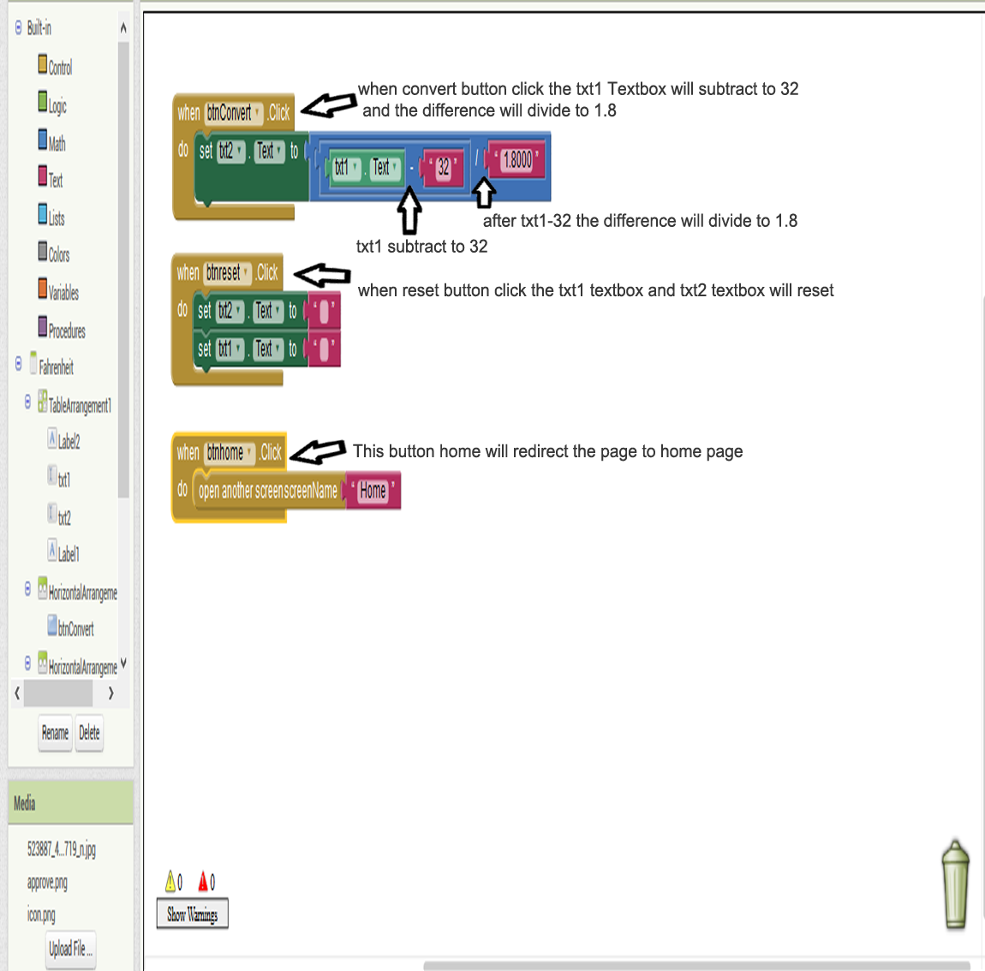

CELSIUS PAGE

