Reinvasion of restored California vernal pools reveals the importance of maintenance and monitoring

Joanna Tang and Madeline Nolan

**Abstract**

Western ideals of restoration often focus on one-time restoration intervention efforts with the goal of creating restored ecosystems that do not require human maintenance. However, mixed success of these short-term implementation efforts questions the efficacy of this approach. Here, we ask, do short-term restoration efforts result in long-term success or do these restored ecosystems require long-term management to prevent degradation? We address this question using a case study of restored vernal pool wetlands along the south coast of California. Over the last century, over 95% of California’s vernal pool ecosystems have been lost due to land conversion for human use. However, recognition of the importance of wetland ecosystems, including vernal pools, has led to a growing effort to restore these ecosystems and their associated endemic flora and fauna. Restoration efforts are, however, often hindered because restored vernal pools often exist within a grassland matrix and are prone to invasion by exotic annual grasses. Moreover, we hypothesize that restored vernal pools are susceptible to exotic invasion because most restoration projects only budget for short-term invasive species control, and portions of the pools are not deep enough for abiotic exclusion of invasive grasses. To test this, we assessed exotic species abundance and diversity after intensive weeding had ceased in a complex of restored vernal pools along the South Coast of California. We simultaneously evaluated invasion relative to location along a depth gradient within the pools. We found that exotic species cover and biomass increased over time, particularly around the edges of the pools, accelerating strongly after 5-6 years. The central bottoms of pools, however, showed much less invasion and no trend over time. This increase in exotics around pool edges indicates encroachment of exotic grasses from the upland grassland into the pools ad was much more pronounced in upland pool edges than in transition zones and pool centers. Our findings indicate that restored ecosystems are susceptible to reinvasion over time, but that this depends on abiotic conditions within the ecosystem. Our findings highlight the importance of ongoing monitoring and adaptive management in long-term restoration success.

**Introduction**

Invasive species management in restoration projects is often heavily frontloaded due to budget constraints. Yet, such frontloading does not guarantee a restored ecosystem’s long-term resistance to invasion. Indeed, exotic species are one of the major impediments to successful restoration (CITATION). For example, Gutrich, Taylor & Fennessy (2009) showed that restored wetlands may attain high native species cover during the first few years after restoration, but native cover subsequently declines in the long run due to an increase in invasive exotic species cover.

Invasion by exotic species in restored vernal pool ecosystems is of special concern. California’s vernal pools form atop an impermeable subsurface soil layer during the cool, wet winters of California’s Mediterranean climate. Endemic plants and animals grow and reproduce quickly during the spring, before the pools completely desiccate during the warm, dry summers. These species are specially adapted to grow and reproduce quickly during the spring, and their seeds or eggs can remain dormant in the dry soil until the next winter rains arrive. Vernal pools, which often form within a flat grassland matrix, are especially prone to invasion by exotic annual grasses that now dominate most of California’s grassland ecosystems. California’s highly endemic vernal pool ecosystems are facing increased exotic species invasion exacerbated by global change. 95% of California’s vernal pools have been degraded or destroyed, largely due to urbanization, agriculture, and grazing (Mooney & Zavaleta 2016).

Vernal pool restoration began in southern California in the 1980s, but efforts have resulted in mixed success (Black & Zedler 1998). Furthermore, budget constraints often limit restoration efforts to only the vernal pools themselves, to the exclusion of the surrounding grassland matrix. Thus, restored vernal pools face invasion pressure from unrestored exotic grassland assemblages adjacent to them. Climate change further favors invasive species, especially as increased drought precludes pools forming (Faist & Beals 2018). However, despite restored vernal pools being susceptible to reinvasion, long-term maintenance and monitoring of restoration projects is scarce (CITATION). Are restoration projects successful in the long run? Do native species remain dominant, and do exotic populations remain low?

We investigated the dynamics of exotic species abundance after intensive invasive species management had ceased. We monitored species cover of a complex of urban vernal pools along the South Coast of California. These pools had been created in a mitigation site. After initial restoration efforts had ceased, we continued to monitor the pools into the “maintenance phase”, which included some periodic weeding. We hypothesized that the surrounding invaded landscape would hinder long-term restoration success by raining propagules into the pools, resulting in an increase in exotic abundance over time. We further hypothesized that this increase would differ across a depth gradient within the pools because of both distance from the invasion front and greater abiotic resistance near pool bottoms where inundation is prolonged. Generalist exotic annual grasses are able to withstand prolonged inundation, while endemic vernal pool assemblages are adapted to the highly dynamic hydrologic regime of vernal pools.

**Methods**

*Study Area*

This study was conducted on land managed by the University of California, Santa Barbara, in Santa Barbara County, California, USA. This land is part of unceded ancestral territory of the Chumash people. The study area lies within one mile or less of the Pacific Ocean, and experiences a Mediterranean climate that is cool and wet during the months of November-April, and warm and dry during the remainder of the year. Rainfall averages approximately 17 inches per year with notable variation often exacerbated by extreme rainfall events and droughts. (CITATION). The close proximity to the Pacific Ocean moderates winter lows and frost is relatively rare. Summer fog likewise moderates summer temperatures although offshore “sundowner” winds may bring hot dry conditions over 90ºF to the area, especially in the late summer and fall. Soil formation is typically the result of weathering of uplifted shales and are dominated by clay. All of the vernal pools were formed in an area where the topsoils were scraped off in the 1960s, leaving clay soils that are typically high in sodium and low in organic material and nitrogen, and the soils are thus classified as Xerorthents.

*The Focal Vernal Pools*

All vernal pool restoration was conducted by the Cheadle Center for Biodiversity and Ecological Restoration at UCSB (CCBER; https://ccber.ucsb.edu). We monitored 7 restored vernal pools within the management unit named North Parcel (Figure 1). The pools were created between 2011 and 2014, and varied in size and depth (Table 1), but all 7 pools were restored in a similar fashion.

*Restoration Actions*

Restoration of the vernal pools began by grading to deepen vernal pool basins. As vernal pools were constructed with adjacent upland area to facilitate soil restoration, sifted compost from the Santa Barbara County was distributed throughout the area at approximately 6 inches in depth. A tractor tilled the compost into dry soil to a depth of approximately 8-10 inches. No organic material was incorporated into the wetland basins. Additionally, a humate product called Live Earth Soil Conditioner (1.50% sulfur, 2.25% iron, 45% humic acid) and Live Earth First Green (4% calcium, 5% sulfur, 1% iron, and 5% nitrogen, 3% phosphorous, and 1% potassium) was equally distributed one time, across both wetland and upland soils, at a rate of approximately (need amount).

After the site was physically manipulated and amended, the individual pools were planted, and to a lesser degree seeded, with approximately 140 species of locally-sourced native plants from vernal pool, vernal marsh, coastal prairie, and coastal sage scrub assemblages. Plants were installed. Vegetation was purposely planted in patches to mimic landscape patterns generally observed in nature, according to soil types, hydrology, and other site factors. Planting continued throughout the summer months in some cases. Installed plantings were watered-in using mainly moveable drip irrigation until establishment was achieved.

After the initial planting was completed, the sites were actively maintained in a number of ways. First, native annual thatch was periodically removed in the late summer and fall months, to simulate clearing likely done by historically indigenous burning practices. Species whose thatch was removed include *Centromadia parryi* ssp. *australis*, *Simphyotrichium sublatum*, *Dienandra fasciculata*, for example. In addition, the thatch material from perennial natives, such as *Stipa pulchra*, was also removed annually in places for the same effect. Second, certain natives are removed periodically to maintain landscape variability, facilitate the colonization of novel or desirable native species, and avoid homogenization of common species such as *Baccharis pilularis*, *Typha* spp., *Schoenoplectus californicus*, and *Salix* spp. Third, exotic species were controlled mainly by hand-weeding, although also through solarization, herbicide, and green flaming. The implementation phase of this restoration project lasted 5 years.

|  |  |  |  |
| --- | --- | --- | --- |
| **Vernal Pool** | **Creation Date** | **Depth (inches)** | **Size (square meters)** |
| 19 | 2013 | 15 | 359.36 |
| 9 | 2015 | 16.5 | 160.07 |
| PH1 | 2010 | 16 | 173.13 |
| 3 | 2012 | 14 | ‎67.81 |
| 7 | 2012 | 18 | 79.45 |
| 14 | 2014 | 16 | 432.89 |
| 16 | 2014 | 17 | 424.18 |

*Table 1. Depth and size of monitored vernal pools.*

*Vernal Pool Monitoring Experiment*

Experimental Design

Within each restored vernal pool, we set up a series of permanent monitoring quadrats. We delineated each pool into three zones: a *central zone* that is fully inundated during the winter rainy months, a *transition zone* that is never inundated but experiences continually wet soils throughout the winter rainy season, and an *upland zone* that only receives water from precipitation events and does not receive additional water from the vernal pool (Figure 2). Within each of these zones (central, transition, and upland) we haphazardly placed three 1m2 quadrats for a total of nine quadrats per pool.



Figure . Schematic of zones and representation of the haphazard distribution of the quadrats in each vernal pool..

Data Collection

From November 2016 to December 2019, we monitored the plant communities in each vernal pool every month. Within each quadrat, we assessed the identity and percent cover of all species present. We counted the number of native and exotic species to find native and exotic species richness. We also estimated the number and percent cover of germinating seedlings for native species. For exotic species, we destructively sampled all exotic species every month and measured the above ground biomass for each species. We also assessed percent cover of bare ground, water, and thatch.

The harvested exotic species biomass was dried in an 60ºC oven for at least 48 hours and then weighed on a Fisher Scientific accuSeries®4102, Mettler PM400, and Mettler PC440 digital scales.

*Data Analysis*

From monthly species percent cover data, monthly total exotic species cover was calculated for each quadrat. The maximum total exotic species cover per year was extracted from this dataset. This distribution was skewed right, which precluded an ANOVA on raw data. Instead, raw data were used to construct a generalized linear mixed effects model with a negative binomial distribution because data were overdispersed compared to a Poisson distribution. In this model, maximum total exotic species cover was predicted by the age of the pool and the zone, and the interaction thereof, with monitoring year, quadrat, pool depth, and pool size included as random effects. Model predictions for pool age and zone were compared using an ANOVA and post-hoc Tukey’s tests to determine differences in exotic cover over time in each zone. An alpha of *p* < 0.1 determined significant differences.

Monthly exotic biomass was summed to calculate total annual biomass for a given growing season. This distribution was skewed right, which precluded an ANOVA on raw data. Instead, raw data were used to construct a generalized linear mixed effects model with a gamma distribution. In this model, total annual exotic biomass was predicted by the age of the pool and the zone, and the interaction thereof, with monitoring year, quadrat, pool depth, and pool size included as random effects. Model predictions for pool age and zone were compared using an ANOVA and post-hoc Tukey’s tests to determine differences in exotic biomass over time in each zone. An alpha of *p* < 0.1 determined significant differences.

All data analysis was performed in RStudio version 1.4.1106. The **glmer** function of the “lme4” package was used to generate generalized linear mixed effects models. The **anova** function from the “stats” package was used to calculate analysis of variance. The **emmeans** function from the “emmeans” package was used to calculate post-hoc Tukey’s least-squares means. All graphs were generated using the functions in the package “ggplot2”.

**Results**

The most common exotic species found in the vernal pools were a suite of invasive grasses, including *Polypogon monspeliensis*, *Bromus hordeaceus*, *Bromus diandrus*, *Poa annua*, *Festuca myuros*, *Festuca perennis*, and *Hordeum murinum*. In the central zone, we found an average exotic species richness of 7.71 and an average native species richness of 9.14. In addition to invasive grasses, we found some exotic forbs including *Helminthotheca echiodes*, *Geranium dissectum*, *Sonchus oleraceus*, and *Medicago polymorpha*. However, plant cover in the central zone was dominated by native species, including *Eleocharis macrostachya*, *Juncus mexicanus*, and *Juncus phaeocephalus*. In the transition zone, we found an average exotic species richness of 19.42 and an average native species richness of 17.42. In addition to invasive grasses, we found some exotic forbs including *Plantago coronopus*, *Spergularia* spp., *Geranium dissectum*, *Centaurium tenuiflorum*, *Lysimachia arvensis*, *Lythrum hyssopifolia*, *Rumex crispus*, and *Sonchus asper*. Dominant native species in the transition zone included *Carex praegracilis* *Eleocharis macrostachya*, *Distichlis spicata*, *Juncus mexicanus*, and *Elymus triticoides*. In the upland zone, we found an average exotic species richness of 24.57 and an average native species richness of 16.14. In addition to invasive grasses, we found some exotic forbs including *Centaurium tenuiflorum*, *Medicago polymorpha*, *Vicia villosa*, *Vicia sat*iva, *Geranium dissectum*, and *Melilotus* spp. Dominant native species in the upland zone included *Stipa pulchra*, *Cyperus eragrostis*, and *Hordeum brachyantherum*.

Annual total exotic species cover significantly increased over time, but only in the transition and upland zones (Figure 3). Post-hoc Tukey’s tests of generalized mixed effects model outputs indicate that, in the transition zone, exotic species cover significantly increased as the pools aged from 3 to 5 years old (*p* = 0.006). In the upland zone, exotic species cover significantly increased as the pools aged from 4-5 years old (*p* = 0.0071). There was no significant increase in exotics in the central zone.

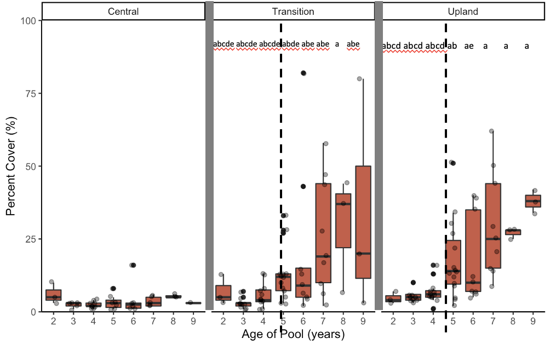

Figure . Total exotic species cover in restored vernal pool zones over time. Boxplots show median and interquartile ranges. Letters show significant differences for post-hoc Tukey’s tests on generalized linear mixed effects model predictions (alpha = 0.1).

Annual total exotic biomass similarly significantly increased over time, but only in the transition zone (Figure 4). Post-hoc Tukey’s tests of generalized mixed effects model outputs indicate that, in the transition zone, exotic species biomass significantly increased as the pools aged from 3 to 7 years old (*p* = 0.0031). In the central zone, 3-year-old pools had significantly lower exotic biomass than 2-year-old (*p* = 0.0390) and 7-year-old (*p* = 0.0513) pools. There was no significant increase in exotics in the upland zone.

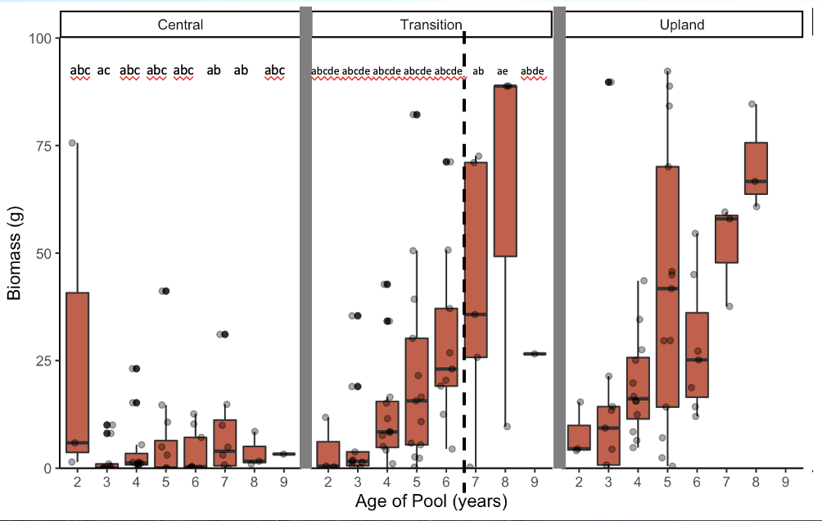

Figure . Total exotic species biomass in restored vernal pool zones over time. Boxplots show median and interquartile ranges. Letters show significant differences for post-hoc Tukey’s tests on generalized linear mixed effects model predictions (alpha = 0.1).

**Discussion**

The increase in exotic plant cover and biomass in restored vernal pools reveals that restored vernal pools are susceptible to invasion over time. The pools in this study were created and planted with native species within a grassland landscape. Intensive exotic species weeding continued for about 3-5 years after each pool was created, but then the pools phased into the maintenance phase and were only periodically hand-weeded or cleared with a weed-whacker. Our analysis shows that the intensive exotic species weeding kept exotic cover low. However, after intensive weeding ceased as the pools aged to 5 years and older, exotic species cover and biomass increased.

Our results also highlight the importance of continued maintenance and monitoring of restoration projects with the goal of identifying vulnerable portions of the landscape. During the implementation phase of restoration, native plants are installed and exotic plants are removed. However, the Society for Ecological Restoration (SER) identifies a post-implementation “maintenance phase” as an equally important part of the restoration process (Gann et al. 2019). During this maintenance phase, SER standards of practice recommend ongoing management and monitoring to ensure long-term success (Gann et al. 2019). The importance of monitoring can be seen by the long-term trends found in our data (Figs. 3-4). If monitoring had ceased three or four years post-restoration, site managers may have inaccurately assumed exotic species cover would remain low in the long run. However, the marked increase in exotic cover and biomass around year five changes the story of the restoration site. This change can act as a trigger for adaptive management, e.g., if exotics continue to increase despite routine maintenance weeding, site managers can pivot their strategy and prioritize their resources on more large-scale weeding efforts. Long-term monitoring data are necessary for maintaining an adaptive management plan that can correct for rising exotic species. Contrary to the Western perspective that short-term restoration projects should create self-sustaining restored ecosystems, our case study suggests that long-term management is necessary to prevent reinvasion (CITATION). Instead of viewing restoration projects primarily as short-term implementation efforts with auxiliary “maintenance phase”, the implementation phase of restoration should be viewed as an initiation of an ongoing restoration management plan. This hearkens back to indigenous land management practices, where humans are viewed as part of the annual and interannual dynamic of ecosystems (CITATION). We suggest that “restoration” entails not only restoration of native plants and animals, but also the restoration of the symbiotic relationship between humans and nature via long-term human stewardship to create desirable ecosystems.

Our findings show that long-term monitoring provides data useful for developing long-term adaptive management. In this case study, the most marked increases in exotic abundance and diversity occurred around the edges of the vernal pools, in the transition and upland zones. This suggests that the pools are susceptible to exotic encroachment from the upland grassland matrix into the vernal pool. The dichotomy of the invaded transition and upland zones vs. the relatively uninvaded central zone can be explained by 1) exotic seeds blowing from the upland matrix into the transition zone, and 2) the abiotic filter of inundation in the center of the pool precluding invasion. If the upland grassland matrix is not included in the maintenance phase weeding, exotic species can proliferate and spread into restored vernal pools. The most dominant species found in our survey were *Festuca perennis*, *Festuca myuros*, *Polypogon monospeliensis*, *Centaurium tenuiflorum*, *Bromus diandrus*, *Geranium dissectum*, *Plantago coronopus*, and *Bromus hordeaceus*. Many of these grasses and low-growing forbs are listed by the California Invasive Plant Council as invasive species capable of out-competing native species and forming monocultures (California Invasive Plant Council; https://cal-ipc.org/plants/inventory/). Native species are still present in the all of the pools in this study, and wetland graminoids like *Eleocharis macrostachya*, *Juncus mexicanus*, and *Juncus phaeocephalus* currently still dominate the central zones of the pools. Yet, many of these native species were planted in the transition and upland zones, which are now dominated by invasive graminoids. This further suggests that the invasive grasses are encroaching from the upland grassland into the pools themselves. Traditionally, strong abiotic filters associated with vernal pools, e.g., highly dynamic seasonal flooding and drying, preclude generalist exotics from invading into the pool centers (Bliss & Zedler 1998). However, increased drought due to climate change may be breaking down this abiotic filter. In drier conditions when the pools do not fill with water, grassland species are able to encroach through the center of the pool basin. This has been seen in local degraded vernal pools, with *Festuca perennis* dominating throughout the central, transition, and upland zones (Tang, unpublished data). Thus, Collinge and colleagues have emphasized the role of both abiotic and biotic filters in creating restored landscapes that are resistant to exotic invasion (Collinge, Ray & Gerhardt 2011; Gerhardt & Collinge 2009). Biotic filters that can decrease susceptibility to reinvasion include adaptive management strategies such as planting with competitive native species and removing exotic competitors through an array of weed management strategies. For example, restoration projects may increase a vernal pool’s resistance to invasion by employing an array of invasive species management techniques in addition to short-term intensive weeding, such as bolstering the native seed bank and sourcing seed from competitive native ecotypes.

**Conclusion**

Our long-term monitoring study of restored vernal pools highlights the importance of monitoring and management long-term species composition dynamics to ensure restoration success. We found that exotic species cover and biomass in restored vernal pools increased after short-term exotic species weeding had ceased. An increase in exotic annual grasses around the vernal pools’ edges indicates encroachment of exotic grasses from the upland grassland into the pools. These findings indicate that native assemblages in restored vernal pools are not resistant to invasion by exotic species. In this case study, the short-term invasive species management in the implementation phase did not ensure long-term success of restored vernal pools because exotic grasses reinvaded the pools after intensive weeding ceased. This suggests that restoration is best conducted when there are long-term investments in ecosystem management. Long-term adaptive management plans require ongoing monitoring so that management can pivot to address rising challenges. When funds are limited, engagement of local community groups to help with weeding can achieve both ecological goals and social goals of engaging a diversity of people in maintaining biodiversity (CITATION).

**Acknowledgements**

We received field assistance, plant identification, and monitoring advice from Catherine Reilly, Wayne Chapman, Lisa Stratton, Ryan Clark, Darwin Richardson, Eirik De Wit, Lauren Weichart, and Justin Luong. Carla D’Antonio provided feedback on an early manuscript draft.

**References**

Black, C., & Zedler, P. H. (1998). An overview of 15 years of vernal pool restoration and construction activities in San Diego County, California. In *Ecology, Conservation and Management of Vernal Pool Ecosystems–Proceedings from a 1996 Conference. California Native Plant Society, Sacramento, CA* (pp. 195-205).

California Invasive Plant Council. (n.d.). *The Cal-IPC Inventory*. California Invasive Plant Council. Retrieved January 9, 2022, from https://www.cal-ipc.org/plants/inventory/

Collinge, S. K., Ray, C., & Gerhardt, F. (2011). Long‐term dynamics of biotic and abiotic resistance to exotic species invasion in restored vernal pool plant communities. *Ecological Applications*, *21*(6), 2105-2118.

Faist, A. M., & Beals, S. C. (2018). Invasive plant feedbacks promote alternative states in California vernal pools. *Restoration Ecology*, *26*(2), 255-263.

Gann, G. D., McDonald, T., Walder, B., Aronson, J., Nelson, C. R., Jonson, J., ... & Dixon, K. W. (2019). International principles and standards for the practice of ecological restoration. *Restoration Ecology, 27*(S1), S1-S46.

Gerhardt, F., & Collinge, S. K. (2007). Abiotic constraints eclipse biotic resistance in determining invasibility along experimental vernal pool gradients. *Ecological Applications*, *17*(3), 922-933.

Gutrich, J. J., Taylor, K. J., & Fennessy, M. S. (2009). Restoration of vegetation communities of created depressional marshes in Ohio and Colorado (USA): the importance of initial effort for mitigation success. *Ecological Engineering*, *35*(3), 351-368.

Mitsch, W. J., & Wilson, R. F. (1996). Improving the success of wetland creation and restoration with know‐how, time, and self‐design. *Ecological Applications*, *6*(1), 77-83.

Mooney, H., & Zavaleta, E. (2016). *Ecosystems of California*. Univ of California Press.

**Supplemental Figures**

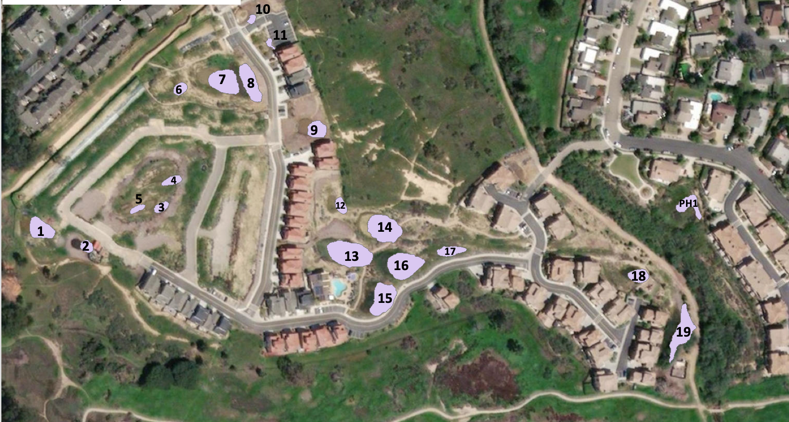

S1. North Parcel vernal pools. #3, 7, 9, 14, 16, 19, & PH1 monitored in this study.

S2. Full species list of species found throughout pools.

|  |  |
| --- | --- |
| **Species** | **Native Status (Native = N, Exotic = E)** |
| Acmispon species | E |
| Alisma triviale | N |
| Alopecurus saccatus | N |
| Ambrosia psilostachya | N |
| Asclepias fascicularis | N |
| Atriplex semibaccata | E |
| Baccharis pilularis | N |
| Bolboschoenus maritimus | N |
| Brachypodium distachyon | E |
| Brassica nigra | E |
| Bromus carinatus | N |
| Bromus diandrus | E |
| Bromus hordeaceus | E |
| Bromus madritensis | E |
| Calystegia macrostegia | N |
| Carduus pycnocephalus | E |
| Carex praegracilis | N |
| Centaurium tenuiflorum | E |
| Centromadia parryi ssp. australis | N |
| Corethrogyne filaginifolia | N |
| Cotula coronopifolia | E |
| Crassula aquatica | N |
| Croton setigerus | N |
| Crypsis schoenoides | E |
| Cyperus eragrostis | N |
| Deinandra fasciculata | N |
| Distichlis spicata | N |
| Eleocharis machrostachya | N |
| Elymus condensatus | N |
| Elymus glaucus | N |
| Elymus triticoides | N |
| Epilobium brachycarphum | N |
| Epilobium canum | N |
| Erigeron bonariensis | E |
| Erigeron canadensis | N |
| Erigeron sumatrensis | E |
| Erodium cicutarium | E |
| Eryngium armatum | N |
| Eryngium vaseyi | N |
| Eschscholzia californica | N |
| Euphorbia peplus | E |
| Euphorbia serpens | E |
| Extriplex californica | N |
| Festuca myuros | E |
| Festuca perennis | E |
| Foeniculum vulgare | E |
| Frankenia salina | N |
| Geranium dissectum | E |
| Grindelia camporum | N |
| Hazardia squarrosa | N |
| Helminthotheca echiodes | E |
| Heterotheca grandifolia | N |
| Hordeum brachyantherum | N |
| Hordeum murinum | E |
| Hypochaeris glabra | E |
| Isolepis cernua | N |
| Juncus bufonius | N |
| Juncus mexicanus | N |
| Juncus occidentalis | N |
| Juncus patens | N |
| Juncus phaeocephalus | N |
| Juncus textilis | N |
| Lactuca serriola | E |
| Laennecia coulteri | N |
| Lepidium nitidum | N |
| Logfia gallica | E |
| Lupinus microcarpus | N |
| Lupinus succulentus | N |
| Lysimachia arvensis | E |
| Lythrum hyssopifolia | E |
| Malva parviflora | E |
| Malvella leprosa | N |
| Medicago lupulina | E |
| Medicago polymorpha | E |
| Melilotus indicus | E |
| Melilotus species | E |
| Oxalis californica | N |
| Paraphalis incurva | E |
| Phalaris lemmonii | N |
| Plagiobothrys undulatus | N |
| Plantago coronopus | E |
| Plantago lanceolata | E |
| Poa annua | E |
| Polycarpon tetraphyllum | E |
| Polygonum aviculare ssp.depressum | E |
| Polypogon interruptus | E |
| Polypogon monospeliensis | E |
| Pseudognaphalium luteoalbum | E |
| Psilocarphus brevissimus | N |
| Raphanus sativus | E |
| Rumex crispus | E |
| Rumex salicifolius | N |
| Salsola tragus | E |
| Schoenoplectus americanus | N |
| Schoenoplectus californicus | N |
| Schoenoplectus pungens | N |
| Senecio vulgaris | E |
| Sisyrinchium bellum | N |
| Sonchus asper | E |
| Sonchus oleraceus | E |
| Spergularia species | E |
| Stipa pulchra | N |
| Symphyotrichum subulatum | N |
| Taraxacum officinale | E |
| Trifolium hirtum | E |
| Verbena lasiostachys | N |
| Vicia sativa | E |
| Vicia villosa | E |

S3. Post-hoc Tukey’s results for exotic percent cover generalized linear mixed effects model

|  |  |  |  |
| --- | --- | --- | --- |
| Central Zone |  |  |  |
| contrast estimate SE df z.ratio p.value | | | |
| 2 - 3 0.81886 0.498 Inf 1.643 0.7239 | | | |
| 2 - 4 0.86742 0.493 Inf 1.759 0.6481 | | | |
| 2 - 5 0.81618 0.545 Inf 1.499 0.8085 | | | |
| 2 - 6 0.67774 0.568 Inf 1.192 0.9344 | | | |
| 2 - 7 0.51696 0.619 Inf 0.835 0.9911 | | | |
| 2 - 8 0.08345 0.627 Inf 0.133 1.0000 | | | |
| 2 - 9 0.76070 0.957 Inf 0.795 0.9934 | | | |
| 3 - 4 0.04856 0.460 Inf 0.106 1.0000 | | | |
| 3 - 5 -0.00268 0.509 Inf -0.005 1.0000 | | | |
| 3 - 6 -0.14112 0.538 Inf -0.262 1.0000 | | | |
| 3 - 7 -0.30190 0.591 Inf -0.511 0.9996 | | | |
| 3 - 8 -0.73541 0.603 Inf -1.220 0.9262 | | | |
| 3 - 9 -0.05816 0.940 Inf -0.062 1.0000 | | | |
| 4 - 5 -0.05124 0.397 Inf -0.129 1.0000 | | | |
| 4 - 6 -0.18969 0.434 Inf -0.437 0.9999 | | | |
| 4 - 7 -0.35046 0.503 Inf -0.697 0.9971 | | | |
| 4 - 8 -0.78397 0.539 Inf -1.453 0.8321 | | | |
| 4 - 9 -0.10673 0.890 Inf -0.120 1.0000 | | | |
| 5 - 6 -0.13845 0.404 Inf -0.343 1.0000 | | | |
| 5 - 7 -0.29922 0.492 Inf -0.608 0.9988 | | | |
| 5 - 8 -0.73273 0.556 Inf -1.317 0.8927 | | | |
| 5 - 9 -0.05549 0.889 Inf -0.062 1.0000 | | | |
| 6 - 7 -0.16077 0.456 Inf -0.353 1.0000 | | | |
| 6 - 8 -0.59429 0.573 Inf -1.037 0.9689 | | | |
| 6 - 9 0.08296 0.889 Inf 0.093 1.0000 | | | |
| 7 - 8 -0.43351 0.617 Inf -0.703 0.9969 | | | |
| 7 - 9 0.24373 0.902 Inf 0.270 1.0000 | | | |
| 8 - 9 0.67725 0.866 Inf 0.782 0.9940 | | | |

|  |  |  |  |
| --- | --- | --- | --- |
| Transition Zone |  |  |  |
| contrast estimate SE df z.ratio p.value | | | |
| 2 - 3 0.90877 0.433 Inf 2.101 0.4143 | | | |
| 2 - 4 0.22585 0.423 Inf 0.534 0.9995 | | | |
| 2 - 5 -0.44604 0.450 Inf -0.992 0.9757 | | | |
| 2 - 6 -0.66823 0.483 Inf -1.384 0.8651 | | | |
| 2 - 7 -0.95981 0.527 Inf -1.820 0.6064 | | | |
| 2 - 8 -1.69743 0.584 Inf -2.907 0.0712 | | | |
| 2 - 9 -1.50799 0.656 Inf -2.300 0.2935 | | | |
| 3 - 4 -0.68292 0.310 Inf -2.200 0.3517 | | | |
| 3 - 5 -1.35480 0.321 Inf -4.225 0.0006 | | | |
| 3 - 6 -1.57700 0.368 Inf -4.280 0.0005 | | | |
| 3 - 7 -1.86858 0.420 Inf -4.444 0.0002 | | | |
| 3 - 8 -2.60620 0.493 Inf -5.292 <.0001 | | | |
| 3 - 9 -2.41676 0.569 Inf -4.246 0.0006 | | | |
| 4 - 5 -0.67189 0.249 Inf -2.693 0.1245 | | | |
| 4 - 6 -0.89408 0.296 Inf -3.022 0.0513 | | | |
| 4 - 7 -1.18566 0.342 Inf -3.464 0.0125 | | | |
| 4 - 8 -1.92328 0.437 Inf -4.403 0.0003 | | | |
| 4 - 9 -1.73384 0.500 Inf -3.469 0.0122 | | | |
| 5 - 6 -0.22219 0.236 Inf -0.942 0.9819 | | | |
| 5 - 7 -0.51377 0.262 Inf -1.964 0.5067 | | | |
| 5 - 8 -1.25140 0.406 Inf -3.085 0.0426 | | | |
| 5 - 9 -1.06195 0.448 Inf -2.369 0.2565 | | | |
| 6 - 7 -0.29158 0.269 Inf -1.083 0.9605 | | | |
| 6 - 8 -1.02920 0.411 Inf -2.505 0.1933 | | | |
| 6 - 9 -0.83976 0.456 Inf -1.842 0.5909 | | | |
| 7 - 8 -0.73763 0.392 Inf -1.883 0.5628 | | | |
| 7 - 9 -0.54818 0.381 Inf -1.437 0.8400 | | | |
| 8 - 9 0.18944 0.420 Inf 0.451 0.9998 | | | |
| Upland Zone |  |  |  |
| contrast estimate SE df z.ratio p.value | | | |
| 2 - 3 0.15432 0.440 Inf 0.351 1.0000 | | | |
| 2 - 4 -0.21262 0.441 Inf -0.482 0.9997 | | | |
| 2 - 5 -1.06518 0.471 Inf -2.264 0.3139 | | | |
| 2 - 6 -1.24390 0.508 Inf -2.451 0.2170 | | | |
| 2 - 7 -1.63658 0.542 Inf -3.018 0.0519 | | | |
| 2 - 8 -1.69556 0.596 Inf -2.847 0.0837 | | | |
| 2 - 9 -1.90874 0.670 Inf -2.847 0.0838 | | | |
| 3 - 4 -0.36694 0.272 Inf -1.348 0.8803 | | | |
| 3 - 5 -1.21950 0.293 Inf -4.162 0.0008 | | | |
| 3 - 6 -1.39822 0.354 Inf -3.955 0.0020 | | | |
| 3 - 7 -1.79090 0.399 Inf -4.493 0.0002 | | | |
| 3 - 8 -1.84988 0.469 Inf -3.941 0.0021 | | | |
| 3 - 9 -2.06306 0.555 Inf -3.718 0.0049 | | | |
| 4 - 5 -0.85256 0.235 Inf -3.623 0.0071 | | | |
| 4 - 6 -1.03127 0.286 Inf -3.609 0.0074 | | | |
| 4 - 7 -1.42396 0.334 Inf -4.268 0.0005 | | | |
| 4 - 8 -1.48294 0.418 Inf -3.550 0.0092 | | | |
| 4 - 9 -1.69612 0.493 Inf -3.440 0.0135 | | | |
| 5 - 6 -0.17872 0.229 Inf -0.779 0.9942 | | | |
| 5 - 7 -0.57140 0.250 Inf -2.286 0.3010 | | | |
| 5 - 8 -0.63038 0.381 Inf -1.653 0.7174 | | | |
| 5 - 9 -0.84356 0.427 Inf -1.974 0.4999 | | | |
| 6 - 7 -0.39268 0.260 Inf -1.507 0.8038 | | | |
| 6 - 8 -0.45166 0.385 Inf -1.175 0.9393 | | | |
| 6 - 9 -0.66485 0.429 Inf -1.550 0.7800 | | | |
| 7 - 8 -0.05898 0.352 Inf -0.168 1.0000 | | | |
| 7 - 9 -0.27216 0.351 Inf -0.775 0.9944 | | | |
| 8 - 9 -0.21318 0.405 Inf -0.526 0.9995 | | | |

S4. Post-hoc Tukey’s results for biomass generalized linear mixed effects model

Central Zone

contrast estimate SE df z.ratio p.value

2 - 3 1.6887 0.542 Inf 3.114 0.0390

2 - 4 1.1387 0.611 Inf 1.863 0.5765

2 - 5 0.6464 0.677 Inf 0.955 0.9804

2 - 6 0.8876 0.742 Inf 1.196 0.9333

2 - 7 -0.0713 0.790 Inf -0.090 1.0000

2 - 8 0.5671 0.938 Inf 0.605 0.9988

2 - 9 0.1769 1.173 Inf 0.151 1.0000

3 - 4 -0.5500 0.355 Inf -1.548 0.7814

3 - 5 -1.0424 0.439 Inf -2.377 0.2527

3 - 6 -0.8011 0.514 Inf -1.560 0.7742

3 - 7 -1.7600 0.582 Inf -3.022 0.0513

3 - 8 -1.1217 0.748 Inf -1.499 0.8081

3 - 9 -1.5119 1.028 Inf -1.470 0.8234

4 - 5 -0.4924 0.375 Inf -1.314 0.8940

4 - 6 -0.2511 0.434 Inf -0.579 0.9991

4 - 7 -1.2100 0.516 Inf -2.343 0.2701

4 - 8 -0.5717 0.691 Inf -0.827 0.9916

4 - 9 -0.9619 0.982 Inf -0.979 0.9774

5 - 6 0.2413 0.319 Inf 0.756 0.9952

5 - 7 -0.7176 0.408 Inf -1.758 0.6487

5 - 8 -0.0793 0.628 Inf -0.126 1.0000

5 - 9 -0.4695 0.928 Inf -0.506 0.9996

6 - 7 -0.9589 0.384 Inf -2.497 0.1966

6 - 8 -0.3205 0.610 Inf -0.526 0.9995

6 - 9 -0.7108 0.907 Inf -0.784 0.9940

7 - 8 0.6383 0.559 Inf 1.142 0.9477

7 - 9 0.2481 0.856 Inf 0.290 1.0000

8 - 9 -0.3902 0.814 Inf -0.479 0.9997

Transition Zone

contrast estimate SE df z.ratio p.value

2 - 3 0.1114 0.540 Inf 0.206 1.0000

2 - 4 -0.6725 0.568 Inf -1.183 0.9370

2 - 5 -0.7969 0.617 Inf -1.292 0.9023

2 - 6 -1.1408 0.699 Inf -1.632 0.7310

2 - 7 -1.9789 0.738 Inf -2.680 0.1286

2 - 8 -2.5196 0.875 Inf -2.879 0.0768

2 - 9 -2.5948 0.935 Inf -2.774 0.1015

3 - 4 -0.7839 0.340 Inf -2.307 0.2898

3 - 5 -0.9083 0.376 Inf -2.418 0.2322

3 - 6 -1.2521 0.490 Inf -2.553 0.1735

3 - 7 -2.0902 0.545 Inf -3.837 0.0031

3 - 8 -2.6309 0.714 Inf -3.683 0.0057

3 - 9 -2.7062 0.785 Inf -3.449 0.0131

4 - 5 -0.1244 0.316 Inf -0.394 0.9999

4 - 6 -0.4683 0.411 Inf -1.139 0.9482

4 - 7 -1.3064 0.467 Inf -2.797 0.0955

4 - 8 -1.8471 0.652 Inf -2.831 0.0874

4 - 9 -1.9223 0.713 Inf -2.697 0.1234

5 - 6 -0.3439 0.336 Inf -1.025 0.9709

5 - 7 -1.1820 0.366 Inf -3.229 0.0272

5 - 8 -1.7227 0.612 Inf -2.816 0.0909

5 - 9 -1.7979 0.654 Inf -2.749 0.1083

6 - 7 -0.8381 0.368 Inf -2.277 0.3063

6 - 8 -1.3788 0.601 Inf -2.296 0.2957

6 - 9 -1.4540 0.644 Inf -2.259 0.3164

7 - 8 -0.5407 0.547 Inf -0.989 0.9761

7 - 9 -0.6159 0.552 Inf -1.116 0.9535

8 - 9 -0.0752 0.558 Inf -0.135 1.0000

Upland Zone

contrast estimate SE df z.ratio p.value

2 - 3 0.4905 0.522 Inf 0.939 0.9822

2 - 4 -0.1651 0.511 Inf -0.323 1.0000

2 - 5 -0.4905 0.591 Inf -0.830 0.9914

2 - 6 -0.7481 0.666 Inf -1.124 0.9518

2 - 7 -0.9486 0.729 Inf -1.301 0.8988

2 - 8 -0.8067 0.876 Inf -0.920 0.9842

2 - 9 -1.0561 0.953 Inf -1.109 0.9552

3 - 4 -0.6556 0.339 Inf -1.933 0.5276

3 - 5 -0.9810 0.380 Inf -2.585 0.1612

3 - 6 -1.2387 0.488 Inf -2.536 0.1802

3 - 7 -1.4391 0.552 Inf -2.606 0.1536

3 - 8 -1.2972 0.730 Inf -1.777 0.6361

3 - 9 -1.5467 0.805 Inf -1.921 0.5363

4 - 5 -0.3254 0.317 Inf -1.025 0.9708

4 - 6 -0.5831 0.389 Inf -1.500 0.8077

4 - 7 -0.7835 0.479 Inf -1.637 0.7278

4 - 8 -0.6416 0.660 Inf -0.972 0.9784

4 - 9 -0.8911 0.733 Inf -1.215 0.9277

5 - 6 -0.2577 0.324 Inf -0.795 0.9934

5 - 7 -0.4581 0.371 Inf -1.235 0.9215

5 - 8 -0.3162 0.602 Inf -0.525 0.9995

5 - 9 -0.5657 0.651 Inf -0.869 0.9887

6 - 7 -0.2005 0.384 Inf -0.521 0.9996

6 - 8 -0.0585 0.586 Inf -0.100 1.0000

6 - 9 -0.3080 0.636 Inf -0.484 0.9997

7 - 8 0.1419 0.503 Inf 0.282 1.0000

7 - 9 -0.1075 0.514 Inf -0.209 1.0000

8 - 9 -0.2495 0.559 Inf -0.446 0.9998