**DATA VISUALISATION-CIA3**

JOANNA THOMAS

2341443

INTRODUCTION

Small-scale industries (SSIs) are vital for the economic growth and development of nations, particularly in developing and least-developed countries. These enterprises contribute significantly to job creation, income generation, and economic diversification. Aligned with the Sustainable Development Goals (SDGs)—especially Goal 9, which promotes sustainable industrialization—SSIs play a crucial role in fostering long-term sustainability.

This assignment examines the global state of SSIs, focusing on their distribution and performance across different countries. Using data visualization techniques like Tableau, we will analyze disparities in SSI representation and their economic contributions. The goal is to identify challenges and opportunities for enhancing SSIs and propose actionable recommendations aligned with SDG 9.

The following sections will cover the problem statement, objectives, data analysis, findings, and conclusions, highlighting how SSIs can be leveraged for sustainable development.

PROBLEM STATEMENT

1. Small-scale manufacturing industries (SSMIs) significantly contribute to economic growth but account for a disproportionately low share of total manufacturing value added in many countries. This disparity limits job creation, income generation, and innovation. Understanding the factors behind this underrepresentation is crucial for developing strategies to enhance SSMIs’ contributions to overall manufacturing, thereby promoting sustainable economic development in line with the Sustainable Development Goals (SDGs), particularly Goal 9.

NEED FOR ADDRESSING THE PROBLEM STATEMENT

* Growth in small-scale industries is crucial for economic diversity and reducing inequality.
* Technological advancement and innovation depend heavily on improving small-scale industries.
* Addressing industrial disparities across countries can foster global economic resilience.

OBJECTIVES

* Increase the share of small-scale industries in total manufacturing output.
* Reduce the inequality between countries in terms of industrial output.
* Enhance technological advancements and innovations in less developed regions.
* Improve data-driven decision-making in industrial policy.
* Achieve sustainable industrialization by promoting green technologies.
* Support inclusive policies that help small-scale industries thrive.
* Monitor and track growth using data-driven methodologies.
* Develop infrastructure that supports industrial growth.

ANALYSIS

DASHBOARD 1

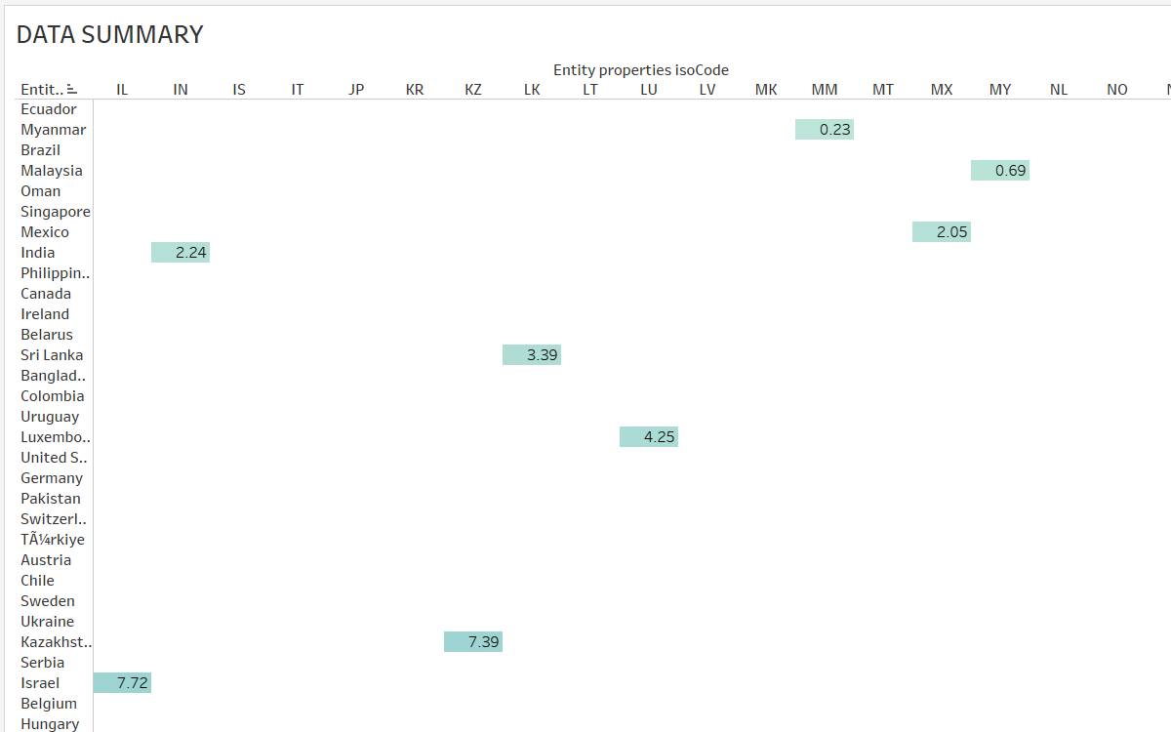

DASHBOARD 2

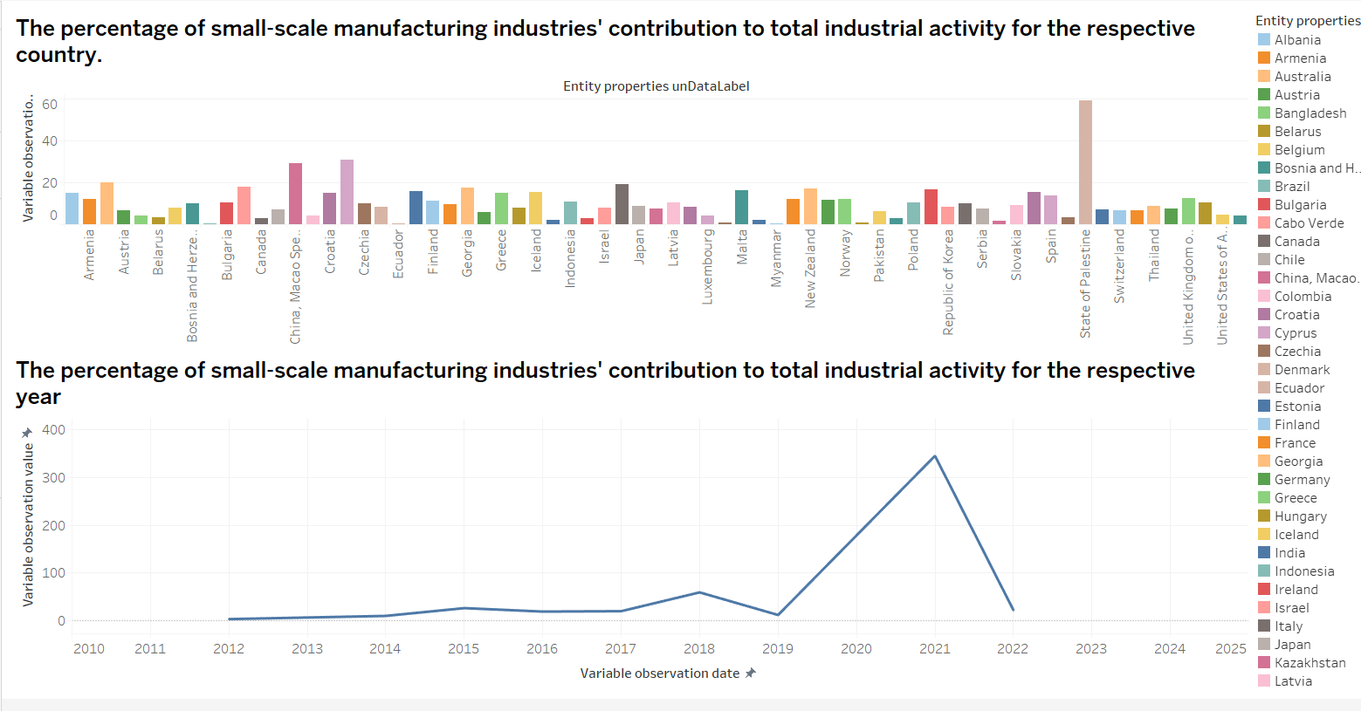

**Interpretation:**

* **Variability Across Countries:** The percentage contribution of small-scale manufacturing industries varies significantly across countries. Some countries have a high contribution, while others have a low contribution.
* **Country-Specific Trends:** Some countries show increasing contributions over the years, while others have experienced declines.
* **Regional Patterns:** There might be regional trends, where countries within certain geographic regions have similar patterns of contribution.
* **Economic Factors:** The contribution of small-scale manufacturing industries is likely influenced by various economic factors, such as government policies, industrial development strategies, and the overall economic climate.

**Insights:**

* **Country-Specific Policies:** Countries with high contributions may have implemented policies or initiatives that support small-scale manufacturing.
* **Economic Development:** The contribution of small-scale manufacturing industries might be correlated with overall economic development levels.
* **Industrial Structure:** The structure of the industrial sector in each country can influence the role of small-scale manufacturing.

DASHBOARD 3

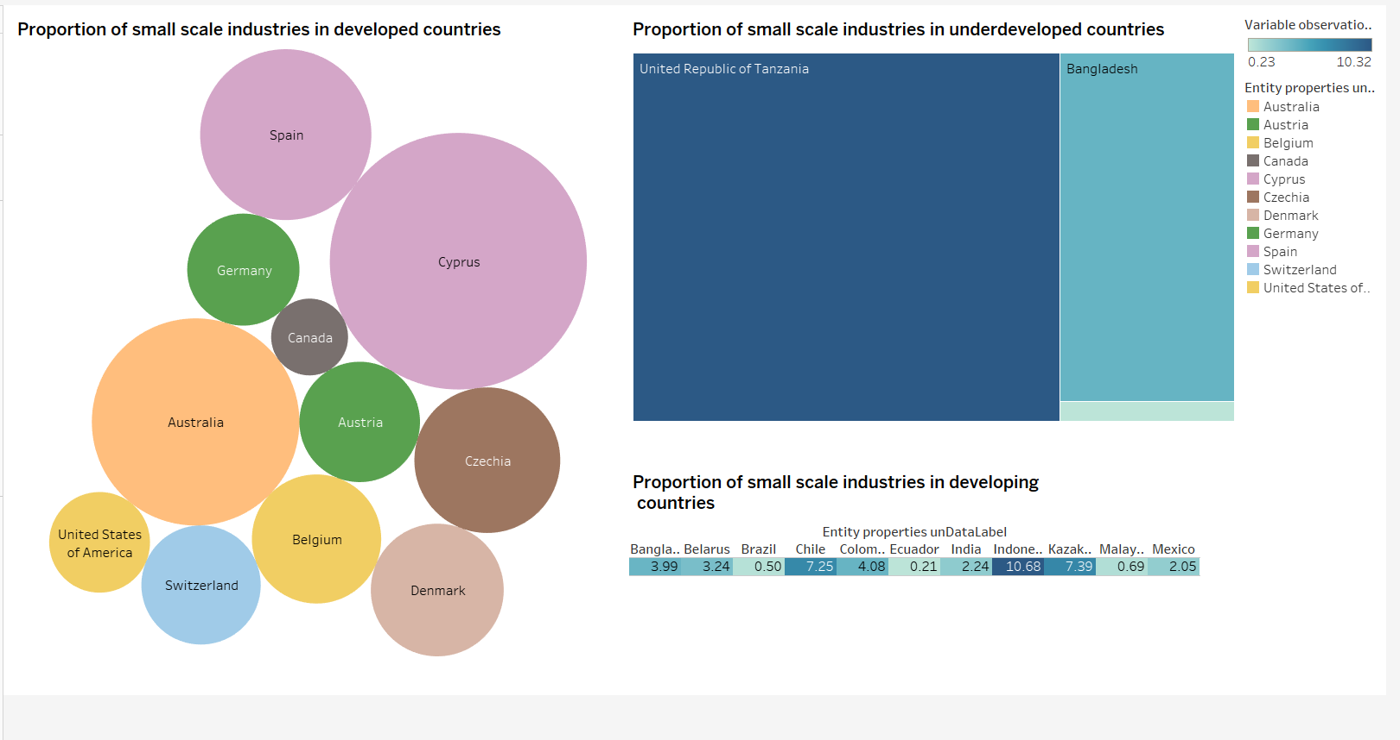

**Interpretations:**

**Developed Countries:**

* **Size Distribution:** The bubble chart indicates that there is a wide range in the proportion of small-scale industries among developed countries. Some countries have a significantly higher proportion compared to others.
* **Clustering:** There seem to be clusters of countries with similar proportions, suggesting regional or economic factors influencing this distribution.

**Developing Countries:**

* **Dominance:** The bar chart shows that small-scale industries contribute a significantly higher proportion to the total industrial activity in developing countries compared to developed countries.
* **Country Variations:** There is still some variation among developing countries, with some having higher or lower proportions.

**Insights:**

* **Scale Difference:** Small-scale industries play a more prominent role in developing countries compared to developed countries.
* **Economic Factors:** The level of industrialization, economic development, and government policies likely influence the proportion of small-scale industries in each country.
* **Regional Trends:** Further analysis could reveal regional patterns or differences in the contribution of small-scale industries.

DASHBOARD 4

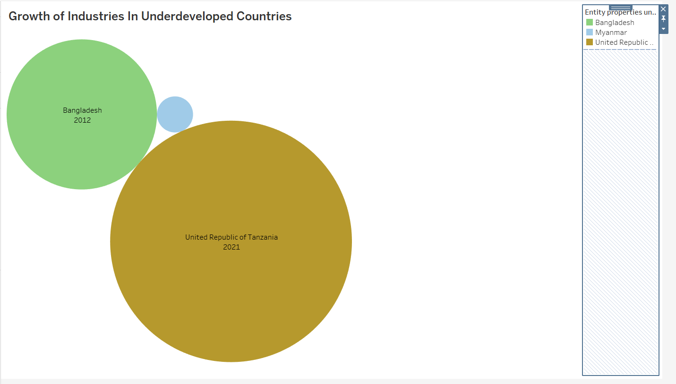

**Interpretation:**

* **Comparison of Growth:** The bubble chart visually compares the growth of industries in Bangladesh and the United Republic of Tanzania.
* **Size Represents Growth:** The size of the bubbles likely represents the magnitude of industrial growth.
* **Time Dimension:** The years 2012 and 2021 suggest a comparison of growth over time.

**Insights:**

* **Rapid Growth in Bangladesh:** The larger size of the Bangladesh bubble for 2012 compared to 2021 suggests that Bangladesh experienced more rapid industrial growth during that period.
* **Growth in Tanzania:** The increase in the size of the Tanzania bubble from 2012 to 2021 indicates that Tanzania also experienced industrial growth, although possibly at a slower rate than Bangladesh.
* **Relative Growth:** The relative sizes of the bubbles provide a visual comparison of the growth rates between the two countries.

INDIA CASE STUDY

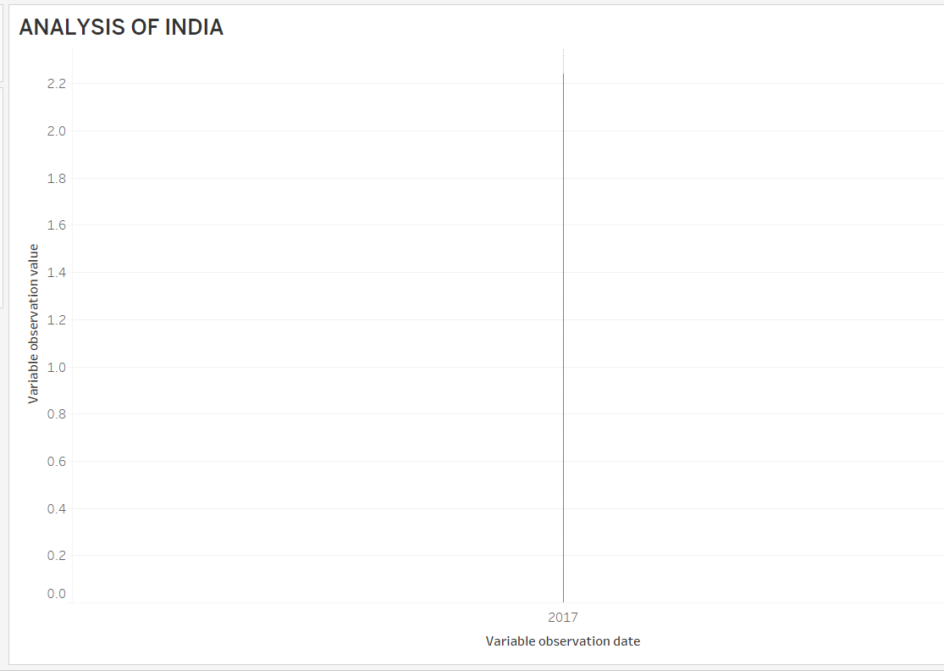

CONCLUSION:

By implementing these recommendations, countries can harness the potential of small-scale industries to achieve sustainable economic development, create jobs, and reduce inequality. By fostering a supportive environment for small-scale industries, governments can contribute to a more inclusive and prosperous future.