Proposal of a New ETL Pipeline
Retrieving, Transforming, and Delivering Multi-Modal Market Data
for an Entropy-Gated Adaptive Hybrid Forecasting System
Prepared by: Joanne Wijetunga
Project: Stock Price Prediction — Entropy-Gated Adaptive Hybrid Forecasting System (“Gap B”)

1. Problem Statement and Motivation
The literature review conducted for this project examined seven academic systems and five commercially deployed AI-driven stock prediction tools. Across all twelve, a consistent architectural weakness emerged: every hybrid forecasting model applies a fixed, static weighting between sentiment-derived signals and technical indicator signals, treating both feature streams as equally important regardless of the current market regime. None of the reviewed systems adapt this weighting in real time using a principled, measurable property of the current information environment.
The proposed system — the Entropy-Gated Adaptive Hybrid Forecasting System (“Gap B”) — closes this gap by introducing a learnable entropy-driven gate that continuously reweights sentiment versus technical features using the Shannon entropy of FinBERT's daily sentiment-classification distribution, H_t = −Σ p_i · log(p_i), as a real-time regime signal. The gate weight α_t = σ(w·H_t + b) determines the fused feature vector F_t = α_t·S_t + (1−α_t)·X_t that is ultimately passed to the Informer forecasting model.
Ingesting and combining heterogeneous data sources is, of course, not new — every hybrid system reviewed (Papers 1, 2, 4, and 5 in particular) and every commercial tool examined already retrieves price data alongside news or social text, cleans it, and transforms it into model-ready features. What none of them do is treat the Shannon entropy of the sentiment distribution, H_t, as a first-class, persisted, point-in-time feature. In every reviewed system, sentiment is consumed as a score and discarded; entropy, where it appears at all (as in ALERA's risk-quantification layer), is computed transiently for a downstream decision and is never stored as a queryable historical signal in its own right. The proposed gating mechanism, however, must be trained and — critically — backtested against specific historical regime-shift windows (the COVID-19 crash, the 2022 rate-hike cycle, the SVB crisis), which means H_t has to exist historically, at daily granularity, for every ticker and date, computed only from information available as of that date. That is a structural requirement that standard sentiment-plus-technical pipelines were never built to satisfy, and it is the specific reason a new ETL pipeline — one engineered to compute, persist, and serve X_t, S_t, and H_t as synchronized, temporally-aligned, point-in-time features — must be designed and built. This is the subject of the present proposal.

2. Objective
The objective of this proposal is to design and build an automated, fault-tolerant, and observable ETL pipeline that performs the following functions:
- Extract — Continuously ingest raw market price data (OHLCV) and unstructured text data (financial news headlines and retail-investor social media posts) from external sources into a central data lake.
- Transform — Clean, deduplicate, temporally align, and transform these heterogeneous streams into a unified, versioned, query-ready feature store.
- Engineer — Compute and persist the intermediate signals required by the forecasting model: technical/price features (X_t), FinBERT-derived sentiment scores and Shannon-entropy values (S_t, H_t), drawn from cleaned and normalized text.
- Load — Deliver these features to the ML inference layer (the Sentiment, Fusion/Gating, and Forecast Agents) with the latency, consistency, and as-of-date correctness that real-time multi-step price forecasting requires.
- Monitor — Operate under continuous observability — instrumented end-to-end with monitoring, alerting, and automated data-quality validation — so that pipeline failures or data-quality regressions are caught before they propagate into the forecasting model.

3. High-Level Pipeline Description
The proposed pipeline follows the deployment architecture shown in Figure 1 below (the same architecture developed earlier for this project, here annotated with the numbered data-flow sequence ①–⑩). It is organized into six cooperating layers: external data sources, a streaming-and-orchestration layer, a processing-and-storage layer, an ML inference server, an agentic coordination layer, and an output / monitoring layer.
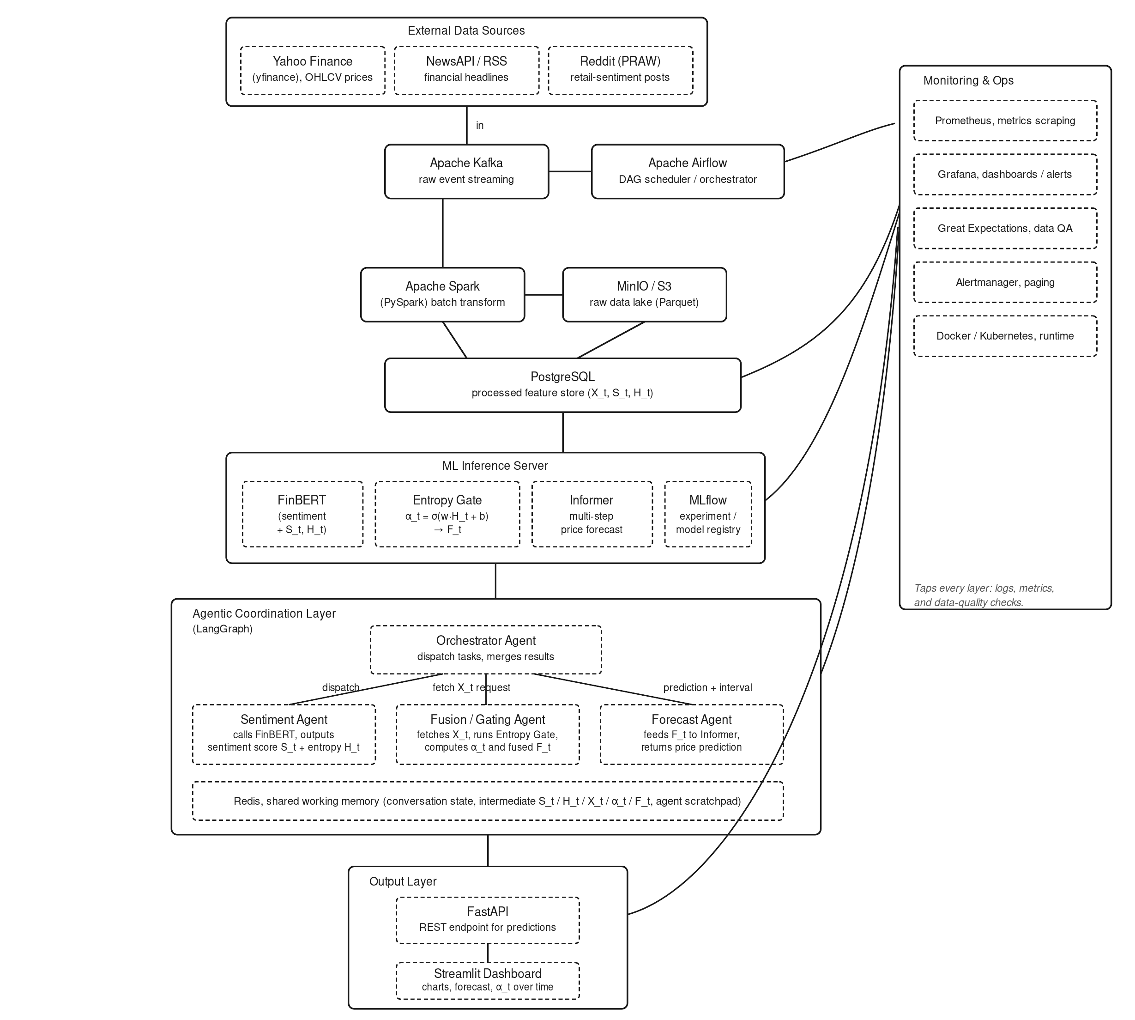
Figure 1. Deployment architecture of the Entropy-Gated Adaptive Hybrid Forecasting System, annotated with the numbered ETL data-flow sequence ①–⑩ referenced throughout this proposal.

3.1 Extract
Three external sources are polled and streamed continuously: Yahoo Finance via the yfinance API (daily OHLCV price and volume history), NewsAPI / RSS feeds (financial news headlines), and Reddit via the PRAW API (retail-investor sentiment posts). Each source publishes its raw payloads as events onto dedicated Apache Kafka topics (①), which act as a durable, replayable buffer between unreliable, rate-limited external APIs and the rest of the pipeline. Apache Airflow DAGs orchestrate the polling schedule, retry logic, and downstream trigger conditions for each source (②).

3.2 Transform and Load (Raw → Processed)
Airflow triggers Apache Spark (PySpark) jobs that consume the raw Kafka events, write an immutable copy of every payload to the MinIO / S3 data lake in Parquet format (③, ④), and then apply the transformation logic: deduplication, resampling of price data to consistent daily bars, computation of technical indicators (SMA, RSI, OBV, ADX, etc.) that constitute X_t, and cleaning / normalization of headline and post text. The cleaned text is passed to FinBERT inside the ML Inference Server, which produces the sentiment score S_t and the Shannon entropy H_t of its three-class probability distribution (⑥). The fully transformed, feature-engineered records — X_t, S_t, and H_t, keyed by ticker and trading date — are then loaded into PostgreSQL as the processed feature store (⑤): the single source of truth that the inference layer queries.

3.3 Serve (Feature Store → Inference)
At inference time, the Agentic Coordination Layer — Orchestrator, Sentiment, Fusion/Gating, and Forecast Agents, coordinated through LangGraph and backed by Redis as shared working memory — reads from the feature store rather than calling external APIs directly (⑦). The Sentiment Agent supplies S_t and H_t; the Fusion/Gating Agent fetches X_t directly from PostgreSQL, runs the entropy gate α_t = σ(w·H_t + b), and produces the fused vector F_t; the Forecast Agent feeds F_t into the Informer model (ProbSparse Attention, Self-Attention Distilling, and a Generative Decoder) to produce price forecasts at +5, +10, and +20 trading-day horizons.

3.4 Output and Monitoring
Forecasts and the gate weight α_t are exposed through a FastAPI REST endpoint and visualized in a Streamlit dashboard (⑧). Prometheus, Grafana, Great Expectations, and Alertmanager — running on Docker / Kubernetes — instrument every layer of the pipeline end-to-end, scraping metrics, validating data quality at each load step, rendering operational dashboards, and paging on failure (⑨).

4. Justification of Data Sources, Pipeline Shape, and Technology Choices

4.1 Why these three data sources
Papers 1 and 2 in the literature review demonstrated that hybrid sentiment-plus-technical systems consistently outperform single-input models, but also that automated sentiment pipelines are only as good as the breadth and freshness of the text they ingest. NewsAPI / RSS provides institutional-grade financial news coverage, while Reddit (via PRAW) captures retail-investor sentiment — a complementary signal absent from every commercial tool reviewed (none of I Know First, StarMine, Seeking Alpha Quant, Danelfin, or Tickeron integrate live, multi-source NLP sentiment into their core prediction architecture). Combining both with Yahoo Finance OHLCV data gives the model the full triad of inputs — price, institutional narrative, and retail narrative — needed to compute a meaningful, real-time entropy signal.

4.2 Why a raw data lake and a separate processed feature store
Splitting storage into an immutable raw layer (MinIO / S3, Parquet) and a queryable processed layer (PostgreSQL) serves two purposes. First, it preserves the complete historical record needed for reproducible retraining and backtesting — directly addressing Wang and Lera's (2025) finding that regime-aware models such as FinPFN require access to broad historical distributional context, not just the most recent processed window. Second, it gives the latency-sensitive inference layer a clean, structured, indexed store to query, decoupling slow, unreliable, rate-limited external retrieval from fast, predictable model-serving reads.

4.3 Why Kafka and Airflow for streaming and orchestration
Market data, news, and social posts arrive asynchronously and at very different cadences (intraday ticks versus sporadic headlines versus continuous social posts). An event-streaming backbone (Kafka) absorbs this variability and provides replay capability if downstream processing fails, while a DAG-based scheduler (Airflow) coordinates the batch transformation jobs, manages retries and dependencies, and enforces the “always-on” operating model that a live prediction service requires. This combination is the industry-standard pattern for production-grade ML data engineering.

4.4 Why Spark / PySpark for transformation
The pipeline must process two structurally different kinds of data — numerical OHLCV time series and unstructured natural-language text — at a volume that scales with the number of tickers tracked and the rate of incoming news and social content. A distributed processing engine such as Spark allows the cleaning, resampling, deduplication, and feature-computation stages to scale horizontally as coverage grows, without redesigning the transformation logic.

4.5 Why entropy is computed and persisted in the pipeline, not only at inference time
H_t must exist not only as a live, real-time signal but also as a historical, queryable feature: the validation strategy defined for the proposed system requires backtesting the adaptive model against specific historical regime-shift windows — the COVID-19 crash of March 2020, the Federal Reserve rate-hike cycle of 2022, and the SVB banking crisis of March 2023. This is only possible if H_t (and S_t and X_t) are computed during the Transform stage and persisted as first-class, versioned features in the store — not generated ephemerally inside the model at inference time.

4.6 Why automated data-quality validation (Great Expectations) is a first-class pipeline stage
Prata et al. (2024) showed empirically that the great majority of deep-learning stock-prediction models degrade sharply when fed data that is even slightly out-of-distribution relative to their training data, and that this systemic overfitting is frequently masked by strong in-sample performance. A pipeline that loads data into the feature store without first validating schema conformance, value ranges, null rates, and temporal completeness would silently propagate exactly this fragility into the proposed forecasting system. Embedding Great Expectations checks at every load boundary, paired with Prometheus / Grafana monitoring and Alertmanager paging, makes data quality an enforced property of the pipeline rather than an assumption made about it.

5. How the ML Model Consumes the Pipeline's Output
The forecasting model never calls external data APIs directly. Instead, the Sentiment, Fusion/Gating, and Forecast Agents consume exclusively from the processed feature store (PostgreSQL) and the shared Redis working memory that the pipeline populates. This decouples the slow, rate-limited, and occasionally unreliable process of external data acquisition from the fast, latency-sensitive path of generating a live prediction. The consumption sequence is:
- Step 1 — the Sentiment Agent retrieves the most recent cleaned headlines and posts for a given ticker and date, invokes FinBERT, and returns the sentiment score S_t and entropy H_t (persisting both back to the feature store for future reuse and backtesting);
- Step 2 — the Fusion/Gating Agent independently retrieves X_t directly from the feature store, computes the gate weight α_t = σ(w·H_t + b), and produces the fused feature vector F_t = α_t·S_t + (1−α_t)·X_t;
- Step 3 — the Forecast Agent retrieves F_t and feeds it into the Informer architecture, generating price forecasts at the +5, +10, and +20 trading-day horizons together with an associated confidence signal derived from α_t.
Crucially, this only produces valid forecasts if the pipeline guarantees strict temporal alignment: the X_t, S_t, and H_t values associated with a given trading day must be derived only from data that was actually available as of that day, with no lookahead leakage from future price movements or later-published news. This as-of-date correctness is a property that must be designed directly into the Transform stage of the pipeline — through careful watermarking, event-time processing, and point-in-time joins in the Spark transformation jobs — rather than something that can be corrected after the fact.

6. Expected Value and Outcomes
- Foundational enabler — it produces the foundational layer without which the entropy-gated fusion mechanism — the system's core academic contribution — cannot function: a clean, versioned, temporally-aligned, multi-modal feature store assembled from three disparate, noisy, asynchronous external sources;
- Reproducible regime-shift backtesting — because raw historical data is preserved immutably in the data lake and can be re-processed through the same transformation logic used in production, the pipeline enables reproducible backtesting against the specific historical regime-shift windows defined in the validation strategy (the COVID-19 crash, the 2022 rate-hike cycle, and the SVB crisis) — the exact conditions under which the proposed adaptive model is expected to outperform fixed-weight baselines;
- Closes a documented systemic gap — by embedding Great Expectations validation, Prometheus / Grafana monitoring, and Alertmanager paging throughout, the pipeline supplies exactly the kind of systemic data-quality and observability guarantees that the literature review identified as absent from prior academic systems and commercial tools — directly addressing the documented finding that “performance consistently degrades during regime transitions... confirming that static [and unmonitored] models cannot generalize across changing market environments”;
- Standalone engineering deliverable — independent of the forecasting model itself, the pipeline is a complete demonstration of production-grade data-engineering competency — streaming ingestion, distributed transformation, feature-store design, workflow orchestration, and full-stack monitoring — forming a deliverable in its own right and the direct foundation for the ML-enabled tool to be implemented in the next phase of this project.

