Joanne Kwon

PID: A15359545

**Lab1_Kwon**

LAB QUESTION #1

* I predict that using single quotes, like ‘1+1’, will output similar results as using double quotes. Therefore, I think single quotes will simply output ‘1+1’.

LAB QUESTION #2

* Using single quotes outputted ‘1+1’ just as I had predicted.

LAB QUESTION #3

* When I typed ‘1+1’ MATLAB outputted exactly what I had typed in, including the math problem and single quotes. Whereas typing in 1+1 without the quotes outputted 2. I think MATLAB outputted exactly what I had inputted because, with quotations, this input is a string.

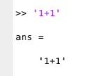

LAB QUESTION #4

* I predict that factoring a number that is not an integer will output nothing because, in math, non-integers are difficult to factor. For example, it is difficult to factor pi. When inputting factor(4.4) in MATLAB it outputted an error because the program can only process real positive integers for factoring.

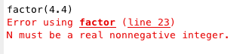

LAB QUESTION #5

* For the function gcd(10, 25), if I only provide one argument there is an error because there are not enough input arguments.

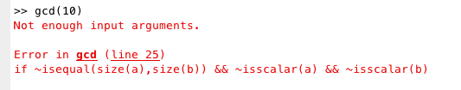

LAB QUESTION #6

* Errors that occur inside functions do not output an answer and, instead, output and error message that tells the user what is wrong with the function. On the other hand, the previous errors did output an answer instead of an error, meaning the syntax wasn’t wrong.

LAB QUESTION #7

* I predict that the output will be 17.

LAB QUESTION #8

* Yes, the answer matched my prediction.

LAB QUESTION #9

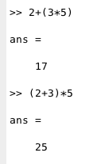

LAB QUESTION #10

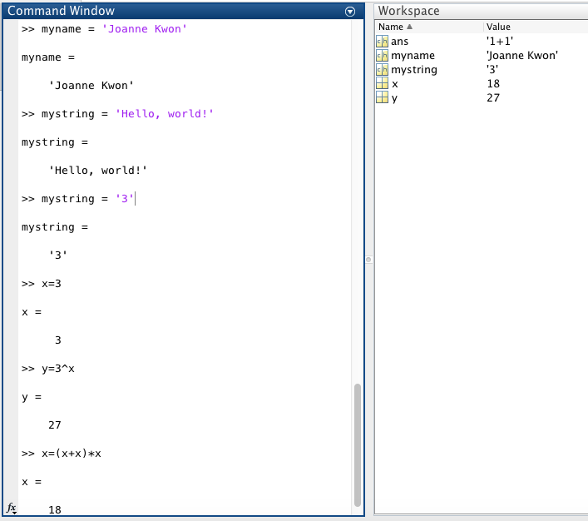

LAB QUESTION #11

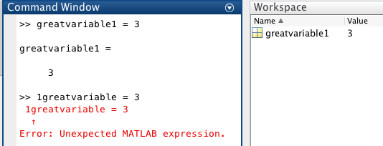

* When choosing a variable name, do not put numeric numbers in the front of the variable name because this creates an error and no calculation is done. Numbers in the middle or end of a variable name is fine.

LAB QUESTION #12

* When making two variables with the same name, except for capitalization MATLAB processes each variable as different variables. I am able to tell because two different variables are created in the workspace.

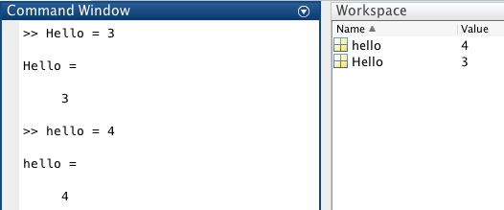

LAB QUESTION #13

* Underscores are allowed in the variable name. However, the underscore cannot be located in the beginning of the variable name. Dashes are not allowed in any part of the variable name. I have also experimented with other punctuation marks like, ?, !, /, @, &, but all of them outputted an error message.

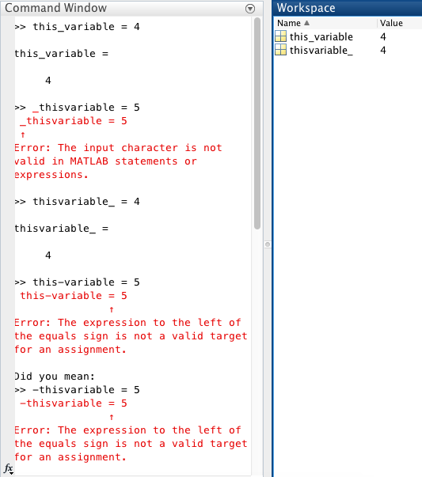

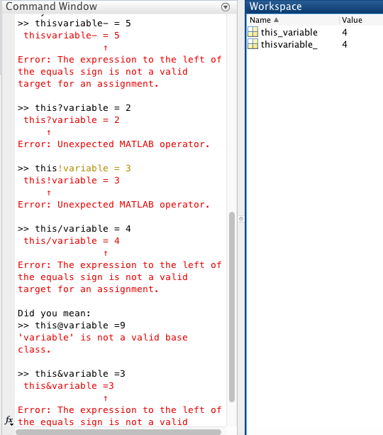

LAB QUESTION #14

* In this piece of code, x is assigned to a string of characters (ex: x = ‘abcd’) that hold a set of numerical values (ex: x = “97 98 99 100). These numerical values can be found on the ASCII table. Then, when an equation is entered into the program (ex: z = x+1) , those string of characters/numerical values are inputted into the equation and output a new set of numbers (ex: 98 99 100 101). Therefore, if I happened to type x = ‘efgh’ and then z = x+1 the program will output 102 103 104 105.

LAB QUESTION #15

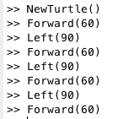 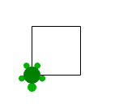

**HW1_Kwon**

**Part I**

Code:

(a+b)/(sqrt((a^2)+(b^2)))

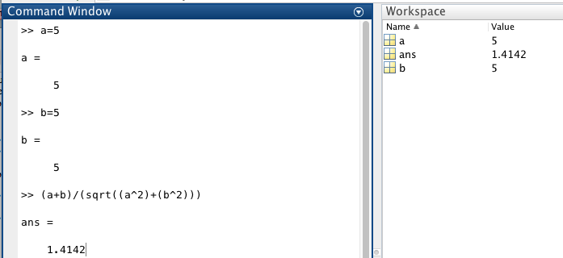

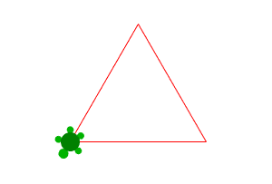

**Part II: Turtle Assignment**

Code:

>> NewTurtle()

>> LineColor (255, 0, 0)

>> distance = 150

distance =

150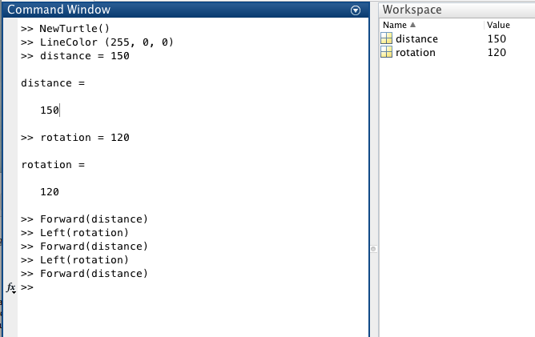

>> rotation = 120

rotation =

120

>> Forward(distance)

>> Left(rotation)

>> Forward(distance)

>> Left(rotation)

>> Forward(distance)

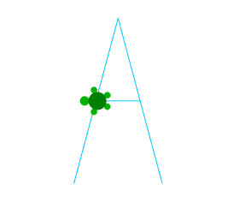

Code:

>> NewTurtle()

>> LineColor(0, 200, 255)

>> side_length = 200

side_length =

200

>> rotation = 180

rotation =

180

>> center_length = 50

center_length =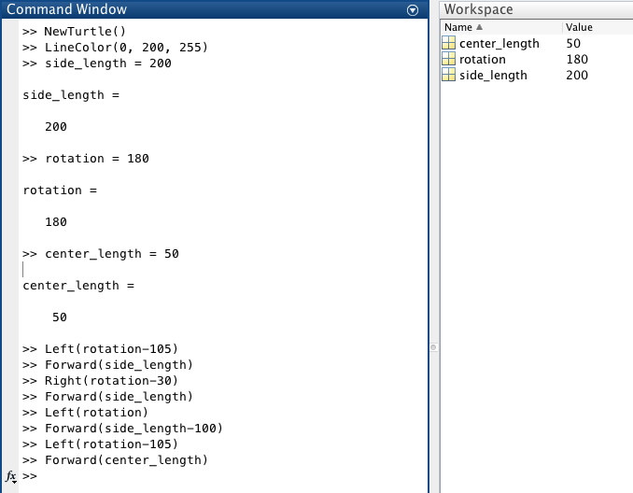

50

>> Left(rotation-105)

>> Forward(side_length)

>> Right(rotation-30)

>> Forward(side_length)

>> Left(rotation)

>> Forward(side_length-100)

>> Left(rotation-105)

>> Forward(center_length)

Code:

>> NewTurtle()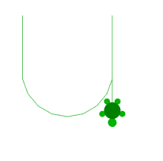

>> LineColor(100,200,100)

>> distance = 20

distance =

20

>> rotate = 20

rotate =

20

>> Right(90)

>> Forward(distance*4)

>> Left(rotate)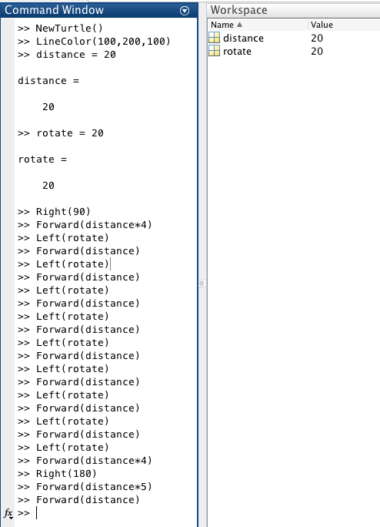

>> Forward(distance)

>> Left(rotate)

>> Forward(distance)

>> Left(rotate)

>> Forward(distance)

>> Left(rotate)

>> Forward(distance)

>> Left(rotate)

>> Forward(distance)

>> Left(rotate)

>> Forward(distance)

>> Left(rotate)

>> Forward(distance)

>> Left(rotate)

>> Forward(distance)

>> Left(rotate)

>> Forward(distance*4)

>> Right(180)

>> Forward(distance*5)

>> Forward(distance)

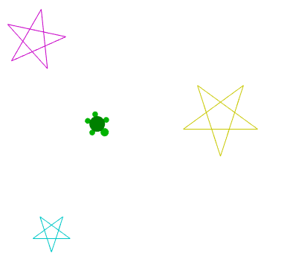

Code:

>> NewTurtle()

>> LineColor(200,200,0)

>> distance_one = 100

distance_one =

100

>> distance_two = 50

distance_two =

50

>> distance_three = 80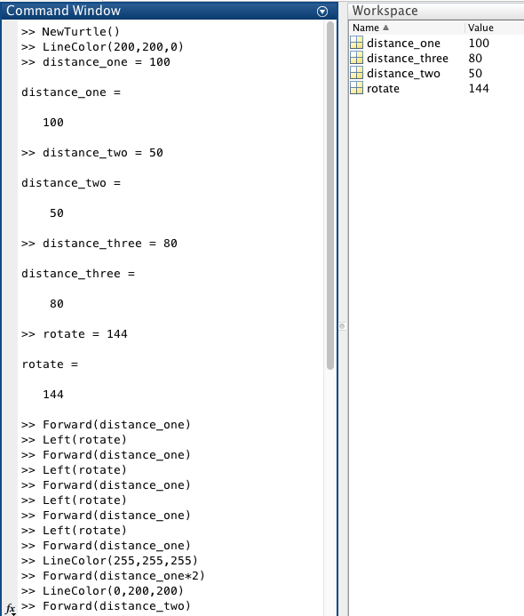

distance_three =

80

>> rotate = 144

rotate =

144

>> Forward(distance_one)

>> Left(rotate)

>> Forward(distance_one)

>> Left(rotate)

>> Forward(distance_one)

>> Left(rotate)

>> Forward(distance_one)

>> Left(rotate)

>> Forward(distance_one)

>> LineColor(255,255,255)

>> Forward(distance_one*2)

>> LineColor(0,200,200)

>> Forward(distance_two)

>> Left(rotate)

>> Forward(distance_two)

>> Left(rotate)

>> Forward(distance_two)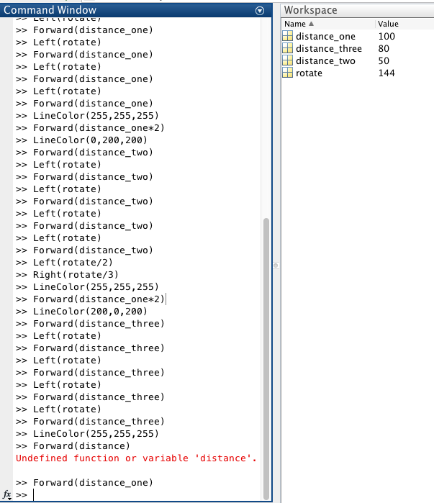

>> Left(rotate)

>> Forward(distance_two)

>> Left(rotate)

>> Forward(distance_two)

>> Left(rotate/2)

>> Right(rotate/3)

>> LineColor(255,255,255)

>> Forward(distance_one*2)

>> LineColor(200,0,200)

>> Forward(distance_three)

>> Left(rotate)

>> Forward(distance_three)

>> Left(rotate)

>> Forward(distance_three)

>> Left(rotate)

>> Forward(distance_three)

>> Left(rotate)

>> Forward(distance_three)

>> LineColor(255,255,255)

>> Forward(distance_one)