Joanne Kwon

PID: A15359545

**Lab2_Kwon**

**LAB QUESTION #1**

* When I input DrawRedTriangle; it outputs all the associated variables and their values, which is similar to DrawRedTriangle. In the workspace it updates all its values to reflect DrawRedTriangle;.

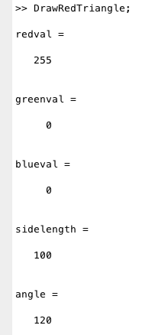

**LAB QUESTION #2**

* When I put a semicolon at the end of each command in the editor and ran DrawRedTriangle in the command window no output was produced and the triangle image popped up. The workspace all the values are updated to reflect DrawRedTriangle;.



**LAB QUESTION #3**

* Inputting sidelength outputs a value of 100.

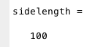

**LAB QUESTION #4**

* I predict that removing the variable from the workspace will produce an error because sidelength is completely removed. My prediction was partially correct because there was an error output after removing the variable, however, it was because there is a script and variable under the name sidelength.

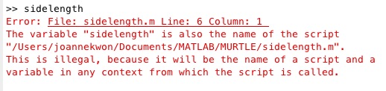

**LAB QUESTION #5**

* I made an error by changing the variable names redval, greenval, and blueval by placing a numerical number in the front of each variable name. When I ran the script there was an error output.

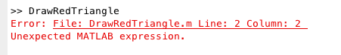

**LAB QUESTION #6**

* I predict that when I run the script the color of the triangle would be different (more blue added to color). The blueval in the workspace window is 200.

**LAB QUESTION #7**

* “Give the last element of the vector.”

>> myvec(end)

ans =

33

* “Give the 3rd through 5th elements of the vector.”

>> myvec(3:5)

ans =

108 108 111

* “Give the elements of the vector starting with the 5th through to the end.”

>> myvec(5:end)

ans =

111 44 32 119 111 114 108 100 33

**HW2_Kwon**

**Original Images**

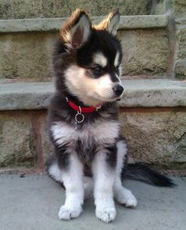 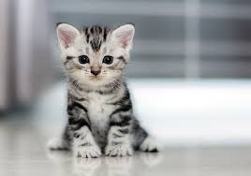

**FunHouseTall**

Code:

% Name: Joanne Kwon

% This code is called FunHouseTall.

% This code decreases an image's width while the height remains the same.

% This makes the image look "tall".

image=imread(filename);

funnyimage=image(:,2:2:end,:);

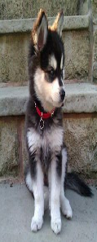

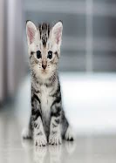

**FunHouseShort**

Code:

% Name: Joanne Kwon

% This code is called FunHouseShort.

% This code decreases an image's height while the width remains the same.

% This makes the image look "short".

image=imread(filename);

funnyimage=image(2:2:end,:,:);

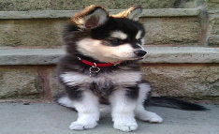 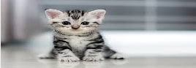

**CropTopRightQuadrant**

Code:

% Name: Joanne Kwon

% This code is called CropTopRightQuadrant.

% This code takes the top right corner of an image.

% (approximately 1/4th of the original image)

image = imread(filename);

funnyimage=image(1:floor(end/2), floor (end/2): end, :);

