MAGARARU, JOANNE S.
BSIT 2F1

EXERCISE 17

1. Find and list the ids and spouse names of all employees who are
married.
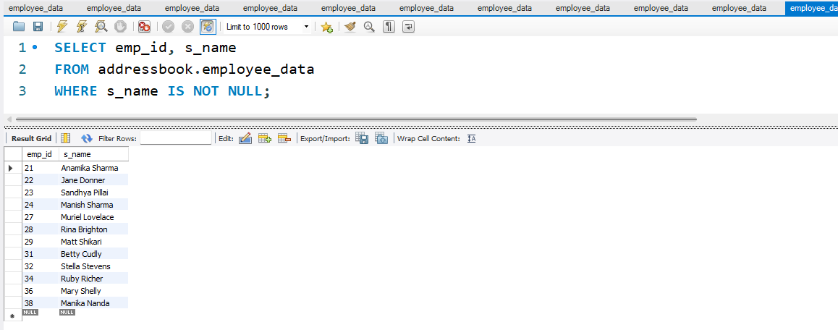
2. Change the above so that the display is sorted on spouse names.
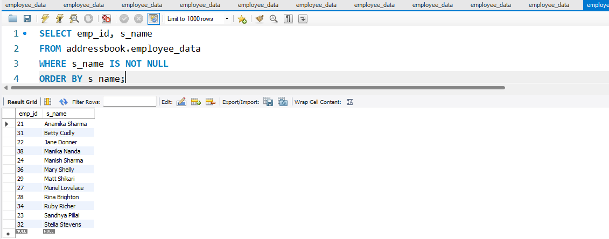
3. How many employees do we have under each sex (male and female)?
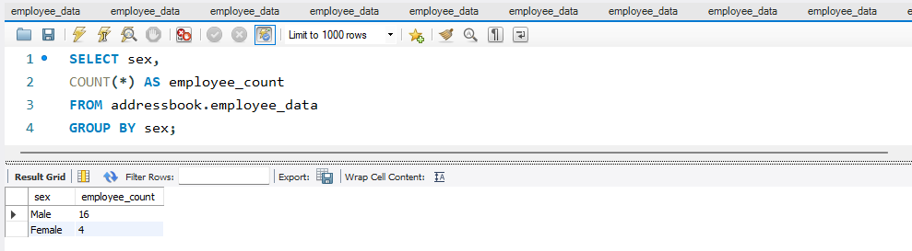
4. How many of our employees are married and unmarried?
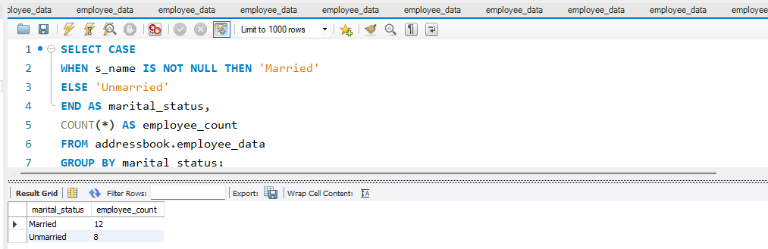
5. Find the total number of children.
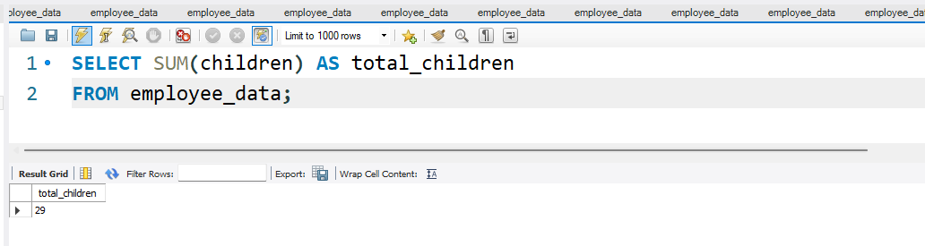
6. Make unique groups of children and find the number in each group.
Sort the display with the group having maximum children, at the top.
