**Last updated: 29 06 2017 by Joanne**

The general, language and courtesy part of the tutorial will be the parts that come up as the user first logs onto IRIS. The rest will be shown when they come across a that certain type of image.

**General**

* Be **detailed** with your description
  + E.g. Rather than writing "The graph's x-axis goes from -10 to 10", write, "The graph's x-axis goes from -10 to 10 in increments of 1."
* Write about **all** important features of the image
* Only describe what is in the image
  + E.g. Title, axis units and curve.
* Only supply **necessary** information
  + Eg. The colour of a graph is irrelevant unless specifically requested
* Put numerical data in tables
  + Data in structured tables are easier to read than narrative descriptions
* Put flow chart info into lists
  + It makes it easier to create a mental image
* Annotate mathematics
  + Use accessible math editor to add mathematical notation

**Language**

* Be **fully descriptive**
  + E.g. Rather than saying that it looks like a     ‘sine function’ talk about how it looks like a     wave. The recipient may not know what a     sine function looks like!
* Use **appropriate** language from the recipient's discipline
  + E.g. Use “curve” rather than “line”.
* **Identify and describe** each feature of the image fully before moving on
  + E.g. The image has an equilateral triangle     of side length 5, inside it is a circle with     radius 1.
* Be **clear** and **concise** with your answer

**Courtesy**

* Be **polite!**
* Say **hello and goodbye**. The more engaged the users are, the more they will get out of this service
* We want to create and sustain a **friendly, supportive** community

**Bar Graph**

* **Brief** summary including axis titles and ranges
* **Include** features, number and position of intersections.
* **Describe** minima, maxima and any extreme data points.
* **Compare** the data if there are multiple lines

Example

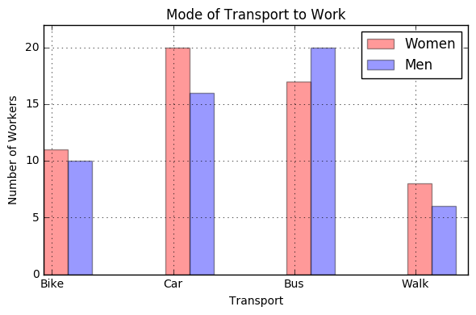

Bad Description

*The diagram shows the differences between modes of transport to work between men and women. Most women drive to work where as most men take the bus. Both women and men are least likely to walk.*

Good Description

* *The graphic shown is a bar graph titled “Modes of Transport”.*
* *The x axis is labelled “Transport”*
* *The y axis is the ”Number of Workers”*

|  |  |  |
| --- | --- | --- |
| **Transport** | **Number of Women** | **Number of Men** |
| Bike | 11 | 10 |
| Car | 20 | 16 |
| Bus | 17 | 20 |
| Walk | 8 | 6 |

**Line Graph**

1. **Brief** summary including axis titles and ranges
2. **Include** style features, number and position of intersections.
3. **Describe** minima, maxima and any extreme point on a data feature.
4. **Comparison** of data if more than one line

Example: Delta Function

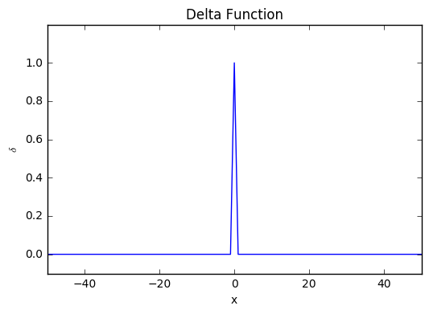

Bad Description

*The image is of a line graph. The blue line is constantly at zero until it peaks to 1 at x = 0.*

The title and axis have not been described. The colour of the line is also not physically significant and so can be left out.

Good Description

*The line graph is titled “Delta Function”. The x-axis, showing position, has a range -50 to 50. The y-axis showing the value of delta function at the position x has a range from 0 to 1. The line is horizontal l at delta=0 until it sharply peaks at x = 0 at a value of delta=1. It then dips back to delta=0 for the rest of the graph.*

Example: A mathematical function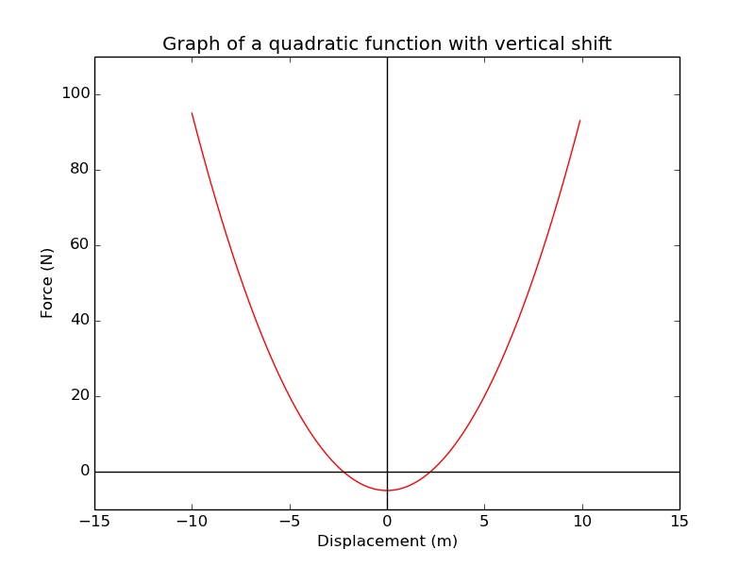

*The figure has the title “Graph of a quadratic function with a vertical shift”. The horizontal axis show a displacement in units of meter, while the vertical axis show a force in units of newton. The scale on the horizontal axis have limits of -15 and +15 and the plotted values range from -10 to +10 in steps of 5. Limits on the vertical axis are -10 and +110 and the range of values are plotted between -5 and 95 in steps of 5. The figure shows only one continuous function of a parabola opened upward, plotted with a red dashed line. The quadratic function is shifted downward by 5 units, has no horizontal shift. It intersects the y-axis at [0, -5] and cuts twice the x-axis at the points approximately between -2, -2.5 and +2, +2.5. The minimum of the parabola is at its intersection with the vertical axis.*

**Pie Charts**

1. **Brief** summary including title
2. Data should be put into a **table**
3. Data should be put from **largest to smallest** percentage

Example

Bad Description

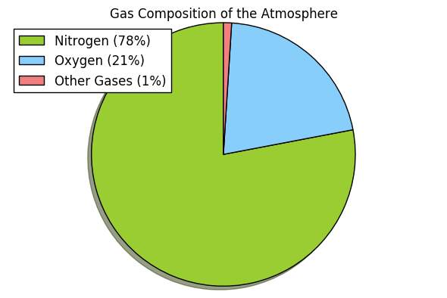

*A chart showing the gas compositions in the atmosphere. Nitrogen (78%) in green, Oxygen (21%) in blue, and other gases (1%) in red.*

Whilst the description does present the correct information to the user, it is jumbled with a lot of arbitrary details.

Good Description

A pie chart captioned “The percentages of each of the gases in the atmosphere.”

|  |  |
| --- | --- |
| **Gas** | **Percentage** |
| Nitrogen | 78% |
| Oxygen | 21% |
| Other | 1% |

Tables in descending order are especially useful when there is a large amount of data being presented.

**Venn Diagram**

* Focus on the data, not on the diagrams appearance

Example

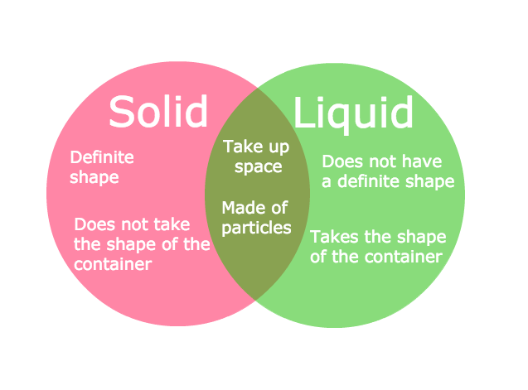

Bad Description

*The graphic shows a Venn diagram of the similarities and differences in solids and liquids. The left “solid” bubble has the sentences “Definite shape” and “Does not take the shape of the container. The middle of the diagram says, “Takes up space” and “Made of particles”. The right “Liquid” side has “Does not have definite shape”, and “Takes the shape of the container” inside.*

Good Description

*The graphic is a Venn diagram of the similarities and differences in solids and liquids. It shows that:*

* *Solids have a “definite shape” and “ do not take the shape of the container”*
* *Where as liquids “do not have a definite shape” but do “take the shape of the container”.*
* *The similarities between the two are that both phases of materials “take up space” and are “made of particles”*

**Flow Charts**

* Your response should describe the **order** of the boxes.
* The **shape** of each box should be included if it provides additional information in the given context
* State if there is more than **one** starting box

Example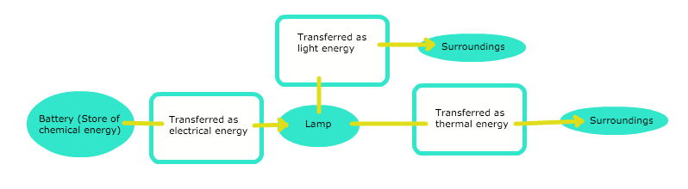Bad Description

*The image shows a flow chart describing the energy changes involved with a lamp. It starts as chemical energy in the battery that changes to electrical energy before reaching the lamp. It is then converted into either light energy or thermal energy.*

Good Description

*The image shows a flow chart describing the energy changes involved with a lamp.*

1. *“Battery (Store of chemical energy)”*
   1. *Forward to “Transferred as electrical energy”*
2. *“Transferred as electrical energy”*
   1. *Back to “Battery (Store of chemical energy)”*
   2. *Forward to “Lamp”*
3. *“Lamp”*
   1. *Back to “Transferred as electrical energy”*
   2. *Forward to “Transferred as light energy”*
   3. *Forward to “Transferred as thermal energy”*
4. *“Transferred as light energy”*
   1. *Back to “Lamp”*
   2. *Lateral to “Transferred as thermal energy”*
   3. *Forward to “Surroundings”*
5. *“Transferred as thermal energy”*
   1. *Back to “Lamp”*
   2. *Lateral to “Transferred as thermal energy”*
   3. *Forward to “Surroundings”*

**Diagram**

* General description
* Summarise in bullet points or list
* Describe image from left to right

Example: Moon’s Phases

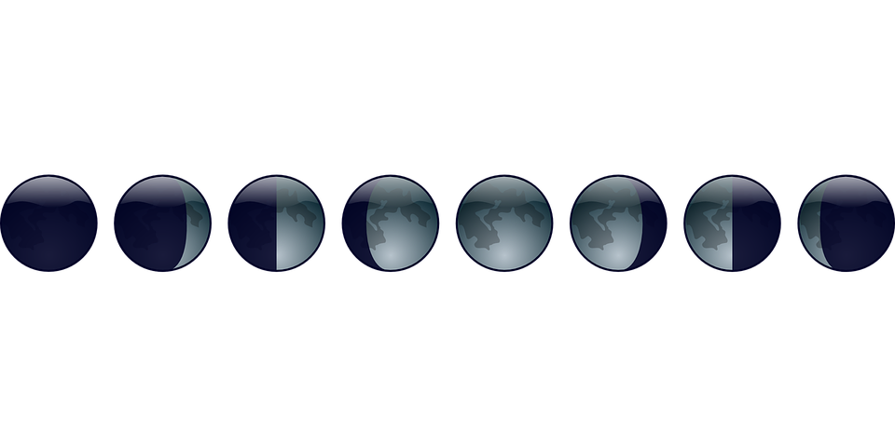

Bad Description

*The image shows the moon through its lunar phases. It starts with a new moon, transitioning to a full moon and then back to a new moon*

Good Description

*The image shows the moon through its lunar phases. There are eight images shown, from left to right:*

* *New moon. The moon cannot be seen from the Earth and so is completely black.*
* *Waxing crescent. One quarter of the right of the moon can be seen.*
* *First quarter. A semi circle of the right of the moon is seen.*
* *Waxing Gibbous. Three quarters of the right side of the moon is illuminated.*
* *Full moon. The whole circle of the moon is seen.*
* *Waning Gibbous. Three quarters to the left side of the moon is seen.*
* *Third quarter. The left semicircle to the moon is seen.*
* *Waning Crescent. One quarter to the left of the moon is seen.*

Example : Electric circuit design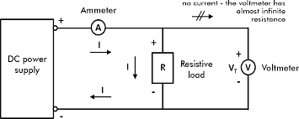

*The image has no title and shows a schematic electric circuit. A total of four electric components and a set of connecting wires are represented. The figure has*

*• a rectangle with the label “DC power supply” with a + sign on top, and a - sign at the bottom,*

*• an other rectangle, with the label capital R in it, and a text on the right saying “Resistive load”. Again with a + sign on top, and a - sign at the bottom,*

*• a circle with the label capital A, and a text saying Am-meter near that,*

*• a circle with the label capital V subscript capital T, and a text saying Volt-meter near that, with a + sign on top, and a - sign at the bottom.*

*The relative position of these components is as follows. Imagine a horizontal, rectangular frame with a vertical line bisecting it in the middle. The DC power supply sits on the left edge of the frame. The Am-meter sits on the top, left section of the frame. The resistive load sits in the middle of the bisecting vertical line. The Volt-meter sits on the right edge of the frame. The DC power supply, Am-meter, resistive load are connected in series, with the Volt-meter being connected in parallel to the resistive load. The frame itself with the bisecting line are representations of the wire.*

*A right pointing arrow with a capital I label under the Am-meter, a downward pointing arrow with a capital I label to the left of the resistive load, and a left pointing arrow with a capital I label above the lower edge of the frame, indicate the direction of current flow. The top, right section of the wire is crossed out and a label says “no current, the voltmeter, has almost infinite resistance.”.*

Example: Image of a water molecule

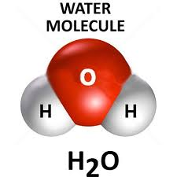

*The figure has the title “Water molecule” and is based on a white background. At the bottom of the image, the chemical formula H2O can be read. In the centre a red sphere is visible with two additional, half size grey spheres placed at 8 and 4 o’clock relative to the central, bigger sphere. The two grey objects are similar to a distorted sphere where they join the red sphere. The connections are shown as straight edges. The central sphere has a label capital O printed in black, and the smaller spheres are labelled with capital H.*

**Math Equations**

* Use the provided math editor
  + It will output a readable source for our users

Example

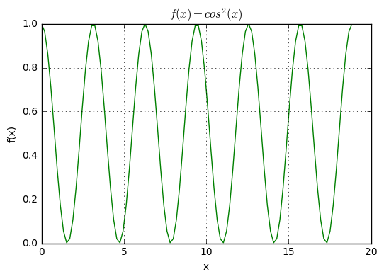

Bad Description

*The graphic shows a line graph titled “ f bracket x bracket equal to cos squared bracket x bracket”…*

Try not to use plain English but rather out math editor!

Good Description

*The graphic shows a line graph titled* *****…*

Using our math editor makes it much easier for our users to understand what is being described.

Example: Different functions

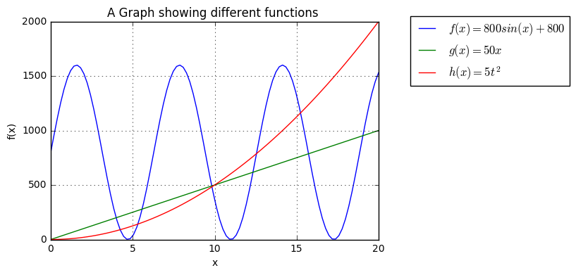

Acknowledgements

We would like the acknowledge the contribution, as express gratitude to:

**National Center for Accessible Media** (**NCAM)** "Experience + Learn / Educational Media / Effective Practices For Description Of Science Content Within Digital Talking Books / NCAM". *Ncam.wgbh.org*. N.p., 2017. Web. 17 June 2017.

**Diagram Center** "Accessible Dynamic Scientific Graphics – DIAGRAM Center"

**Be Spectacular** "How Can You Use The Bespecular App?". *Bespecular.com*. N.p., 2017. Web. 17 June 2017.

**Open University** "Enabling Access To The Chemistry Curriculum For Visually Impaired Students | Esteem". *Open.ac.uk*. N.p., 2017. Web. 17 June 2017.