Open Water Battery Electronics Design Specification

Project Ref #: OWP001

COMPANY CONFIDENTIAL
TITLE |  | DOC. NO. | REV.
Open Water Battery Electronics Design Specification |  | SP-13690 | 0.1
Boston Engineering |  | Boston Engineering
PREPARED BY | DATE | APPROVED BY | DATE
______________________________ | _______________ | ______________________________ | _______________
Y.WONG |  | Name
Electrical Engineer |  | Job Title
Boston Engineering |  | Client
REVIEWED BY | DATE | APPROVED BY | DATE
______________________________ | _______________ | ______________________________ | _______________
Name |  | Name
Job Title |  | Job Title

REVISION HISTORY

Revision | Description | Date | Author
0.1 | Draft | 07/29/2016 | Y.Wong

TABLE OF CONTENTS

1 Purpose 4
2 Background 4
3 Related Documents 4
3.1 Documents 4
4 Project 4
4.1 System Overview 4
4.2 Open Water PCB Specifcations 6
4.2.1 PCB Outline 6
4.3 Open Water PCB Design 6
4.3.1 PCB Funcitionality 6

TABLE OF FIGURES

Figure 1: System Block Diagram 5
Figure 2: Open Water PCB Outline Drawing 6
Figure 3: Battery Management Design 7
Figure 4: Input Voltage Regulation Loop 8
Figure 5: TPL0401A Digital Potentiometer 9
Figure 6: Input Voltage Monitoring 9
Figure 7: Charge Current Regulation Loop 10
Figure 8: Battery Voltage Regulation Loop 11
Figure 9: Output Voltage Regulation Loop 11
Figure 10: LT3759 – SEPIC Controller 14
Figure 11: LTC3788 Dual Couput Boost Power Supply 18
Figure 12: Buck Power Supply (3A) 24
Figure 13: Buck 3V Local Power Supply (0.5A) 28
Figure 14: INA301 Unidirectional Current Sense Amplifier 31
Figure 15: MS5837 pressure and temperature sensor 38
Figure 16: MMA8652FC accelerometer orientation detection 39
Figure 17: MMA8652FC accelerometer circuit connection 39
Figure 18: Conductivity Sensor Interface Circuit 40
Figure 19: DAC Analog Output 42
Figure 20: SD Card Connector 45

Purpose
The purpose of this document is to detail the engineering electroncis (PCB) design specifications for open water battery module

Background
Open Water Power has asked Boston Engineering to design the open water battery module with their existing aluminimum water based battery cell technology. This document describes the hardware design details of the electronics.

Related Documents

Documents
- 160603_DraftSpecificationsOpenWaterBatteryElectronics.docx
- OWP_Requirements.xlsx

Project

System Overview
The following block diagram shown in Figure 1 provides a overveiw of open water battery module.
Figure 1: System Block Diagram

Open Water PCB Specifcations

PCB Outline
- Dimension shall be within 4.5” x 4.5” (LxW)
- Height shall be limited < 0.75” (TBD)

Overall dimension of the Open Water PCB design is shown in Figure 2.

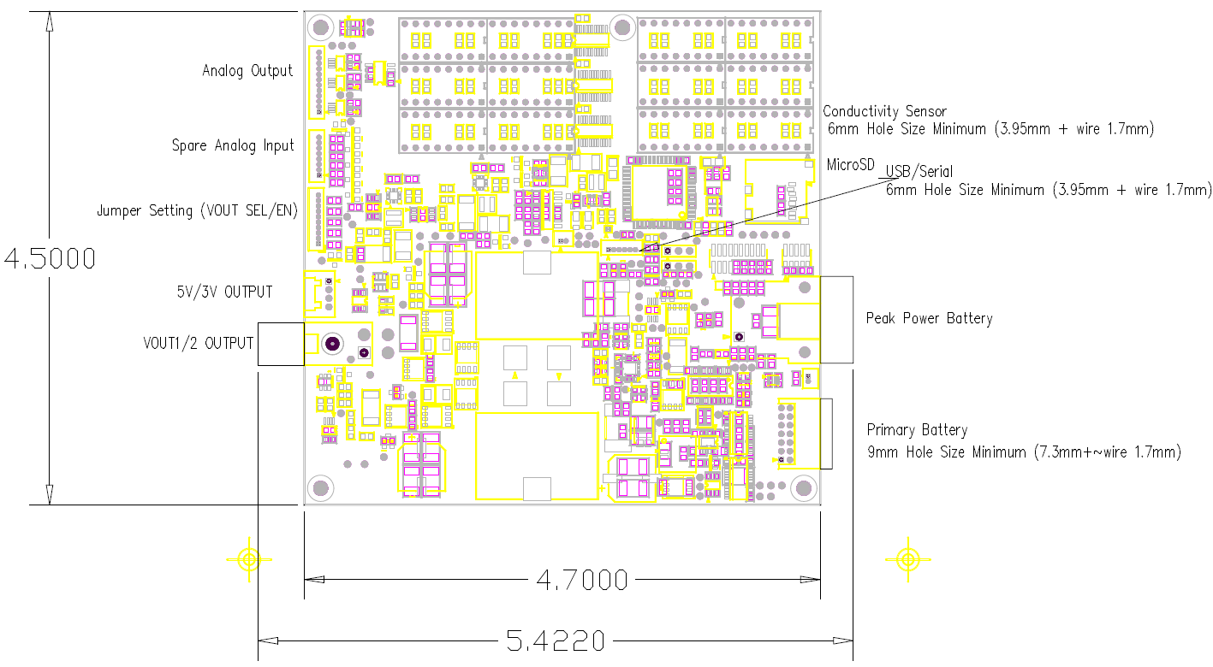
Figure 2: Open Water PCB Outline Drawing

Open Water PCB Design

PCB Funcitionality
PCB Electronics shall consist of following function

- Battery Management
- DC/DC Converter
- Power Monitor
- Microcontroller
- Sensors
- Output Indicator
- User Interface
- Data Logging

Battery Management
LTC4000-1, Linear Techcnology battery management controller shall be used in this application.The controller converts DC/DC power supplies to battery chargers with maximum power point control. The overall battery managament design is shown in Figure 3.
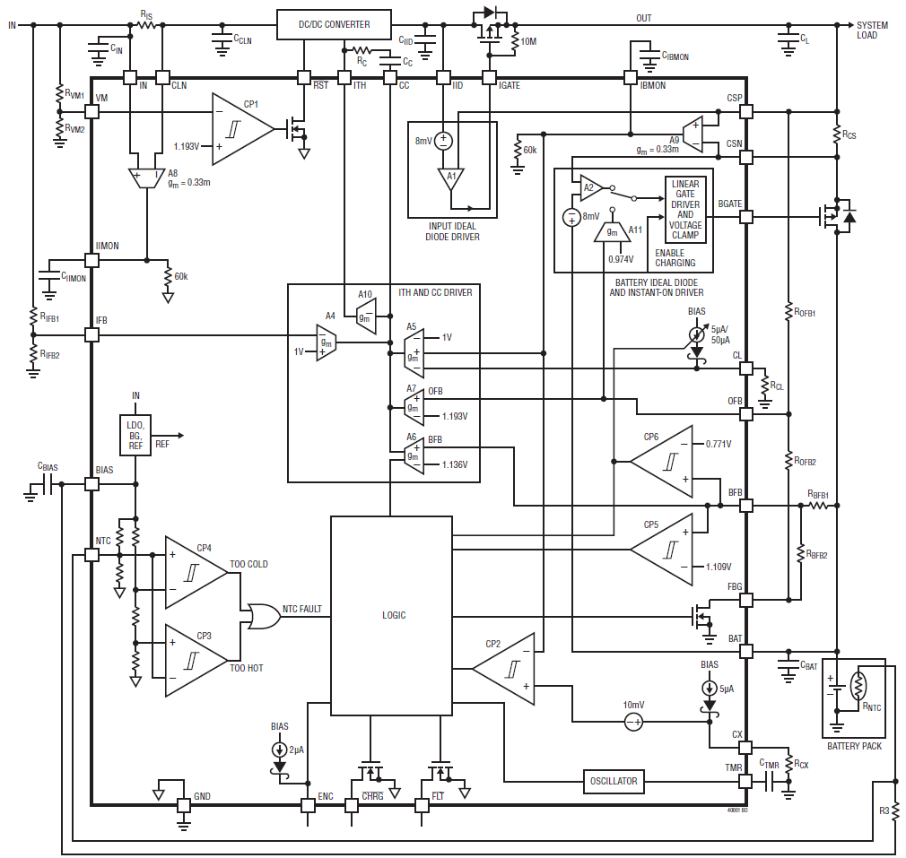
Figure 3: Battery Management Design

The controller includes four different regulation loops: input voltage, charge current, battery float voltage and output voltage. Whichever loop requires the lowest voltage on the ITH pin for its regulation controls the external DC/DC converter

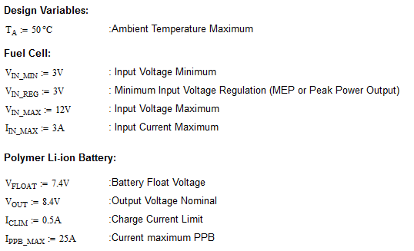

Input Voltage Regulation Loop
Figure 4: Input Voltage Regulation Loop
The iput voltage regulation loop prevents the input voltage from dropping below the programmed level.
When the input souce is high impedance, the input voltage drops as the load current increases. In our case the microcontroller set the regulation voltage by look-up table. The digital potentiometer shall be used to adjust voltage from 3V up to 7.5V to achieve maximum power efficiency.

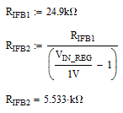

R_{IFB2} is 2.49kohm when V_{IN_REG} = 11V, 12.45kohm when V_{IN_REG} = 3V
Therefore RIFB2 can combine 2.49kohm resistor with 10k digital Potentiometer (TPL0401A-10)

TPL0401A-10 is 128 tap digital 20kohm potentiometer with I2C Interface.
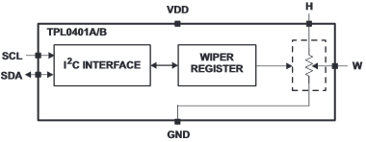
Figure 5: TPL0401A Digital Potentiometer

The input current through resistor R_{IS} is available for monitoring through IIMON with gain of 20.
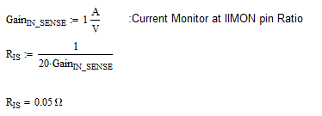
R_{IS} select the value = 50mohm, 1W resistor
Figure 6: Input Voltage Monitoring
The voltage monitoring feature is to ensure the converter is turned off when the voltage at he input is below a certain level. The /RST pin is connected to the DC/DC converter chip enable line.
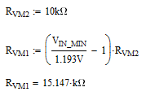
R_{VM1} select the closet value = 15.4kohm

Charge Current Regulation Loop
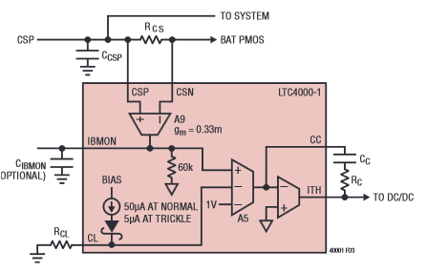
Figure 7: Charge Current Regulation Loop

The charge current regulation loop ensures the charge current sensed through the charge current sense resistor R_{CS} does not exceed the programmed full charge current.

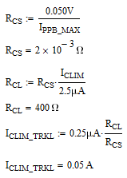

R_{CS} select the value = 2mohm, 2W resistor, and the calculated trickle charge current is 50mA
Use CSNL2512FT2L00, Vishay, 2mohm, 2W, 1%

Battery Voltage Regulation Loop
Figure 8: Battery Voltage Regulation Loop

Once the battery float voltage is reached, the battery voltage regulation loop takes over from the charge current regulation loop. The battery voltage regulation loop ensures the battery voltage will not exceed the programmed voltage

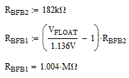

R_{BFB1} select the closet value = 1.00Mohm

Output Voltage Regulation Loop
Figure 9: Output Voltage Regulation Loop
When charging terminates and the system load is completely supplied from the input, the PMOS connected to BGATE is turned off. In this case, the output voltage regulation loop takes over from the battery float voltage regulation loop . The output voltage regulation loop ensure the output voltage will not exceed the programmed voltage

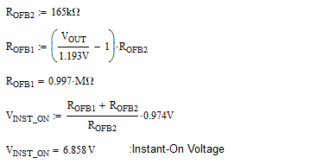

R_{OFB1} select the closet value = 1.00Mohm and calculated instant-on voltage is 6.858V

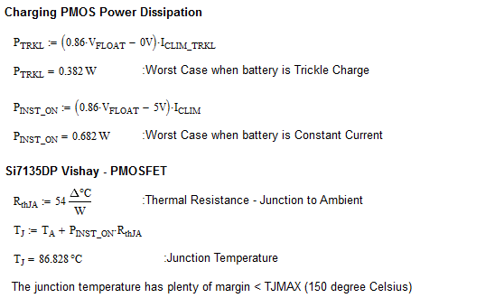

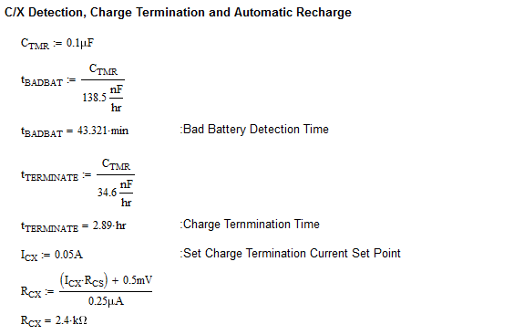

DC/DC Converter LT3759 – SEPIC Controller

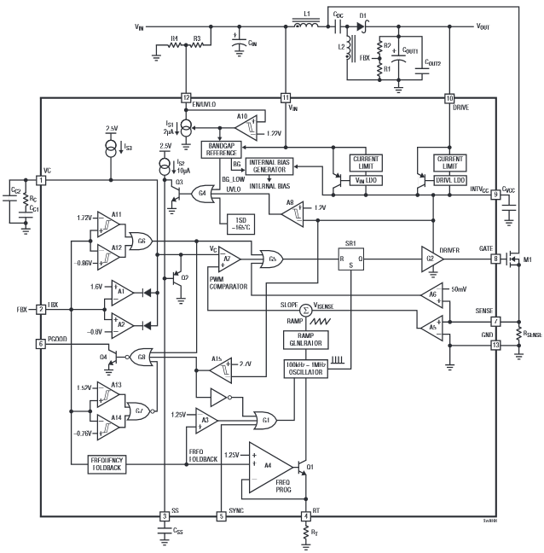

Figure 10: LT3759 – SEPIC Controller

Programming Turn-On and Turn-Off Threshold EN/UVLO Pin

Pin EN/UVLO shall be connected to the /RST of LTC4000-1 to control on and off of the controller. We would eliminate R3 and R4.

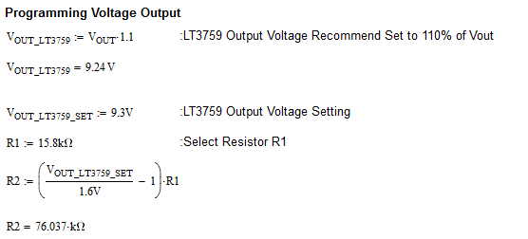

R2 select the closet value = 76.8kohm

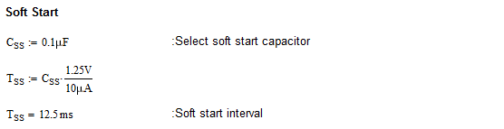

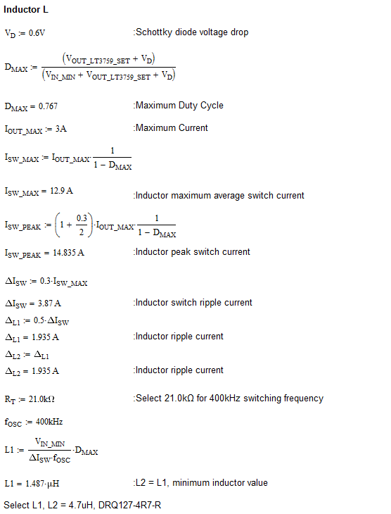

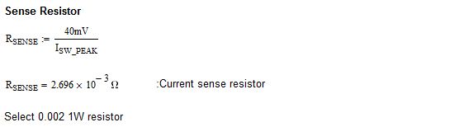

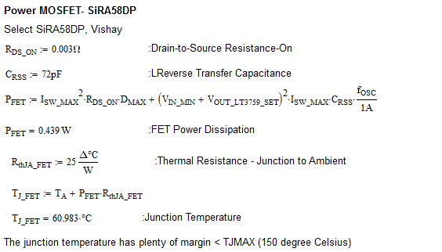

DC/DC Converter

Dual Output 150W Power Supply

LTC3788 Dual boost converter feature independent SS pin and run pin to enable power supply by user or microcontroller.

The PLLIN/MODE pin would select Burst Mode operation for higher efficiency at light load.

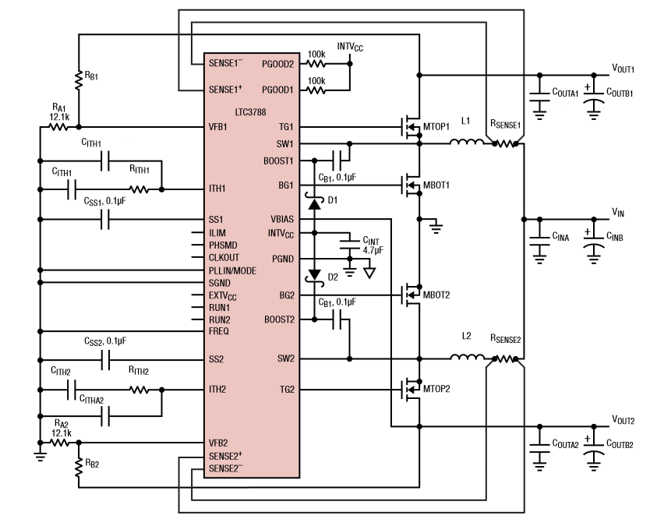
Figure 11: LTC3788 Dual Couput Boost Power Supply



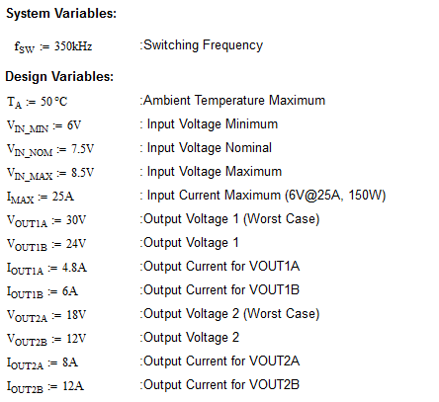

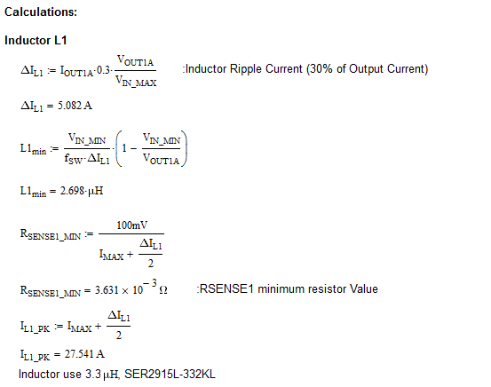

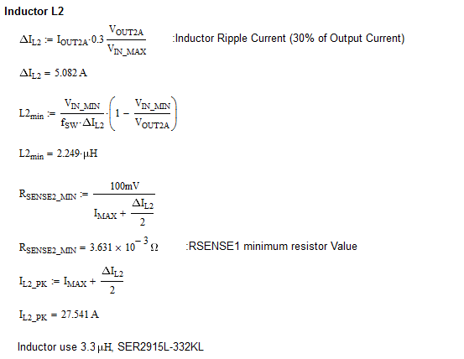

Analog switch ADG819 is used to switch between the feedback resistor to change desired voltage.

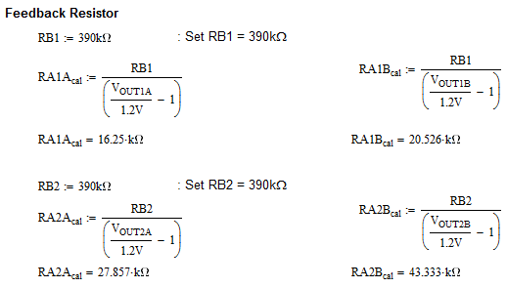

RB1A shall use the closet value 16.2k for 30V and RB1B shall use the closet value 20.5k for 24V

RB2A shall use the closet value 27.4k for 18V and RB1B shall use the closet value 43.2k for 12V

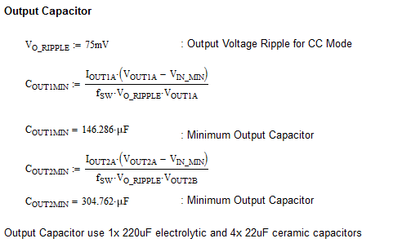

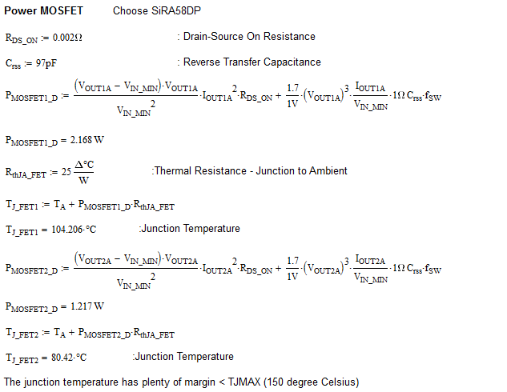

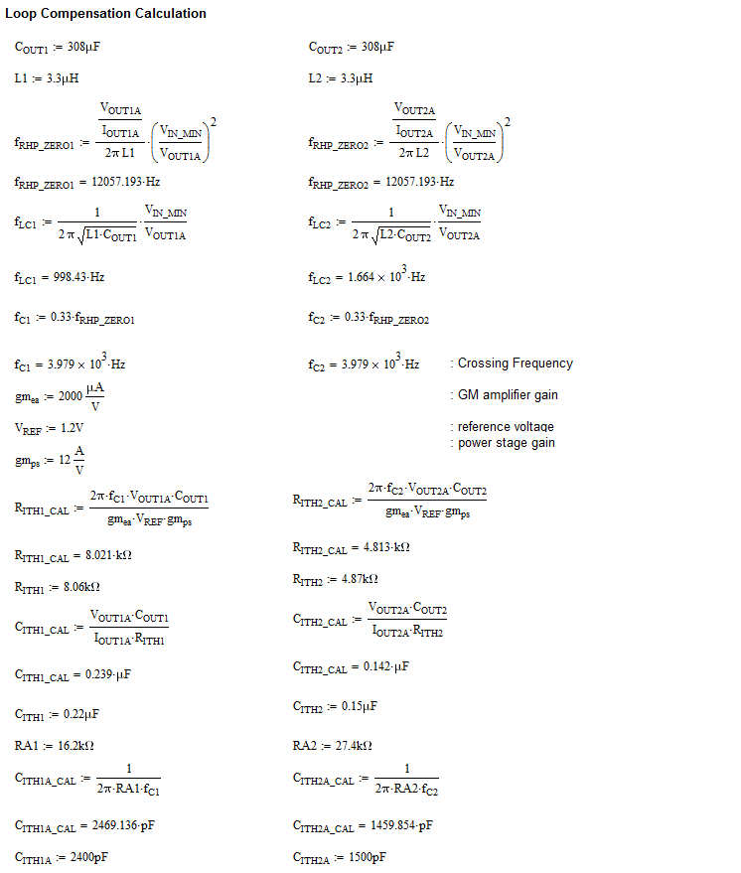

D1, D2 schottky diode shall us BAS140W

Boost Converter Short Circuit Protection
Boost Converter do not have true shutdown and short circuit protection. Additional PMOS switch shall be added on both output. For overcurrent and short circuit protection, current shunt monitor and overcurrent comparator INA301 shall be used to disable both converter and PMOS switch

Low Voltage 5V and 3V Power Supply

TPS62130 buck converter feature high switching frequency 2.5MHz allows to use of small inductors.
The converter internal switch can handle up to 3A output current in high efficiency for heavy load while it entered automatically and seamlessly into power save mode when the load is small.

TPS62130 buck converter have protection against heavy load and short circuit events. When Vout is dropped below 0.5V, the current limit is reduced to 1.6A. At heavy load, if the high-side FET is turned off when the current limit is reached.
Figure 12: Buck Power Supply (3A)

5V Power Supply Design Calculations
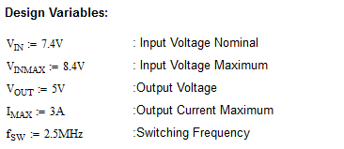

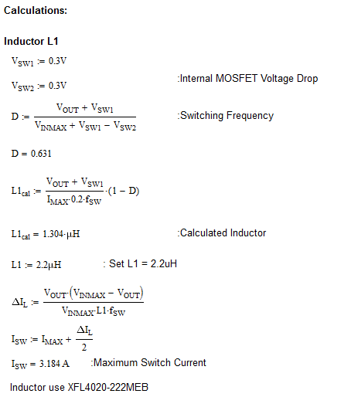

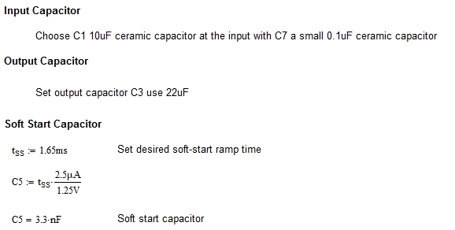

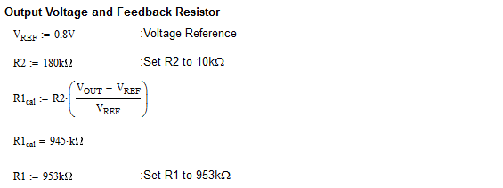

3V Power Supply Design Calculations

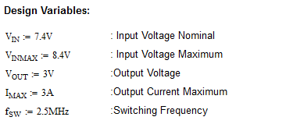

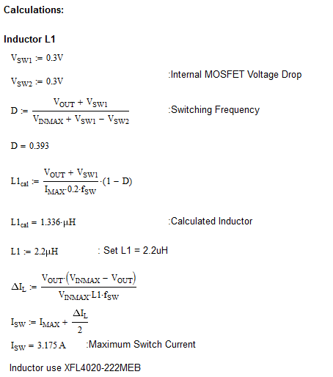



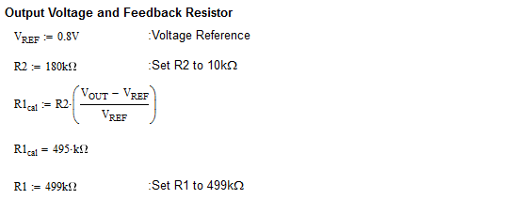

Low Power 3V Regulator
A low power 3V Regulator is used for power internal electronics

TPS62170 buck converter feature high switching frequency 2.25MHz allows to use of small inductors.
The converter internal switch can handle up to 0.5A output current in high efficiency for heavy load while it entered automatically and seamlessly into power save mode when the load is small.

TPS62170 buck converter have protection against heavy load and short circuit events. Thehigh-side FET is turned off when the current limit is reached.

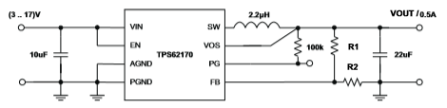
Figure 13: Buck 3V Local Power Supply (0.5A)
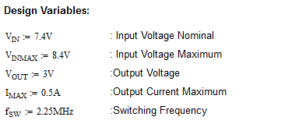

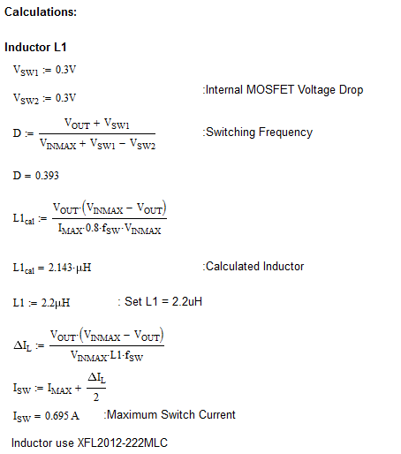
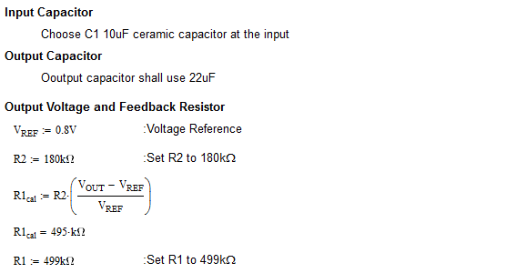

Power Monitor

Primary Battery Voltage/Current Monitor
Primary Battery Voltage Range
- 0V up to 12V
  - Gain 1/5 – ADC input: 0V to 2.4V
  - Use – 75K and 300K resistor
Primary Individual Battery Voltage Sense
- ~1.1-1.2V
  - Use ADG1607 Analog Mux with

Primary Battery Current Range
- 0A to 3A
  - Connect to IIMON pin which is 1V/A resolution.

Peak Power Battery Voltage/Current Monitor
Peak Power Battery Voltage Range
- 0V up to 8.4V
  - Gain 1/3 – ADC input: 0V to 2.8V
  - Use – 137K and 274K resistor

Peak Power Battery Current Range
- -25A to 25A
  - Using RCS 2mohm resistor as the current sense
  - Use AD8418 and configure as bi-directional
  - ADC Range will be 0.5V to 2.5V (-25A to +25A) center at 1.5V = 0A
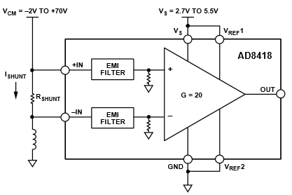

DC/DC converter Voltage/Current Monitor

Voltage Monitor

A simple resistor divider is used to sense the output voltage to microcontroller ADC
- 24VDC – 30VDC
  - Gain 1/12 – ADC input: 2V to 2.5V
  - Use – 100K and 1.1M resistor
- 12VDC – 18VDC
  - Gain 1/8 – ADC input: 1.5V to 2.25V
  - Use – 133K and 931K resistor
- 5VDC
  - Gain – 1/2 ADC input: 2.5V
  - Use – 249K and 249K resistor
- 3VDC
  - Gain – 0.75 ADC input: 2.25V
  - Use – 102K and 34K resistor

Current Monitor
INA301 is used to measure output current on all four DC/DC converters. For full range 0-3V analog, the RSENSE resistors used are as follow:

- 24VDC- 30VDC supply – current max. = 6A
  - RSENSE = 20mohm provide (0.4V/A) (0 -7.5A for 0 – 3V)
  - CSRN2512FK20L0, Stackpole, 40mohm, 1%, 2W
- 12VDC-18VDC supply – current max. = 12A
  - RSENSE = 10mohm provide (0.2V/A) (0 -15A for 0 – 3V)
  - Use two 20mohm in parallel
  - CSRN2512FK20L0, Stackpole, 40mohm, 1%, 2W
- 5VDC supply – current max. = 3A
  - RSENSE = 40mohm provide (0.8V/A) (0 -3.75A for 0 – 3V)
  - CSRN2512FK40L0, Stackpole, 40mohm, 1%, 2W
- 3VDC supply – current max. = 3A
  - RSENSE = 40mohm provide (0.8V/A) (0 -3.75A for 0 – 3V)
  - CSRN2512FK40L0, Stackpole, 40mohm, 1%, 2W

INA301 is connected in undirectional operation as follow:
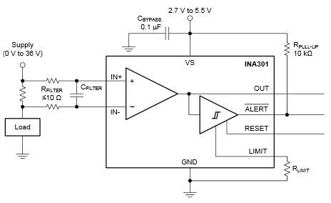
Figure 14: INA301 Unidirectional Current Sense Amplifier
- 24V Power@6 A
  - VLIMIT = 2.4V
  - RLIMIT = 2.4V/80uA = 30kohm
- 30V Power@4.8 A
  - VLIMIT = 1.92V
  - RLIMIT = 1.92V/80uA = 24kohm
- 12V Power@12A
  - VLIMIT = 2.4V
  - RLIMIT = 2.4V/80uA = 30kohm
- 18V Power@8 A
  - VLIMIT = 1.6V
  - RLIMIT = 1.6V/80uA = 20kohm
- 5V Power@3 A
  - VLIMIT = 2.4V
  - RLIMIT = 2.4V/80uA = 30kohm
- 3V Power@3 A
  - VLIMIT = 2.4V
  - RLIMIT = 2.4V/80uA = 30kohm

Microcontroller
STM32L151VB-A 128KB Flash , 32KB RAM low power processor is selected.
- 8 MHz Crystal and 32.678kHz for normal mode and low power mode
- ADC reference is tied to 3V for 0-3V Range

Pin Numbers | Pin name | AF0 | AF1 | AF2 | AF3 | AF4 | AF5 | AF6 | AF7 | AF8 | AF9 | AF10 | AF11 | AF14 | AF15 | Additional function 1 | Additional function 2 | Additional function 3 | Additional function 4 | Signal Name | Description
1 | PE2 | TRACECLK |  | TIM3_ETR |  |  |  |  |  |  |  |  |  | TIMx_IC3 | EVENTOUT |  |  |  |  | PE2 | Trace Connector or User spare
2 | PE3 | TRACED0 |  | TIM3_CH1 |  |  |  |  |  |  |  |  |  | TIMx_IC4 | EVENTOUT |  |  |  |  | PE3 | Trace Connector or User spare
3 | PE4 | TRACED1 |  | TIM3_CH2 |  |  |  |  |  |  |  |  |  | TIMx_IC1 | EVENTOUT |  |  |  |  | PE4 | Trace Connector or User spare
4 | PE5 | TRACED2 |  |  | TIM9_CH1 |  |  |  |  |  |  |  |  | TIMx_IC2 | EVENTOUT |  |  |  |  | PE5 | Trace Connector or User spare
5 | PE6-WKUP3 | TRACED3 |  |  | TIM9_CH2 |  |  |  |  |  |  |  |  | TIMx_IC3 | EVENTOUT | WKUP3 | RTC_TAMP3 |  |  | PE6 | Trace Connector or User spare
6 | VLCD |  |  |  |  |  |  |  |  |  |  |  |  |  |  |  |  |  |  |  | Connected to VDD for STM32L151
7 | PC13-WKUP2 |  |  |  |  |  |  |  |  |  |  |  |  | TIMx_IC2 | EVENTOUT | RTC_TAMP1 | RTC_TS | RTC_OUT | WKUP2 | PC13_MUX2_EN | Multiplexer 2 Enable
8 | PC14-OSC32_IN |  |  |  |  |  |  |  |  |  |  |  |  | TIMx_IC3 | EVENTOUT | OSC32_IN |  |  |  |  | 32.768kHz Crystal
9 | PC15-OSC32_OUT |  |  |  |  |  |  |  |  |  |  |  |  | TIMx_IC4 | EVENTOUT | OSC32_OUT |  |  |  |  | 32.768kHz Crystal
10 | VSS_5
11 | VDD_5
12 | PH0-OSC_IN |  |  |  |  |  |  |  |  |  |  |  |  |  |  | OSC_IN |  |  |  |  | 8MHz Crystal
13 | PH1-OSC_OUT |  |  |  |  |  |  |  |  |  |  |  |  |  |  | OSC_OUT |  |  |  |  | 8MHz Crystal
14 | NRST | NRST |  |  |  |  |  |  |  |  |  |  |  |  |  |  |  |  |  | /RST | Device reset input/ internal reset output
15 | PC0 |  |  |  |  |  |  |  |  |  |  |  |  | TIMx_IC1 | EVENTOUT | ADC_IN10 | COMP1_INP |  |  | ADC_IN10_VOUT1_VSENSE | 24-30V Power Supply Voltage Sense
16 | PC1 |  |  |  |  |  |  |  |  |  |  |  |  | TIMx_IC2 | EVENTOUT | ADC_IN11 | COMP1_INP |  |  | ADC_IN11_VOUT1_ISENSE | 24-30V Power Supply Current Sense
17 | PC2 |  |  |  |  |  |  |  |  |  |  |  |  | TIMx_IC3 | EVENTOUT | ADC_IN12 | COMP1_INP |  |  | ADC_IN12_VOUT2_VSENSE | 12-18V Power Supply Voltage Sense
18 | PC3 |  |  |  |  |  |  |  |  |  |  |  |  | TIMx_IC4 | EVENTOUT | ADC_IN13 | COMP1_INP |  |  | ADC_IN13_VOUT2_ISENSE | 12-18V Power Supply Current Sense
19 | VSSA |  |  |  |  |  |  |  |  |  |  |  |  |  |  |  |  |  |  |  | Analog ground
20 | VREF- |  |  |  |  |  |  |  |  |  |  |  |  |  |  |  |  |  |  |  | Reference voltage for ADC, COMP, DAC
21 | VREF+ |  |  |  |  |  |  |  |  |  |  |  |  |  |  |  |  |  |  |  | Reference voltage for ADC, COMP, DAC
22 | VDDA |  |  |  |  |  |  |  |  |  |  |  |  |  |  |  |  |  |  |  | Analog power supply
23 | PA0-WKUP1 |  | TIM2_CH1_ETR |  |  |  |  |  | USART2_CTS |  |  |  |  | TIMx_IC1 | EVENTOUT | WKUP1 | ADC_IN0 | COMP1_INP | RTC_TAMP2 | ADC_IN0_PB_VSENSE | Primary Battery Overall Voltage Sense
24 | PA1 |  | TIM2_CH2 |  |  |  |  |  | USART2_RTS |  |  |  |  | TIMx_IC2 | EVENTOUT | ADC_IN1 | COMP1_INP |  |  | ADC_IN1_PB_ISENSE | Primary Battery Current Sense (from LTC4000-1)
25 | PA2 |  | TIM2_CH3 |  | TIM9_CH1 |  |  |  | USART2_TX |  |  |  |  | TIMx_IC3 | EVENTOUT | ADC_IN2 | COMP1_INP |  |  | ADC_IN2_PPB_VSENSE | Peak Power Battery Voltage Sense
26 | PA3 |  | TIM2_CH4 |  | TIM9_CH2 |  |  |  | USART2_RX |  |  |  |  | TIMx_IC4 | EVENTOUT | ADC_IN3 | COMP1_INP |  |  | ADC_IN3_PPB_ISENSE | Peak Power Battery Current Sense (bi directional, charge , discharge)
27 | VSS_4
28 | VDD_4
29 | PA4 |  |  |  |  |  | SPI1_NSS |  | USART2_CK |  |  |  |  | TIMx_IC1 | EVENTOUT | ADC_IN4 | DAC_OUT1 | COMP1_INP |  | /PA4_SPI1_CS | SD Card Chip Select
30 | PA5 |  | TIM2_CH1_ETR |  |  |  | SPI1_SCK |  |  |  |  |  |  | TIMx_IC2 | EVENTOUT | ADC_IN5 | DAC_OUT2 | COMP1_INP |  | SPI1_SCK | SD Card SPI Clock
31 | PA6 |  |  | TIM3_CH1 | TIM10_CH1 |  | SPI1_MISO |  |  |  |  |  |  | TIMx_IC3 | EVENTOUT | ADC_IN6 | COMP1_INP |  |  | SPI1_MISO | SD Card MISO
32 | PA7 |  |  | TIM3_CH2 | TIM11_CH1 |  | SPI1_MOSI |  |  |  |  |  |  | TIMx_IC4 | EVENTOUT | ADC_IN7 | COMP1_INP |  |  | SPI1_MOSI | SD Card MOSI
33 | PC4 |  |  |  |  |  |  |  |  |  |  |  |  | TIMx_IC1 | EVENTOUT | ADC_IN14 | COMP1_INP |  |  | ADC_IN14_5V_VSENSE | 5V Power Supply Voltage Sense
34 | PC5 |  |  |  |  |  |  |  |  |  |  |  |  | TIMx_IC2 | EVENTOUT | ADC_IN15 | COMP1_INP |  |  | ADC_IN15_5V_ISENSE | 5V Power Supply Current Sense
35 | PB0 |  |  | TIM3_CH3 |  |  |  |  |  |  |  |  |  |  | EVENTOUT | ADC_IN8 | COMP1_INP | VREF_OUT |  | ADC_IN8_3V_VSENSE | 3V Power Supply Voltage Sense
36 | PB1 |  |  | TIM3_CH4 |  |  |  |  |  |  |  |  |  |  | EVENTOUT | ADC_IN9 | COMP1_INP | VREF_OUT |  | ADC_IN9_3V_ISENSE | 3V Power Supply Current Sense
37 | PB2 | BOOT1 |  |  |  |  |  |  |  |  |  |  |  |  |  |  |  |  |  |  | BOOT1 Selection
38 | PE7 |  |  |  |  |  |  |  |  |  |  |  |  | TIMx_IC4 | EVENTOUT | ADC_IN22 | COMP1_INP |  |  | ADC_IN22_SPARE3 | User spare
39 | PE8 |  |  |  |  |  |  |  |  |  |  |  |  | TIMx_IC1 | EVENTOUT | ADC_IN23 | COMP1_INP |  |  | ADC_IN23_SPARE4 | User spare
40 | PE9 |  | TIM2_CH1_ETR |  |  |  |  |  |  |  |  |  |  | TIMx_IC2 | EVENTOUT | ADC_IN24 | COMP1_INP |  |  | ADC_IN24_SPARE5 | User spare
41 | PE10 |  | TIM2_CH2 |  |  |  |  |  |  |  |  |  |  | TIMx_IC3 | EVENTOUT | ADC_IN25 | COMP1_INP |  |  | ADC_IN25_SPARE6 | User spare
42 | PE11 |  | TIM2_CH3 |  |  |  |  |  |  |  |  |  |  |  |  |  |  |  |  | PE11_COND_SENSOR_EN | Conductivity Sensor Enable
43 | PE12 |  | TIM2_CH4 |  |  |  | SPI1_NSS |  |  |  |  |  |  | TIMx_IC1 | EVENTOUT |  |  |  |  | PE12 | User spare
44 | PE13 |  |  |  |  |  | SPI1_SCK |  |  |  |  |  |  | TIMx_IC2 | EVENTOUT |  |  |  |  | PE13 | User spare
45 | PE14 |  |  |  |  |  | SPI1_MISO |  |  |  |  |  |  | TIMx_IC3 | EVENTOUT |  |  |  |  | PE14 | User spare
46 | PE15 |  |  |  |  |  | SPI1_MOSI |  |  |  |  |  |  | TIMx_IC4 | EVENTOUT |  |  |  |  | PE15 | User spare
47 | PB10 |  | TIM2_CH3 |  |  | I2C2_SCL |  |  | USART3_TX |  |  |  |  |  | EVENTOUT |  |  |  |  | I2C2_SCL | I2C2 clock acceleromter and pressure temperature sensor
48 | PB11 |  | TIM2_CH4 |  |  | I2C2_SDA |  |  | USART3_RX |  |  |  |  |  | EVENTOUT |  |  |  |  | I2C2_SDA | I2C2 data acceleromter and pressure temperature sensor
49 | VSS_1
50 | VDD_1
51 | PB12 |  |  |  | TIM10_CH1 | I2C2_SMBA | SPI2_NSS |  | USART3_CK |  |  |  |  |  | EVENTOUT | ADC_IN18 | COMP1_INP |  |  | ADC_IN18_COND_SENSE | Conductivity Sensor Sense Signal
52 | PB13 |  |  |  | TIM9_CH1 |  | SPI2_SCK |  | USART3_CTS |  |  |  |  |  | EVENTOUT | ADC_IN19 | COMP1_INP |  |  | ADC_IN19_PB_IND_VSENSE | Individual Primary Battery Voltage Sense (Mux + Differential Amp)
53 | PB14 |  |  |  | TIM9_CH2 |  | SPI2_MISO |  | USART3_RTS |  |  |  |  |  | EVENTOUT | ADC_IN20 | COMP1_INP |  |  | ADC_IN20_SPARE1 | User spare
54 | PB15 |  |  |  | TIM11_CH1 |  | SPI2_MOSI |  |  |  |  |  |  |  |  | ADC_IN21 | COMP1_INP | RTC_REFIN |  | ADC_IN21_SPARE2 | User spare
55 | PD8 |  |  |  |  |  |  |  | USART3_TX |  |  |  |  | TIMx_IC1 | EVENTOUT |  |  |  |  | PD8_24V/30V_SEL | 24VDC or 30VDC Power Supply Selection H = 24VDC, L = 30VDC
56 | PD9 |  |  |  |  |  |  |  | USART3_RX |  |  |  |  | TIMx_IC2 | EVENTOUT |  |  |  |  | PD9_12V/18V_SEL | 12VDC or 18VDC Power Supply Selection H= 12VDC, L = 18VDC
57 | PD10 |  |  |  |  |  |  |  | USART3_CK |  |  |  |  | TIMx_IC3 | EVENTOUT |  |  |  |  | PD10_24V/30V_JUMPER | 24VDC or 30VDC Power Supply Selection Jumper H = 24VDC, L = 30VDC
58 | PD11 |  |  |  |  |  |  |  | USART3_CTS |  |  |  |  | TIMx_IC4 | EVENTOUT |  |  |  |  | PD11_12V/18V_JUMPER | 12VDC or 18VDC Power Supply Selection Jumper H = 12VDC, L = 18VDC
59 | PD12 |  |  | TIM4_CH1 |  |  |  |  | USART3_RTS |  |  |  |  | TIMx_IC1 | EVENTOUT |  |  |  |  | PD12_VOUT1_JUMPER_EN | 24V-30VDC Power Supply Jumper Enable
60 | PD13 |  |  | TIM4_CH2 |  |  |  |  |  |  |  |  |  | TIMx_IC2 | EVENTOUT |  |  |  |  | PD13_VOUT1_EN | 24V-30VDC Power Supply Enable
61 | PD14 |  |  | TIM4_CH3 |  |  |  |  |  |  |  |  |  | TIMx_IC3 | EVENTOUT |  |  |  |  | PD14_VOUT2_JUMPER_EN | 12V-18VDC Power Supply Jumper Enable
62 | PD15 |  |  | TIM4_CH4 |  |  |  |  |  |  |  |  |  | TIMx_IC4 | EVENTOUT |  |  |  |  | PD15_VOUT2_EN | 12V-18VDC Power Supply Enable
63 | PC6 |  |  | TIM3_CH1 |  |  |  |  |  |  |  |  |  | TIMx_IC3 | EVENTOUT |  |  |  |  | PC6_MUX1_A0 | Multiplexer 1 A0
64 | PC7 |  |  | TIM3_CH2 |  |  |  |  |  |  |  |  |  | TIMx_IC4 | EVENTOUT |  |  |  |  | PC7_MUX1_A1 | Multiplexer 1 A1
65 | PC8 |  |  | TIM3_CH3 |  |  |  |  |  |  |  |  |  | TIMx_IC1 | EVENTOUT |  |  |  |  | PC8_MUX1_A2 | Multiplexer 1 A2
66 | PC9 |  |  | TIM3_CH4 |  |  |  |  |  |  |  |  |  | TIMx_IC2 | EVENTOUT |  |  |  |  | PC9_MUX1_EN | Multiplexer 1 Enable
67 | PA8 | MCO |  |  |  |  |  |  | USART1_CK |  |  |  |  | TIMx_IC1 | EVENTOUT |  |  |  |  | PA8_LED_STATUS_JUMPER | LED Status Jumper Enable/Disable
68 | PA9 |  |  |  |  |  |  |  | USART1_TX |  |  |  |  | TIMx_IC2 | EVENTOUT |  |  |  |  | USART1_TX | Serial communication
69 | PA10 |  |  |  |  |  |  |  | USART1_RX |  |  |  |  | TIMx_IC3 | EVENTOUT |  |  |  |  | USART1_RX | Serial communication
70 | PA11 |  |  |  |  |  | SPI1_MISO |  | USART1_CTS |  |  |  |  | TIMx_IC4 | EVENTOUT | USB_DM |  |  |  | USB_DM | USB Data Minus
71 | PA12 |  |  |  |  |  | SPI1_MOSI |  | USART1_RTS |  |  |  |  | TIMx_IC1 | EVENTOUT | USB_DP |  |  |  | USB_DP | USB Data Plus
72 | PA13 | JTMS-SWDIO |  |  |  |  |  |  |  |  |  |  |  | TIMx_IC2 | EVENTOUT |  |  |  |  | JTMS-SWDIO | JTAG TMS
73 | PH2 |  |  |  |  |  |  |  |  |  |  |  |  |  |  |  |  |  |  | PH2_DEBUG_LED | Debug LED
74 | VSS_2
75 | VDD_2
76 | PA14 | JTCK-SWCLK |  |  |  |  |  |  |  |  |  |  |  | TIMx_IC3 | EVENTOUT |  |  |  |  | JTCK-SWCLK | JTAG TCK
77 | PA15 | JTDI | TIM2_CH1_ETR |  |  |  | SPI1_NSS |  |  |  |  |  |  | TIMx_IC4 | EVENTOUT |  |  |  |  | JTDI | JTAG TDI
78 | PC10 |  |  |  |  |  |  |  | USART3_TX |  |  |  |  | TIMx_IC3 | EVENTOUT |  |  |  |  | PC10_MUX2_A0 | Multiplexer 2 A0
79 | PC11 |  |  |  |  |  |  |  | USART3_RX |  |  |  |  | TIMx_IC4 | EVENTOUT |  |  |  |  | PC11_MUX2_A1 | Multiplexer 2 A1
80 | PC12 |  |  |  |  |  |  |  | USART3_CK |  |  |  |  | TIMx_IC1 | EVENTOUT |  |  |  |  | PC12_MUX2_A2 | Multiplexer 2 A2
81 | PD0 |  |  |  | TIM9_CH1 |  | SPI2_NSS |  |  |  |  |  |  | TIMx_IC1 | EVENTOUT |  |  |  |  | /PD0_SPI2_CS1 | Analog Output Channel 1-2 chip select
82 | PD1 |  |  |  |  |  | SPI2_SCK |  |  |  |  |  |  | TIMx_IC2 | EVENTOUT |  |  |  |  | SPI2_SCK | Analog Output SPI Clock
83 | PD2 |  |  | TIM3_ETR |  |  |  |  |  |  |  |  |  | TIMx_IC3 | EVENTOUT |  |  |  |  | /PD2_SPI2_CS2 | Analog Output Channel 3-4 chip select
84 | PD3 |  |  |  |  |  | SPI2_MISO |  | USART2_CTS |  |  |  |  | TIMx_IC4 | EVENTOUT |  |  |  |  | SPI2_MISO | Analog Output MISO
85 | PD4 |  |  |  |  |  | SPI2_MOSI |  | USART2_RTS |  |  |  |  | TIMx_IC1 | EVENTOUT |  |  |  |  | SPI2_MOSI | Analog Output MOSI
86 | PD5 |  |  |  |  |  |  |  | USART2_TX |  |  |  |  | TIMx_IC2 | EVENTOUT |  |  |  |  | /PD5_SPI2_CS3 | Analog Output Channel 5-6 chip select
87 | PD6 |  |  |  |  |  |  |  | USART2_TRX |  |  |  |  | TIMx_IC3 | EVENTOUT |  |  |  |  | PD6_USB_DISCONNECT | USB Disconnect
88 | PD7 |  |  |  | TIM9_CH2 |  |  |  | USART2_CK |  |  |  |  | TIMx_IC4 | EVENTOUT |  |  |  |  | PD7_USB_CONNECT | USB Connect Sense
89 | PB3 | JTDO | TIM2_CH2 |  |  |  | SPI1_SCK |  |  |  |  |  |  |  | EVENTOUT | COMP2_INM |  |  |  | JTDO | JTAG JTDO
90 | PB4 | NJTRST |  | TIM3_CH1 |  |  | SPI1_MISO |  |  |  |  |  |  |  | EVENTOUT | COMP2_INM |  |  |  | /JTRST | JTAG Reset
91 | PB5 |  |  | TIM3_CH2 |  | I2C1_SMBA | SPI1_MOSI |  |  |  |  |  |  |  | EVENTOUT | COMP2_INM |  |  |  | /PB5_INT1 | Accelerometer Interrupt
92 | PB6 |  |  | TIM4_CH1 |  | I2C1_SCL |  |  | USART1_TX |  |  |  |  |  | EVENTOUT |  |  |  |  | /PB6_INT2 | Accelerometer Interrupt
93 | PB7 |  |  | TIM4_CH2 |  | I2C1_SDA |  |  | USART1_RX |  |  |  |  |  | EVENTOUT | PVD_IN |  |  |  | PB7_ENC | Peak Power Battery Charge Enable
94 | BOOT0 | BOOT0 |  |  |  |  |  |  |  |  |  |  |  |  |  |  |  |  |  |  | BOOT0 Selection
95 | PB8 |  |  | TIM4_CH3 | TIM10_CH1 | I2C1_SCL |  |  |  |  |  |  |  |  | EVENTOUT |  |  |  |  | I2C1_SCL | I2C1 clock digital potentiometer
96 | PB9 |  |  | TIM4_CH4 | TIM11_CH1 | I2C1_SDA |  |  |  |  |  |  |  |  | EVENTOUT |  |  |  |  | I2C1_SDA | I2C2 clock digital potentiometer
97 | PE0 |  |  | TIM4_ETR | TIM10_CH1 |  |  |  |  |  |  |  |  | TIMx_IC1 | EVENTOUT |  |  |  |  | PE0_/CHRG | Charge Status Indicator
98 | PE1 |  |  |  | TIM11_CH1 |  |  |  |  |  |  |  |  | TIMx_IC2 | EVENTOUT |  |  |  |  | PE1_/FLT | Charge Fault
99 | VSS_3
100 | VDD_3

Table 1: Microcontroller Pin Assignment

Microcontroller Control
- VOUT1 (24V and 30V) selection and on/off
Input  PD10  (24/30V_JUMPER) | Input  PD12 (VOUT1_JUMPER_EN) | Output  PD8 (24/30V_SEL) | Output  PD13 (VOUT1_EN)
0 | 0 | 0 | 0
0 | 1 | 0 | 1
1 | 0 | 1 | 0
1 | 1 | 1 | 1
Table 2: True Table for 24/30V Power Supply Control

- VOUT2 (12V and 18V) selection and on/off
Input  PD11  (12/18V_JUMPER) | Input  PD14 (VOUT2_JUMPER_EN) | Output  PD9 (12/18V_SEL) | Output  PD15 (VOUT2_EN)
0 | 0 | 0 | 0
0 | 1 | 0 | 1
1 | 0 | 1 | 0
1 | 1 | 1 | 1
Table 3: True Table for 12/18V Power Supply Control
- Multiplixer Control Primary Battery Voltage Sense
Primary Battery  Individual Cell # | Output  PC6  (MUX1_A0) | Output  PC7  (MUX1_A1) | Output  PC8  (MUX1_A2) | Output  PC9  (MUX1_EN) | Output  PC10  (MUX2_A0) | Output  PC11  (MUX2_A1) | Output  PC12  (MUX2_A2) | Output  PC13  (MUX2_EN)
1 | X | X | X | 0 | 0 | 1 | 1 | 1
2 | X | X | X | 0 | 0 | 1 | 0 | 1
3 | X | X | X | 0 | 0 | 0 | 1 | 1
4 | X | X | X | 0 | 0 | 0 | 0 | 1
5 | 1 | 1 | 1 | 1 | X | X | X | 0
6 | 1 | 1 | 0 | 1 | X | X | X | 0
7 | 1 | 0 | 1 | 1 | X | X | X | 0
8 | 1 | 0 | 0 | 1 | X | X | X | 0
9 | 0 | 1 | 1 | 1 | X | X | X | 0
10 | 0 | 1 | 0 | 1 | X | X | X | 0
11 | 0 | 0 | 1 | 1 | X | X | X | 0
12 | 0 | 0 | 0 | 1 | X | X | X | 0
Table 4: Muliplixer Control Primary Battery Voltage Sense
- ADC Channels
ADC Channel | Used For
ADC_IN0 | Primary Battery Overall Voltage Sense
ADC_IN1 | Primary Battery Current Sense
ADC_IN2 | Peak Power Battery Voltage Sense
ADC_IN3 | Peak Power Battery Current Sense
ADC_IN8 | 3V Power Supply Voltage Sense
ADC_IN9 | 3V Power Supply Current Sense
ADC_IN10 | 24V/30V Power Supply Voltage Sense
ADC_IN11 | 24V/30V Power Supply Current Sense
ADC_IN12 | 12V/18V Power Supply Voltage Sense
ADC_IN13 | 12V/18V Power Supply Current Sense
ADC_IN14 | 5V Power Supply Voltage Sense
ADC_IN15 | 5V Power Supply Current Sense
ADC_IN18 | Conductivity Sensor Sense
ADC_IN19 | Primary Battery Individual Voltage Sense
Table 5: ADC Channel mapping

Sensors

Pressure and Temperature Sensor

MS5837-30BA pressure and temperature sensor is used for water depth and temperature measurement. The sensor module can measure up to 30bar (~300m) and it includes a high linearity pressure sensor and ultra low power 24 bit ADC with internal factory calibrated coefficients. A high resolution temperature output is avaiable for compensated pressure. The communication protocol use I2C interface and easy to communicate.
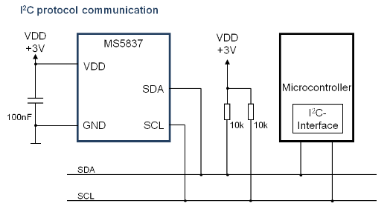
Figure 15: MS5837 pressure and temperature sensor

3 axis Accelerometer

MMA8652FC accelerometer is used for measure axis orientation of the battery module. The sensor module use I2C interface with programmable interrupts for user to detect orientation.
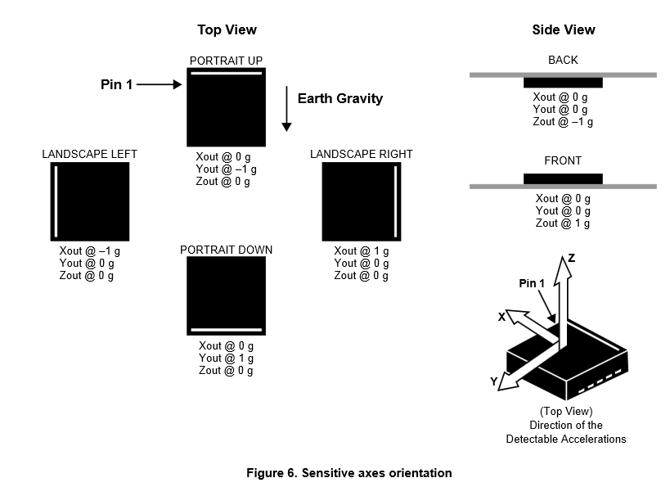
Figure 16: MMA8652FC accelerometer orientation detection

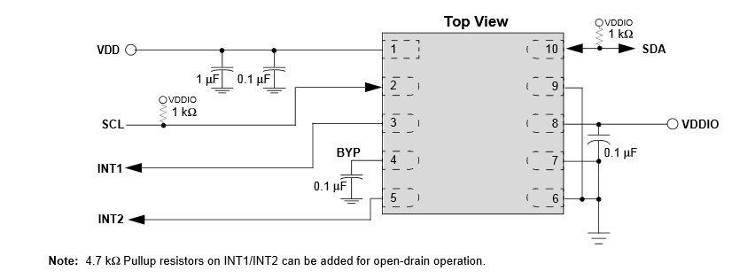
Figure 17: MMA8652FC accelerometer circuit connection

Conductivity Sensor

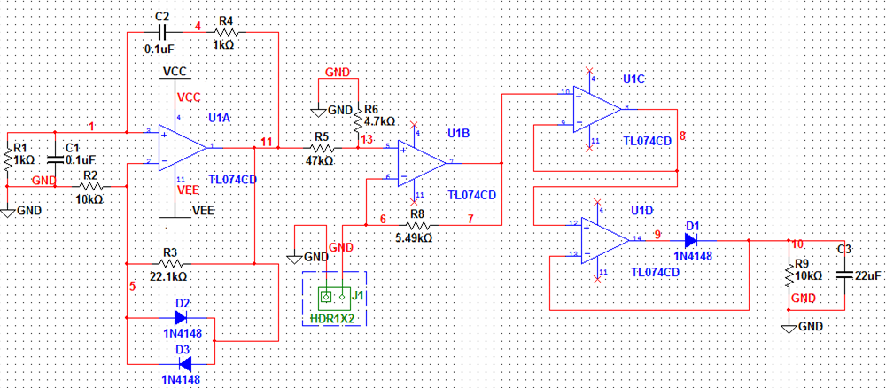
Figure 18: Conductivity Sensor Interface Circuit

The cell constant, K, is equal to the distance in cm between the probe's electrodes divided by the surface area of the electrodes in cm². For high conducitivity sea water measurement, we should use a higher constant K = 10.

Node 11 is AC excitation circuit with frequency around 1.59kHz±10%. The Vpk-pk is around 800mV - 1.2V depends on the voltage drop on D2 and D3. Use various resistance across J1 to simulate the electrode probes.

Calculated Conductivity from resistance and cell constant (uScm⁻¹) | Cell Constant (cm⁻¹) | Resistor Resistance (ohm) | Measured Voltage Output (V)
15456 | 10 | 647 | 0.412
62073 | 10 | 161.1 | 1.542
66357 | 10 | 150.7 | 1.654
99701 | 10 | 100.3 | 2.434
124533 | 10 | 80.3 | 2.906

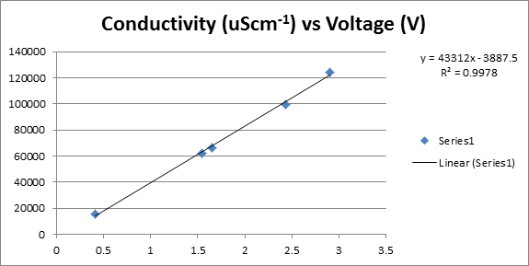

Output Indicator

LED Output

Current instantaneous efficiency relative to MEP
- Use 2x 4 bar array of LED (Yellow Color)

1-hour moving average efficiency relative to MEP
- Use 2x 4 bar array of LED (Yellow Color)

Total power output relative to primary battery steady-state max and burst max.
- Use 2x 4 bar array of LED (Red Color)

Total power output relative to peak power battery steady-state max and burst max.
- Use 2x 4 bar array of LED (Red Color)

State of peak power battery capacity
- Use 2x 4 bar array of LED (Green Color)

Remaining primary battery capacity
- Use 2x 4 bar array of LED (Green Color)

Analog Output

3x LTC1662 10-bit Dual DAC are used to provide six channels DACs. 5V Reference voltage and VCC is used to provide full range analog output 0-5V. LT1461CCS8-5#PBF 5V reference is used to supply power to all 3 DACs.

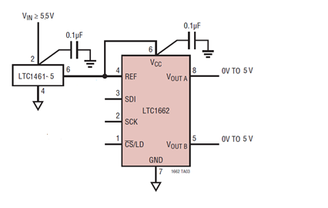
Figure 19: DAC Analog Output

Current instantaneous efficiency relative to MEP
- 0-5V indicates fraction of MEP power (0%-100% of MEP)

1-hour moving average efficiency relative to MEP
- 0-5V indicates fraction of MEP power (0%-100% of MEP)

Total power output relative to primary battery steady-state max and burst max.
- 0-5V indicates primary power use in proportion to max primary power available

Total power output relative to peak primary battery steady-state max and burst max.
- 0-5V indicates peak primary power use in proportion to max peak primary power available

State of peak power battery capacity
- 0-5V indicates the peak power battery capacity

Remaining primary battery capacity
- 0-5V indicates the primary battery capacity

Pin | Signal | Signal Description | I/O | Signal Type | Signal Level
J12-1 | VOUT1A | Current instantaneous efficiency relative to MEP | O | ANALOG | +5V
J12-2 | GND | Ground | - | GROUND | GND
J12-3 | VOUT1B | 1-hour moving average efficiency relative to MEP | O | ANALOG | +5V
J12-4 | GND | Ground | - | GROUND | GND
J12-5 | VOUT2A | Total power output relative to primary battery steady-state max and burst max | O | ANALOG | +5V
J12-6 | GND | Ground | - | GROUND | GND
J12-7 | VOUT2B | Total power output relative to peak power battery steady-state max and burst max | O | ANALOG | +5V
J12-8 | GND | Ground | - | GROUND | GND
J12-9 | VOUT3A | State of peak power battery capacity |  | ANALOG | +5V
J12-10 | GND | Ground | - | GROUND | GND
J12-11 | VOUT3B | Remaining primary battery capacity | O | ANALOG | +5V
J12-12 | GND | Ground | - | GROUND | GND
Table 6: Power Output Connector

The PCB mount connector shall be part#: 53047-1210, Molex
The mating connector is part#. 51021-1200, Molex
The mating connector pin is part#. 50079-8000, Molex (26-28AWG)

User Interface

User Power Output Connector

High Voltage Power Output Connector

Pin | Signal | Signal Description | I/O | Signal Type | Signal Level
J6-1 | DGND | Ground | - | GROUND | GND
J6-2 | DGND | Ground | - | GROUND | GND
J6-3 | VOUT1+ | 24V@6A max or 30V@4.8A max | O | POWER | +24-30V
J6-4 | VOUT2+ | 12@12A max or 18V@8A max | O | POWER | +12-18V
Table 7: High Voltage Power Output Connector

The PCB mount connector shall be part#: 39-30-1041, Molex (Gold Contact)
The mating connector is part#. 39-01-2045, Molex
The mating connector pin is part#. 45750-3211, Molex (16AWG) (Gold Contact)
45750-1211, Molex (18-20AWG) (Gold Contact)

5V, 3V Power Output Connector
Pin | Signal | Signal Description | I/O | Signal Type | Signal Level
J15-1 | DGND | Ground | - | GROUND | GND
J15-2 | DGND | Ground | - | GROUND | GND
J15-3 | +5V | 5V Power Output 3A max. | O | POWER | +5V
J15-4 | +3V | 3V Output 3A max. | O | POWER | +3V
Table 8: 5V, 3V Power Output Connector
The PCB mount connector shall be part#: DF3-4P-2DS(01),Hirose (Gold Contact)
The mating connector is part#. DF3-4S-2C, Hirose
The mating connector pin is part#. DF3-22SCFC, Hirose (22AWG) (Gold Contact)
DF3-2428SCFC, Hirose (24-28AWG) (Gold Contact

User Communication Connector

Communication Option
- USB – 5V Power Electronics, USB connect/disconnect detect
- UART Serial 3V Level – External 5V Power Electronics

Pin | Signal | Signal Description | I/O | Signal Type | Signal Level
J8-1 | U5V | USB Bus Power or External 5V | I | POWER | +5V
J8-2 | USBDM | USB Data Minus | I/O | DIGITAL | USB
J8-3 | USBDP | USB Data Plus | I/O | DIGITAL | USB
J8-4 | USART1_TX | UART1 Transmit | O | DIGITAL | +3V
J8-5 | USART_RX | UART1 Receive | I | DIGITAL | +3V
J8-6 | GND | Ground | - | GROUND | GND
Table 9: User Communication Connector
The PCB mount connector shall be part#: 53047-0610, Molex
The mating connector is part#. 51021-0600, Molex
The mating connector pin is part#. 50079-8000, Molex (26-28AWG)

User Selectable Input

Switch / Jumper select boost power supply
- Select 24V or 30V Power
- Select 12V or 18V Power
Switch / Jumper turn on/off unused power supply
- 24, 30VDC Power
- 12, 18VDC Power
Switch / Jumper to turn on/off LED indiciator

Pin | Signal | Signal Description | I/O | Signal Type | Signal Level
J9-1 | PD10_24V/30V_JUMPER | 24V/30V Selection (H=24VDC, L=30VDC) | I | DIGITAL | +3V
J9-2 | GND | Ground | - | POWER | GND
J9-3 | PD11_12V/18V_JUMPER | 12V/18V Selection (H=18VDC, L=12VDC) | I | DIGITAL | +3V
J9-4 | GND | Ground | - | POWER | GND
J9-5 | PD12_VOUT1_JUMPER_EN | 24V/30V Power Supply Enable (Active High) | I | DIGITAL | +3V
J9-6 | GND | Ground | - | POWER | GND
J9-7 | PD14_VOUT2_JUMPER_EN | 12V/18V Power Supply Enable (Active High) | I | DIGITAL | +3V
J9-8 | GND | Ground | - | POWER | GND
J9-9 | PA8_LED_STATUS_JUMPER | LED Status Enable (Active High) | I | DIGITAL | +3V
J9-10 | GND | Ground | - | POWER | GND
Table 10: User Selectable Input Connector

The PCB mount connector shall be part#: 53047-1010, Molex
The mating connector is part#. 51021-1000, Molex
The mating connector pin is part#. 50079-8000, Molex (26-28AWG)

Switch / Jumper to select Processor Boot Mode on PCB

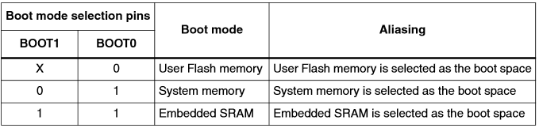

User Analog
Microcontroller spare analog Input (6 channels)

Pin | Signal | Signal Description | I/O | Signal Type | Signal Level
J14-1 | ADC_IN20_SPARE1 | Analog Input Channel 20 Spare 1 | I | ANALOG | 0-3V
J14-2 | ADC_IN21_SPARE2 | Analog Input Channel 21 Spare 2 | I | ANALOG | 0-3V
J14-3 | ADC_IN22_SPARE3 | Analog Input Channel 22 Spare 3 | I | ANALOG | 0-3V
J14-4 | ADC_IN23_SPARE4 | Analog Input Channel 23 Spare 4 | I | ANALOG | 0-3V
J14-5 | ADC_IN24_SPARE5 | Analog Input Channel 24 Spare 5 | I | ANALOG | 0-3V
J14-6 | ADC_IN25_SPARE6 | Analog Input Channel 25 Spare 6 | I | ANALOG | 0-3V
J14-7 | GND | Ground | - | POWER | GND
J14-8 | GND | Ground | - | POWER | GND
Table 11: User Spare Analog Input
The PCB mount connector shall be part#: 53047-0810, Molex
The mating connector is part#. 51021-0800, Molex
The mating connector pin is part#. 50079-8000, Molex (26-28AWG)

Data Logging
MicroSD Card Connector
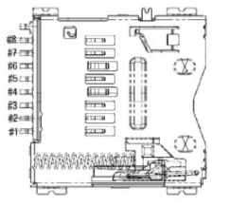
Figure 20: SD Card Connector
Pin | Signal | Signal Description | I/O | Signal Type | Signal Level
J13-1 | NC | No Connect | - | - | -
J13-2 | /PA4_SPI1_CS | SPI1 Chip Select | I | DIGITAL | +3V
J13-3 | SPI1_MOSI | SPI1 MOSI | I | DIGITAL | +3V
J13-4 | +3V_L | +3V Power | - | POWER | +3V
J13-5 | SPI1_SCK | SPI1 Clock | I | DIGITAL | +3V
J13-6 | GND | Ground | - | POWER | GND
J13-7 | SPI1_MISO | SPI1 MISO | O | DIGITAL | +3V
J13-8 | NC | No Connect | - | - | -
Table 12: MicroSD Card Interface
The PCB mount connector shall be part#: 2908-05WB-MG, 3M
The mating part is standard microSD Card Memory Size TBD

