|  |  |  |  |
| --- | --- | --- | --- |
| Open Water Battery Electronics Design Specification  **Project Ref #: OWP001**  COMPANY CONFIDENTIAL | | | |
| **TITLE** | | **DOC. NO.** | **REV.** |
| Open Water Battery Electronics Design Specification | | SP-13690 | 0.1 |
| **Boston Engineering** | | **Boston Engineering** | |
| **PREPARED BY** | **DATE** | **APPROVED BY** | **DATE** |
| **______________________________** | **_______________** | **______________________________** | **_______________** |
| **Y.WONG** | | **Name** | |
| Electrical Engineer | | Job Title | |
| **Boston Engineering** | | **Client** | |
| **REVIEWED BY** | **DATE** | **APPROVED BY** | **DATE** |
| **______________________________** | **_______________** | **______________________________** | **_______________** |
| **Name** | | **Name** | |
| Job Title | | Job Title | |

***REVISION HISTORY***

|  |  |  |  |
| --- | --- | --- | --- |
| **Revision** | **Description** | **Date** | **Author** |
| 0.1 | Draft | 07/29/2016 | Y.Wong |
|  |  |  |  |
|  |  |  |  |
|  |  |  |  |
|  |  |  |  |

***TABLE OF CONTENTS***

1 Purpose 4

2 Background 4

3 Related Documents 4

3.1 Documents 4

4 Project 4

4.1 System Overview 4

4.2 Open Water PCB Specifcations 6

4.2.1 PCB Outline 6

4.3 Open Water PCB Design 6

4.3.1 PCB Funcitionality 6

***TABLE OF FIGURES***

Figure 1: System Block Diagram 5

Figure 2: Open Water PCB Outline Drawing 6

Figure 3: Battery Management Design 7

Figure 4: Input Voltage Regulation Loop 8

Figure 5: TPL0401A Digital Potentiometer 9

Figure 6: Input Voltage Monitoring 9

Figure 7: Charge Current Regulation Loop 10

Figure 8: Battery Voltage Regulation Loop 11

Figure 9: Output Voltage Regulation Loop 11

Figure 10: LT3759 – SEPIC Controller 14

Figure 11: LTC3788 Dual Couput Boost Power Supply 18

Figure 12: Buck Power Supply (3A) 24

Figure 13: Buck 3V Local Power Supply (0.5A) 28

Figure 14: INA301 Unidirectional Current Sense Amplifier 31

Figure 15: MS5837 pressure and temperature sensor 38

Figure 16: MMA8652FC accelerometer orientation detection 39

Figure 17: MMA8652FC accelerometer circuit connection 39

Figure 18: Conductivity Sensor Interface Circuit 40

Figure 19: DAC Analog Output 42

Figure 20: SD Card Connector 45

# Purpose

The purpose of this document is to detail the engineering electroncis (PCB) design specifications for open water battery module

# Background

Open Water Power has asked Boston Engineering to design the open water battery module with their existing aluminimum water based battery cell technology. This document describes the hardware design details of the electronics.

# Related Documents

## Documents

* 160603_DraftSpecificationsOpenWaterBatteryElectronics.docx
* OWP_Requirements.xlsx

# Project

## System Overview

The following block diagram shown in Figure 1 provides a overveiw of open water battery module.



Figure : System Block Diagram

## Open Water PCB Specifcations

### PCB Outline

* Dimension shall be within 4.5” x 4.5” (LxW)
* Height shall be limited < 0.75” (TBD)

Overall dimension of the Open Water PCB design is shown in Figure 2.

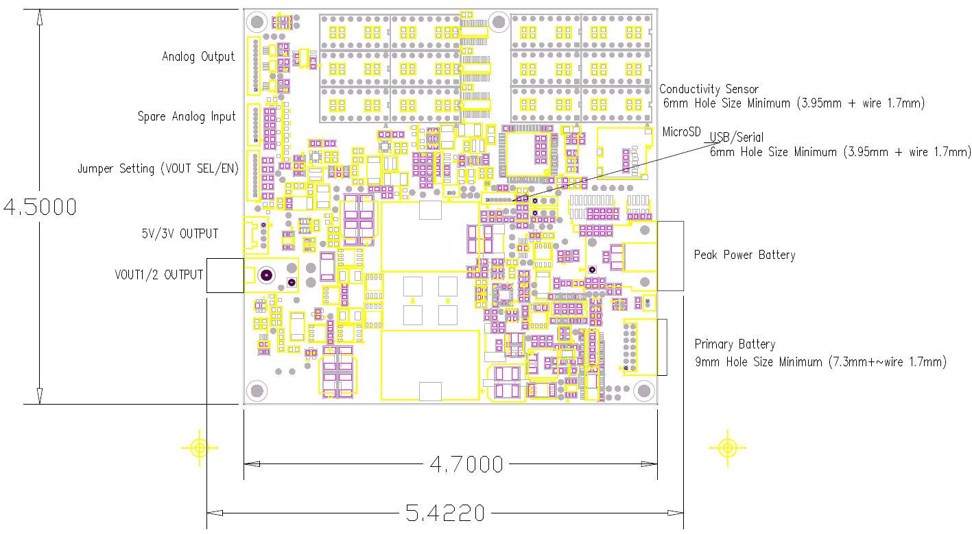

Figure : Open Water PCB Outline Drawing

## Open Water PCB Design

### PCB Funcitionality

PCB Electronics shall consist of following function

* Battery Management
* DC/DC Converter
* Power Monitor
* Microcontroller
* Sensors
* Output Indicator
* User Interface
* Data Logging

#### Battery Management

LTC4000-1, Linear Techcnology battery management controller shall be used in this application.The controller converts DC/DC power supplies to battery chargers with maximum power point control. The overall battery managament design is shown in Figure 3.

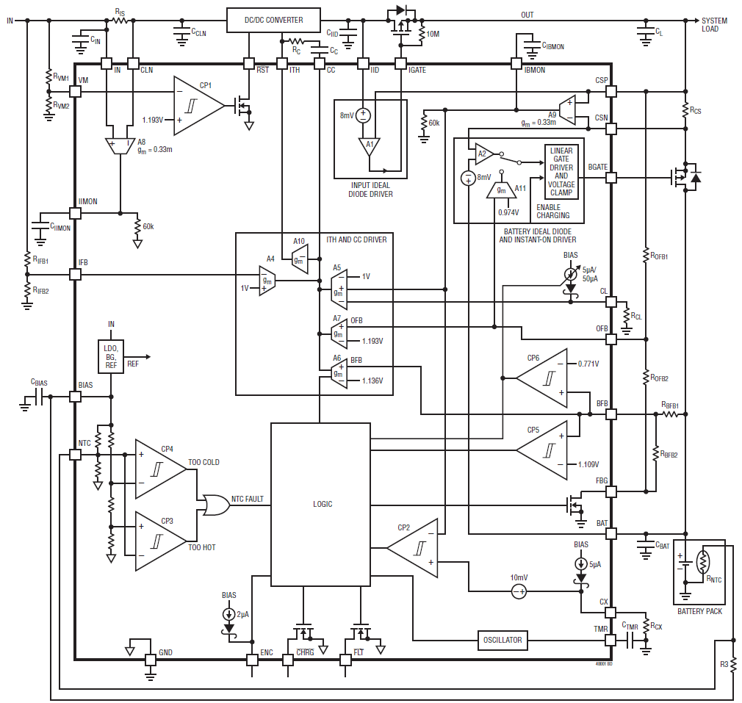

Figure : Battery Management Design

The controller includes four different regulation loops: input voltage, charge current, battery float voltage and output voltage. Whichever loop requires the lowest voltage on the ITH pin for its regulation controls the external DC/DC converter

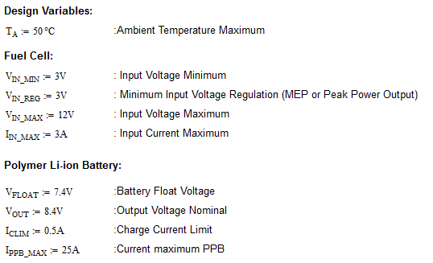

**Input Voltage Regulation Loop**



Figure : Input Voltage Regulation Loop

The iput voltage regulation loop prevents the input voltage from dropping below the programmed level.

When the input souce is high impedance, the input voltage drops as the load current increases. In our case the microcontroller set the regulation voltage by look-up table. The digital potentiometer shall be used to adjust voltage from 3V up to 7.5V to achieve maximum power efficiency.

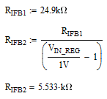

RIFB2 is 2.49kohm when VIN_REG = 11V, 12.45kohm when VIN_REG = 3V

Therefore RIFB2 can combine 2.49kohm resistor with 10k digital Potentiometer (TPL0401A-10)

TPL0401A-10 is 128 tap digital 20kohm potentiometer with I2C Interface.

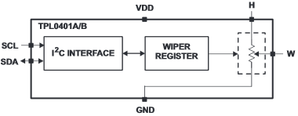

Figure : TPL0401A Digital Potentiometer

The input current through resistor RIS is available for monitoring through IIMON with gain of 20.

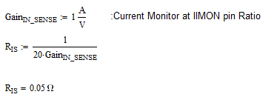

RIS select the value = 50mohm, 1W resistor



Figure : Input Voltage Monitoring

The voltage monitoring feature is to ensure the converter is turned off when the voltage at he input is below a certain level. The /RST pin is connected to the DC/DC converter chip enable line.

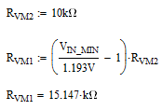

RVM1 select the closet value = 15.4kohm

**Charge Current Regulation Loop**

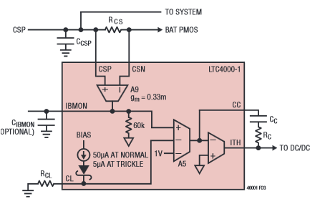

Figure : Charge Current Regulation Loop

The charge current regulation loop ensures the charge current sensed through the charge current sense resistor RCS does not exceed the programmed full charge current.

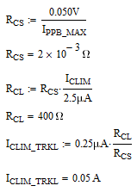

RCS select the value = 2mohm, 2W resistor, and the calculated trickle charge current is 50mA

Use CSNL2512FT2L00, Vishay, 2mohm, 2W, 1%

**Battery Voltage Regulation Loop**



Figure : Battery Voltage Regulation Loop

Once the battery float voltage is reached, the battery voltage regulation loop takes over from the charge current regulation loop. The battery voltage regulation loop ensures the battery voltage will not exceed the programmed voltage

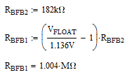

RBFB1 select the closet value = 1.00Mohm

**Output Voltage Regulation Loop**



Figure : Output Voltage Regulation Loop

When charging terminates and the system load is completely supplied from the input, the PMOS connected to BGATE is turned off. In this case, the output voltage regulation loop takes over from the battery float voltage regulation loop . The output voltage regulation loop ensure the output voltage will not exceed the programmed voltage

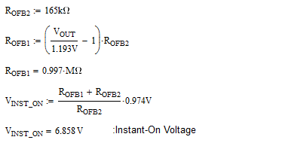

ROFB1 select the closet value = 1.00Mohm and calculated instant-on voltage is 6.858V

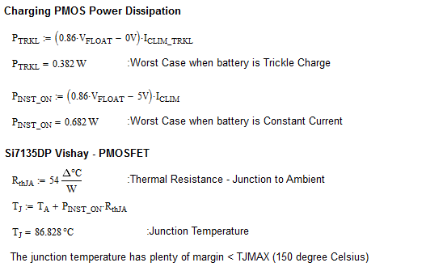

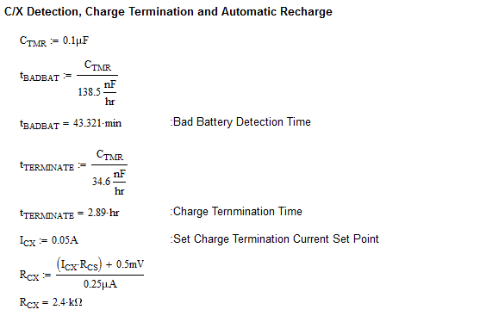

**DC/DC Converter LT3759 – SEPIC Controller**

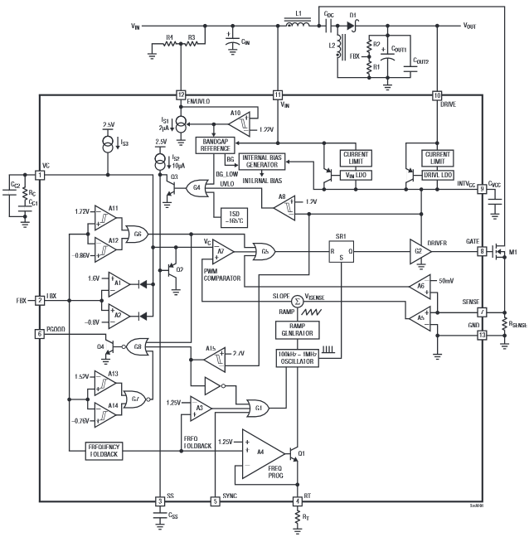

Figure : LT3759 – SEPIC Controller

**Programming Turn-On and Turn-Off Threshold EN/UVLO Pin**

Pin EN/UVLO shall be connected to the /RST of LTC4000-1 to control on and off of the controller. We would eliminate R3 and R4.

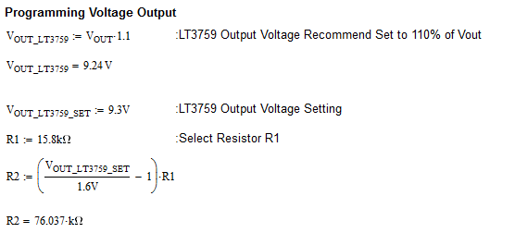

R2 select the closet value = 76.8kohm

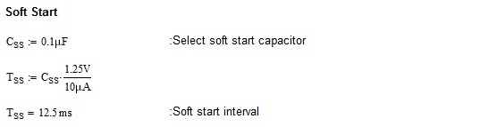

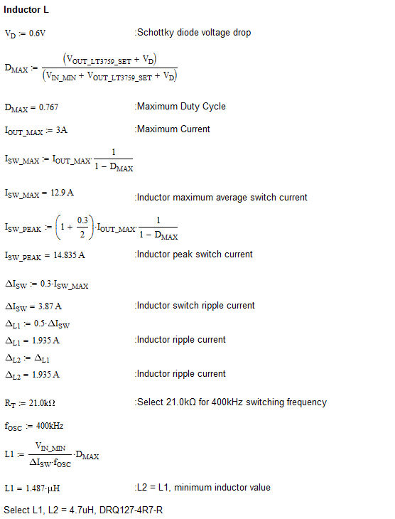

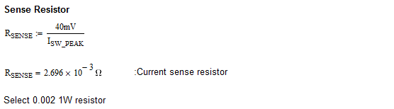

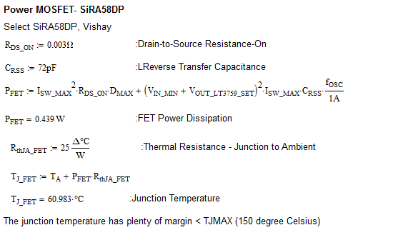

#### DC/DC Converter

##### Dual Output 150W Power Supply

LTC3788 Dual boost converter feature independent SS pin and run pin to enable power supply by user or microcontroller.

The PLLIN/MODE pin would select Burst Mode operation for higher efficiency at light load.

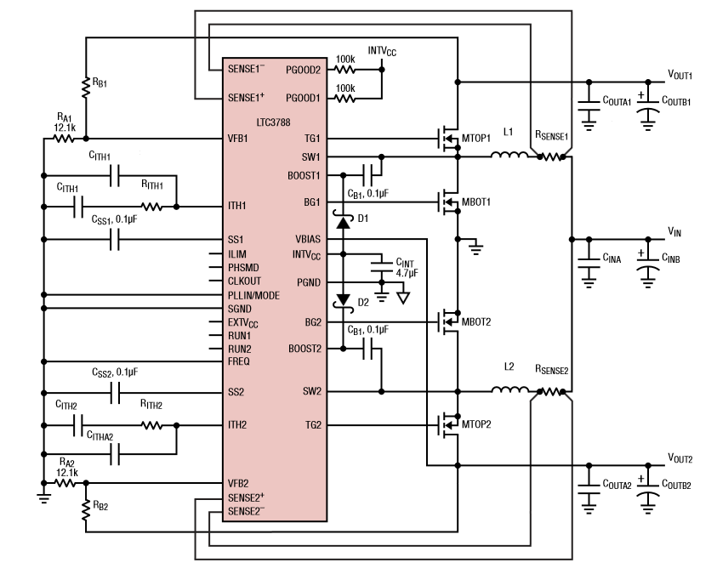

Figure : LTC3788 Dual Couput Boost Power Supply



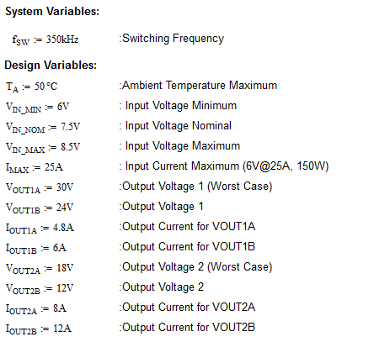

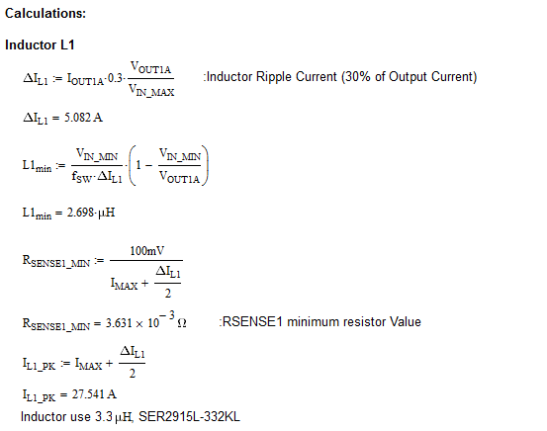

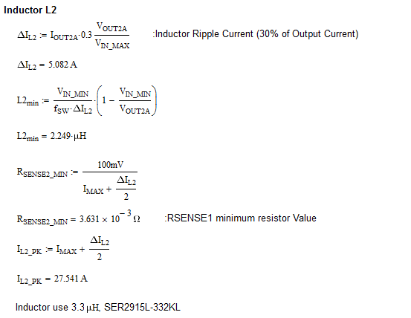

Analog switch ADG819 is used to switch between the feedback resistor to change desired voltage.

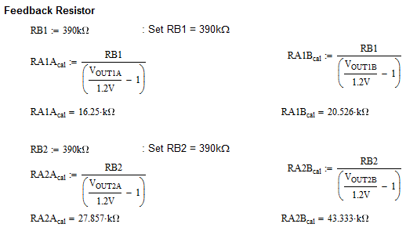

RB1A shall use the closet value 16.2k for 30V and RB1B shall use the closet value 20.5k for 24V

RB2A shall use the closet value 27.4k for 18V and RB1B shall use the closet value 43.2k for 12V

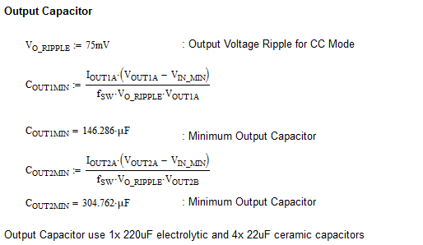

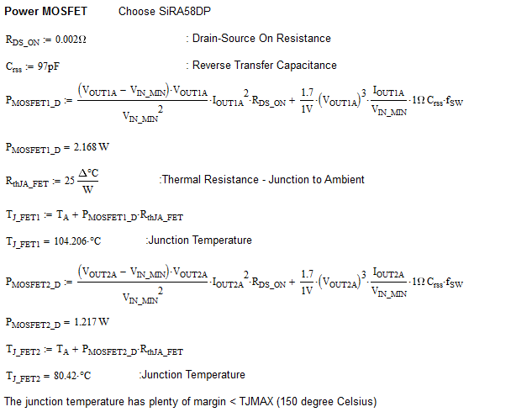

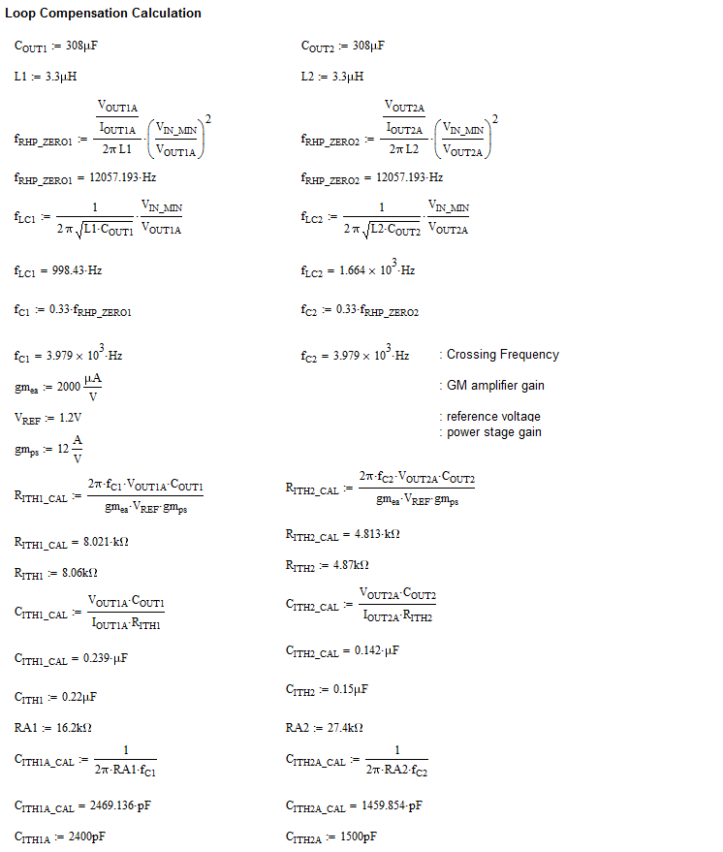

D1, D2 schottky diode shall us BAS140W

##### Boost Converter Short Circuit Protection

Boost Converter do not have true shutdown and short circuit protection. Additional PMOS switch shall be added on both output. For overcurrent and short circuit protection, current shunt monitor and overcurrent comparator INA301 shall be used to disable both converter and PMOS switch

##### Low Voltage 5V and 3V Power Supply

TPS62130 buck converter feature high switching frequency 2.5MHz allows to use of small inductors.

The converter internal switch can handle up to 3A output current in high efficiency for heavy load while it entered automatically and seamlessly into power save mode when the load is small.

TPS62130 buck converter have protection against heavy load and short circuit events. When Vout is dropped below 0.5V, the current limit is reduced to 1.6A. At heavy load, if the high-side FET is turned off when the current limit is reached.

##### 

Figure : Buck Power Supply (3A)

###### 5V Power Supply Design Calculations

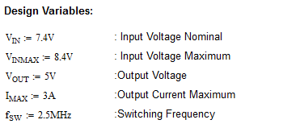

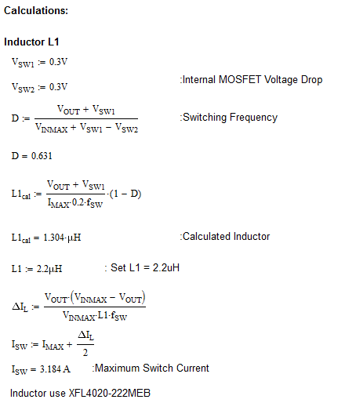

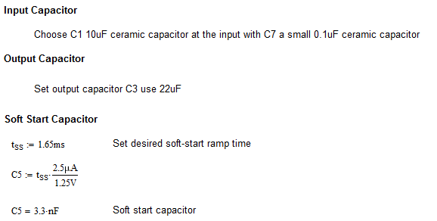

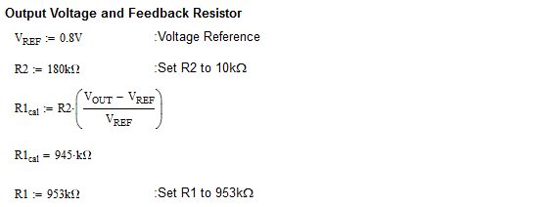

###### 3V Power Supply Design Calculations

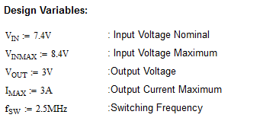

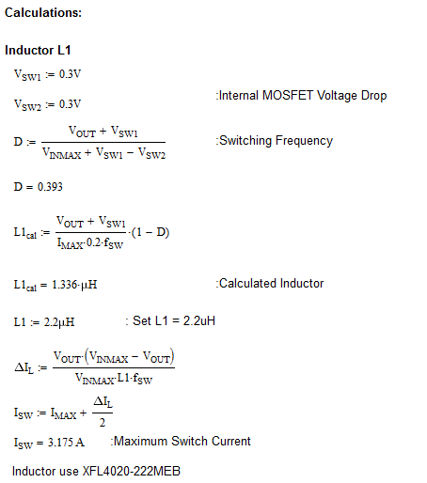



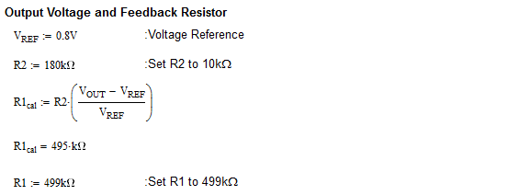

##### Low Power 3V Regulator

A low power 3V Regulator is used for power internal electronics

TPS62170 buck converter feature high switching frequency 2.25MHz allows to use of small inductors.

The converter internal switch can handle up to 0.5A output current in high efficiency for heavy load while it entered automatically and seamlessly into power save mode when the load is small.

TPS62170 buck converter have protection against heavy load and short circuit events. Thehigh-side FET is turned off when the current limit is reached.

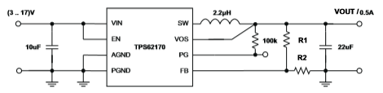

Figure : Buck 3V Local Power Supply (0.5A)

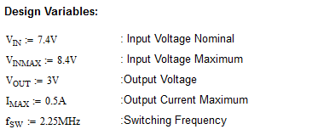

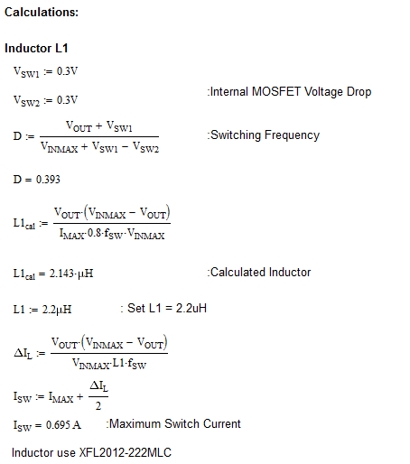

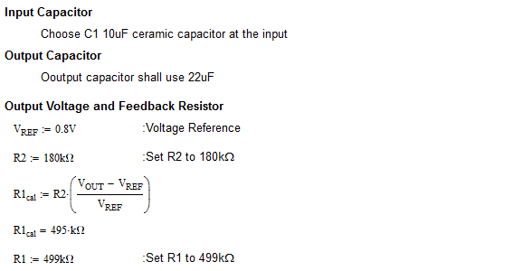

#### Power Monitor

##### Primary Battery Voltage/Current Monitor

Primary Battery Voltage Range

* 0V up to 12V
  + Gain 1/5 – ADC input: 0V to 2.4V
  + Use – 75K and 300K resistor

Primary Individual Battery Voltage Sense

* ~1.1-1.2V
  + Use ADG1607 Analog Mux with

Primary Battery Current Range

* 0A to 3A
  + Connect to IIMON pin which is 1V/A resolution.

##### Peak Power Battery Voltage/Current Monitor

Peak Power Battery Voltage Range

* 0V up to 8.4V
  + Gain 1/3 – ADC input: 0V to 2.8V
  + Use – 137K and 274K resistor

Peak Power Battery Current Range

* -25A to 25A
  + Using RCS 2mohm resistor as the current sense
  + Use AD8418 and configure as bi-directional
  + ADC Range will be 0.5V to 2.5V (-25A to +25A) center at 1.5V = 0A

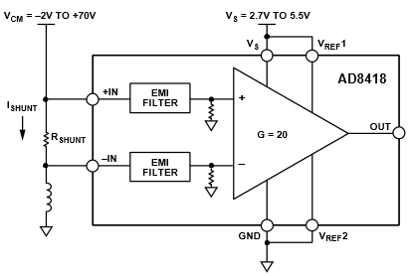

##### DC/DC converter Voltage/Current Monitor

##### Voltage Monitor

##### A simple resistor divider is used to sense the output voltage to microcontroller ADC

* 24VDC – 30VDC
  + Gain 1/12 – ADC input: 2V to 2.5V
  + Use – 100K and 1.1M resistor
* 12VDC – 18VDC
  + Gain 1/8 – ADC input: 1.5V to 2.25V
  + Use – 133K and 931K resistor
* 5VDC
  + Gain – 1/2 ADC input: 2.5V
  + Use – 249K and 249K resistor
* 3VDC
  + Gain – 0.75 ADC input: 2.25V
  + Use – 102K and 34K resistor

**Current Monitor**

INA301 is used to measure output current on all four DC/DC converters. For full range 0-3V analog, the RSENSE resistors used are as follow:

* 24VDC- 30VDC supply – current max. = 6A
  + RSENSE = 20mohm provide (0.4V/A) (0 -7.5A for 0 – 3V)
  + CSRN2512FK20L0, Stackpole, 40mohm, 1%, 2W
* 12VDC-18VDC supply – current max. = 12A
  + RSENSE = 10mohm provide (0.2V/A) (0 -15A for 0 – 3V)
  + Use two 20mohm in parallel
  + CSRN2512FK20L0, Stackpole, 40mohm, 1%, 2W
* 5VDC supply – current max. = 3A
  + RSENSE = 40mohm provide (0.8V/A) (0 -3.75A for 0 – 3V)
  + CSRN2512FK40L0, Stackpole, 40mohm, 1%, 2W
* 3VDC supply – current max. = 3A
  + RSENSE = 40mohm provide (0.8V/A) (0 -3.75A for 0 – 3V)
  + CSRN2512FK40L0, Stackpole, 40mohm, 1%, 2W

INA301 is connected in undirectional operation as follow:

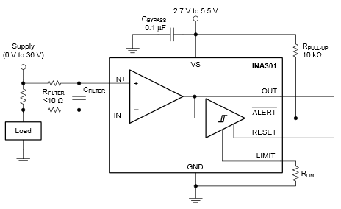

Figure : INA301 Unidirectional Current Sense Amplifier

* 24V Power@6 A
  + VLIMIT = 2.4V
  + RLIMIT = 2.4V/80uA = 30kohm
* 30V Power@4.8 A
  + VLIMIT = 1.92V
  + RLIMIT = 1.92V/80uA = 24kohm
* 12V Power@12A
  + VLIMIT = 2.4V
  + RLIMIT = 2.4V/80uA = 30kohm
* 18V Power@8 A
  + VLIMIT = 1.6V
  + RLIMIT = 1.6V/80uA = 20kohm
* 5V Power@3 A
  + VLIMIT = 2.4V
  + RLIMIT = 2.4V/80uA = 30kohm
* 3V Power@3 A
  + VLIMIT = 2.4V
  + RLIMIT = 2.4V/80uA = 30kohm

#### Microcontroller

STM32L151VB-A 128KB Flash , 32KB RAM low power processor is selected.

* 8 MHz Crystal and 32.678kHz for normal mode and low power mode
* ADC reference is tied to 3V for 0-3V Range

|  |  |  |  |  |  |  |  |  |  |  |  |  |  |  |  |  |  |  |  |  |  |
| --- | --- | --- | --- | --- | --- | --- | --- | --- | --- | --- | --- | --- | --- | --- | --- | --- | --- | --- | --- | --- | --- |
| **Pin Numbers** | **Pin name** | **AF0** | **AF1** | **AF2** | **AF3** | **AF4** | **AF5** | **AF6** | **AF7** | **AF8** | **AF9** | **AF10** | **AF11** | **AF14** | **AF15** | **Additional function 1** | **Additional function 2** | **Additional function 3** | **Additional function 4** | **Signal Name** | **Description** |
| 1 | PE2 | TRACECLK |  | TIM3_ETR |  |  |  |  |  |  |  |  |  | TIMx_IC3 | EVENTOUT |  |  |  |  | PE2 | Trace Connector or User spare |
| 2 | PE3 | TRACED0 |  | TIM3_CH1 |  |  |  |  |  |  |  |  |  | TIMx_IC4 | EVENTOUT |  |  |  |  | PE3 | Trace Connector or User spare |
| 3 | PE4 | TRACED1 |  | TIM3_CH2 |  |  |  |  |  |  |  |  |  | TIMx_IC1 | EVENTOUT |  |  |  |  | PE4 | Trace Connector or User spare |
| 4 | PE5 | TRACED2 |  |  | TIM9_CH1 |  |  |  |  |  |  |  |  | TIMx_IC2 | EVENTOUT |  |  |  |  | PE5 | Trace Connector or User spare |
| 5 | PE6-WKUP3 | TRACED3 |  |  | TIM9_CH2 |  |  |  |  |  |  |  |  | TIMx_IC3 | EVENTOUT | WKUP3 | RTC_TAMP3 |  |  | PE6 | Trace Connector or User spare |
| 6 | VLCD |  |  |  |  |  |  |  |  |  |  |  |  |  |  |  |  |  |  |  | Connected to VDD for STM32L151 |
| 7 | PC13-WKUP2 |  |  |  |  |  |  |  |  |  |  |  |  | TIMx_IC2 | EVENTOUT | RTC_TAMP1 | RTC_TS | RTC_OUT | WKUP2 | PC13_MUX2_EN | Multiplexer 2 Enable |
| 8 | PC14-OSC32_IN |  |  |  |  |  |  |  |  |  |  |  |  | TIMx_IC3 | EVENTOUT | OSC32_IN |  |  |  |  | 32.768kHz Crystal |
| 9 | PC15-OSC32_OUT |  |  |  |  |  |  |  |  |  |  |  |  | TIMx_IC4 | EVENTOUT | OSC32_OUT |  |  |  |  | 32.768kHz Crystal |
| 10 | VSS_5 |  |  |  |  |  |  |  |  |  |  |  |  |  |  |  |  |  |  |  |  |
| 11 | VDD_5 |  |  |  |  |  |  |  |  |  |  |  |  |  |  |  |  |  |  |  |  |
| 12 | PH0-OSC_IN |  |  |  |  |  |  |  |  |  |  |  |  |  |  | OSC_IN |  |  |  |  | 8MHz Crystal |
| 13 | PH1-OSC_OUT |  |  |  |  |  |  |  |  |  |  |  |  |  |  | OSC_OUT |  |  |  |  | 8MHz Crystal |
| 14 | NRST | NRST |  |  |  |  |  |  |  |  |  |  |  |  |  |  |  |  |  | /RST | Device reset input/ internal reset output |
| 15 | PC0 |  |  |  |  |  |  |  |  |  |  |  |  | TIMx_IC1 | EVENTOUT | ADC_IN10 | COMP1_INP |  |  | ADC_IN10_VOUT1_VSENSE | 24-30V Power Supply Voltage Sense |
| 16 | PC1 |  |  |  |  |  |  |  |  |  |  |  |  | TIMx_IC2 | EVENTOUT | ADC_IN11 | COMP1_INP |  |  | ADC_IN11_VOUT1_ISENSE | 24-30V Power Supply Current Sense |
| 17 | PC2 |  |  |  |  |  |  |  |  |  |  |  |  | TIMx_IC3 | EVENTOUT | ADC_IN12 | COMP1_INP |  |  | ADC_IN12_VOUT2_VSENSE | 12-18V Power Supply Voltage Sense |
| 18 | PC3 |  |  |  |  |  |  |  |  |  |  |  |  | TIMx_IC4 | EVENTOUT | ADC_IN13 | COMP1_INP |  |  | ADC_IN13_VOUT2_ISENSE | 12-18V Power Supply Current Sense |
| 19 | VSSA |  |  |  |  |  |  |  |  |  |  |  |  |  |  |  |  |  |  |  | Analog ground |
| 20 | VREF- |  |  |  |  |  |  |  |  |  |  |  |  |  |  |  |  |  |  |  | Reference voltage for ADC, COMP, DAC |
| 21 | VREF+ |  |  |  |  |  |  |  |  |  |  |  |  |  |  |  |  |  |  |  | Reference voltage for ADC, COMP, DAC |
| 22 | VDDA |  |  |  |  |  |  |  |  |  |  |  |  |  |  |  |  |  |  |  | Analog power supply |
| 23 | PA0-WKUP1 |  | TIM2_CH1_ETR |  |  |  |  |  | USART2_CTS |  |  |  |  | TIMx_IC1 | EVENTOUT | WKUP1 | ADC_IN0 | COMP1_INP | RTC_TAMP2 | ADC_IN0_PB_VSENSE | Primary Battery Overall Voltage Sense |
| 24 | PA1 |  | TIM2_CH2 |  |  |  |  |  | USART2_RTS |  |  |  |  | TIMx_IC2 | EVENTOUT | ADC_IN1 | COMP1_INP |  |  | ADC_IN1_PB_ISENSE | Primary Battery Current Sense (from LTC4000-1) |
| 25 | PA2 |  | TIM2_CH3 |  | TIM9_CH1 |  |  |  | USART2_TX |  |  |  |  | TIMx_IC3 | EVENTOUT | ADC_IN2 | COMP1_INP |  |  | ADC_IN2_PPB_VSENSE | Peak Power Battery Voltage Sense |
| 26 | PA3 |  | TIM2_CH4 |  | TIM9_CH2 |  |  |  | USART2_RX |  |  |  |  | TIMx_IC4 | EVENTOUT | ADC_IN3 | COMP1_INP |  |  | ADC_IN3_PPB_ISENSE | Peak Power Battery Current Sense (bi directional, charge , discharge) |
| 27 | VSS_4 |  |  |  |  |  |  |  |  |  |  |  |  |  |  |  |  |  |  |  |  |
| 28 | VDD_4 |  |  |  |  |  |  |  |  |  |  |  |  |  |  |  |  |  |  |  |  |
| 29 | PA4 |  |  |  |  |  | SPI1_NSS |  | USART2_CK |  |  |  |  | TIMx_IC1 | EVENTOUT | ADC_IN4 | DAC_OUT1 | COMP1_INP |  | /PA4_SPI1_CS | SD Card Chip Select |
| 30 | PA5 |  | TIM2_CH1_ETR |  |  |  | SPI1_SCK |  |  |  |  |  |  | TIMx_IC2 | EVENTOUT | ADC_IN5 | DAC_OUT2 | COMP1_INP |  | SPI1_SCK | SD Card SPI Clock |
| 31 | PA6 |  |  | TIM3_CH1 | TIM10_CH1 |  | SPI1_MISO |  |  |  |  |  |  | TIMx_IC3 | EVENTOUT | ADC_IN6 | COMP1_INP |  |  | SPI1_MISO | SD Card MISO |
| 32 | PA7 |  |  | TIM3_CH2 | TIM11_CH1 |  | SPI1_MOSI |  |  |  |  |  |  | TIMx_IC4 | EVENTOUT | ADC_IN7 | COMP1_INP |  |  | SPI1_MOSI | SD Card MOSI |
| 33 | PC4 |  |  |  |  |  |  |  |  |  |  |  |  | TIMx_IC1 | EVENTOUT | ADC_IN14 | COMP1_INP |  |  | ADC_IN14_5V_VSENSE | 5V Power Supply Voltage Sense |
| 34 | PC5 |  |  |  |  |  |  |  |  |  |  |  |  | TIMx_IC2 | EVENTOUT | ADC_IN15 | COMP1_INP |  |  | ADC_IN15_5V_ISENSE | 5V Power Supply Current Sense |
| 35 | PB0 |  |  | TIM3_CH3 |  |  |  |  |  |  |  |  |  |  | EVENTOUT | ADC_IN8 | COMP1_INP | VREF_OUT |  | ADC_IN8_3V_VSENSE | 3V Power Supply Voltage Sense |
| 36 | PB1 |  |  | TIM3_CH4 |  |  |  |  |  |  |  |  |  |  | EVENTOUT | ADC_IN9 | COMP1_INP | VREF_OUT |  | ADC_IN9_3V_ISENSE | 3V Power Supply Current Sense |
| 37 | PB2 | BOOT1 |  |  |  |  |  |  |  |  |  |  |  |  |  |  |  |  |  |  | BOOT1 Selection |
| 38 | PE7 |  |  |  |  |  |  |  |  |  |  |  |  | TIMx_IC4 | EVENTOUT | ADC_IN22 | COMP1_INP |  |  | ADC_IN22_SPARE3 | User spare |
| 39 | PE8 |  |  |  |  |  |  |  |  |  |  |  |  | TIMx_IC1 | EVENTOUT | ADC_IN23 | COMP1_INP |  |  | ADC_IN23_SPARE4 | User spare |
| 40 | PE9 |  | TIM2_CH1_ETR |  |  |  |  |  |  |  |  |  |  | TIMx_IC2 | EVENTOUT | ADC_IN24 | COMP1_INP |  |  | ADC_IN24_SPARE5 | User spare |
| 41 | PE10 |  | TIM2_CH2 |  |  |  |  |  |  |  |  |  |  | TIMx_IC3 | EVENTOUT | ADC_IN25 | COMP1_INP |  |  | ADC_IN25_SPARE6 | User spare |
| 42 | PE11 |  | TIM2_CH3 |  |  |  |  |  |  |  |  |  |  |  |  |  |  |  |  | PE11_COND_SENSOR_EN | Conductivity Sensor Enable |
| 43 | PE12 |  | TIM2_CH4 |  |  |  | SPI1_NSS |  |  |  |  |  |  | TIMx_IC1 | EVENTOUT |  |  |  |  | PE12 | User spare |
| 44 | PE13 |  |  |  |  |  | SPI1_SCK |  |  |  |  |  |  | TIMx_IC2 | EVENTOUT |  |  |  |  | PE13 | User spare |
| 45 | PE14 |  |  |  |  |  | SPI1_MISO |  |  |  |  |  |  | TIMx_IC3 | EVENTOUT |  |  |  |  | PE14 | User spare |
| 46 | PE15 |  |  |  |  |  | SPI1_MOSI |  |  |  |  |  |  | TIMx_IC4 | EVENTOUT |  |  |  |  | PE15 | User spare |
| 47 | PB10 |  | TIM2_CH3 |  |  | I2C2_SCL |  |  | USART3_TX |  |  |  |  |  | EVENTOUT |  |  |  |  | I2C2_SCL | I2C2 clock acceleromter and pressure temperature sensor |
| 48 | PB11 |  | TIM2_CH4 |  |  | I2C2_SDA |  |  | USART3_RX |  |  |  |  |  | EVENTOUT |  |  |  |  | I2C2_SDA | I2C2 data acceleromter and pressure temperature sensor |
| 49 | VSS_1 |  |  |  |  |  |  |  |  |  |  |  |  |  |  |  |  |  |  |  |  |
| 50 | VDD_1 |  |  |  |  |  |  |  |  |  |  |  |  |  |  |  |  |  |  |  |  |
| 51 | PB12 |  |  |  | TIM10_CH1 | I2C2_SMBA | SPI2_NSS |  | USART3_CK |  |  |  |  |  | EVENTOUT | ADC_IN18 | COMP1_INP |  |  | ADC_IN18_COND_SENSE | Conductivity Sensor Sense Signal |
| 52 | PB13 |  |  |  | TIM9_CH1 |  | SPI2_SCK |  | USART3_CTS |  |  |  |  |  | EVENTOUT | ADC_IN19 | COMP1_INP |  |  | ADC_IN19_PB_IND_VSENSE | Individual Primary Battery Voltage Sense (Mux + Differential Amp) |
| 53 | PB14 |  |  |  | TIM9_CH2 |  | SPI2_MISO |  | USART3_RTS |  |  |  |  |  | EVENTOUT | ADC_IN20 | COMP1_INP |  |  | ADC_IN20_SPARE1 | User spare |
| 54 | PB15 |  |  |  | TIM11_CH1 |  | SPI2_MOSI |  |  |  |  |  |  |  |  | ADC_IN21 | COMP1_INP | RTC_REFIN |  | ADC_IN21_SPARE2 | User spare |
| 55 | PD8 |  |  |  |  |  |  |  | USART3_TX |  |  |  |  | TIMx_IC1 | EVENTOUT |  |  |  |  | PD8_24V/30V_SEL | 24VDC or 30VDC Power Supply Selection H = 24VDC, L = 30VDC |
| 56 | PD9 |  |  |  |  |  |  |  | USART3_RX |  |  |  |  | TIMx_IC2 | EVENTOUT |  |  |  |  | PD9_12V/18V_SEL | 12VDC or 18VDC Power Supply Selection H= 12VDC, L = 18VDC |
| 57 | PD10 |  |  |  |  |  |  |  | USART3_CK |  |  |  |  | TIMx_IC3 | EVENTOUT |  |  |  |  | PD10_24V/30V_JUMPER | 24VDC or 30VDC Power Supply Selection Jumper H = 24VDC, L = 30VDC |
| 58 | PD11 |  |  |  |  |  |  |  | USART3_CTS |  |  |  |  | TIMx_IC4 | EVENTOUT |  |  |  |  | PD11_12V/18V_JUMPER | 12VDC or 18VDC Power Supply Selection Jumper H = 12VDC, L = 18VDC |
| 59 | PD12 |  |  | TIM4_CH1 |  |  |  |  | USART3_RTS |  |  |  |  | TIMx_IC1 | EVENTOUT |  |  |  |  | PD12_VOUT1_JUMPER_EN | 24V-30VDC Power Supply Jumper Enable |
| 60 | PD13 |  |  | TIM4_CH2 |  |  |  |  |  |  |  |  |  | TIMx_IC2 | EVENTOUT |  |  |  |  | PD13_VOUT1_EN | 24V-30VDC Power Supply Enable |
| 61 | PD14 |  |  | TIM4_CH3 |  |  |  |  |  |  |  |  |  | TIMx_IC3 | EVENTOUT |  |  |  |  | PD14_VOUT2_JUMPER_EN | 12V-18VDC Power Supply Jumper Enable |
| 62 | PD15 |  |  | TIM4_CH4 |  |  |  |  |  |  |  |  |  | TIMx_IC4 | EVENTOUT |  |  |  |  | PD15_VOUT2_EN | 12V-18VDC Power Supply Enable |
| 63 | PC6 |  |  | TIM3_CH1 |  |  |  |  |  |  |  |  |  | TIMx_IC3 | EVENTOUT |  |  |  |  | PC6_MUX1_A0 | Multiplexer 1 A0 |
| 64 | PC7 |  |  | TIM3_CH2 |  |  |  |  |  |  |  |  |  | TIMx_IC4 | EVENTOUT |  |  |  |  | PC7_MUX1_A1 | Multiplexer 1 A1 |
| 65 | PC8 |  |  | TIM3_CH3 |  |  |  |  |  |  |  |  |  | TIMx_IC1 | EVENTOUT |  |  |  |  | PC8_MUX1_A2 | Multiplexer 1 A2 |
| 66 | PC9 |  |  | TIM3_CH4 |  |  |  |  |  |  |  |  |  | TIMx_IC2 | EVENTOUT |  |  |  |  | PC9_MUX1_EN | Multiplexer 1 Enable |
| 67 | PA8 | MCO |  |  |  |  |  |  | USART1_CK |  |  |  |  | TIMx_IC1 | EVENTOUT |  |  |  |  | PA8_LED_STATUS_JUMPER | LED Status Jumper Enable/Disable |
| 68 | PA9 |  |  |  |  |  |  |  | USART1_TX |  |  |  |  | TIMx_IC2 | EVENTOUT |  |  |  |  | USART1_TX | Serial communication |
| 69 | PA10 |  |  |  |  |  |  |  | USART1_RX |  |  |  |  | TIMx_IC3 | EVENTOUT |  |  |  |  | USART1_RX | Serial communication |
| 70 | PA11 |  |  |  |  |  | SPI1_MISO |  | USART1_CTS |  |  |  |  | TIMx_IC4 | EVENTOUT | USB_DM |  |  |  | USB_DM | USB Data Minus |
| 71 | PA12 |  |  |  |  |  | SPI1_MOSI |  | USART1_RTS |  |  |  |  | TIMx_IC1 | EVENTOUT | USB_DP |  |  |  | USB_DP | USB Data Plus |
| 72 | PA13 | JTMS-SWDIO |  |  |  |  |  |  |  |  |  |  |  | TIMx_IC2 | EVENTOUT |  |  |  |  | JTMS-SWDIO | JTAG TMS |
| 73 | PH2 |  |  |  |  |  |  |  |  |  |  |  |  |  |  |  |  |  |  | PH2_DEBUG_LED | Debug LED |
| 74 | VSS_2 |  |  |  |  |  |  |  |  |  |  |  |  |  |  |  |  |  |  |  |  |
| 75 | VDD_2 |  |  |  |  |  |  |  |  |  |  |  |  |  |  |  |  |  |  |  |  |
| 76 | PA14 | JTCK-SWCLK |  |  |  |  |  |  |  |  |  |  |  | TIMx_IC3 | EVENTOUT |  |  |  |  | JTCK-SWCLK | JTAG TCK |
| 77 | PA15 | JTDI | TIM2_CH1_ETR |  |  |  | SPI1_NSS |  |  |  |  |  |  | TIMx_IC4 | EVENTOUT |  |  |  |  | JTDI | JTAG TDI |
| 78 | PC10 |  |  |  |  |  |  |  | USART3_TX |  |  |  |  | TIMx_IC3 | EVENTOUT |  |  |  |  | PC10_MUX2_A0 | Multiplexer 2 A0 |
| 79 | PC11 |  |  |  |  |  |  |  | USART3_RX |  |  |  |  | TIMx_IC4 | EVENTOUT |  |  |  |  | PC11_MUX2_A1 | Multiplexer 2 A1 |
| 80 | PC12 |  |  |  |  |  |  |  | USART3_CK |  |  |  |  | TIMx_IC1 | EVENTOUT |  |  |  |  | PC12_MUX2_A2 | Multiplexer 2 A2 |
| 81 | PD0 |  |  |  | TIM9_CH1 |  | SPI2_NSS |  |  |  |  |  |  | TIMx_IC1 | EVENTOUT |  |  |  |  | /PD0_SPI2_CS1 | Analog Output Channel 1-2 chip select |
| 82 | PD1 |  |  |  |  |  | SPI2_SCK |  |  |  |  |  |  | TIMx_IC2 | EVENTOUT |  |  |  |  | SPI2_SCK | Analog Output SPI Clock |
| 83 | PD2 |  |  | TIM3_ETR |  |  |  |  |  |  |  |  |  | TIMx_IC3 | EVENTOUT |  |  |  |  | /PD2_SPI2_CS2 | Analog Output Channel 3-4 chip select |
| 84 | PD3 |  |  |  |  |  | SPI2_MISO |  | USART2_CTS |  |  |  |  | TIMx_IC4 | EVENTOUT |  |  |  |  | SPI2_MISO | Analog Output MISO |
| 85 | PD4 |  |  |  |  |  | SPI2_MOSI |  | USART2_RTS |  |  |  |  | TIMx_IC1 | EVENTOUT |  |  |  |  | SPI2_MOSI | Analog Output MOSI |
| 86 | PD5 |  |  |  |  |  |  |  | USART2_TX |  |  |  |  | TIMx_IC2 | EVENTOUT |  |  |  |  | /PD5_SPI2_CS3 | Analog Output Channel 5-6 chip select |
| 87 | PD6 |  |  |  |  |  |  |  | USART2_TRX |  |  |  |  | TIMx_IC3 | EVENTOUT |  |  |  |  | PD6_USB_DISCONNECT | USB Disconnect |
| 88 | PD7 |  |  |  | TIM9_CH2 |  |  |  | USART2_CK |  |  |  |  | TIMx_IC4 | EVENTOUT |  |  |  |  | PD7_USB_CONNECT | USB Connect Sense |
| 89 | PB3 | JTDO | TIM2_CH2 |  |  |  | SPI1_SCK |  |  |  |  |  |  |  | EVENTOUT | COMP2_INM |  |  |  | JTDO | JTAG JTDO |
| 90 | PB4 | NJTRST |  | TIM3_CH1 |  |  | SPI1_MISO |  |  |  |  |  |  |  | EVENTOUT | COMP2_INM |  |  |  | /JTRST | JTAG Reset |
| 91 | PB5 |  |  | TIM3_CH2 |  | I2C1_SMBA | SPI1_MOSI |  |  |  |  |  |  |  | EVENTOUT | COMP2_INM |  |  |  | /PB5_INT1 | Accelerometer Interrupt |
| 92 | PB6 |  |  | TIM4_CH1 |  | I2C1_SCL |  |  | USART1_TX |  |  |  |  |  | EVENTOUT |  |  |  |  | /PB6_INT2 | Accelerometer Interrupt |
| 93 | PB7 |  |  | TIM4_CH2 |  | I2C1_SDA |  |  | USART1_RX |  |  |  |  |  | EVENTOUT | PVD_IN |  |  |  | PB7_ENC | Peak Power Battery Charge Enable |
| 94 | BOOT0 | BOOT0 |  |  |  |  |  |  |  |  |  |  |  |  |  |  |  |  |  |  | BOOT0 Selection |
| 95 | PB8 |  |  | TIM4_CH3 | TIM10_CH1 | I2C1_SCL |  |  |  |  |  |  |  |  | EVENTOUT |  |  |  |  | I2C1_SCL | I2C1 clock digital potentiometer |
| 96 | PB9 |  |  | TIM4_CH4 | TIM11_CH1 | I2C1_SDA |  |  |  |  |  |  |  |  | EVENTOUT |  |  |  |  | I2C1_SDA | I2C2 clock digital potentiometer |
| 97 | PE0 |  |  | TIM4_ETR | TIM10_CH1 |  |  |  |  |  |  |  |  | TIMx_IC1 | EVENTOUT |  |  |  |  | PE0_/CHRG | Charge Status Indicator |
| 98 | PE1 |  |  |  | TIM11_CH1 |  |  |  |  |  |  |  |  | TIMx_IC2 | EVENTOUT |  |  |  |  | PE1_/FLT | Charge Fault |
| 99 | VSS_3 |  |  |  |  |  |  |  |  |  |  |  |  |  |  |  |  |  |  |  |  |
| 100 | VDD_3 |  |  |  |  |  |  |  |  |  |  |  |  |  |  |  |  |  |  |  |  |

Table : Microcontroller Pin Assignment

##### Microcontroller Control

* VOUT1 (24V and 30V) selection and on/off

|  |  |  |  |
| --- | --- | --- | --- |
| **Input**  **PD10**  **(24/30V_JUMPER)** | **Input**  **PD12 (VOUT1_JUMPER_EN)** | **Output**  **PD8 (24/30V_SEL)** | **Output**  **PD13 (VOUT1_EN)** |
| 0 | 0 | 0 | 0 |
| 0 | 1 | 0 | 1 |
| 1 | 0 | 1 | 0 |
| 1 | 1 | 1 | 1 |

Table : True Table for 24/30V Power Supply Control

* VOUT2 (12V and 18V) selection and on/off

|  |  |  |  |
| --- | --- | --- | --- |
| **Input**  **PD11**  **(12/18V_JUMPER)** | **Input**  **PD14 (VOUT2_JUMPER_EN)** | **Output**  **PD9 (12/18V_SEL)** | **Output**  **PD15 (VOUT2_EN)** |
| 0 | 0 | 0 | 0 |
| 0 | 1 | 0 | 1 |
| 1 | 0 | 1 | 0 |
| 1 | 1 | 1 | 1 |

Table : True Table for 12/18V Power Supply Control

* Multiplixer Control Primary Battery Voltage Sense

|  |  |  |  |  |  |  |  |  |
| --- | --- | --- | --- | --- | --- | --- | --- | --- |
| **Primary Battery**  **Individual Cell #** | **Output**  **PC6**  **(MUX1_A0)** | **Output**  **PC7**  **(MUX1_A1)** | **Output**  **PC8**  **(MUX1_A2)** | **Output**  **PC9**  **(MUX1_EN)** | **Output**  **PC10**  **(MUX2_A0)** | **Output**  **PC11**  **(MUX2_A1)** | **Output**  **PC12**  **(MUX2_A2)** | **Output**  **PC13**  **(MUX2_EN)** |
| 1 | X | X | X | 0 | 0 | 1 | 1 | 1 |
| 2 | X | X | X | 0 | 0 | 1 | 0 | 1 |
| 3 | X | X | X | 0 | 0 | 0 | 1 | 1 |
| 4 | X | X | X | 0 | 0 | 0 | 0 | 1 |
| 5 | 1 | 1 | 1 | 1 | X | X | X | 0 |
| 6 | 1 | 1 | 0 | 1 | X | X | X | 0 |
| 7 | 1 | 0 | 1 | 1 | X | X | X | 0 |
| 8 | 1 | 0 | 0 | 1 | X | X | X | 0 |
| 9 | 0 | 1 | 1 | 1 | X | X | X | 0 |
| 10 | 0 | 1 | 0 | 1 | X | X | X | 0 |
| 11 | 0 | 0 | 1 | 1 | X | X | X | 0 |
| 12 | 0 | 0 | 0 | 1 | X | X | X | 0 |

Table : Muliplixer Control Primary Battery Voltage Sense

* ADC Channels

|  |  |
| --- | --- |
| **ADC Channel** | **Used For** |
| ADC_IN0 | Primary Battery Overall Voltage Sense |
| ADC_IN1 | Primary Battery Current Sense |
| ADC_IN2 | Peak Power Battery Voltage Sense |
| ADC_IN3 | Peak Power Battery Current Sense |
| ADC_IN8 | 3V Power Supply Voltage Sense |
| ADC_IN9 | 3V Power Supply Current Sense |
| ADC_IN10 | 24V/30V Power Supply Voltage Sense |
| ADC_IN11 | 24V/30V Power Supply Current Sense |
| ADC_IN12 | 12V/18V Power Supply Voltage Sense |
| ADC_IN13 | 12V/18V Power Supply Current Sense |
| ADC_IN14 | 5V Power Supply Voltage Sense |
| ADC_IN15 | 5V Power Supply Current Sense |
| ADC_IN18 | Conductivity Sensor Sense |
| ADC_IN19 | Primary Battery Individual Voltage Sense |

Table : ADC Channel mapping

#### Sensors

##### Pressure and Temperature Sensor

MS5837-30BA pressure and temperature sensor is used for water depth and temperature measurement. The sensor module can measure up to 30bar (~300m) and it includes a high linearity pressure sensor and ultra low power 24 bit ADC with internal factory calibrated coefficients. A high resolution temperature output is avaiable for compensated pressure. The communication protocol use I2C interface and easy to communicate.

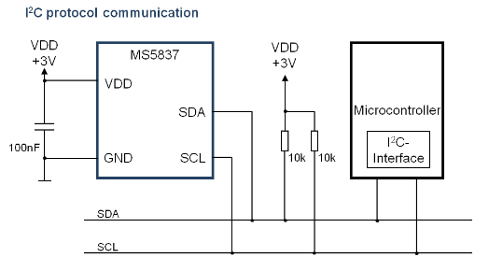

Figure : MS5837 pressure and temperature sensor

##### 3 axis Accelerometer

MMA8652FC accelerometer is used for measure axis orientation of the battery module. The sensor module use I2C interface with programmable interrupts for user to detect orientation.

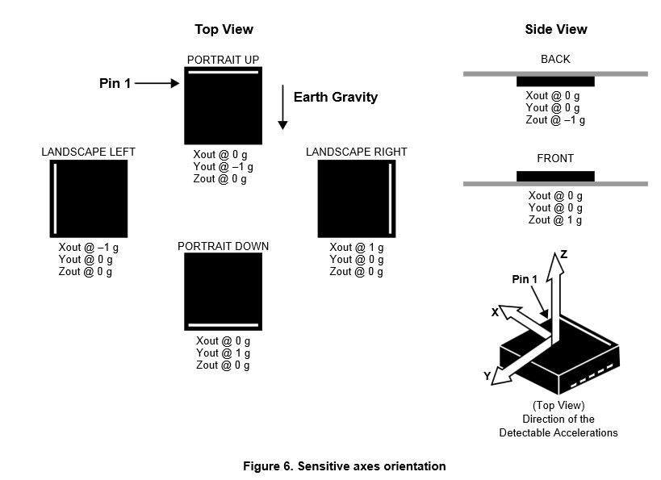

Figure : MMA8652FC accelerometer orientation detection

##### 

Figure : MMA8652FC accelerometer circuit connection

##### Conductivity Sensor

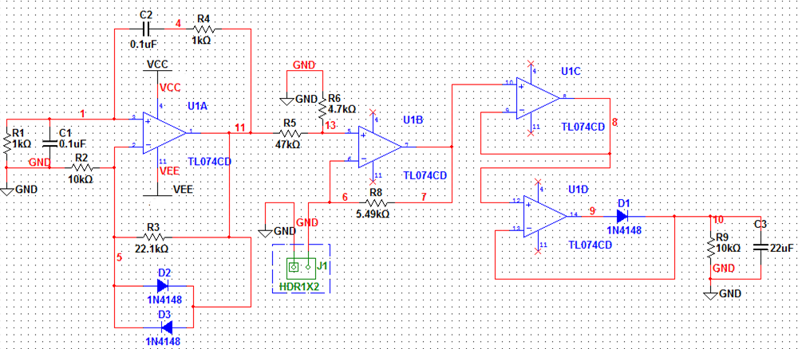

Figure : Conductivity Sensor Interface Circuit

The cell constant, **K**, is equal to the distance in cm between the probe's electrodes divided by the surface area of the electrodes in cm2. For high conducitivity sea water measurement, we should use a higher constant K = 10.

Node 11 is AC excitation circuit with frequency around 1.59kHz±10%. The Vpk-pk is around 800mV - 1.2V depends on the voltage drop on D2 and D3. Use various resistance across J1 to simulate the electrode probes.

|  |  |  |  |
| --- | --- | --- | --- |
| **Calculated Conductivity from resistance and cell constant (uScm-1)** | **Cell Constant (cm-1)** | **Resistor Resistance (ohm)** | **Measured Voltage Output (V)** |
| 15456 | 10 | 647 | 0.412 |
| 62073 | 10 | 161.1 | 1.542 |
| 66357 | 10 | 150.7 | 1.654 |
| 99701 | 10 | 100.3 | 2.434 |
| 124533 | 10 | 80.3 | 2.906 |

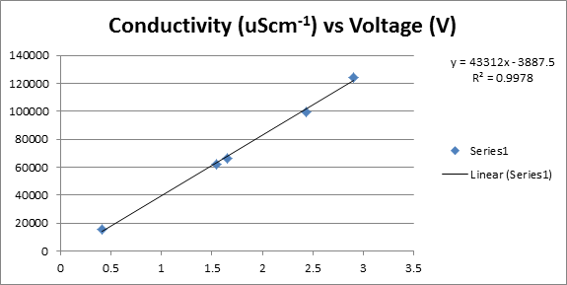

#### Output Indicator

##### LED Output

###### Current instantaneous efficiency relative to MEP

* Use 2x 4 bar array of LED (Yellow Color)

###### 1-hour moving average efficiency relative to MEP

* Use 2x 4 bar array of LED (Yellow Color)

###### Total power output relative to primary battery steady-state max and burst max.

* Use 2x 4 bar array of LED (Red Color)

###### Total power output relative to peak power battery steady-state max and burst max.

* Use 2x 4 bar array of LED (Red Color)

###### State of peak power battery capacity

* Use 2x 4 bar array of LED (Green Color)

###### Remaining primary battery capacity

* Use 2x 4 bar array of LED (Green Color)

#### Analog Output

3x LTC1662 10-bit Dual DAC are used to provide six channels DACs. 5V Reference voltage and VCC is used to provide full range analog output 0-5V. LT1461CCS8-5#PBF 5V reference is used to supply power to all 3 DACs.

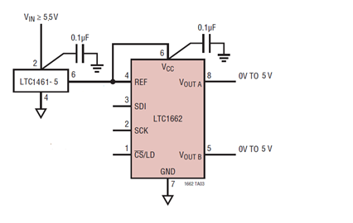

Figure : DAC Analog Output

###### Current instantaneous efficiency relative to MEP

* 0-5V indicates fraction of MEP power (0%-100% of MEP)

###### 1-hour moving average efficiency relative to MEP

* 0-5V indicates fraction of MEP power (0%-100% of MEP)

###### Total power output relative to primary battery steady-state max and burst max.

* 0-5V indicates primary power use in proportion to max primary power available

###### Total power output relative to peak primary battery steady-state max and burst max.

* 0-5V indicates peak primary power use in proportion to max peak primary power available

###### State of peak power battery capacity

* 0-5V indicates the peak power battery capacity

###### Remaining primary battery capacity

* 0-5V indicates the primary battery capacity

|  |  |  |  |  |  |
| --- | --- | --- | --- | --- | --- |
| **Pin** | **Signal** | **Signal Description** | **I/O** | **Signal Type** | **Signal Level** |
| J12-1 | VOUT1A | Current instantaneous efficiency relative to MEP | O | ANALOG | +5V |
| J12-2 | GND | Ground | - | GROUND | GND |
| J12-3 | VOUT1B | 1-hour moving average efficiency relative to MEP | O | ANALOG | +5V |
| J12-4 | GND | Ground | - | GROUND | GND |
| J12-5 | VOUT2A | Total power output relative to primary battery steady-state max and burst max | O | ANALOG | +5V |
| J12-6 | GND | Ground | - | GROUND | GND |
| J12-7 | VOUT2B | Total power output relative to peak power battery steady-state max and burst max | O | ANALOG | +5V |
| J12-8 | GND | Ground | - | GROUND | GND |
| J12-9 | VOUT3A | State of peak power battery capacity |  | ANALOG | +5V |
| J12-10 | GND | Ground | - | GROUND | GND |
| J12-11 | VOUT3B | Remaining primary battery capacity | O | ANALOG | +5V |
| J12-12 | GND | Ground | - | GROUND | GND |

Table : Power Output Connector

The PCB mount connector shall be part#: 53047-1210, Molex

The mating connector is part#. 51021-1200, Molex

The mating connector pin is part#. 50079-8000, Molex (26-28AWG)

#### User Interface

##### User Power Output Connector

###### High Voltage Power Output Connector

|  |  |  |  |  |  |
| --- | --- | --- | --- | --- | --- |
| **Pin** | **Signal** | **Signal Description** | **I/O** | **Signal Type** | **Signal Level** |
| J6-1 | DGND | Ground | - | GROUND | GND |
| J6-2 | DGND | Ground | - | GROUND | GND |
| J6-3 | VOUT1+ | 24V@6A max or 30V@4.8A max | O | POWER | +24-30V |
| J6-4 | VOUT2+ | 12@12A max or 18V@8A max | O | POWER | +12-18V |

Table : High Voltage Power Output Connector

The PCB mount connector shall be part#: 39-30-1041, Molex (Gold Contact)

The mating connector is part#. 39-01-2045, Molex

The mating connector pin is part#. 45750-3211, Molex (16AWG) (Gold Contact)

45750-1211, Molex (18-20AWG) (Gold Contact)

###### 5V, 3V Power Output Connector

|  |  |  |  |  |  |
| --- | --- | --- | --- | --- | --- |
| **Pin** | **Signal** | **Signal Description** | **I/O** | **Signal Type** | **Signal Level** |
| J15-1 | DGND | Ground | - | GROUND | GND |
| J15-2 | DGND | Ground | - | GROUND | GND |
| J15-3 | +5V | 5V Power Output 3A max. | O | POWER | +5V |
| J15-4 | +3V | 3V Output 3A max. | O | POWER | +3V |

Table : 5V, 3V Power Output Connector

The PCB mount connector shall be part#: DF3-4P-2DS(01),Hirose (Gold Contact)

The mating connector is part#. DF3-4S-2C, Hirose

The mating connector pin is part#. DF3-22SCFC, Hirose (22AWG) (Gold Contact)

DF3-2428SCFC, Hirose (24-28AWG) (Gold Contact

##### User Communication Connector

Communication Option

* USB – 5V Power Electronics, USB connect/disconnect detect
* UART Serial 3V Level – External 5V Power Electronics

|  |  |  |  |  |  |
| --- | --- | --- | --- | --- | --- |
| **Pin** | **Signal** | **Signal Description** | **I/O** | **Signal Type** | **Signal Level** |
| J8-1 | U5V | USB Bus Power or External 5V | I | POWER | +5V |
| J8-2 | USBDM | USB Data Minus | I/O | DIGITAL | USB |
| J8-3 | USBDP | USB Data Plus | I/O | DIGITAL | USB |
| J8-4 | USART1_TX | UART1 Transmit | O | DIGITAL | +3V |
| J8-5 | USART_RX | UART1 Receive | I | DIGITAL | +3V |
| J8-6 | GND | Ground | - | GROUND | GND |

Table : User Communication Connector

The PCB mount connector shall be part#: 53047-0610, Molex

The mating connector is part#. 51021-0600, Molex

The mating connector pin is part#. 50079-8000, Molex (26-28AWG)

##### User Selectable Input

Switch / Jumper select boost power supply

* Select 24V or 30V Power
* Select 12V or 18V Power

Switch / Jumper turn on/off unused power supply

* 24, 30VDC Power
* 12, 18VDC Power

Switch / Jumper to turn on/off LED indiciator

|  |  |  |  |  |  |
| --- | --- | --- | --- | --- | --- |
| **Pin** | **Signal** | **Signal Description** | **I/O** | **Signal Type** | **Signal Level** |
| J9-1 | PD10_24V/30V_JUMPER | 24V/30V Selection (H=24VDC, L=30VDC) | I | DIGITAL | +3V |
| J9-2 | GND | Ground | - | POWER | GND |
| J9-3 | PD11_12V/18V_JUMPER | 12V/18V Selection (H=18VDC, L=12VDC) | I | DIGITAL | +3V |
| J9-4 | GND | Ground | - | POWER | GND |
| J9-5 | PD12_VOUT1_JUMPER_EN | 24V/30V Power Supply Enable (Active High) | I | DIGITAL | +3V |
| J9-6 | GND | Ground | - | POWER | GND |
| J9-7 | PD14_VOUT2_JUMPER_EN | 12V/18V Power Supply Enable (Active High) | I | DIGITAL | +3V |
| J9-8 | GND | Ground | - | POWER | GND |
| J9-9 | PA8_LED_STATUS_JUMPER | LED Status Enable (Active High) | I | DIGITAL | +3V |
| J9-10 | GND | Ground | - | POWER | GND |

Table : User Selectable Input Connector

The PCB mount connector shall be part#: 53047-1010, Molex

The mating connector is part#. 51021-1000, Molex

The mating connector pin is part#. 50079-8000, Molex (26-28AWG)

Switch / Jumper to select Processor Boot Mode on PCB

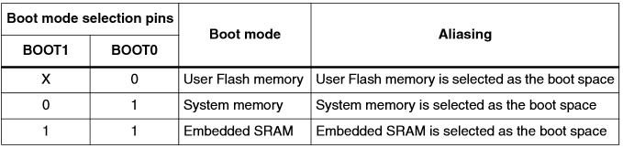

##### User Analog

Microcontroller spare analog Input (6 channels)

|  |  |  |  |  |  |
| --- | --- | --- | --- | --- | --- |
| **Pin** | **Signal** | **Signal Description** | **I/O** | **Signal Type** | **Signal Level** |
| J14-1 | ADC_IN20_SPARE1 | Analog Input Channel 20 Spare 1 | I | ANALOG | 0-3V |
| J14-2 | ADC_IN21_SPARE2 | Analog Input Channel 21 Spare 2 | I | ANALOG | 0-3V |
| J14-3 | ADC_IN22_SPARE3 | Analog Input Channel 22 Spare 3 | I | ANALOG | 0-3V |
| J14-4 | ADC_IN23_SPARE4 | Analog Input Channel 23 Spare 4 | I | ANALOG | 0-3V |
| J14-5 | ADC_IN24_SPARE5 | Analog Input Channel 24 Spare 5 | I | ANALOG | 0-3V |
| J14-6 | ADC_IN25_SPARE6 | Analog Input Channel 25 Spare 6 | I | ANALOG | 0-3V |
| J14-7 | GND | Ground | - | POWER | GND |
| J14-8 | GND | Ground | - | POWER | GND |

Table : User Spare Analog Input

The PCB mount connector shall be part#: 53047-0810, Molex

The mating connector is part#. 51021-0800, Molex

The mating connector pin is part#. 50079-8000, Molex (26-28AWG)

#### Data Logging

MicroSD Card Connector

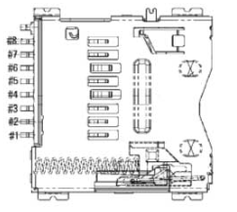

Figure : SD Card Connector

|  |  |  |  |  |  |
| --- | --- | --- | --- | --- | --- |
| **Pin** | **Signal** | **Signal Description** | **I/O** | **Signal Type** | **Signal Level** |
| J13-1 | NC | No Connect | - | - | - |
| J13-2 | /PA4_SPI1_CS | SPI1 Chip Select | I | DIGITAL | +3V |
| J13-3 | SPI1_MOSI | SPI1 MOSI | I | DIGITAL | +3V |
| J13-4 | +3V_L | +3V Power | - | POWER | +3V |
| J13-5 | SPI1_SCK | SPI1 Clock | I | DIGITAL | +3V |
| J13-6 | GND | Ground | - | POWER | GND |
| J13-7 | SPI1_MISO | SPI1 MISO | O | DIGITAL | +3V |
| J13-8 | NC | No Connect | - | - | - |

Table : MicroSD Card Interface

The PCB mount connector shall be part#: 2908-05WB-MG, 3M

The mating part is standard microSD Card Memory Size TBD